Supplementary Materials for

Low-cost augmented reality goggles enable precision fluorescence-guided cancer surgery

Leonid Shmuylovich* Christine M. O’Brien, Karen Nwosu, Samuel Achilefu*

*Corresponding author. Email: LS: shmuylol@wustl.edu, SA: samuel.achilefu@utsouthwestern.edu

This PDF file includes:

Supplementary Text
Figs. S1 to S20
Tables S1 to S4

Section 1. Characterization of Raspberry Pi V2 camera

1A. RPiV2 camera module specifications
Prior to 2023, the Raspberry Pi Foundation produced 3 official camera modules, the v1, v2, and HQ cameras that all integrate directly with Raspberry Pi SBCs and support custom image acquisition through python software libraries. These camera modules are inexpensive ($25-30 for v1 and v2, $50 for HQ), available from multiple vendors, and operate seamlessly without additional components. The RPiV2 camera module has higher resolution (8MP vs 5MP) than the v1 camera and unlike the 12 MP HQ camera is available in both visible light and infrared (NoIR) versions. The RPiV2 consists of a Sony 8MP (3280 x 2464 1.12 µm square pixels) IMX219 CMOS sensor that snaps into a camera module circuit board. The circuit board has a standard 15 pin MIPI connector that can be connected via cable to a Raspberry Pi SBC camera serial interface (CSI) port. Software libraries provided by the Raspberry Pi Foundation³⁴ provide convenient methods for custom control of image and video acquisition parameters with the option to save 8-bit processed or 10-bit raw Bayer data ³⁵. The IMX219 imaging sensor of the RPiV2 camera module is integrated into an 8mm x 8mm x 5mm lens housing. The IMX219 sensor housing has a central threaded cylinder with an adjustable lens. The lens has a 3.04 mm focal length, 2.0 aperture, and 62.2° by 48.8° horizontal and vertical field of view (FOV) respectively. The IMX219 sensor and housing can be attached to the camera module circuit board directly, or can be attached to the camera module circuit board via IMX219 sensor extension cables (B0186, Arducam, Nanjing China). These extension cables are inexpensive ($12.99), readily available from Amazon.com or uctronics.com, and allow the integration of the IMX219 sensor into space-constrained designs by decoupling the sensor from the 25 mm x 25 mm camera module circuit board. Figure S1A shows the components of a RPiV2 camera and demonstrates how the camera sensor can be connected to the camera PCB with an extension cable.
The visible light version of the RPiV2 camera filters out infrared with an IR filter placed between the imaging sensor and lens, while the NoIR version has no IR filter in front of the IMX219 sensor. The characteristics of the RPiV2 built-in IR filter have not been released by the Raspberry Pi Foundation, and thus we removed the IR filter from a standard RPiV2 camera module to measure its optical properties. A broadband halogen light source with diffuser and visible-NIR spectrometer (USB2000+VIS-NIR-ES, Ocean Insight, Orlando, FL) were positioned on opposite ends of the RPiV2 IR filter. Background-subtracted non-saturated spectra of the halogen lamp with and without the filter were obtained and used to generate optical transmission curves for the built in IR filter. We found that the optical density (OD) exceeded 2 above 700 nm (Figure S1B).

1B. RPiV2 camera spatial resolution and depth of focus theoretical prediction
To test the feasibility of the RPiV2 camera for FGS, the camera spatial resolution and depth of focus limits were determined from a theoretical and experimental perspective. Imaging system resolution is typically expressed in terms of resolvable line-pairs per mm (lp/mm), where a line pair consists of 2 contrasting lines (i.e. one light line and one dark line). The theoretical spatial resolution limits at a given imaging distance of the IMX219 sensor can be estimated by first determining the number of pixels per millimeter at a given distance. The pixels per mm along horizontal and vertical direction is given by:

${\frac{px}{mm}}_{H.V}=\frac{{\#pixels}_{H,V}}{2×d×\tan{\frac{{FOV}_{H,V}}{2}}}$ Equation 1

, where d is the distance from the camera in millimeters, #pixels_{H,V} is the number of pixels along horizontal and vertical direction respectively, and FOV_{H,V} is the horizontal and vertical field of view respectively. Plugging in the sensor dimensions and FOV characteristics of the IMX219 sensor and RPiV2 lens into Eq 1 yields the following expression for both horizontal and vertical pixels per millimeter as a function of distance d:

$\frac{px}{mm}≈\frac{2720}{d}$ Equation 2

The minimum line-pair thickness is 2 pixels thick, and therefore half of the pixels per millimeter at a given distance defines the maximum lp/mm as a function of distance:

$\frac{lp}{mm}=\frac{1}{2}\frac{px}{mm}≈\frac{1360}{d}$ Equation 3

Figure S2A plots line pairs per mm vs imaging distance d using Equation 3.
The stock position of the RPiV2 lens is focused at a hyperfocal distance of approximately 1 m rendering objects placed at distances of 50 cm to infinity in focus ³⁶. The minimum focus distance can be adjusted by manually turning the lens and translating it within its threaded housing to a desired distance from the imaging sensor. Focusing to distances closer than the hyperfocal distance results in a decreased depth of field Z’’-Z’, which can be estimated from the following equation:
$Z^{'}= \frac{df^{2}}{f^{2}+Fc\left(d-f\right)}, Z^{''}= \frac{df^{2}}{f^{2}-Fc\left(d-f\right)}$ Equation 4

,where Z’ is the near-focus distance, Z’’ is the far-focus distance, f is the focal length, F is the aperture, c is the diameter of the circle of confusion (largest acceptable blurred sized of a point not in perfect focus), and d is the distance where the lens is maximally focused ³⁷.
In the FAR-Pi system the camera module can be placed in several positions – in front of the surgeon’s eyes on a forehead mounted articulating arm, between the eyes on the heads up display glasses, or above the glasses with a beamsplitter design. With these different options the distance between camera and surgical field varies from 40 to 50 cm, assuming a working distance of 50 cm between eyes and surgical field. Thus the RPiV2 camera lens must be adjusted from its stock position and be focused closer than the hyperfocal distance, resulting in a reduction in depth of field. Based on Equation 4, focusing the RPiV2 camera to a distance d = 40 cm and assuming a circle of confusion c equal to the size of three sensor pixels (3•1.12 µm), results in a depth of field of 25 cm, with near-focus and far-focus distances of 31 cm and 56.2 cm respectively. These depth of field limits are plotted in Figure S2A as vertical lines.

1C. RPiV2 camera spatial resolution and depth of focus experimental determination
A backlit Thorlabs NSB 1963A resolution test target (R2L2S1N, Thorlabs Inc, Newton, NJ) was positioned in front of an RPiV2 camera module on a linear rail so that the center of the resolution target aligned with the center of the camera field of view. Images of the resolution test target (Figure S2B) were obtained at distances between 30 cm and 65 cm in 5 cm increments. For any chosen group number, a row vector consisting of the total gray-scale pixel intensity across each column defined the vertical line pairs, and a column vector consisting of the total gray-scale pixel intensity across each row defined the horizontal line pairs (Figure S2C). Local maxima and minima of these 1-dimensional vectors correspond to resolved line pairs, and the highest line pair that demonstrated 5 clear distinct maxima corresponding to all 5 line pairs in a group defined the resolution limit at each distance (Figure S2A).

1D. RPiV2 Dual Camera Alignment
A key component of an FGS system is the co-aligned simultaneous detection of NIR and visible light. We designed the FAR-Pi system to achieve dual NIR and visible imaging by using a 45° cold IR mirror plate beamsplitter (#62-634 Edmund Optics, Barrington, NJ) to optically coalign a standard RPiV2 camera (that contains an IR filter and is sensitive to visible light only), with a NoIR camera (which has no built-in IR filter and is sensitive to NIR light).
This cold mirror is made of floated borosilicate, with >95% reflection of visible light and >90% transmission of NIR, has an index of refraction between 1.47 and 1.465 from 650-900 nm, and has dimensions of 12.5 mm x12.5 mm x 1.1 mm. Less than 5% of the incoming NIR light is reflected off the cold mirror, and though this reflected light is incident on the RPiV2 standard camera dedicated to visible imaging, the built-in IR filter of the RPiV2 standard model camera removes this reflected NIR component, obviating the need for additional filters. The position of cameras and beamsplitter are determined to ensure equal pathlength for both the visible and NIR imaging arms, which requires taking into account differential pathlength due to refraction through the beamsplitter. Figure S3A shows a to-scale schematic of a dual visible/NIR imaging assembly where camera sensors are positioned to ensure equal optical path length (ab = ac+cd), and a cold IR mirror is positioned to operate as a visible/NIR beam splitter.
In FGS, the excitation light source must have a spectral profile that overlaps with the excitation band of the desired fluorophore, and there must be a mechanism to maximize detection of fluorescence emission while minimizing detection of excitation light. For both indocyanine green (ICG) and a novel cancer-targeting NIR-fluorophore developed in our lab called LS301²⁵, emission and excitation profiles are similar, with efficient excitation from 780-800 nm and peak emission at 815-830 nm.
Even when using a narrow-peak 780 nm excitation laser, there is a non-negligible long tail that extends to the peak of ICG and LS301 emission. An excitation filter that cuts only the peak of laser excitation would allow for maximal detection of NIR-fluorophore emission, but would not block the laser diode tail. Given these trade-offs, imaging modules were designed, constructed and tested with multiple excitation filter options. Different filter options required different amounts of clearance between beamsplitter and NoIR mirror, and thus the enclosure has to be adjusted for each design to accommodate variable filter thickness.
To facilitate the design of an enclosure that is easy to modify for different filter options, we determined how sensors must be positioned relative to the beamsplitter in order to ensure equal optical pathlength. When using a plate beamsplitter, refraction in the transmitted light path results in the optical path being displaced and the optical path length being extended along the transmitted arm. This effect is visible in Figure S3A, where the light path from the right that is incident on (a) is parallel but displaced a distance (h) from the NIR light path (cd), and the distance (ac) is smaller than the distance the light would have travelled straight through the mirror without refraction (along path ae).
Applying Snell’s law, the vertical deviation in optical path assuming an angle of incidence to the beamsplitter of 45° can be expressed by the following equation:

$h=t\frac{\sqrt{2}}{2}\left(1-\frac{1}{\sqrt{{2\left(\frac{n_{mirror}}{n_{air}}\right)}^{2}-1}}\right)$ Equation 5

, where h is the deviation of the optical path in a direction perpendicular to the incident ray, t is the mirror thickness, n_{mirror} is the refractive index of the mirror and n_{air} is the refractive index of air. For a mirror thickness of t = 1.10 mm, n_{air} = 1.0003 and n_{mirror} varying between 1.4650 and 1.47, the optical path displacement h varies from 0.349 to 0.351 mm. The change in optical path length due to refraction ∆l can be derived and expressed by the following equation:
$Δl=t\left(\frac{1}{\sqrt{1-\frac{1}{2}{\left(\frac{n_{air}}{n_{mirror}}\right)}^{2}}}-\frac{\sqrt{2}}{2}\left(1+\frac{1}{\sqrt{{2\left(\frac{n_{mirror}}{n_{air}}\right)}^{2}-1}}\right)\right)$ Equation 6

This distance ∆l is the difference between distances ab and ae in Figure 3A, and for a mirror thickness of t = 1.10 mm, n_{air} = 1.0003 and n_{mirror} varying between 1.4650 and 1.47, ∆l varies from 0.049 to 0.050 mm.
Applying Snell’s law yields a displacement h = 0.35mm and a difference of ∆l = ab-ae = 0.05 mm. Thus the use of a plate beamsplitter requires positioning the camera along the transmitted NIR light arm 0.05 mm closer and 0.35 mm higher than would be required if using a cube beamsplitter where there is no beamsplitter-associated deviation of optical path or path length. These deviations in optical path are smaller than the typical errors inherent to 3D printing.
To determine suitable placement of cameras sensors and optical elements that met these constraints, a parametric 3D CAD model was developed in AutoDesk Fusion. This model parameterizes the distance ab as an adjustable variable, and incorporates Equations 5 and 6 as well as the exact dimensions of the RPiV2 cameras and optical components to ensure that 1) each optical element captures the entire FOV of both cameras and 2) the optical path and pathlength are identical for both cameras.
Setting the distance between the standard RPiV2 camera and cold IR mirror surface ab to 5 mm constrains the RPiV2 NoIR camera to have the center ab+h = 5.35nmm above point b, with lens surface at a distance ae = ab-∆l = 4.95 mm away from point a. In this arrangement the transmitted NIR light path is composed of dc = 3.755 mm and ca = 1.255 mm, which together equals the 5 mm optical path ab between mirror surface and IR-filter containing RPiV2 camera. An excitation light filter is placed in front of the NoIR camera, and therefore there needs to be clearance between the NoIR camera and the beamsplitter edge. To increase the clearance between the edge of the beamsplitter and the NoIR camera, the beamsplitter can be shifted along a 45 degree plane to a limit where the edges of 48.8° degree FOV are incident upon the edges of the beamsplitter (Figure S3B). At this limit with ab =5 mm and beamsplitter thickness t = 1.10 mm, the clearance w is 2.61 mm. The clearance in front and behind the excitation filter needs to be at least 0.1 mm, so the effective space available for the excitation filter is approximately 2.4 mm. This clearance is sufficient for a single 830 nm Newport longpass filter (thickness 1.1 mm), a single 832 nm Edmunds bandpass filter (thickness 2.0 mm), or a single 808 nm Semrock EdgeBasic longpass filter (thickness 2.0 mm).
However fitting two 830 nm LP filters with a small air gap is extremely challenging with a clearance of only 2.4 mm, as it leaves only 0.2 mm air gap between filters and leaves no room for the ±0.1 mm thickness tolerance associated with the 830 nm filter. An advantage of the parametric model is that one can change the distance ab between camera and mirror to provide sufficient space for alternate excitation filter options, and the position of both cameras will update programmatically to keep optical path and path length equal. Figure S3C demonstrates that shifting the cameras away from the beamsplitter increases the clearance for the excitation filter. Thus to make more space for a double 830 nm filter design, the cameras sensor housings were shifted by 0.4 mm away from the beamsplitter (setting ab = 5.4 mm in the parametric design), which increased w to 2.88 mm. This width accommodates 0.1 mm clearance between filter and front of the camera surface, 0.1 mm clearance between filter and beam splitter edge, a 0.25 mm air gap between two 1.1 mm thick filters, and leaves 0.23 mm of tolerance for filter thickness.

1E. Imaging Module Assembly

A parameterized CAD model was used to create a 3D printed enclosure for the dual RPiV2 camera assembly. The enclosure consists of 3 pieces which were 3D printed on a <$500 CR10v2 printer (Creality3D, Hong Kong) with 1.75 mm PLA (Hatchbox) using a layer height of 0.12 mm and 50% infill. The central enclosure piece has perpendicularly oriented square openings into which the RPIV2 IMX219 sensor housings are press fit, a 45° rectangular slot into which the 12.5 mm square 1.10 mm thick cold IR mirror are pushed into, and vertically oriented slots into which the excitation filters (either single or double) are pushed into (Figure S4A-C).

The imaging module assembly steps are shown in Figure S4 D-E. First the imaging sensor housing from an RPiV2 standard camera and a NoIR RPiV2 camera must be removed from their camera module circuit boards and connected to Arducam MIPI sensor extension cables before being press fit into the 3D printed central enclosure piece. The NoIR camera is positioned on the back while the standard camera is positioned on the bottom. The central enclosure also has eight slots into which M1.4 nuts are pushed into (Figure S4D). Next the cold IR mirror is press fit into the 45 degree central enclosure slot, and the excitation filter is press fit into the vertical central enclosure slot directly in front of the NoIR camera (Figure S4E). If using the enclosure with 2 slots for 2 excitation filters (Figures S4C), then two filters are slid into two separate slots. In the last step additional 3D printed pieces are added to the back/top of the enclosure and bottom of the enclosure to secure the cameras and excitation filter. Both pieces have 4 M4 holes that align with the 4 M4 holes on the back and bottom of the central enclosure. A total of 8 M1.4 screws are used to secure these two enclosure pieces to the central enclosure.

1F. Validation of camera sensor alignment

Despite accurate accounting of refraction-associated optical path deviation there are several sources of inaccuracy that may result in mis-aligned visible and NIR images. For example, the IMX219 camera sensors may have small errors in placement relative to the RPiV2 camera housing, and the 3D printed enclosures may have inaccuracies related to 3D printer resolution limits.

To quantify the effect of these potential inaccuracies, the dual camera enclosure was positioned at a distance of 30, 50 and 70 cm from a Thorlabs NSB 1963A resolution test target and images from both the standard and NoIR RPiV2 cameras were captured and exported for further analysis. The resolution test target was backlit with a broadband halogen light source (providing visible and near infrared illumination) to ensure that both the visible camera and the NoIR camera (with one of 4 longpass filter combinations in front) had sufficient illumination for imaging. MATLAB (Mathworks, Natick, MA) scripts were developed to analyze and compare visible and NoIR camera images. Images were converted to grayscale, cropped to include either the vertical or horizontal line pairs of the 1.0 resolution target group, and then reduced into row or column vectors by summing pixel intensities along all rows or columns respectively. The 5 peaks present in these row and column vectors correspond to the x and y pixel coordinates respectively at the centers of the vertical and horizontal line pairs, and the number of pixels between peaks defined a mm to pixel conversion for a given image because adjacent peaks for the 1.0 resolution target group are 1.0 mm apart. Plotting these row and column vectors for both visible camera and NoIR camera images provided a quantitative visualization of the degree of vertical and horizontal misalignment between camera sensors (Main Text, Figure 3D).

1E. Software-based correction of sensor disparity

The visible and NoIR images of the resolution test target positioned 50 cm from the dual camera module were loaded into a custom MATLAB script and using the ‘cpselect’ tool 4 corresponding fiducial points were manually selected at the corners of the resolution test target in both images. These points were used as inputs to the ‘fitgeotrans’ function to derive an affine geometric transformation that could be applied to the visible image (using ‘imwarp’) in order to more closely coalign it with the NoIR image. Because the misalignment between cameras is a constant regardless of imaging distance, the affine transform defined by the images at 50 cm applies to images at any distance. This transform corrects for inaccuracies in 3D printing and sensor alignment within the plastic lens housing. Each build may introduce a unique set of inaccuracies in alignment, and therefore a new transform must be determined for each dual enclosure that is built. Four different enclosures were built to accommodate each of the four different filter options, and each had slightly different alignment transforms. While this transform was derived through analysis with MATLAB, the transformation matrix can be applied to the real time RPiV2 visible camera stream using python OpenCV.

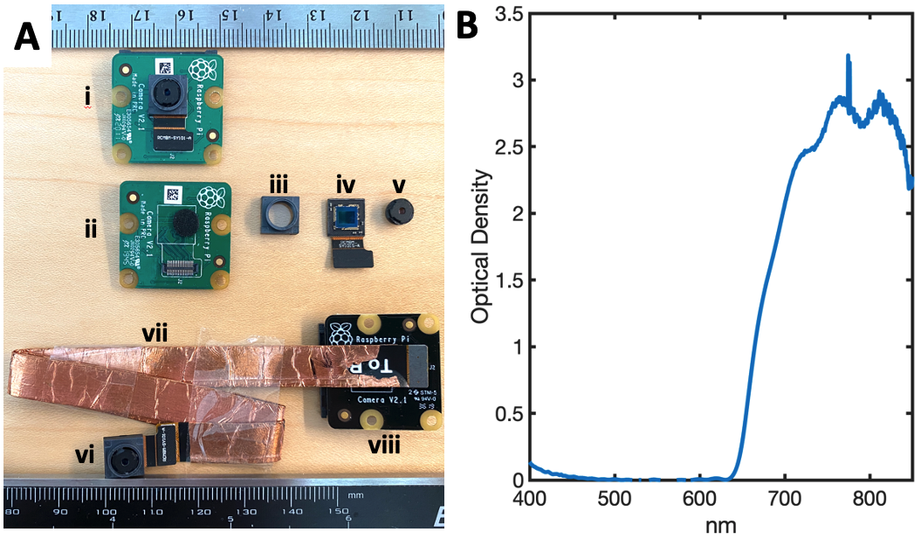

Figure S1. A) Raspberry Pi V2 camera module components. i) The module is preassembled and consists of a PCB (green for standard, black for NoIR version) and a camera sensor and lens housing that is connected to the PCB through MIPI pins. The module can be disassembled by removing the camera sensor and lens housing from the PCB (ii). The housing (ii) can be removed from the sensor (iv) with a sharp blade. This process reveals the built in IR filter (present for standard IR version, not shown in this diagram). Turning the lens (v) counterclockwise removes the lens from the threaded housing. To facilitate miniaturization, the camera sensor and lens housing (vi) can be connected with third party flexible extension cables from Arducam (vii) to the camera PCB (vii). B) Optical density of RPiV2 built-in IR filter. Less than 1% of light above 700 nm is transmitted through the filter.

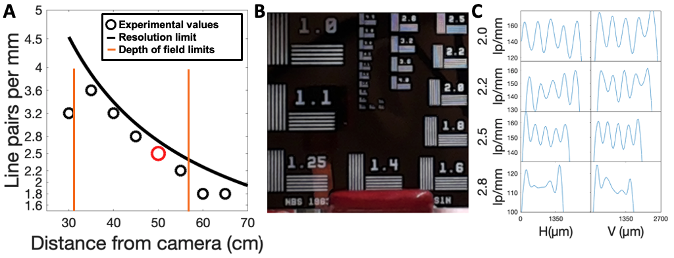
Figure S2. A) IMX219 sensor dimensions and lens field of view, focal length, and aperture can be used to predict camera spatial resolution and depth of focus limits as a function of object distance. Theoretical predictions were confirmed by determining the highest resolvable line pair group in a Thorlabs 1963A resolution test target at a given distance. Red circle indicates results at 50cm, which are shown in B) and C). B) Raspberry Pi v2 camera module-captured image of a Thorlabs 1963A resolution test target at a distance of 50 cm. C) Quantification of total pixel intensity across for horizontal and vertical line pairs within the 2.0, 2.2, 2.5, and 2.8 resolution target group numbers. Peaks correspond to centers of the white lines within each line pair, the highest group number with 5 discernible peaks (in this case group 2.5, corresponding to 200 µm resolution) defines the resolution limit.

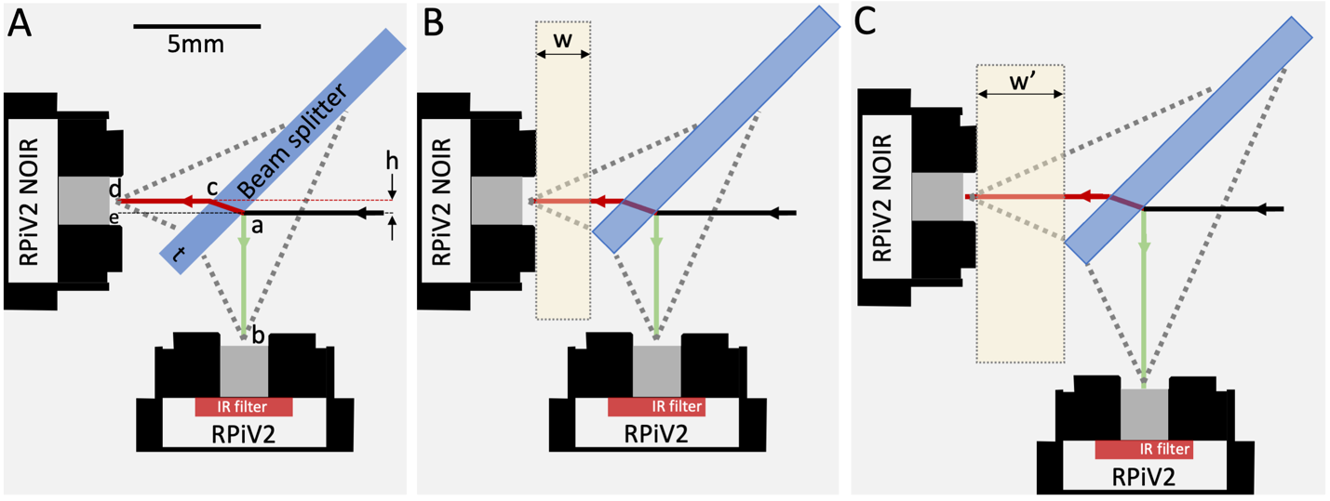

Figure S3. A) Incoming light (black arrow) is either reflected off the cold IR plate beamsplitter (ab) and incident upon a standard RPiV2 camera lens or transmitted and refracted through (acd) and incident upon a RPiV2 camera without built-in IR filter. Refraction through the beamsplitter (with thickness t) results in vertical deviation h of the transmitted light. B) Shifting the beam splitter along the 45 degree plane while ensuring that the lens FOV remains fully incident upon the beam splitter increases the clearance (w) between NoIR camera and beamsplitter edge, allowing for thicker long pass filter assemblies to be placed in front of the NoIR camera. C) To increase the clearance to a larger value (w’), both cameras can be moved an equal distance away from the beamsplitter. The position of the beamsplitter must also be slightly adjusted to ensure the edges are incident with the edge of the field of view. The cameras in this example were moved by 1.65 mm for demonstrative purposes so that the change in clearance width would be easier to visually perceive.
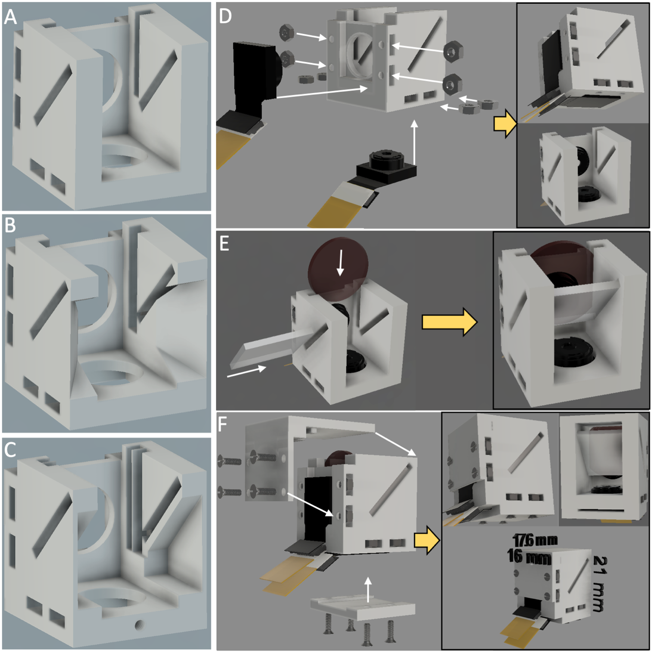

Figure S4. Different designs for imaging module central enclosure supporting alternative excitation filters and step by step assembly all imaging module components. A) Baseline model for central enclosure, supporting a single 1.1 mm thick excitation filter. B) Alternate central enclosure module that supports single 2.0 mm thick excitation filters. In addition some of the internal enclosure wall is thinned out to ensure that camera field of view is not blocked by enclosure wall. C) Alternate central enclosure module supporting two 1.1 mm thick excitation filters with 0.25 mm air gap. D) Assembly step 1, adding RPiV2 camera sensors connected to flexible extension cables and M4 nuts to central enclosure. E) Assembly step 2, adding 45 degree beamsplitter and excitation filter to slots in central enclosure. F) Assembly step 3, securing cameras, excitation filter, and closing central enclosure with 2 outer enclosure pieces and 8 M4 screws.

Section 2 - Illumination Module Design and Assembly

2A. Design
A parametric CAD design was created in Fusion 360 (Autodesk, Inc, San Rafael, CA) that positioned any number of laser diodes a distance d from the center of a circular array with inclination angle θ relative a normal from the laser array center (Main text, Figure 2B). In order to have sufficient space for a centrally placed imaging module, d was set to a distance of 18.475 mm between laser center and array center. An angle θ = 3° ($\tan^{-1}\left(\frac{d=18.475mm}{L=400mm}\right)$) of inclination towards the center of the laser diode array was chosen to support laser intersection at approximately 40 cm (the distance of the head-mounted laser diode array relative to the surgical site when the surgeon’s eyes are 50 cm away). The collimating lenses of each laser diode were focused close to ensure maximum divergence at the surgical site.
The circular laser diode array provided a flexible baseline design that was utilized to implement several designs for the laser array, including 1) placing the imaging module in the center of the laser diode array (Figure S5, S6), and 2) placing a white light LED in the center of the laser diode array (Figure S7).

2B. Assembly – Imaging module centered within laser array
We first describe the illumination module implementation where the imaging module is positioned centrally within the laser array. Figure S5 details the assembly steps. Each 780 laser diode module consists of a 780 nm laser diode epoxied in a 6mm diameter aluminum tube which has interior threads for securing a collimating lens, and exterior threads that secure to a cylindrical aluminum shell designed to protect the laser driver circuit board. To minimize space and weight of the final assembly, the hollow aluminum outer shell was unscrewed and discarded, leaving the laser driver circuitry exposed (Figure S5A).
A 3D printable laser and camera holder was designed to secure the imaging module and 3 laser diodes. The laser holder was generated by the parametric laser array as described above and merged with the imaging module mounting plate. The laser diodes fit in cylindrical holes whose diameter can be clamped down with an M2 screw. The cylindrical holes have an outer diameter of 5.625 mm, which is large enough to not block the laser beam, but smaller than the 6 mm laser outer shell. Thus after removing the collimating lens assembly, the lasers can be pushed into the cylindrical holes until they hit a flat lip, and then clamped in place (Figure S5B). Once this step is complete, the collimating lens assemblies can be reattached, and the imaging module can be secured to the center of the laser assembly using the same M1.4 screws and M1.4 holes used to secure the imaging module bottom outer enclosure in Figure S4F. With the collimating lenses and imaging module secure, the entire assembly is connected with the aid of 3 M2 screws to a bottom outer enclosure that protects the exposed laser driver circuits and provides mounting holes for an articulating arm (Figure S5C). Each laser diode has a black ground wire and red power wire, and each RPiV2 camera sensor has an Arducam sensor extension cable. All of these wires and cables pass through the back of the bottom enclosure and are secured under wire clamps that are mounted to the bottom enclosure (bottom right panel of Figure S5C). The wire clamps ensure that the wires and cables do not get disconnected from the laser driver circuit boards and camera sensors even if the wiring is pulled. To simplify connecting the laser diodes to a power source, the power and ground wires can be incorporated into a 2 pin JST housing or 2 pin female header connectors.
This design also accommodates the addition of individual laser clean-up filters to each of the 3 diodes. The ring assembly to which the 3 laser diodes are clamped has 3 M4 threaded holes equidistant from the laser diodes. An additional 3D printed component that holds 12.5 mm Thorlabs 785 nm laser line premium bandpass filters (FBH05780-10, Thorlabs, Newark, NJ) positioned to fit on the laser diode collimating lens can be secured with these 3 M4 threaded holes (Figure S5D). These additional clean-up filters reduce the intensity of detected NIR background by removing part of the laser’s weak but long NIR tail.
Assembling the imaging and illumination modules can be achieved with 3D printed parts and simple tools like screwdrivers, tweezers and wire crimpers in less than 1 hour. All components were arranged to be printed together and occupied an area of approximately 11cm x 11cm, which fits on numerous inexpensive 3D printers like the Creality Ender 3 (<$200) or CR10v2 (<$500). Printing all components at once on a Creality CR10v2 printer with layer height of 0.12 mm and 50% infill took 10 hours and required 45g of PLA filament (Figure S6A). The assembled illumination module has dimensions of 54 mm diameter base x 34 mm height and weighs 54 grams.

2C. Assembly – Illumination module coupled with central white light LED
While the laser diodes produce some visible light (due to the long tail on both sides of the laser diode peak), the laser spot is faint compared to room light. Visualizing the location of the laser spot is important for the FGS system operator to ensure that they are interrogating the appropriate area of interest and also to ensure safe operation of the system with respect to other people in the vicinity of the FGS system. To solve this problem the parametric laser array design was modified by increasing the distance between lasers to allow a white light LED to be placed in the middle of the laser diode array (Figure S7). White light LEDs have weak but long NIR tails that are stronger than the long NIR tail of the excitation laser source, and therefore an IR filter is placed in front of the white light LED filter out any NIR light emanating from the white light source that may increase the detected background signal.
The assembly steps for this design are presented in Figure S7. Similar to the other illumination module designs, all components were modeled in Autodesk Fusion 360 and 3D printed prior to assembly. First each laser diode module is deconstructed as shown in Figure S5B, and the hollow outer shell is discarded. Then the 3 laser diode modules, with collimating lens assembly removed, are pushed into the laser diode holder holes and clamped with M2 screws (Figure S7A). The collimating lens are screwed back in to the laser diode modules once the modules are secured in the laser holder assembly. This laser holder has a space in the center for a rechargeable battery-powered white light LED ($32.99, ASIN B07WSQ3N6G, Amazon.com), which consists of a bright 5W white LED placed inside a cylindrical tube with a lens at the end. The white light LED is positioned in the center and flush with the laser holder array and secured with M3 set screws. Next, similar to the steps shown in Figure S5C, an outer enclosure is attached with 3 M2 screws to protect the laser diode circuitry (Figure S7B). The back side of this outer enclosure has wire clamps that secure the laser power and ground wires to protect them from being pulled out of the laser diode PCBs (Figure S7B right panel). Finally, similar to the steps in Figure S5D, a 3D printed component is attached with 3 M4 screws to the laser diode array ring which secures three 12.5 mm 785 nm Thorlabs premium bandpass filters to the laser collimating lens assemblies (Figure S7C). In addition, this 3D printed component secures an IR-cut filter (12.5 mm Square IR Cut-Off Filter, #55-235 Edmund Optics) in front of the white light LED.

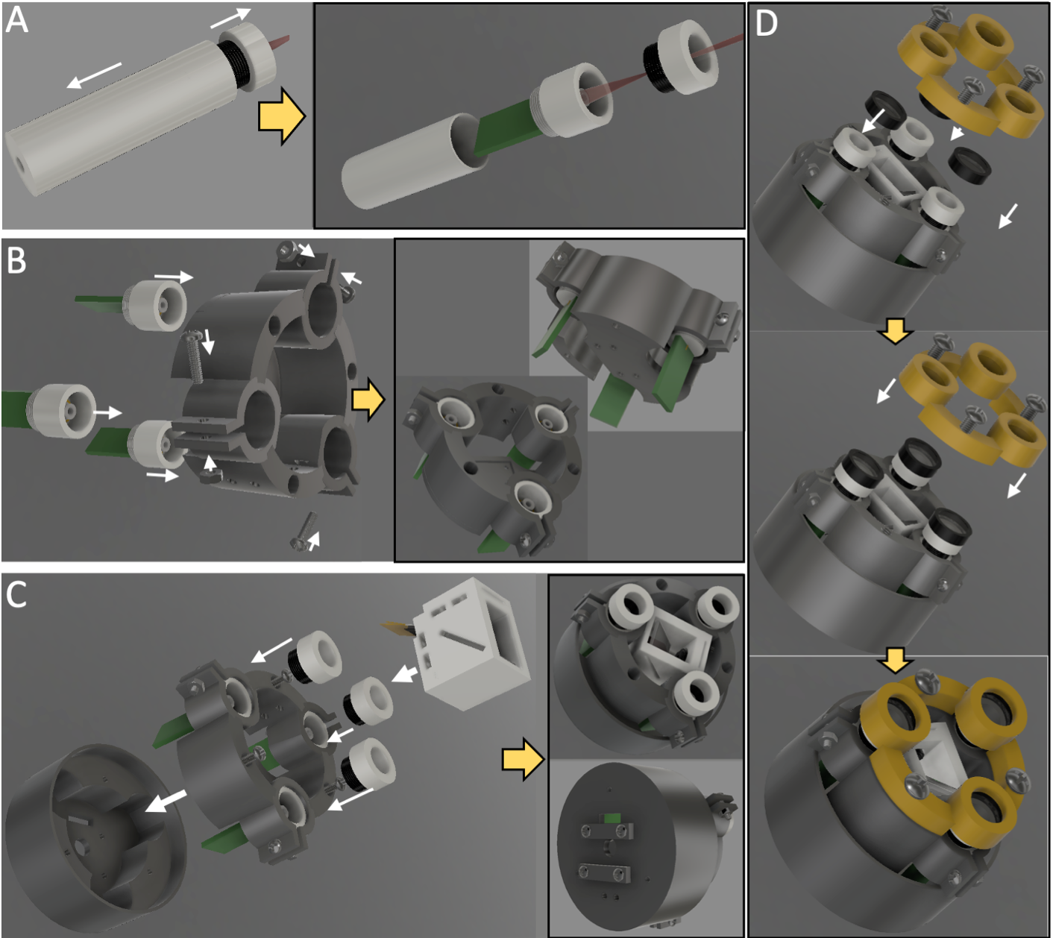Figure S5. Illumination module with central imaging module assembly and step by step build. A) A single laser diode is first disassembled, the aluminum shell is discarded, exposing the laser diode control circuitry, and the collimating lens assembly in the front is set aside until a later step of assembly. B) Laser diodes are press fit into a custom 3D printed laser array holder. M2 screws and nuts are used to secure each laser diode after it is inserted into the laser array holder. The laser array holder has a space in the middle with mounting holes that line up with the imaging module. C) The imaging module is inserted into the middle of the laser array holder and secured with the same M1.4 screws used to secure the bottom outer enclosure of the imaging module (as in Figure S3F). The collimating lens assemblies are screwed back into each laser diode assembly. The entire assembly is attached to an outer 3D printed laser array enclosure with 3 M2 screws. This outer enclosure protects the laser diode circuitry and also has threaded holes for wire clamps and mounting brackets on the back (lower right panel). D) This design also supports addition of three 12.5 mm 785 nm premium bandpass filters that are fitted on each laser diode and secured with a 3D printed component that attaches to the inner enclosure with 3 M4 screws.

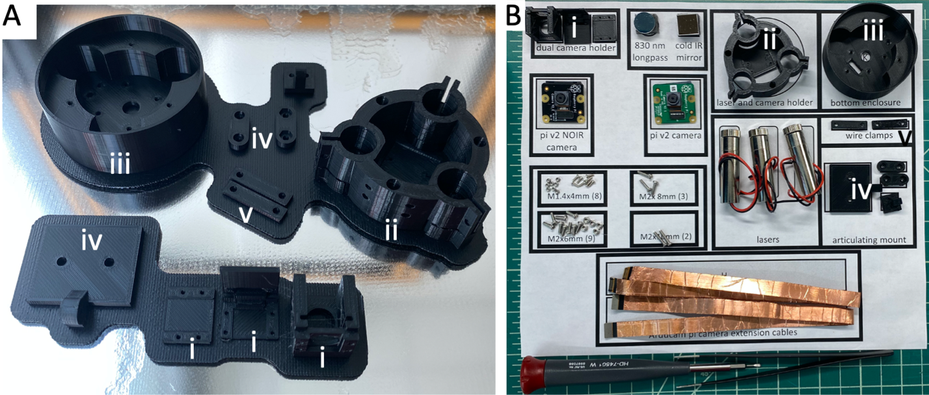Figure S6. Imaging and illumination module 3D printed components can be printed at once and incorporated with simple tools and off the shelf components into the full assembly. A) 3D printed components printed together, including the imaging module enclosures (i), the laser array and imaging module holder (ii), the laser array outer enclosure (iii), the articulating arm that mounts to the laser outer enclosure (iv), and the wire clamps that attach to the back of the laser array outer enclosure (v). B) All the components necessary to build the combined imaging/illumination module are organized on an 8”x11” template to simplify the build process.

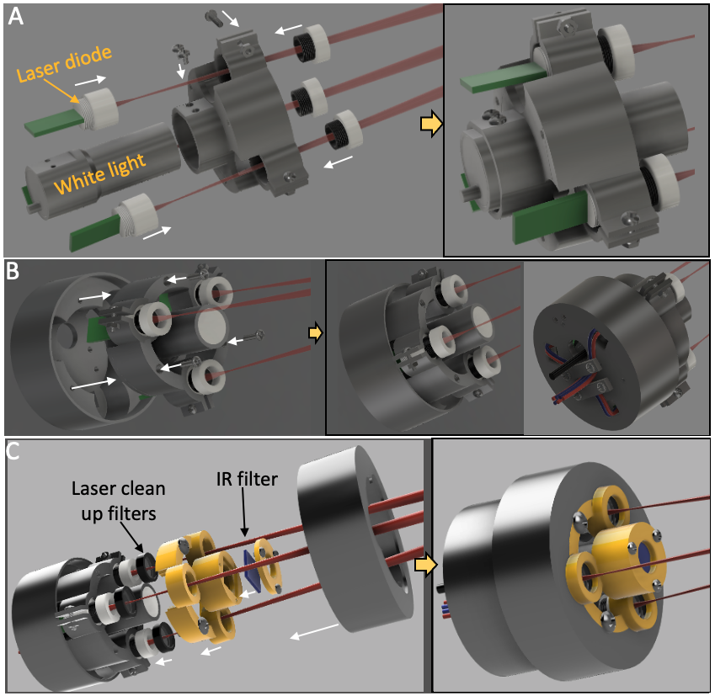

Figure S7. Assembly steps for an illumination module with a white light LED centrally within a laser diode array. A) 3 laser diode modules are positioned and clamped into a 3D printed laser holder array. A white light LED is secured to the center of the laser holder array with M3 set screws. B) The entire assembly is attached to an outer 3D printed laser array enclosure with 3 M2 screws. This outer enclosure protects the laser diode circuitry and also has threaded holes for wire clamps and mounting brackets on the back (right panel) C) This design also supports addition of three 12.5 mm 785 nm premium bandpass filters that are fitted on each laser diode as well as an IR cut-off filter fitted on the white light LED. These optical filters are secured with a 3D printed component that attaches to the inner enclosure with 3 M4 screws. The final assembly has an outer diameter of 65 mm and height of 58 mm.

Section 3. Integration of Imaging and Illumination Modules with Raspberry Pi Single Board Computers

3A. Implementing dual camera streaming with a Raspberry Pi V4 computer
The Raspberry Pi V4B (RPiV4) single board computer (SBC) is a light weight (46 g), wearable (88 x 58 x 19.5mm) and inexpensive ($45 for the 2GB RAM model, $55 for the 4GB RAM model). The RPiV4 has a quad-core 1.5 processor, 2-8 GB of RAM, 2 HDMI display outputs, 4 USB ports, 1 CSI port, and 40 GPIO pins that can be directly integrated with custom external electronics. The RPiV4 hard drive and operating system run on a separate micro SD card. To ensure stability, we used version 10 of Raspbian Buster, a 32 bit legacy Raspberry Pi Foundation operating system based on Debian Linux. This operating system was flashed onto a Sandisk 64 GB class 10 micro SD card ($12.19, ASIN #B08GYBBBBH, Amazon.com) and inserted into the RPiV4.
The single CSI port on the RPiV4 creates a challenge because there are two RPiV2 cameras in the FAR-Pi system, but the RPiV4 only has one CSI camera port. There are several options for acquiring synchronized image streams from multiple Raspberry Pi camera modules. One approach is to have multiple Raspberry Pi computers each with CSI-connected Raspberry Pi camera modules that are then synchronized together through an ethernet router ³⁸. Another option is using 3rd party hardware add-ons, like the $129.99 Arducam synchronized stereo camera HAT that allows two IMX219 sensor-based cameras to be connected to one CSI port³⁹.
A less bulky, simpler, and more cost effective strategy is to convert the RPiV2 cameras into USB cameras that can be plugged into a RPiV4 USB port (Figure S8 A,B). For example, Arducam offers a $30 UVC complaint USB Camera module (B0196, 8MP 1080P USB Camera Module) that the RPiV2 IMX219 sensor can plug into (item #6 in Figure S8A). This approach relies on smaller 3rd party manufacturer support, and innocuous appearing changes may lead to feature loss. For example, the first version (Rev A) of the Arducam USB Camera Module circuit board supports the use of a camera sensor extension cable (item #4 in Figure S8B), but the firmware on the second version (Rev B) does not. Such incompatibilities can be addressed through direct interaction with the manufacturer, but point out the inherent instability introduced when a design relies on integration of products from disparate hardware providers.
A solution that overcomes this challenge is the open-source “showmewebcam” project ⁴⁰, which relies solely on Raspberry Pi Foundation hardware. The showmewebcam software converts the RPiV2 camera module into a UVC compliant USB webcam by passing the imaging data through a compact (66 mm x 30.5 mm x 5 mm) and inexpensive Raspberry Pi Zero SBC. Setup consists of flashing the latest “showmewebcam” repository image file onto a >64MB micro SD card, inserting the SD card into the Raspberry Pi Zero, connecting the RPiV2 camera via CSI cable to the Raspberry Pi Zero, and then connecting the Raspberry PI Zero USB port into a RPiV4 (Figure S8A, #7-10). In this configuration the RPiV2 camera stream is detected as a USB webcam, and the total cost is ~$35-$40. Though this solution has slightly greater physical footprint and is ~$5-10 more expensive that the Arducam USB camera module, it is arguably a more stable solution because it relies only on Raspberry Pi Foundation hardware and open-source software.

3B. Implementing dual camera streaming with a Raspberry Pi Compute Module 4
The Raspberry Pi Compute Module 4 at the time of writing is the most powerful Raspberry Pi SBC, with a 64 bit quad-core 1.5 GHz processor, WiFi and Bluetooth support, up to 8 GB RAM, up to 32 GB eMMC, and with appropriate carrier board^{41,42}, ports for Ethernet, USB 2.0, 2 HDMI outputs, and 2 camera serial interface (CSI) inputs.
Setup of the CM4 was more complex than the RPiV4 as it required a 3rd party carrier board and the setup process with the CM4 required more technical expertise to write the operating system to the eMMC. However, the process was well documented in online resources⁴³, and the use of the CM4 allows for native dual camera streaming via CSI port, obviating the need for the Raspberry Pi Zero “showmewebcam” workaround. The total cost of implementing the CM4 approach or the RPiV4 approach is equivocal – cost savings realized by removing the need for the RPiV4 micro SD card and Raspberry Pi Zero are counterbalanced by the need for a 3rd party carrier board.
We used the RPiCM4 with 4GB RAM, 16 GB eMMC and WiFi/Bluetooth chip ($65, CM4104016, Seeed Studio, Shenzhen, China) with a Base-A carrier board (Figure S8D, item #1), and two RPiV2 camera module PCBs (Figure S8D items #3, #7) were connected to the 2 CSI ports on the carrier board (Figure S8D items 2, 6). RPiV2 standard and NoIR sensors (Figure S8D items #5, #9) were connected to each PCB with Arducam extension cables (Figure S8D items #4, #8). Instead of flashing the operating system to an external microSD as was done for the RPiV4, the operating system (Version 10 of the 32 bit Raspbian Buster) was flashed directly to the onboard eMMC.

3C. Ensuring robust camera signal with HDMI adapters
The use of Arducam flexible extension cables supports miniaturization of the camera sensor assembly, but introduces a challenge with respect to the maximum distance between the camera PCB and the CSI ports on the Raspberry Pi . When the camera sensor is directly connected to the camera PCB, we have found camera signal to be robust with CSI cables up to 100 cm long. With the 300 mm Arducam sensor extension cable installed however, we have found that camera signal is most consistent when the CSI cable is 10 cm or smaller. This limitation in cable distance restricts the location of the computational module to be head mounted only. To overcome this restriction and allow the computational module to be waist-worn, we evaluated the Arducam CSI to HDMI Adapter Set (B0091, $13.99, Arducam). This component consists of two components: 1) a PCB that is mounted on top of the RPiV2 camera PCB and converts the RPiV2 CSI input into an HDMI output and 2) and PCB that converts HDMI input into a CSI output that is fed to the computational module. This approach allows the use of a long HDMI cable (3-5 m) between camera PCB and computational module without loss of signal.

3D. Enabling control of laser diode array by Raspberry Pi SBC with custom electronics
A custom ‘Hardware Attached on Top’ (HAT) circuit to control the laser diode array through Raspberry Pi SBC GPIO pins was constructed on a custom breadboard kit (ASIN B08M9QS31F, Amazon.com) and installed directly onto the Raspberry Pi GPIO pins (Figure S8E, Figure S9). The HAT provides power to the 3.3 V laser diode array with a 5V->3.3V voltage regulator (LD1117AV33, STMicroelectronics, Mouser Electronics), 3 laser status LEDs (COM-09594, SparkFun Electronics, Niwot, Colorado), and a cooling fan (ASIN B08LHBGTL4, Amazon.com). A micro USB breakout board #1833, Adafruit Industries, New York, NY) provided power to the HAT through an external 5V USB power supply. To achieve switching of the white light LED, individual laser diodes, and the entire laser diode array, GPIO pins were connected to N-channel MOSFETs (FQP30N06L, OnSemi, DigiKey Electronics, Thief River Falls, MN). An additional 10 kOhm pull-down resistor was added between GPIO Pin 36 and ground to ensure that during Raspberry Pi computer startup there was no GPIO control pin switching due to floating voltages.
To achieve real-time NIR-background subtraction, laser excitation was synchronized with camera frame acquisition and pulsed at half the frame rate. Synchronizing the laser array with camera frame acquisition required modifying the Raspberry Pi SBC device tree. Specifically, we modified the device tree^{44,45} in both the RPiCM4 and RPiV4 so that GPIO pin 40 goes HIGH and LOW with camera frame read start and stop events respectively (Main text, Figure 4A, camera pulse), and these detected events served as delayed surrogates for when camera sensor exposure occurs. GPIO pin 38 was configured as an INPUT and connected to GPIO pin 40 with a 1 kOhm resistor. Python code was developed to monitor GPIO pin 38 for frame read events and trigger the laser diode master switch (GPIO pin 36) ON at the end of every other frame read event (half the frame rate), resulting in laser excitation every 66 ms when the camera is operating at 30 fps (Main text, Figure 4A NIR pulse). Consecutive grayscale frames were subtracted in real-time to provide a real-time NIR-background-subtracted video stream (Main Text, Figure 4C). The start of camera sensor exposure for a given frame may precede the time when the prior frame was read into memory, and therefore when laser excitation is triggered at the end of a frame read event, it is likely starting after frame exposure started. In such a scenario, if the laser remains on for the duration of a full frame it will bleed into the next frame. Thus the duration of laser excitation must be less than the duration of a full frame. We tested setting laser duration to 30%, 50%, 70%, and 90% of frame duration to determine the maximum permissible duration where laser bleed through between frames did not occur.

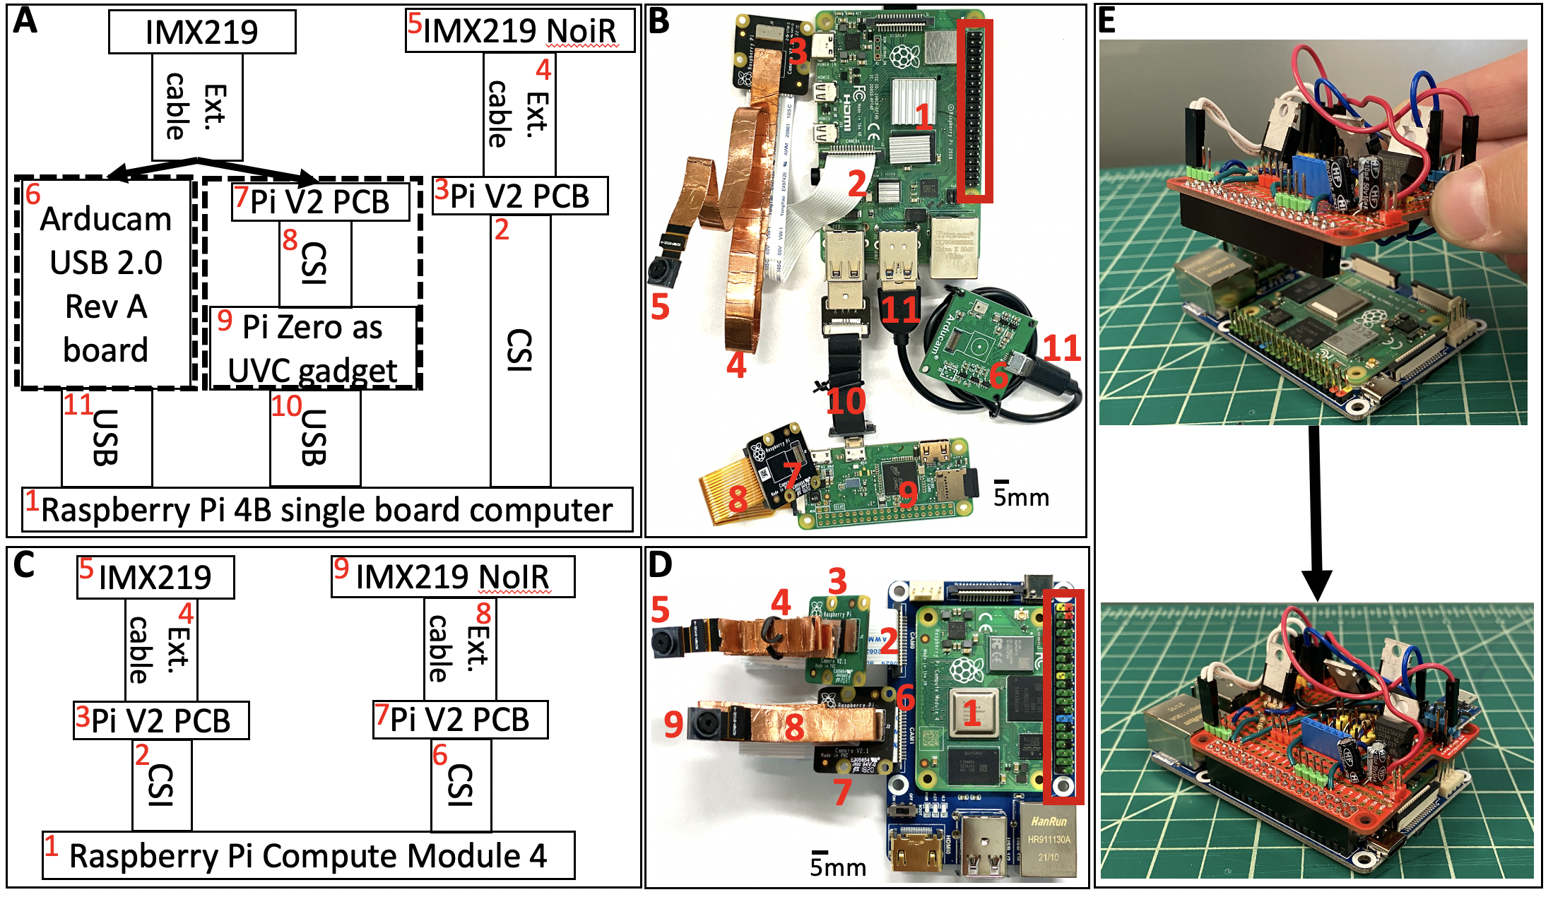
Figure S8. Raspberry Pi single board computers can simultaneously process two Raspberry Pi v2 camera module streams and control an external laser diode array. A) Schematic for connecting two Raspberry Pi v2 (RPiV2) IMX219 camera sensors to a Raspberry Pi 4B (RPiV4) (#1). RPiV2 sensors (#5) are connected to a camera PCB with an extension cable (#4). One RPiV2 camera PCB (#3) can be connected directly with a CSI cable to the CSI port (#2) of the RPiV4 (#1). The RPiV4 has only one CSI port, but second camera can be connected via USB cable (#10, #11) to one of RPiV4 USB-ports if it is first converted into a USB-compatible camera. Connecting the RPiV2 sensor to a 3rd party PCB from Arducam (#6) creates a USB-compatible camera. Alternatively connecting the RPiV2 PCB (#7) via CSI port to a Raspberry Pi Zero (#9) that is running ‘showmewebcam’ firmware also creates a USB-compatible camera. B) Numbered items in A) are implemented with physical components. C) Schematic demonstrating alternative to A), where two RPiV2 camera sensors are connected directly to a Raspberry Pi Compute Module 4 (RPiCM4). Because the RPiCM4 supports two CSI ports, both sensors (#5, #9) can be connected directly to the RPiCM4 (#1). D) Schematic in C) is implemented with physical components. E) Assembled laser array control circuit ‘Hardware Attached on Top’ (HAT) installed onto the Raspberry Pi GPIO pins.

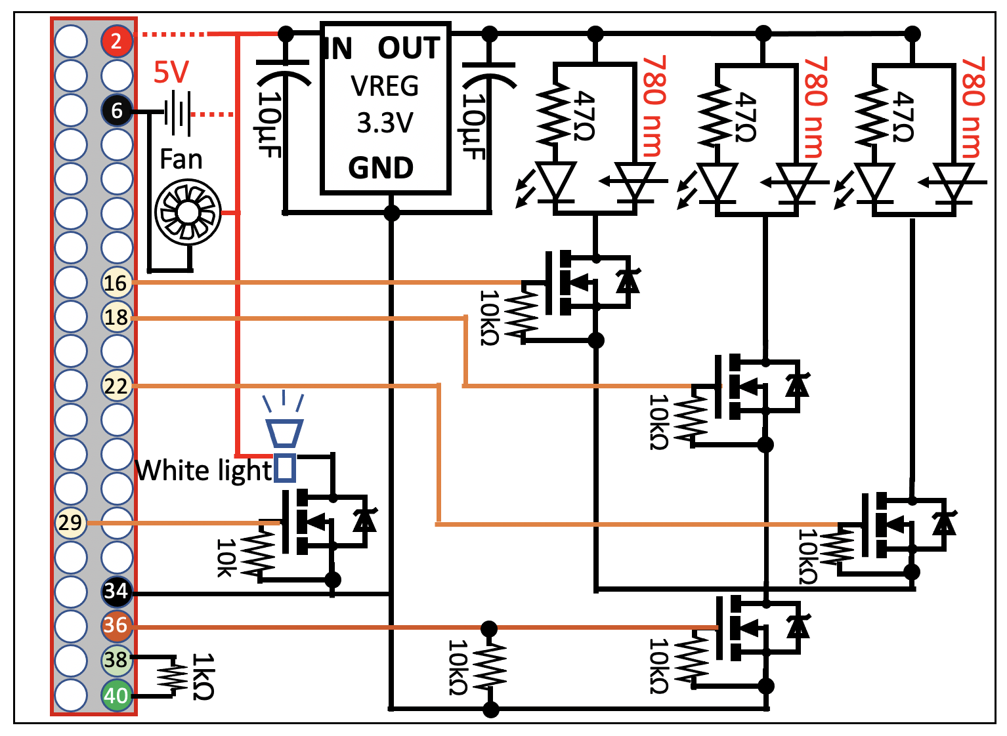

Figure S9. Schematic for custom circuit connected to the 40 GPIO pins of either the RPiV4 or RPiCM4. Power is drawn from either GPIO Pin 2 or from an external 5V supply. A 5V to 3.3V voltage regulator provides appropriate voltage to the laser diode array. N-channel MOSFET switches controlled by GPIO pins 29, 36, 16, 18, and 22 toggle a white light source, the entire laser diode array, or each of the 3 individual laser diodes respectively. GPIO pins 6 and 34 are ground pins. GPIO pin 40 is set as an output pin that toggles with camera frame read events, and GPIO pin 38 functions as input pin which can be used to react to camera frame read events.
Section 4 – Combining all components into a wearable assembly

4A. Enclosure for RPiV4 Computational Module
Figure S10 shows the internal components of the computational module within a custom 3D printed enclosure. As described in Supplemental section 3, while the single CSI port of the RPiV4 increases the complexity of the build, the computational module can be built with the RPiV4 by using a Raspberry Pi Zero to convert one of the cameras into a USB camera and then feeding that USB camera into one of the RPiV4 USB ports. First the RPiV4 is connected with GPIO pins to the custom laser diode control ‘Hardware Attached on Top’ (HAT) circuit and a 5000 mAh PiSugar Pro battery supply is connected to the underside of the RPiV4. The HAT has a micro USB power input that powers the laser diode array. This assembly is then secured into the bottom of a custom 3D printed computer enclosure. This enclosure is designed to provide access to the RPiV4 input and output ports (Figure S10A). The cooling fan and enclosure for the Raspberry Pi Zero and 2 RPiV2 camera module PCBs are attached to the top of the RPiV4 SBC enclosure, which is then secured to the bottom of the enclosure built in the prior step (Figure S10B). The top of the RPIV4 enclosure holds a space for the female 5V barrel jack which connects to the HAT and provides power for an additional white light LED. Note that the RPiV2 camera module PCBs are attached with a spacer between them, one PCB faces down while the other faces up. The CSI output from the bottom RPiV2 camera PCB connects to the CSI input port of the RPiV4. The enclosure that houses the RPiV2 camera PCBs also has threaded holes for attaching wire clamps. The wire clamps secure the flexible MIPI cables that connect the RPiV2 camera sensors to the RPiV2 camera PCBs. The Raspberry Pi Zero is attached above the RPiV2 camera PCBs and then an outer cover is attached above to protect the Raspberry Pi Zero while allowing access to the Raspberry Pi Zero CSI input port and USB output ports. The Raspberry Pi Zero CSI input port connects to the top RPiV2 camera PCB CSI output, and a USB cable connects from the Raspberry Pi Zero to one of the RPiV4 USB input ports.
To support extending the distance between this computational module enclosure and the camera sensors, Arducam HDMI to CSI adapter can also be incorporated into this design. This can be achieved by modifying the enclosure that houses the Pi Zero to include two HDMI to CSI adapters instead of the RPiV2 PCBs (Figure S11). In this configuration the RPiV2 camera PCBs are coupled with HMDI to CSI adapters and head-mounted near the imaging module, while the RPiV4 enclosure and Pi Zero enclosure are waist-worn and connected to the RPiV2 camera PCBs via HDMI cables.

4B. Enclosure for RPiCM4 Computational Module
A 3D printed enclosure was designed to combine the RPiCM4 with the laser diode control circuit, a power supply, a cooling fan, and camera related hardware (Figure S12). The RPiCM4’s required 5V 3.5A input power is supplied by the PiSugar2 Plus (PiSugar, Guangzhou, China), which is a 5000 mAh uninterrupted power supply (UPS) designed to integrate directly with the Raspberry Pi SBC (item ‘e’, Figure S12). The PiSugar2 is installed directly on the underside of the CM4 carrier board (item ‘d’, Figure 7) while the CM4 itself (item ‘c’, Figure 9) is installed on top. Arducam HDMI to CSI adapters (items ‘i’ right lower panel, Figure S12) are connected via 6 cm CSI cables to the 2 CSI inputs on the CM4 carrier board. The custom HAT circuit (item ‘b’, Figure S12) that controls the laser diodes and white light LED is installed onto the GPIO pins of the CM4 carrier board. This custom HAT has a micro USB power input that provides power to the cooling fan, laser diode array, and white light LED (item ‘h’, Figure S12) and a female barrel jack adaptor (item ‘g’, Figure 9) that provides power output to the white light LED. All of these items are secured in a custom 3D printed enclosure (item ‘a’, Figure S12) that has access to the CM4 carrier board ports, the PiSugar board ports, the HDMI inputs for the HDMI to CSI adapters, and the power inputs and outputs. A separate 20,100 mAh 5V 4.8A portable USB Anker PowerCore battery power bank is used to provide power to the micro USB power input and to the PiSugar power input (thereby continuously recharging the PiSugar to extend the maximum duration of battery powered operation).

4C. Enclosure for Raspberry Pi Camera cable to HDMI cable conversion boards
As described above, the imaging module was made more compact by using flexible extension cables between camera sensors and camera PCB, but this introduced image quality degradation when the cables between camera PCB and RPiCM4 exceeded 10cm. To support having a head-mounted imaging module with a waist-worn computational module, distances greater than 10 cm between the imaging module and computational module must be supported. This was achieved by applying CSI to HDMI adapters both the standard and NoIR RPiV2 camera PCBs. Figure 12C demonstrates this implementation, where the RPiV2 PCBs (items ‘k’) are coupled with CSI-to-HDMI adapters (items ‘i’) with a spacer within a head mounted assembly (‘item ‘j’). The Arducam flexible extension cables connect the camera sensors from the head mounted imaging module to the RPiV2 PCBs, and HDMI cables from each camera emanate from this head mounted assembly to the waist-worn computational module, where the signal is converted back with CSI-to-HDMI adapters (items ‘i’, Figure 12B) and then input into the CM4 module directly.

4D. Mounting computational module to a surgical headband
An existing off-the-shelf surgical headband and white light LED (Ocean Aquarius 5W Dental Headlight $56.99 B0823QZSLL, Amazon.com) with adjustable headband and overhead strap was used as a template onto which FAR-Pi components could be incorporated (Figure S13A). The surgical headband has a plastic component positioned on the mid and posterior scalp with a central knob that can be turned to move the vertically oriented flexible straps closer or further apart, thereby adjusting the tightness of the overhead straps. To support mounting FAR-Pi components on mid or posterior scalp, we disassembled the tension adjustment components (Figure S13B) and replaced the central channel that the flexible straps move through with a 3D printed channel with the same dimensions but with threaded mounting holes on the side (Figure S13C-D). A custom 3D-printed elevated stage with threaded mounting holes was then designed to be mounted to the mid or posterior scalp channel assembly (Figure S13E). With the computational module mounted over the tension knob, it can become ergonomically challenging to adjust the knob because the module enclosure is in the way. An adjustment gear with edges extending beyond the RPiV4 and RPiCM4 enclosure bases was designed to fit over the existing knob to allow for easy adjustment of strap tension (Figure S13E-F). Figure S14A demonstrates attaching the computational module onto the mid scalp stage, while Figure S14B demonstrates attaching the computational module onto the posterior scalp stage.

4E. Heads up display modification
We modified the Rokid Air augmented reality heads up display (Figure S15A) so that it could be integrated with the FAR-Pi imaging and illumination modules. Rokid Air were selected to be used as the HUD glasses for the FAR-Pi system because they have a large 43° field of view, can be adjusted for different degrees of myopia, are easy to source from Amazon.com, and are are relatively inexpensive (~$430 with HDMI adapter). First the front outer cover of the Rokid Air glasses was removed after removing mounting screws (Figure S15B). This exposes that flexible cables that connect to both left and right eye displays (viewed from the back and top of the glasses in Figure S15C and S15D, respectively). Then the right eye display can be disconnected to ensure no double-vision effect given the fact that the displays are mirrored. After disconnecting the display, the front outer cover was reinstalled.
To accommodate mounting imaging and illumination modules to the Rokid Air glasses and mounting the Rokid Air glasses themselves to a surgical headband, a custom 3D printed coupling component was designed. This component was design in Autodesk Fusion to fit onto the contour of a 3D model of the Rokid Air glasses and to secure to the mounting holes present on the front of the Rokid Air glasses (Figure S15E-F). This coupling component has a central vertical mounting assembly that extends above the Rokid Air glasses at the level of the user’s forehead – these mounting holes correspond to the central forehead mounting holes of the surgical headband and can also be used to mount the illumination module. Figure S16 shows assembly steps.

4F. Mounting the imaging module to surgical headband
If using the imaging module that is centrally positioned within the illumination array, then the assembly steps in Figure S16 can be applied. However, the imaging module can be placed in different positions in the FAR-Pi system, including between the eyes and coaligned with the eye.
Figure S17A shows assembly steps for positioning the imaging module between the eyes, and Figure S17C shows a rendering of the fully built assembly. This assembly modifies the imaging module enclosure (item ‘e’, Figure S17A) by using a custom backing (item ‘f’, Figure S17A) behind the standard RPiV2 camera (item ‘d’, Figure S17A). This backing has mounting holes that align with the central forehead mounting holes that were included in the custom 3D printed component that couples to the HUD glasses (item ‘g’ in Figure S17A and Figure S15E). Connecting item ‘f’ and to item ‘g’ in Figure S17A positions the imaging module at eye level equidistant between the eyes. Flexible MIPI extension (items ‘h’, Figure 17A) cables connect from the RPiV2 cameras and extend to the assembly outlined in Figure S17B, which consists of camera PCBs (items ‘j’, Figure 17B), HDMI conversion boards (items ‘i', Figure 17B), and a spacer between the boards (item ‘k’, Figure 17B). An outer enclosure (item ‘l’, Figure 17B) secures these components and adds clamps (item ‘m’, Figure 17B) to keep the flexible camera sensor cables from disconnecting with motion. This assembly converts the camera signal into a signal that can extend several feet over HDMI cables without loss of signal integrity.
Figure S18A-E shows assembly steps achieving coalignment between the imaging module and the surgeon’s eye, while Figure S18F-G shows a rendering of the fully built assembly viewed from the front and behind the glasses. To make the imaging module coaxial with the eyes, a glass beamsplitter (item ‘g’, Figure S18) is positioned at 45° in front of the eyes, and the imaging module (item ‘a’, Figure S18) is positioned above the beamsplitter. These components are secured and coupled to the heads up display glasses with a custom coupling component (item ‘f’, Figure S18). Camera sensor cables (items ‘j’, Figure S18) are also secured to the heads up display glasses with a clamp (item ‘k’, Figure S18).
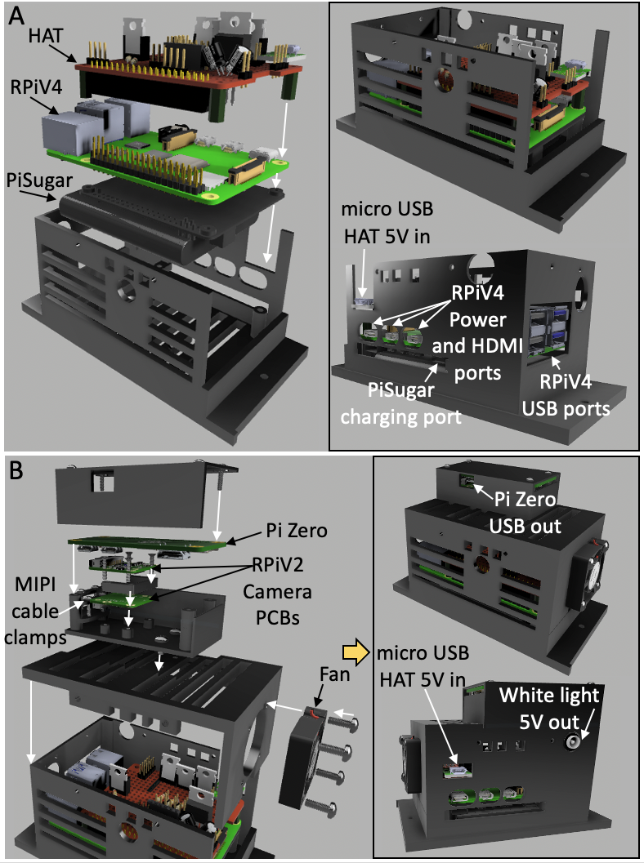
Figure S10. Assembly of Raspberry Pi V4 (RPiV4)-based computational module with enclosure. A) RPiV4 single board computer (SBC), custom laser diode array controller circuit (red breadboard) and PiSugar power supply are combined and secured in a 3D printed enclosure. B) Wire clamps as well as two RPiV2 camera control boards separated by a 3D printed spacer are secured to a rectangular 3D printed enclosure with M2 screws, and this assembly is secured with M3 screws to a 3D printed component that serves as the top of the computational module enclosure. The bottom RPiV2 camera PCB is connected to the CSI port of the RPiV4 SBC. A cooling fan is secured to the top of the computational module enclosure, and then the top and bottom pieces of computational module enclosure are secured together with M3 screws. Then a Raspberry Pi Zero is secured above the RPiV2 control boards with another 3D printed component that serves as the top of an enclosure protecting the Raspberry Pi Zero. The Raspberry Pi Zero CSI port connects to the top RPiV2 PCB.

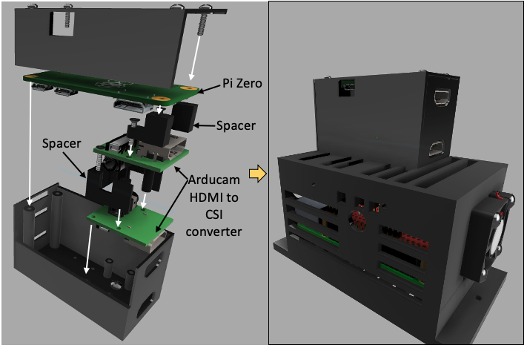

Figure S11. To support positioning the RPiV4 computational enclosure on the waist, an HDMI to CSI adapter must be incorporated to allow the camera stream to be transferred via HDMI cables from the imaging module to the computational module. This is achieved by positioning the RPiV2 camera PCBs in close proximity to the imaging module, converting the camera stream to an HDMI compatible stream, and then using HDMI cables to connect to the computational module. In the computational module enclosure two HDMI to CSI adapters are mounted together with 3d printed spacers, with one HDMI to CSI adapter sending a CSI input to the Raspberry Pi Zero (running showmewebcam) and the other HDMI to CSI adapter sending a CSI input to the RPiV4. Similar to Figure S7B, the enclosure containing both HDMI to CSI adapters and Raspberry Pi Zero is mounted on top of the enclosure housing the RPiV4, PiSugar battery and custom laser diode control HAT.

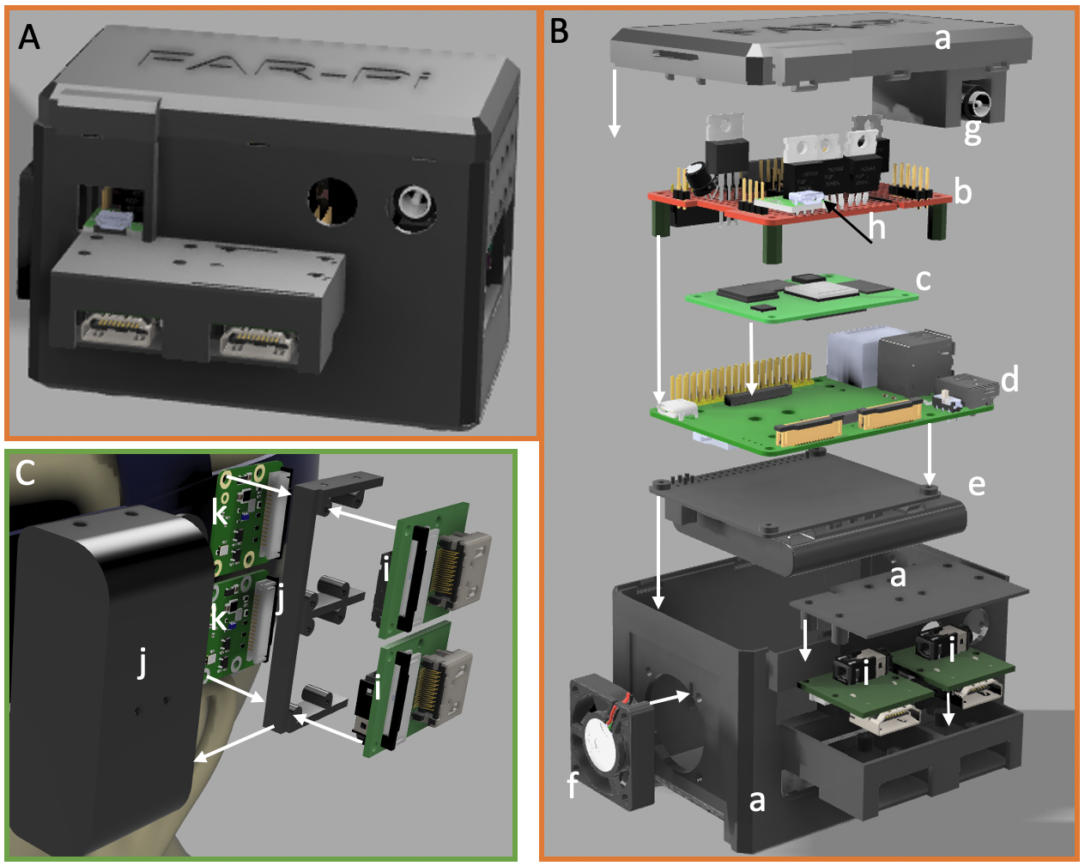

Figure S12. A) 3D printed enclosure for waist-mounted computational module consisting of RPiCM4. B) Internal components of 3D printed enclosure (a). This enclosure secures an illumination module control circuit (b) which connects via GPIO pins to the Raspberry Pi CM4 (c) coupled with a CM4 carrier board (d). A PiSugar battery (e) is secured to the carrier board to provide a rechargeable uninterrupted power supply, and an external cooling fan (f) is secured to the outer enclosure as well. The video HDMI input from the head mounted HDMI conversion assembly is fed into HDMI-CSI conversion PCBs (i), which are connected to the CM4 carrier board CSI boards via short CSI cables. Of note, the 5V micro USB power input (h) to the illumination module circuit board and 5V output to the white light LED (g) remain accessible in the fully assembled enclosure. C) Detailed view of the head-mounted camera CSI cable to HDMI cable conversion circuitry. All components are secured to a head-mounted 3D printed enclosure (j) which consists of an outer case and internal spacer that separates RpiV2 camera PCBs (k) and HDMI-CSI converter boards (i). Camera cables from the RPiV2 camera sensors connect to the RPiV2 PCBs (which are combined with HDMI-CSI converter boards (same as the converter boards in B) to convert the RPiV2 camera signal into an HDMI video signal that can be extended over large distances.

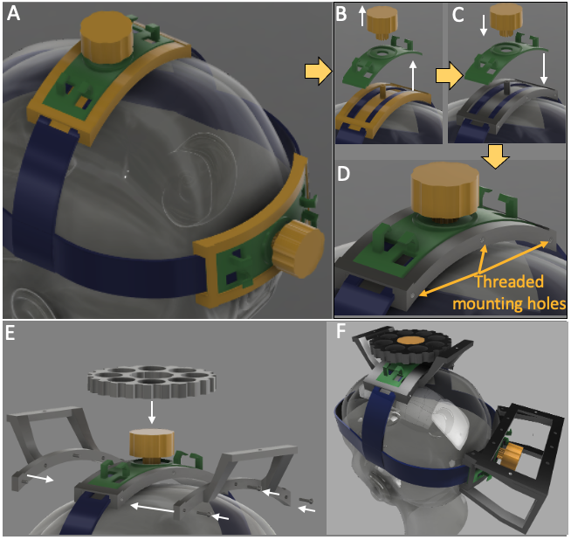
Figure S13. Modifying and off-the-shelf headmount to support mounting additional components to the headmount. A) An off-the-shelf headmount has rack and pinion gear assembly at the scalp vertex that tightens the band that extends from temple to temple over the head. B) Removing the gear (yellow) and outer cover (green) allows one to remove the channel (yellow) through which the straps (blue) travel. C-D) The channel (yellow) is replaced with a custom designed 3D printed channel (gray) that has threaded mounting holes on the side. The outer cover (green) and gear (yellow) are then placed back into position. E) Custom components that function as a flat stage for mounting the computational module can be mounted to the threaded mounding holes of the channel. An oversized gear can be mounted over the existing gear to allow access to the gear assembly with the stage legs installed. F) Custom stage can be mounted to either the mid or posterior scalp gear assembly to allow for mid- or posterior-scalp positioning of the computational module.

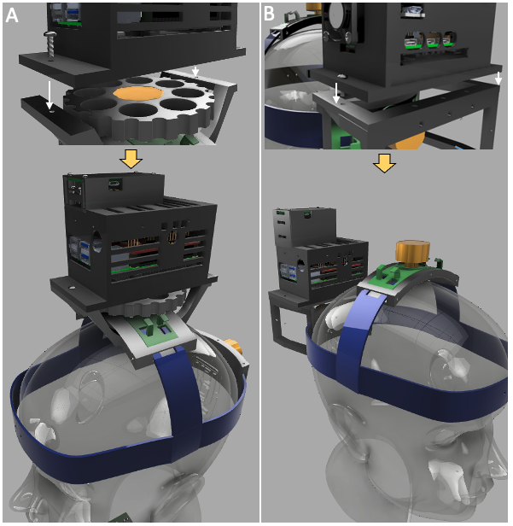

Figure S14. An elevated stage provides a mounting surface for the FAR-Pi computational module enclosure. A) Demonstration of the assembly of the RPiV4-based FAR-Pi computational module (without internal HDMI to CSI extension) on the mid-scalp elevated stage. B) Demonstration of the assembly of the RPiV4-based FAR-Pi computational module (with internal HDMI to CSI extension) on the posterior-scalp elevated stage.

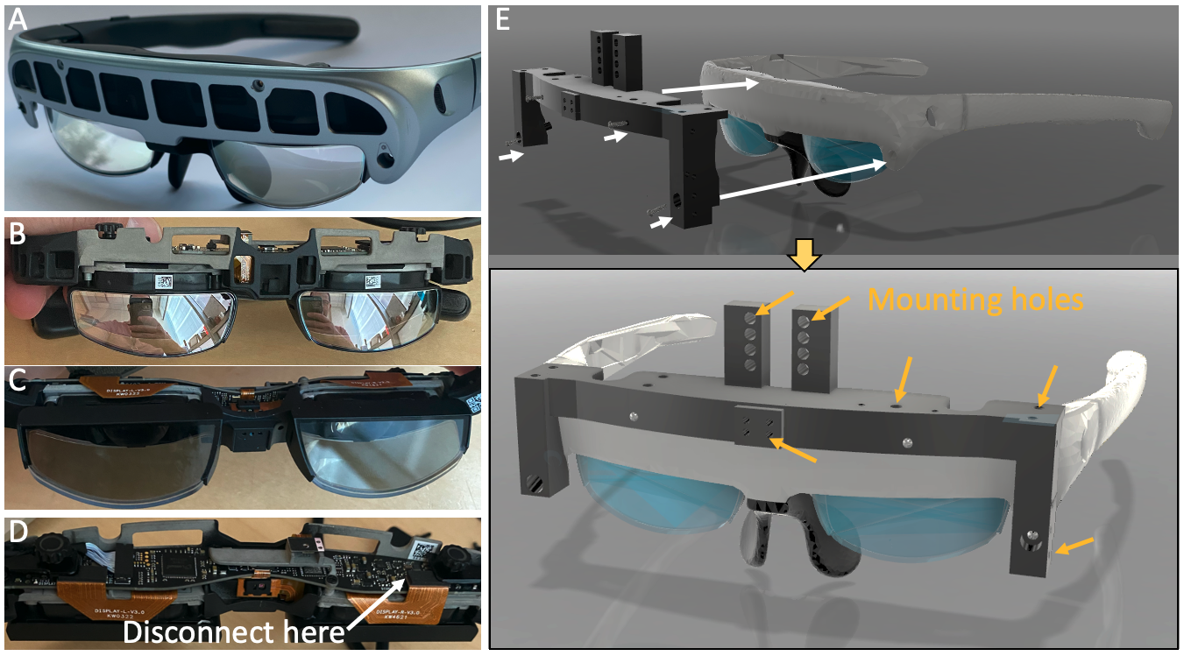Figure S15. Modifying the Rokid Air augmented reality glasses to support monocular vision and to enable mounting of custom components. A) Unmodified Rokid Air augmented reality glasses with 4 mounting holes on the front. Removing the screws from the mounting holes allows the front cover to be removed. B) With the front cover removed, the internal circuitry is exposed. C) Viewing the Rokid Air glasses from the back with the front cover removed. D) Viewing the Rokid Air glasses from above with the front cover removed. Flexible cables connect the left and right eye display screens to separate circuit boards. To convert the Rokid Air into a monocular display, disconnecting either the left or right cable from the circuit board (thereby turning off the left or right eye display, respectively). E) A custom 3D printed coupling component is designed to fit directly over the front of the Rokid Air glasses using the 4 front mounting holes present in the Rokid Air glasses. This coupling component has multiple mounting holes (orange arrows) to support incorporating additional FAR-Pi components with the Rokid Air glasses.

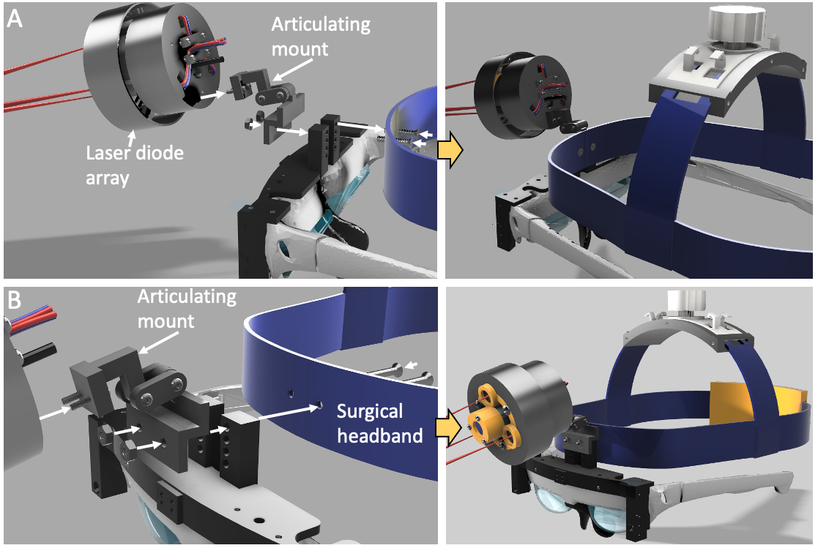Figure. S16. See-thru heads up display glasses can be mounted to the FAR-Pi surgical headband with a custom 3D printed adaptor. Back (A) and front (B) views of the mounting of the illumination module to the heads up display goggles and surgical headband. The heads up display glasses have a 3D-printed coupling component with mounting holes that align with holes on an articulating mount and surgical headband. With the articulating mount in place, the illumination module with central imaging module is attached to the FAR-Pi system.

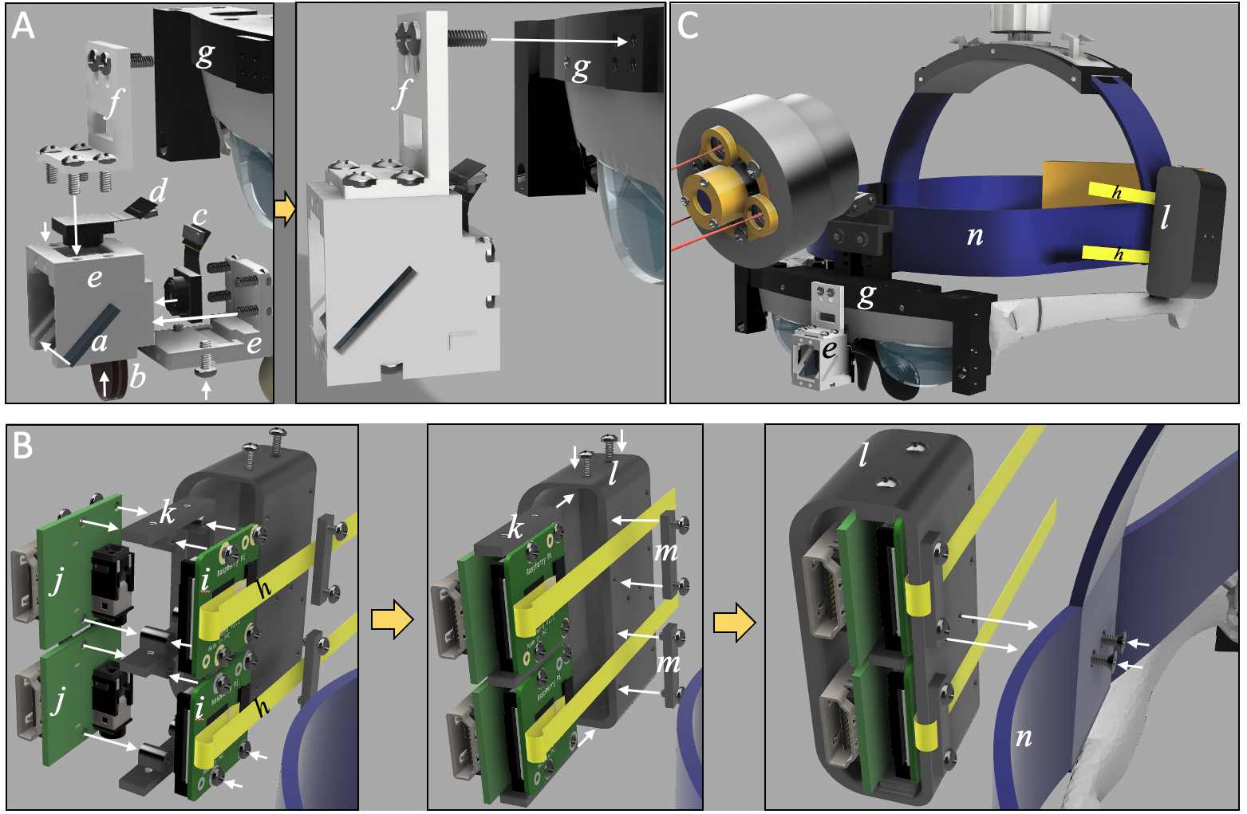
Figure S17. Assembly steps for coupling imaging module components to surgical headband after illumination module and heads up display glasses have been incorporated. A) Exploded view of the imaging module components with a modified enclosure to support positioning at eye level between the eyes. The imaging module consists of optical elements (cold mirror that acts as a VIS/NIR beamsplitter (a) and an NIR selective filter (b) that separates excitation light) as well as visible (c) and NIR-sensitive (d) RPiV2 camera sensors. Those components are secured in place within a 3D printed enclosure (e). The enclosure backing (f) that holds the standard camera sensor in place is designed to secure to a component that is coupled to the heads up display glasses (g), and when secured, positions the imaging module at eye level. B) Exploded view of the head-mounted component that converts the RPiV2 camera stream from 15-pin MIPI cables HDMI cables, which allows for the use of longer cables between the RPiV2 PCBs and the Raspberry Pi and supports having a head mounted imaging module with a waist-worn computational module. Flexible extension cables from each RPiV2 camera (h) are connected to individual RPiV2 camera PCBs (i). Short CSI cables (not shown) connect the RPiV2 camera PCBs to HDMI converter PCBs (j). The RPiV2 and HDMI converter PCBs are held in close proximity with a spacer (k), and the entire assembly is secured within an outer case (l). Clamps (m) are used to secure the flexible RPiV2 camera sensor cables to ensure that there is no disconnection or disruption of camera input with any motion.

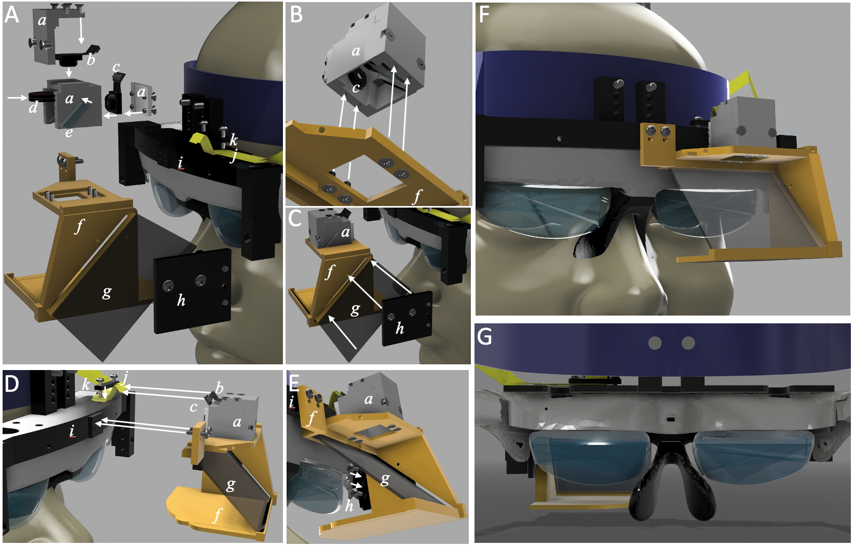
Figure S18. Assembly steps for optically co-aligning imaging module with the surgeon’s eyes by including a beamsplitter in front of the eye. A) Exploded component view. The imaging module enclosure (a) secures NIR-sensitive (b) and NIR-insensitive (c) RPiV2 cameras with a fluorophore emission selective filter (d) and cold mirror acting as beamsplitter (e). The imaging module enclosure mounts to a custom coupling component (f), which is designed to hold a beamsplitter (g) at 45° angle in front of the left eye and imaging module. An additional component (h) secures the beamsplitter in place and connects to a coupling component (i) that is integrated with the heads up display glasses. Flexible camera sensor extension cables (j) connect to the camera sensors and are clamped (k) to the heads up display glasses coupling component (i). B-E) First the assembled imaging module is secured to component (f), then the beamsplitter g is introduced into component (f) and secured by component (h). Finally the entire assembly (f) is secured to the heads up display and flexible camera sensor cables are secured to the heads up display. F) Fully assembled view from the front. G) Fully assembled view when wearing the glasses.
Section 5 - Software

5A. Image capture and processing.
For the RPiV4-based implementation, custom Python software was developed to process the image stream from both the CSI-connected NoIR RPiV2 camera and the USB-connected standard RPiV2 camera. To read the data from two different cameras synchronously, each camera stream was processed on a separate python thread. The python package ‘picamera’, which serves as a python interface for any Raspberry Pi camera module connected via CSI port ³⁴, was used to control image acquisition and camera settings for the NoIR RPiV2 camera. The USB-connected RPiV2 camera could not be directly accessed with the ‘picamera’ package and instead the python OpenCV VideoCapture class ⁴⁶ was used to initialize, set parameters for, and read images from the USB-connected RPiV2 camera. To ensure equivalent field of view, both the CSI-connected and USB-connected cameras were set programmatically to have the same resolution of 1920 x 1080. For the NoIR camera this is achieved using sensor mode 1, which supports up to 30 frames per second (fps) without pixel binning. Higher frame rates (40-90fps) are supported by reducing resolution size and allowing 2 x 2 pixel binning.
For the RPiCM4-based implementation, both cameras are connected via CSI ports, and both camera streams can be read in using the ‘picamera’ class. Each individual camera stream could be accessed simultaneously by creating threaded instances of the picamera.PiCamera class with the camera_num parameter set to 0 or 1³⁴. Alternatively, both camera streams could be acquired simultaneously by setting the stereo_mode parameter of the picamera.PiCamera class to ‘side-by-side’ ⁴⁷. Each captured frame can then be cropped into left and right halves, each half corresponding to either camera stream.
Since the NIR stream does not contain any relevant color information, only a monochrome pixel intensity is necessary. Each frame can be acquired in RGB mode, where pixel intensity must be calculated from R,G,B values separately, or can be captured in ‘YUV’ mode where pixel intensity is in the ‘Y’ channel (the first 3rd of the frame data packet) and color is in the ‘UV’ channel. This reduces the computational burden by a factor of 3 for each frame and obviates the need for additional grayscale conversion.
In both RPiV4- and CM4-based implementations the Python OpenCV package was also used to perform real-time image processing operations, including image cropping, affine transforms, thresholding, merging, and real time image subtraction.
To ensure coalignment between the visible and NIR cameras an initial set of images of a fiducial marker are obtained with both the visible and NIR camera, and the coordinates of at least 3 corresponding points between the images are extracted to create coordinate arrays fiducialNirCoords and fiducialVisCoords. Then a the projective transformation matrix is determined by running cv2.getPerspectiveTransform(fiducialNirCoords, fiducialVisCoords), and this projective transformation matrix is applied to the generate a coaligned transformed visible camera stream by running cv2.warpPerspective() function in real time on a frame-by-frame basis. Of note the transformation matrix is determined only in initial device calibration.
The circuity controlling the illumination module is integrated with the Raspberry Pi GPIO pins, which can be software controlled. To achieve this the python RPi.GPIO module was utilized. GPIO pins that are used to toggle the illumination module lasers or white light LED were initialized through RPI.GPIO as ‘input’ pins. For example GPIO pin 36 was set to be the laser array master switch (GPIOMasterSwitch), and setting that pin value to HIGH by running GPIO.output(GpioMasterSwitch,GPIO.HIGH) turns on the laser array. To support synchronization between camera frames and laser illumination, GPIO pin 40, which was set to toggle with camera frame capture by modifying the system device tree, was initialized through RPi.GPIO as an ‘output’ pin. This allows an event listener to be attached to the status of the pin by running GPIO.add_event_detect(40, GPIO.both, frame_detected_callback_function). This results in the frame_detected_callback_function being called when a new frame starts and stops being read into memory. Within the frame_detected_callback_function the laser diode master switch is toggled between on and off at half the camera frame rate. Taken together, this code results in laser illumination toggling on and off with each subsequent frame. We then introduce a variable to keep track of the prior frame (priorFrame) and in real time use OpenCV methods to modify the current frame (currentFrame) by doing real-time subtraction between the current frame and prior frame and taking the absolute value cv2.absdiff(currentFrame,priorFrame). This achieves real time NIR-background-subtracted imaging through pulsed illumination that is synchronized with the camera stream.

5B. User facing application
A sample application was written in python using the Flask web application platform to support FAR-Pi implementation in the operating room setting. The Flask framework allows the Raspberry Pi to function as a web server, and the FAR-Pi application is essentially a webpage that provides video output and HTML input elements like buttons and toggles that allow the user control of the application. The python webserver has numerous functions, including accepting user inputs from HTML ‘POST’ commands, processing the RPiV2 video streams, applying image processing algorithms and calibration related transformations to the video frames, and then streaming the video signal through a Motion-JPEG stream, The application was designed to consist of two separate webpages, a ‘local’ route that provides input controls and a false-color NIR video overlay to the surgeon and a ‘remote’ route that provides a remote viewer both the NIR and visible video streams. Loading the ‘local’ route address on a web browser running on the FAR-Pi computational module provides the surgeon with an application view that has input elements to perform system calibration, and control white light and laser illumination. Loading the ‘remote’ route address on a web browser running on any computer that is on the same network as the FAR-Pi computation module loads a view that shows a remote viewer both the visible and NIR video streams.
Figure S19 shows the view through the glasses from surgeon’s perspective (generated by placing an iPhone behind the glasses at the position of the surgeon’s eye. In this figure the surgeon is looking at a piece of white paper with a black rectangle that has a white circle in the bottom corner. The application runs within a webpage, so initially a web browser window is opened. In Figure S19A the web browser background loading page, which was chosen to be white to highlight the fact that when using a heads up display, overlaying a window with a white background effectively obscures the surgeon’s vision. To ensure that the surgeon’s view is not obstructed the FAR-Pi Flask app loads a page with a black background. Figure S19B demonstrates that when the window has a black background, the surgeon can see the real world view and can also see application buttons and text overlayed with the real world. When a broadband NIR light source (such as a halogen lamp) is turned on, the FAR-Pi NIR camera detects an NIR signal and this signal can be displayed in false-color and with any degree of desired transparency over the surgeon’s field of view. In Figure S19C the surgeon has placed their hand in front of the calibration target, and we can see the NIR signal detected by the camera overlayed with the surgeon’s field of view. Importantly, the edges of the calibration target displayed from the NIR camera do not align with the edges of the calibration target visible in the real-world view. Effectively the surgeon is seeing double. To address this issue and ensure alignment between the surgeons’ view and the imaging module camera stream, an initial calibration step is required at application start. Once the surgeon selects to start calibration, OpenCV feature detection algorithms (cv2.Canny() and cv2.findContours()) are used to detect the edges and corners of the calibration target within the NIR camera image stream, and these edges and corners are displayed to the user. Figure 19D shows how the algorithmically-determined edges and corners of the calibration target are displayed. The surgeon then selects the points in their real-world view that correspond to these automatically detected corners (Figure 19E), and in so doing defines an image transformation (determined from cv2.getPerspectiveTransform()) that is subsequently applied (using cv2.warpPerspective) in real time to the NIR camera stream to ensure that the projected background-subtracted fluorescence signal is coaligned with the surgeon’s view (Figure 19F). When the imaging module is coaligned with the surgeon’s eye this transformation remains valid beyond the distance at which calibration was performed.
Figure S20 demonstrates how the FAR-Pi image stream can be simultaneously viewed by multiple users. The top panel shows the view from the perspective of the surgeon, which as described above is accessed by launching a web browser on the RPi computational module and navigating the Flask app’s ‘local’ route (or web address). In this case the illumination module is exciting a vial of ICG and the detected NIR fluorescence is presented as a false color green overlay perfectly aligned with the vial. The bottom panel shows the simultaneous view from a remote observer. The remote observer’s device is on the same network as the Flask App and navigates to ‘remote’ route served by the Flask app. While the ‘local’ route only displays the NIR camera stream to the user (since the surgeon already see the visible signal with their own eyes), the ‘remote’ route displays both the NIR stream and the visible stream. In Figure S20 the streams are shown separately for clarity, overlapping these images can be easily accomplished.

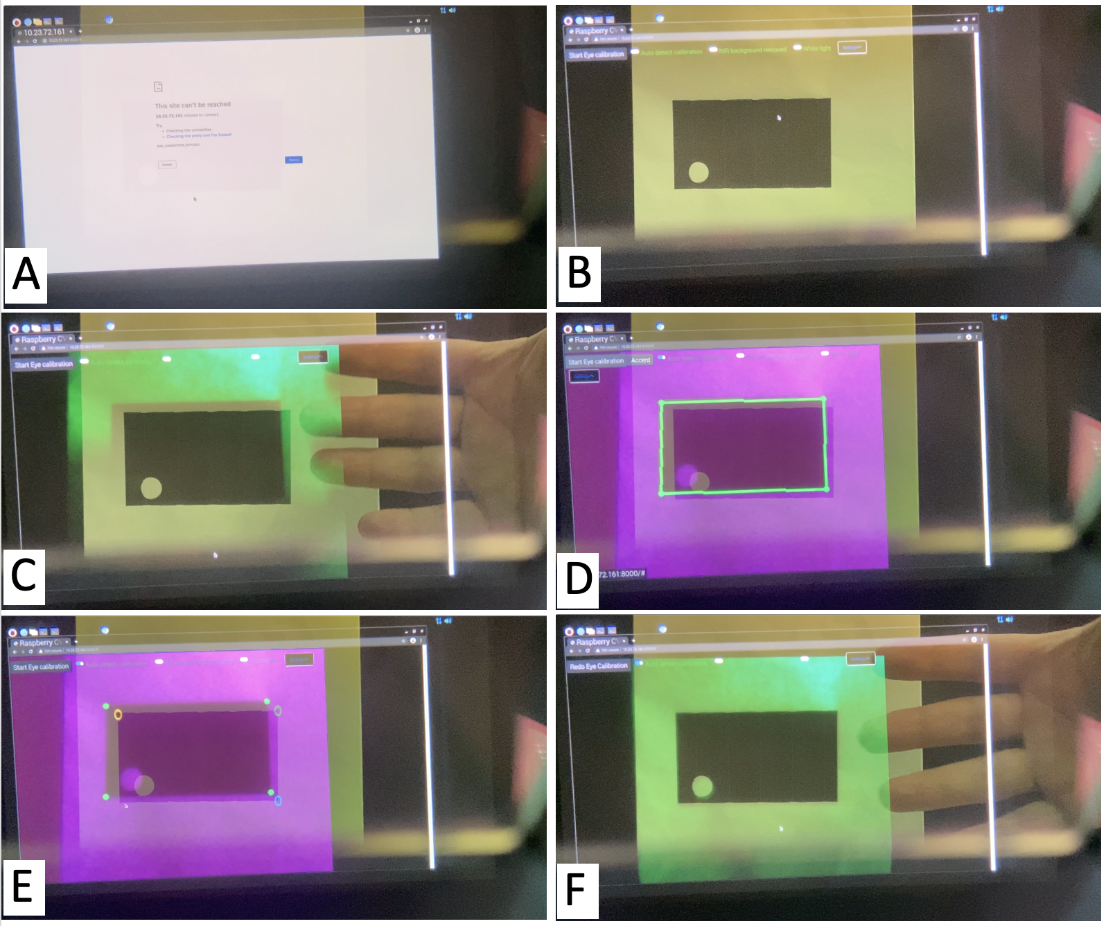
Figure S19. Demonstration of the calibration process for ensuring alignment between FAR-Pi imaging module camera view and surgeon’s view. Here an iPhone is placed at the position of the surgeon’s eye to ‘look through’ the FAR-Pi heads up display glasses while the FAR-Pi software is launched. A) In this view a window with a white background is open. This effectively obscures the surgeon’s view and demonstrates the importance of using a black background to ensure no disruption of the surgeon’s view. B) When the FAR-Pi application launches, the black background of the application window allows the surgeon to clearly see the real world. In this case a calibration target with a black rectangle is seen. C) When an external near infrared light is turned on, the FAR-Pi NIR camera detects the reflected light and projects the detected calibration target in a green overlay. The surgeon sees the green overlay with a central rectangular shape, but the edges of the rectangle do not correspond to the edges of the real world calibration target. D) Here the calibration code has launched, and the detected NIR signal is shown in purple. The edges of the calibration target are automatically detected in green. E) The corners detected by the calibration algorithm are displayed to the surgeon, and the surgeon selects the corresponding edges that they see in their real world view. F) Once 3 points are selected the calibration process is complete and now the NIR overlay (in green) aligns with the surgeon’s real world view.

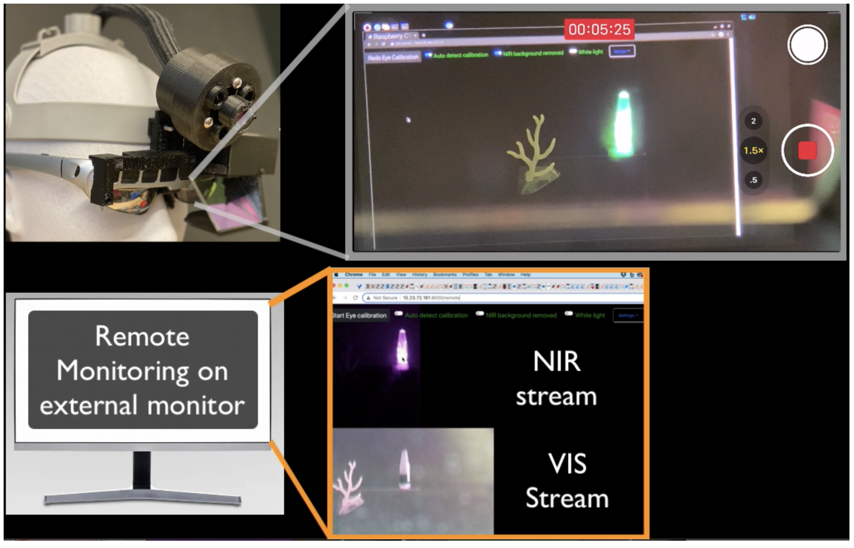
Figure S20. The FAR-Pi system detects both NIR and visible signals and can display one or both of these signals simultaneously to different users. The top panel demonstrates the view from the perspective of the surgeon. Here the fluorescent emission of a vial of ICG that is excited by the FAR-Pi illiumination module is detected by the FAR-Pi imaging module. The surgeon see the real world in front of them, and the detected NIR signal is superimposed in real time on the surgeon’s view as a green overlay. The bottom panel shows the view visible by a remote viewer. The FAR-Pi system wirelessly transfers the detected signal to devices on a shared network, and can display both the visible (VIS) and NIR stream to the remote viewer.

Section 6 - Fluorescent tissue phantom protocol
A 1 mM stock concentration of fluorophore (IR-125, 09030, Exciton Inc., Lockburne, OH) was achieved by dissolving 7.27 mg of IR-125 powder in 10 mL DMSO (Sigma Aldrich, St. Louis, MO). This concentration was validated using a spectrophotometer in which 1 µL of the 1 mM stock solution was dissolved in 999 µL of deionized water and calculated using the molar extinction coefficient of ICG in water. The ICG coefficient was used because 1) IR-125 has a nearly identical chemical structure and 2) the IR-125 molar extinction coefficient has only been characterized in methanol (232,000 cm⁻¹ mol⁻¹ , from Exciton Inc. Certificate of Analysis) and was found to be comparable to ICG in methanol (221,000 cm⁻¹ mol⁻¹)⁴⁸. After concentration validation, the 1 mM IR-125 in DMSO stock solution was further diluted into 100 µM and 100 nm stocks with volumes of 1 mL each.

The base of the phantom was made using polyurethane (WC-783 A/B, BJB Enterprises, Tustin, CA) which consists of two parts (A and B) that are mixed together in a 10:9 part ratio. To begin, 20 mL of part A and 18 mL of part B were poured into a plastic disposable cup and mixed manually for 5 minutes. After mixing, 95 µL of the 100 nm stock was added and subsequently mixed to create an IR-125 concentration of 250 pM in polyurethane. Approximately 400 µL of the mixture was poured into two neighbor wells of the 96 well plate to achieve a 250 pM tissue mimicking phantom. Additional volumes of the IR-125 stock solution were serially added to the polyurethane mixture to create tissue phantom wells spanning 250 pM to 100 nM. Once all concentrations were poured into the 96 well plate, it was placed in a light-tight chamber at room temperature to cure overnight. Of note, when mixing the polyurethane and performing the serial dilutions, work quickly because curing begins in ~30 minutes.

Section 7 - Off the shelf component sourcing and cost

There are several different implementations of the FAR-Pi system, each implementation has the same set of core components with some implementation specific individual components. We list the parts that are needed to build the imaging module, illumination module, and computational module in tables S1-S3. The 3D printed parts that are used as enclosures and adaptors for each of the different FAR-Pi modules are not listed separately in the parts tables. In total these components require less than 250 grams of PLA, which can typically be purchased in 1 kg spools for $20. Assembly requires the use of a few dozen M1.4, M2 and M3 screws and bolts, which can be purchased in bulk kits containing hundreds of screws from Amazon.com for less than $20. Once assembled the imaging, illumination, and computational modules are mounted to a surgical headstrap. Adjustable surgical headbands can be purchased from Amazon.com, though they typically are packaged with additional components like a white light LED or a binocular loop which increases the total cost (Amazon.com ASIN: $65.99 #B01M3RF5GP, $56.99 #B0823QZSLL). We have found that the surgical headband alone can be 3D printed with PLA, and this makes purchase of a separate surgical headband unnecessary.

Imaging Module

Table S1 lists the components, cost, and vendor for the parts necessary to build the FAR-Pi imaging module. Because the imaging module can be built with different excitation filter options, the total cost of the imaging module is listed for each filter option.

While the FAR-Pi imaging module can be constructed for only $156 (option a), this option has limited fluorescence sensitivity and in-vivo SBR (see Figure 9, Main Text). The $200 filter (option b) however has excellent fluorescence sensitivity and in-vivo SBR, rivaling the more expensive filter c and d options.

Illumination Module

Table S2 lists the components, cost, and vendor for the parts necessary to build the FAR-Pi illumination module. We highlight 3 different designs, and for each design an additional excitation filter can be added. In design a, the imaging module is placed in the center. In design b, the imaging module is decoupled from the laser array and the lasers are closely packed without any space in the center. In design c there is space in the center of the lasers for a white light LED with IR cut off filter. For designs a and c individual clean-up filters are added to each laser diode. In design b the diodes are closely packed and a single clean-up filter can be utilized for all 3 laser diodes. The cost subtotals for each possible illumination module implementation are listed in Table S2.

Computational Module

Table S3 lists the components, cost, and vendor for the parts necessary to build the FAR-Pi computational module. The computational module has 2 different designs, one based on a Raspberry Pi 4B single board computer (RPiV4), and one with a Raspberry Pi Computational Module 4 (RPiCM4). The RPiV4 has only one camera CSI port, which is the input port that an RPiV2 camera requires. To support the use of two RPiV2 requires an additional Raspberry Pi Zero is used to convert one of the RPiV2 cameras into a USB camera that can be input to the RPiV4 via USB input. The RPiCM4 doesn’t have any output or input ports built in and requires an additional carrier board to exposure input and output. The additional cost of the RPiCM4 implementation is offset by the fact that the RPiCM4 supports two CSI input, obviating the need for an additional Raspberry Pi Zero. As a result the cost of both implementations is identical.

The total cost of the FAR-Pi system varies depending on choice of illumination module and imaging module filter. Table S4 summarize these costs for each unique implementation.

Component |  | # | Cost |  | Vendor
RPiV2 standard (white light) camera module |  | 1 | $ 25.00 |  | Raspberry Pi, multiple resellers
RPiV2 NOIR (NIR) camera module |  | 1 | $ 30.00 |  | Raspberry Pi, multiple resellers
IMX219 Arducam sensor extension cables |  | 2 | $ 25.98 |  | Arducam, #B0186
IR Beamplitter - Cold IR Mirror |  | 1 | $ 37.50 |  | Edmunds Optics, #62-634
Optical filter options (Options b-d showed significantly better performance than option a)

a) Longpass filter - 830 nm CGA |  | 1 | $ 38.00 |  | Newport, #5CGA-830
b) Longpass filter - Double 830 nm CGA |  | 2 | $ 76.00 |  | Newport, #5CGA-830
c) Bandpass filter - OD 6 832 nm |  | 1 | $ 225.00 |  | Edmund Optics, #84-091
d) Longpass filter - 808 nm Edge Basic |  | 1 | $ 525.00 |  | AVR Optics, BLP01-808R-12.5  *$525 Price includes $150 for custom sizing, waived if buying 10 or more
Subtotals
Imaging module with filter option a | Imaging module with filter option b |  |  | Imaging module with filter option c |  | Imaging module with filter option d
$ 156.48 | $ 194.48 |  |  | $ 343.48 |  | $ 643.48

Table S1.
Parts list for four implementations of the FAR-Pi imaging module showing component, quantity (#), total cost for the quantity of components listed, and vendor. Prices may be subject to change.

Component |  | # | Cost |  | Vendor
Designs a-c
780nm laser diode 120 mW |  | 3 | $ 52.26 |  | Laserlands.net, #1230-780D-11071007D
Custom electronics for excitation control
PiHat breadboard with 40-Pin GPIO header |  | 1 | $ 3.50 |  | Amazon, #B08M9QS31F
N Channel MOSFET |  | 4 | $ 5.92 |  | Digikey, #FQP30N06L-ND
Indicator LED |  | 3 | $ 1.05 |  | Sparkfun, #9594
5V to 3.3V 1A regulator (LD1117AV33) |  | 1 | $ 0.68 |  | Digikey, #497-1485-5-ND
47 Ohm resistor |  | 3 | $ 0.30 |  | Digikey, #13-CFR-25JT-52-47RCT-ND
10 kOhm resistor |  | 5 | $ 0.50 |  | Digikey, #A104668CT-ND
10 µF 50V capacitor |  | 2 | $ 0.56 |  | Digikey, #P19445CT-ND
JST 2Pin Female |  | 5 | $ 0.85 |  | Digikey, #455-1704-ND
JST 2Pin Male |  | 3 | $ 0.30 |  | Digikey, #455-1165-ND
JSTI 6 Pin Female |  | 1 | $ 0.33 |  | Digikey, #455-1708-ND
JSTI 6 Pin Male |  | 1 | $ 0.12 |  | Digikey, #455-1162-ND
Crimping connectors |  | 20 | $ 1.40 |  | Digikey, #A98623CT-ND
Hookup wire, red, green, black |  | 1 | $ 2.97 |  | Digikey, #C2003(B,G,R)-5-ND
Heat shrink 3/32" 1 inch length |  | 4 | $ 0.80 |  | Digikey, #F2213/32BK147-ND
Power: USB micro breakout board |  | 1 | $ 1.50 |  | Adafruit, #1833
Power cable: USB2.0 6ft micro B to A |  | 1 | $ 5.86 |  | Amazon, #B07232M876
Design c – white light source
White 5W LED with rechargeable battery |  | 1 | $ 32.99 |  | Amazon B07WSQ3N6G
IR-Cut filter |  | 1 | $ 36.00 |  | Edmund Optics, #55235
Excitation clean-up filters
12.5 mm 785 nm bandpass (Design a/c) |  | 3 | $ 369.00 |  | Thorlabs, #FBH05780-10
25 mm 785 nm OD 4.0 bandpass (Design b) |  | 1 | $ 225 |  | Edmund Optics, #84-092
Subtotals
Design a or design b without clean-up filter | Design c without clean-up filter |  |  | Design a with clean-up filter |  | Design b with clean-up filter | Design c with clean-up filter
$ 73.04 | $142.03 |  |  | $ 442.04 |  | $ 318.04 | $ 511.03

Table S2.
Parts and cost for 4 different implementations of the FAR-Pi illumination module with laser control circuit, showing component, quantity (#), total cost for the quantity of components listed, and vendor. Design a positions imaging module in the center of a laser diode array. Design b positions the laser diodes in close proximity. Design c positions a white light LED in the center of the laser array. Prices may be subject to change.

Component | # | Cost | Vendor
Raspberry PI V4 based (RPiV4)
Computer - Raspberry Pi v4 4GB | 1 | $ 55.00 | Raspberry Pi, multiple resellers
Sandisk 64GB Class 10 micro SD | 1 | $ 12.19 | Amazon, #B08GYBBBBH
Converting one RPiV2 camera to USB camera *not needed if using Raspberry Pi Computer Module 4
Raspberry Pi Zero | 1 | $ 5.00 | Raspberry Pi, multiple resellers
CSI cable Pi Zero | 1 | $ 5.95 | Adafruit, #3157
Sandisk 32GB class 10 microSD | 1 | $ 6.85 | Amazon #B010NE3QHQ
Raspberry Pi CM4 based (RPiCM4)
Computer- Raspberry PI Compute Module 4 4GB RAM 16 GB EEMC | 1 | $ 65.00 | Seeed Studio, CM4102032
Carrier board with two CSI inputs | 1 | $ 19.99 | Waveshare, CM4-IO-BASE-A
Components for either assembly
Raspberry Pi USB Pi Switch | 1 | $ 7.99 | Amazon, #B089ZVK2T6
Cooling Fan, 5V 0.2A | 1 | $ 2.95 | Digikey,#1528-4468-ND
USB Quick Charge A to C power cable 6ft | 2 | $ 10.99 | Amazon, #B077Z2LCG8
30 cm micro HDMI to micro HDMI | 1 | $ 11.59 | Amazon, #B019BVYAZO
Power bank - Anker 5V 4.8A 20,100mAh | 1 | $ 59.99 | Amazon, #B00X5RV14Y
Power splitter | 1 | $ 5.88 | Amazon, #B07CKQSTCB
Subtotals
RPiV4-based computational Module |  | RPiCM4-based computational module
$ 184.38 |  | $ 184.38

Table S3.
Parts and cost for 4 different implementations of the FAR-Pi computational module, showing component, quantity (#), total cost for the quantity of components listed, and vendor. Prices may be subject to change.

Total Cost | Imaging filter a | Imaging filter b | Imaging filter c | Imaging filter d
Illumination a or b without excitation clean-up filter | $ 413.90 | $ 451.90 | $ 600.90 | $ 900.90
Illumination c without excitation clean-up filter | $ 482.89 | $ 520.89 | $ 669.89 | $ 969.89
Illumination a with excitation clean-up filter | $ 782.90 | $ 820.90 | $ 969.90 | $ 1,269.90
Illumination b with excitation clean-up filter | $ 658.90 | $ 696.90 | $ 845.90 | $ 1,145.90
Illumination c with excitation clean-up filter | $ 851.89 | $ 889.89 | $ 1,038.89 | $ 1,338.89

Table S4.
Total component cost of assembled FAR-Pi system depends on choice illumination and imaging modules.

