Basic Genetics and NGS technique (IS)
Humans have approximately 20,000 genes in their bodies. Genes are made up of DNA (deoxyribonucleic acid). These are chemical instructions that direct the cell to perform a particular function. A gene is like a recipe for making a specific protein that performs important functions in every cell of the body (illustrated below).
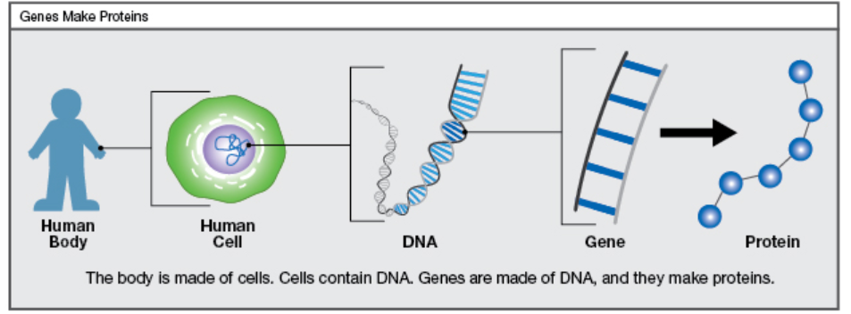
Source: https://www.cincinnatichildrens.org/service/d/diagnostic-labs/molecular-genetics/whole-exome-sequencing/families

Genes are written in code, with four chemicals (represented by the alphabets A, T, G, and C) that spell out instructions in making a protein. We all have two copies of each gene, one of the copies is inherited from our father and another from our mother when we are born.
Genes are organized into exons and introns (illustrated below). Exons are the regions that make proteins required for normal growth, development and organ function while introns often act as helpers to exons and do not make proteins.
Gene A
Exon 1
Exon 2
Exon 3
Intron 1
Intron 2
Exon 1+2+3
Protein A
A person’s entire DNA (both introns and exons) is their genome. Similarly, a person’s exome includes only the exons (the parts used to make proteins). If you think of the genome as all the action in a cricket game, the exome is like reading the highlights of the game the next day.
Next Generation Sequencing (NGS):
Most of the changes in the genome that cause disease are found in the exome. Next Generation Sequencing technique looks at the genetic information in our 20,000 genes in one single test. Exome sequencing is a type of NGS where the entire exons (exome) in our body is sequenced. This is different from other genetic tests that might look at only one or a handful of genes at a time. NGS helps in early diagnosis of the patient’s genetic condition thereby helping in early management. The chance of detecting the patient’s genetic disease by NGS is 50-50 (~50%).
How is NGS done?
A 3-4 mL EDTA blood is collected from the patient and DNA is isolated in the laboratory from the blood. The patient’s DNA is then “read” in the machine and compared to a ‘normal’ sequence of human DNA to find any differences between patient’s DNA and the healthy human to look for changes/ variations.

What is the effect of changes in the DNA?
Most of the DNA changes are commonly found in healthy individuals and do not usually cause diseases. Only few DNA (genetic) changes lead to diseases which are also known as monogenic diseases. Many other genetic changes are responsible for variations seen in different individuals (eg. hair colour or eye colour). Some such genetic changes also interact with the environment and may result in susceptibility or resistance to infection and other common diseases like heart disease, diabetes, psychiatric illness or cancers. Genetic testing for these common disorders is not routinely done for patient care.
Why is NGS done?
- It is done to confirm the diagnosis of a disease caused by change in a single gene (monogenic) with or without family history of any disease.
- It is also done to confirm a hereditary cancer in a child/ adult with or without family history of cancer which may help in advising close monitoring, early diagnosis and management of the patient and other family members.
- It is also being utilized in research for carrier screening of healthy couples and newborn screening for common/ rare genetic disorders.
- It is also being done to study the effect of certain drugs on the body and to understand if it will be causing an adverse reaction in the patient.
Possible results of NGS:
- Positive result: meaning the genetic cause of the patient’s disease is identified.
- Negative result: meaning there is no change identified in the patient’s DNA which can explain the cause of their disease.
- Variants of Uncertain Significance (VOUS): NGS can also detect changes in DNA about which experts do not have any information, and this may or may not be the cause of the disease.
- Incidental Findings: NGS can sometimes detect changes in a person’s DNA that is unrelated to their current disease but are of medical importance and early management is available for such diseases. Eg. Inherited cancers, inherited heart diseases, etc. Such results can be helpful to the patient by way of providing appropriate preventive or treatment measures.

