To supporting file:

Adaptive resistance to cefiderocol in carbapenem-resistant Acinetobacter baumannii (CRAB): microbiological and clinical issues
Anissa Desmoulin^{1*}, Loïk Sababadichetty², Laure Kamus^{1,2}, Marion Daniel², Lucie Feletti¹, Nicolas Allou³, Anais Potron⁴, Anne-Gaëlle Leroy⁵, Marie-Christine Jaffar-Bandjee¹, Olivier Belmonte¹, Thomas Garrigos^{1,2}, Guillaume Miltgen^{1,2,6}

¹ Laboratoire de Bactériologie, CHU Félix Guyon, Saint-Denis, La Réunion, France.
² UMR PIMIT, Processus Infectieux en Milieu Insulaire Tropical, CNRS 9192, INSERM U1187, IRD 249, Université de La Réunion, Sainte-Clotilde, La Réunion, France.
³ Service de Réanimation Polyvalente, CHU Félix Guyon, Saint-Denis, La Réunion, France.
⁴ Centre National de la Résistance aux Antibiotiques, Laboratoire associé Pseudomonas et Acinetobacter, CHU Jean Minjoz, Besançon, France.
⁵Laboratoire de Bactériologie, Groupe Hospitalier Sud Réunion, Saint-Pierre, La Réunion, France.
⁶Centre Régional en Antibiothérapie de La Réunion, Saint-Denis, La Réunion, France.

Appendix Table S1: Antibiograms of pulmonary isolates (P) of Acinetobacter baumannii and Enterobacter cloacae complex and a blood culture isolate (B) of Acinetobacter baumannii from case described.
Appendix Fig. S1: Testing for adaptive resistance in a OXA-23 carbapenem-resistant A. baumannii isolate by the disk diffusion and minimum inhibitory concentration methods.
Appendix Table S1: Antibiograms of pulmonary isolates (P) of Acinetobacter baumannii and Enterobacter cloacae complex and a blood culture isolate (B) of Acinetobacter baumannii blood culture isolate (B) from case described.
Antibiotics (MIC mg/L) | Enterobacter  cloacae complex (P) | Acinetobacter  baumannii (P) | Acinetobacter  baumannii (B)
Penicillins  Amoxicillin  Amoxicillin/clavulanic acid  Ticarcillin  Temocillin  Ticarcillin/ clavulanic acid  Piperacillin  Piperacillin/tazobactam | R  R  R  R (16)  -  R  R (32) | -  -  R  -  R  R  SIE (32) | -  -  R  -  R  R  SIE (32)
Cephalosporins (oral)  Cefixime  Cephalosporins (intravenous)  Cefalothin  Cefuroxime  Cefoxitin  Cefotaxime  Ceftazidime  Ceftazidime/avibactam  Ceftolozane/tazobactam  Cefepime  Cefiderocol | R  R  R  R  R (> 32)  R (> 32)  S (1)  R (8)  R (> 32)  R | -  -  -  -  -  R  R* (> 16)  R  R (> 16)  S (2) | -  -  -  -  -  R  R* (> 16)  R (> 8)  R (> 16)  S (2)
Monobactams  Aztreonam  Ampicillin/sulbactam | R (>32)  - | R  R (64) | R  R (64)
Carbapenems  Ertapenem  Imipenem  Imipenem/relebactam  Meropenem | S (0.25)  S (≤ 0.5)  -  S (≤ 0.12) | -  R (>8)  R (>8)  R (>16) | -  R (>8)  R (>8)  R (>16)
Aminoglycosides  Gentamicin  Tobramycin  Amikacin | R (> 8)  R  S (4) | R  R (>4)  R (>32) | R  R (>4)  R (>32)
Sulfamides  Cotrimoxazole  (trimethroprin-sulfamethoxazole) | R | R | R
Quinolones  Nalidixic acid  Ofloxacin  Ciprofloxacin | R  R  R (> 8) | -  -  R (> 8) | -  -  R (> 8)
Cyclines  Tigecycline | S (0.5) | ND (1) | ND (1)
Polypeptides  Colistin (MIC in microdilution) | S | S (≤ 0.5) | S (≤ 0.5)
MIC: minimum inhibitory concentration; R: resistant; S: susceptible; SIE: susceptible on increased exposure; ND: not determined.
* PK/PD critical concentrations (EUCAST 2020)

Appendix Fig. S1: Testing for adaptive resistance in a OXA-23 carbapenem-resistant A. baumannii isolate by the disk diffusion and minimum inhibitory concentration methods.
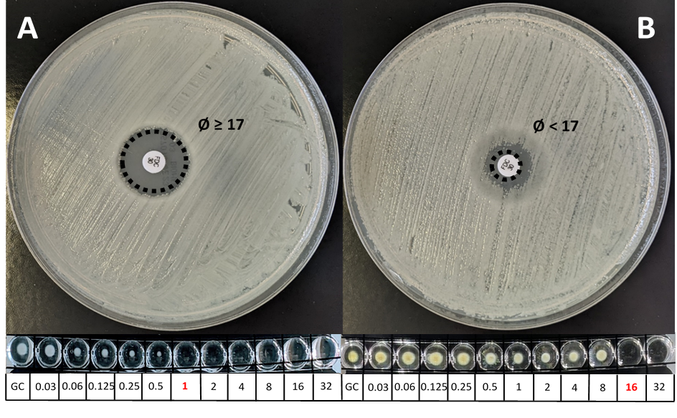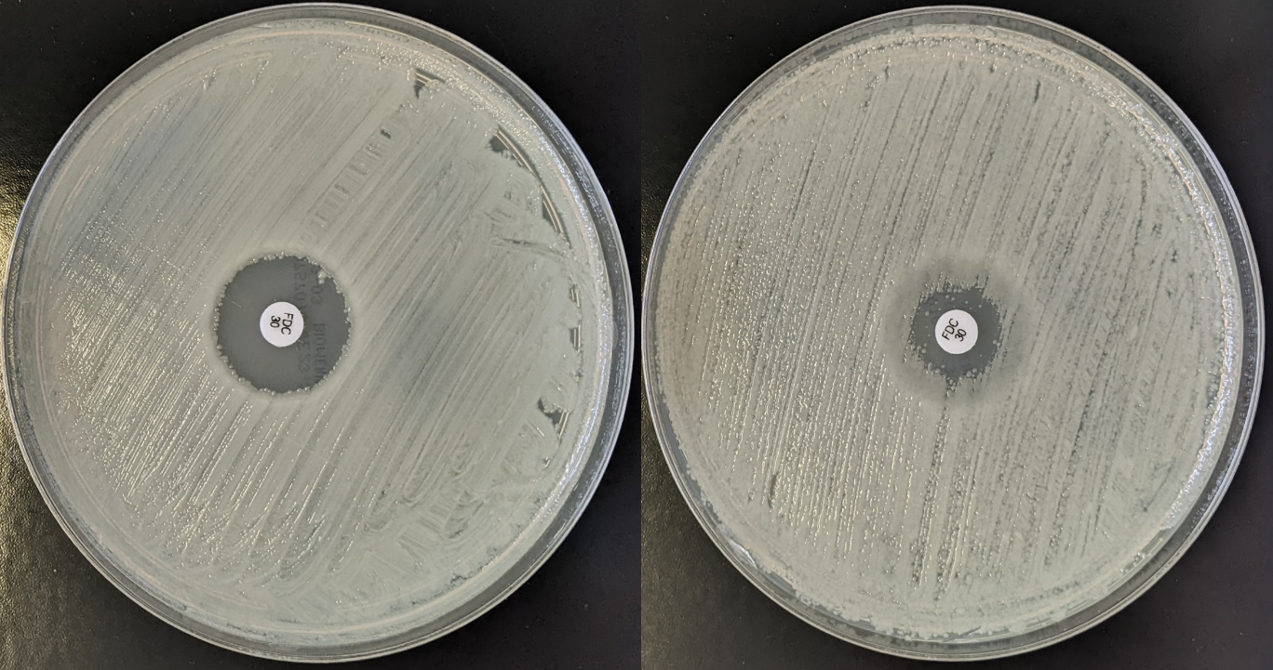
Ø ≥ 17mm
Ø < 17mm
A: Inhibition diameter ≥ 17 mm and MIC ≤ 2 mg/L after 48 h of exposure to cefiderocol for a carbapenem-resistant A. baumanii isolate without adaptive resistance to cefiderocol.
B: Inhibition diameter < 17 mm and MIC > 2 mg/L after 48 h of exposure to cefiderocol for a carbapenem-resistant A. baumanii isolate with adaptive resistance to cefiderocol.

