Table 1. Cell colonization assessment with the Gram-positive bacterium Staphylococcus epidermidis, two hour colonization at 37º C.
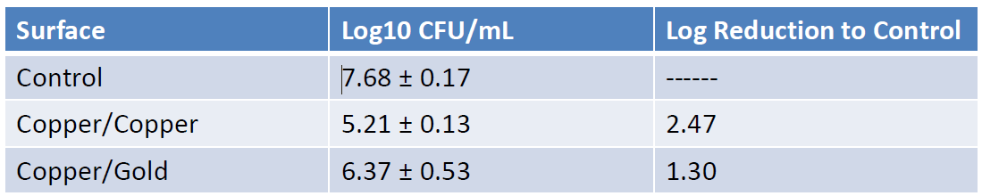

Table 2. Cell colonization assessment with the Gram-positive bacterium Staphylococcus epidermidis for twenty four hour colonization at 37º C.
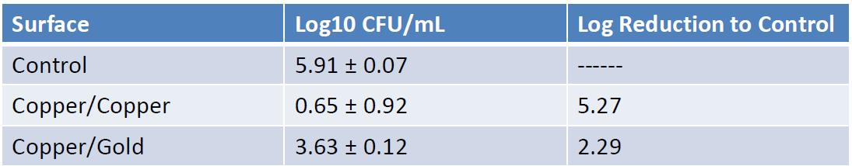

Table 3. Cell colonization assessment with the Gram-negative bacterium Escherichia coli for two hour colonization at 37º C.
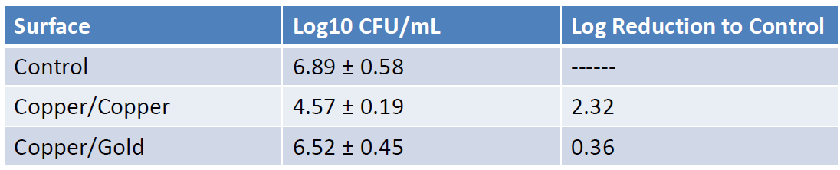
Table 4. Cell colonization assessment with the Gram-negative bacterium Escherichia coli for twenty four hour colonization at 37º C.
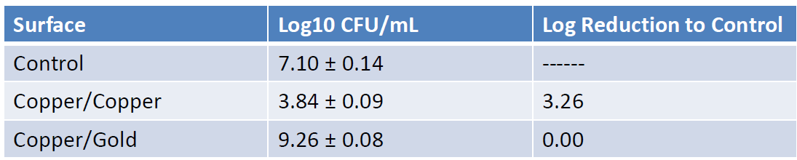

Table 5. Cell colonization assessment with the opportunistic fungal pathogen Candida albicans for two hour colonization at 37º C.
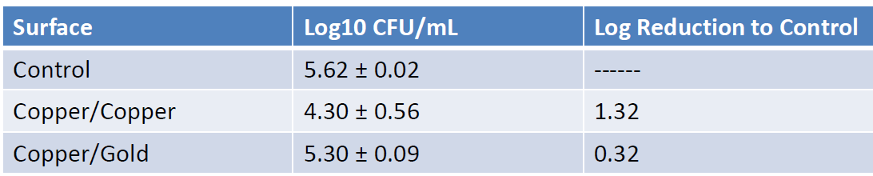

Table 6. Cell colonization assessment with the opportunistic fungal pathogen Candida albicans for twenty four hour colonization at 37º C.
