Supporting Information

- Materials and Methods (protein expression, crystallization and assays)
  - Expression of ShGdmF
  - Simulated structures of ShGdmF and NAT1
  - Parameter of refinement
  - Transformation of thioesters by ShGdmF
  - Binding assay for affinity estimation

- Materials and Methods (Synthesis)
- Experimental Procedures (Synthesis)
  - Truncated thioesters
  - 3-Hydroxyanilines
  - Total synthesis of seco-acid derivatives 26, 28 and 30

- Biotransformation of SNAC ester 27b
- References (Supporting Information)

Attachment: Copies of ¹H- and ¹³C-NMR spectra

1. Materials and Methods (protein expression, crystallization and assays)
1.1 Expression of ShGdmF
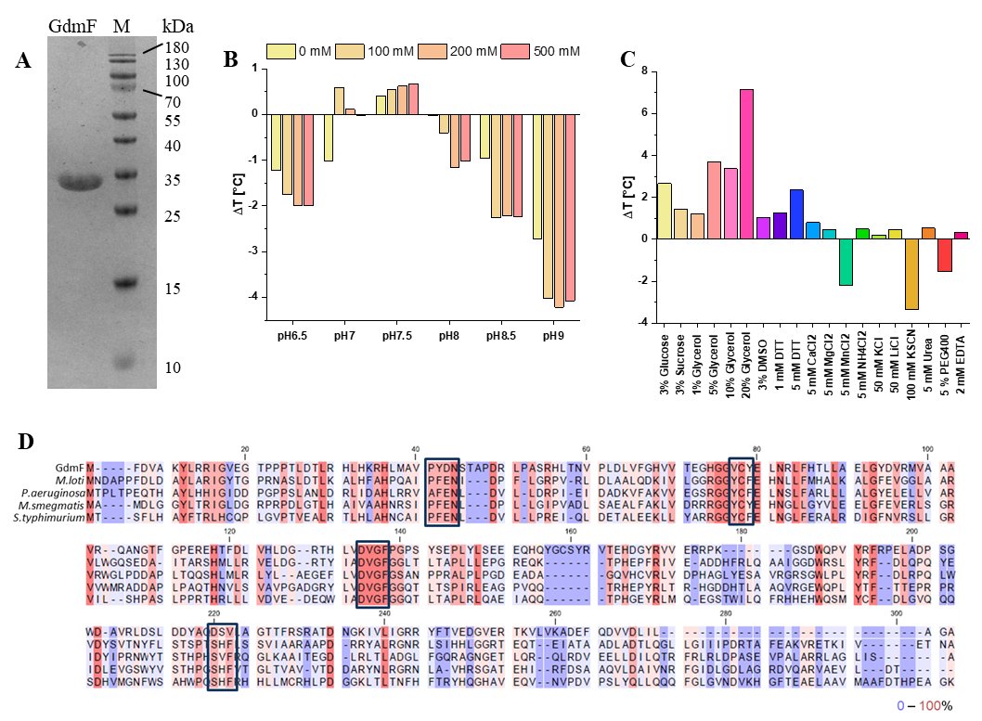
Figure S1: (A) SDS-PAGE gel of the purified full-length ShGdmF after gel filtration. The band corresponds to the monomeric ShGdmF with a size of approximately 31 kDa. Marker: PageRuler Plus Pre-stained Protein Ladder. (B) Increase or decrease of the protein stability, measured as the difference temperature compared to the determined, inital melting temperature of 38.6 °C (20 mM Tris-HCl buffer, pH 8.0, 150 mM NaCl, and 1 mM DTT) of ShGdmF at different buffer pH and NaCl concentrations. (C) Additive test of ShGdmF on the protein stability, measured as the difference temperature compared to the determined, inital melting temperature of 38.6 °C of ShGdmF. (D) Sequence alignment of ShGdmF and related NATs. Amino acid conservation is color coded from 0% (blue) to 100% (red).

1.2 Simulated structures of ShGdmF and NAT1

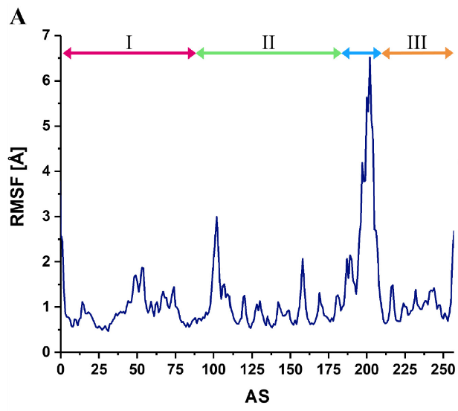
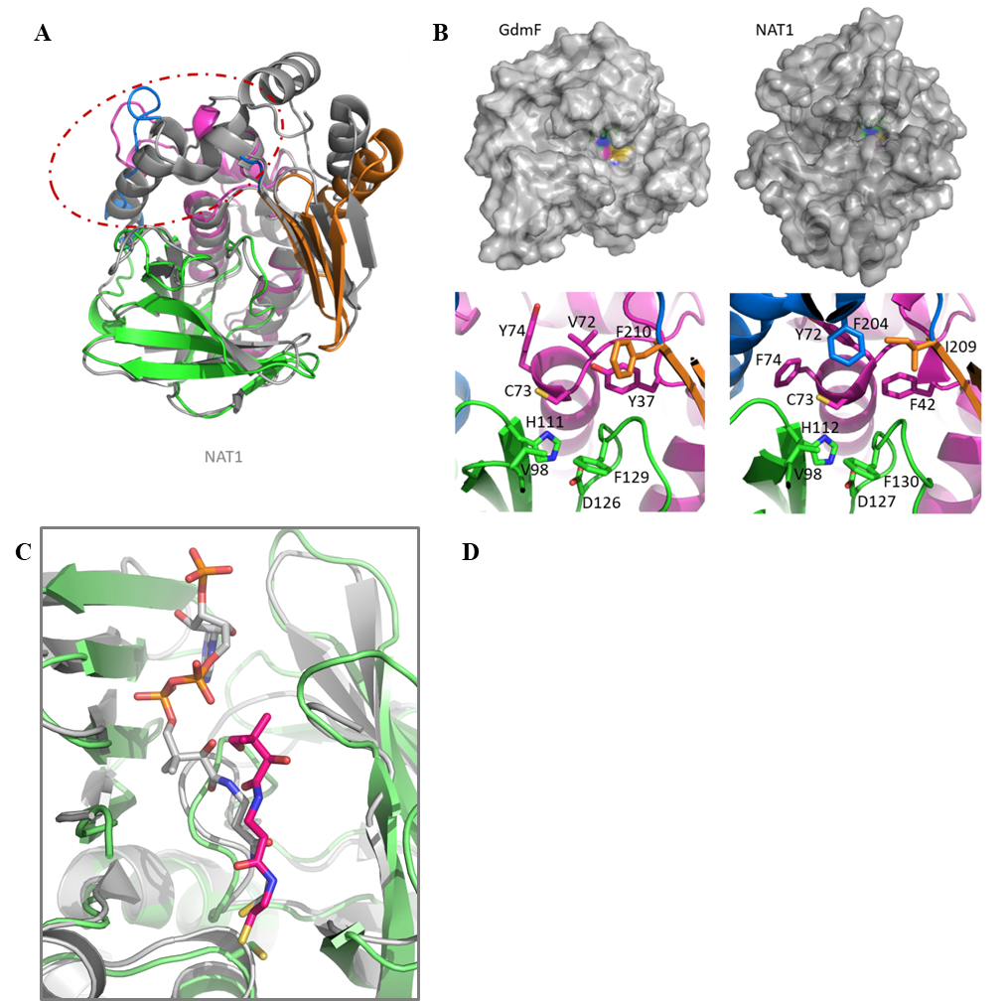
Figure S2: (A) Structure comparison of ShGdmF (colored) superposed on MlNAT1 (grey). The largest differences between the two structures can be observed in the interdomain region (blue) and the C-terminal α/β-lid (orange). (B) Surface representations (upper panels) and close-up views on the active sites (lower panels) of ShGdmF and MlNAT1. Note the widened active site cleft in GdmF. The catalytic triad is highlighted. (C) ShGdmf (green) in complex pantetheine (purple) superimposed on the structure of MlNAT1 (grey) with bound CoA (pdb: 4nv7). (D) Root mean square fluctuations (RMSF) along the 150 ns MD simulations reveal a drastically reduced flexibility of the P-loop (orange) in ShGdmF as compared to MlNAT1, allowing the P-loop to block the CoA binding site.

1.3 Parameter of refinement
Table S1: Data collection and refinement statistics.
 | apo ShGdMF | ShGdmF · 13b | ShGdmF · 11b | ShGdmF · 31 | ShGdmF · 32
Data collection
Beamline | Soleil PX-2A | DESY P13 | Soleil PX-2A | Soleil PX-2A | DESY P13
Space group | C2221 | C2221 | C2221 | C2221 | C2221
Wavelength [Å] | 0.98 | 0.98 | 0.98 | 0.98 | 0.98
Cell parameters
a, b, c [Å] | 90.93, 144.22, 156.94 | 72.87, 96.18, 86.75 | 74.30, 95.29, 86.59 | 74.33, 95.37, 86.48 | 72.54, 96.39, 86.63
α, β, γ [°] | 90, 90, 90 | 90, 90, 90 | 90, 90, 90 | 90, 90, 90 | 90, 90, 90
Rmerge [%] | 0.055 (1.139) | 0.086 (0.765) | 0.060 (1.141) | 0.046 (0.990) | 0.077 (1.358)
I / σI | 25.56 (2.00) | 13.04 (2.11) | 19.70 (1.89) | 24.42 (2.08) | 21.26 (2.03)
CC1/2 | 1.00 (0.825) | 0.998 (0.72) | 0.999 (0.825) | 1.00 (0.878) | 0.999 (0.694)
Completeness (%) | 99.94 (99.88) | 99.29 (99.49) | 99.96 (99.92) | 99.92 (99.83) | 97.94 (96.86)
Refinement
Resolution [Å] | 48.28 – 1.40  (1.45 – 1.40) | 48.27 – 1.82  (1.89 – 1.82) | 43.30 – 1.28  (1.33 – 1.28) | 43.24 – 1.26  (1.31 – 1.26) | 42.12 – 1.77  (1.83 – 1.77)
No. reflections | 60043 (5906) | 27484 (2723) | 79128 (7821) | 82845 (8177) | 29329 (2867)
Rwork / Rfree | 17.27 / 18.42 | 17.02 / 19.60 | 16.54 / 18.02 | 16.95 / 19.12 | 16.98 / 18.48
No. atoms | 2259 | 2121 | 2292 | 2264 | 2054
Protein | 2084 | 2019 | 2058 | 2054 | 1905
Ligand/ion | 16 | 12 | 29 | 19 | 82
Water | 159 | 90 | 205 | 191 | 67
B-factors [Å] | 23.94 | 27.42 | 23.50 | 23.16 | 34.64
Protein | 23.14 | 27.09 | 22.46 | 22.27 | 33.43
Ligand/ion | 46.62 | 45.63 | 43.74 | 49.99 | 40.98
Water | 32.20 | 32.29 | 31.07 | 30.00 | 57.46
R.M.S. deviations
Bond lengths [Å] | 0.010 | 0.015 | 0.016 | 0.016 | 0.011
Bond angles [°] | 1.19 | 1.35 | 1.42 | 1.51 | 1.27

1.4 Transformation of thioesters by ShGdmF
Table S2: Kinetic parameters for the substrate conversion of thioesters 11a-c and 13a-c, and aminophenols 31 and 32 by ShGdmF as obtained from photometric steady-state assays using Ellman‘s reagent.
Compound | + aminophenol 31
 | KM [µM] | kcat [s⁻¹] | kcat/ KM [s⁻¹ M⁻¹]
11a | 858.1 ± 232.7 | 0.0016 ± 1.9·10-4 | 1.87
11b | 2735.0 ± 610.3 | 0.0071 ± 7.0·10-4 | 2.60
11c | 2070.2 ± 476.7 | 0.0087 ± 1.2·10-3 | 4.20
13a | 6413.6 ± 2070.4 | 0.0164 ± 3.9·10-3 | 2.56
13b | 1136.8 ± 136.9 | 0.0027 ± 1.3·10-4 | 2.37
13c | 3497.5 ± 1289.9 | 0.0016 ± 3.1·10-4 | 0.46
 | + aminophenol 32
11a | 1865.1 ± 253.7 | 0.0032 ± 2.6·10-4 | 1.72
11b | 6902.4 ± 4142.6 | 0.0120 ± 5.8·10-3 | 1.74
11c | 3669.8 ± 1533.3 | 0.0228 ± 5.8·10-3 | 6.21
13a | 3648.3 ± 2812.7 | 0.0075 ± 5.1·10-3 | 2.06
13b | 8267.7 ± 1610.7 | 0.0084 ± 1.3·10-3 | 1.02
13c | 1712.8 ± 475.5 | 0.0013 ± 1.7·10-4 | 0.76

1.5 Binding assay for affinity estimation
Although progeldanamycin (2) is the cyclization product of ShGdmF, we assumed that the more accessible and structurally similar geldanamycin (3) would also provide information on binding with ShGdmF, as is known to be the case with its target protein Hsp90, where ATP binding is the target site. The heat map (Figure S3; supporting information) reveals that Geldanamycin-FITC binds to GdmF and Hsp90 (Figure S3a, A, B, control), and ATP-Cy5 binds to Hsp90 (Figure S3a, C, control; supporting information).
As previously published by us,40 neither ATP nor geldanamycin bind to Hsp90 in the presence of the known Hsp-inibitor radicicol 35 (Figure S3, B2, C2; supporting information), whereas the binding of geldanamycin-FITC to ShGdmF appears to be slightly increased. The displacement experiments show that thioesters 11a-c, 13b (Figure S3a) are differentially able to displace geldanamycin-FITC from ShGdmF, indicating that 11a, c and little or no displacement activity with 11b, 13b and radicicol 34, while 10a enhances Gda-FITC fluorescence. Thioesters 11a-c showed little displacement activity on Hsp90. However, dose-response activities were not confirmed for aminophenols 31, 32, although the activity identified in Figure S3a and acetyl-CoA 33 with ATP-Cy5 on Hsp90 or with Gda-FITC on ShGdmF tended to displace Gda-FITC only at high concentrations >300 µM. Note that the fluorescence intensities were normalized to the control value, while the comparison of intensities between Hsp90a and ShGdmF showed a 50% higher binding activity of Gda-FITC to Hsp90a. The lower susceptibility of ShGdmF could be due to a different open state or accessibility for the speckled protein. However, MST measurements with His tag labelled ShGdmF gave only for 2 and 11c stable dose-dependent activities with IC50 values of 819.21 ± 233.16 µM and 423.48 ± 227.14 µM, respectively, (Figure S3b). A comparison of the KM and Kd values for 11c shows that the Michaelis constant is greater than the dissociation constant indicating that the substrate is rapidly converted into a product. Stable binding data could only be obtained for 11c and 2 suggesting that the other enzyme-substrate complexes are not stable enough for MST or microarray measurements. Interestingly, the difference of one CH2 group, which is the difference between 11b and 11c, is sufficient for a stable enzyme-substrate complex.

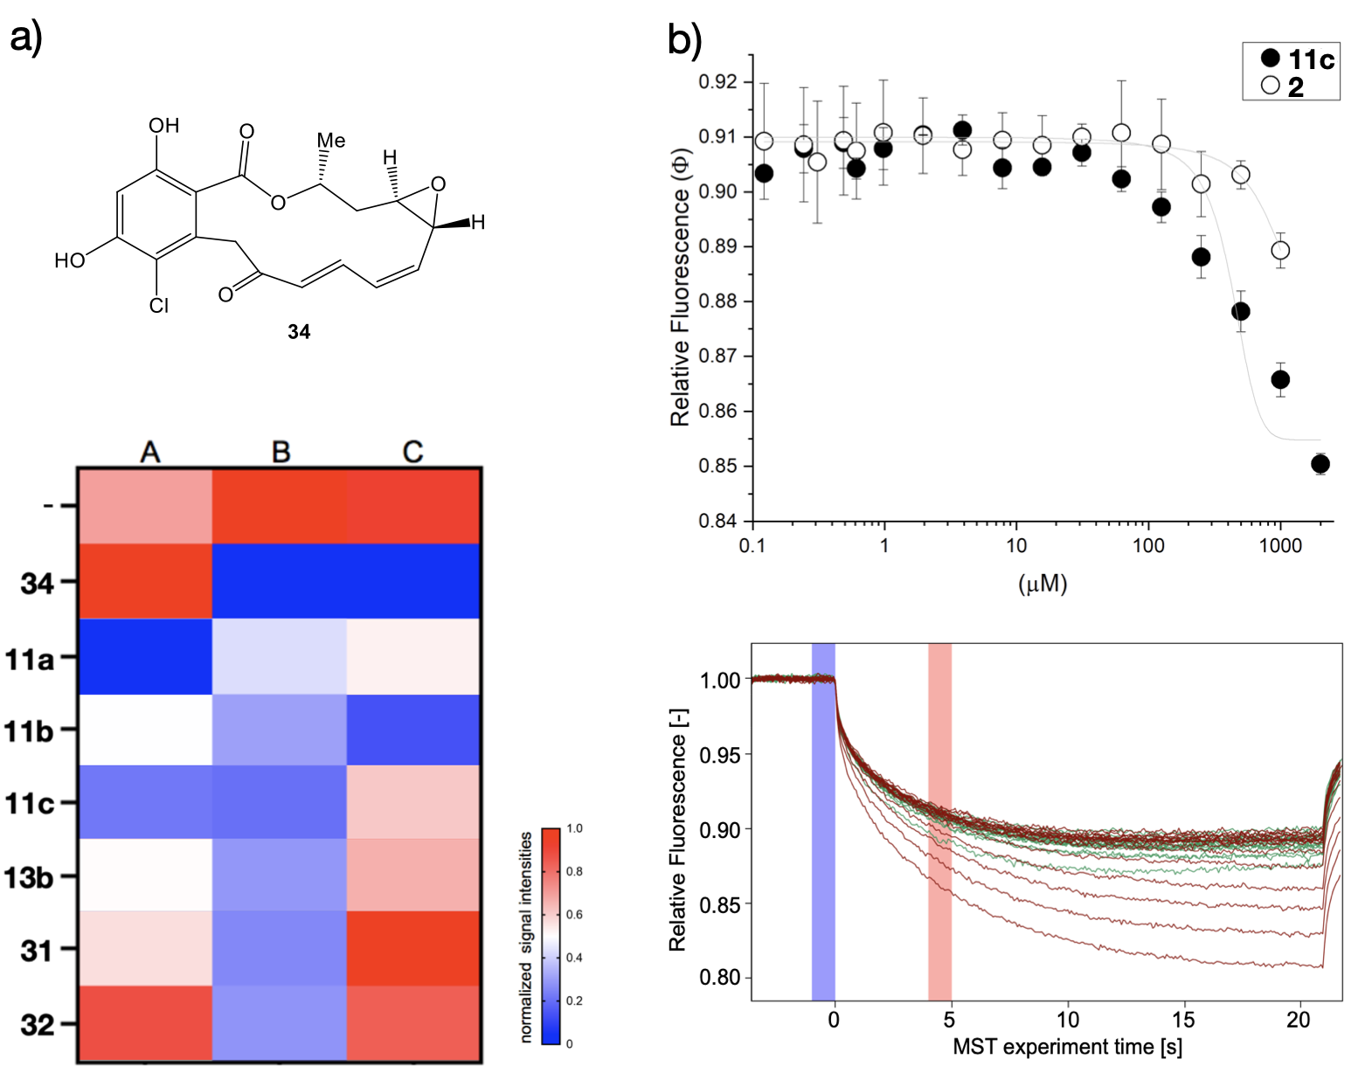

Figure S3: Microarray-based displacement activity on ShGdmF and Hsp90a and MST on ShGdmF. a) Binding of Gda-FITC (1 µM) on spotted ShGdmF (A) and Hsp90a (B) or binding of ATP-Cy5 on Hsp90a (C) analyzed with radicicol 35 (1 µM) or compounds 11a-c, 13b, 31, 33 (10 µM) or without (-). b) Dose-responsive binding activity of 2 and 11c on Cy5 His-tag labeled ShGdmF by typical MST (lower panel) with corresponding typical MST traces of compound 2 (green) and 11c (red), respectively. MST-traces are displayed in the mode of Thermophoresis + T-jump. The color of blue and red bars in the figure represents Fcold and Fhot respectively, which show the positions of data collection.

- Materials and Methods (Synthesis)
Reagents and solvents: All non-aqueous reactions were carried out under an inert atmosphere (argon) with dried glassware, using standard techniques. Anhydrous solvents (such as MeCN, CH2Cl2) were obtained from a MB solvent purification system (MBRAUN) or commercial solvents were used. Petroleum ether (60 °C) and THF were distilled before application and triethylamine was dried over KOH and distilled as well. Commercial reagents were used as supplied.
Thin layer chromatography (TLC): Analytical thin-layer chromatography was performed on precoated aluminium-backed silica gel plates with a layer thickness of 0.2 mm. Visualization of the developed chromatogram was performed by UV absorbance (254 nm) and/or stained with aqueous potassium permanganate solution with subsequent heat treatment.
Flash column chromatography: Flash column chromatography was performed using mesh silica (grain size 40-63 µm), with the indicated solvent system according to the standard techniques. Alternatively, a BÜCHI purification system was applied containing two pump modules (C-605), a UV-Vis detector (C-630), a fraction collector (C-660) and the control unit C-620. The separation was performed with a Cartridge PP 12/150 column and a FC60 (60 x 20 mL) rack. The system was controlled via Sepacore® control software.
Nuclear magnetic resonance (NMR) spectroscopy: NMR spectra were recorded on a BRUKER Ultrashield 500 MHz with Avance-III HD console, an Ascend 400 MHz with Avance-III console, an Ascend 400 MHz with Avance-III HD console, an Ultrashield 400 MHz with Avance-I console and an Ascend 600 MHz with Avance Neo console.
Chemical shifts for ¹H-NMR spectra are recorded in parts per million from tetramethylsilane with the residual protic solvent resonance as the internal standard (CDCl3: δ 7.26 ppm, CD3OD: δ 3.31 ppm, (CD3)2SO: δ 2.50 ppm, C6D6: δ 7.16 ppm, D2O: δ 4.79 ppm, CD3CN: δ 1.94 ppm). Data are reported as follows: chemical shift (multiplicity [s = singlet, bs = broad singlet, d = doublet, dd = doublet of doublets, t = triplet, q = quartet, quin = quintet, oct = octet and m = multiplet], coupling constant (in Hz), integration and assignment). All multiplet signals were quoted over a chemical shift range.
¹³C-NMR spectra are recorded with complete proton decoupling. Chemical shifts are reported in parts per million from tetramethylsilane with the solvent resonance as the internal standard (CDCl3: δ 77.00 ppm, CD3OD: δ 49.00 ppm, (CD3)2SO: δ 39.52 ppm, C6D⁶: δ 128.06 ppm, CD3CN: δ 1.32 ppm, 118.26 ppm). The multiplicities are corresponding to the non-decoupled spectra and are described as follows: p = primary, s = secondary, t = tertiary, q = quaternary.
Assignments of ¹H- and ¹³C-spectra were based upon the analysis of δ- and J-values, as well as COSY, HMBC, HSQC and adequate experiments where appropriate.
Mass spectrometry (MS): High resolution mass spectrometry (HRMS) was measured with a Micromass LCT with lockspray source. The injection proceeded in loop-mode with a HPLC system by Waters (Alliance 2695). Alternatively, mass spectra were recorded with a Acquity-UPLC system by Waters in combination with a QTOF Premier mass spectrometer by Waters in lockspray mode. The ionization happened by electrospray ionization (ESI) or by chemical ionization at atmospheric pressure (APCI). The calculated and found mass are reported.
High performance liquid chromatography (HPLC): Semi-preparative HPLC was performed using an Alliance 2695 HPLC-system by Waters with a Waters 996 diode array detector (λ = 200-350 nm) and a Nucleodur C18 HTec column (5 µm, 250 mm, Ø 8 mm) by MACHEREY-NAGEL. Mass detection was conducted with a Waters Quattro micro API mass spectrometer in negative ionization mode.
Preparative HPLC was performed using a GILSON HPLC-system (pump 331/332) with additional MERCK Hitachi Split-Pump (L-6200A, UV-Vis detector L-4250) and a MACHEREY-NAGEL Nucleodur C18 ISIS column (5 µm, 250 mm, Ø 21 mm with guard cartridge, 40 mm, Ø 21 mm). Mass detection was conducted with a Waters Micromass ZQ mass spectrometer in negative ionisation mode. Operating conditions and retention times (tR) are reported in the experimental details.
Melting points: Melting points were determined on a SRS OptiMelt apparatus and are not corrected.
Optical Rotation: Specific optical rotation values [α]tD were measured in a quartz cuvette on a polarimeter 341 by PerkinElmer at a wavelength of 589 nm (D) and given temperature t. Concentrations c are given in g/100 mL solvent.
Freeze-pump-thaw-technique (fpt): Degassed solvents were prepared by the fpt technique. For this, the appropriate dry solvent was placed under an argon atmosphere in a SCHLENK flask being connected to the SCHLENK line. The solvent was frozen in the flask using liquid nitrogen. Then the stopcock was opened to vacuum and the atmosphere was evaporated for 5 minutes. The flask was sealed and thawed until the solvent melted using an acetone bath being replaced by the cooling bath in order to repeat these steps until a gas evolution at the solution was no longer seen. A minimum of three cycles was needed. Subsequently, the flask was filled with argon gas and sealed. The solvent was ready to use.

3. Experimental Procedures (Synthesis)
  - Truncated thioesters
3.1.1 Pantetheine thioesters
Pantetheine dimethylketal (S1)
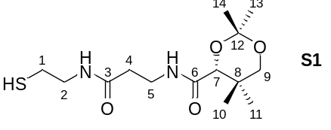The pantetheine dimethyl ketal S1 was prepared according procedure published protocol reported by Townsend et al.[S1] in 87 % yield (1.45 g, 4.57 mmol). ¹H-NMR (400 MHz, CDCl3, CHCl3 = 7.26 ppm): δ 7.07 (s, 1H, NH), 6.62 (s, 1H, NH), 4.08 (s, 1H, H-7), 3.67 (d, J = 11.7 Hz, H-9), 3.61 – 3.36 (m, 4H, H-2, H-5) 2.27 (d, J = 11.7 Hz, H-9’), 2.66 (q, J = 6.8 Hz, 2H, H-1), 2.51 (t, J = 6.0 Hz, 2H, H-4), 1.45 (s, 3H, Me-12/13), 1.41 (s, 3H, Me-12/13), 1.03 (s, 3H, Me-10/11), 0.96 (s, 3H, Me-10/11); ¹³C-NMR (400 MHz, CDCl3 = 77.16 ppm): δ 171.2 (s, C-3), 170.4 (s, C-6), 99.2 (s, C-12), 77.3 (d, C-7), 71.5 (t, C-9), 42.6 (t, C-2), 36.2 (t, C-4), 35.0 (t, C-5), 33.1 (s, C-8), 29.6 (q, C-13/14), 24.6 (t, C-1), 22.2 (q, C-10/11), 19.0 (q, C-10/11), 18.8 (q, C-13/14); m.p. 100 °C, ref. [S1] 99-101 °C; $[{α]}_{D}^{24}$ +45.0 (c = 0.9, CHCl3), ref. [S1] $[{α]}_{D}^{24}$ +48.0 (c = 1.0, CHCl3); HRMS-ESI m/z for C14H27N2O5S [M+H]+ calc. 319.1692, found: 319.1692.

General procedure for the synthesis of acyl pantetheine dimethylketals
Pantetheine dimethyl ketal (0.155 g, 0.49 mmol, 1.0 eq.) was dissolved in CH2Cl2 (3 mL) and the respective carboxylic acid (0.49 mmol, 1.0 eq.) was added. The mixture was cooled to 0 °C and DMAP (0.048 g, 0.39 mmol, 0.8 eq.) and EDC∙HCl (0.187 g, 0.98 mmol, 2.0 eq.) were added subsequently. The mixture was then allowed to reach room temperature and stirred for 2 h. The reaction was terminated by addition of a 2 M HCl solution (8 mL), the layers were separated and the aqueous phase was extracted with CH2Cl2 (3 x 3 mL). The combined organic layers were dried over MgSO4, filtered and the solvent was removed under reduced pressure. The crude product was purified by flash column chromatography (100 % ethyl acetate).

Acetyl pantetheine dimethylketal (S2)
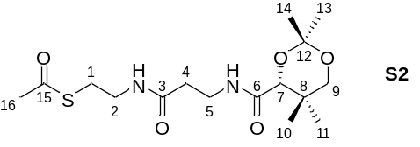Acetyl pantetheine dimethylketal (S2, 0.122 g, 0.38 mmol, 78 %) was obtained as a colorless oil. ¹H-NMR (400 MHz, CDCl3, CHCl3 = 7.26 ppm): δ 7.02 (t, J = 6.3 Hz, 1H, NH), 6.60 (bs, 1H, NH), 4.03 (s, 1H, H-7), 3.63 (d, J = 11.7 Hz, 1H, H-9), 3.56 – 3.42 (m, 2H, H-5), 3.42 – 3.30 (m, 2H, H-2) 3.22 (d, J = 11.7 Hz, 1H, H-9’), 2.96 (t, J = 6.6 Hz, 2H, H-1), 2.40 (t, J = 6.2 Hz, 2H, H-4), 2.30 (s, 3H, Me-16), 1.41 (s, 3H, Me-13/14), 1.37 (s, 3H, Me-12/13), 0.98 (s, 3H, Me-10/11), 0.92 (s, 3H, Me-10/11) ppm; ¹³C-NMR (400 MHz, CDCl3 = 77.16 ppm): δ 196.1 (s, C-15), 171.4 (s, C-3), 170.3 (s, C-6), 99.1 (s, C-12), 77.2 (d, C-7), 71.4 (t, C-9), 39.4 (t, C-2), 35.9 (t, C-4), 34.9 (t, C-5), 33.0 (s, C-8), 30.7 (q, C-16), 29.5 (q, C-13/14), 28.7 (t, C-1), 22.2 (q, C-10/11), 20.0 (q, C-10/11), 18.7 (q, C-13/14); HRMS-ESI m/z for C16H28N2O5SNa [M+Na]+ calc. 383.1617, found: 383.1616.

(E)-Pent-2-enoyl pantetheine dimethylketal (S3)
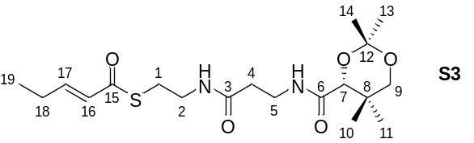(E)-Pent-2-enoyl Pantetheine dimethylketal (S3, 0.125 g, 0.31 mmol, 64 %) was obtained as a colorless oil. ¹H-NMR (400 MHz, MeOD-d4, MeOH = 3.31 ppm): δ 8.22 (bs, 1H, NH), 7.65 (bs, 1H, NH), 6.98 (dt, J = 15.4, 6.5 Hz, 1H, H-17), 6.16 (dt, J = 15.5, 1.7 Hz, 1H, H-16), 4.12 (s, 1H, H-7), 3.73 (d, J = 11.7 Hz, 1H, H-9), 3.48 – 3.43 (m, 2H, H-2), 3.35 (t, J = 6.6 Hz, 2H, H-5), 3.26 (d, J = 11.6 Hz, 1H, H-9’), 3.06 (t, J = 6.6 Hz, 2H, H-1), 2.40 (t, J = 6.6 Hz, 2H, H-4), 2.28 – 2.21 (m, 2H, H-18), 1.45 (s, 3H, Me-13/14), 1.44 (s, 3H, Me-13/14), 1.07 (t, J = 7.4 Hz, 3H, H-19), 0.99 (s, 3H, Me-10/11), 0.97 (s, 3H, Me-10/11) ppm; ¹³C-NMR (400 MHz, MeOD = 49.00 ppm): δ 191.0 (s, C-15), 173.8 (s, C-3), 172.1 (s, C-6), 148.8 (d, C-17), 128.6 (d, C-16), 100.4 (s, C-12), 78.4 (d, C-7), 72.3 (t, C-9), 40.2 (t, C-2), 36.3 (t, C-4), 36.1 (t, C-5), 34.0 (s, C-8), 29.7 (q, C-13/14), 28.9 (t, C-1), 26.2 (t, C-18), 22.4 (q, C-10/11), 19.4 (q, C-10/11), 19.0 (q, C-13/14), 12.5 (q, C-19); HRMS-ESI m/z for C19H32N2O5SNa [M+Na]+ calc. 423.1921, found: 423.1920.

(E)-2-Methylbut-2-enoyl pantetheine dimethylketal (S4)
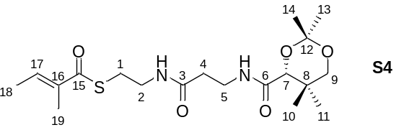(E)-2-Methylbut-2-enoyl Pantetheine Dimethyl Ketal (S4, 0.143 g, 0.40 mmol, 81 %) was obtained as a colorless oil. The analytical data are consistent with those reported in the literature.[S2] ¹H-NMR (400 MHz, CDCl3, CHCl3 = 7.26 ppm): δ 7.02 (t, J = 5.7 Hz, 1H, NH), 6.81 – 6.76 (m, 1H, H-17), 6.64 (bs, 1H, NH), 4.01 (s, 1H, H-7), 3.61 (d, J = 11.6 Hz, 1H, H-9), 3.49 – 3.36 (m, 4H, H-2, H-5), 3.20 (d, J = 11.6 Hz, 1H, H-9’), 2.98 (t, J = 6.5 Hz, 2H, H-1), 2.37 (t, J = 6.2 Hz, 2H, H-4), 1.79 (s, 3H, H-19), 1.76 (d, J = 7.1 Hz, 3H, H-18), 1.38 (s, 3H, Me-13/14), 1.35 (s, 3H, Me-13/14), 0.95 (s, 3H, Me-10/11), 0.90 (s, 3H, Me-10/11) ppm; ¹³C-NMR (400 MHz, CDCl3 = 77.16 ppm): δ 193.5 (s, C-15), 171.4 (s, C-3), 170.2 (s, C-6), 136.8 (d, C-17), 136.8 (q, C-16), 99.1 (s, C-12), 77.1 (d, C-7), 71.4 (t, C-9), 39.6 (t, C-2), 35.8 (t, C-4), 34.9 (t, C-5), 32.9 (s, C-8), 29.4 (q, C-13/14), 28.3 (t, C-1), 22.1 (q, C-10/11), 18.9 (q, C-10/11), 18.7 (q, C-13/14), 14.5 (q, C-18), 12.1 (q, C-19); HRMS-ESI m/z for C19H32N2O5SNa [M+Na]+ calc. 423.1921, found: 423.1919.

General procedure for the InCl3-mediated acetonide deprotection of acyl pantetheine dimethylketals to furnish acyl pantetheines[S3]
Acyl pantetheine dimethylketal (1.0 eq.), InCl3 (2.0 eq.) and H2O (4.0 eq.) were dissolved in MeCN (2 mL) and the mixture was stirred at r.t. for 4 h. The reaction was terminated by the addition of water and CH2Cl2 (10 mL) was added. The layers were separated and the aqueous layer was extracted with CH2Cl2 (2x10 mL). The combined organic phases were dried over MgSO4, filtered and concentrated. The crude product was purified by column chromatography (silica gel, CH2Cl2/MeOH = 30:1 15:1).

Acetyl Pantetheine (13a)
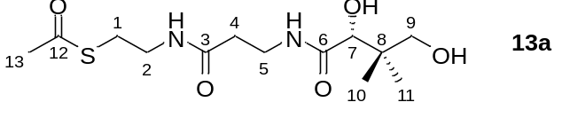
Acetyl pantetheine (13a, 25.0 mg, 0.078 mmol, 50 %) was obtained as a colorless oil. The analytical data are consistent with those reported in the literature.[S4] ¹H-NMR (400 MHz, MeOD-d4, MeOH = 3.31 ppm): δ 3.89 (s, 1H, H-7), 3.50 – 3.33 (m, 6H, H-2, H-5, H-9), 3.00 (t, J = 6.7 Hz, 2H, H-1), 2.41 (t, J = 6.7 Hz, 2H, H-4), 2.33 (s, 3H, Me-13), 0.92 (s, 6H, Me-10, Me-11) ppm; ¹³C-NMR (400 MHz, MeOD-d4 = 49.00 ppm): δ 197.0 (s, C-12), 176.1 (s, C-6), 173.9 (s, C-3), 77.3 (d, C-7), 70.3 (t, C-9), 40.4 (s, C-2), 40.0 (t, C-8), 36.4 (t, C-4), 36.3 (t, C-5), 30.5 (q, C-13), 29.4 (t, C-1), 21.3 (q, C-10/11), 20.9 (q, C-10/11); ${[α]}_{D}^{20}$ = + 19.2 (c = 0.8, MeOH), ref. [S4] ${[α]}_{D}^{20}$ = + 22.0 (c = 1.0, CHCl3); HRMS-ESI m/z for C13H24N2O5SNa [M+Na]⁺ calc. 343.1304, found: 343.1303.

(E)-Pent-2-enoyl pantetheine (13b)
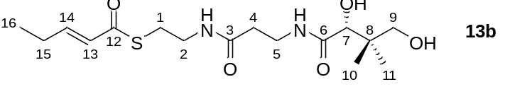
(E)-Pent-2-enoyl pantetheine (13b, 23.1 mg, 0.064 mmol, 32 %) was obtained as a colorless oil. ¹H-NMR (400 MHz, MeOD-d4, MeOH = 3.31 ppm): δ 6.89 (dt, J = 15.4, 6.5 Hz, 1H, H-14), 6.16 (dt, J = 15.5, 1.7 Hz, 1H, H-13), 3.89 (s, 1H, H-7), 3.53 – 3.33 (m, 6H, H-2, H-5, H-9), 3.06 (t, J = 6.7 Hz, 2H, H-1), 2.41 (t, J = 6.7 Hz, 2H, H-2), 2.29 – 2.21 (m, 2H, H-15), 1.08 (t, J = 7.4 Hz, 3H, H-16), 0.92 (s, 6H, H-10, H-11) ppm; ¹³C-NMR (400 MHz, MeOD-d4 = 49.00 ppm): δ 191.2 (s, C-12), 176.0 (s, C-6), 173.9 (s, C-3), 148.8 (d, C-14), 128.6 (d, C-13), 77.3 (d, C-7), 70.4 (t, C-9), 40.4 (t, C-8), 40.2 (s, C-2), 36.4 (t, C-4), 36.4 (t, C-5), 28.9 (t, C-1), 26.2 (t, C-15), 21.4 (q, C-10/11), 20.9 (q, C-10/11), 12.5 (q, C-16); ${[α]}_{D}^{20}$ = + 22.7 (c = 2.3, MeOH); HRMS-ESI m/z for C16H28N2O5SNa [M+Na]+ calc. 383.1617, found: 383.1617.

(E)-2-Methylbut-2-enoyl Pantetheine (13c)
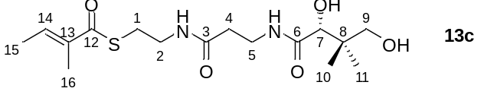(E)-2-Methylbut-2-enoyl pantetheine (13c, 37.6 mg, 0.104 mmol, 52 %) was obtained as a colorless oil. The analytical data are consistent with those reported in the literature [S2]. ¹H-NMR (400 MHz, MeOD-d4, MeOH = 3.31 ppm): δ 6.88 (q, J = 6.6 Hz, 1H, H-14), 3.89 (s, 1H, H-7), 3.50 – 3.33 (m, 6H, H-2, H-5, H-9), 3.03 (t, J = 6.7 Hz, 2H, H-1), 2.41 (t, J = 6.6 Hz, 2H, H-4), 1.85 (s, 3H, H-16), 1.84 (d, J = 7.5 Hz, 3H, H-15), 0.92 (s, 6H, Me-10, Me-11) ppm; ¹³C-NMR (400 MHz, MeOD-d4 = 49.00 ppm): δ 194.4 (s, C-12), 176.1 (s, C-6), 173.9 (s, C-3), 138.2 (d, C-14), 137.6 (s, C-13), 77.3 (d, C-7), 70.3 (t, C-9), 40.4 (s, C-8), 40.2 (t, C-2), 36.4 (t, C-4), 36.3 (t, C-5), 29.0 (t, C-1), 21.3 (q, C-10), 21.0 (q, C-11), 14.4 (q, C-15), 12.1 (q, C-16) ppm; ${[α]}_{D}^{20}$ = + 12.1 (c = 0.9, MeOH); HRMS-ESI m/z for C16H28N2O5SNa [M+Na]⁺ calc. 383.1617, found: 383.1616.

3.1.2 SNAC thioesters
General procedure for the synthesis of SNAC thioesters
N-Acetylcysteamine (238.4 mg, 2.0 mmol, 1.0 eq.) and the respective carboxylic acid (2.0 mmol, 1.0 eq.) were dissolved in CH2Cl2 (10 mL) and cooled to 0 °C. Then, DMAP (48.9 mg, 0.40 mmol, 0.2 eq.) and EDC•HCl (383.4 mg, 2.0 mmol, 1.0 eq.) were added subsequently. The mixture was allowed to reach ambient temperature and stirring was continued for 3 h. The reaction was then terminated by addition of a 2 M HCl solution (5 mL) and the layers were separated. The aqueous phase was extracted with CH2Cl2 (3 x 10 mL) and the combined organic phases were washed with a saturated aqueous NaHCO3 solution and brine, dried over MgSO4, filtered and the solvent was removed under reduced pressure. The crude product was purified by flash column chromatography (PE/EA = 1:1 100 % EA).

Crotonyl-N-acetylcysteamine (11a)
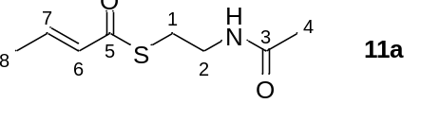Crotonyl-N-acetylcysteamine (11a, 285.0 mg, 1.52 mmol, 76 %) was obtained as a colorless solid. The analytical data are consistent with those reported in the literature. [S5] ¹H-NMR (400 MHz, CDCl3, CHCl3 = 7.26 ppm): δ 6.89 – 6.83 (m, 1H, H-6), 6.28 (bs, 1H, NH), 6.10 (dq, J = 15.4, 1.6 Hz, 1H, H-7), 3.40 – 3.37 (m, 2H, H-2), 3.05 – 3.01 (m, 2H, H-1), 1.92 (s, 3H, Me-4), 1.86 – 1.83 (m, 3H, Me-8) ppm; ¹³C-NMR (400 MHz, CDCl3 = 77.16 ppm): δ 190.0 (s, C-5), 170.5 (s, C-3), 141.7 (d, C-7), 129.9 (d, C-6), 39.7 (t, C-2), 28.1 (t, C-1), 23.1 (q, C-4), 18.0 (q, C-8); m.p. 60 °C; ref. [S6] 61.5 – 62 °C; HRMS-ESI m/z for C8H13NO2SNa [M+Na]+ calc. 210.0565, found: 210.0565.

(E)-2-Methylbut-2-enoyl-N-acetylcysteamine (11b)
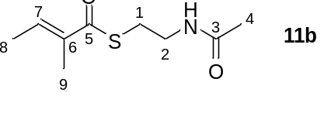(E)-2-Methylbut-2-enoyl-N-acetylcysteamin (11b, 292.5 mg, 1.45 mmol, 73 %) was obtained as a colorless oil. The analytical data are consistent with those reported in the literature.[S2] ¹H-NMR (400 MHz, CDCl3, CHCl3 = 7.26 ppm): δ 6.85 (dq, J = 6.9, 1.1 Hz, 1H, H-7), 6.04 (bs, 1H, NH), 3.42 (dt, J = 6.1, 6.0 Hz 2H, H-2), 3.04 (t, J = 6.4 Hz, 2H, H-1), 1.95 (s, 3H, Me-4), 1.85 (s, 3H, Me-9), 1.82 (d, J = 6.9 Hz, 3H, Me-8) ppm; ¹³C-NMR (400 MHz, CDCl3 = 77.16 ppm): δ 193.4 (s, C-5), 170.6 (s, C-3), 136.7 (d, C-7), 136.5 (s, C-6), 39.5 (t, C-2), 28.2 (t, C-1), 22.9 (q, C-4), 14.3 (q, C-9), 12.0 (q, C-8); HRMS-ESI m/z for C9H15NO2SNa [M+Na]+ calc. 224.0721, found: 224.0721.

(E)-2-Methylpent-2-enoyl-N-acetylcysteamin (11c)
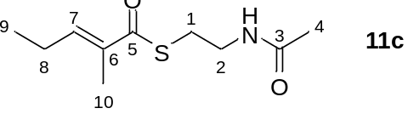(E)-2-Methylpent-2-enoyl-N-acetylcysteamine (11c, 272.0 mg, 1.26 mmol, 63 %) was obtained as a colorless oil. The analytical data are consistent with those reported in the literature.[S7] ¹H-NMR (400 MHz, CDCl3, CHCl3 = 7.26 ppm): δ 6.74 (dt, J = 7.5, 1.1 Hz, 1H, H-7), 6.00 (bs, 1H, NH), 3.43 (q, J = 6.1 Hz, 2H, H-2), 3.05 (t, J = 6.4 Hz, 2H, H-1), 2.25 – 2.18 (m, 2H, H-8), 1.95 (s, 3H, Me-4), 1.86 (s, 3H, Me-10), 1.06 (t, J = 7.5 Hz, 3H, Me-9) ppm; ¹³C-NMR (400 MHz, CDCl3 = 77.16 ppm): δ 194.1 (s, C-5), 170.8 (s, C-3), 143.6 (d, C-7), 135.3 (s, C-6), 40.0 (t, C-2), 28.3 (t, C-1), 23.2 (q, C-4), 22.2 (t, C-8), 13.0 (q, C-9), 12.4 q, C-10); HRMS-ESI m/z for C10H17NO2SNa [M+Na]⁺ calc. 238.0878, found: 238.0876.

3.2 3-Hydroxyanilines
3-Amino-5-methylphenol (32)
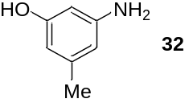5-Methylresorcinol (2.1 g, 16.92 mmol, 1.0 eq.) was dissolved in water (10 mL) and ammonium chloride (1.5 g, 28.04 mmol, 1.7 eq.) and aqueous ammonia (28 %, 5.8 mL) were added. The mixture was heated in an autoclave to 180 °C and stirred for 17 h. The mixture was extracted with ethyl acetate (3 x 15 mL) and the combined organic layers were dried over MgSO4, filtered and the solvent removed under reduced pressure. The crude product was purified by flash column chromatography (PE/EA = 3:1) to yield 3-amino-5-methylphenol (32) as a brown solid (0.96 g, 4.02 mmol, 52 % brsm). The analytical data are consistent with those reported in the literature.[S8] ¹H-NMR (400 MHz, DMSO-d6, DMSO = 2.50 ppm): δ 8.69 (s, 1H, OH), 5.83 – 5.82 (m, 1H, HAr), 5.81 – 5.80 (m ,1H, HAr), 5.76 – 5.75 (m, 1H, HAr), 4.77 (s, 2H, NH2), 2.04 (s, 3H, Me) ppm; ¹³C-NMR (400 MHz, DMSO-d6 = 39.52 ppm): δ 158.0 (s, CAr), 149.5 (s, CAr), 138.5 (s, CAr), 106.3 (d, CAr), 104.4 (d, CAr), 98.4 (d, CAr), 21.3 (q, Me); m.p. 137 °C; ref. [S8] 138 °C.

3.3 Total synthesis of seco-acid derivatives 26, 28 and 30
3.3.1 Total synthesis of western fragment 19
tert-Butyl {3-[(tert-butyldiphenylsilyl)oxy]-5-(iodomethyl)phenyl}carbamate (S5)

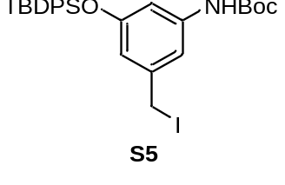PPh₃ (9.73 g, 37.0 mmol, 1.2 eq.) and imidazole (2.53 g, 37.0 mmol, 1.2 eq.) were dissolved in CH₂Cl₂ (300 mL) at room temperature. The reaction was cooled to 0 °C and iodine (9.39 g, 37.0 mmol, 1.2 eq.) was added in the absence of light. Stirring was continued at this temperature for 30 minutes. Benzylic alcohol 37 (14.7 g, 30.8 mmol, 1.0 eq.) dissolved in CH₂Cl₂ (50 mL) was added via canula. The reaction was stirred at 0 °C for 4 h. Silica gel was added and the solvent was removed under reduced pressure. The crude product was purified by flash column chromatography (PE/EtOAc = 10:1 6:1) to yield benzylic iodide S5 (16.29 g, 27.72 mmol, 90%) as a pale-yellow oil. The analytical data are consistent with those reported in the literature.
R_{f} = 0.7 (PE/EtOAc = 4:1); ¹H-NMR (400 MHz, CDCl₃, CHCl₃ = 7.26 ppm): δ 7.71 – 7.69 (m, 4H, TBDPS), 7.43 – 7.36 (m, 6H, TBDPS), 7.12 (bs, 1H, C_{Ar}), 6.55 – 6.54 (m, 1H, C_{Ar}), 6.40 – 6.39 (m, 1H, C_{Ar}), 6.25 (bs, 1H, NH), 4.18 (s, 2H, CH₂I), 1.48 (s, 9H, Boc), 1.09 (s, 9H, TBDPS) ppm; ¹³C-NMR (400 MHz, CDCl₃, CDCl₃ = 77.16 ppm): δ 156.2 (s, C_{Ar}), 152.5 (s, Boc), 140.9 (s, C_{Ar}), 139.5 (s, C_{Ar}), 135.6 (d, 4C, TBDPS), 132.7 (s, 2C, TBDPS), 130.1 (d, 2C, TBDPS), 128.0 (d, 4C, TBDPS), 115.1 (d, C_{Ar}), 111.7 (d, C_{Ar}), 109.5 (d, C_{Ar}), 80.8 (s, Boc), 28.4 (q, 3C, Boc), 26.6 (q, 3C, TBDPS), 19.6 (s, TBDPS), 5.5 (t, CH₂I) ppm; HRMS-ESI m/z for C₂₈H₃₄INO₃SiNa [M+Na]⁺ calc. 610.1250, found 610.1248.

tert-Butyl {3-[(R)-3-((S)-4-benzyl-2-oxooxazolidin-3-yl)-2-methyl-3-oxopropyl]-5-[(tert-butyldiphenylsilyl)oxy]phenyl}carbamate (15)
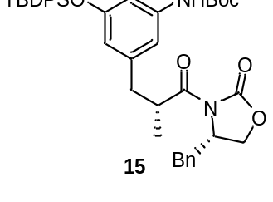DIPA (1.29 mL, 9.24 mmol, 1.7 eq.) was dissolved in THF (25 mL) and cooled to –78 °C. n-BuLi (2.5 M in hexane, 3.69 mL, 9.24 mmol, 1.7 eq.) was added slowly and stirring was continued at –78 °C for 5 min. (S)-Oxazolidinone 20 (2.16 g, 9.24 mmol, 1.7 eq.) was added as a solution in THF (20 mL) via cannula. Stirring was continued for 15 min at –78 °C. Iodide S5 (3.19 g, 5.44 mmol, 1.0 eq.) was added as a solution in THF (30 mL) via cannula. The reaction was stirred at –78 °C for 15 min and then slowly warmed to –35 °C over 2.5 h. The reaction was terminated by the addition of an aqueous saturated NH₄Cl solution. The phases were separated and the aqueous phase was extracted with EtOAc (6 x 75 mL). The combined organic phases were dried over MgSO₄, filtered and the solvent was removed under reduced pressure. The crude product was purified by flash column chromatography (PE/EtOAc = 10:1 2:1) to yield 15 (3.14 g, 4.53 mmol, 83%) as a yellow foam.
R_{f} = 0.2 (PE/EtOAc = 4:1); ¹H-NMR (400 MHz, CDCl₃, CHCl₃ = 7.26 ppm): δ 7.71 – 7.68 (m, 4H, TBDPS), 7.43 – 7.24 (m, 9H, TBDPS, Bn), 7.12 – 7.10 (m, 2H, Bn), 6.86 (bs, 1H, H_{Ar}), 6.73 (bs, 1H, NH), 6.29 (m, 1H, H_{Ar}), 6.25 (bs, 1H, H_{Ar}), 4.67 – 4.61 (m, 1H, CHBn), 4.18 – 4.10 (m, 2H, CH₂CHBn), 3.86 – 3.81 (m, 1H, C-14), 3.16 (dd, J = 13.4, 3.2 Hz, 1H, Bn), 2.93 (dd, J = 13.2, 6.2 Hz, 1H, C-15), 2.60 (dd, J = 13.4, 9.5 Hz, 1H, Bn), 2.33 (dd, J = 13.2, 8.4 Hz, 1H, C-15), 1.45 (s, 9H, Boc), 1.07 (s, 9H, TBDPS), 0.93 (d, J = 6.7 Hz, 3H, Me-14) ppm; ¹³C-NMR (400 MHz, CDCl₃, CDCl₃ = 77.16 ppm): δ 176.6 (s, C-13), 156.1 (s, C_{Ar}), 153.1 (s, Aux), 152.5 (s, Boc), 140.9 (s, C_{Ar}), 139.3 (s, C_{Ar}), 135.7 (d, 4C, TBDPS), 135.6 (s, Bn), 133.0 (s, 2C, TBDPS), 132.9 (d, Bn), 129.9 (d, 2C, TBDPS), 129.5 (d, Bn), 129.0 (d, Bn), 127.9 (d, 4C, TBDPS), 127.8 (d, Bn), 127.4 (d, Bn), 115.8 (d, C_{Ar}), 112.2 (d, C_{Ar}), 108.2 (d, C_{Ar}), 80.5 (s, Boc), 66.1 (t, CH₂O), 55.3 (d, CHN), 39.7 (s, Bn), 39.5 (d, C-14), 38.0 (t, C-15), 28.4 (q, 3C, Boc), 26.6 (q, 3C, TBDPS), 19.6 (s, TBDPS), 16.2 (q, Me-14) ppm; ${[α]}_{D}^{20}$ = –2.4 (c = 1.0, CHCl₃; HRMS-ESI m/z for C₄₁H₄₈N₂O₆SiNa [M+Na]⁺ calc. 715.3179, found 715.3179.

(2R)-3-[3-(tert-Butoxycarbonylamino)-5-(tert-butyldiphenylsiloxy)-phenyl]-2-methyl-propan-1-ol (S6)
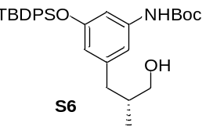The oxazolidinone 15 (10.2 g, 14.7 mmol, 1.0 eq.) was dissolved in Et2O (70 mL) under argon atmosphere, added with water (0.23 mL, 14.7 mmol, 1.0 eq.) and cooled to 0 °C. Then lithium borohydride (2 M solution in THF) (16.2 mL, 32.4 mmol, 2.2 eq.) was slowly added and the reaction mixture was stirred for 1.5 h at 0 °C. The combined organic extracts were washed with aqueous NaCl solution, dried over MgSO4 and concentrated under reduced pressure. The crude product was purified by flash chromatography (PE:EtOAc = 10:1 → 2:1) to give alcohol S6 (5.95 g, 11.5 mmol, 78%) as a colorless foam; Rf = 0.4 (PE:EA= 2:1). ¹H-NMR (400 MHz, CDCl3, CHCl3 = 7.26 ppm) δ 7.71-7.69 (m, 4H, SiPh), 7.43-7.37 (m, 6H, SiPh), 6.80 (bs, 1H, Ph), 6.68 (dd, J = 2.1, 2.1 Hz, 1H, Ph), 6.25 (bs, 1H, NH), 6.09 (dd, J = 1.7, 1.7 Hz, 1H, Ph), 3.26 (dd, J = 10.5, 5.6 Hz, 1H, CH2OH), 3.17 (dd, J = 10.5, 5.9 Hz, 1H, CH2OH), 2.39 (dd, J = 13.3, 6.9 Hz, 1H, ArCH2), 2.15 (dd, J = 13.3, 7.7 Hz, 1H, ArCH2), 1.66-1.58 (m, 1H, CHCH3), 1.48 (s, 9H, t-Bu), 1.25 (bs, CH2OH), 1.07 (s, 9H, t-SiBu), 0.70 (d, J = 6.8 Hz, 3H, CHCH3) ppm; ¹³C-NMR (100 MHz, CDCl3, CDCl3 = 77.16 ppm) δ 155.8 (s, C-Ar), 152.5 (s, NCOO), 142.3 (s, C-Ar), 139.1 (s, C-Ar), 135.5 (d, C-Ar), 132.9 (s, C-Ar), 129.8 (d, C-Ar), 127.7 (d, C-Ar), 115.3 (d, C-Ar), 111.9 (d, C-Ar), 107.5 (d, C-Ar), 80.3 (s, t-Bu), 67.1 (t, CH2), 39.4 (t, CH2), 37.3 (d, CH), 28.3 (q, t-Bu), 26.4 (q, Sit-Bu), 19.4 (s, Sit-Bu), 16.4 (q, CH3) ppm; HRMS (ESI) m/z for C31H41NO4SiNa [M+Na]⁺: caculated: 542.2703, found: 542.2699; [α]²⁰D= +4.9° (c = 1.0, CHCl3).

(2R)-3-[3-(tert-Butoxycarbonylamino)-5-(tert-butyldiphenylsiloxy)-phenyl]-2-methyl-propanal (S7)
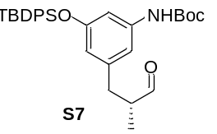Alcohol S6 (5.90 g, 11.4 mmol, 1.0 eq.) was dissolved in CH2Cl2 (170 mL), cooled to 0 °C, and NaHCO3 (1.16 g, 13.6 mmol, 1.2 eq.) was added followed by the Dess-Martin periodinane reagent (5.76 g, 13.6 mmol, 1.2 eq.).After 1 h, the reaction was terminated by the addition of an aqueous Na2SO3-solution and the aqueous phase was extracted three times with CH2Cl2. The combined organic phases were washed with brine, dried over MgSO4, and concentrated under reduced pressure. Aldehyde S7 (5.80 g, 11.2 mmol, 99%) was obtained as a colorless foam; Rf = 0.6 (PE:EA = 2:1). The aldehyde S7 was directly used in the next reaction.

Ethyl (4R)-5-[3-(tert-Butoxycarbonylamino)-5-(tert-butyldiphenylsiloxy)-phenyl]-2-methyl-pent-2-enoate (16)
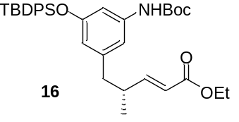Aldehyde S7 (5.80 g, 11.2 mmol, 1.0 eq.) was dissolved in CHCl3 (35 mL) and phosphorylide Ph3P=CHCO2Et (5.85 g, 16.8 mmol, 1.5 eq.) was added. The reaction mixture was heated to 50 °C and stirred for an additional 15 h at 50 °C. The solvent was removed under reduced pressure, the crude product was purified by flash chromatography (PE:EA= 15:1 → 4:1), and ester 16 (6.40 g, 10.9 mmol, 97%) was obtained as a colorless foam; Rf = 0.3 (PE:EA= 5:1). ¹H-NMR (400 MHz, CDCl3, CHCl3 = 7.26 ppm) δ 7.72-7.68 (m, 4H, SiPh), 7.44-7.34 (m, 6H, SiPh), 6.81 (dd, J = 15.7, 7.0 Hz, 1H, 3-H), 6.79 (bs, 1H, NH), 6.64 (s, 1H, Ph), 6.27 (bs, 1H, Ph), 6.09 (s, 1H, Ph), 5.63 (dd, J = 15.7, 0.6 Hz, 1H, 2-H), 4.16 (q, J = 7.1 Hz, 2H, OCH2), 2.52-2.48 (m, 1H, 5-Ha), 2.27 (dq, J = 6.8, 6.7 Hz, 1H, 4-H), 2.23-2.17 (m, 1H, 5-Hb), 1.48 (s, 9H, t-Bu), 1.27 (t, J = 7.1 Hz, 3H, OCH2CH3), 1.07 (s, 9H, Sit-Bu), 0.78 (d, J = 6.7 Hz, 3H, 6-H) ppm; ¹³C-NMR (100 MHz, CDCl3, CDCl3 = 77.16 ppm) δ 166.9 (s, COOEt), 156.1 (s, C- Ar), 153.6 (d, C-3), 152.6 (s, NHCOO), 141.5 (s, C-Ar), 139.2 (s, C-Ar), 133.0 (d, C-Ar), 133.0 (s, C-Ar), 130.0 (d, C-Ar), 130.0 (d, C- Ar), 128.7 (d, C-Ar), 119.8 (d, C-2), 115.3 (d, C-Ar), 112.0 (d, C-Ar), 107.9 (d, C-Ar), 80.5 (s, t-Bu), 60.2 (t, OCH2), 42.2 (t, C-5), 37.9 (d, C-4), 28.4 (q, t-Bu), 26.6 (q, Sit-Bu), 19.5 (s, Sit-Bu), 18.5 (q, C-6), 14.4 (q, OCH2CH3) ppm; HRMS (ESI) m/z for C35H45NO5SiNa [M+Na]⁺: calculated: 610.2965, found: 610.2962; [α]²⁰D = -19.1° (c = 1.2, CHCl3).

(4R)-5-[3-(tert-Butoxycarbonylamino)-5-(tert-butyldiphenylsiloxy)-phenyl]-4-methyl-pent-2-enol (S8)
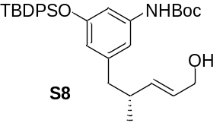Ester S7 (6.35 g, 10.8 mmol, 1.0 eq.) was dissolved in CH2Cl2 (100 mL) under argon atmosphere, cooled to -78 °C, and slowly mixed with DIBAL-H (1.2 M solution in toluene) (22.5 mL, 27.0 mmol, 2.5 eq.). The reaction mixture was stirred at -78 °C for 5 h and then warmed to room temperature.The reaction was terminated by addition of an aqueous Na-K tartrate solution and the reaction mixture was stirred overnight at room temperature. The aqueous phase was extracted three times with CH2Cl2. The combined organic extracts were washed with brine, dried over MgSO4 and concentrated under reduced pressure. The crude product was purified by flash chromatography (PE:EA= 10:1 → 2:1) to give alcohol S8 (4.50 g, 8.25 mmol, 76%) as a colorless foam; Rf = 0.4 (PE:EA= 2:1). ¹H-NMR (400 MHz, CDCl3, CHCl3 = 7.26 ppm) δ 7.71-7.69 (m, 4H, SiPh), 7.43-7.33 (m, 6H, SiPh), 6.91 (s, 1H, Ph), 6.46 (m, 1H, Ph), 6.23 (bs, 1H, NH), 6.14 (m, 1H, Ph), 5.50 (dd, J = 15.5, 7.0 Hz, 1H, 3-H), 5.39 (dt, J = 15.5, 5.5 Hz, 1H, 2-H), 3.99 (t, J = 5.5 Hz, 2H, 1-H), 2.39 (dd, J = 13.1, 7.3 Hz, 1H, 5-Ha), 2.28 (dd, J = 13.1, 6.7 Hz, 1H, 5-Hb), 2.16 (m, 1H, 4-H), 1.73 (bs, 1H, CH2OH), 1.47 (s, 9H, t-Bu), 1.09 (s, 9H, Sit-Bu), 0.80 (d, J = 6.8 Hz, 3H, 5-Me) ppm; ¹³C-NMR (100 MHz, CDCl3, CDCl3 = 77.16 ppm) δ 155.8 (s, C-Ar), 152.9 (s, NHCOO), 142.4 (s, C-Ar), 138.7 (s, C-Ar), 138.0 (d, C-3), 135.6 (d, C-Ar), 133.0 (s, C-Ar), 130.0 (d, C-Ar), 127.8 (d, C-2), 115.7 (d, C-Ar), 112.9 (d, C-Ar), 107.7 (d, C-Ar), 80.6 (s, t-Bu), 63.9 (t, C-1), 43.4 (t, C-5), 37.8 (d, C-4), 28.5 (q, t-Bu), 26.6 (q, Sit-Bu), 19.7 (q, 5-Me), 19.6 (s, Sit-Bu) ppm; HRMS (ESI) m/z for C33H44NO4Si [M+H]⁺: calculated: 546.3040, found: 546.3031; [α]²⁰D = -10.7° (c = 1.0, CHCl3).

tert-Butyl {3-[(tert-butyldiphenylsilyl)oxy]-5-[(R)-2-[(2R,3R)-3-(hydroxymethyl)oxiran-2-yl]propyl]phenyl}carbamate (17)
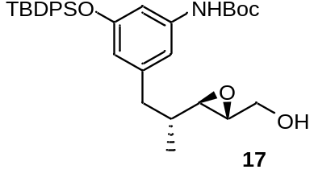Freshly activated molecular sieves (4 Å) were suspended in CH2Cl2 (40 mL) and D-(-)-DET (0.82 mL, 4.76 mmol, 1.3 eq.) was added. The reaction was cooled to – 20 °C and Ti(OiPr)4 (1.29 mL, 4.39 mmol, 1.2 eq) and t-BuOOH (5.0 – 6.0 M in decane, 2.93 mL, 14.65 – 17.58 mmol, 4.0 eq.) were added subsequently. Stirring was continued at this temperature for 1 h. Allylic alcohol S8 (2.00 g, 3.66 mmol, 1.0 eq.) as a solution in CH2Cl2 (10 mL) was slowly added to the reaction mixture and stirring was continued at – 20 °C for 42 h. The reaction was terminated by addition of a EDTE (1.09 g, 4.61 mmol, 1.26 eq.; EDTE= N,N,N’,N’-tetrakis(2-hydroxyethyl)ethylenediamine; 1.05 eq. relative to the amount of Ti(OiPr)4). The mixture was heated to 55 °C for 15 min and after cooling to room temperature, the mixture was diluted with aqueous NH4OH and CH2Cl2. The two clear phases were separated and the aqueous layer was extracted with CH2Cl2 (3 x 20 mL). The combined organic layers were dried over MgSO4, filtered and the solvent was removed under reduced pressure. The crude product was purified by flash column chromatography (PE/EtOAc = 10:1 2:1) to yield epoxide 17 (1.96 g, 3.48 mmol, 96%, d.r. > 10:1) as a colourless foam. Rf = 0.3 (PE/EtOAc = 4:1); ¹H-NMR (400 MHz, CDCl3, CHCl3 = 7.26 ppm): δ 7.71 – 7.69 (m, 4H, TBDPS), 7.43 – 7.34 (m, 6H, TBDPS), 6.85 (bs, 1H, HAr), 6.63 – 6.62 (m, 1H, HAr), 6.29 (bs, 1H, NH), 6.12 – 6.11 (m, 1H, HAr), 3.81 (dd, J = 12.6, 2.7 Hz, 1H, H-11), 3.56 (dd, J = 12.6, 4.2 Hz, 1H, H-11’), 2.86 – 2.84 (m, 1H, H-12), 2.70 (dd, J = 6.8, 2.3 Hz, 1H, H-13), 2.62 (dd, J = 13.4, 5.3 Hz, 1H, H-15), 2.22 (dd, J = 13.3, 8.9 Hz, 1H, H-15’), 1.53 – 1.15 (m, 1H, H-14), 1.48, (s, 9H, Boc), 1.08 (s, 9H, TBDPS), 0.59 (d, J = 6.8 Hz, 3H, Me-14) ppm; ¹³C-NMR (400 MHz, CDCl3, CDCl3 = 77.16 ppm): δ 156.0 (s, CAr), 152.7 (s, Boc), 141.4 (s, CAr), 139.1 (s, CAr), 135.6 (d, CAr), 135.6 (d, CAr), 133.0 (s, CAr), 133.0 (s, CAr), 130.0 (d, CAr), 130.0 (d, CAr), 127.9 (d, CAr), 127.9 (d, CAr), 115.6 (d, CAr), 112.4 (d, CAr), 107.9 (d, CAr), 80.6 (s, Boc), 61.9 (t, C-11), 59.9 (d, C-13), 57.2 (d, C-12), 40.1 (t, C-15), 36.4 (d, C-14), 28.5 (q, Boc), 26.6 (q, TBDPS), 19.6 (s, TBDPS), 14.8 (q, Me-14) ppm; ${[α]}_{D}^{20}$ = + 5.6 (c = 1.2, CH2Cl2; HRMS-ESI m/z for C33H43NO5SiNa [M+Na]+ calc. 584.2808, found: 584.2807.

(4R, 2S)-5-[3-(tert-Butoxycarbonylamino)-5-(tert-butyldiphenylsiloxy)-phenyl]-4-methyl-1,2-pentanediol (S9)
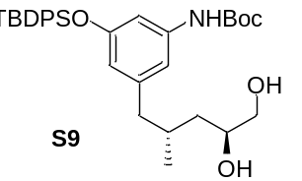Epoxide 17 (7.16 g, 12.8 mmol, 1.0 eq.) was dissolved in Et2O (450 mL) under argon atmosphere, cooled to 0 °C and mixed with DIBAL-H (1.2 M solution in toluene) (53.1 mL, 63.7 mmol, 5.0 eq.). The reaction mixture was warmed to room temperature and stirred for an additional 5 h at room temperature. Na-K-tartrate solution was added and the reaction mixture was stirred overnight at room temperature. The aqueous phase was extracted three times with ethylacetate. The combined organic extracts were washed with brine, dried over MgSO4 and concentrated under reduced pressure. The crude product was purified by flash chromatography (PE:EtOAc = 1:1 → 1:4) to give diol S9 (6.09 g, 10.8 mmol, 85%) as a colorless foam; Rf = 0.5 (PE:EA = 1:4). ¹H-NMR (400 MHz, CDCl3, CHCl3 = 7.26 ppm) δ 7.71-7.69 (m, 4H, SiPh), 7.41-7.34 (m, 6H, SiPh), 6.80 (s, 1H, Ph), 6.63 (m, 1H, Ph), 6.26 (bs, 1H, NH), 6.11 (m, 1H, Ph), 3.72-3.65 (m, 1H, 2-H), 3.52 (ddd, J = 10.8, 5.8, 3.3 Hz, 1H, 1-Ha), 3.30 (ddd, J = 10.8, 7.3, 4.0 Hz, 1H, 1-Hb), 2.31 (dd, J = 13.3, 6.6 Hz, 1H, 5-Ha), 2.19 (dd, J = 13.3, 7.8 Hz, 1H, 5-Hb), 1.86 (dd, J = 5.8, 4.0 Hz, 1H, 1-OH), 1.77 (d, J = 4.4 Hz, 1H, 2-OH), 1.73-1.64 (m, 1H, 4-H), 1.47 (s, 9H, t-Bu), 1.31 (ddd, J = 13.8, 9.3, 4.6 Hz, 1H, 3-Ha), 1.07 (s, 9H, Sit-Bu), 0.97 (ddd, J = 13.8, 9.7, 3.9 Hz, 1H, 3-Hb), 0.69 (d, J = 6.4 Hz, 3H, 5-Me) ppm; ¹³C-NMR (100 MHz, CDCl3, CDCl3 = 77.16 ppm) δ 155.9 (s, C-Ar), 152.7 (s, NHCOO), 142.6 (s,C-Ar), 139.0 (s, C-Ar), 135.6 (d, C-Ar), 133.0 (s, C-Ar), 129.9 (d, C-Ar), 127.8 (d, C-Ar), 115.5 (d, C-Ar), 112.3 (d, C-Ar), 107.9 (d, C-Ar), 80.5 (s, t-Bu), 70.1 (d, C-2), 67.5 (t, C-1), 44.0 (t, C-5), 39.7 (t, C-3), 30.8 (d, C-4), 28.4 (q, t-Bu), 26.6 (q, Sit-Bu), 19.5 (s, Sit-Bu), 14.7 (q, 5-Me) ppm; HRMS (ESI) m/z for C33H45NO5SiNa [M+Na]⁺: calculated: 586.2965, found: 586.2964; [α]²⁰D = -10.1° (c = 1.0, CHCl3).

tert-Butyl {3-[(2R,4S)-5-[(tert-butyldimethylsilyl)oxy]-4-hydroxy-2-methylpentyl]-5-[(tert-butyldiphenylsilyl)oxy]phenyl}carbamate (S10)
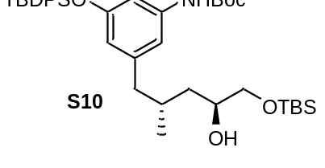Diol S9 (1.81 g, 3.20 mmol, 1.0 eq.) was dissolved in CH₂Cl₂ (100 mL) and cooled to 0 °C. 2,6-Lutidine (372 µL, 3.20 mmol, 1.0 eq.) was added followed by dropwise addition of TBSOTf (736 µL, 3.20 mmol, 1.0 eq.). The reaction was stirred at 0 °C for 30 min and was terminated by the addition of a saturated aqueous NH₄Cl solution. The phases were separated and the aqueous phase was extracted with CH₂Cl₂ (4 x 20 mL). The combined organic phases were washed with brine, dried over MgSO₄, filtered and the solvent was removed under reduced pressure. The crude product was purified by flash column chromatography (PE/EtOAc = 20:1) to yield silyl ether S10 (1.67 g, 2.46 mmol, 77%, 92% brsm) as a colorless oil. R_{f} = 0.5 (PE/EtOAc = 4:1); ¹H-NMR (400 MHz, CDCl₃, CHCl₃ = 7.26 ppm): δ 7.72 – 7.70 (m, 4H, TBDPS), 7.43 – 7.34 (m, 6H, TBDPS), 6.78 (bs, 1H, H_{Ar}), 6.66 (s, 1H, H_{Ar}), 6.26 (bs, 1H, NH), 6.15 (s, 1H, H_{Ar}), 3.70 – 3.64 (m 1H, H-12), 3.52 (dd, J = 9.9, 3.4 Hz, 1H, H-11), 3.31 (dd, J = 9.8, 7.6 Hz, H-11’), 2.40 (dd, J = 13.3, 6.0 Hz, 1H, H-15), 2.13 (dd, J = 13.3, 8.4 Hz, 1H, H-15’), 1.82 – 1.73 (m, 1H, H-14), 1.48 (s, 9H, Boc), 1.37 – 1.31 (m, 1H, H-13), 1.08 (s, 9H, TBDPS), 0.99 – 0.92 (m, 1H, H-13’), 0.90 (s, 9H, TBDPS), 0.67 (d, J = 6.6 Hz, 3H, Me-14), 0.07 (s, 6H, TBDPS) ppm; ¹³C-NMR (400 MHz, CDCl₃, CDCl₃ = 77.16 ppm): δ 155.9 (s, C_{Ar}), 152.6 (s, Boc), 142.9 (s, C_{Ar}), 139.0 (s, C_{Ar}), 135.7 (d, 4C, TBDPS), 133.1 (s, 2C, TBDPS), 129.9 (d, 2C, TBDPS), 127.9 (d, 4C, TBDPS), 115.6 (d, C_{Ar}), 112.3 (d, C_{Ar}), 107.6 (d, C_{Ar}), 80.4 (s, Boc), 69.7 (d, C-12), 68.0 (t, C-11), 44.3 (t, C-15), 39.6 (t, C-13), 31.0 (d, C-14), 28.5 (q, 3C, Boc), 26.6 (q, 3C, TBDPS), 26.0 (q, 3C, TBS), 19.6 (s, TBDPS), 19.0 (q, Me-14), 18.4 (s, TBS), -5.2 (q, 2C, TBS) ppm; ${[α]}_{D}^{20}$ = – 2.0 (c = 1.4, CH₂Cl₂; HRMS-ESI m/z for C₃₉H₅₉NO₅Si₂Na [M+Na]⁺ calc. 700.3830, found 700.3834.

(4R, 2S)-5-[3-(tert-Butoxycarbonylamino)-5-(tert-butyldiphenylsiloxy)-phenyl]-4-methyl-1-(tert-butyldemethylsiloxy)-2-methoxypentane (S11)
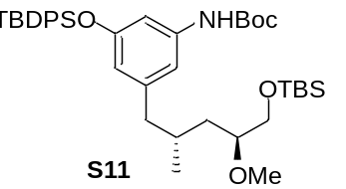Alcohol S10 (4.40 g, 6.49 mmol, 1.0 eq.) was dissolved in CH2Cl2 (120 mL) under argon atmosphere and 1,8-bis(dimethylamino)-naphthalene (4.87 g, 22.7 mmol, 3.5 eq.) and Me3OBF4 (3.08 g, 16.2 mmol, 2.5 eq.) were added. After 1 h, the reaction was terminated by addition of water. The phases were separated and the aqueous phase was extracted three times with CH2Cl2. The combined organic extracts were washed with brine, dried over MgSO4 and concentrated under reduced pressure. The crude product was purified by flash chromatography (PE:EA= 15:1 → 4:1) to give the methylated alcohol S11 (3.98 g, 5.76 mmol, 89%) as a colorless foam; Rf = 0.5 (PE:EtOAc = 4:1). ¹H-NMR (400 MHz, CDCl3, CHCl3 = 7.26 ppm) δ 7.72-7.69 (m, 4H, SiPh), 7.43-7.33 (m, 6H, SiPh), 6.75 (s, 1H, Ph), 6.67 (m, 1H, Ph), 6.24 (bs, 1H, NH), 6.15 (m, 1H, Ph), 3.58 (dd, J = 10.5, 5.8 Hz, 1H, 1-Ha), 3.46 (dd, J = 10.5, 4.6 Hz, 1H, 1-Hb), 3.36 (s, 3H, OMe), 3.25-3.19 (m, 1H, 2-H), 2.42 (dd, J = 13.2, 5.5 Hz, 1H, 5-Ha), 2.06 (dd, J = 13.2, 9.0 Hz, 1H, 5-Hb), 1.75-1.66 (m, 1H, 4-H), 1.48 (s, 9H, t-Bu), 1.38-1.31 (m, 1H, 3-Ha), 1.08 (s, 9H, Sit-Bu), 0.98-0.93 (m, 1H, 3-Hb), 0.89 (s, 9H, Sit-Bu), 0.62 (d, J = 6.5 Hz, 3H, 5-Me), 0.05 (s, 6H, SiMe) ppm; ¹³C-NMR (100 MHz, CDCl3, CDCl3 = 77.16 ppm) δ 155.9 (s, C-Ar), 152.6 (s, NHCOO), 143.1 (s,C-Ar), 139.0 (s, C-Ar), 135.7 (d, C-Ar), 133.1 (s, C-Ar), 129.9 (d, C-Ar), 127.8 (d, C-Ar), 115.6 (d, C-Ar), 112.3 (d, C-Ar), 107.6 (d, C-Ar), 80.4 (s, t-Bu), 80.0 (d, C-2), 66.1 (t, C-1), 58.2 (q, OMe), 44.4 (t, C-5), 39.2 (t, C-3), 31.2 (d, C-4), 28.5 (q, t-Bu), 26.6 (q, Sit-Bu), 26.1 (q, Sit-Bu) 19.6 (s, Sit-Bu), 19.0 (q, 5-Me), 18.4 (s, Sit-Bu), -5.2 (q, SiMe) ppm; [α]²⁰D = -7.4° (c = 1.0, CHCl3).

(4R, 2S)-5-[3-(tert-Butoxycarbonylamino)-5-(tert-butyldiphenylsiloxy)-phenyl]-4-methyl-2-methoxypentane (18)
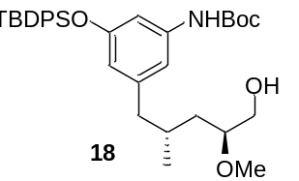Alcohol S11 (3.98 g, 5.76 mmol, 1.0 eq.) was dissolved in CH2Cl2 (40 mL) under argon atmosphere and acetonitrile (40 mL) and LiBF4 (1.62 g, 17.3 mmol, 3.0 eq.) were added. After 48 h, the reaction was terminated by addition of waterThe phases were separated and the aqueous phase was extracted three times with CH2Cl2. The combined organic extracts were washed with brine, dried over MgSO4 and concentrated under reduced pressure. The crude product was purified by flash chromatography (PE:EA= 10:1 → 2:1) followed by preparative HPLC (C18-P) (H2O:MeOH = 80:20 {5 min}, gradient H2O:MeOH = 80:20 → 0:100 {85 min}, H2O:MeOH = 0:100 {10 min}, 15 mL/min) (tR = 85. 0 min) was purified and the methylated alcohol 18 (2.50 g, 4.32 mmol, 75%) was obtained as a colorless foam; Rf = 0.3 (PE:EA= 2:1).
¹H-NMR (400 MHz, CDCl3, CHCl3 = 7.26 ppm) δ 7.71-7.69 (m, 4H, SiPh), 7.41-7.34 (m, 6H, SiPh), 6.77 (s, 1H, Ph), 6.66 (m, 1H, Ph), 6.26 (bs, 1H, NH), 6.11 (m, 1H, Ph), 3.61-3.58 (m, 1H, 1-Ha), 3.40-3.35 (m, 1H, 1-Hb), 3.30 (s, 3H, OMe), 3.28-3.22 (m, 1H, 2-H), 2.38 (dd, J = 13.2, 5.8 Hz, 1H, 5-Ha), 2.07 (dd, J = 13.2, 8.7 Hz, 1H, 5-Hb), 1.85 (br. s, 1H, 1-OH), 1.66-1.59 (m, 1H, 4-H), 1.48 (s, 9H, t-Bu), 1.50-1.46 (m, 1H, 3-Ha), 1.07 (s, 9H, Sit-Bu), 1.10-1.05 (m, 1H, 3-Hb), 0.69 (d, J = 6.8 Hz, 3H, 5-Me) ppm; ¹³C-NMR (100 MHz, CDCl3, CDCl3 = 77.16 ppm) δ 155.9 (s, C-Ar), 152.7 (s, NHCOO), 142.6 (s, C-Ar), 139.0 (s, C-Ar), 135.6 (d, C-Ar), 133.0 (s, C-Ar), 129.9 (d, C-Ar), 127.8 (d, C-Ar), 115.5 (d, C-Ar), 112.3 (d, C-Ar), 107.9 (d, C-Ar), 80.5 (s, t-Bu), 79.6 (d, C-2), 64.3 (t, C-1), 57.0 (q, OMe), 44.0 (t, C-5), 37.9 (t, C-3), 31.4 (d, C-4), 28.4 (q, t-Bu), 26.6 (q, Sit-Bu), 19.5 (s, Sit-Bu), 19.5 (q, 5-Me) ppm; HRMS (ESI) m/z for C37H48NO5Si [M+H]⁺: calculated: 578.3454, found: 578.3467; [α]²⁰D = +6.1° (c = 1.0, CH2Cl2).

(4R, 2S)-5-[3-(tert-Butoxycarbonylamino)-5-(tert-butyldiphenylsiloxy)-phenyl]-4-methyl-2-methoxy-1-pentanal (S12)

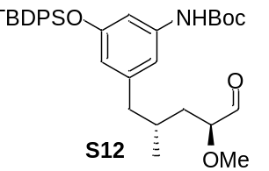Alcohol 18 (0.15 g, 0.25 mmol, 1.0 eq.) was dissolved in CH₂Cl₂ (20 mL), cooled to 0 °C, and NaHCO₃ (0.03 g, 0.30 mmol, 1.2 eq.) and the Dess-Martin periodinane reagent (0.13 g, 0.30 mmol, 1.2 eq.) were added. After 1 h at room temperature, the reaction was terminated by addition of an aqueous Na₂SO₃ solution. The phases were separated and the aqueous phase was extracted three times with CH₂Cl₂. The combined organic phases were washed with aqueous NaCl solution, dried over MgSO₄, concentrated under reduced pressure, and aldehyde S12 (0.15 g, 0.25 mmol, 99%) was obtained as a colorless foam; Rf = 0.8 (PE:EA= 2:1). The aldehyde S12 was directly reused without characterization.

(3S, 4R, 5S, 7R)-8-[3-tert-Butoxycarbonylamino-5-(tert-butyldiphenylsiloxy)-phenyl]-4-hydroxy-5-methoxy-3,7-dimethyl-oct-2-ene (19)
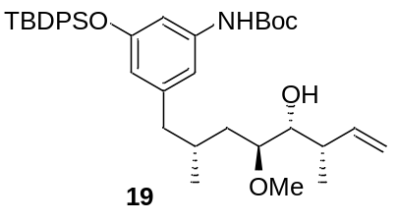Z-Crotylboronate 21 (0.18 g, 0.61 mmol, 2.5 eq.) was dissolved in toluene (2.0 mL) under argon atmosphere. Molecular sieves 4Å (0.10 g) was then added, the reaction mixture was stirred at room temperature for 20 min, and then cooled to -78 °C. Aldehyde S12 (0.14 g, 0.24 mmol, 1.0 eq.) was dissolved in toluene (1.0 mL) and slowly added to the reaction mixture. After 20 h, the reaction was terminated by addition of an aqueous NaOH solution (1.0 M). The reaction mixture was heated to room temperature and stirred for 1 h at this temperature. The molecular sieves were filtered off over Celite™ and the aqueous phase was extracted three times with Et2O. The combined organic extracts were washed with brine, dried over MgSO4 and concentrated under reduced pressure. The crude product was purified by flash chromatography (PE:EA= 10:1 → 4:1) to afford alkene 19 (0.15 g, 0.24 mmol, 97%) as a colorless foam; Rf = 0.4 (PE:EA= 5:1). ¹H-NMR (400 MHz, CDCl3, CHCl3 = 7.26 ppm) δ 7.72-7.69 (m, 4H, SiPh), 7.42-7.34 (m, 6H, SiPh), 6.77 (s, 1H, Ph), 6.66 (m, 1H, Ph), 6.28 (bs, 1H, NH), 6.16 (m, 1H, Ph), 5.61 (ddd, J = 17.2, 10.2, 8.6 Hz, 1H, 2-H), 5.03 (d, J = 10.2 Hz, 1-Ha), 4.99 (d, J = 3.1 Hz, 1H, 1-Hb), 3.58 (d, J = 8.9 Hz, 1H, 4-H), 3.29 (s, 3H, OMe), 3.21-3.19 (m, 1H, 5-H), 2.42 (dd, J = 13.3, 5.5 Hz, 1H, 8-Ha), 2.26-2.16 (m, 1H, 3-H), 2.09 (br. s, 1H, 4-OH), 2.09-2.03 (m, 1H, 8-Hb), 1.76-1.63 (m, 1H, 7-H), 1.57-1.51 (m, 1H, 6-Ha), 1.48 (s, 9H, t-Bu), 1.13 (d, J = 6.5 Hz, 3H, 3-Me), 1.08 (s, 9H, Sit-Bu), 1.07-1.02 (m, 1H, 6-Hb), 0.58 (d, J = 6.5 Hz, 3H, 7-Me) ppm; ¹³C-NMR (100 MHz, CDCl3, CDCl3 = 77.16 ppm) δ 155.9 (s, C-Ar), 152.7 (s, NHCOO), 143.1 (s, C-Ar), 140.1 (d, C-2), 139.0 (s, C-Ar), 135.6 (d, C-Ar), 133.1 (s, C-Ar), 129.9 (d, C-Ar), 115.6 (t, C-1), 115.3 (d, C-Ar), 112.3 (d, C-Ar), 107.6 (d, C-Ar), 80.5 (s, t-Bu), 80.2 (d, C-5), 73.5 (d, C-4), 57.1 (q, OMe), 44.7 (t, C-8), 40.5 (d, C-3), 34.7 (t, C-6), 30.9 (d, C-7), 28.5 (q, t-Bu), 26.6 (q, Sit-Bu), 19.6 (s, Sit-Bu), 18.5 (q, 7-Me), 17.5 (q, 3-Me) ppm; HRMS (ESI) m/z for C38H53NO5SiNa [M+Na]⁺: calculated: 654.3591, found: 654.3577; [α]²⁰D = -17.8° (c = 1.0, CHCl3).

3.3.2 Synthesis of eastern fragment 24
(S)-5-Oxotetrahydrofuran-2-carboxylic acid (22) (ref. S9]
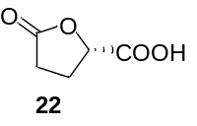L-glutamic acid (19.0 g, 129 mmol, 1.0 eq.) was dissolved in water (140 mL), hydrochloric acid (2 M, 85 mL) was added, and the reaction mixture was cooled to -10 °C. NaNO2 (10.7 g, 155 mmol, 1.2 eq.) was dissolved in water (85 mL) and slowly added to the reaction mixture within 3 h. The reaction mixture was cooled to room temperature and stirred for 12 h. The aqueous phase was extracted three times with ethyl acetate. The combined organic extracts were dried over MgSO4 and concentrated under reduced pressure. The acid 22 (8.57 g, 65.9 mmol, 66%) was obtained as a colorless solid. ¹H-NMR (400 MHz, MeOD-d4, MeOH = 3.31 ppm): δ 5.00 (dd, J = 7.8, 4.9 Hz, 1H, H-4), 2.70-2.55 (m, 2H, H-2), 2.55-2.40 (m, 1H, H-3a), 2.38-2.25 (m, 1H, H-3b) ppm; HRMS (ESI) m/z for C5H5O4 [M-H]⁻: calculated: 129.0188, found: 129.0190; mp= 69 °C; [α]²⁰D = +14.5° (c = 1.0, MeOH); ref. S10: [α]²⁰D = +15.6° (c = 2.0, EtOH).

(S)-5-(Hydroxymethyl)-2-oxotetrahydrofuran (S13)
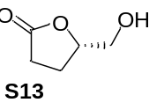Acid 22 (7.50 g, 57.7 mmol, 1.0 eq.) was dissolved in THF (200 mL) under argon atmosphere. The solution was cooled to 0 °C and BH3*SMe2 (8.20 mL, 86.5 mmol, 1.5 eq.) were added. The reaction mixture was warmed to room temperature stirred for 3 h. The reaction was terminated by addition of MeOH and the solvent was removed under reduced pressure to give lactone S13 (6.5 g, 56.0 mmol, 97%) as a colorless oil. ¹H-NMR (400 MHz, MeOD-d4, MeOH = 3.31 ppm): δ 4.72-4.56 (m, 1H, 4-H), 3.91 (dd, J = 1.9, 3.4 Hz, 1H, 5-Ha), 3.66 (dd, J = 11.9, 4.4 Hz, 1H, 5-Hb), 2.68-2.53 (m, 2H, 2-H), 2.35-2.05 (m, 2H, 3-H) ppm; [α]²⁰D = +44.6° (c = 1.0, CHCl3); ref. [S9]: [α]²⁰D = +31.3° (c = 2.92, EtOH).

(S)-5-[(4-Methoxybenzyl)oxymethyl]-2-oxotetrahydrofuran (S14)
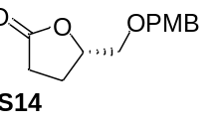Alcohol S13 (1.66 g, 14.28 mmol, 1.0 eq.) was dissolved in CH2Cl2 (50 mL) at room temperature. 4-Methoxybenzyl-2,2,2-trichloroacetimidate (6.05 g, 21.42 mmol, 1.5 eq.) was added, followed by CSA (165.8 mg, 0.71 mmol, 5 mol%). Stirring was continued for 3 days before the reaction was terminated by the addition of a saturated aqueous NaHCO3 solution. The phases were separated and the aqueous phase was extracted with CH2Cl2 (3 x 30 mL). The combined organic phases were dried over MgSO4, filtered and the solvent was removed under reduced pressure. The crude product was purified by flash column chromatography (PE/EtOAc = 6:1 1:1) to furnish protected alcohol S14 (3.09 g, 13.07 mmol, 92%) as an orange oil.
Rf = 0.2 (PE/EtOAc = 2:1); ¹H-NMR (400 MHz, CDCl3, CHCl3 = 7.26 ppm): δ 7.24 (d, J = 8.8 Hz, 2H, PMB), 6.88 (app. d, J = 8.7 Hz, 2H, PMB), 4.68 – 4.62 (m, 1H, H-6), 4.49 (dd, J = 26.6, 3.4 Hz, 2H, PMB), 3.80 (s, 3H, PMB), 3.64 (dd, J = 10.7, 3.5 Hz, 1H, H-7), 3.55 (dd, J = 10.7, 4.2 Hz, 1H, H-7’), 2.61 (ddd, J = 17.7, 10.0, 6.6 Hz, 1H, H-4), 2.47 (ddd, J = 17.7, 9.9, 7.0 Hz, 1H, H-4’), 2.27 (dddd, J = 12.8, 9.9, 7.8, 6.6 Hz, 1H, H-5), 2.11 (dddd, J = 12.8, 10.0, 7.0, 5.9 Hz, 1H, H-5’) ppm; ${[α]}_{D}^{20}$ = +6.9 (c = 1.1, CH2Cl2; ref. [S10] ${[α]}_{D}^{20}$ = +10.6, c = 1.0, CHCl3; HRMS-ESI m/z for C13H16O4Na [M+Na]+ calc. 259.0947, found 259.0944.

(S)-5-[(4-Methoxybenzyl)oxy]pentane-1,4-diol (S15)
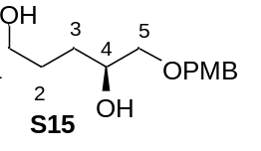PMB-ether S14 (1.72 g, 7.28 mmol, 1.0 eq.) as a solution in THF (20 mL) was slowly added to a suspension of lithium aluminium hydride (0.69 g, 18.21 mmol, 2.5 eq.) in THF (80 mL) at –10 °C. Stirring was continued for 2 h before the reaction was terminated by careful addition of MeOH (20 mL). A saturated aqueous Rochelle’s salt solution and Et2O was added and the mixture was allowed to reach room temperature and stirred vigorously for 5 h. The phases were separated and the aqueous phase was extracted with Et2O (3 x 40 mL). The combined organic phases were washed with brine, dried over MgSO4, filtered and the solvent was removed under reduced pressure. The corresponding diol S15 (1.59 g, 6.63 mmol, 91%) was obtained as a colorless oil and was of sufficient purity to be used without further purification. Rf = 0.3 (100% EtOAc); ¹H-NMR (400 MHz, CDCl3, CHCl3 = 7.26 ppm): δ 7.25 (app. d, J = 8.7 Hz, 2H, PMB), 6.88 (d, J = 8.7 Hz, 2H, PMB), 4.48 (s, 2H, PMB), 3.86 – 3.82 (m, 1H, H-6), 3.81 (s, 3H, PMB), 3.66 (ddd, J = 23.1, 10.8, 5.9 Hz, 2H, H-3), 3.47 (dd, J = 9.4, 3.3 Hz, 1H, H-7), 3.32 (dd, J = 9.4, 8.0 Hz, 1H, H-7’), 2.79 (bs, 1H, OH), 2.36 (bs, 1H, OH), 1.72 – 1.66 (m, 2H, H-4), 1.63 – 1.55 (m, 1H, H-5), 1.54 – 1.44 (m, 1H, H-5’) ppm; ${[α]}_{D}^{23}$ = –7.4 (c = 1.0, EtOH; HRMS-ESI m/z for C13H20O4Na [M+Na]+ calc. 263.1260, found 263.1258.

(S)-5-(tert-Butyldimethylsilyloxy)-1-[(4-methoxybenzyl)oxy]pentane-2-ol (S16)
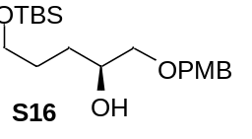Diol S15 (0.85 g, 3.54 mmol, 1.0 eq.) was dissolved in CH2Cl2 (25 mL) under argon atmosphere, cooled to 0 °C, and mixed with imidazole (0.48 g, 7.08 mmol, 2.0 eq.) followed by TBSCl (0.59 g, 3.90 mmol, 1.1 eq.). The reaction mixture was heated to room temperature and stirred for 1 h. The reaction was terminated by addition of an aqueous NH4Cl solution. The phases were separated and the aqueous phase was extracted three times with CH2Cl2. The combined organic extracts were washed with brine, dried over MgSO4 and concentrated under reduced pressure. The crude product was purified by flash chromatography (PE:EA= 5:1 → 2:1) to give the protected alcohol S16 (1.25 g, 3.53 mmol, 99%) as a colorless oil; Rf = 0.7 (PE:EA= 1:1). ¹H-NMR (400 MHz, CDCl3, CHCl3 = 7.26 ppm) δ 7.30 (d, J = 8.4 Hz, 2H, PMB), 6.92 (d, J = 8.4 Hz, 2H, PMB), 4.53 (s, 2H, PMB), 3.90-3.81 (m, 1H, 4-H), 3.85 (s, 3H, PMB), 3.73-3.63 (m, 2H, 1-H), 3.51 (dd, J = 9.3, 3.7 Hz, 1H, 5-Ha), 3.38 (dd, J = 9.3, 7.4 Hz, 5-Hb), 2.86 (br. s, 1H, 4-OH), 1.75-1.50 (m, 2H, 2-H), 1.75-1.50 (m, 2H, 3-H), 0.93 (s, 9H, Sit-Bu), 0.09 (s, 6H, SiMe) ppm; ¹³C-NMR (100 MHz, CDCl3, CDCl3 = 77.16 ppm) δ 159.6 (s, PMB), 129.7 (d, PMB), 114.2 (d, PMB), 74.6 (d, C-4), 73.3 (t, PMB), 70.6 (t, C-5), 63.6 (t, C-1), 55.6 (q, PMB), 30.6 (t, C-2), 29.3 (t, C-3), 26.3 (q, Sit-Bu), 18.5 (s, Sit-Bu), -5.00 (q, SiMe) ppm; HRMS (ESI) m/z for C19H35O4Si [M+H]⁺: calculated: 355.2305, found: 355.2305; [α]²⁰D = -2.3° (c = 1.0, CHCl3). HRMS-ESI m/z for C20H36O4SiNa [M+Na]+ calc. 391.2281, found 391.2285.

(S)-5-(tert-Butyldimethylsilyloxy)-1-[(4-methoxybenzyl)oxy]-4-(methoxy)pentane (S17)
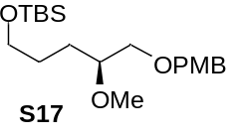 | Alcohol S16 (1.20 g, 3.39 mmol, 1.0 eq.) was dissolved in Et2O (20 mL) under argon atmosphere, cooled to 0 °C, and NaH (60% suspension in mineral oil) (0.20 g, 5.08 mmol, 1.5 eq.) was added followed by MeI (0.21 mL, 0.53 mmol, 1.1 eq.).
The reaction mixture was warmed up to room temperature and stirred for 72 h. The reaction was terminated by addition of water. The phases were separated and the aqueous phase was extracted three times with ethyl acetate. The combined organic extracts were washed with brine, dried over MgSO4 and concentrated under reduced pressure. The crude product was purified by flash chromatography (PE:EA= 5:1 → 2:1) to give the protected alcohol S17 (1.09 g, 2.96 mmol, 88%) as a colorless oil; Rf = 0.5 (PE:EA= 2:1). ¹H-NMR (400 MHz, CDCl3, CHCl3 = 7.26 ppm) δ 7.24 (d, J = 8.5 Hz, 2H, PMB), 6.87 (d, J = 8.5 Hz, 2H, PMB), 4.48 (s, 2H, PMB), 3.80 (s, 3H, PMB), 3.63-3.57 (m, 2H, 1-H), 3.45 (d, J = 4.8 Hz, 2H, 5-H), 3.04 (s, 3H, OMe), 3.38-3.34 (m, 1H, 4-H), 1.61-1.48 (m, 2H, 2-H), 1.61-1.48 (m, 2H, 3-H), 0.89 (s, 9H, Sit-Bu), 0.04 (s, 6H, SiMe) ppm; ¹³C-NMR (100 MHz, CDCl3, CDCl3 = 77.16 ppm) δ 159.5 (s, PMB), 130.8 (s, PMB), 129.6 (d, PMB), 114.1 (d, PMB), 80.3 (d, C-4), 73.3 (t, PMB), 72.1 (t, C-5), 63.5 (t, C-1), 57.8 (q, OMe), 55.6 (q, PMB), 29.0 (t, C-2), 28.1 (t, C-3), 26.3 (q, Sit-Bu), 18.7 (s, Sit-Bu), -4.9 (q, SiMe) ppm; HRMS (ESI) m/z for C20H36O4SiNa [M+Na]⁺: calculated: 391.2281, found: 391.2290; [α]²⁰D = -6.0° (c = 1.0, CHCl3)

(S)-5-(tert-Butyldimethylsilyloxy)-4-methoxypentane-1-ol (S18)
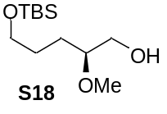 | Alcohol S17 (1.05 g, 2.85 mmol, 1.0 eq.) was dissolved in CH2Cl2 (80 mL), cooled to 0 °C, and phosphate buffer (pH 7, 8 mL) and DDQ (0.78 g, 3.42 mmol, 1.2 eq.) were added.
The reaction mixture was warmed to room temperature and stirred for 1.5 h. The reaction was terminated by addition of an aqueous bicarbonate solution. The phases were separated and the aqueous phase was extracted three times with CH2Cl2. The combined organic extracts were washed with brine, dried over MgSO4 and concentrated under reduced pressure. The crude product was purified by flash chromatography (PE:EA= 5:1 → 2:1) to afford the deprotected alcohol S18 (0.65 g, 2.62 mmol, 92%) as a colorless oil; Rf = 0.4 (PE:EA= 2:1). ¹H-NMR (400 MHz, CDCl3, CHCl3 = 7.26 ppm) δ 3.71-3.65 (m, 1H, 5-Ha), 3.63-3.60 (m, 2H, 1-H), 3.52-3.47 (m, 1H, 5-Ha), 3.04 (s, 3H, OMe), 3.32-3.27 (m, 1H, 4-H), 1.98-1.95 (m, 1H, OH), 1.65-1.47 (m, 2H, 3-H), 1.65-1.47 (m, 2H, 2-H), 0.89 (s, 9H, Sit-Bu), 0.05 (s, 6H, SiMe) ppm; ¹³C-NMR (100 MHz, CDCl3, CDCl3 = 77.16 ppm) δ 81.5 (d, C-4), 64.1 (t, C-5), 63.2 (t, C-1), 57.2 (q, OMe), 28.6 (t, C-2), 26.7 (t, C-3), 26.1 (q, Sit-Bu), 18.5 (s, Sit-Bu), -5.2 (q, SiMe) ppm; HRMS (ESI) m/z for C12H28O3SiNa [M+Na]⁺: calculated: 271.1705, found: 271.1704; [α]²⁰D = +20.0° (c = 1.0, CHCl3).

(S)-5-(tert-Butyldimethylsilyloxy)-4-methoxypentan-1-al (23)
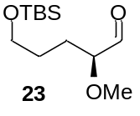 | Alcohol S30 (0.10 g, 0.40 mmol, 1.0 eq.) was dissolved in CH2Cl2 (30 mL), cooled to 0 °C, and NaHCO3 (0.04 g, 0.48 mmol, 1.2 eq.) was added followed by the Dess-Martin periodinane reagent (0.21 g, 0.48 mmol, 1.2 eq.).
The reaction mixture was heated to room temperature and stirred for 1 h. The reaction was terminated by addition of an aqueous Na2SO3 solution. The phases were separated and the aqueous phase was extracted three times with CH2Cl2. The combined organic phases were washed with brine, dried over MgSO4 and concentrated under reduced pressure. Aldehyde S23 (0.10 g, 0.39 mmol, 99%) was obtained as a colorless foam; Rf = 0.7 (PE:EtOAc = 2:1). The aldehyde 23 was used directly without further characterization.

(3S,4R)-7-(tert-Butyldimethylsilyloxy)-4-methoxyhept-1-en-3-ol (24)
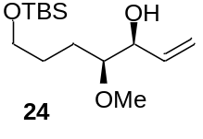 | Aldehyde 23 (0.05 g, 0.20 mmol, 1.0 eq.) was dissolved in CH2Cl2 (3.0 mL) under an argon atmosphere, cooled to 0 °C, and MgBr2*Et2O (0.13 g, 0.49 mmol, 2.4 eq.) was added.
The reaction mixture was stirred at 0 °C for 30 min, then cooled to 78 °C and vinyl magnesium bromide (0.72 mL, 0.51 mmol, 2.5 eq.) (0.7 M solution in THF) was added slowly. After 3 h, the reaction was terminated by addition of an aqueous NH4Cl solution. The phases were separated and the aqueous phase was extracted three times with CH2Cl2. The combined organic extracts were washed with brine solution, dried over MgSO4 and concentrated under reduced pressure. The crude product was purified by flash chromatography (PE:EA= 5:1 → 2:1) to give alkene 24 (0.03 g, 0.10 mmol, 61%, from S30, syn:anti d.r. = 3:1) as a colorless oil; Rf = 0.5 (PE:EA= 2:1). ¹H-NMR (400 MHz, CDCl3, CHCl3 = 7.26 ppm) δ 5.89-5.80 (m, 1H, 6-H), 5.35 (d, J = 17.1 Hz, 1H, 7-Ha), 5.21 (d, J = 10.2 Hz, 1H, 7-Hb), 4.05-4.00 (m, 1H, 5-H), 3.63-3.57 (m, 2H, 1-H), 3.42 (s, 3H, OMe), 3.14-3.10 (m, 1H, 4-H), 2.55 (s, 1H, 5-OH), 1.70-1.48 (m, 2H, 3-H), 1.70-1.48 (m, 2H, 2-H), 0.89 (s, 9H, Sit-Bu), 0.04 (s, 6H, SiMe) ppm; ¹³C-NMR (100 MHz, CDCl3, CDCl3 = 77.16 ppm) δ 137.5 (d, C-6), 117.2 (t, C-7), 83.9 (d, C-4), 74.5 (t, C-5), 63.2 (t, C-1), 58.1 (q, OMe), 28.2 (t, C-2), 26.2 (t, C-3), 26.1 (q, Sit-Bu), 18.5 (s, Sit-Bu), -5.2 (q, SiMe; HRMS (ESI) m/z for C12H28O3SiNa [M+Na]⁺: calculated: 271.1705, found: 271.1704.
To verify the absolute configuration at C-5, the secondary alcohol was converted to the corresponding Mosher esters S19a and S19b,[S11] respectively, and analyzed by NMR spectroscopy.
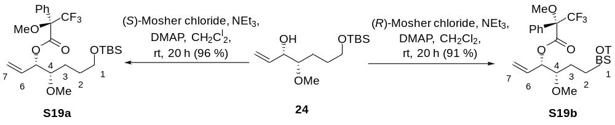
Table S3: Analysis of ¹H NMR specra of Mosher esters S19a and S19b.
signal | δ (R)-Mosher ester [ppm] | δ (S)-Mosher ester [ppm] | δ S - δ R
H-6 | 5.84 | 5.74 | -0.10
H-7a | 5.43 | 5.32 | -0.11
H-7b | 5.34 | 5.28 | -0.06
H-4 | 3.27 | 3.34 | 0.07
OMe | 3.24 | 3.38 | 0.14

3.3.3 End game synthesis towards seco acid derivative 28

Olefine metathesis product 25
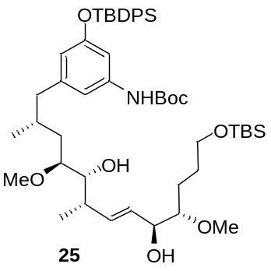 | Alkene 19 (50.0 mg, 0.08 mmol, 1.0 eq.) was dissolved in (CH2Cl)2 (3.0 mL) under argon atmosphere, alkene 24 (40.0 mg, 0.13 mmol, 1.7 eq.) and Grubbs-Hoveyda II catalyst (4.90 mg, 8.00 µmol, 0.1 eq.) were added, and the reaction mixture was heated to 40 °C. After 10 h each, a further amount of Grubbs-Hoyveda II catalyst (4.90 mg, 8.00 µmol, 0.1 eq.) was added in portions. After 48 h, the reaction mixture was cooled to room temperature and the solvent was removed under reduced pressure.
The crude product was purified by flash chromatography (PE:EA= 10:1 → 2:1) followed by preparative HPLC (C18-P) (H2O:MeOH = 80:20 {5 min}, gradient H2O:MeOH = 80:20 → 0:100 {85 min}, H2O:MeOH = 0:100 {10 min}, 15 mL/min) (tr = 83. 0 min) was purified and alcohol 25 (27.0 mg, 30.7 µmol, 39%, 5S:5R d.r. = 6:1) was obtained as a colorless oil; Rf = 0.1 (PE:EA= 2:3). ¹H-NMR (400 MHz, CDCl3, CHCl3 = 7.26 ppm): δ 7.73-7.67 (m, 4H, SiPh), 7.42-7.33 (m, 6H, SiPh), 6.77 (s, 1H, Ph), 6.65 (s, 1H, Ph), 6.29 (s, 1H, NH), 6.16 (s, 1H, Ph), 5.60 (dd, J = 15.7, 8.3 Hz, 7-H), 5.48 (dd, J = 15.7, 5.6 Hz, 1H, 6-H), 4.01-3.95 (m, 1H, 5H), 3.63-3.55 (m, 1H, 9-H), 3.63-3.55 (m, 2H, 1-H), 3.41 (s, 3H, 4-OMe), 3.29 (s, 3H, 10-OMe), 3.23-3.15 (m, 1H, 4-H), 3.11-3.06 (m, 1H, 10-H), 2.54 (s, 1H, OH), 2.41 (dd, 1H, J = 13.4, 5.6 Hz, 13-Ha), 2.28-2.20 (m, 1H, 8H), 2.10-2.02 (m, 1H, 13-Hb), 1.80-1.71 (m, 1H, 12-H), 1.78-1.60 (m, 2H, 2-H), 1.78-1.60 (m, 2H, 3-H), 1.78-1.60 (m, 1H, 11-Ha), 1.48 (s, 9H, t-Bu), 1.12 (d, J = 6.6 Hz, 3H, 8-Me), 1.08 (s, 9H, Sit-Bu), 1.02-0.96 (m, 1H, 11-Hb), 0.89 (s, 9H, Sit-Bu), 0.59 (d, J = 6.5 Hz, 3H, 12-Me), 0.05 (s, 6H, SiMe) ppm; ¹³C-NMR (100 MHz, CDCl3, CDCl3 = 77.16 ppm) δ 155.9 (s, C-Ar), 152.7 (s, NHCOO), 143.1 (s, C-Ar), 139.0 (d, C-Ar), 135.6 (s, C-Ar), 134.4 (d, C-7), 133.1 (s, C-Ar), 130.0 (s, C-Ar), 129.9 (d, C-6), 127.9 (s, C-Ar), 115.6 (d, C-Ar), 112.3 (d, C-Ar), 107.6 (d, C-Ar), 84.0 (d, C-4), 80.1 (d, C-10), 73.7 (d, C-9), 73.6 (d, C-5), 63.3 (t, C-1), 58.2 (q, 4-OMe), 57.2 (q, 10-OMe), 44.7 (t, C-13), 38.8 (d, C-8), 35.1 (t, C-11), 30.9 (d, C-12), 28.5 (t, C-2), 28.3 (q, t-Bu), 26.6 (q, Sit-Bu), 26.2 (q, Sit-Bu), 26.1 (t, C-3), 19.6 (s, Sit-Bu), 18.8 (q, 12-Me), 18.5 (s, Sit-Bu), 17.4 (q, 8-Me), -5.1 (q, SiMe) ppm; HRMS (ESI) m/z for C50H79NO8Si2Na [M+Na]⁺: calculated: 900.5242, found: 900.5239.

Diol S20
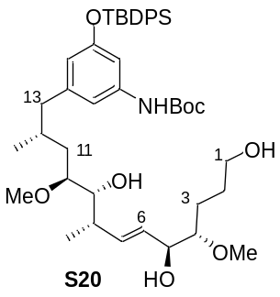 | Alcohol 25 (15.0 mg, 17.1 μmol, 1.0 eq.) was dissolved in CH2Cl2 (3.0 mL) under argon atmosphere, cooled to 0 °C, and added MeOH (2.0 mL) and CSA (2.00 mg, 5.10 μmol, 0.3 eq.). After 4 h, the reaction was terminated by addition of an aqueous bicarbonate solution. The phases were separated and the aqueous phase was extracted three times with CH2Cl2. The combined organic extracts were washed with brine, dried over MgSO4 and concentrated under reduced pressure.
The crude product was purified by flash chromatography (PE:EA= 5:1 → 1:1) to afford alcohol S20 (12.0 mg, 15.7 μmol, 92%) as a colorless oil; Rf = 0.1 (PE:EA= 2:3). ¹H-NMR (400 MHz, CDCl3, CHCl3 = 7.26 ppm): δ 7.73-7.67 (m, 4H, SiPh), 7.43-7.32 (m, 6H, SiPh), 6.82 (s, 1H, NH), 6.59 (s, 1H, Ph), 6.35 (s, 1H, Ph), 6.16 (s, 1H, Ph), 5.61 (dd, J = 15.8, 7.8 Hz, 1H, 7-H), 5.45 (dd, J = 15.8, 6.0 Hz, 6-H), 4.04-3.97 (m, 1H, 5-H), 3.68-3.61 (m, 2H, 1-H), 3.57 (dd, 1H, J = 7.9, 3.5 Hz, 9-H), 3.43 (s, 3H, 4-OMe), 3.29 (s, 3H, 10-OMe), 3.22-3.15 (m, 1H, 10-H), 3.13-3.08 (m, 1H, 4-H), 2.52 (s, 1H, OH), 2.43 (dd, J = 13.0, 5.8 Hz, 1H, 13-Ha), 2.30-2.20 (m, 1H, 8H), 2.07 (dd, 1H, J = 13.1, 8.8 Hz, 13-Hb), 1.80-1.58 (m, 1H, 12-H), 1.80-1.58 (m, 2H, 2-H), 1.80-1.58 (m, 2H, 3-H), 1.69-1.55 (m, 1H, 11-Ha), 1.47 (s, 9H, t-Bu), 1.30-1.20 (m, 1H, 11-Hb), 1.11 (d, J = 6.6 Hz, 3H, 8-Me), 1.08 (s, 9H, Sit-Bu), 0.60 (d, J = 6.4 Hz, 3H, 12-Me) ppm; ¹³C-NMR (100 MHz, CDCl3, CDCl3 = 77.16 ppm) δ 155.9 (s, C-Ar), 152.7 (s, NHCOO), 143.1 (s, C-Ar), 139.0 (d, C-Ar), 135.7 (s, C-Ar), 135.6 (d, C-7), 133.1 (d, C-Ar), 129.9 (s, C-Ar), 129.6 (d, C-6), 129.0 (s, C-Ar), 127.9 (s, C-Ar), 115.7 (d, C-19), 112.3 (d, C-15), 107.6 (d, C-17), 84.1 (d, C-4), 80.2 (d, C-10), 79.8 (s, t-Bu), 73.9 (d, C-5), 73.8 (d, C-9), 62.9 (t, C-1), 58.3 (q, 4-OMe), 57.1 (q, 10-OMe), 44.6 (t, C-13), 39.0 (d, C-8), 35.0 (t, C-11), 31.0 (d, C-12), 28.5 (q, t-Bu), 28.0 ( t, C-3), 26.6 (q, Sit-Bu), 26.5 (t, C-2), 19.6 (q, 12-Me), 18.8 (s, Sit-Bu), 17.3 (q, 8-Me) ppm; HRMS (ESI) m/z for C44H65NO8SiNa [M+Na]⁺: calculated: 786.4377, found: 786.4372.

Per-O-silylated polyol S21
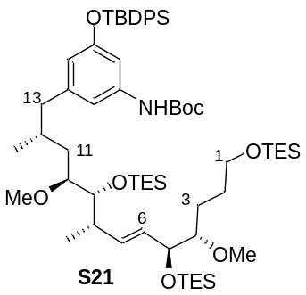 | Alcohol S20 (30.0 mg, 39.0 μmol, 1.0 eq.) was dissolved in CH2Cl2 (15 mL) under argon atmosphere, cooled to 0 °C, and mixed with 2,6-lutidine (23.0 μL, 195 μmol, 5.0 eq.) followed by TESOTf (30.0 μL, 137 μmol, 3.5 eq.). The reaction mixture was warmed up to room temperature and stirred for an additional 3 h. The reaction was terminated by addition of an aqueous NH4Cl solution. The phases were separated and the aqueous phase was extracted three times with CH2Cl2.
The combined organic extracts were washed with brine, dried over MgSO4 and concentrated under reduced pressure. The crude product was purified by flash chromatography (PE:EA= 100:1 → 20:1) to afford the protected alcohol S21 (35.0 mg, 31.6 μmol, 81%) as a colorless oil; Rf = 0.5 (PE:EA= 10:1). ¹H-NMR (400 MHz, C6D6, C6D5H = 7.16 ppm): δ 7.89-7.83 (m, 4H, SiPh), 7.27 (s, 1H, Ph), 7.23-7.19 (m, 6H, SiPh), 6.59 (s, 1H, Ph), 6.48 (s, 1H, Ph), 5.89 (s, 1H, NH), 5.66 (dd, 1H, J = 15.5, 6.3 Hz, 7-H), 5.56 (dd, 1H, J = 15.5, 8.6 Hz, 6-H), 4.38-4.34 (m, 1H, 5-H), 3.73-3.63 (m, 1H, 9-H), 3.73-3.63 (m, 2H, 1-H), 3.31 (s, 3H, 4-OMe), 3.35-3.30 (m, 1H, 10-H), 3.25 (s, 3H, 10-OMe), 3.22-3.17 (m, 1H, H-4), 2.46 (dd, J = 13.0, 5.7 Hz, 1H, 13-Ha), 2.36-2.27 (m, 1H, 8-H), 2.12 (dd, 1H, J =13.0, 9.0 Hz, 13-Hb), 2.05-1.95 (m, 1H, 12-H), 1.93-1.84 (m, 1H, 2-Ha), 1.93-1.84 (m, 1H, 11-Ha), 1.79-1.68 (m, 1H, 3-Ha), 1.79-1.68 (m, 1H, 2-Hb), 1.64-1.50 (m, 1H, 3-Hb), 1.39 (s, 9H, t-Bu), 1.25 (d, J = 6.7 Hz, 3H, 8-Me), 1.20 (s, 9H, Sit-Bu), 1.15-1.05 (m, 1H, 11-Hb), 1.12-1.03 (m, 27H, SiCH2CH3), 0.79-0.60 (m, 18H, SiCH2CH3), 0.79-0.60 (m, 3H, 12-Me) ppm; ¹³C-NMR (100 MHz, C6D6, C6D6 = 128.06 ppm) δ 156.4 (s, C-Ar), 152.3 (s, NHCOO), 143.5 (s, C-Ar), 140.1 (d, C-Ar), 136.0 (s, C-Ar), 134.7 (d, C-7), 133.7 (d, C-Ar), 130.2 (d, C-6), 130.1 (s, C-Ar), 115.7 (d, C-Ar), 112.4 (d, C-Ar), 107.9 (d, C-Ar), 85.4 (d, C-4), 81.4 (d, C-10), 79.5 (s, t-Bu), 76.5 (d, C-9), 74.1 (d, C-5), 63.4 (t, C-1), 58.3 (q, 4-OMe), 57.2 (q, 10-OMe), 45.2 (t, C-13), 41.2 (d, C-8), 35.9 (t, C-11), 31.6 (d, C-12), 30.2 (t, C-2), 28.3 (q, t-Bu), 26.8 (q, Sit-Bu), 26.6 (t, C-3), 19.8 (s, Sit-Bu), 19.3 (q, 12-Me), 18.8 (q, 8-Me), 7.5 (q, SiCH2CH3), 7.3 (q, SiCH2CH3), 7.2 (q, SiCH2CH3), 5.7 (t, SiCH2CH3), 5.5 (t, SiCH2CH3), 4.9 (t, SiCH2CH3) ppm; HRMS (ESI): The recording of high-resolution mass spectrometry could not be successfully performed for this molecule.

Aldehyde S22
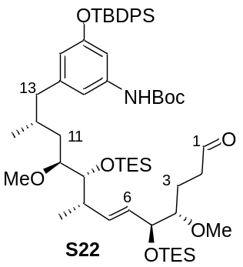 | DMSO (3.9 μL, 54 μmol, 3.0 eq.) was dissolved in CH2Cl2 (4.0 mL) under argon atmosphere, cooled to -78 °C, and oxalyl chloride (3.1 μL, 36 μmol, 2.0 eq.) was added. After 10 min, alcohol S21(20 mg, 18 μmol, 1.0 eq.) was dissolved in CH2Cl2 (0.6 mL) and added to the reaction mixture. After another 10 min, the reaction mixture was heated to 60 °C and stirred for 1.5 h. The reaction mixture was allowed to cool.
The reaction mixture was then cooled back to -78 °C, to which DIPEA (21 μL, 126 μmol, 7.0 eq.) was added and warmed up to room temperature. The reaction was terminated by addition of phosphate buffer (pH 7). The aqueous phase was extracted three times with CH2Cl2. The combined organic phases were washed brine, dried over MgSO4 and concentrated under reduced pressure (91 % crude). The crude product was purified by flash chromatography (PE:EA= 50:1 → 10:1) to give aldehyde S22 (13 mg, 13 μmol, 73%) as a colorless oil; Rf = 0.4 (PE:EA= 9:1). ¹H-NMR (400 MHz, C6D6, C6D5H = 7.16 ppm): δ 9.44 (s, 1H, 1-H), 7.90-7.81 (m, 4H, SiPh), 7.24 (s, 1H, Ph), 7.22-7.19 (m, 6H, SiPh), 6.65 (s, 1H, Ph), 6.48 (s, 1H, Ph), 5.94 (s, 1H, NH), 5.51-5.46 (m, 1H, 7-H), 5.51-5.46 (m, 1H, 6-H), 4.25-4.20 (m, 1H, 5-H), 3.67 (d, J = 9.2 Hz, 1H, 9-H), 3.29-3.25 (m, 1H, 10-H), 3.23 (s, 3H, 4-OMe), 3.20 (s, 3H, 10-OMe), 3.07-3.00 (m, 1H, H-4), 2.49 (dd, J = 13.2, 5.6 Hz, 1H, 13-Ha), 2.34-2.23 (m, 1H, 8-H), 2.21-2.06 (m, 2H, 2-H), 2.21-2.06 (m, 1H, H-13b), 2.06-1.93 (m, 1H, 12-H), 1.93-1.78 (m, 1H, 3-Ha), 1.93-1.78 (m, 1H, 11-Ha), 1.66-1.52 (m, 1H, 3-Hb), 1.39 (s, 9H, t-Bu), 1.22 (d, J = 6.7 Hz, 3H, 8-Me), 1.19-1.12 (m, 1H, 11-Hb), 1.19 (s, 9H, Sit-Bu), 1.12-1.04 (m, 18H, SiCH2CH3), 0.79-0.64 (m, 12H, SiCH2CH3), 0.79-0.71 (m, 3H, 12-Me) ppm; ¹³C-NMR (100 MHz, C6D6, C6D6 = 128.06 ppm) δ 200.6 (t, C-1), 156.4 (s, C-Ar), 152.3 (s, NHCOO), 143.4 (s, C-Ar), 140.1 (d, C-Ar), 136.0 (s, C-Ar), 135.3 (d, C-7), 133.6 (d, C-Ar), 130.1 (s, C-Ar), 129.8 (d, C-6), 115.7 (d, C-Ar), 112.4 (d, C-Ar), 107.9 (d, C-Ar), 84.3 (d, C-4), 81.4 (d, C-10), 79.6 (s, t-Bu), 76.4 (d, C-9), 74.4 (d, C-5), 58.4 (q, 4-OMe), 57.2 (q, 10-OMe), 45.1 (t, C-13), 41.3 (d, C-8), 40.8 (t, C-2), 35.9 (t, C-11), 31.6 (d, C-12), 28.3 (q, t-Bu), 26.8 (q, Sit-Bu), 23.3 (t, C-3), 19.8 (s, Sit-Bu), 19.3 (q, 12-Me), 18.8 (q, 8-Me), 7.5 (q, SiCH2CH3), 7.2 (q, SiCH2CH3), 5.7 (t, SiCH2CH3), 5.4 (t, SiCH2CH3) ppm; HRMS (ESI): The recording of high-resolution mass spectrometry could not be successfully performed for this molecule.

Hemiacetal 26
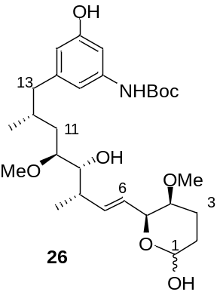Aldehyde S22 (21 mg, 21 μmol, 1.0 eq.) was dissolved in THF (8.0 mL) under argon atmosphere and pyridine (1.0 mL) and HF*Py (700 μL) were added. After 4 days, the reaction was terminated by addition of an aqueous bicarbonate solution. The phases were separated and the aqueous phase was extracted three times with ethyl acetate. The combined organic extracts were washed with brine, dried over MgSO4 and concentrated under reduced pressure.The crude product was analyzed by preparative HPLC (C18 ISIS SP) (H2O:MeOH = 90:10 {5 min}, gradient H2O:MeOH = 90:10 → 0:100 {55 min}, H2O:MeOH = 0:100 {10 min}, 2. 5 mL/min) (tR = 54.6 min) was purified to give lactol 26 (10 mg, 19 μmol, 91%) as a colorless oil; Rf = 0.1 (PE:EA= 1:1). Compound 26 was used directly in the next steps without further purification. HRMS (ESI) m/z for C28H45NO8Na [M+Na]⁺: calculated: 546.3043, found: 546.3045.

N-Boc SNAC-ester 27
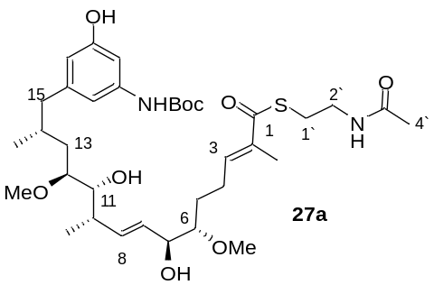Lactol 26 (5.0 mg, 9.6 μmol, 1.0 eq.) was dissolved in CHCl3 (0.2 mL) to which phosphorylide Ph3P=C(CH3)C(O)SCH2CH2NHAc (21 mg, 49 μmol, 5.0 eq.) was added and stirred at room temperature for 5 days. The solvent was removed under reduced pressure and the crude product was purified by flash chromatography (EtOAc). This was followed by preparative HPLC (C18 ISIS SP) (H2O:MeOH = 70:30 {5 min}, gradient H2O:MeOH = 70:30 → 40:60 {45 min}, 40:60 → 15:85 {40 min}, 15:85 → 0:100 {10 min}, 2.5 mL/min) (tR = 50.0 min). The SNAC ester 27a (3.5 mg, 5.1 μmol, 54%) was obtained as a colorless oil; Rf = 0.1 (EtOAc). ¹H-NMR (400 MHz, CDCl3, CHCl3 = 7.26 ppm): δ 6.83 (s, 1H, Ph), 6.72 (t, J = 7.4 Hz, 1H, 3-H), 6.64 (s, 1H, Ph), 6.49 (s, 1H, OH), 6.41 (s, 1H, NH), 6.34 (s, 1H, Ph), 5.92 (s, 1H, NH), 5.62 (dd, J = 15.5, 8.8 Hz, 1H, 9-H), 5.46 (dd, J = 15.5, 6.4 Hz, 8-H), 4.03-3.99 (m, 1H, 7-H), 3.65-3.60 (m, 1H, 11-H), 3.51-3.41 (m, 2H, 2’-H), 3.44 (s, 3H, 6-OMe), 3.33 (s, 3H, 12-OMe), 3.26-3.20 (m, 1H, 12-H), 3.14-3.09 (m, 1H, 6-H), 3.07-3.00 (m, 2H, 1’-H), 2.58 (dd, J = 13.3, 5.5 Hz, 1H, 15-Ha), 2.45 (d, J = 3.8 Hz, 1H, 7-OH), 2.35-2.25 (m, 1H, 10-H), 2.35-2.25 (m, 2H, 4-H), 2.35-2.25 (m, 1H, 15-Hb), 2.14 (d, J = 2.4 Hz, 1H, 11-OH), 1.98 (s, 3H, 4’-H), 1.97-1.90 (m, 1H, 14-H), 1.88 (s, 3H, 2-Me), 1.76-1.59 (m, 1H, 13-Ha), 1.76-1.59 (m, 1H, 5-Ha), 1.76-1.59 (m, 1H, 5-Hb), 1.50 (s, 9H, t-Bu), 1.28-1.17 (m, 1H, 13-Hb), 1.14 (d, J = 6.6 Hz, 3H, 10-Me), 0.81 (d, J = 6.5 Hz, 3H, 14-Me) ppm; ¹³C-NMR (100 MHz, CDCl3, CDCl3 = 77.16 ppm) δ 194.5 (s, C-1), 170.9 (s, C-3’), 156.8 (s, C-Ar), 152.8 (s, NHCOO), 143.4 (s, C-Ar), 141.3 (d, C-3), 139.5 (s, C-Ar), 136.3 (d, C-2), 135.8 (d, C-9), 129.6 (d, C-8), 111.4 (d, C-Ar), 111.2 (d, C-Ar), 103.5 (d, C-Ar), 83.4 (d, C-6), 80.3 (d, C-12), 73.9 (d, C-7), 73.6 (d, C-11), 58.6 (q, 6-OMe), 57.2 (q, 12-OMe), 44.6 (t, C-15), 40.0 (t, C-2’), 39.1 (d, C-10), 34.8 (t, C-13), 31.0 (d, C-14), 28.9 (t, C-1’), 28.5 (q, t-Bu), 28.5 (t, C-5), 24.4 (t, C-4), 23.4 (q, C-4’), 19.3 (q, 14-Me), 17.8 (q, 10-Me), 12.7 (q, 2-Me) ppm; HRMS (ESI) m/z for C35H56N2O9SNa [M+Na]⁺: calculated: 703.3604, found: 703.3610.

SNAC-ester 27b
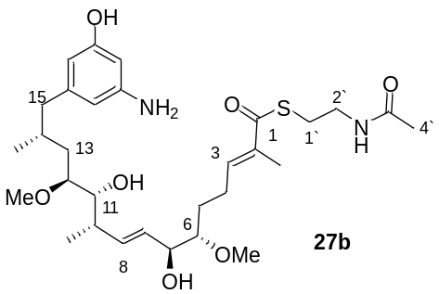 | The SNAC ester 27a (3.0 mg, 4.4 μmol, 1.0 eq.) was dissolved in CH2Cl2 (3.0 mL) under argon atmosphere, cooled to 0 °C, and TFA (350.0 μl) was added. After 3 h, the reaction was terminated by addition of an aqueous bicarbonate solution. The layers were separated and the aqueous phase was extracted three times with ethyl acetate.
The combined organic phases were washed with brine, dried over MgSO4 and concentrated under reduced pressure. The crude product was purified by preparative HPLC (C18 ISIS SP) (H2O:MeOH = 70:30 {5 min}, gradient H2O:MeOH = 70:30 → 40:60 {80 min}, 40:60 → 15:85 {5 min}, 15:85 → 0:100 {10 min}, 2.5 mL/min) (tR = 55.6 min) to give SNAC ester 27b (2.0 mg, 3.4 μmol, 77%) as a colorless oil. ¹H-NMR (400 MHz, CDCl3, CHCl3 = 7.26 ppm): δ 6.75-6.70 (m, 1H, 3-H), 6.23 (s, 1H, OH), 6.07 (s, 1H, Ph), 6.07 (s, 1H, Ph), 6.04 (s, 1H, Ph), 5.89 (s, 1H, NH), 5.62 (dd, J = 15.7, 8.2 Hz, 1H, 9-H), 5.48 (dd, J = 15.7, 6.5 Hz, 8-H), 4.05-4.00 (m, 1H, 7-H), 3.66-3.61 (m, 1H, 11-H), 3.49-3.46 (m, 2H, 2’-H), 3.44 (s, 3H, 6-OMe), 3.34 (s, 3H, 12-OMe), 3.26-3.21 (m, 1H, 12-H), 3.15-3.09 (m, 1H, 6-H), 3.09-3.06 (m, 2H, 1’-H), 2.53 (dd, J = 13.2, 5.8 Hz, 1H, 15-Ha), 2.45 (d, J = 3.8 Hz, 1H, 7-OH), 2.35-2.26 (m, 1H, 10-H), 2.35-2.26 (m, 2H, 4-H), 2.19 (dd, J = 13.2, 8.2 Hz, 1H, 15-Hb), 2.12 (d, J = 2.4 Hz, 1H, 11-OH), 1.97 (s, 3H, 4’-H), 1.98-1.88 (m, 1H, 14-H), 1.89 (s, 3H, 2-Me), 1.75-1.58 (m, 1H, 13-Ha), 1.73-1.62 (m, 2H, 5-H), 1.26-1.17 (m, 1H, 13-Hb), 1.14 (d, J = 6.6 Hz, 3H, 10-Me), 0.82 (d, J = 6.4 Hz, 3H, 14-Me) ppm; ¹³C-NMR (100 MHz, CDCl3, CDCl3 = 77.16 ppm) δ 194.4 (s, C-1), 170.9 (s, C-3’), 157.2 (s, C-Ar), 147.7 (s, C-Ar), 143.8 (d, C-3), 141.3 (s, C-Ar), 136.4 (s, C-2), 135.8 (d, C-9), 129.6 (d, C-8), 108.7 (d, C-Ar), 107.1 (d, C-Ar), 100.2 (d, C-Ar), 83.4 (d, C-6), 80.4 (d, C-12), 73.9 (d, C-7), 73.6 (d, C-11), 58.6 (q, 6-OMe), 57.2 (q, 12-OMe), 44.7 (t, C-15), 40.0 (t, C-2’), 39.0 (d, C-10), 34.9 (t, C-13), 30.9 (d, C-14), 28.9 (t, C-1’), 28.5 (t, C-5), 24.4 (t, C-4), 23.4 (q, C-4’), 19.4 (q, 14-Me), 17.7 (q, 10-Me), 12.7 (q, 2-Me) ppm; HRMS (ESI) m/z for C30H49N2O7S [M+H]⁺: calculated: 581.3260, found: 581.3262; [α]²⁰D = -9.0° (c = 0.6, MeOH).

3.3.4 End game synthesis towards seco acid derivative 29
TBS-ether S23
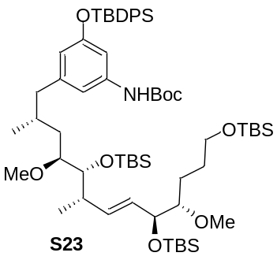Diol S23 (24.0 mg, 27.3 μmol, 1.0 eq.) was dissolved in CH2Cl2 (10 mL) under argon atmosphere, cooled to -78 °C, and 2,6-lutidine (15.6 μL, 137 μmol, 5.0 eq.) was added followed by TBSOTf (19.0 μL, 82.0 μmol, 3.0 eq.). The reaction mixture was heated to room temperature and stirring was continued for an additional 3 h at room temperature. The reaction was terminated by addition of an aqueous NH4Cl solution. The phases were separated and the aqueous phase was extracted three times with CH2Cl2. The combined organic phases were washed with brine, dried over MgSO4, filtered and concentrated under reduced pressure. The crude product was purified by flash chromatography (PE:EtOAc = 100:1 → 20:1) to afford the protected alcohol S23 (28.0 mg, 25.3 μmol, 93%, d.r.= 4:1) as a colorless oil; Rf = 0.5 (PE:EtOAc = 10:1).
¹H-NMR (400 MHz, CDCl3, CHCl3 = 7.26 ppm): δ 7.74-7.68 (m, 4H, SiPh), 7.42-7.31 (m, 6H, SiPh), 6.71 (s, 1H, Ph), 6.68 (s, 1H, Ph), 6.24 (s, 1H, NH), 6.17 (s, 1H, Ph), 5.47-5.37 (m, 1H, 7-H), 5.47-5.37 (m, 1H, 6-H), 4.10-4.03 (m, 1H, 5-H), 3.65-3.47 (m, 1H, 9-H), 3.65-3.47 (m, 2H, 1-H), 3.38 (s, 3H, 4-OMe), 3.21 (s, 3H, 10-OMe), 3.15-3.09 (m, 1H, 10-H), 3.09-3.00 (m, 1H, H-4), 2.40 (dd, J = 13.2, 5.8 Hz, 1H, 13-Ha), 2.23-2.12 (m, 1H, 8-H), 2.05-2.00 (m, 1H, 13-Hb), 1.76-1.60 (m, 1H, 12-H), 1.76-1.60 (m, 1H, 2-Ha), 1.58-1.53 (m, 1H, 11-Ha), 1.56-1.49 (m, 1H, 2-Hb), 1.48-1.36 (m, 1H, 3-Ha), 1.25-1.17 (m, 1H, 3-Hb), 1.47 (s, 9H, t-Bu), 1.07-1.03 (m, 1H, 11-Hb), 1.07 (s, 9H, Sit-Bu), 1.03 (d, J = 6.7 Hz, 3H, 8-Me), 0.90 (s, 9H, Sit-Bu), 0.89 (s, 9H, Sit-Bu), 0.86 (s, 9H, Sit-Bu), 0.58 (d, J = 6.4 Hz, 3H, 12-Me), 0.07 (s, 3H, SiMe), 0.06 (s, 9H, SiMe), 0.04 (s, 6H, SiMe) ppm; ¹³C-NMR (100 MHz, CDCl3, CDCl3 = 77.16 ppm) δ 155.9 (s, C-Ar), 152.6 (s, NHCOO), 143.4 (s, C-Ar), 138.9 (s, C-Ar), 135.6 (d, C-Ar), 134.6 (d, C-7), 133.2 (s, C-Ar), 130.5 (d, C-6), 129.8 (s, C-Ar), 127.8 (d, C-Ar), 115.6 (d, C-Ar), 112.3 (d, C-Ar), 107.5 (d, C-Ar), 85.3 (d, C-4), 81.3 (d, C-10), 80.3 (s, t-Bu), 75.3 (d, C-9), 73.7 (d, C-5), 63.5 (t, C-1), 58.5 (q, 4-OMe), 57.1 (q, 10-OMe), 44.7 (t, C-13), 40.7 (d, C-8), 36.0 (t, C-11), 31.2 (d, C-12), 29.2 (t, C-2), 28.5 (q, t-Bu), 26.7 (q, Sit-Bu), 26.3 (q, Sit-Bu), 26.1 (q, Sit-Bu), 25.8 (t, C-3), 19.6 (q, 12-Me), 19.0 (s, Sit-Bu), 18.6 (q, 8-Me), 18.3 (s, Sit-Bu), -3.8 (q, SiMe), -4.0 (q, SiMe), -4.6 (q, SiMe), -5.1 (q, SiMe) ppm; HRMS (ESI): The recording of high-resolution mass spectrometry could not be successfully performed for this molecule.

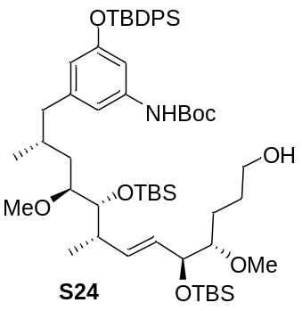Alcohol S24
Silyl ether S23 (10 mg, 9.0 μmol, 1.0 eq.) was dissolved in CH2Cl2 (2.0 mL) under argon atmosphere, cooled to 0 °C, and added MeOH (1.3 mL) and CSA (0.6 mg, 2.7 μmol, 0.3 eq.). After 4 h, the reaction was terminated by addition of an aqueous NaHCO3 solution. The aqueous phase was extracted three times with CH2Cl2. The combined organic phases were washed with aqueous NaCl solution, dried over MgSO4 and concentrated under reduced pressure. The crude product was purified by flash chromatography (PE:EtOAc = 10:1 → 5:1) to give alcohol S24 (8.0 mg, 8.1 μmol, 88%, d.r. = 4:1) as a colorless oil; Rf = 0.1 (PE:EtOAc = 9:1).
¹H-NMR (400 MHz, CDCl3, CHCl3 = 7.26 ppm): δ 7.74-7.67 (m, 4H, SiPh), 7.45-7.30 (m, 6H, SiPh), 6.73 (s, 1H, Ph), 6.65 (s, 1H, Ph), 6.30 (s, 1H, NH), 6.17 (s, 1H, Ph), 5.51-5.35 (m, 1H, 7-H), 5.51-5.35 (m, 1H, 6-H), 4.17-4.08 (m, 1H, 5-H), 3.67-3.57 (m, 2H, 1-H), 3.52 (dd, J = 8.7, 1.3 Hz, 1H, 9-H), 3.40 (s, 3H, 4-OMe), 3.21 (s, 3H, 10-OMe), 3.19-3.10 (m, 1H, 10-H), 3.10-3.03 (m, 1H, H-4), 2.42 (dd, J = 13.3, 5.6 Hz, 1H, 13-Ha), 2.23-2.15 (m, 1H, 8-H), 2.09-2.02 (m, 1H, 13-Hb), 1.74-1.60 (m, 1H, 12-H), 1.74-1.60 (m, 2H, 2-H), 1.60-1.46 (m, 2H, 3-H), 1.60-1.46 (m, 1H, 11-Ha), 1.47 (s, 9H, t-Bu), 1.07 (s, 9H, Sit-Bu), 1.03 (d, J = 6.7 Hz, 3H, 8-Me), 1.03-0.89 (m, 1H, 11-Hb), 0.89 (s, 9H, Sit-Bu), 0.86 (s, 9H, Sit-Bu), 0.58 (d, J = 6.5 Hz, 3H, 12-Me), 0.06 (s, 3H, SiMe), 0.03 (s, 6H, SiMe), 0.02 (s, 3H, SiMe) ppm; ¹³C-NMR (100 MHz, CDCl3, CDCl3 = 77.16 ppm) δ 155.9 (s, C-Ar), 152.7 (s, NHCOO), 143.4 (s, C-Ar), 138.9 (s, C-Ar), 135.7 (d, C-Ar), 134.8 (d, C-7), 133.2 (s, C-Ar), 130.3 (d, C-6), 129.8 (s, C-Ar), 127.8 (d, C-Ar), 115.6 (d, C-Ar), 112.3 (d, C-Ar), 107.5 (d, C-Ar), 85.5 (d, C-4), 81.4 (d, C-10), 80.3 (s, t-Bu), 75.9 (d, C-9), 74.9 (d, C-5), 63.1 (t, C-1), 58.4 (q, 4-OMe), 57.1 (q, 10-OMe), 44.7 (t, C-13), 40.9 (d, C-8), 36.1 (t, C-11), 31.3 (d, C-12), 29.4 (t, C-2), 28.5 (q, t-Bu), 26.8 (t, C-3), 26.7 (q, Sit-Bu), 26.3 (q, Sit-Bu), 26.0 (q, Sit-Bu), 19.6 (s, Sit-Bu), 19.0 (q, 12-Me), 18.6 (s, Sit-Bu), 18.3 (q, 8-Me), -3.8 (q, SiMe), -4.0 (q, SiMe), -4.6 (q, SiMe) ppm; HRMS (ESI): The recording of high-resolution mass spectrometry could not be successfully performed for this molecule.

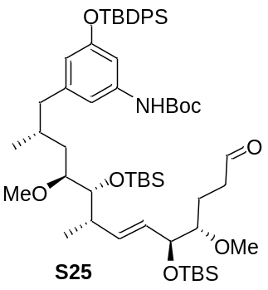Aldehyde S25
Alcohol S24 (30.0 mg, 30.2 μmol, 1.0 eq.) was dissolved in CH2Cl2 (8.0 mL), cooled to 0 °C, and NaHCO3 (3.00 mg, 36.3 μmol, 1.2 eq.) was added followed by the Dess-Martin reagent (15.4 mg, 36.3 μmol, 1.2 eq.). The reaction mixture was warmed to room temperature and stirred for 1 h. The reaction was terminated by addition of an aqueous Na2SO3 solution. The phases were separated and the aqueous phase was extracted three times with CH2Cl2. The combined organic phases were washed with brine, dried over MgSO4 and concentrated under reduced pressure. The crude product was purified by flash chromatography (PE:EtOAc = 50:1 → 10:1) to give aldehyde S25 (21.0 mg, 21.2 μmol, 70%, d.r. = 4:1) as a colorless oil; Rf = 0.4 (PE:EtOAc = 9:1).
¹H-NMR (400 MHz, C6D6, C6D5H = 7.16 ppm): δ 9.44 (s, 1H, 1-H), 7.86-7.84 (m, 4H, SiPh), 7.21-7.17 (m, 6H, SiPh), 7.19 (s, 1H, 17-H), 6.65 (s, 1H, 15-H), 6.47 (s, 1H, 19-H), 5.97 (s, 1H, NH), 5.64 (dd, J = 15.5, 8.5 Hz, 1H, 7-H), 5.51 (dd, J = 15.5, 5.3 Hz, 1H, 6-H), 4.25-4.20 (m, 1H, 5-H), 3.67 (d, J = 8.5 Hz, 1H, 9-H), 3.31-3.25 (m, 1H, 10-H), 3.21 (s, 3H, 4-OMe), 3.18 (s, 3H, 10-OMe), 3.03-2.99 (m, 1H, H-4), 2.48 (dd, J = 12.6, 5.5 Hz, 1H, 13-Ha), 2.35-2.24 (m, 1H, 8-H), 2.18-2.08 (m, 2H, 2-H), 2.18-2.08 (m, 1H, H-13b), 2.01-1.92 (m, 1H, 12-H), 1.89-1.75 (m, 1H, 11-Ha), 1.89-1.75 (m, 1H, 3-Ha), 1.65-1.54 (m, 1H, 3-Hb), 1.39 (s, 9H, t-Bu), 1.19 (s, 9H, Sit-Bu), 1.16 (d, J = 6.8 Hz, 3H, 8-Me), 1.19-1.16 (m, 1H, 11-Hb), 1.07 (s, 9H, Sit-Bu), 1.01 (s, 9H, Sit-Bu), 0.75 (d, J = 6.5 Hz, 3H, 12-Me), 0.21 (s, 3H, SiMe), 0.15 (s, 6H, SiMe), 0.12 (s, 3H, SiMe) ppm; ¹³C-NMR (100 MHz, C6D6, C6D6 = 128.06 ppm) δ 200.6 (d, C-1), 156.5 (s, C-Ar), 152.4 (s, NHCOO), 143.5 (s, C-Ar), 140.2 (d, C-Ar), 136.1 (s, C-Ar), 135.2 (d, C-7), 133.7 (d, C-Ar), 130.2 (s, C-Ar), 129.5 (d, C-6), 115.8 (d, C-19), 112.6 (d, C-15), 108.0 (d, C-17), 84.6 (d, C-4), 81.6 (d, C-10), 79.7 (s, t-Bu), 76.8 (d, C-9), 73.9 (d, C-5), 58.5 (q, 4-OMe), 57.1 (q, 10-OMe), 45.1 (t, C-13), 40.9 (d, C-8), 40.7 (t, C-2), 36.4 (t, C-11), 31.8 (d, C-12), 28.4 (q, t-Bu), 26.9 (q, Sit-Bu), 26.6 (q, Sit-Bu), 26.3 (q, Sit-Bu), 23.3 (t, C-3), 19.9 (q, 12-Me), 19.5 (s, Sit-Bu), 19.0 (q, 8-Me), 18.6 (s, Sit-Bu), -3.4 (q, SiMe), -4.1 (q, SiMe), -4.5 (q, SiMe) ppm; HRMS (ESI). The recording of high-resolution mass spectrometry could not be successfully performed for this molecule.

Ethyl thioester 29
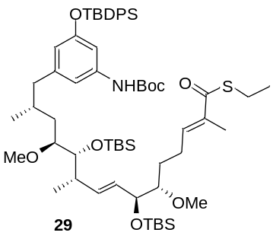
Aldehyde S25 (14.0 mg, 14.1 μmol, 1.0 eq.) was dissolved in CHCl3 (2.5 mL) and phosphorylide Ph3P=C(CH3)C(O)SEt 28b (6.20 mg, 16.9 μmol, 1.2 eq.) was added. The reaction mixture was heated to 40 °C and stirred for an additional 24 h at 40 °C. The solvent was removed under reduced pressure, the crude product was purified by flash chromatography (PE:EtOAc = 20:1 → 10:1), and thioester 29 (13.0 mg, 12.1 μmol, 86%, d.r. = 4:1) was obtained as a colorless oil; Rf = 0.4 (PE:EtOAc = 10:1).
¹H-NMR (400 MHz, CDCl3, CHCl3 = 7.26 ppm): δ 7.77-7.66 (m, 4H, SiPh), 7.45-7.29 (m, 6H, SiPh), 6.87 (ddd, J = 15.5, 9.3, 4.8 Hz, 1H, 3-H), 6.72 (s, 1H, Ph), 6.68 (s, 1H, Ph), 6.26 (s, 1H, NH), 6.16 (s, 1H, Ph), 5.54-5.31 (m, 1H, 9-H), 5.54-5.31 (m, 1H, 8-H), 4.12-4.08 (m, 1H, 7-H), 3.52 (dd, J = 8.6, 1.3 Hz, 1H, 11-H), 3.37 (s, 3H, 6-OMe), 3.21 (s, 3H, 12-OMe), 3.16-3.10 (m, 1H, 12-H), 3.05-2.97 (m, 1H, H-6), 2.97-2.87 (m, 2H, SCH2CH3), 2.39 (dd, J = 13.3, 5.7 Hz, 1H, 15-Ha), 2.35-2.26 (m, 1H, 4-Ha), 2.26-2.13 (m, 1H, 10-H), 2.26-2.13 (m, 1H, 4-Hb), 2.13-1.97 (m, 1H, H-15b), 1.80 (s, 3H, 2-Me), 1.77-1.60 (m, 1H, 14-H), 1.64-1.43 (m, 2H, 5-Ha), 1.63-1.50 (m, 1H, 13-Ha), 1.47 (s, 9H, t-Bu), 1.28-1.25 (m, 3H, SCH2CH3), 1.08 (s, 9H, Sit-Bu), 1.04 (d, J = 6.7 Hz, 3H, 10-Me), 1.05-1.00 (m, 1H, 13-Hb), 0.89 (s, 9H, Sit-Bu), 0.86 (s, 9H, Sit-Bu), 0.58 (d, J = 6.4 Hz, 3H, 14-Me), 0.05 (s, 3H, SiMe), 0.03 (s, 6H, SiMe), 0.02 (s, 3H, SiMe) ppm; ¹³C-NMR (100 MHz, CDCl3, CDCl3 = 77.16 ppm) δ 190.3 (d, C-1), 155.9 (s, C-Ar), 152.6 (s, NHCOO), 145.3 (d, C-3), 143.3 (s, C-Ar), 139.0 (s, C-Ar), 135.9 (s, C-2), 135.7 (d, C-Ar), 135.1 (d, C-9), 133.2 (s, C-Ar), 130.2 (d, C-8), 129.9 (d, C-Ar), 127.8 (d, C-Ar), 115.6 (d, C-Ar), 112.3 (d, C-Ar), 107.6 (d, C-Ar), 84.4 (d, C-6), 81.3 (d, C-12), 80.3 (s, t-Bu), 75.9 (d, C-11), 74.7 (d, C-7), 58.5 (q, 6-OMe), 57.2 (q, 12-OMe), 44.7 (t, C-15), 40.8 (d, C-10), 36.0 (t, C-13), 31.2 (d, C-14), 28.6 (t, C-4), 28.6 (t, C-5), 28.5 (q, t-Bu), 26.7 (q, Sit-Bu), 26.3 (q, Sit-Bu), 26.0 (q, Sit-Bu), 23.2 (t, SCH2CH3), 19.6 (s, Sit-Bu), 19.0 (q, 14-Me), 18.6 (s, Sit-Bu), 18.3 (q, 10-Me), 15.0 (q, SCH2CH3), 12.4 (q, 2-Me), -3.8 (q, SiMe), -4.0 (q, SiMe), -4.6 (q, SiMe) ppm.

Ethyl thioester S26
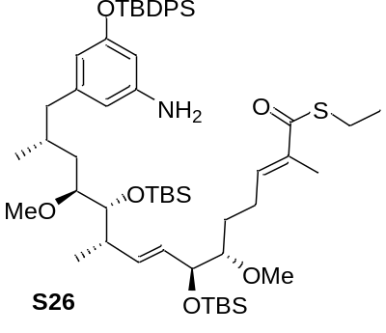Thioester 29 (11.0 mg, 10.2 μmol, 1.0 eq.) was dissolved in CH2Cl2 (6.0 mL) under argon atmosphere, cooled to 0 °C, and TFA (400 μL) was added. After 4 h, the reaction was terminated by addition of an aqueous NaHCO3 solution. The phases were separated and the aqueous phase was extracted three times with CH2Cl2. The combined organic phases were washed with aqueous NaCl solution, dried over MgSO4, filtered and concentrated under reduced pressure. The crude product was purified by flash chromatography (PE:EtOAc = 10:1 → 3:1) to afford amine S26 (4.00 mg, 4.10 μmol, 40%, d.r. = 4:1) as a colorless oil; Rf = 0.2 (PE:EtOAc = 9:1).
¹H-NMR (400 MHz, CDCl3, CHCl3 = 7.26 ppm): δ 7.79-7.66 (m, 4H, SiPh), 7.45-7.29 (m, 6H, SiPh), 6.95-6.79 (m, 1H, 3-H), 6.05 (s, 1H, Ph), 6.01 (s, 1H, Ph), 5.94 (s, 1H, Ph), 5.54-5.34 (m, 1H, 9-H), 5.54-5.34 (m, 1H, 8-H), 4.19-4.02 (m, 1H, 7-H), 3.59-3.53 (m, 1H, 11-H), 3.37 (s, 3H, 6-OMe), 3.23 (s, 3H, 12-OMe), 3.20-3.10 (m, 1H, 12-H), 3.05-2.98 (m, 1H, H-6), 2.98-2.93 (m, 2H, SCH2CH3), 2.40 (dd, J = 13.3, 5.7 Hz, 1H, 15-Ha), 2.35-2.26 (m, 1H, 4-Ha), 2.26-2.13 (m, 1H, 10-H), 2.26-2.13 (m, 1H, 4-Hb), 2.07-1.97 (m, 1H, H-15b), 1.82 (s, 3H, 2-Me), 1.80-1.70 (m, 1H, 14-H), 1.65-1.43 (m, 2H, 5-Ha), 1.65-1.43 (m, 1H, 13-Ha), 1.31-1.22 (m, 3H, SCH2CH3), 1.07 (s, 9H, Sit-Bu), 1.04 (d, J = 6.8 Hz, 3H, 10-Me), 1.05-1.00 (m, 1H, 13-Hb), 0.89 (s, 9H, Sit-Bu), 0.88 (s, 9H, Sit-Bu), 0.62 (d, J = 6.5 Hz, 3H, 14-Me), 0.07 (s, 3H, SiMe), 0.05 (s, 6H, SiMe), 0.02 (s, 3H, SiMe) ppm.

3.3.5 Macrolactamizations
Progeldanamycin derivate S27 [S12]
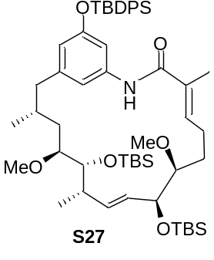Thioester S26 (4.0 mg, 4.1 μmol, 1.0 eq.) was dissolved in THF (6.0 mL) under an argon atmosphere and 2,6-lutidine (40 μL) and silver nitrate (11 mg, 62 μmol, 15 eq.) were added. The reaction mixture was stirred at 55 °C for 1.5d and then cooled to room temperature. The reaction was terminated by addition of an aqueous CuSO4 solutionThe phases were separated and the aqueous layer was extracted three times with EtOAc. The combined organic phases were washed with brine, dried over MgSO4 and concentrated under reduced pressure. The crude product was purified by flash chromatography (PE:EtOAc= 10:1→3:1) to afford progeldanamycin derivative S27 (2.0 mg, 2.2 μmol, 53%, d.r. = 4:1) as a colorless oil; Rf = 0.2 (PE:EtOAc = 9:1).
¹H-NMR (400 MHz, CDCl3, CHCl3 = 7.26 ppm): δ 7.77-7.64 (m, 4H, SiPh), 7.47-7.34 (m, 6H, SiPh), 6.97-6.84 (m, 1H, 3-H), 6.47 (s, 1H, Ph), 6.40 (s, 1H, Ph), 6.28 (s, 1H, Ph), 5.43 (dd, J = 15.3, 8.5 Hz, 1H, 8-H), 5.30 (dd, J = 15.3, 5.9 Hz, 1H, 9-H), 4.37-4.30 (m, 1H, 7-H), 3.58-3.53 (m, 1H, 11-H), 3.42 (s, 3H, 6-OMe), 3.28 (s, 3H, 12-OMe), 3.20-3.12 (m, 1H, 12-H), 3.12-3.07 (m, 1H, H-6), 2.91-2.81 (m, 1H, 15-Ha), 2.28-2.15 (m, 1H, 10-H), 2.15-2.00 (m, 2H, 4-H), 2.15-2.00 (m, 1H, H-15b), 1.77 (s, 3H, 2-Me), 1.76-1.70 (m, 1H, 14-H), 1.65-1.43 (m, 2H, 5-H), 1.65-1.43 (m, 1H, 13-Ha), 1.13 (s, 9H, Sit-Bu), 1.09-1.00 (m, 1H, 13-Hb), 1.09 (d, J = 6.4 Hz, 3H, 10-Me), 0.92 (s, 9H, Sit-Bu), 0.90 (s, 9H, Sit-Bu), 0.56 (d, J = 6.2 Hz, 3H, 14-Me), 0.09 (s, 3H, SiMe), 0.06 (s, 6H, SiMe), 0.04 (s, 3H, SiMe) ppm. The crude material was directly employed in the next step.

Progeldanamycin derivate 30
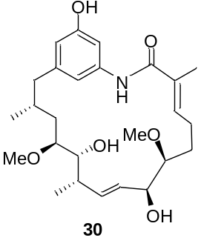Progeldanamycin derivative S27 (2.0 mg, 2.2 μmol, 1.0 eq.) was dissolved in THF (2.0 mL) under argon atmosphere and pyridine (500 μL) and HF*Py (500 μL) were added. After 7 days, the reaction was terminated by addition of an aqueous NaHCO3 solution. The phases were separated and the aqueous phase was extracted three times with EtOAc. The combined organic phases were washed with CuSO4 solution, dried over MgSO4, filtered and concentrated under reduced pressure. The crude product was purified by preparative HPLC (C18 ISIS SP) (H2O:MeOH = 90:10 {5 min}, gradient H2O:MeOH = 90:10 → 40:60 {65 min}, H2O:MeOH = 40:60 → 0:100 {20 min}, H2O:MeOH = 0:100 {10 min}, 2.5 mL/min) (Rt = 36.5 min). Lactam 30 (0.6 mg, 1.3 μmol, 60%) and starting lactam S27 (0.2 mg, 0.5 μmol, 20%) were obtained as colorless oils.
30: ¹H-NMR (500 MHz, MeOD, MeOD = 3.31 ppm): δ 6.89-6.80 (m, 1H, 3-H), 6.49 (s, 1H, Ph), 6.42 (s, 1H, Ph), 6.37 (s, 1H, Ph), 5.52-5.40 (m, 1H, 8-H), 5.52-5.40 (m, 1H, 9-H), 4.23 (d, J = 5.4 Hz, 1H, 7-H), 3.65-3.54 (m, 1H, 11-H), 3.41 (s, 3H, 6-OMe), 3.34 (s, 3H, 12-OMe), 3.34-3.20 (m, 1H, 12-H), 3.13-3.05 (m, 1H, H-6), 2.97-2.81 (m, 1H, 15-Ha), 2.46-2.34 (m, 1H, 4-Ha), 2.24-2.15 (m, 1H, 10-H), 2.15-2.10 (m, 1H, H-15b), 2.10-1.96 (m, 1H, 4-Hb), 1.94 (s, 3H, 2-Me), 1.80-1.70 (m, 1H, 14-H), 1.73-1.59 (m, 1H, 5-Ha), 1.73-1.59 (m, 1H, 13-Ha), 1.48-1.36 (m, 1H, 5-Hb), 1.27-1.19 (m, 1H, 13-Hb), 1.12 (d, J = 6.4 Hz, 3H, 10-Me), 0.76 (d, J = 6.2 Hz, 3H, 14-Me); ¹³C-NMR (125 MHz, MeOD, MeOD = 49.0 ppm): δ 166.4 (d, C-1), 159.4 (s, C-Ar), 146.5 (d, C-3), 139.4 (s, C-Ar), 137.2 (d, C-9), 137.0 (s, C-2), 133.8 (s, C-Ar), 130.4 (d, C-8), 120.7 (d, C-Ar), 115.2 (d, C-Ar), 109.3 (d, C-Ar), 86.3 (d, C-6), 83.3 (d, C-12), 74.0 (d, C-11), 74.0 (d, C-7), 58.1 (q, 6-OMe), 58.1 (q, 12-OMe), 44.8 (t, C-15), 41.9 (d, C-10), 35.8 (t, C-13), 33.5 (d, C-14), 30.6 (t, C-4), 28.9 (t, C-5), 19.9 (q, 14-Me), 19.1 (q, 10-Me) 13.7 (q, 2-Me) ppm; HRMS (ESI) m/z for C26H39NO6Na [M+Na]⁺: calculated: 484.2675, found: 484.2669.

4. Biotransformation of SNAC ester 27b using amide synthase ShGdmF
SNAC ester 27b (0.2 mg, 0.4 μmol,) in Hepes-buffer (25 mM Hepes, 150 nM NaCl, pH 6.8) was incubated with ShGdmF for 24 h at 37°C and the reaction mixture was extracted with ethylacetate (5 mL). The phases were separated and the ethyl acetate extract was analyzed by mass spectrometry that revealed formation of macrolactam 30 as well as the hydrolysis product 29 (Figure S4).

Figure S4: Mass spectra of the enzymatic reaction with SNAC ester 27b; a: negative control, b: progeldanamycin derivative 30 [M+Na], c: seco acid 31 [M+H], d: SNAC ester 27b [M+H].
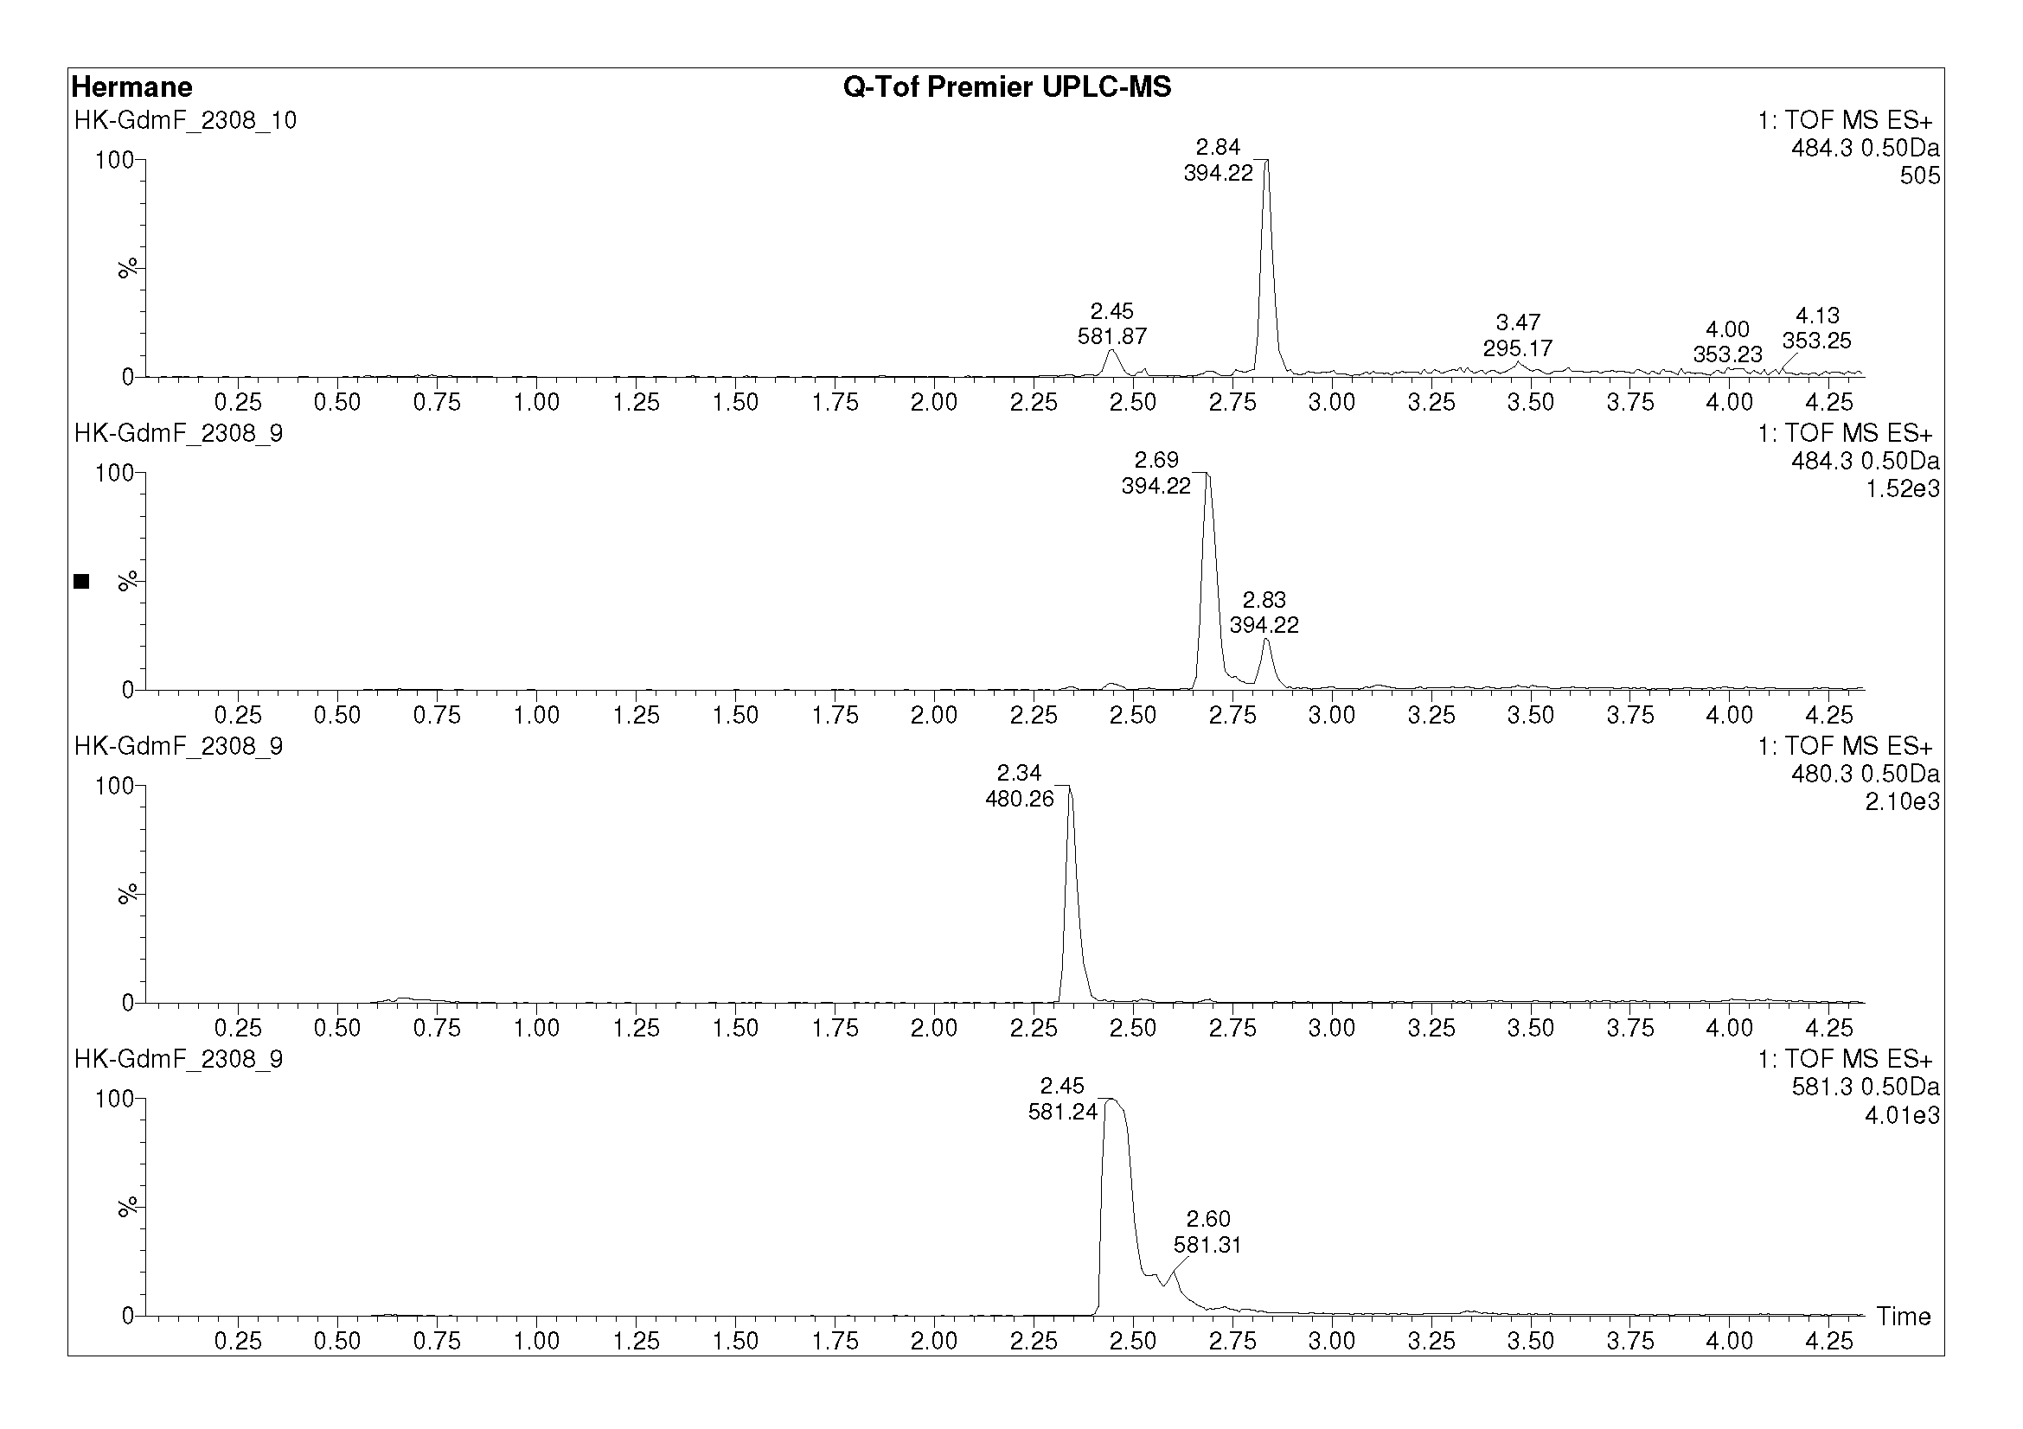
27b
component of medium
component of medium
31
30
b
a
c
d

The structure of progeldanamycin derivative 30 was confirmed by MS/MS fragmentation experiment (Figure S5).
Figure S5: MS-MS fragmentation experiment of progeldanamycine derivative 30.
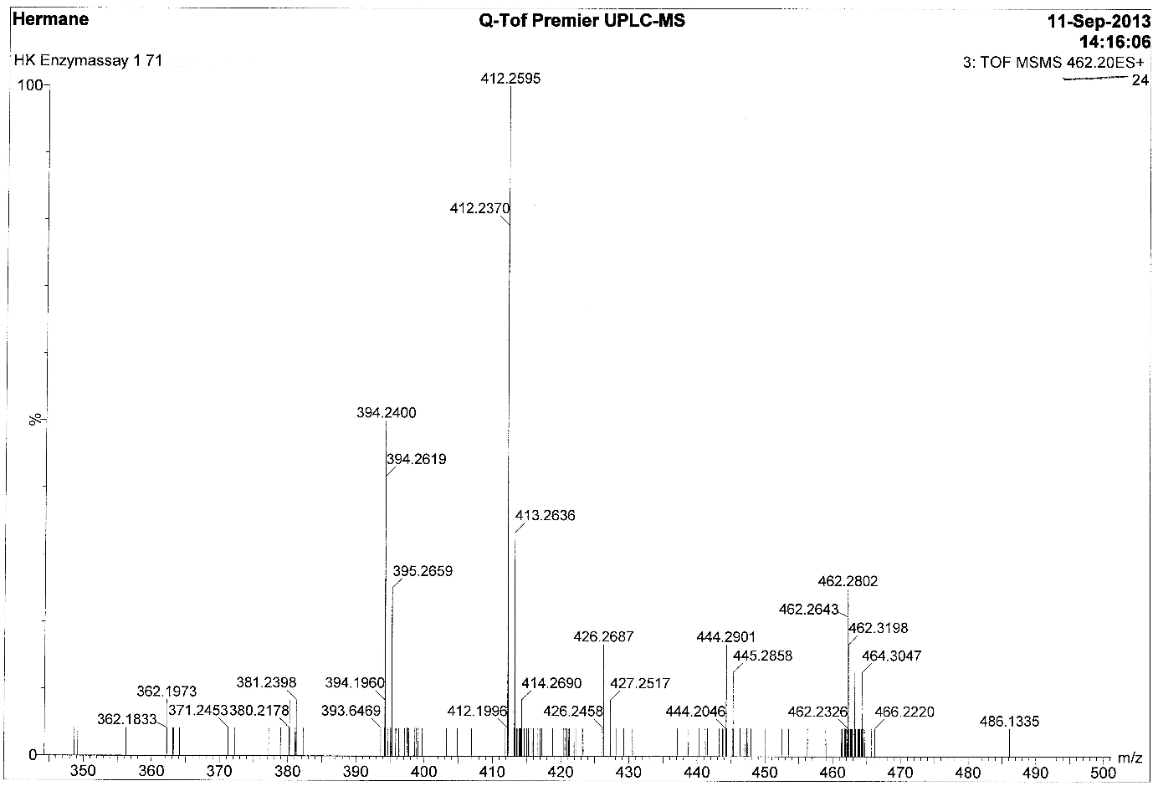
M-H2O+H
M-2H2O+H
M+H
M-2H2O-MeOH+H
M-H2O-MeOH+H

5. References (Supporting information)
[S1] N. M. Gaudelli, C. A. Townsend, J. Org. Chem. 2013, 78, 6412–6426.
[S2] D. M. Roberts, C. Bartel, A. Scott, D. Ivison, T. J. Simpson, R. J. Cox, Chem. Sci. 2017,
8, 1116–1126.
[S3] F. Pfrengle, V. Dekaris, L. Schefzig, R. Zimmer, H. U. Reissig, Synlett 2008, 2965–2968.
[S4] P. D. Walker, C. Williams, A. N. M. Weir, L. Wang, J. Crosby, P. R. Race, T. J. Simpson, C. L. Willis, M. P. Crump, Angew. Chem. Int. Ed. 2019, 58, 12446–12450.
[S5] O. Vergnolle, F. Hahn, A. Baerga-Ortiz, P. F. Leadlay, J. N. Andexer, ChemBioChem 2011, 12, 1011–1014.
[S6] W. Seubert, F. Lynen, J. Am. Chem. Soc. 1953, 75, 2787–2788.
[S7] K. K. Sharma, C. N. Boddy, Bioorg. Med. Chem. Lett. 2007, 17, 3034–3037.
[S8] A. Dey, M. T. Kirchner, V. R. Vangala, G. R. Desiraju, R. Mondal, J. A. K. Howard, J. Am. Chem. Soc. 2005, 127, 10545–10559.
[S9] U. Ravid, R. M. Silverstein, L. R. Smith, Tetrahedron 1978, 34, 1449-1452.
[S10] R. A. Pilli, M. M. Victor, A. de Meijere, J. Org. Chem. 2000, 65, 5910-5916.
[S11] T. R. Hoye, C. S. Jeffrey, F. Shao, Nat. Protoc. 2007, 2451-2458.
[S12] G. E. Keck, J. A. Murry, J. Org. Chem. 1991, 56, 6606-6611.

Attachment: Copies of ¹H- and ¹³C-NMR spectra
