Supplementary Information of the manuscript

Earliest isotopic evidence of high reliance on plant food in the Late Pleistocene hunter-gatherer population (Taforalt, Morocco)

Supplementary Information 1: Archeological context
Supplementary Information 2: Details on isotope proxies used in this study
Supplementary Information 3: Material and Methods
Supplementary Information 4: Results
Supplementary Information 5: Additional discussion
Supplementary Information 6: Supplementary figures and tables
Supplementary Information 7: 3D models of the human teeth and sampling strategy

Supplementary Information 1: Archeological context

  - The site of Taforalt “Grotte des Pigeons”
The site of Taforalt (also known as La Grotte des Pigeons) is located in eastern Morocco (34° 48’ 38” N, 2° 24’ 30” W) and more precisely 500 m distant from the village from which it takes the name. The site is approximately 40 km inland from the Mediterranean Sea and at an altitude of 750 m above sea level. The cave has a form of a large dolomite limestone cavity formed in the Beni Snassen Mountains and opens to Northeastern with 30 m in width and 15 m in length.
The site was first discovered by Dr. Pinchon in 1908, since then the cave was the subject of several excavations. The first excavations were initiated by Ruhlmann from 1944 to 1947 where he made two surveys: in the central and the right lateral part of the cave and he reached the bottom of the fill inside the cavity. His works have provided insight into the nature of the archeological deposits which span the Aterian (Middle Stone Age) and The Iberomaurusian (Later Stone Age) (Roche, 1976). From 1950 to 1955 Roche carried out a systematic excavation of the cave on the ashy layers where he described them as an Iberomaurusian occupation. During his campaign, he uncovered an extensive series of burials in the grey ashy deposits. This includes the two burial areas (designated Necropolis I and II). Moreover, he recovered multiple human graves which were analyzed by Ferembach in 1962. Further excavations were carried out from 1969 to 1979 to acquire detailed information about the archaeological and geological aspects ¹.
From 2003 to 2017 a new work was conducted on the Iberomaurusian sequence of Taforalt. These new investigation of the Iberomaurusian sequence described two main units.^{2,3}
The Yellow series (YS): The underlying deposit has been recognized as the yellow series, and is associated with the early Iberomaurusian phase which is dated around 22,292-21,825 cal B.P (Barton et al., 2013). A clear sedimentation change of the Iberomaurusian deposits occurs around 15,190- 14,830 cal BP.
The Grey series (GS): The upper unit refers to the grey ashy deposits of the Iberomaurusian occupation with a 4-meter thickness and it is dated between 15,000 and 12,600 cal B.P. ³. The sedimentary change between the YS and GS coincides with a change in subsistence strategy by the Iberomaurusians. The recent excavations revealed a series of primary burials in sector 10 in the grey ashy deposits and evidence show that this area was reused several times because earlier burials were disturbed by subsequent ones.
1.2 The human burials at Taforalt
The recent excavations (2003-2017) revealed a series of additional burials including 12 partially articulated skeletons (7 adults and 5 infants). This disarticulation indicates the intensive use of the area. In addition to that, an almost complete infant skeleton and a broken cranium along with a mandible were discovered in the same area. The cemetery includes basically primary burials which indicate that death happened not too far from the site. In addition to that, there are some secondary depositions of skeletal elements with post mortem modifications (removal of soft tissues). There are two suggested hypotheses for these burials, either the individuals died elsewhere and were carried to the site for burial or they simply reflect an elaboration in the funerary practices ⁴.
However, most of the discovered skeletons were buried in a seated or semi-reclined position. The majority of the individuals were facing towards the entrance of the cave. The bodies were probably surrounded by a pocket of empty space during their decomposition and were covered by organic materials because of the partial loss of anatomical articulation of skeleton elements. It should be mentioned that many burials were associated with funerary objects like horn cores and stones stained with ochre ⁵.
Seven human bone samples from Sector 10 (grey series) have been directly dated by radiocarbon accelerator mass spectrometry (AMS) using ultrafiltration giving dates that span the period of 15,077 cal. BP and 13,892 cal. y BP ³

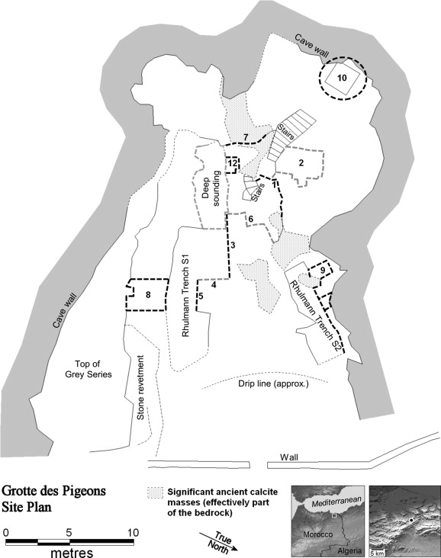

Figure S1.1 Plan of Taforalt showing location of different sectors and the earlier Roche excavations and main sectors of the recent field campaigns (From Barton et al., 2013)³.
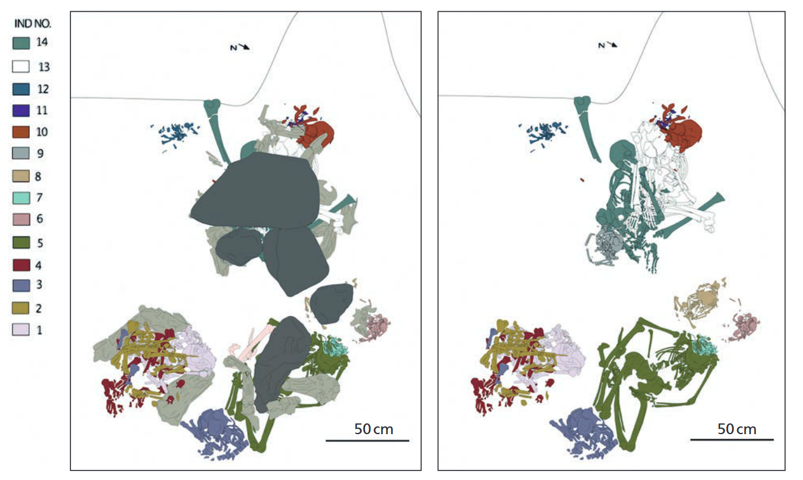
Figure S1.2: (left) Composite drawing of the human burials from sector 10 showing Individuals 1-14 and including cover stones from 2005 to 2016 excavations. (right) Composite drawing of the human burials showing Individuals 1-14 but with cover stones and horn cores removed ⁶.

1.3 The Iberomaurusian culture
In Northwest Africa, the end of the Late Pleistocene is associated with the Iberomaurusian culture characterized by bladelets and microlithic backed tools, which marks a technological break with the antecedent Aterian (Middle Stone Age)^{7,8}. The Iberomaurusian culture first appeared around 25,000 cal BP in North Africa ⁸ and may have persisted in the Holocene after 11,600 cal BP ⁹. The Iberomaurusian culture has covered a vast geographical area stretching from modern day Morocco in the west (10°W) to Cyrenaica in the east (22°E). However, its southern extension is still not well understood but it reaches up to about 33°N along the Atlantic coast. The term of the "Iberomaurusian" was coined by Pallary in 1909. He refers to this name as an assemblage composed mainly of microlithic tools, which he discovered under the shelter of La Mouillah (Oran region, west Algeria). The second part "maurusian" refers to the Moors which is a Roman name for North Africa. Pallary used the term "Ibéromaurusien" to draw attention to the similarities between the lithic industries found in Spain and Morocco. However, the cultural link with southern Europe was later rejected by archaeologists who noted stronger African affinities. As an alternative, they adopted names such as "Oranian" or "Mouillian". Recently some researchers proposed "Late Upper Palaeolithic of Northwest African facies" in order to avoid terminological confusion ¹⁰. However, the scientific community prefers to keep the term of Iberomaurusien as proposed by Camps, 1974 ¹. This term has always persisted in the literature and that is why we will use it in our manuscript.
1.4 Faunal remains of Taforalt
Several animal taxa are recovered from the Later Stone Age deposits at Taforalt. The most dominant species are Barbary sheep (Ammotragus lervia), equids, large bovines, gazelle and members of the Alcelaphini (hartebeest). Barbary sheep was the dominant species of game exploited by the Iberomaurusians at this site. This can be easily explained by the location of the cave which corresponds to its favorite habitat (stony plateaus, steep valley slopes). The rest of the species are typical of open grassland or steppe. Butchery and burning marks on the remains of Barbary sheep indicate its was primary consumption by this population. The presence of Barbary sheep horn cores accompanying human burials in sector 10 suggests their use as funerary objects. The study of the faunal assemblage from Taforalt indicates that the Iberomarusians hunted all age-groups of herbivores but that prime adults were preferentially chosen ¹¹
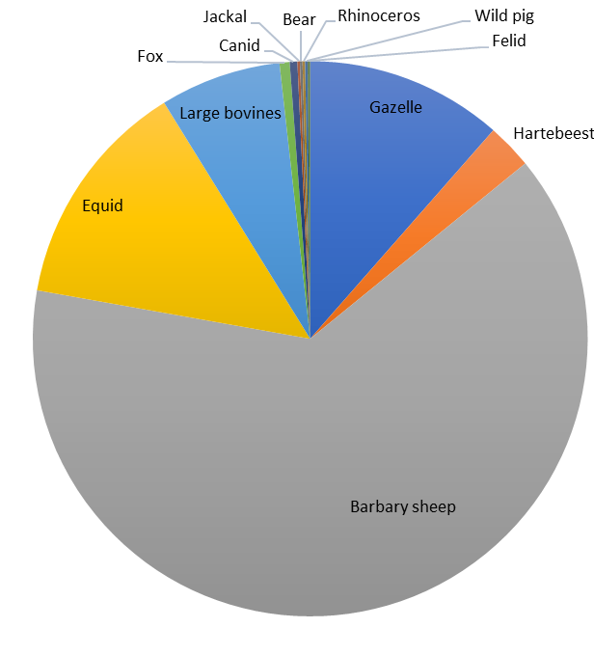
Figure S1.3: The percentage of number of identifiable animal species from sector 10 at Taforalt¹²

Table S1.1: List of the identifiable faunal species from sector 10 Taforalt ^{11,12}
Faunal remains sector 10
Taxa | NISP | NISP %
Gazelle (Gazella sp.) | 78 | 10.88
Hartebeest (Alcelaphus buselaphus) | 18 | 2.51
Barbary sheep (Ammotragus lervia) | 433 | 60.39
Equid (Equidae) | 91 | 12.69
Large bovines | 48 | 6.69
Fox (Vulpes Vulpes) | 4 | 0.56
Canid (Canidae) | 3 | 0.42
Jackal (Canis aureus) | 1 | 0.14
Bear (Ursidae) | 1 | 0.14
Rhinoceros (Rhinocerotidae) | 1 | 0.14
Wild pig (Sus scrofa) | 1 | 0.14
Felid (Felidae) | 1 | 0.14
Total | 681 | 95

Supplementary Information 2: Details on isotope proxies used in the study

2.1 Carbon and nitrogen isotope ratios of bulk collagen and single amino acids

Nitrogen isotope ratios (δ¹⁵N) reflect the trophic position of an individual in the food web, as there is 3-5‰ enrichment in δ¹⁵N between diet and consumer ^{12,13}. Carbon isotope ratios (δ¹³C), on the other hand, provides an indication on the source of primary production at the base of the food web in addition to the possible involvement of marine resources in diet ¹⁴. Carbon and nitrogen isotope analyses from bone proteins therefore provide valuable information on the diet of past humans. However, reconstructing the paleodiet using the bulk collagen has three major limits.
- The utilization of bulk collagen δ¹³C to reconstruct diet is often limited in regions with mixed C3 and C4 environments. This is because of the overlap in δ¹³C values of C4 plants and high marine proteins consumers, both having relatively more positive values. Freshwater fish and terrestrial meat can also exhibit similar δ¹³C values. Previous studies showed the limitation of estimating the marine food contribution in the diet of humans living in regions with mixed C3/C4 terrestrial environments^{13,14}.
- Bulk collagen δ¹⁵N isotope ratios are affected by several environmental and physiological factors in addition to the trophic level effect. For instance, elevated δ¹⁵N values of herbivore tissues are documented in arid regions, and consequently lead to a misinterpretation of the trophic levels of humans ^{15,16}. In addition, there is a strong baseline effect impacting the δ¹⁵N and δ¹³C of animals with similar diets, but coming from different regions. This is due to environmental factors, such as the aridity, influencing the isotope composition of plants. Usually there is a 3.4‰ increase in each trophic level¹⁷. Deniro and Epstein et al. observed the δ¹⁵N change in each trophic level can display a wide variation for different samples (-0.5 to +9.2).
- Another problem is related to the characterization of δ¹⁵N in the primary producers which can display an important temporal and geographical variation, possibly because of the assimilation of nitrogen from different sources ¹⁸.
Compound Specific Isotope Analysis of Amino Acids (CSIA-AA) has recently been used to overcome the methodological problems of bulk isotope analyses. The use of this powerful new technique allows estimating more precisely the trophic position of organisms and eliminating the influence of environmental factors. The analyses of δ¹³C isotope value of Single Amino Acid (SAA) (Phe: Phenylalaline, Val: Valine) can clearly differentiate terrestrial from freshwater food resources while N isotope on SAA (Phe: Phenylalaline, Glu: Glutamic acid) elucidate the trophic position with more precision than with the bulk isotope analyses (Figure 2.1) ^{19,20}.

a. Trophic position estimation using δ¹⁵N of amino acids

One could estimate the Trophic Position (TP) of humans without need to characterize the δ¹⁵N values of the associated fauna by analyzing nitrogen in amino acids, particularly on the Phenylalanine (Phe) and Glutamic acids (Glu). These amino acids serve as excellent tracers of the trophic level. The δ¹⁵N_{Glu} is significantly enriched for each trophic position (+8.00 ‰) because of the important isotopic fractionation occurring during the transamination. The δ¹⁵N_{Phe} shows only a slight change with each trophic position (+0.4‰) and mainly reflects the local base line, which in turn influences the δ¹⁵N_{Glu} with the same amplitude (Figure S2.2). By combining the analysis of these two amino acids, it becomes possible to determine the trophic position of an organism while effectively eliminating interference from the baseline effect ¹⁹.
The analysis of δ¹⁵N on these two amino acids provides an internal trophic position (TP) indicator which can be calculated by employing the following equation:
TP(C3) = [(Δ¹⁵N_{Glu}-_{Phe} + 8.4)/7.6] + 1.

b. Carbon isotope ratios of amino acids and exploited environment

Previous studies ^{20,21} demonstrated the potential of carbon analyses on the phenylalanine (Phe) and the Valine (Val) to distinguish between 4 main dietary groups (Marine fish consumers; freshwater fish consumers, terrestrial C3 consumers, C4 terrestrial consumers). Generally, animals eating terrestrial plants have similar δ¹³C_{Phe} and δ¹³C_{Val} in collagen. The animals in a C4 plant-based environment would also exhibit similar δ¹³C_{Phe} and δ¹³C_{Val} but relatively higher. The δ¹³C_{Val} values of freshwater fish consumers overlap with animals from a C3 plant environment but have a lower δ¹³C_{Phe}. The δ¹³C_{Val} of marine proteins consumers overlap with animals from C4 environments but have lower δ¹³C_{Phe} ^{20,21}
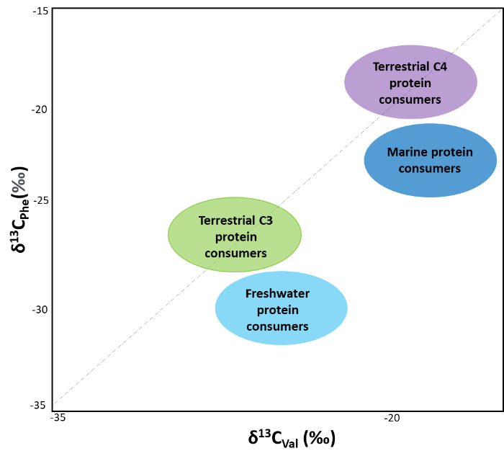
Figure S2.1: A schematic illustration showing the expected Carbon isotopic composition on Valine and Phenylalanine for different dietary types (C3, C4, high Marine Protein Consumer and freshwater protein consumers (After Honch et al. 2012)²⁰.
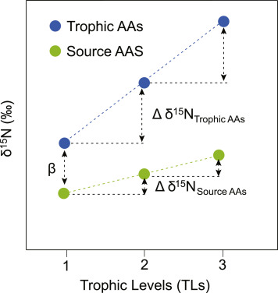
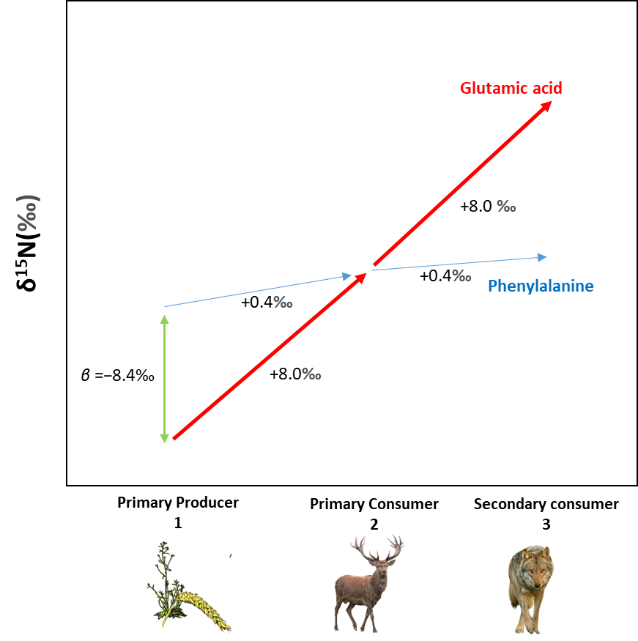

Figure S2.2 : : On the left: Schematic illustration of the relationship between the nitrogen isotope ratio of source and trophic amino acids and trophic level (TL) in a food web (altered from Chikaraishi et al., 2010)¹⁹. β indicates the offset between the nitrogen isotope ratio of the trophic amino acid and the source amino acid in a primary producer. On the right: Schematic illustration of the relationship between animal trophic position and nitrogen isotopic composition of glutamic acid and phenylalanine a terrestrial ecosystem β indicate trophic position in an ecosystem for terrestrial plants was estimated to be −8.4‰¹⁹.

2.2 Zinc isotope ratios: a dietary tracer retrieved from dental enamel
Dental enamel appeared to be less affected by diagenesis than bone collagen, therefore, investigations of the new isotopic systems have been established on the hydroxyapatite Ca₁₀(PO₄) ₆(OH)₂ of tooth tissues. The isotopic composition of Zn in human and animal tissues appears to be strongly related to diet^{22–26}.They can be analyzed in dental enamel, a tissue very resistant to diagenesis.
The variability of the ⁶⁶Zn/⁶⁴Zn ratio (expressed as δ⁶⁶Zn value) in a food web is caused by two main factors. The Zn isotopic composition from the source of intake and the Zn isotopic fractionation within the organism. In the food web, the Zn isotopic composition of primary producers, like plants, comes from the underlying bedrock. However, Zn values of this later can exhibit some variations depending on the nature of local geology^{23,27}. For instance, marine carbonate (+0.3 to +1.4‰) could display higher values than the volcanic (+0.3 ± 0.14‰ [2σ]) and other sedimentary rocks^{28–30}.
Previous work on Zn have shown a δ⁶⁶Zn enrichment in herbivore’s enamel bioapatite relative to that of carnivores. This is because plants are typically ⁶⁶Zn enriched compared to meat (Costas Rodriguez et al. 2014). Zinc isotope compositions become relatively depleted in heavy isotopes with successive trophic levels. Therefore, herbivore have systematically higher δ ⁶⁶Zn values than carnivores (δ⁶⁶Zn herbivore > δ⁶⁶Zn carnivore).
The isotopic fractionation occurs also between the different parts of an organism. For plants, this results in different isotopic composition between roots, stems and leaves. This isotopic variation within the plant affects the entire trophic web. Some Zn studies showed that animals feeding on leaves (“browsers”) have a different δ⁶⁶Zn values than those feeding on grass (“grazers”)^{25,26}. Leaves are usually ⁶⁴Zn-enriched compared to the other parts of the plants. Consequently, browsers exhibit lower Zn isotopic ratios than grazers, which diet, consist on eating the whole plants ^{26,31}. However, it has not been observed on South East Asian food webs^{22,23}. The body muscles are usually depleted in heavy Zn isotopes compared to the rest of body tissues ^{32,33}. Carnivores, which consume exclusively meat, are expected to exhibit lower zinc isotope ratios compared to their prey. This results in lower δ⁶⁶Zn values for carnivores compared to their dietary sources. Bones have a different isotopic composition than muscles as they are enriched in heavy isotopes. Consequently, bone consumers like hyena usually exhibit a different isotopic composition than carnivores who feed only meat ²⁶.
One study documented the impact of breastfeeding on Zn isotope ratios, and teeth formed during the breastfeeding time show the highest ratios ²⁷
In sum, meat consumption is associated to low δ⁶⁶Zn values -when it is revealed by elevated δ¹⁵N values in bone collagen. Conversely to nitrogen, Zn becomes relatively depleted in heavy isotopes with successive trophic levels. However, both N and Zn show higher isotope ratios in tissues of breastfed children relative to their nurturer.

2.3 Strontium isotope ratios: a mobility tracer retrieved from dental enamel

Strontium is trace element and has four naturally occurring isotopes. Three of them are stable ⁸⁴Sr, ⁸⁶Sr, ⁸⁸Sr and one is radiogenic ⁸⁷Sr. This later is produced by the process of the radioactive decay of rubidium Rb. The natural abundances of these isotopes are respectively (0.56%), (9.879%), (82.53%) and (7.04%). In fact, ⁸⁷Sr is formed overtime by the β-decay of rubidium ⁸⁷Rb (half-life ~ 4.7 × 10¹⁰ years). The amount of radiogenic ⁸⁷Sr in a rock depends on its age and its ⁸⁷Rb/⁸⁷Sr ratio. Therefore, the ⁸⁷Rb/⁸⁷Sr of bedrock varies in function to the age and the type of the rock. ^{34,35}.
The isotopic composition of strontium is expressed as a ratio ⁸⁷Sr/ ⁸⁶Sr. Generally, the ⁸⁷Sr/ ⁸⁶Sr signature of the continental crust vary between 0.700-0.750 (Price, 2002). The oldest rocks (~100mya) with expected high original ⁸⁷Rb/⁸⁷Sr will exhibit a higher ⁸⁷Sr/ ⁸⁶Sr ratio, usually above 0.710. This includes geological formations such as granite and gneiss. Younger rocks (~1-10mya) with low ⁸⁷Rb/⁸⁷Sr have usually low ⁸⁷Sr/ ⁸⁶Sr ratio (0.706) and less in basalts (0.704). On the other hand, marine limestone and dolomite exhibit an intermediate Sr signature (0.707-0.709). Although the isotopic variations seem small, they are extremely large compared to the instrumental error of the modern mass spectrometer (± 0.00001) (Bentley, 2006)³⁴.
Strontium is chemically and structurally similar to the calcium. As consequence, Sr substitutes for Ca in minerals such as calcite, dolomite and aragonite, also in enamel apatite of animal and human skeleton³⁶. Strontium is released from rocks by weathering and incorporated into the soil, ground water and stream which will be taken up by primarily producers and then passed through the food web. The fractionation of ⁸⁷Sr/⁸⁶Sr is negligible due to its large isotopic mass. Therefore, Sr signature of living being reflects that of local geology. For humans, strontium is incorporated into their skeleton via diet. Thus, their ⁸⁷Sr/⁸⁶Sr serve as a tracer of the location where the individual grew up and their skeleton was formed.

2.4 Sulphur isotope ratios: a mobility tracer retrieved from bone and tooth collagen

Sulphur (S) isotope analysis has been recently utilized as a complementary method to carbon and nitrogen analyses. It has been demonstrated to be a valuable tool for gaining insights into the mobility and consumption of marine foods ^{37,38}.
On earth, there are three main reservoirs for Sulphur: Oceanic dissolved sulphates, evaporitic sulphates and the pyrite.
Sulfur analysis is primarily based on the variations in δ³⁴S values observed across different ecosystems, such as marine, freshwater, and terrestrial environments. These variations serve as a fundamental principle for studying sulfur isotopes. In marine ecosystem, the δ³⁴S values are close +20‰ which is the value of the oceanic sulphates³⁹. Individuals living close to coastal regions display δ³⁴S values close to +20‰ due to the “sea spray effect”. Plants which are at the base of the trophic chain receive their Sulphur through soil minerals or from aerosols. The aerosols are the main sources of Sulphur for plants living close to coastal regions ⁴⁰
Meanwhile, the δ³⁴S values in the terrestrial values varies from (ca. -20‰ to +20‰) and depends on the Sulphur in the local bedrock ^{38,41}. Sulphur is released from rocks by weathering and incorporated into the soil, which will be taken up by primarily producers and then passed through the food web. For instance, δ³⁴S values are found in sedimentary sulphides and igneous minerals, while the values largely increase in geological sulphates ⁴⁰
The plants are depleted by 1.5‰ to their sources of sulphates ⁴². A small number of works shows that the isotopic fractionation between food and the consumers tissue is generally small to negligible. Therefore, the δ³⁴S values reflect the local ecosystem of the individual (Richards et al., 2003). Combining this with carbon and nitrogen, it is possible to detect seafood consumption ^{42–45}.

Supplementary Information 3: Material and Methods

3.1 Animal species and tooth identification

Faunal remains were taxonomically identified using both traditional zooarchaeology¹¹ and Zooarchaeology by mass spectrometry⁴⁶ (ZooMS) (Table 3.1). Only a small number of carnivore remains were available at the site (NISP= 9) (Table S1.1) and we sampled all teeth available for the isotopic analysis. However, those carnivores might not have a pure carnivorous diet, since many canid species can feed on a variable amount of plants⁴⁷.
One carnivore (SEVA 35834, Table 3.1) was identified by ZooMS as a Canidae (although the identification and combination of peptide markers for this sample exclude the possibility of a red fox (Vulpes vulpes) (Table S3.1). This means that this specimen more likely belongs to the Caninae subfamily. Another carnivore (SEVA 35828) was identified using traditional zooarchaeology as a red fox (Vulpes vulpes)¹¹. Among the herbivore taxa, most of them are expected to be grazers but Barbary sheep and gazelles can be mixed-feeders^{48,49}. Gazelles, Hartebeest⁵⁰ and Barbary sheep⁵¹ are also drought tolerant.

3.1.1 Zooarchaeology by mass spectrometry

ZooMS is a minimally destructive proteomic method that focuses on unidentifiable bone fragments. Through the analysis of bone collagen protein type I, it provides a taxonomic identification based on protein amino acid sequence variation. ZooMS analysis followed extraction protocols detailed elsewhere^{46,52,53}. Selected faunal specimens from Taforalt were analysed through ZooMS and sampled using pliers (10-20mg). Soluble collagen was first extracted through incubation in 100µl of 50mM ammonium-bicarbonate (AmBic) buffer at 65°C for one hour. In order to improve the taxonomic identity obtained from soluble collagen, each bone sample was demineralised in 250µl 0.6M hydrochloric acid (HCL) at 4°C for 20h. Samples were then centrifuged for 1 min at 10k rpm and the supernatant was removed. The demineralized collagen was rinsed three times in 200µl of 50mM AmBic to be neutralized to pH 7, and 100µl of 50mM Ambic was added to each sample. Next, samples were incubated at 65°C for 1h. Then, 50µl of the resulting supernatant was digested with trypsin (0.5µg/µl, Promega) at 37°C overnight, acidified using 1µl of trifluoroacetic acid (20% TFA), and cleaned on C18 ZipTips (Thermo Scientific). Digested peptides were spotted in triplicate on a MALDI Bruker plate with the addition of α-cyano-4-hydroxycinnamic acid (CHCA, Sigma) matrix. MALDI-TOF-MS analysis was conducted at the Fraunhofer IZI in Leipzig (Germany), using an autoflex speed LRF MALDI-TOF (Bruker) in reflector mode, positive polarity, matrix suppression up to 590 Da and collected in the mass-to-charge range 700-3500 m/z. Triplicates were merged for each sample and taxonomic identifications were made manually through peptide marker mass identification in comparison to a database of peptide marker series for medium to larger sized Pleistocene mammalian species^{52,54}. We performed laboratory blanks alongside the samples in order to assess any potential contamination by non-endogenous peptides. These remained empty of collagenous peptides, excluding the possibility of modern laboratory or storage contamination.

Table S3.1: The morphological and ZooMS taxinomic identification of the animal remains included in this study. S-EVA numbers are the ID giving to each sample in the Max Planck Institute for Evolutionary Anthropology.

ID | Sector | S-EVA | Zooarchaological identification | Tissue Type | ZooMS | Final identification | Latin name
TAF 10- 11408 |  | 34565 | Equus | M |  | Equus | Equidae
TAF 05- 3475 | sector 10 | 34566 | Barbary sheep |  |  | Barbary sheep | Ammotragus lervia
TAF.13-12280 | sector 10 | 35819 | Barbary sheep | M3 | Unidentifiable | Barbary sheep | Ammotragus lervia
TAF.04-379 | sector 8 | 35820 | Equus | M1 /2 | Equidae | Equus | Equidae
TAF.13-11819 | sector 10 | 35821 | Barbary sheep | dm3 | Caprinae (Ovis) | Barbary sheep | Ammotragus lervia
TAF.13-11617 | sector 10 | 35822 | Equus | I | Equidae | Equus | Equidae
TAF 05-2907 | sector 10 | 35823 | Hare | bone | Unidentifiable | Hare | Lepus
TAF-1807 |  | 35824 | Bovid | M3 | Alcelaphinae | Hartebeest | Alcelaphus buselaphus
TAF.04- 2188 |  | 35825 | Equus | M3 | Equidae | Equus | Equidae
TAF 13 - 12127 | sector 10 | 35826 | Equus | dp | Equidae | Equus | Equidae
TAF 08- F23 | sector 4 | 35827 | Alcelaphus | M2 | Alcelaphinae | Hartebeest | Alcelaphus buselaphus
TAF 05- 2498 | sector 10 | 35828 | Fox | M1 | Unidentifiable | Fox | Vulpes Vulpes
TAF 05- 2649 | sector 10 | 35829 | Gazelle | M3 | Bovidae (not Bovinae or Caprinae) /  Cervinae / Giraffidae | Gazelle | Gazella sp.
TAF 13- 11933 | sector 10 | 35830 | Barbary sheep | I | Caprinae (Ovis) | Barbary sheep | Ammotragus lervia
TAF 13- 11757 | sector 10 | 35831 | Barbary sheep | M2 | Caprinae (Ovis) | Barbary sheep | Ammotragus lervia
TAF 13- 11660 | sector 10 | 35832 | Gazelle | P2/P3 |  | Gazelle | Gazella sp.
TAF 05- 2450 | sector 10 | 35833 | Gazelle | P | Antilopinae | Gazelle | Gazella sp.
TAF 10- 11226 | sector 10 | 35834 | Canid | M | Canidae (not red fox) | Canid | Canidae
TAF 04- 1842 | sector 8 | 35835 | Gazelle | P2 |  | Gazelle | Gazella sp.
TAF 04- 375 | sector 8 | 35836 | Rhinoceros | P or M | Rhinocerotidae | Rhinoceros | Rhinocerotidae

3.2 Human teeth and bones
The human teeth were scanned using a micro-CT scanner in the Department of Human Evolution at MPI-EVA (Leipzig, Germany. 23 teeth and 7 bones belonging to a maximum of 13 individuals from the site of Taforalt were analyzed in this study (Table S3.2). Most of the samples belong to 7 individuals buried in the sector 10⁶. The other samples were isolated and are therefore described as “unassigned”. The teeth were scanned and revealed an important amount of hypoplasia (78% of our samples; n=23) and caries (13% of our samples; n=23). All 3D scans are not available online but are shared by the authors after request. The location of the caries and hypoplasia can be seen on the Supplementary Information 7 and are summarized in the Table S3.3. Areas sampled for Sr and Zn isotope measurement can also be seen on the Supplementary Information 7 (Teeth scans).
The sampling strategy is described in detail in section 3.3.1.1, titled "Strategy of Tooth Sampling. The approximate areas that were sampled in the vertical plane are represented by arrows on the tooth scans (Supplementary Information 7). However, it is crucial to note that these arrows provide a general indication of the sampled regions and do not accurately represent the depth or width of the sampled areas.
Most of the teeth analysed in this study show the presence of dentine or enamel stress (Supplementary Information 4), indicating periods of disruption during the formation of the teeth, which could be related to nutritional stress^{55,56}. The presence of linear enamel hypoplasia among teeth formed early in life (i.e., incisors and canine) might be linked to weaning, which is usually considered a stressful nutritional period for infants⁵⁵.
In the case of individual 6 analyzed at Taforalt, while it is possible that the observed findings align with dietary factors, it is important to exercise caution in interpreting them solely as indicators of nutritional stresses. The stress could also be influenced by factors such as genetic, environmental, or psychological stress⁵⁷. Thus, considering alternative possibilities, the presence of stress indicators in specific parts of the tooth formed later in an individual's life (e.g., 2nd molar, third molar) could potentially signify other types of stresses.
Compared to the Natufian population, the Iberomaurusians from Taforalt exhibit a much higher frequency of caries^{4,58}. The presence of enamel hypoplasia has been attested in Natufian sites like Nahal Oren in the Levant, mainly between the age of 3-7 years ⁵⁸. However, we could not establish the frequency of this stress between Natufians and our samples due to our limited sample size.

Individual | SEVA | ID | Element | Sex | Age at death
1 | 35961 | TAF_06_3966 | M2 | male | 20 yrs
1 | 35962 | TAF_06_4164 | M2 | male | 20 yrs
1 | 35967 | TAF_06_3966 | I2 | male | 20 yrs
1 | 35970 | TAF_06_3967 | M | male | 20 yrs
1 | 35979 | TAF_06_4167 | P4 | male | 20 yrs
1 | 35985 | TAF_06_H576 | bone | male | 20 yrs
1 | 35963.A | TAF_06_4164 | C | male | 20 yrs
1 | 35963.B | TAF_06_4164 | M2 | male | 20 yrs
2 | 35981 | TAF_05_3281 | bone | ND | ND
5 | 35977 | TAF_08_6875 | M2 | female | 16-18 yrs
5 | 35978 | TAF_08_6875 | C | female | 16-18 yrs
5 | 35971.A | TAF_08_6880 | I1 | female | 16-18 yrs
5 | 35971.B | TAF_08_6880 | M1 | female | 16-18 yrs
6 | 35964 | TAF_06_4753 | dm2 | male | 6-12 mo
6 | 35965 | TAF_06_4753 | di1 | male | 6-12 mo
6 | 35982 | TAF_08_5883 | bone | male | 6-12 mo
6 | 35983 | TAF_08_5753 | bone | male | 6-12 mo
9 | 35966 | TAF_09_8111 | di1 | female | 5-6 mo
9 | 35966 | TAF_09_8111 | bone | female | 5-6 mo
13 | 35975 | TAF_13_1000 | M3 | male | 18-20 yrs
13 | 35975 | TAF_13_1000 | bone | male | 18-20 yrs
14 | 35980 | TAF_10_10105 | P4 | male | 18-20 yrs
unassigned | 35959 | TAF_05_2882 | bone | ND | ND
unassigned | 35959 | TAF_05_2882 | I | ND | ND
unassigned | 35960 | TAF_05_3380 | I2 | ND | ND
unassigned | 35968 | TAF_04_1031 | M3 | ND | ND
unassigned | 35969 | TAF_05_3685 | I2 | ND | ND
unassigned | 35972 | TAF_06_4224 | P3 | ND | ND
unassigned | 35973 | TAF_05_3144 | I2 | ND | ND
unassigned | 35974 | TAF_06_3907 | M3 | ND | ND
unassigned | 35976 | TAF_05_3613 | M | ND | ND
unassigned | 34561 | TAF_10_11025 | I1 | ND | ND

Table S3.2: The human samples from the sector 10 of Taforalt. analyzed in this study with their sex and age of death estimation (from Humphrey et al., 2019) ⁶. SEVA are the identification numbers used at the Max Planck Institute for Evolutionary Anthropology). The ID are the identification numbers given to the samples during the excavations. ND stands for Not Determined

Table S3.3: Caries and hypoplasia presence in the human teeth from Taforalt included in this study. Hypoplasia are detected on the CT scans (3D models and 2D virtual sections in Supplementary 7). We utilized the positioning of hypoplasia within the teeth in relation to the tooth's developmental timeline ⁵⁹to make an approximate estimation of its occurrence period.

Individual | sex | age of death | SEVA | tooth | presence of caries | presence of hypoplasia | location | period of hypoplasia/ stress
1 | male | 20 yr | 35963.B | LLM2 | yes | yes | Whole tooth | 3yrs-16yrs
1 | male | 20 yr | 35961 | ULM2 | no | yes | Whole tooth | 3.5 yrs-16yrs
1 | male | 20 yr | 35963.A | LLC | no | yes | Whole tooth | 4yrs- 14yrs
1 | male | 20 yr | 35962 | LLM2 | yes | yes | root | 7 yrs- 15yrs
1 | male | 20 yr | 35970 | UxM | no | yes | crown | ?
1 | male | 20 yr | 35967 | LRI2 | no | yes | Whole tooth | 3 yrs-10yrs
5 | female | 16-18 yr | 35971.A | LLI1 | no | yes | Whole tooth | small hypoplasia around  3 yrs and again 5yrs
5 | female | 16-18 yr | 35971.B | LRM1 | no | yes | crown enamel | between 2.5 yrs and 5 yrs
5 | female | 16-18 yr | 35978 | ULC | no | no | crown | light EH around 3.5 yrs
6 | male | 6-12 mo | 35965 | URdi1 | no | yes | root dentine | 4.5mo-11mo
6 | male | 6-12 mo | 35964 | URdm2 | no | no
9 | female | 5-6 mo | 35966 | ULM2 | no | no
13 | male | 18-20 yr | 35975 | LRM3 | no | yes | crown enamel | around 13-14yrs
14 | male | 18-20 yr | 35980 | LRP4 | no | yes | Whole tooth | 4yrs- 10yrs
unassigned |  |  | 35959 | LxI | no | yes | root | 3yrs- 11yrs
unassigned |  |  | 35960 | llI2 | no | yes | Whole tooth | strong EH 3yrs-5yrs + slight stress between 5 and 10yrs
unassigned |  |  | 35968 | ULM3 | no | yes | Whole tooth | 14yrs-16yrs
unassigned |  |  | 35969 | LRI2 | no | yes | root | 7yrs-10yrs
unassigned |  |  | 35972 | LLP3 | no | yes | root | 6yrs-10yrs
unassigned |  |  | 35973 | LRI2 ou LRC | no | no
unassigned |  |  | 35974 | ULM3 | yes | yes | crown and root | 12 yrs-
unassigned |  |  | 35976 | LRM | no | yes | crown and root | ?
unassigned |  |  | 34561 | UI1

3.3 Isotope analyses
3.3.1 Stable zinc and radiogenic strontium isotope analyses
Zinc and strontium isotopic analyses were conducted in the Max Planck Institute for evolutionary anthropology, Leipzig, Germany.
3.3.1.1 Strategy of tooth sampling for herbivores:
Section 1: Human Teeth Sampling Approach
To investigate potential variations during tooth development in humans, we employed a sampling approach that involved collecting enamel samples from both the upper (Top) and lower (Bottom) parts of the crown (Excel Table SI3). This allowed us to track any potential isotopic variations across the different stages of tooth formation. However, it should be noted that this sampling approach was not systematically conducted for all teeth.
Enamel samples were collected using a precise and minimally disruptive method. We used a diamond-tipped drill to mechanically extract a powder from multiple parts along the height of the tooth crown. The amount of enamel collected ranged from 5 to 20 mg, ensuring that we captured sufficient material for isotopic analysis while minimizing any disruption to the tooth structure.
To estimate the period of formation for each tooth, we referred to the study by Al Qahtani (2012) ⁵⁹. This reference provided valuable information for determining the timing of tooth development. Additionally, we utilized the work of Reid and Dean ⁶⁰ to estimate the age of the sampled enamel for each tooth. However, it is important to note that Reid and Dean did not provide the timing of formation specifically for premolars and deciduous teeth. Therefore, to overcome this limitation, we estimated the timing of formation for these teeth using the data from Al Qahtani (2012). For more specific details are found in accompanying Excel document (Table SI3).

Section 2: Animal Teeth Sampling Approach
In the case of animal teeth, particularly herbivores, we implemented a multisampling method to account for potential isotopic variations. Animals such as Equids, with teeth of sufficient height, provided an opportunity for multisampling. We collected samples from the tooth crown at multiple points, approximately 3-5 times along its height (5 to 20 mg). This multisampling approach facilitated the tracking of isotopic changes from approximately the initiation of enamel formation of the tooth to the completion of crown formation.
By employing these specific sampling approaches for human and animal teeth, we aimed to comprehensively investigate isotopic variations within tooth formation. These methods allowed us to track isotopic changes throughout tooth development and gain insights into dietary patterns, environmental influences, and the potential for isotopic variation over time.
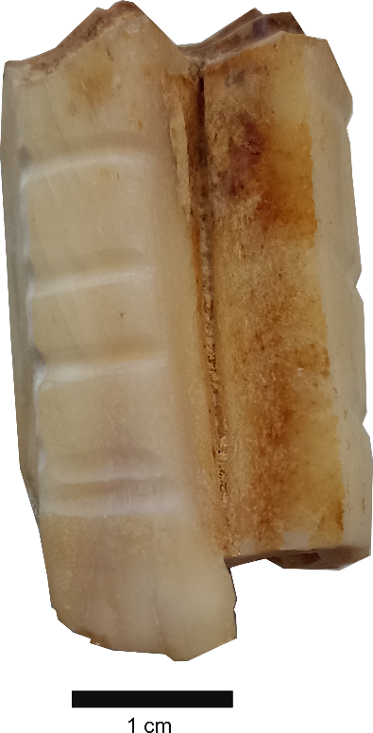
Figure S.3.1 An example of sampling Strategy for Zn Isotope Analysis in a Horse Tooth

3.3.1.2 Column chromatography and isotope analyses
Zinc and strontium were extracted from tooth enamel. For every preparation batch, we included 2 control beakers. The first one contains the powder of a standard sample to control the ⁸⁷Sr/⁸⁶Sr or the δ⁶⁶Zn of each batch and the second is a blank beaker to make sure that contamination was avoided during the preparation of samples for the isotopic measurements.
The purification step of zinc was achieved using the ion exchange method. The samples were dissolved in 1 ml of HCl, evaporated then dissolved in 1.5 HBr. The Zn was purified following the the protocol adapted from Moynier et al. (2006)³⁰ and described in Jaouen et al., 2016²⁶. The purification of Zn was achieved on AG1X8 resin chloride foam using 2ml of 1.5 HBr. For the Zn elution, we used 5ml of HNO3. Contamination control was achieved through including an in-house standard AZE bone powder and a blank at each prepared batch. The Zn isotope ratios were measured at a Thermo Neptune Plus Multi-collector ICP-MS at Max Planck Institute for Evolutionary Anthropology (Leipzig, Germany). The isotopic ratios of zinc were measured and every sample was repeated twice using standard sample bracketing and Cu doping and then average values were calculated. All the zinc data are reported δ notation in per mil relative to a standard reference.
δ⁶⁶Zn = (⁶⁶Zn /⁶⁴Zn sample/⁶⁶Zn /⁶⁴Zn standard - 1) × 1000
The Zn concentrations were estimated by measuring the ⁶⁴Zn signal intensity of three solutions (150 ppb, 300 ppb, 600 ppb) and the δ⁶⁶Zn are reported relative to the standard JMC-Lyon.
For strontium, the purification was achieved using the protocol adapted from Copeland et al. (2008)⁶¹. The enamel was dissolved in 2ml of HNO3 evaporated and subsequently dissolved in 3N HNO3. The Sr, was purified using Sr.spec.TM resin and eluted from the resin with 1.5 ml ultrapure deionized Milli Q water before evaporation. The dry samples were dissolved in 2ml 3% HNO3 for the isotopic measurements. The Sr isotopic ratios were measured on the Thermo Neptune Multicollector ICP-MS (Inductively coupled plasma mass spectrometry). The interference from rubidium (Rb) with ⁸⁷Sr/⁸⁶Sr measurements was corrected based on the repeated analysis of standard (SRM 987). The Sr concentration were calculated by measuring the ⁸⁸Sr signal intensity (V) of three diluted solutions with known concentrations (100ppb, 400ppb, and 700ppb).
3.3.2 Carbon, nitrogen and sulphur isotope analyses
For collagen extraction, both human and animal tooth dentine and bone samples, weighing between ~200 and 500 mg, were carefully removed using a diamond-tipped burr. Collagen was extracted following the protocol described in Talamo and Richards (2011)⁶². Dentine and bone were cleaned by abrasion then demineralized in HCl for several weeks at 4°C. Samples were immersed in NaOH for 30 minutes. The purified solution containing collagen was rinsed and soaked again in HCl. The insoluble collagen was solubilized in HCl (pH=3) at 75°C for 20 hours. The supernatant containing the collagen was filtered with Ezee filters then ultra-filtrated to collect the >30kDa collagen molecules, frozen for 48 h and lyophilized.
The C and N isotopic ratios were obtained using a Thermo Finnigan Flash EA coupled to a Delta V isotope ratio mass spectrometer. Carbon and nitrogen stable isotope ratios were respectively measured relative to VPDB (Vienna PeeDee Belemnite) and to AIR (atmospheric N₂). The analytical error of 0.1 and 0.2 for δ¹³C and δ¹⁵N were determined by the repeated analysis of internal and international standards.
3.3.3 Sulphur isotope analyses
The sulphur isotopic analyses were conducted by the Isoanalytical Ltd. company (Crewe, UK). Eight mg of collagen were loaded into tin capsules in addition to the NBS-1577B (bovine liver powder) standard used as a control. The samples and the standards were measured using an EA-IRMS (ANCA-GSL/20-20, Europa Scientific, Crewe, UK) and the isotope ratios are reported to the international reference standard VCDT (Vienna-Canyon Diablo Troilite).
3.3.4. Compound specific isotopic analyses of amino acid
The CSIA-AA isotope analyses were conducted in the commercial Stable Isotope Facility of the University of Davis, California. The samples were analyzed following the protocol developed by (Yarnes & Herszage, 2017)⁶³. The detailed procedure is described in: (https://stableisotopefacility.ucdavis.edu/compound-specific-13c-15n-analysis-amino-acids-gc-c-irms)

Supplementary Information 4. Results

4.1 Data quality assessment

Several reference materials (SRM 1400 and SRM 1486) were prepared and analyzed along with the samples and gave values in the range of the previous ones reported in the literature (Table S4.1).

Table S4.1: Zinc and Sr isotope ratios of reference materials from this study and literature data ^{22,23,25–27,64,65}.
 | This study |  |  | Literature data
 | δ⁶⁶Zn | SD | n | δ⁶⁶Zn | SD | References
SRM 1400 | 0.93 | 0.03 | 5 | 0.96 | 0.02 | Jaouen et al. (2018, 2020, 2022);  Bourgon et al (2020, 2021);McCormack et al (2021)
SRM 1486 | 1.23 | 0.04 | 2 | 1.2 | 0.04 | Jaouen et al. (2016), McCormack et al (2021)
 | ⁸⁷Sr/⁸⁶Sr | SD | n | ⁸⁷Sr/⁸⁶Sr |  | References
SRM 1486 | 0.7093 | 2E-05 | 7 | 0.703 | 3E-05 | Long term value at MPI-EVA, n=137

The weight percentage of carbon (wt% C) and nitrogen (wt% N) in samples ranges respectively from 47.8 to 14.4% and 17.1 to 5.6% and the atomic ratio fall within the acceptable range (3.0-3.3). We were able to extract enough collagen to conduct CSIA for 54% of the samples and Sulphur isotope analyses for 3 samples.
Reference materials were analyzed along with the samples and gave results consistent with the expected values (Table S4.2). Sulphur isotope ratios were commercially analyzed by the society Isoanalytical are given in the Table S4.3

Table 4.2: Carbon and N isotope ratios of reference materials from this study and literature data.
 |  | This study |  |  |  | Expected values
 | Material | δ¹³C (‰, VPDB) | SD | δ¹⁵N (‰, AIR) | SD | δ¹³C (‰, VPDB) | δ¹⁵N (‰, AIR)
IAEA N1 CH6 (n=12) | ammonium sulfate | -10.47 | 0.3 | 0.43 | 0.04 | −10.449 ± 0.03 | 0.43 ± 0.07
IAEA N2 CH7 (n=12) | ammonium sulfate | -32.13 | 0.04 | 20.35 | 0.05 | −32.151 ± 0.05 | 20.41 ​± 0.12

Table S4.3: Reference standards used for Sulphur stable isotopes analyses along with the accepted values
Standard | material | n | δ ³⁴S_{V-CDT (mean)} | SD | accepted values
IA-R061 | (barium sulphate) | 3 | 20.26 | 0.03 | 20.33
IAEA-SO-5 | (barium sulphate) | 2 | 0.35 | 0.19 | 0.50
IA-R068 | (soy protein) | 2 | 5.09 | 0.13 | 5.25
IA-R069 | (tuna protein) | 2 | 18.89 | 0.15 | 18.91

Carbon and nitrogen isotope measurements on single amino acids were commercially performed by the University of Davis. The measurements are calibrated against certified standard reference materials from USGS and IAEA. Internal reference materials with known isotopic values are used to measure accuracy and reproducibility. Reference materials were analyzed along with the samples and gave results consistent with expected values (Table S4.4). For Carbon and Nitrogen, the His, Met are below LOQ for all samples. Hyp, Ile, Tyr are below LOQ for select samples.

In addition, we performed two additional controls:
- - We sent the reference material SRM 1477c (bovine liver) that was previously analyzed and published in Jaouen et al (2019)⁶⁶ (Table S4.4) The carbon, the amino acids Ala, Gly, Leu, Lys, Val, Pro Phe and Val are within the values published in Joauen et al. 2019 except for the Asx, Glx and Thr. Since the publication of Jaouen et al., 2019, significant advancements have been made in measuring carbon isotopic values of threonine (Thr). Unfortunately, there is currently a lack of available carbon isotopic data on Thr for SMR1577C beyond the aforementioned study. We should also mention that we did not include the Thr results in our PCA (Figure S4.19). Our current findings differ from those reported in Jaouen et al. 2019, but we cannot definitively determine whether our values or the values published in 2019 are accurate.
- For nitrogen (Table 4.4) Ala, Asx, Glx, Leu, Pro, Ser, Thr and Val are within the published values except for Lys, Phe.

 |  | Ala |  | Asx |  | Glx |  | Gly |  | Leu |  | Lys
δ¹³C |  | This study | Jaouen et al.2019 | This study | Jaouen et al.2019 | This study | Jaouen et al.2019 | This study | Jaouen et al.2019 | This study | Jaouen et al.2019 | This study | Jaouen et al.2019
δ¹³C | Mean value | -20.18 | -19.82 | -16.06 | -12.81 | -14.63 | -16.56 | -10.04 | -8.10 | -28.89 | -29.66 | -16.64 | -15.89
δ¹³C | SD | 1.14 | 0.47 | 0.91 | 0.25 | 0.51 | 0.41 | 0.98 | 1.15 | 0.01 | 0.71 | 0.17 | 1.2
δ¹³C | n | 2 | 3 | 2 | 3 | 2 | 3 | 2 | 3 | 2 | 3 | 2 | 1
δ¹³C |  | Phe |  | Pro |  | Ser |  | Thr |  | Tyr |  | Val
δ¹³C |  | This study | Jaouen et al.2019 | This study | Jaouen et al.2019 | This study | Jaouen et al.2019 | This study | Jaouen et al.2019 | This study | Jaouen et al.2019 | This study | Jaouen et al.2019
δ¹³C | Mean value | -25.15 | ﻿-25.1 | -18.35 | -18.68 | -7.78 |  | -9.74 | -7.23 | -30.9 |  | -24.57 | -25.2
δ¹³C | SD | 0.23 | 0.50 | 0.59 | 0.19 | 0.77 |  | 0.06 | 0.25 | 1.2 |  | 0.18 | 0.3
δ¹³C | n | 2 | 3 | 2 | 3 | 2 |  | 2 | 1 | 2 |  | 2 | 3
Table S4.4: Carbon and nitrogen isotope ratios of single amino acids measured in the reference material SRM 1577c in our study compared to published values in Joauen et al., 2019.⁶⁶

 |  | Ala |  | Asx |  | Glx |  | Leu |  | Lys |  | Phe
δ¹⁵N |  | This study | Jaouen et al.2019 | This study | Jaouen et al.2019 | This study | Jaouen et al.2019 | This study | Jaouen et al.2019 | This study | Jaouen et al.2019 | This study | Jaouen et al.2019
δ¹⁵N | Mean value | 12.18 | 10.37 | 10.01 | 10.27 | 10.69 | 10.30 | 7.24 | 4.95 | 7.02 | 2.75 | 10.10 | 8.25
δ¹⁵N | SD | 0.38 | 0.61 | 0.88 | 1.15 | 0.68 | 0.40 | 0.16 | 1.86 | 0.67 | 1.11 | 0.38 | 0.12
δ¹⁵N | n | 2 | 3 | 2 | 3 | 2 | 3 | 2 | 3 | 2 | 2 | 2 | 3
δ¹⁵N |  | Pro |  | Ser |  | Thr |  | Tyr |  | Val
δ¹⁵N |  | This study | Jaouen et al.2019 | This study | Jaouen et al.2019 | This study | Jaouen et al.2019 | This study | Jaouen et al.2019 | This study | Jaouen et al.2019
δ¹⁵N | Mean value | 14.91 | 13.70 | 10.85 | 9.37 | -6.74 | -5.77 | 4.76 |  | 10.48 | 10.77
δ¹⁵N | SD | 0.02 | 0.57 | 0.78 |  | 1.2 | 0.88 | 0.81 |  | 0.73 | 0.63
δ¹⁵N | n | 2 | 3 | 2 | 1 | 2 | 3 | 2 |  | 2 | 3

- Following the recommendations of ﻿O'Connell and Collins (2017), we verified the existence of a correlation between isotope ratios measured in hydroxyproline and proline (Figure S4.1 and S4.2).
According to a previous study, the correlation between the δ¹⁵N values of the proline (Pro) and hydroxyproline (Hyp) is essential to assess the data quality (O’Connell and Collins, 2018)⁶⁷. Since the nitrogen in Hyp is synthesized from Pro ⁶⁸, their δ¹⁵N values are expected to be relatively equal and the plot of δ¹⁵H_{Hyp} vs. δ¹⁵N_{Pro} should give a slope close to 1. We verified this on our samples and it shows that there is a strong correlation between the δ¹⁵N values of these amino acids (y= 0.962x+ 0.373; R² = 0.9907) (figure S4.1).
For Carbon, the δ¹³C_{Hyp} was plotted against δ¹³C_{Pro} but the slope was (y = 0.8652x - 3.276
R² = 0.5741), which is inconsistent with the slope of 1 expected (Figure S4.2) Hydroxyproline data are systematically enriched compared to proline data. For this reason, we plotted in grey color (Figure S4.2) the samples that showed an offset superior to 1‰ between δ¹³C_{Hyp} and δ¹³C_{Pro} (Figure S4.2). It corresponds to 9 samples out of 29 samples.
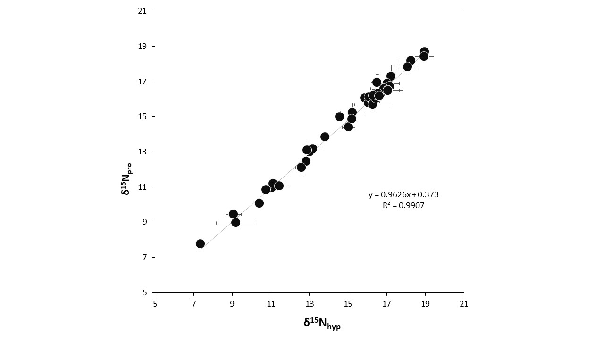
Figure S4.1: Comparison of collagen proline and hydroxyproline δ¹⁵N values of the animals and humans from Taforalt
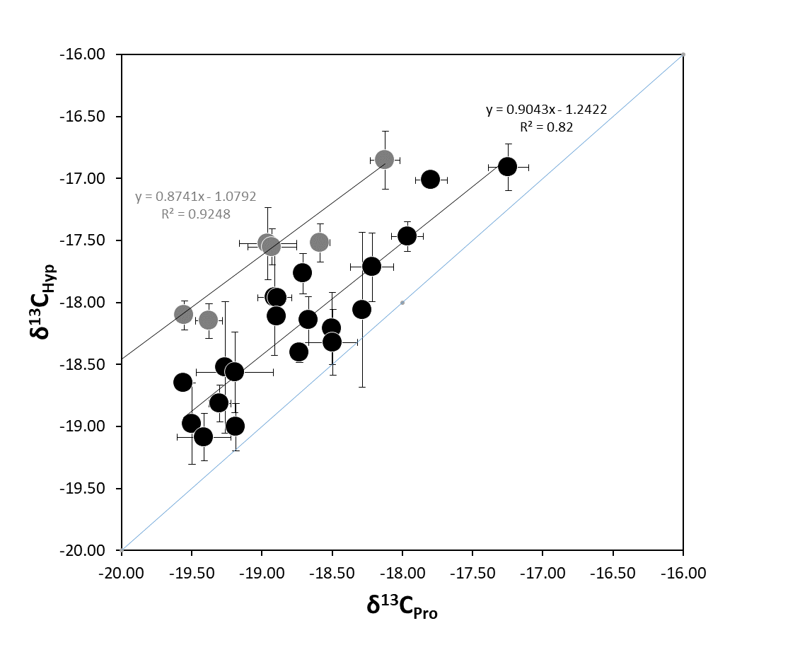
Figure S4.2: Comparison of collagen proline and hydroxyproline δ¹³C _{values} from our study. The blue line shows the expected slope x=y for the δ¹³C_{Hyp} against δ¹³C_{Pro}. The black point are the samples which showed an offset inferior to 1‰ between δ¹³C_{Hyp} and δ¹³C_{Pr}; the grey point showed an offset superior to 1‰ between δ¹³C_{Hyp} and δ¹³C_{Pro}

4.2 Sample preservation

Zinc and strontium were extracted from the tooth enamel of human and animal remains which is generally more resistant to diagenetic alteration^{69,70}.
Zinc isotope ratios correlation between concentrations in tooth enamel show (Figure SI 4.3), is used to test the good preservation of dietary biogenic signatures δ⁶⁶Zn signatures⁷¹. There is a slight correlation between the Zn isotopic ratios and the concentrations (1/conc) in our samples (p-value= 0.000008329) (Figure S4.3), however, this correlation is likely of diet origin: The human enamel systematically has higher Zn concentration than the other animals, and since most of our samples consist of herbivore which have usually lower Zn concentration they create a correlation between δ⁶⁶Zn and the concentration (Figure 4.3). However, there is no correlation between the concentration and the zinc isotope ratio if we consider human and animals separately
The ⁸⁷Sr/⁸⁶Sr and Sr concentration of our samples show no correlation indicating the preservation of biogenic strontium (Figure SI 4.4).
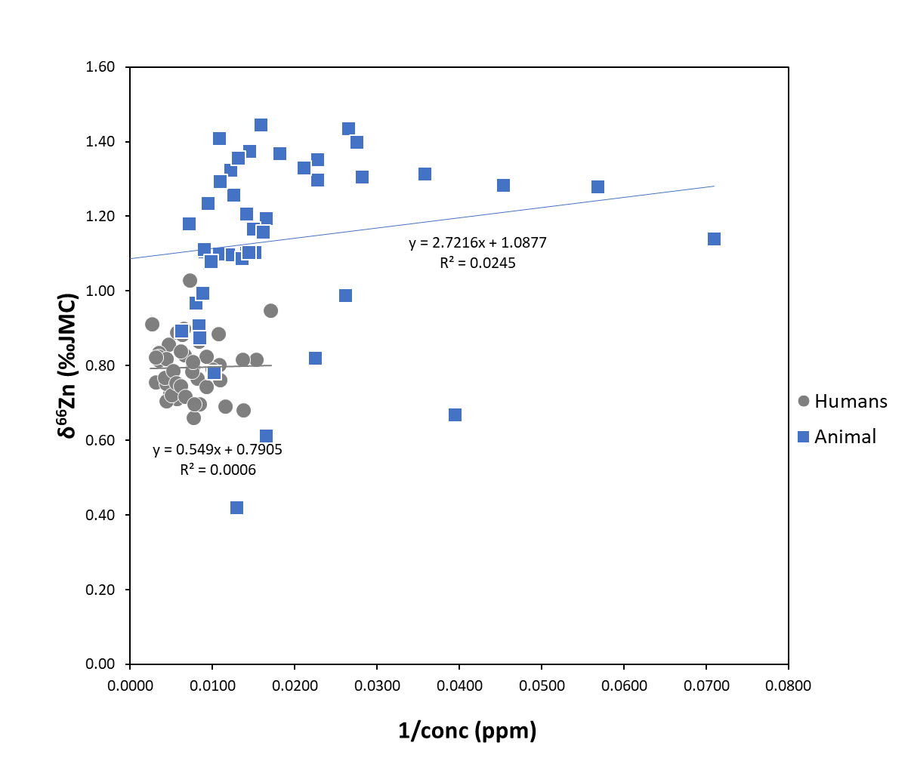

Figure S4.3: Relationship between the Zn isotope ratio and Zn concentration in enamel of fossil teeth from Taforalt, Morocco.

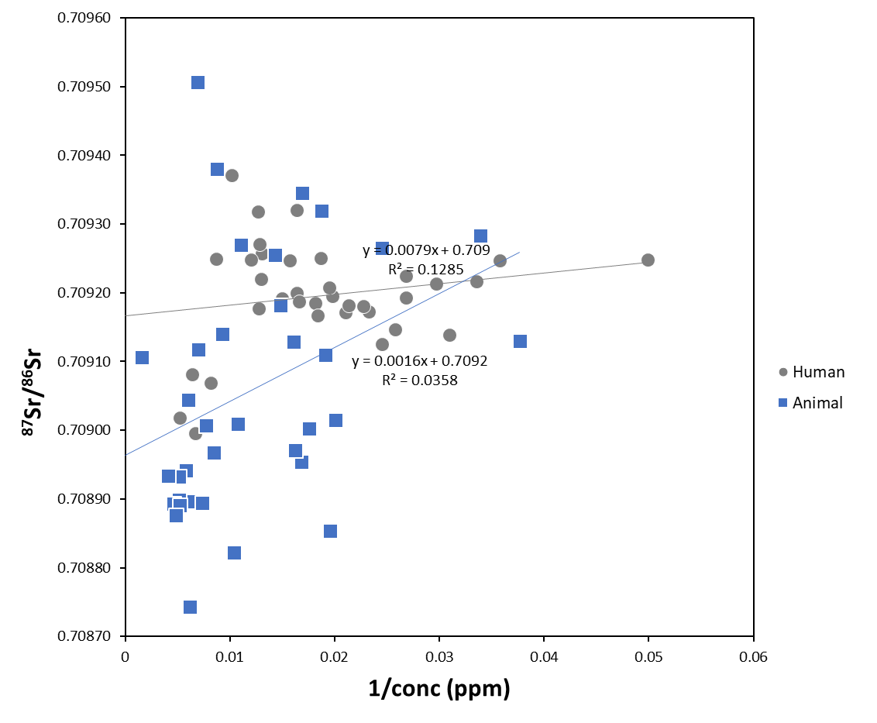
Figure S 4.4: Relationship between the Sr isotope ratio and Sr concentration in enamel of human and animal teeth from Taforalt, Morocco.

4.3 Zinc isotopic data
The δ⁶⁶Zn values of the animals from Taforalt ranges from 1.45 to 0.42 ‰ which is comparable with the range observed in the modern food web of Koobi Fora (Kenya) and Gabasa (Spain) ^{26,64}. The δ⁶⁶Zn enamel values are clearly different between dietary groups (herbivores and carnivores, Figure S4.5) (Kruskal Wallis chi-squared = 21.205, df = 2, p-value = 0.00002485). The herbivores exhibit the highest δ⁶⁶Zn values ranging from 1.45 to 0.67 ‰ (1.17± 0.18‰, n= 14). If we exclude the deciduous teeth which are likely to exhibit higher Zn isotope ratios, from the effect of breasfeeding, ²⁷ the herbivore group have an average δ⁶⁶Zn of (1.15 ± 0.18‰, n= 13). The carnivores (a fox and a canid), on average, show lower values (0.52 ± 0.14‰, n=2) (Figure 3). The trophic level spacing is therefore of 0.64 ‰, which fit with ranges observed in other food webs ^{23,26,72}.

4.3.1. The zinc variability among herbivores:

In Taforalt, we observe a clear pattern of δ⁶⁶Zn between herbivore species (Kruskal-Wallis chi-squared = 19.287, df = 2, p-value = 0.00006484) (Figure 4.5). Grazers have the highest δ⁶⁶Zn values (1.28‰ ± 0.15, n= 21). The browsers (e.i Gazelle) and mixed feeders (e.i Barbary sheep) have lower δ⁶⁶Zn values. This pattern is similar to what is observed in the modern food web of Koobi Fora in the African Savannah ²⁶, and could be due to their consumption of leaves and fruits. The roots, shoots and all low growing plants are usually more enriched in heavy Zn isotopes, while tree leaves have lower δ⁶⁶Zn values^{31,73}.
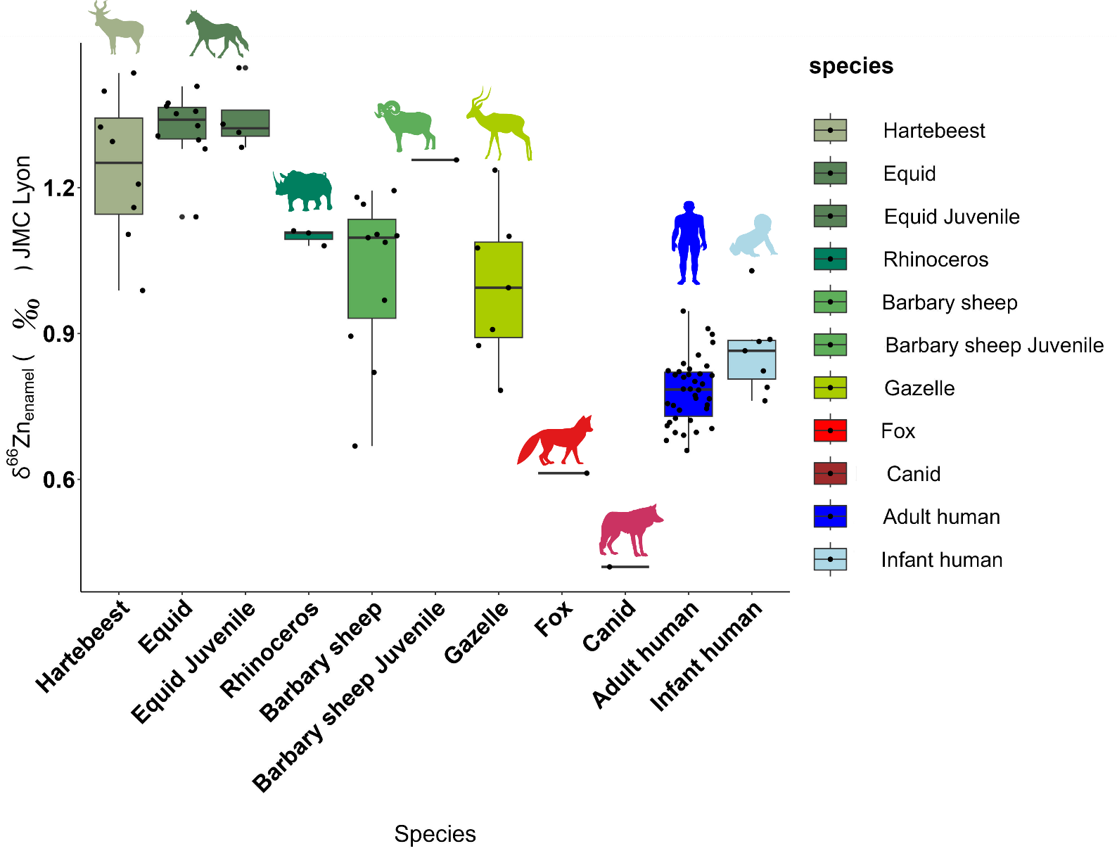
Figure S4.5: Zinc isotopic ratios in tooth enamel of various animal species and the humans analyzed in this study.

The humans from Taforalt have elevated δ⁶⁶Zn values (0.78 ± 0.07‰, n= 21) that are close to that of the herbivores from the same site. The offset between the humans and the herbivores is 0.36 ‰.

4.3.2. The zinc isotopic variations among human individuals
The zinc isotopic values do not vary significantly among the analyzed individuals if we consider the average value of each individual (Kruskal-Wallis chi-squared = 5, df = 5, p-value = 0.4159).
No sex-related distinction could be observed from Taforalt. The Zn isotopic values show no significant relationship to the sex of the adult individuals (Kruskal-Wallis chi-squared = 2.0061, df = 2, p-value = 0.3668, Figure S4.6). The same thing applies to nitrogen isotopic values (Kruskal-Wallis chi-squared = 0.32468 , df = 2, p-value = 0.5688, Figure S4.7). However, the sample size is too small to generalize for the entire population.

Table S 4.5: Chi-squared and p-value of Kruskal Wallis tests comparing Zn and N isotope ratios with the gender of the human samples from Taforalt

No age considered | chi-squared | p value | p-value<0.05
Biological sex (Zn) | 2.6549 | 0.2652 | No
Biological sex (N) | 0.1343 | 0.9350 | No

Infant | chi-squared | p value | p-value<0.05
Biological sex (Zn) | 0.0000 | 1.0000 | No
Biological sex (N) | 0.2143 | 0.6434 | No

Adult | chi-squared | p value | p-value<0.05
Biological sex (Zn) | 2.0061 | 0.3668 | No
Biological sex (N) | 0.3247 | 0.5688 | No

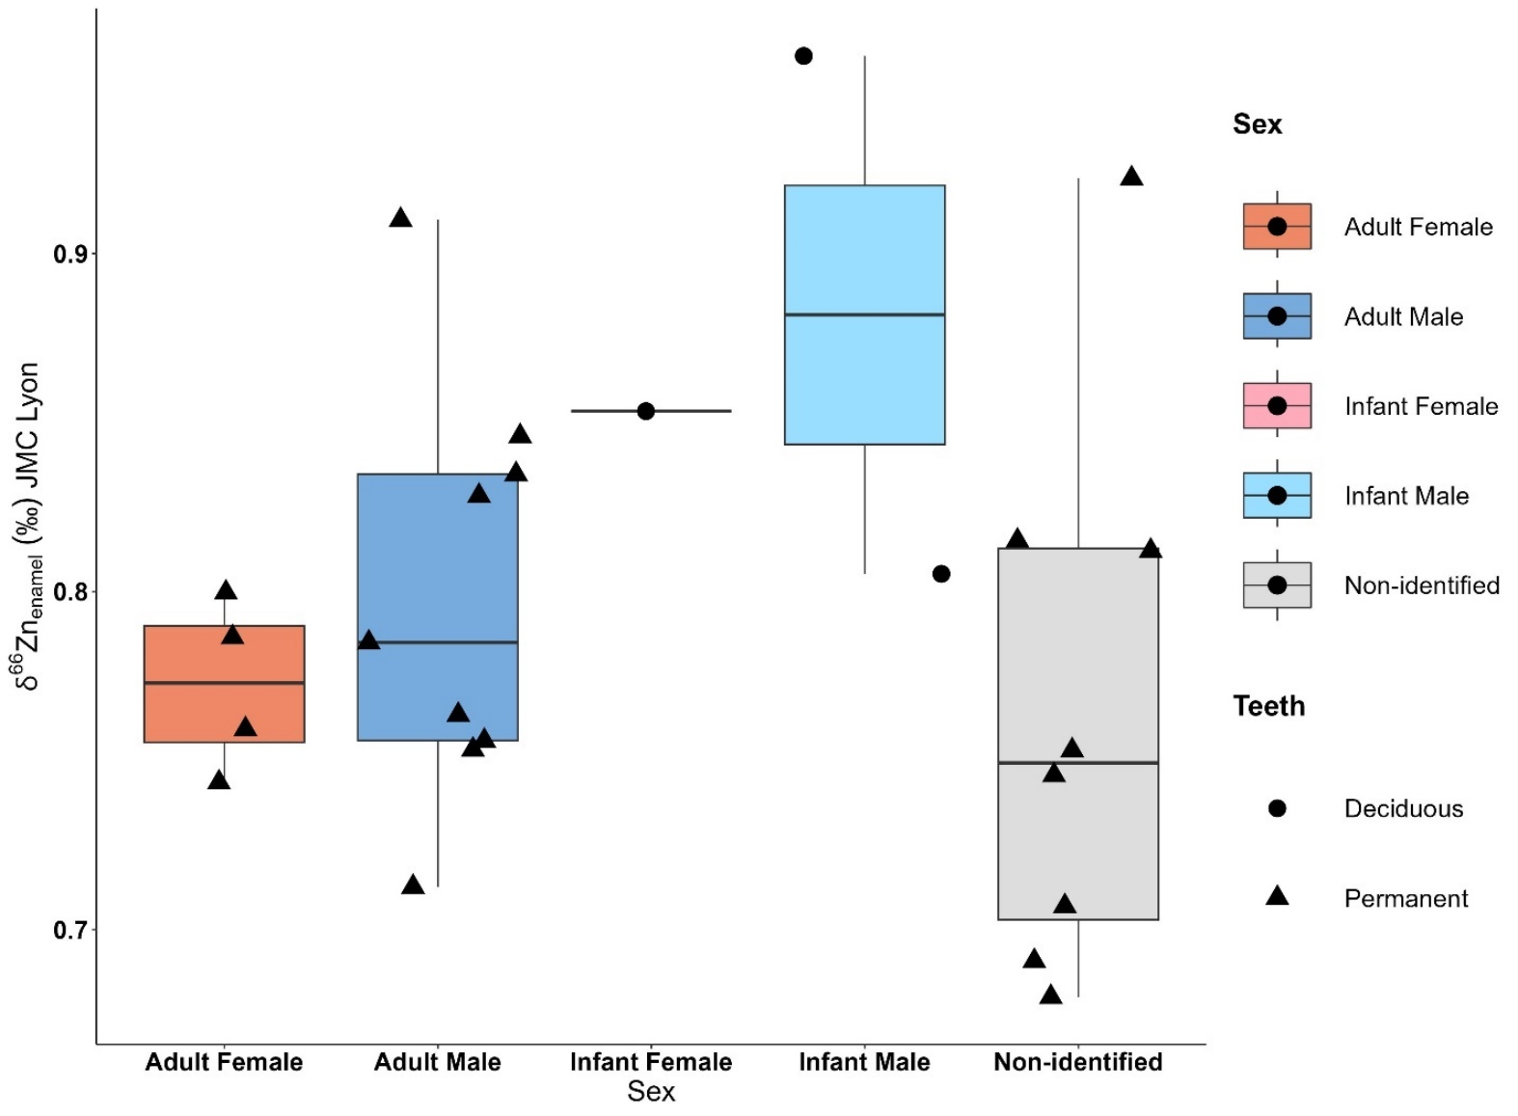
Figure S4.6 Boxplot of zinc isotopic ratios obtained from deciduous and permanent teeth from male and female samples in Taforalt. Each point represents the average zinc value obtained from each tooth.

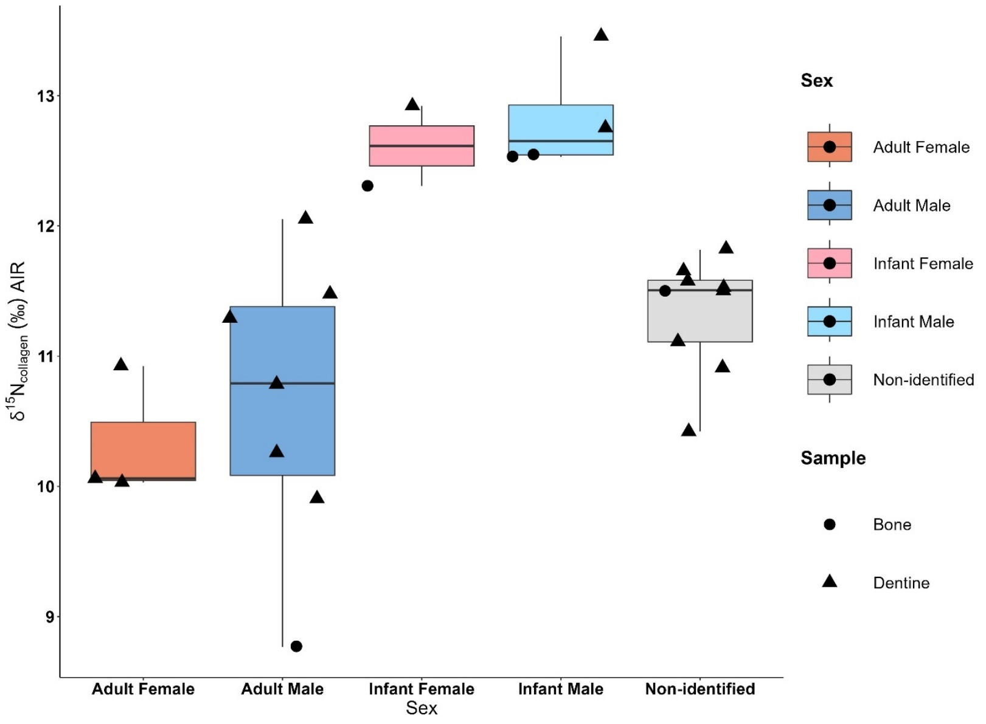
Figure S4.7: Boxplot of nitrogen isotopic values obtained from the bone and dentine collagen of the male and female samples from Taforalt.

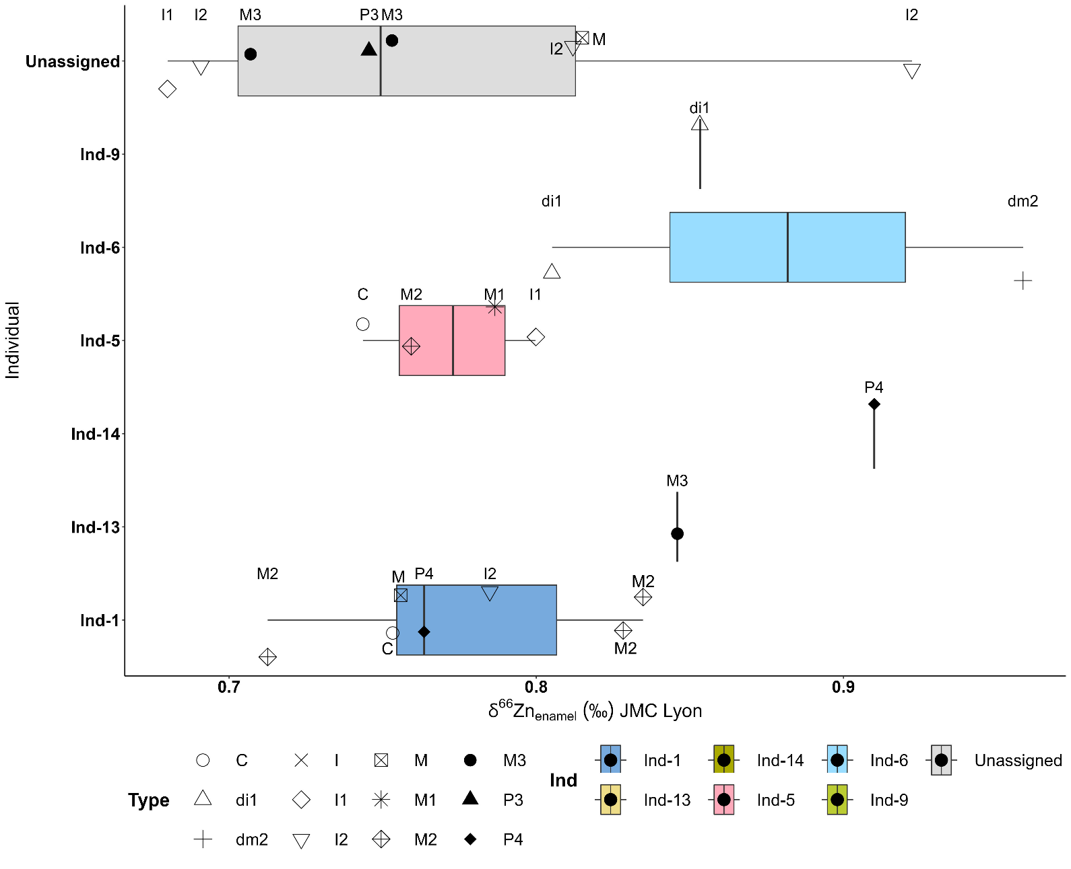
Figure S4.8: Boxplot of the δ⁶⁶Zn values from tooth enamel of different individuals analyzed in this study. Different parts of the tooth crowns were sampled so each point represents an average zinc isotopic value of different samplings taken from the same tooth.

4.3 Bulk Carbon and Nitrogen isotope data
The δ¹³C bulk collagen ranges from -20.91 to -18.06. For δ¹⁵N on bulk collagen, the values from the fauna range from to 5.5 to 11.7 ‰ and for human from 8.8 to 13.5‰. Contrary to Zn, there is a clear overlap between some herbivores, humans and carnivores (Figure 2 main paper). If we included only adult δ¹⁵N values, the overall trophic offset between humans and herbivores is (+2.5‰) and it is slightly larger with the Barbary sheep, the most dominant species in the site (+2.9‰). There were not enough carnivores (n=2) to accurately estimate the trophic level effect TLE but based on our data it is of +0.64‰ for δ⁶⁶Zn and +2.5‰ for δ¹⁵N. Although the canids could have possible had an omnivorous diet, our CSIA analysis on nitrogen show that one of the specimens has a carnivore trophic level (See 4.4 section)

4.4 Isotopic measurements on single amino acids (CSIA-AA)

4.4.1 Carbon isotope ratios of collagen amino acids
In order to assess the diet of the human from Taforalt using the individual amino acids isotopic values we used the principal component analysis (PCA) method used by Ma et al., 2021 ⁷⁴to separate between different dietary groups(Figure SI 4.9). We present the first two component with the calculated eigenvalues for each of the features used in the (Table SI 10). The bulk δ¹³C, δ¹³C_{Pro,} δ¹³C_{Asp,} δ¹³C_{Lys,} δ¹³C_{Ala,} δ¹³C_{Val,} δ¹³C_{Glx,} δ¹³C_{Gly} have the highest positive effect on the first principal component (PC1), while Δ¹³C_{Gly-Phe}, Δ¹³C_{Val-Phe}, and bulk δ¹⁵N have most significant negative effect on the second principal component (PC2) (Table SI 10).
When plotting the human and animals from Taforalt with different dietary groups: C₃ animals, C₃ humans, C₄ humans, and the marine and freshwater consumers from published studies (Figure SI 4.9, 4.10, 4.11,4.12) we see that our individual plot well with the C3 consumers. This confirms their terrestrial C3 diet and the absence/ rare consumption of marine and freshwater resources.

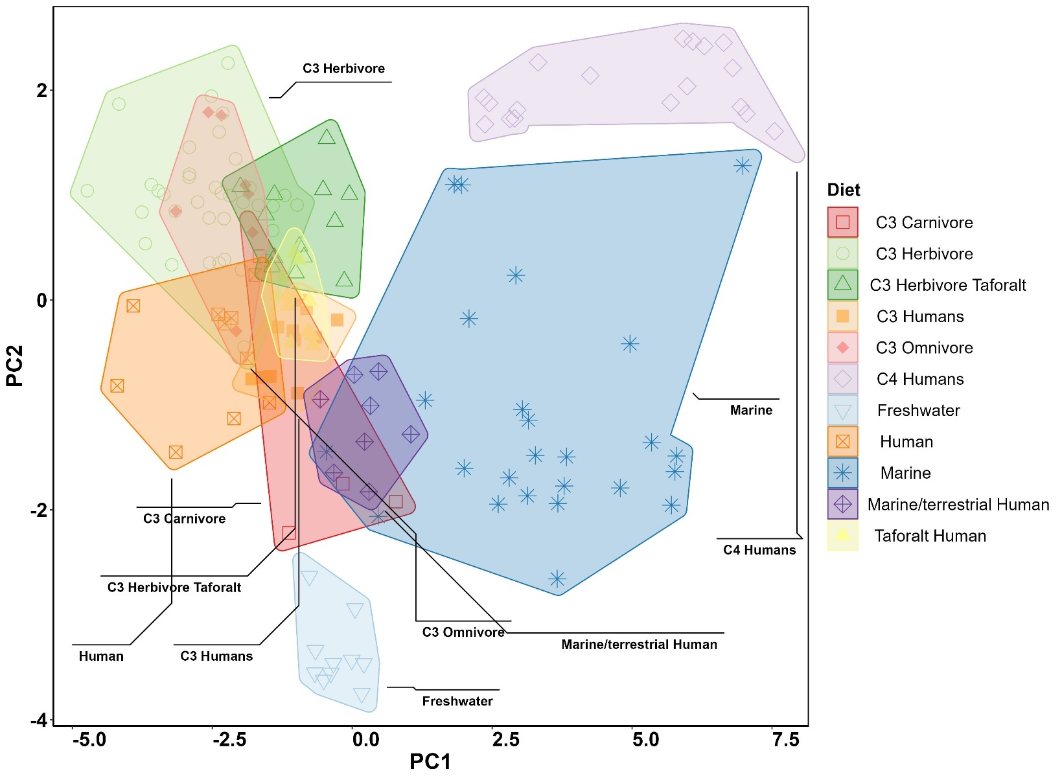
Figure S4.9: PCA plot of the ¹³C_{Ala,} ¹³C_{Asp ,} ¹³C_{Glx ,} ¹³C_{Gly ,} ¹³C_{Gly-Phe,} ¹³C_{Lys,} ¹³C_{Phe,} ¹³C_{Pro,} ¹³C_{val,} ¹³C_{Val-Phe} measurement with bulk ¹³C and ¹⁵N values from Taforalt and published data^{20,45,66,75–78,78}

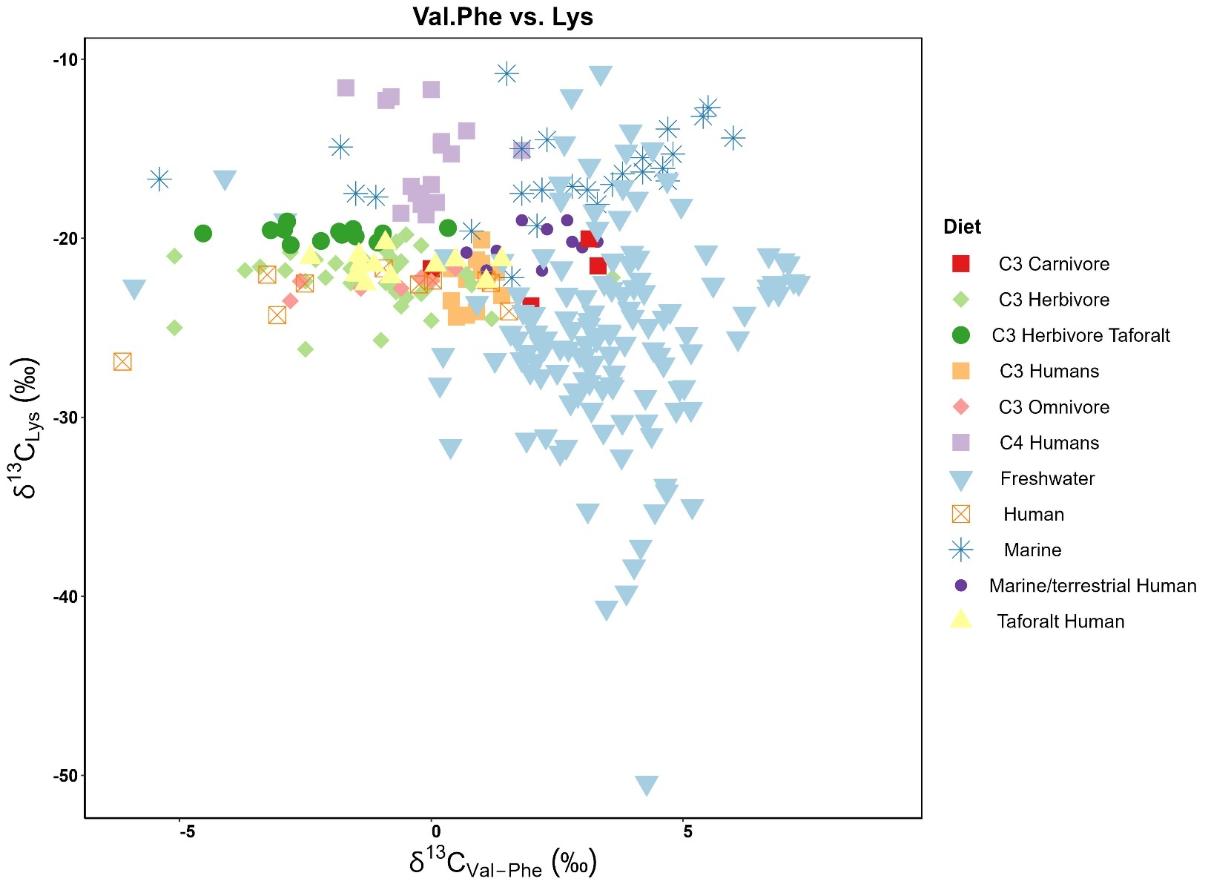
Figure S 4.10: Bivariate plots of the δ¹³C_{Lys} vs. Δ¹³C_{Val-Phe} of the samples from Taforalt and published data ^{20,45,66,75–78,78}

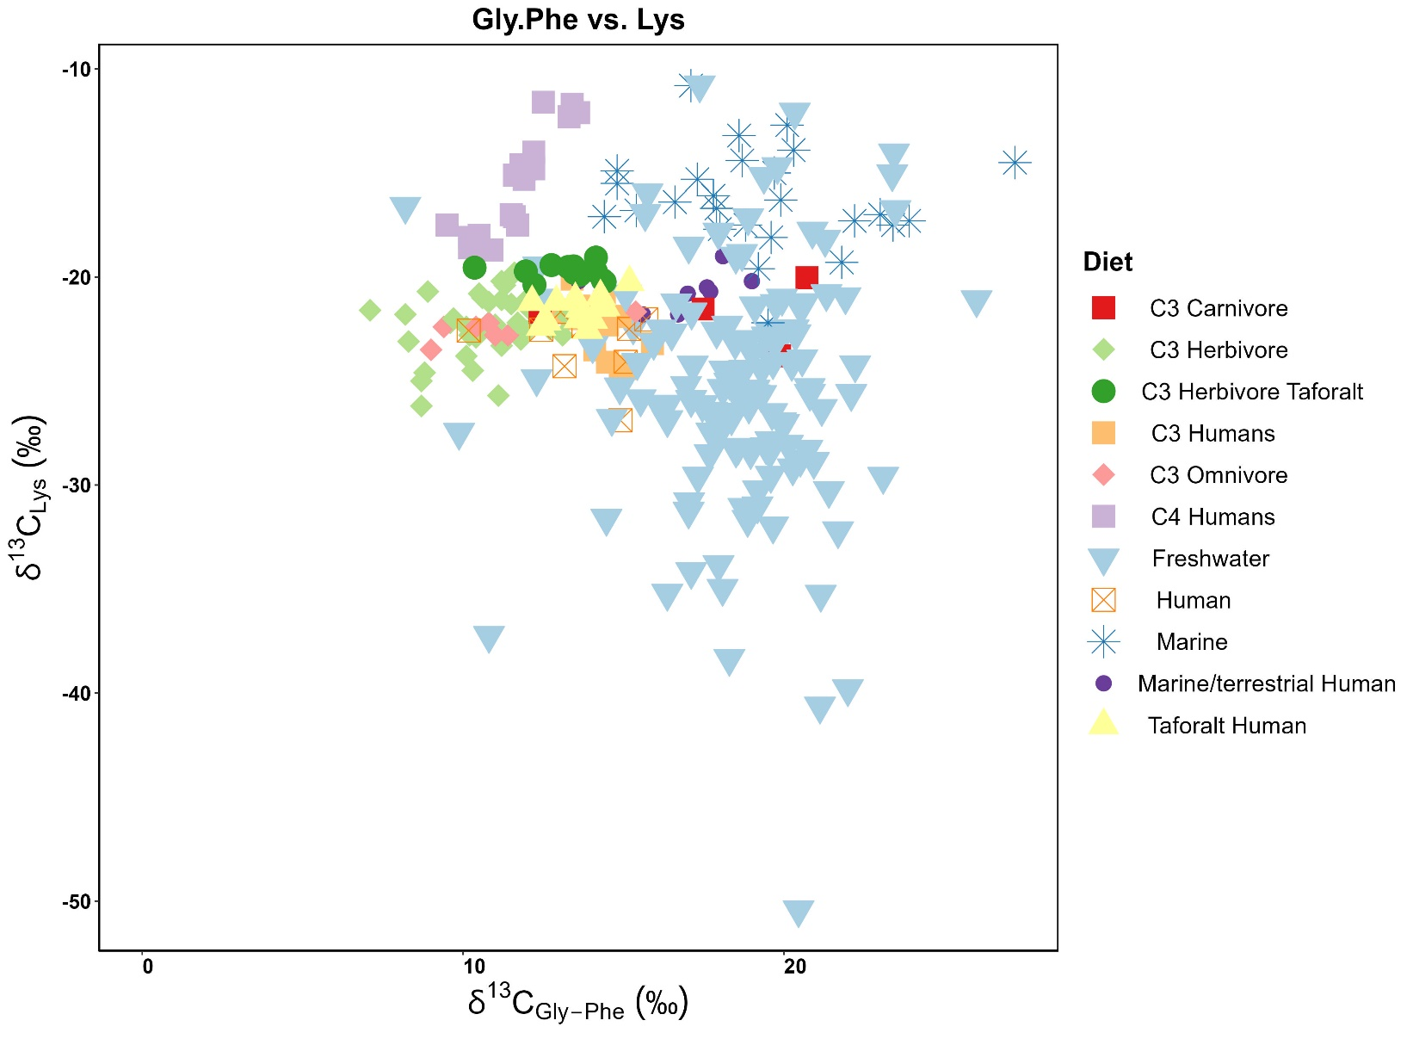
Figure S4.11: Bivariate plots of the δ¹³C_{Lys} vs. Δ¹³C_{Gly-Phe} of the samples from Taforalt and published data ^{20,45,66,75–78,78}

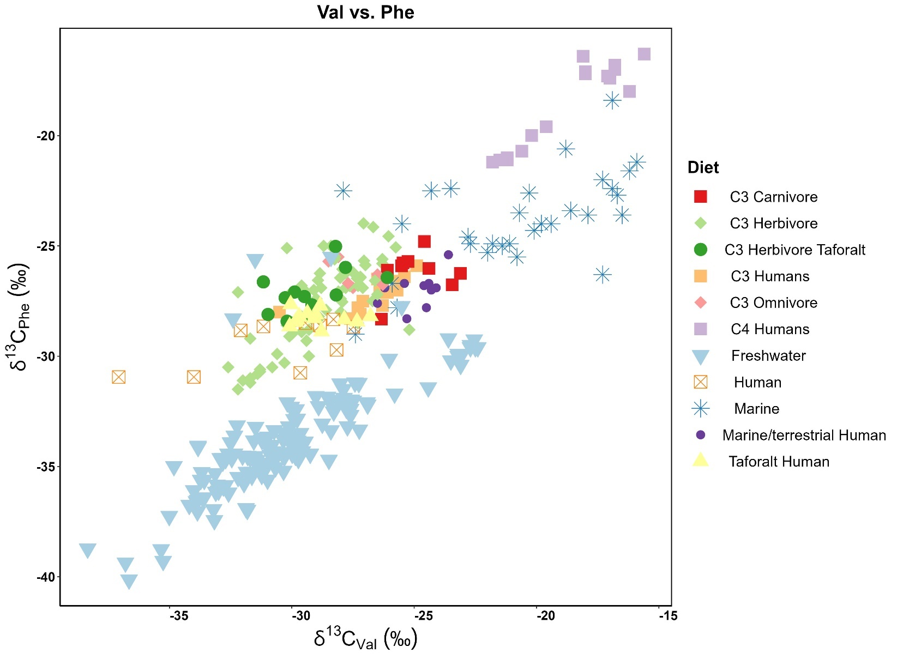
Figure 4.12: Bivariate plot of the Taforalt δ¹³C_{Phe} and δ¹³C_{Val} results by dietary classification with known types of dietary consumers from published data ^{20,45,66,75–78,78}

4.4.2. The isotopic baseline assessment from δ¹⁵N_{Phe.}
The δ¹⁵N_{Phe} usually reflect the local baseline. In the overall samples, there is no correlation between the δ¹⁵N_{bulk} and δ¹⁵N_{Phe} (r=0.17, R²= 0.04231, p-value: 0.1463) since this latter is not affected by the trophic enrichment. The herbivores in Taforalt exhibit a wide range of δ¹⁵N_{Phe} (9.1- 16.7‰) implying Nitrogen isotope ratio variation at the baseline. A sample from Barbary sheep and an equid have the highest δ¹⁵N_{Phe} values while the hare exhibits the lowest value (Figure SI 4.13). There are also variations within species. The two Barbary sheep have distinctive δ¹⁵N_{Phe} values (16.7‰), (11.6‰). This indicates that the individuals had access to plants with different N isotopic signatures, which explains the difference in the bulk collagen, however, they have similar TP (2.1). The humans δ¹⁵N_{Phe} values fall within the range of herbivores (10.4-13.7‰, mean= 12.23‰, Figure S4.13). The low δ¹⁵N_{Phe} of the carnivores (n= 2; mean: 10.8±0.9‰) compared to the other species indicates that they prey on animals with low δ¹⁵N_{Phe} values, in this case, probably the hare. This latter have also a low nitrogen value from bulk collagen, this explains why the canids overlapped with humans in the δ¹⁵N_{bulk}. There is a moderate to strong correlation between the TP and δ¹⁵N_{Phe} for the human samples (r= -0.693558, p-value = 0.005943). The humans with a lower trophic position seem to have a relatively higher δ¹⁵N_{Phe.}

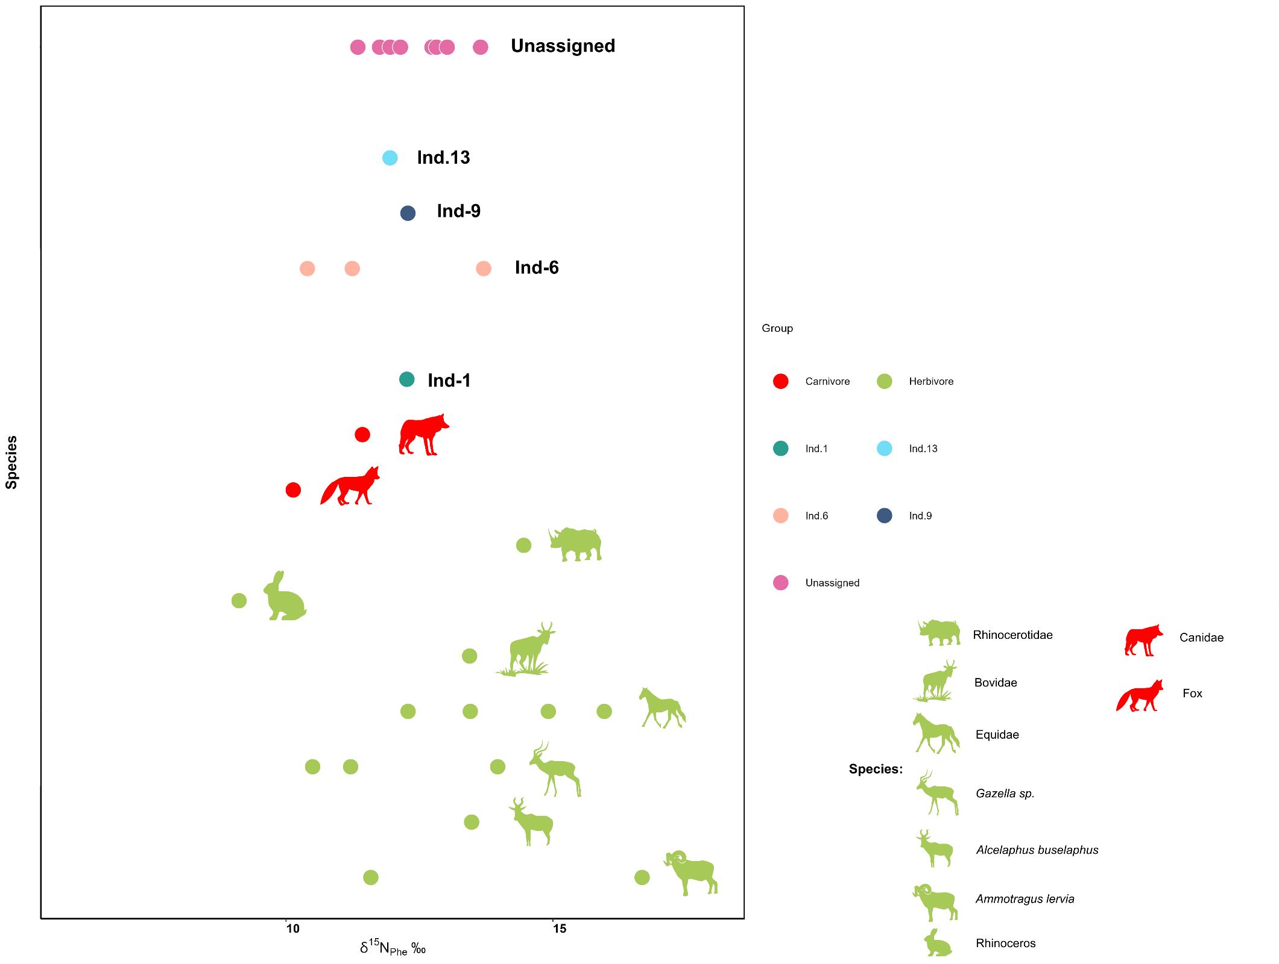
Figure S4.13: The δ¹⁵N_{Phe} values from the collagen of the different animal species analyzed from Taforalt in comparison with the human individuals.

a. Trophic levels of the animals
We estimated the trophic position of animals using δ⁶⁶Zn, δ¹⁵N on bulk collagen and on amino acids.
The δ¹⁵N_{bulk} values of the herbivores display a wide range of variation (5.5 to 11.7 ‰) (Figure 2, Main paper). We suggest that the highest δ¹⁵N values are related to either 1) a metabolic adaptation of drought-tolerant herbivores to the lack of water in arid regions⁷⁹ for an Equid, Hartebeests. and 2) to a suckling effect for a Barbary sheep and Equid; For the δ¹⁵N on the bulk collagen the Trophic level spacing between carnivores and herbivores is only of 2.4 ‰ higher in contrast with the expected 3-5 ‰ ^{17,80–82}
The δ¹⁵N on amino acids generally shows the trophic position (TP) of an individual regardless the baseline variation effect. Thanks to our carbon isotope ratios, we know that there is no aquatic food consumption at Taforalt, and we can then use the C3 equation for the evaluation of the trophic positions of the animals and humans. These equations show a range of 1.7 to 2.3 for herbivores with an average of 2.1, which is close to the theoretical value of 2. This type of variation around the value of 2 has been previously observed^{66,83,84}. Both Barbary sheep have the same TP (=2.1) expected for herbivores, even the deciduous tooth. This indicates that there is no effect of breastfeeding on this latter and that the high δ⁶⁶Zn on enamel and high δ¹⁵N in the bulk collagen of this tooth is related to the diet and not to breastfeeding.
Drought-tolerant herbivores show an average TP of 2.1 and the other herbivores of 2.0. This means that the metabolic adaptation to drought do not impact the TP estimation from amino acids. We reject the possibility of suckling as an explanation for the high δ¹⁵N_{bulk} values for the barbary sheep and the Equid. Some herbivores have a TP above 2.1 it includes a Hartebeest, hare, the Hartebeest and the Rhinoceros. This could be that this species consumed plants with distinctive β factor⁸⁴. It is unlikely that the TP of 2.3 represents suckling effect especially for the hare with a δ¹⁵N_{bulk} of 6‰.

The TP of the canid and the fox are respectively 2.9 and 2.7 (av=2.8) which is a little below the theoretical value of pure carnivores (TP=3) and could be explained by the opportunistic feeding habits of foxes. The second carnivore was only identified using traditional zooarchaeology as a canid. We should mention that the golden jackal (Canis aureus) is the most common Canidae in North Africa. Therefore, we assume that our specimen corresponds to this species. The diet of the golden jackal consists primarily of small games (e.g rodents, birds, hares..etc) and occasionally include fruits^{47,85}

b. Trophic levels of the humans
The TP of human adults range from 2.7 to 2.2 (average 2.5±0.2), while the infants have higher TP values 2.9- 2.5. The Ind.1 bone and an unassigned I2 showed a surprisingly low TP (2.2), indicating an exclusive vegetarian diet and that only 20% of his dietary protein coming from meat.
There is a strong negative correlation between δ⁶⁶Zn and trophic position (TP) (r = -0.73, R²= 0.51, p-value<0.05). However, if we exclude the infants the correlation of TP with δ⁶⁶Zn (r = -0.78, R²= 0.59, p-value<0.05) is even stronger than with δ¹⁵N _{bulk} (r =0.69, R²=0.45, p-value<0.05). The carnivores overlap with the humans and some herbivores in the N from bulk collagen while with δ⁶⁶Zn and δ¹⁵N on amino acids, the canids have clearly a higher trophic level than the humans. This indicates that Zn is less impacted by the baseline effect than nitrogen isotopes (Figure 2 main paper ).

4.5 Strontium isotope data
The ⁸⁷Sr/⁸⁶Sr_{enamel} of animals and humans display a narrow range, from 0.7089 to 0.7093, and 0.7090 to 0.7094 respectively, compatible with what is expected for a coastal region (<100km) dominated by a calcareous bedrock from Late Jurassic^{1,34,38,86} Among all the enamel samples analyzed in this study no correlation between the Zn isotope and Sr isotope ratio has been detected (Figure 2, main paper). This suggests that the Sr in local geology is relatively homogenous and has no influence on the Zn isotopic ratios at Taforalt. All humans show ⁸⁷Sr/⁸⁶Sr compatible with that of the animals, which is compatible with the hypothesis that they were all local individuals.

4.6 Sulphur isotopic ratios of the human and the sea spray effect

Only three samples had enough collagen for the Sulphur analyses. A barbary sheep and an equid gave values of + 14.6‰ + 12.5‰ respectively. The humans have a δ³⁴S of +12.87‰which falls within the range of the herbivores. The relatively high δ³⁴S in the samples from Taforalt possibly indicates the proximity of dietary resources of the humans and animal to the coastal “sea spray effect”. Although the site is 40 km from the coast, it was observed that this phenomenon can extend many kilometers inland in some cases^{41,43} . Since Taforalt is only 40 km from the sea, it is still within the “sea spray effect” ⁸⁶. Another explication for the high δ³⁴S values in our sample is the dust aerosols originating from the Sahara which is rich in sulphur gypsum and have elevated δ³⁴S values ca +12 to +16‰ ^{86–88}.

Supplementary information 5: Additional discussion
5.1 Weaning at Taforalt:

For Zn isotope ratios, although a tooth (M1) formed during breastfeeding period exhibit relatively high Zn isotope ratios (0.79±0.04)‰) (Figure SI 4.8), the zinc isotopic variation between enamel samples, including samples belonging to the same tooth, is not significant (n= 45, Kruskal-Wallis chi-squared = 3.6049, df = 2, p-value = 0.1649), in contradiction to what has been observed in Lapa do Santo (hunter gatherer from Brazil) and Rennes (medieval Breton population) ^{25,27} (Figure S5.1) but matching the conclusion of Bourgon et al. 2021 and Jaouen et al 2022 on single individuals that an M1 can record a post-weaning signal ^{22,64} (Figure S.4.10). First molars have their crown formed between the birth to the age of 2.5 years old, and our sampling select parts formed between ≈1 to 2.5 years old (See Supplementary Information 7, Teeth scans). Zinc mostly deposits during the maturation phase of the enamel, and not at the earlier stages of the formation. This can explain why we do not see the signature of breastfeeding at Taforalt, if the weaning already started around 1 year old.
For δ¹⁵N, the difference between breastfeeding and post-weaning period is more clear than with Zn, but still low (1.65 ‰) than what is usually observed (2-3‰) for δ¹⁵N ^{89,90}. The high TPs of the infants are associated with breastfeeding, which elevates their trophic level above the mother⁹⁰. However, the TP of the deciduous second molar of Ind.6 indicates breastfeeding while that of the rib bone recorded a lower TP probably indicating the introduction of solid food to his diet before death (12 months) since the rib cage has a faster turnover than the other bones. This decrease in trophic level was also detected on the bulk δ¹⁵N since it shows relatively a change isotopic values between the different tissues of the infant (Figure 5.2).
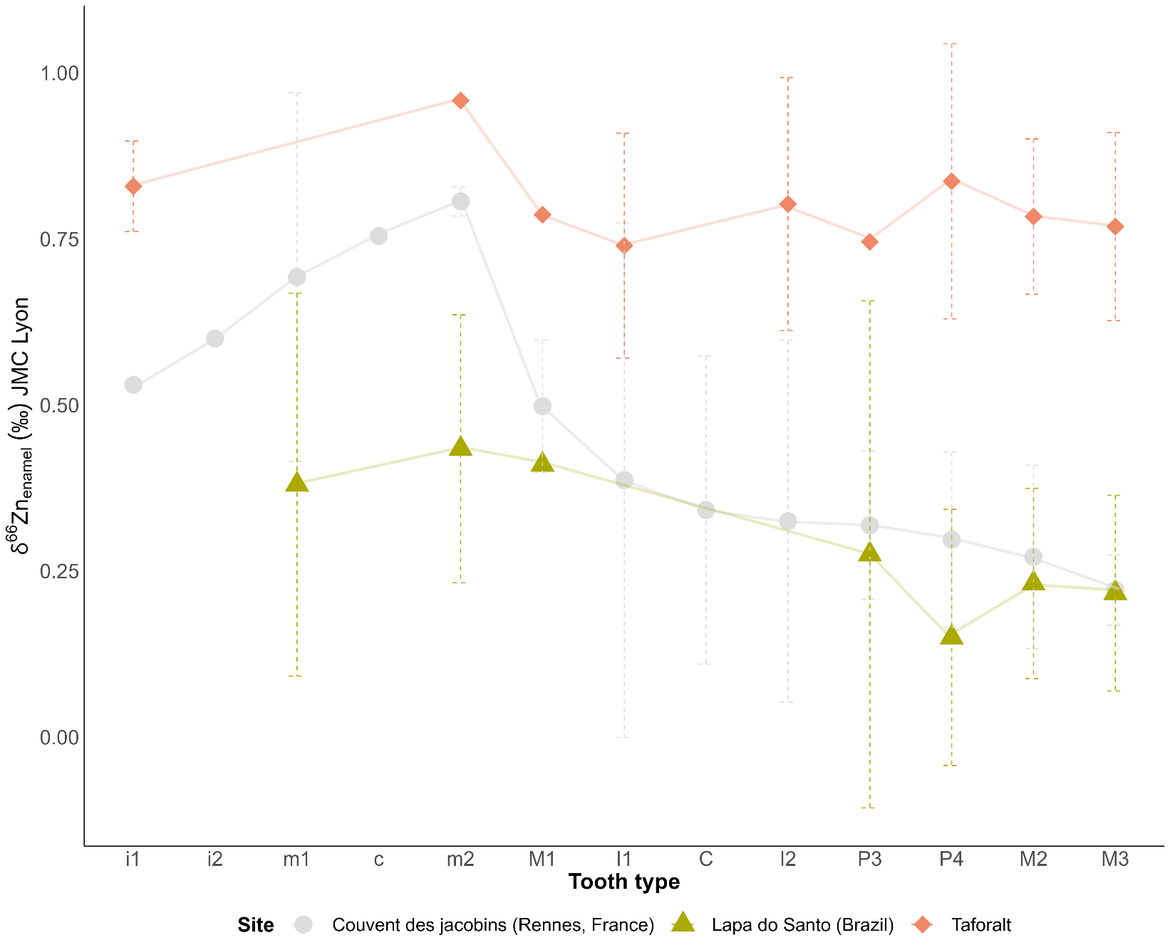
Figure S5.1 : The average Zn isotope ratios in the different human samples from Taforalt compared to those from the Medieval site of Rennes, France²⁵ and Lapa do Santo, Brazil²⁷. The teeth are ranked from the earliest forming enamel to the latest forming crown. The standard deviation for the zinc value is represented in a dashed line. Each point represents the average zinc values of the same type of tooth.

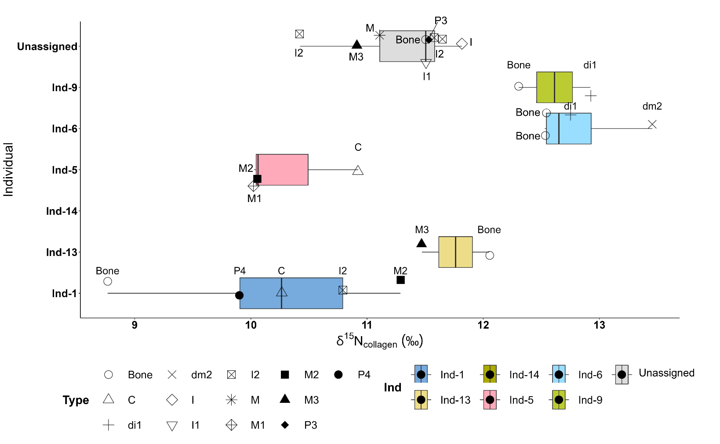

Figure 5.2: Boxplot of the δ^{15N} values from dentine and bone bulk collagen of different individuals analyzed in this study. Different tooth types are represented in different shapes.

5.2 Trophic level prediction with Zn
The CSIA from amino acids are powerful techniques to reconstruct the trophic position of individuals using the TP (C3) equation. However, since only few samples yielded enough preserved collagen, we were able to estimate the TP of few samples. Given the fact that Zn was preserved in all the analyzed samples and shows a strong correlation with the TP (on amino acids), we established an equation to predict the TP of samples that did not yield enough collagen using the δ⁶⁶Zn values:
TP (equation) = -0.8959*δ⁶⁶Zn_{enamel} + 3.1455
The average value of the human from Taforalt was still 2.5 using this equation. Knowing the influence of the geology on local Zn isotope ratios and notable baseline differences between tropical and non-tropical sites (^{23,26},), this equation is possibly only valid for sites with similar biomes and geologies. For example, applying the equation to terrestrial mammals from Tam Hay Marklot, it predicts a TL of 3 for carnivores, a TL of 2.8 for omnivores and a TL of 2.5 for herbivores ²³. Applying the same equation to terrestrial animals from Rennes gives a TL= 2.6 for carnivores and 2.3 for herbivores while it places humans at a TP of 2.8 confirming the intensive animal food consumption in this site ²⁵
Table S5.1 Trophic position estimation of human and animals from Taforalt based on the δ⁶⁶Zn following the established TP equation mentioned above.

SEVA | Site | Specie | Zn | TP (CSIA) | TP (Zn)
35819 | Taforalt | Barbary sheep | 1.05 |  | 2.2
35821 | Taforalt | Barbary sheep | 1.26 | 2.1 | 2.0
35830 | Taforalt | Barbary sheep | 0.82 | 2.1 | 2.4
35831 | Taforalt | Barbary sheep | 1.16 |  | 2.1
35824 | Taforalt | Hartebeest | 1.22 | 2.2 | 2.1
35833 | Taforalt | Gazelle | 1.10 | 2.0 | 2.2
35820 | Taforalt | Equid | 1.32 | 2.0 | 2.0
35822 | Taforalt | Equid | 1.34 | 1.7 | 1.9
35825 | Taforalt | Equid | 1.38 | 1.7 | 1.9
35826 | Taforalt | Equid | 1.34 | 2.1 | 1.9
35829 | Taforalt | Gazelle | 0.85 | 1.9 | 2.4
35835 | Taforalt | Gazelle | 1.08 | 2.0 | 2.2
35823 | Taforalt | Hare |  | 2.3
35827 | Taforalt | Hartebeest | 1.26 | 2.3 | 2.0
35836 | Taforalt | Rhinoceros | 1.10 | 2.3 | 2.2
34565 | Taforalt | Equid | 1.14 |  | 2.1
35828 | Taforalt | Fox | 0.61 | 2.9 | 2.6
35832 | Taforalt | Gazelle | 1.24 |  | 2.0
35834 | Taforalt | Canid | 0.42 | 2.7 | 2.8
34566 | Taforalt | Barbary sheep | 0.82 |  | 2.4
35961 | Taforalt | adult human | 0.83 | 2.6 | 2.4
35962 | Taforalt | adult human | 0.71 |  | 2.5
35967 | Taforalt | adult human | 0.78 |  | 2.4
35970 | Taforalt | adult human | 0.76 |  | 2.5
35979 | Taforalt | adult human | 0.76 |  | 2.5
35985 | Taforalt | adult human |  | 2.2
35963.A | Taforalt | adult human | 0.75 |  | 2.5
35963.B | Taforalt | adult human | 0.83 |  | 2.4
35981 | Taforalt | adult human | 0.92 |  | 2.3
35977 | Taforalt | adult human | 0.76 |  | 2.5
35978 | Taforalt | adult human | 0.74 |  | 2.5
35971.A | Taforalt | adult human | 0.80 |  | 2.4
35971.B | Taforalt | adult human | 0.79 |  | 2.4
35975 | Taforalt | adult human | 0.85 | 2.6 | 2.4
35975 | Taforalt | adult human
35980 | Taforalt | adult human
35959 | Taforalt | adult human
35959 | Taforalt | adult human |  | 2.7
35960 | Taforalt | adult human | 0.81 | 2.2 | 2.4
35968 | Taforalt | adult human | 0.75 | 2.5 | 2.5
35969 | Taforalt | adult human | 0.92 | 2.4 | 2.3
35972 | Taforalt | adult human | 0.75 | 2.5 | 2.5
35973 | Taforalt | adult human | 0.69 | 2.6 | 2.5
35974 | Taforalt | adult human | 0.71 |  | 2.5
35976 | Taforalt | adult human | 0.81 | 2.5 | 2.4
34561 | Taforalt | adult human | 0.68 |  | 2.5

5.3 Enamel hypoplasia in the human teeth from Taforalt

For zinc isotope analyses, the teeth enamel of the human from Taforalt were sampled in several parts in order to detect possible dietary variation during the enamel formation (Figure in S5.2). The majority of the teeth present hypoplasia located on the enamel or on the root.
Enamel hypoplasia occurs as linear or pitted deformation that represent disruptions during the formation of enamel.
Our results show that there is no correlation between the δ⁶⁶Zn values recorded on the part of enamel with hypoplasia and the part with no hypoplasia (Kruskal-Wallis chi-squared = 0.13958, df = 1, p-value = 0.7087) (Figure SI 5.2). The enamel hypoplasia is often associated with nutritional deficiency. Low intake of vitamin D from diet and the lack of exposure to sunlight could result in the presence of EH ⁹¹. The site is not located in high latitude where the exposure to sunlight is limited in winter, therefore the most likely explanation for this anomaly among the population of Taforalt could be related to the fact that the individuals did not consumed a lot of foods rich in vitamin D such as meat, liver, fish and dairy products This goes in line with our isotopic results. Many studies on modern populations have found that low socio-economic status have higher prevalence of enamel hypoplasia than the higher social status population ^{92,93}.This is because the latter have more access to food rich in meat. In archaeological samples there is an increase incidence of EH during the transition to agriculture, associated with a nutrient-poor diet and the increase reliance on cereals ⁹⁴.
The absence of the pattern between δ⁶⁶Zn and the location of EH could be related to the differential timing between the maturation of the enamel and the timing of the deposition of zinc and other minerals ^{95,96}.

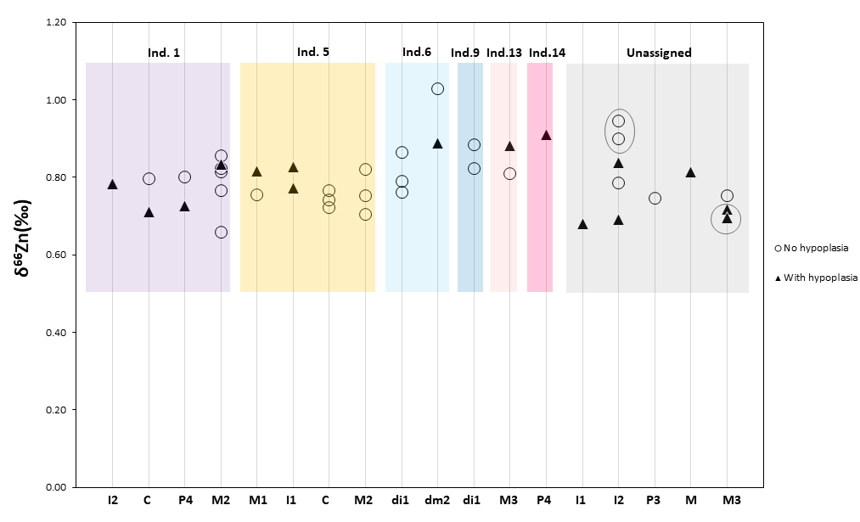
Figure S5.3: The zinc isotope ratio for each human tooth sampled from areas with hypoplasia and with no hypoplasia. For unassigned teeth, the samples belonging to the same tooth are circled in grey. The x-axis corresponds to the tooth type.

5.4 Identified individuals’ summaries based on all isotope measurements

Individual 1: a male individual with a plant-based diet
Most of our human samples come from individual 1, which is a young male as revealed by the aDNA⁹⁷ estimated age at death is 20 years.
The range of enamel analyzed for zinc and strontium for this individual are formed between 4 months (I2) and 8 years (M2). The zinc isotopic ratio does not show any significant changes during this period (0.78‰±0.05) (Figure SI 5.1). On the other hand, the range δ¹⁵N values are obtained from both teeth dentine (4- 16 years) and bone which usually records the last years of life due to the constant bone remodeling. His bone collagen also shows the lowest δ¹⁵N_{bulk} value in the analyzed samples. The lowest TP 2.2 in Taforalt is obtained from the bone collagen of this individual, indicating a predominantly plant-based diet (~20 years) . To our knowledge this is the lowest TP value ever recorded in a pre-agriculturist population. The teeth collagen of this male, formed earlier in life, recorded higher values than his bone collagen suggesting a switch to a plant-based diet shortly before his death. Interestingly, 50% of the remaining teeth of this individual were affected by caries⁶. We should mention that most of this individual’s teeth show evidence of hypoplasia on both the crown and the root (See PowerPoint). The observation of the hypoplasia on the teeth included in this study indicates that he suffered from stress around 3 years (recorded on the I2) until 16 years (recorded on his M2). A possible explanation for this transition to a plant-based diet could be related to a health condition that led to nutritional stress.

Individual 5: a female adolescent individual with an intermediate trophic position
Individual 5 is an adolescent female who died between 16 and 18 years of age ¹. The range zinc isotope values from this individual are obtained from teeth formed between birth (M1) and 8 years (M2) and also show no significant variation (0.77‰±0.04) similarly to δ¹⁵N_{bulk} values (10.34‰±0.51). We did not obtain the TP from CSIA for this individual because we could not recover enough collagen for the analyses. The TL based on δ⁶⁶Zn value suggests 60% of plant consumption. We observed the presence of enamel hypoplasia on the teeth of this female indicating that she experienced stresses between 2.5 and 5 years. Caries were present in 57% of the remaining teeth of this individual, in addition alveolar absorption⁴. The study of the teeth of this individual also shows that this female had the lowest attrition rates among the individuals recovered during the recent excavations ⁶.
Individual 13: a male individual buried with horn cores and freshwater shells who might have increased his meat consumption over the course of his life
Individual 13 is a male whose age of death is estimated between 18 and 20 years. His M3, which started its formation at the approximated age around of 13 and completed at around 20 years ⁵⁹ recorded the highest TP (2.6) in the identifiable individuals. This reflects an omnivorous diet with both meat and plant in his diet. His δ¹⁵N_{bulk} is slightly above the values than the other individuals. However, his δ⁶⁶Zn from the third molar is relatively high (0.85‰). It is therefore possible that the individual increased his meat consumption after the age of 13 years old.
Interestingly, the burial of this individual was associated with seven horn cores of barbary sheep as funerary artifacts in addition to a freshwater snail shell (Melanopsis sp.). In addition, 85% of his remaining teeth were affected by caries and periodontal diseases ¹. The presence of enamel hypoplasia on his teeth indicates that he suffered from stress around 13 years which coincides with the beginning of the formation of the root of his M3.

Individual 14: a male individual with a plant-based diet
Individual 14 is also a male with an age-at death of 18-20 years. No collagen was preserved in the tooth samples. The tooth enamel of the P4 sampled for the Zn and Sr is formed between 2.5 and 7 years, which is unlikely reflecting breastfeeding. The δ⁶⁶Zn value of this individual is relatively high (0.92‰,) indicating an important consumption of plant foods. It is worth mentioning that half of a bivalve marine mollusk shell was associated with the remains of this individual (Glycymeris nummaria) ⁶. The occurrence of marine shells in the burial area of the cave rather than the entrance of the cave indicate that it was used as a funerary object. Our isotopic analyses also show the absence/rare of marine food consumption for all the analyses individuals. The shells possibly were used as ornaments or grave goods that accompanied the grave of the disease. Moreover, a grindstone and a pestle were found in his burial. Caries are present in 42% of the remaining teeth of this individual in addition to alveolar resorption in three teeth. The tooth analyzed for this individual is impressively full of hypoplasia (Supplementary information 7). This period could extend from around 4 to 10 years.
Individual 6: a male infant with an early introduction of solid food in diet
Individual 6 is an infant male that died within the first year of his life (6-12 months). This infant had significant TP change during his short life. His deciduous, m2 is formed between 18 weeks In Utero and 3 years. For this individual the root of this tooth was not totally formed (only 1/3 of the root formed) therefore only reflecting the first year of his life since he died around 6-12 months. The tooth has a TP of 2.8 clearly reflecting breastfeeding. Similarly, a high value is recorded on his long bone collagen (2.9). It is expected for breastfed infants to be one trophic level above the mother ⁹⁰. However, his rib bone collagen TP (2.5) reflects a significant decrease in the trophic level prior to death. Since rib bones have a faster bone remodeling it is possible that they recorded the very last period of this infant life. We suggest that for this individual weaning started before the age of 1 year with an early introduction of adult’s foodstuff into his diet. An early weaning is usually unexpected among hunter-gatherer societies as they have prolonged breastfeeding periods due to the lack of suitable food for weaning⁹⁸. We propose that plant food could have been used to wean infants at this site. This sudden change in trophic position was not detected using the δ¹⁵N from the bulk of collagen, especially between the two bone tissues.
The beginning of the formation of his di1 shows a relatively lower δ⁶⁶Zn value (0.76‰) than the end of the formation of his dm2 (1.03‰). The range of enamel analyzed for zinc and strontium for this individual are formed between 18 weeks in utero (di1) and 10 months (dm2). We suggest that the deciduous incisive, formed in utero, recorded the placental diet coming from the mother, while the dm2 corresponds to an exclusive breastfeeding. A similar pattern was observed in the medieval site from France (Rennes, Jacobins convent) where m2 showed higher δ⁶⁶Zn values ²⁵.
The CT scan on the deciduous first incisive of this infant showed the presence of hypoplasia along the root (PowerPoint file). This indicates that the stress happened between 4 and 11 months of his life. The fact that she died around the age of 12 months suggests that she did not survived what caused this stress

Individual 9: an infant female with an early solid food introduction
Individual 9 is an infant female as determined by aDNA ⁹⁷and has an estimated age at death of 5-6 months. The TP from her bone is 2.7 suggesting at least partial breastfeeding but not as high as for Individual 6. The introduction of solid food could therefore have been quite early for this individual, so that it could be recorded in her bones. No hypoplasia was however detected on the tooth of this individual.

Supplementary information 6: Additional tables and figures

Supplementary figures

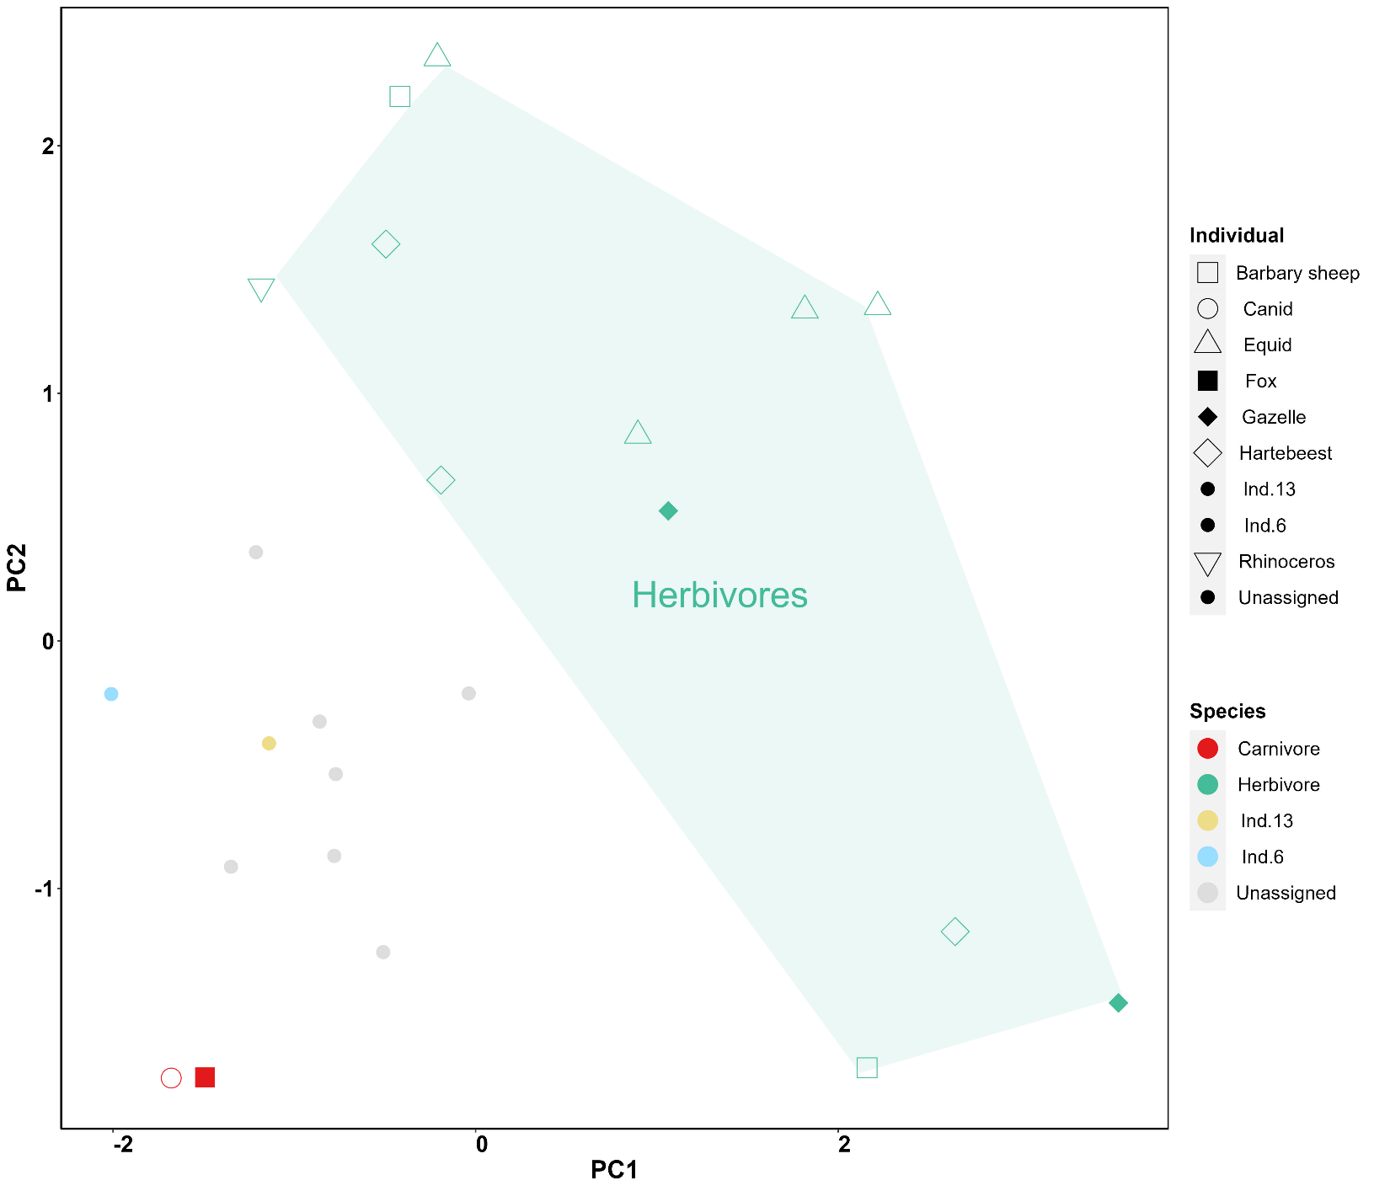

Figure SI 6.1: PCA plot of δ¹³C, δ¹⁵N, δ¹⁵N_{Glu}, δ¹⁵N_{Phe} and δ⁶⁶Zn values from Taforalt

4.2 Comparison of Taforalt with published human zinc data
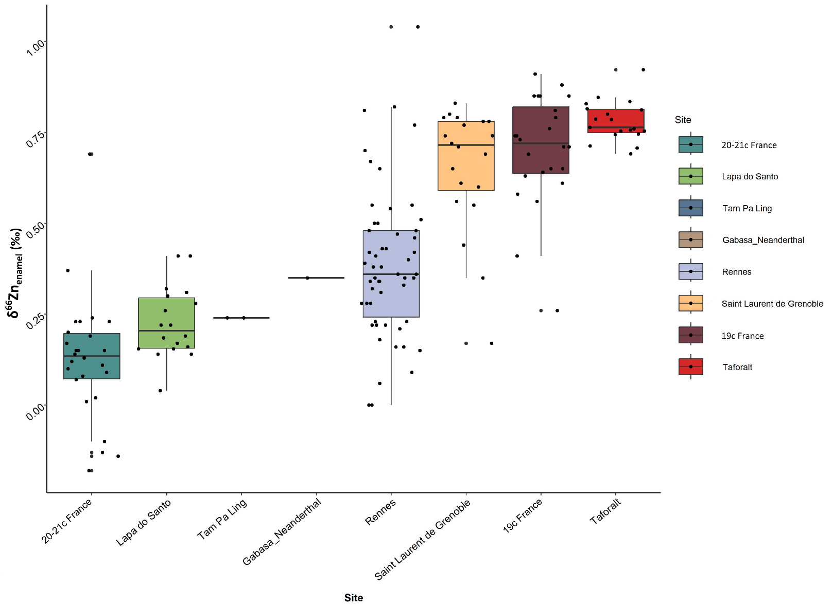
Figure 6.2: Boxplot of Zinc isotopic ratio from Taforalt compared to published data and showing the highest zinc isotopic values recorded for a human population (^{22,25,27,64,99})

Excel sheets:
Table SI 1: The faunal species included in our study along with their diet and water intake information
Table SI 2: The human individuals from Taforalt included in our study along with their age and gender estimation
Table SI 3: Zn, Sr, C, N and S isotope data for human teeth from Taforalt

Table SI 4: Zn, Sr, C, N and S isotope data for the animal’s teeth from Taforalt

Table SI 5: The zooarchaeological and the ZooMs identification of the animal species
Table SI 6: The mean value of the isotopic results for each human individual from Taforalt analysed in this study
Table SI 7: The caries and hypoplasia presence in the analyzed teeth of the humans
Table SI 8: Nitrogen isotope data on amino acids
Table SI 9: Carbon isotope data on amino acids
Table SI 10: Covariance matrix with the calculated eigenvalues for each of the features used.

Supplementary information 7: Extracts of 3D Scans of the human teeth (pdf)

References:

1. Barton, R. N. E. Cemeteries and Sedentism in the Later Stone Age of NW Africa: Excavations at Grotte des Pigeons, Taforalt, Morocco. Monographien des RGZM (2020) doi:10.11588/PROPYLAEUM.734.
2. Barton, R. N. E. et al. Reconsidering the MSA to LSA transition at Taforalt Cave (Morocco) in the light of new multi-proxy dating evidence. Quaternary International 413, 36–49 (2016).
3. Barton, R. N. E. et al. Origins of the Iberomaurusian in NW Africa: New AMS radiocarbon dating of the Middle and Later Stone Age deposits at Taforalt Cave, Morocco. Journal of Human Evolution 65, 266–281 (2013).
4. Humphrey, L. T. et al. Earliest evidence for caries and exploitation of starchy plant foods in Pleistocene hunter-gatherers from Morocco. Proceedings of the National Academy of Sciences 111, 954–959 (2014).
5. Humphrey, L. et al. Infant funerary behavior and kinship in Pleistocene hunter-gatherers from Morocco. Journal of Human Evolution 135, 102637 (2019).
6. Humphrey, L., Freyne, A., Berridge, P. & Berridge, P. HUMAN BURIAL EVIDENCE. in Cemeteries and Sedentism in the Later Stone Age of NW Africa: Excavations at Grotte des Pigeons, Taforalt, Morocco 444–482 (Monographien des Römisch-Germanischen Zentralmuseums, 2019).
7. Bouzouggar, A. et al. Reevaluating the Age of the Iberomaurusian in Morocco. The African Archaeological Review 25, 3–19 (2008).
8. Hogue, J. & Barton, N. New radiocarbon dates for the earliest Later Stone Age microlithic technology in Northwest Africa. Quaternary International (2016) doi:10.1016/j.quaint.2015.11.144.
9. Barton, N. et al. Human Burial Evidence from Hattab II Cave and the Question of Continuity in Late Pleistocene–Holocene Mortuary Practices in Northwest Africa. Cambridge Archaeological Journal vol. 18 (2008).
10. Barton, R. N. E. et al. The Late Upper Palaeolithic Occupation of the Moroccan Northwest Maghreb During the Last Glacial Maximum. Afr Archaeol Rev 22, 77–100 (2005).
11. Turner, E. Large mammalian faunal assemblages. in Cemeteries and Sedentism in the Later Stone Age of NW Africa: Excavations at Grotte des Pigeons, Taforalt, Morocco 239–308 (Monographien des Römisch-Germanischen Zentralmuseums, 2019).
12. Desmond, A. et al. ZooMS identification of bone tools from the North African Later Stone Age. Journal of Archaeological Science 98, 149–157 (2018).
13. Corr, L. T., Sealy, J. C., Horton, M. C. & Evershed, R. P. A novel marine dietary indicator utilising compound-specific bone collagen amino acid δ13C values of ancient humans. Journal of Archaeological Science 32, 321–330 (2005).
14. Hedges, R. E. M. Isotopes and red herrings: comments on Milner et al. and Lidén et al. Antiquity 78, 34–37 (2004).
15. Heaton, T. H. E., Vogel, J. C., von la Chevallerie, G. & Collett, G. Climatic influence on the isotopic composition of bone nitrogen. Nature 322, 822–823 (1986).
16. Schwarcz, H. P. & Schoeninger, M. J. Stable Isotopes of Carbon and Nitrogen as Tracers for Paleo-Diet Reconstruction. in Handbook of Environmental Isotope Geochemistry: Vol I (ed. Baskaran, M.) 725–742 (Springer, 2012). doi:10.1007/978-3-642-10637-8_34.
17. Deniro, M. J. & Epstein, S. Influence of diet on the distribution of nitrogen isotopes in animals. Geochimica et Cosmochimica Acta 45, 341–351 (1981).
18. Hedges, R. E. M. & Reynard, L. M. Nitrogen isotopes and the trophic level of humans in archaeology. Journal of Archaeological Science 34, 1240–1251 (2007).
19. Chikaraishi, Y., Ogawa, N. & Ohkouchi, N. Further evaluation of the trophic level estimation based on nitrogen isotopic composition of amino acids. Earth, Life, and Isotopes 37–51 (2010).
20. Honch, N. V., McCullagh, J. S. O. & Hedges, R. E. M. Variation of bone collagen amino acid δ13c values in archaeological humans and fauna with different dietary regimes: Developing frameworks of dietary discrimination. American Journal of Physical Anthropology 148, 495–511 (2012).
21. Colonese, A. C. et al. Long-Term Resilience of Late Holocene Coastal Subsistence System in Southeastern South America. PLOS ONE 9, e93854 (2014).
22. Bourgon, N. et al. Trophic ecology of a Late Pleistocene early modern human from tropical Southeast Asia inferred from zinc isotopes. Journal of Human Evolution 161, 103075 (2021).
23. Bourgon, N. et al. Zinc isotopes in Late Pleistocene fossil teeth from a Southeast Asian cave setting preserve paleodietary information. PNAS 117, 4675–4681 (2020).
24. Costas-Rodríguez, M., Van Heghe, L. & Vanhaecke, F. Evidence for a possible dietary effect on the isotopic composition of Zn in blood via isotopic analysis of food products by multi-collector ICP-mass spectrometry†. Metallomics 6, 139–146 (2014).
25. Jaouen, K. et al. Tracing intensive fish and meat consumption using Zn isotope ratios: evidence from a historical Breton population (Rennes, France). Sci Rep 8, 5077 (2018).
26. Jaouen, K., Beasley, M., Schoeninger, M., Hublin, J.-J. & Richards, M. P. Zinc isotope ratios of bones and teeth as new dietary indicators: results from a modern food web (Koobi Fora, Kenya). Scientific Reports 6, 26281 (2016).
27. Jaouen, K. et al. Zinc isotope variations in archeological human teeth (Lapa do Santo, Brazil) reveal dietary transitions in childhood and no contamination from gloves. PLOS ONE 15, e0232379 (2020).
28. Cloquet, C., Carignan, J., Lehmann, M. F. & Vanhaecke, F. Variation in the isotopic composition of zinc in the natural environment and the use of zinc isotopes in biogeosciences: a review. Anal Bioanal Chem 390, 451–463 (2008).
29. Maréchal, C. N., Nicolas, E., Douchet, C. & Albarède, F. Abundance of zinc isotopes as a marine biogeochemical tracer. Geochemistry, Geophysics, Geosystems 1, (2000).
30. Moynier, F., Vance, D., Fujii, T. & Savage, P. The Isotope Geochemistry of Zinc and Copper. Reviews in Mineralogy and Geochemistry 82, 543–600 (2017).
31. Viers, J. et al. Evidence of Zn isotopic fractionation in a soil–plant system of a pristine tropical watershed (Nsimi, Cameroon). Chemical Geology 239, 124–137 (2007).
32. Balter, V. et al. Bodily variability of zinc natural isotope abundances in sheep. Rapid Commun Mass Spectrom 24, 605–612 (2010).
33. Moynier, F., Fujii, T., Shaw, A. S. & Le Borgne, M. Heterogeneous distribution of natural zinc isotopes in mice. Metallomics 5, 693–699 (2013).
34. Bentley, A. Strontium Isotopes from the Earth to the Archaeological Skeleton: A Review. J Archaeol Method Theory 13, 135–187 (2006).
35. Price, T. D., Burton, J. H. & Bentley, R. A. The Characterization of Biologically Available Strontium Isotope Ratios for the Study of Prehistoric Migration. Archaeometry 44, 117–135 (2002).
36. Marie, P. J., Ammann, P., Boivin, G. & Rey, C. Mechanisms of action and therapeutic potential of strontium in bone. Calcif Tissue Int 69, 121–129 (2001).
37. Craig, O. E., Ross, R., Andersen, S. H., Milner, N. & Bailey, G. N. Focus: sulphur isotope variation in archaeological marine fauna from northern Europe. Journal of Archaeological Science 33, 1642–1646 (2006).
38. Nehlich, O. The application of sulphur isotope analyses in archaeological research: A review. Earth-Science Reviews 142, 1–17 (2015).
39. Rees, C. E., Jenkins, W. J. & Monster, J. The sulphur isotopic composition of ocean water sulphate. Geochimica et Cosmochimica Acta 42, 377–381 (1978).
40. Thode, G., H. Sulphur Isotopes in Nature and the Environment: An Overview. in (2005).
41. Kusakabe, M., Rafter, T. A., Stout, J. D. & Collie, T. W. Sulphur isotopic variations in nature. New Zealand Journal of Science 19, 433–440 (1976).
42. Trust, B. A. & Fry, B. Stable sulphur isotopes in plants: a review. Plant, Cell & Environment 15, 1105–1110 (1992).
43. Richards, M. P., Fuller, B. T., Sponheimer, M., Robinson, T. & Ayliffe, L. Sulphur isotopes in palaeodietary studies: a review and results from a controlled feeding experiment. International Journal of Osteoarchaeology 13, 37–45 (2003).
44. Tcherkez, G. & Tea, I. 32S/34S isotope fractionation in plant sulphur metabolism. New Phytologist 200, 44–53 (2013).
45. Webb, E. C. et al. Sulphur-isotope compositions of pig tissues from a controlled feeding study. STAR: Science & Technology of Archaeological Research 3, 71–79 (2017).
46. Buckley, M., Collins, M., Thomas-Oates, J. & Wilson, J. C. Species identification by analysis of bone collagen using matrix-assisted laser desorption/ionisation time-of-flight mass spectrometry. Rapid Commun Mass Spectrom 23, 3843–3854 (2009).
47. Wilman, H. et al. EltonTraits 1.0: Species-level foraging attributes of the world’s birds and mammals. Ecology 95, 2027–2027 (2014).
48. Mimoun, J. & Nouira, S. Food habits of the aoudad Ammotragus lervia in the Bou Hedma mountains, Tunisia. South African Journal of Science Volume 111, (2015).
49. Loggers, C. Forage availability versus seasonal diets, as determined by fecal analysis, of dorcas gazelles in Morocco. 55, 255–268 (1991).
50. Estes, R. The behavior guide to African mammals : including hoofed mammals, carnivores, primates. (Berkeley : University of California Press, 1991).
51. Gray, G. G. & Simpson, C. D. Ammotragus lervia. Mammalian Species 1–7 (1980) doi:10.2307/3504009.
52. Welker, F. et al. Palaeoproteomic evidence identifies archaic hominins associated with the Châtelperronian at the Grotte du Renne. Proc Natl Acad Sci U S A 113, 11162–11167 (2016).
53. van Doorn, N. L., Hollund, H. & Collins, M. J. A novel and non-destructive approach for ZooMS analysis: ammonium bicarbonate buffer extraction. Archaeol Anthropol Sci 3, 281–289 (2011).
54. Janzen, A. et al. Distinguishing African bovids using Zooarchaeology by Mass Spectrometry (ZooMS): New peptide markers and insights into Iron Age economies in Zambia. PLOS ONE 16, e0251061 (2021).
55. Ash, A. et al. Regional differences in health, diet and weaning patterns amongst the first Neolithic farmers of central Europe. Sci Rep 6, 29458 (2016).
56. Ogilvie, M. D., Curran, B. K. & Trinkaus, E. Incidence and patterning of dental enamel hypoplasia among the Neandertals. American Journal of Physical Anthropology 79, 25–41 (1989).
57. Wright, J. T. Enamel Phenotypes: Genetic and Environmental Determinants. Genes (Basel) 14, 545 (2023).
58. Bocquentin, F. Pratiques funéraires, paramètres biologiques et identités culturelles au Natoufien : une analyse archéo-anthropologique. (Université Bordeaux 1, 2003).
59. AlQahtani, S. J. The London Atlas: developing an atlas of tooth development and testing its quality and performance measures. (Queen Mary University of London, 2012).
60. Reid, D. J. & Dean, M. C. Variation in modern human enamel formation times. Journal of Human Evolution 50, 329–346 (2006).
61. Copeland, S. R. et al. Strontium isotope ratios (87Sr/86Sr) of tooth enamel: a comparison of solution and laser ablation multicollector inductively coupled plasma mass spectrometry methods. Rapid Communications in Mass Spectrometry 22, 3187–3194 (2008).
62. Talamo, S. & Richards, M. A Comparison of Bone Pretreatment Methods for AMS Dating of Samples >30,000 BP. Radiocarbon 53, 443–449 (2011).
63. Yarnes, C. T. & Herszage, J. The relative influence of derivatization and normalization procedures on the compound-specific stable isotope analysis of nitrogen in amino acids. Rapid Communications in Mass Spectrometry 31, 693–704 (2017).
64. Jaouen, K. et al. A Neandertal dietary conundrum: Insights provided by tooth enamel Zn isotopes from Gabasa, Spain. Proceedings of the National Academy of Sciences 119, e2109315119 (2022).
65. McCormack, J. et al. Combining collagen extraction with mineral Zn isotope analyses from a single sample for robust palaeoecological investigations. Archaeol Anthropol Sci 14, 137 (2022).
66. Jaouen, K. et al. Exceptionally high δ15N values in collagen single amino acids confirm Neandertals as high-trophic level carnivores. PNAS 116, 4928–4933 (2019).
67. O’Connell, T. C. & Collins, M. J. Comment on “Ecological niche of Neanderthals from Spy Cave revealed by nitrogen isotopes of individual amino acids in collagen” [J. Hum. Evol. 93 (2016) 82–90]. Journal of Human Evolution 117, 53–55 (2018).
68. Babraj, J. et al. Sequential extracts of human bone show differing collagen synthetic rates. Biochemical Society Transactions 30, 61–65 (2002).
69. Dauphin, Y. & Williams, C. T. Diagenetic trends of dental tissues. Comptes Rendus Palevol 3, 583–590 (2004).
70. Kohn, M. J., Schoeninger, M. J. & Barker, W. W. Altered states: effects of diagenesis on fossil tooth chemistry. Geochimica et Cosmochimica Acta 63, 2737–2747 (1999).
71. Reynard, B. & Balter, V. Trace elements and their isotopes in bones and teeth: Diet, environments, diagenesis, and dating of archeological and paleontological samples. Palaeogeography, Palaeoclimatology, Palaeoecology 416, 4–16 (2014).
72. McCormack, J. et al. Zinc isotopes from archaeological bones provide reliable trophic level information for marine mammals. Commun Biol 4, 1–11 (2021).
73. Weiss, D. J. et al. Isotopic discrimination of zinc in higher plants. New Phytologist 165, 703–710 (2005).
74. Ma, Y. et al. Aminoisoscapes and palaeodiet reconstruction: New perspectives on millet-based diets in China using amino acid δ13C values. Journal of Archaeological Science 125, 105289 (2021).
75. Cheung, C., Herrscher, E. & Thomas, A. Compound specific isotope evidence points to use of freshwater resources as weaning food in Middle Neolithic Paris Basin. American Journal of Biological Anthropology 179, 118–133 (2022).
76. Choy, K., Smith, C. I., Fuller, B. T. & Richards, M. P. Investigation of amino acid δ13C signatures in bone collagen to reconstruct human palaeodiets using liquid chromatography–isotope ratio mass spectrometry. Geochimica et Cosmochimica Acta 74, 6093–6111 (2010).
77. Mora, A., Pacheco, A., Roberts, C. & Smith, C. Pica 8: Refining dietary reconstruction through amino acid δ13C analysis of tendon collagen and hair keratin. Journal of Archaeological Science 93, 94–109 (2018).
78. Thorp, J. H. & Bowes, R. E. Carbon Sources in Riverine Food Webs: New Evidence from Amino Acid Isotope Techniques. Ecosystems 20, 1029–1041 (2017).
79. Ambrose, S. H. & DeNiro, M. J. Reconstruction of African human diet using bone collagen carbon and nitrogen isotope ratios. Nature 319, 321–324 (1986).
80. Bocherens, H. & Drucker, D. Trophic level isotopic enrichment of carbon and nitrogen in bone collagen: case studies from recent and ancient terrestrial ecosystems. International Journal of osteoarchaeology 13, 46–53 (2003).
81. Minagawa, M. & Wada, E. Stepwise enrichment of 15N along food chains: Further evidence and the relation between δ15N and animal age. Geochimica et Cosmochimica Acta 48, 1135–1140 (1984).
82. Schoeninger, M. J. & DeNiro, M. J. Nitrogen and carbon isotopic composition of bone collagen from marine and terrestrial animals. Geochimica et Cosmochimica Acta 48, 625–639 (1984).
83. Drucker, D. G. et al. Isotopic analyses suggest mammoth and plant in the diet of the oldest anatomically modern humans from far southeast Europe. Sci Rep 7, 6833 (2017).
84. Naito, Y. I. et al. Ecological niche of Neanderthals from Spy Cave revealed by nitrogen isotopes of individual amino acids in collagen. Journal of Human Evolution 93, 82–90 (2016).
85. Jhala, Y. & Moehlman, P. Golden jackal (Canis aureus). Canids: Foxes, Wolves, Jackals and Dogs 156–161 (2004).
86. Bataille, C. P. et al. Triple sulfur-oxygen-strontium isotopes probabilistic geographic assignment of archaeological remains using a novel sulfur isoscape of western Europe. PLOS ONE 16, e0250383 (2021).
87. Drake, N. A., Eckardt, F. D. & White, H., Kevin. Sources of sulphur in gypsiferous sediments and crusts and pathways of gypsum redistribution in southern Tunisia. Earth Surface Processes and Landforms 29, 1459–1471 (2004).
88. Flentje, H. et al. Identification and monitoring of Saharan dust: An inventory representative for south Germany since 1997. Atmospheric Environment 109, 87–96 (2015).
89. Fogel, M., Tuross, N. & DW, O. Nitrogen Isotope Tracers of Human Lactation in Modern and Archaeological Populations. Carnegie Inst Wash Yearbook 88, (1989).
90. Fuller, B. t., Fuller, J. l., Harris, D. a. & Hedges, R. e. m. Detection of breastfeeding and weaning in modern human infants with carbon and nitrogen stable isotope ratios. American Journal of Physical Anthropology 129, 279–293 (2006).
91. Fulton, A., Amlani, M. & Parekh, S. Oral manifestations of vitamin D deficiency in children. Br Dent J 228, 515–518 (2020).
92. Nakayama, N. The Relationship Between Linear Enamel Hypoplasia and Social Status in 18th to 19th Century Edo, Japan. International Journal of Osteoarchaeology 26, 1034–1044 (2016).
93. Saunders, S. R. & Keenleyside, A. Enamel hypoplasia in a Canadian historic sample. American Journal of Human Biology 11, 513–524 (1999).
94. Bocquentin, F., Chamel, B., Anton, M. & Noûs, C. The Subsistence and Foodways Transition during the Neolithization Process. Glimpses from a Contextualized Dental Perspective. Food and History 19, 23–52 (2021).
95. Passey, B. H. et al. Inverse methods for estimating primary input signals from time-averaged isotope profiles. Geochimica et Cosmochimica Acta 69, 4101–4116 (2005).
96. Tacail, T. et al. Assessing human weaning practices with calcium isotopes in tooth enamel. PNAS 114, 6268–6273 (2017).
97. van de Loosdrecht, M. et al. Pleistocene North African genomes link Near Eastern and sub-Saharan African human populations. Science 360, 548–552 (2018).
98. Richards, M., Pearson, J., Molleson, T., Russell, N. & Martin, L. Stable Isotope Evidence of Diet at Neolithic Çatalhöyük, Turkey. Journal of Archaeological Science 30, (2003).
99. Jaouen, K., Herrscher, E. & Balter, V. Copper and zinc isotope ratios in human bone and enamel. Am J Phys Anthropol 162, 491–500 (2017).

