Table S1 Primers used in this study
SI No | Primer Name | Nucleotide sequence (5'-3') | Use
1 | Sp1-F | ATGAATGAGAAAGTGCAGCT | Gene Cloning
2 | Sp1-R | TCTGGTGTAGACGCCTGGTT | Gene Cloning
3 | Sp2-F | TGCTTGCCAGGGAGACAGT | Gene Cloning
4 | Sp2-R | GGAGAAGGGCTGCTTTGCT | Gene Cloning
5 | Sp3-F | GGTAAAGCGGTGAGAAGGCT | Gene Cloning
6 | Sp3-R | TTGACCACAGCTCTGGCCAG | Gene Cloning
7 | SPqPCR-F | GGTCCCTATGAGCAAATCTA | RT-qPCR
8 | SPqPCR-R | TTTCTTCGCTGTGAGTGGT | RT-qPCR
9 | RPL32-F | CCCAAGGGTATCGACAACAGA
10 | RPL32-R | TGCACCAGGAACTTCTTGAATC
11 | SgR-F | TAATACGACTCACTATAGGGTATACCACGTGCCGTACCA  GTTTTAGAGCTAGAAATAGCA | SgRNA Synthesis
12 | SgR-R | AAAAGCACCGACTCGGTGCCACTTTTTCAAGTTGATAACG  GACTAGCCTTATTTTAACTTGCTATTTCTAGCTCTAAAAC | SgRNA Synthesis
13 | Conf-F | TGCAAGCCATACTAACGAAGG | Mutation Detection
14 | Conf-R | CTTTGATTTTTGACCCGTGT | Mutation Detection
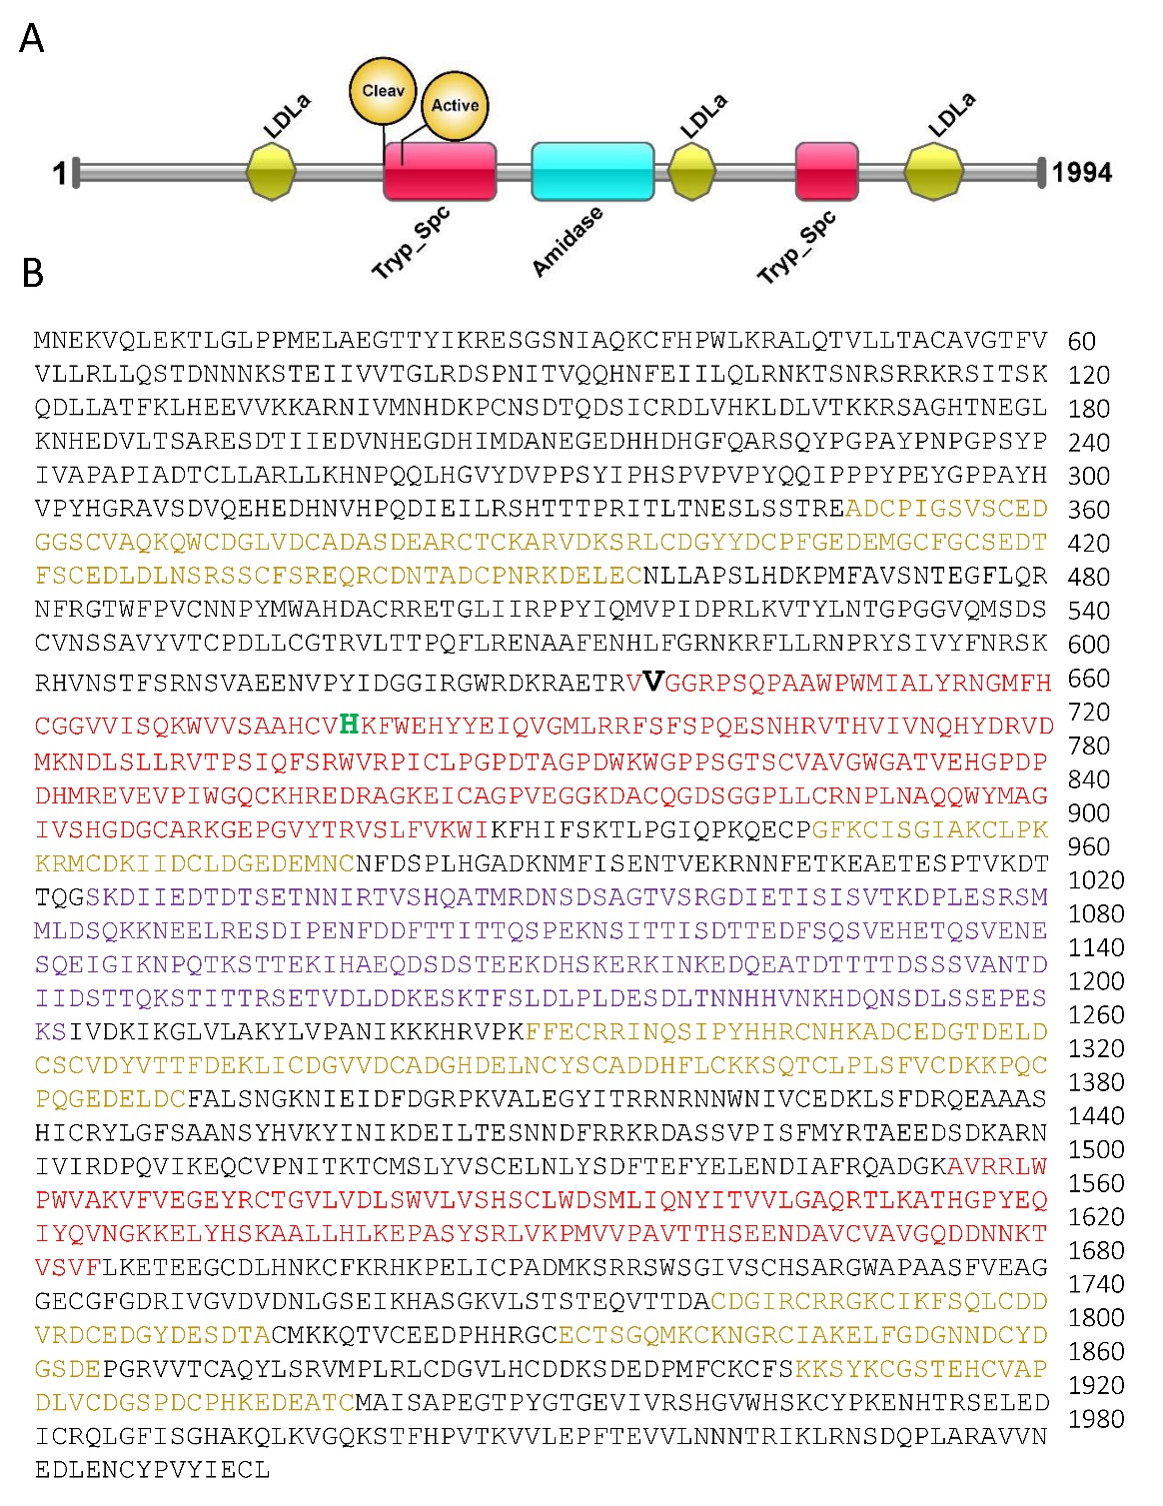
Fig. S1 Conserved domain stucture and full-length protein sequence of PxOsp. A) schematic representation of protein stucture and conserved domains. B) full-length protein sequence of PxOsp. Red color amino acids represent the two trypsin-like peptidase (Try_Spc) conserved domain and orange color amino acid sequences represent the Low-density lipoprotein receptor domain class A (LDLa) and blue color amino acids represent the amidase conserved domain. The black and green bold amino acids highlight the cleavage and active site of protein sequence.
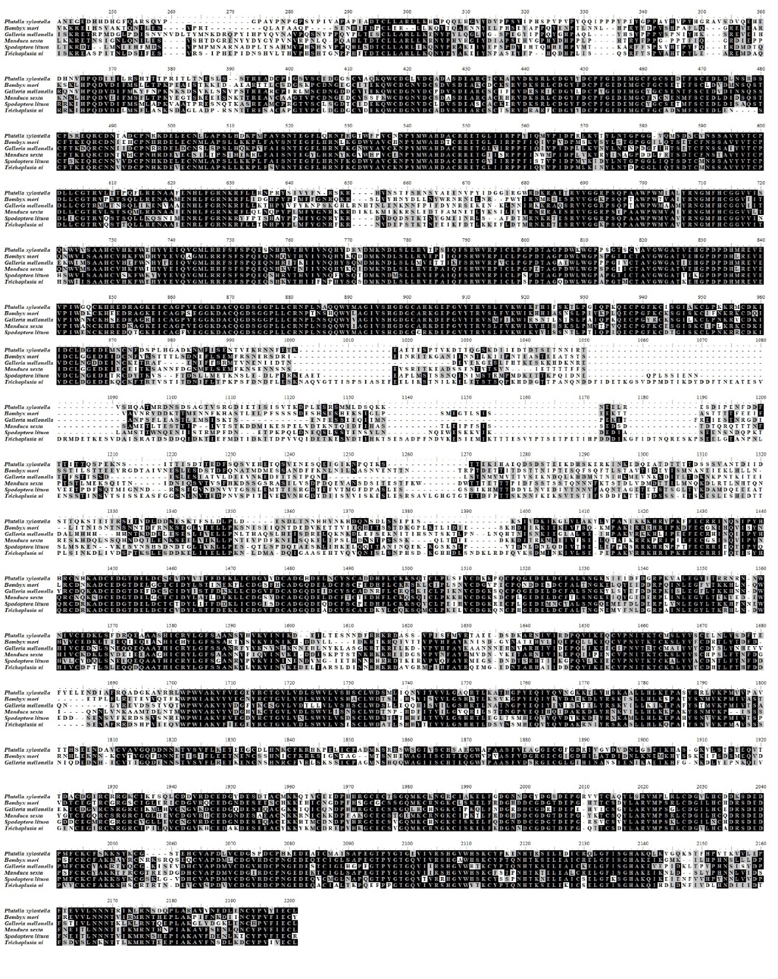
Fig. S2 Multiple allignment of Osp amino acid sequence in six Lepidopteran species, including P. xylostella (Px), B. mori (Bm), G. mellonella (Gm), M. sexta (Ms), S. litura (Sl) and T. ni (Tn).
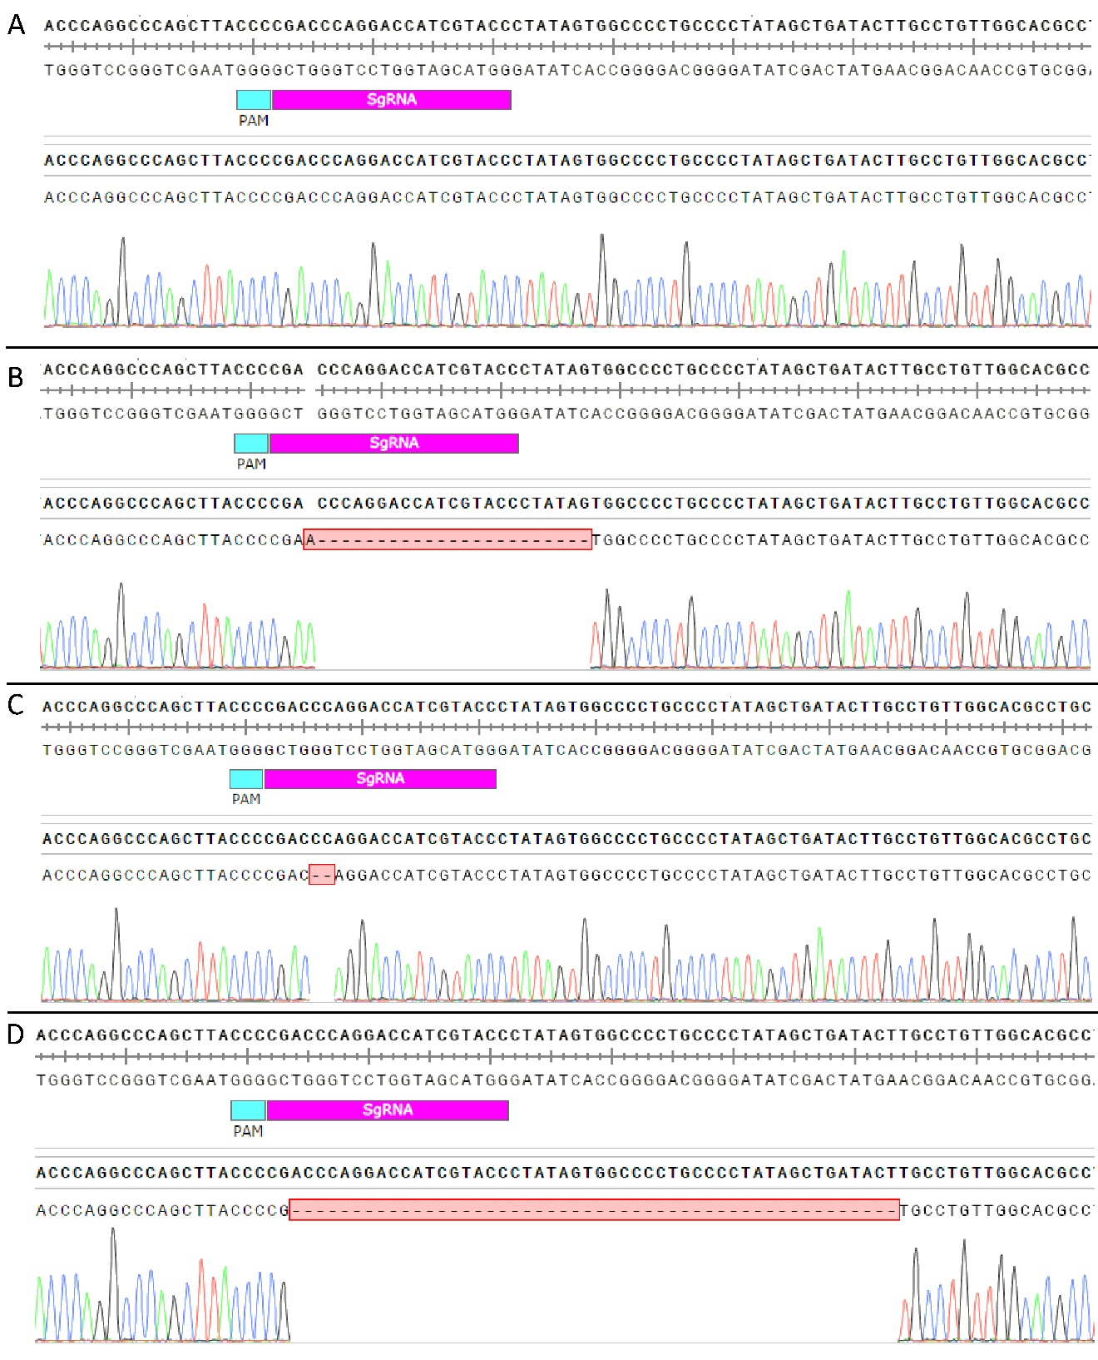
Fig. S3 Three type of homozygous PxOsp mutant strains obtined through CRISPR/Cas9-mediated genome editing tool. A) WT reference sequence, B) PxOsp-22 homozygous mutant sequence, C) PxOsp-2 homozygous mutant sequence, C) PxOsp-50 homozygous mutant sequence.
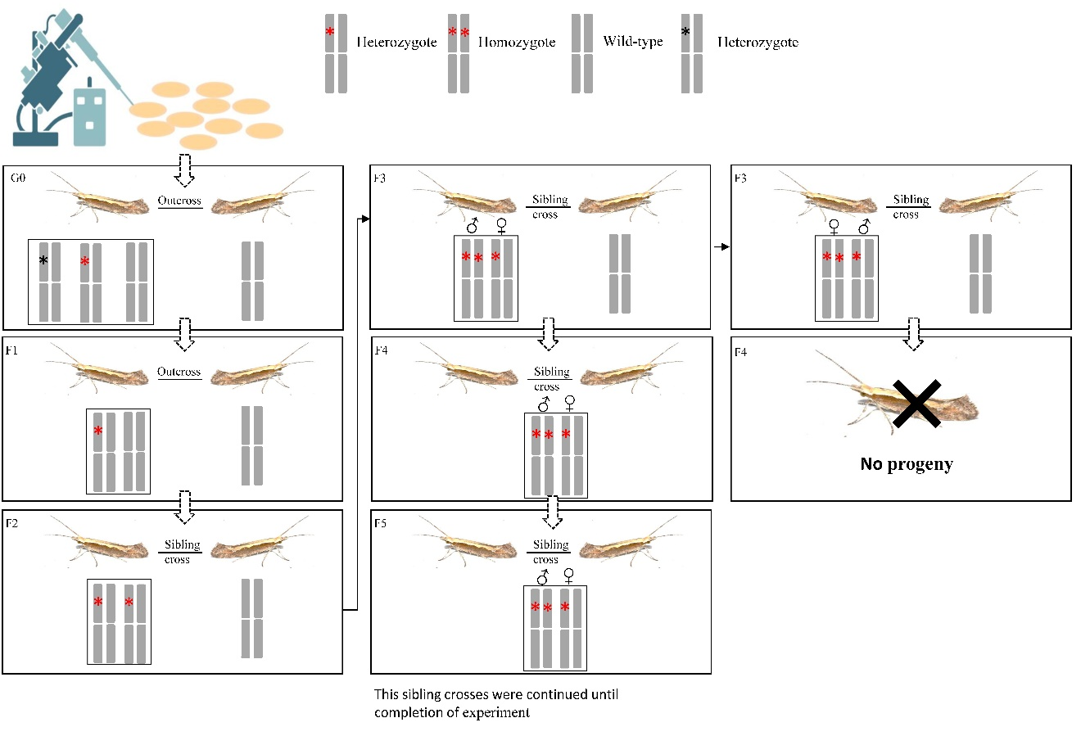
Fig. S4 Schematic representation of crossing for the development of homozygous PxOsp mutants. Newly emerged G₀ adults were separately crossed with newly emerged wild-type (WT) adults, allowing for the segregation of the mutant allele into the progeny of the F₁ generation. Mutation types and genotypes were confirmed through blunt-end cloning and Sanger sequencing. Black boxes represent the autosomes, with genotypes used for crossing further highlighted with gray columns. The black asterisk denotes the different types of mutations, while the red asterisk represents three frameshift mutations (-2bp, -23 +1bp, and -50bp), which were subsequently used to obtain three types of homozygous mutants

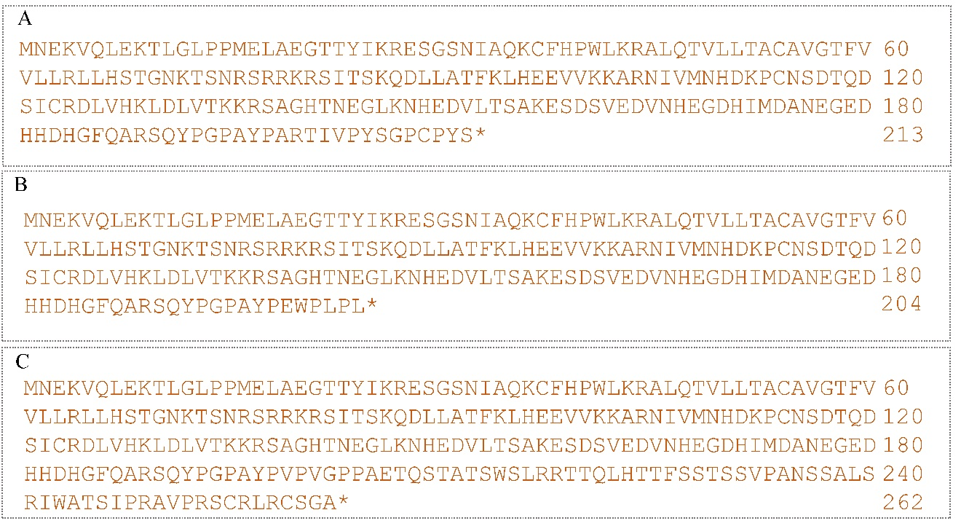
Fig. S5 Truncated protein sequences obtained after knockout of PxOsp gene. A) truncated protein sequence after deletion of 2 bp from the gRNA target site, B) truncated protein sequence after deletion of 23 bp and addition of 1 bp from the gRNA target site; C) truncated protein sequence after deletion of 50 bp from the gRNA target site. The airstricks * represent the prmature stop codon generated after nockout of PxOsp gene.

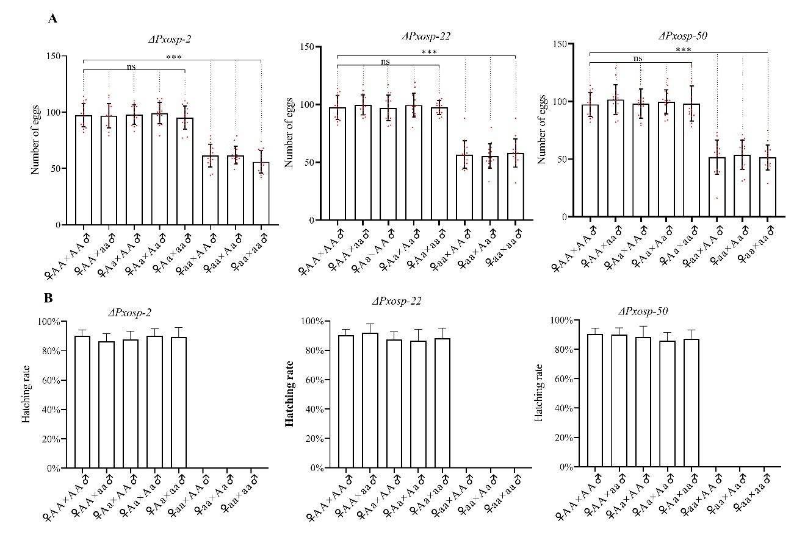
Fig. S6 Comparison of number eggs laid by females and hatchability rate during different crosses of three types of homozygous mutants. (A) The number of eggs laid by females was examined in various crosses of the three types of homozygous mutants. A total of 15 replications (n=15) were conducted for each cross. (B) The hatching rate was evaluated in different crosses of the three types of homozygous mutants. The bars in the graph represent the Mean±SD of 15 replications. The "ns" indicates a non-significant difference between the target cross and control cross. Three asterisks (***) indicate a highly significant difference with P<0.001 between the target cross and control cross.
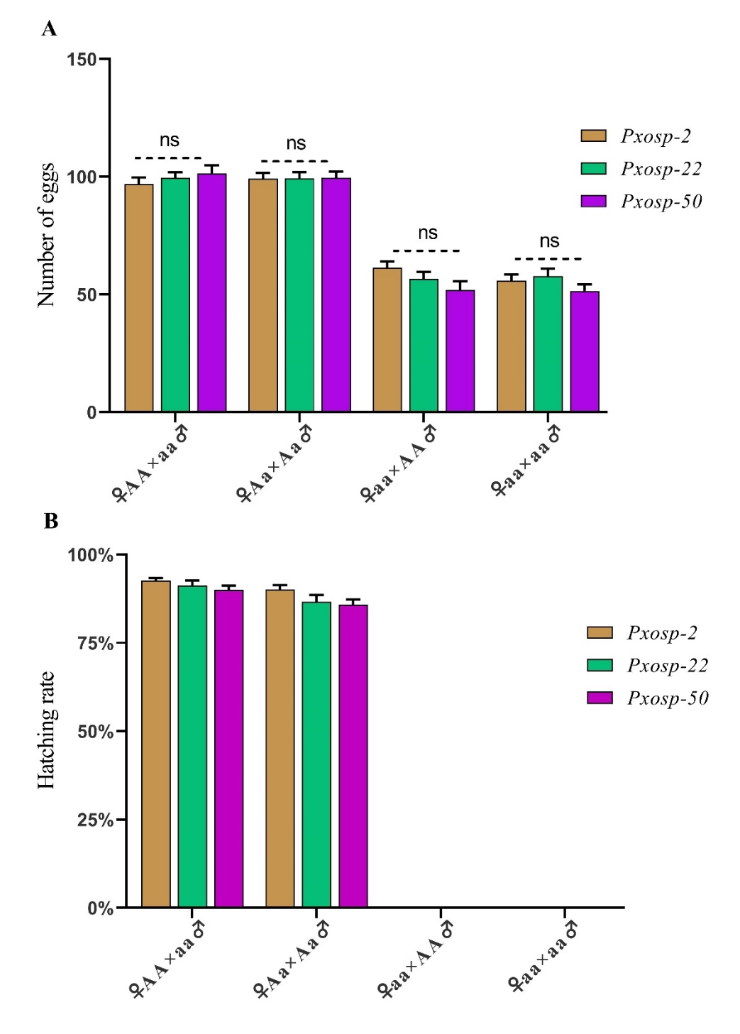
Fig. S7 Comparison of number eggs laid by females and hatchability rate after different crosses between three different types of mutants. A) comparison of number eggs produced by heterozygote and homozygous females from three different types of mutants. A total of 15 replications (n=15) were used for each cross. B) comparison of hatching rate of three different types of mutants. The bars represent the Mean±SEM of 15 replications. The ns highlights non-significant difference between three different types of mutants.
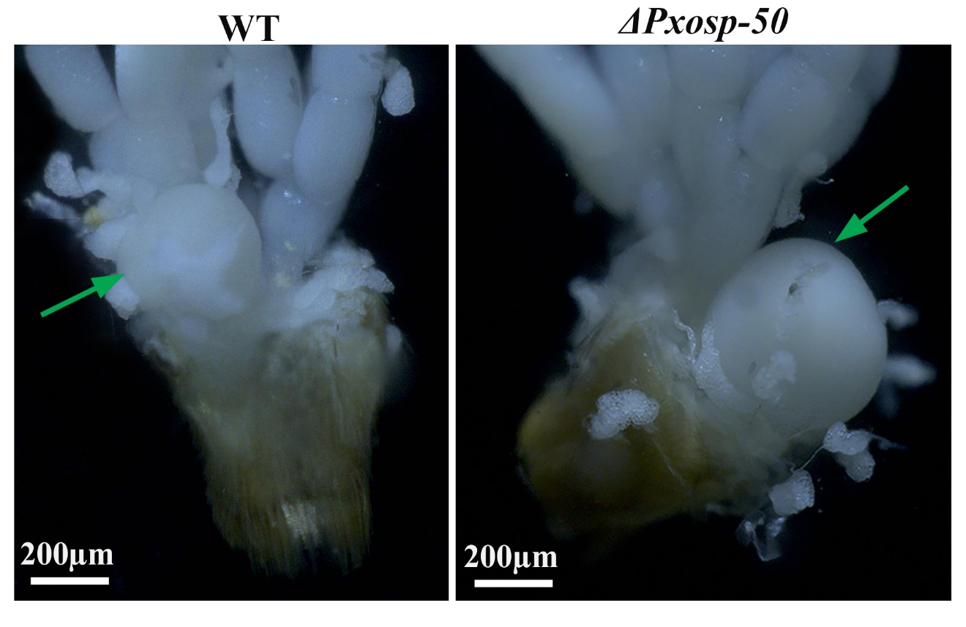
Fig. S8 The bursa copulatrix organ in wild-type (WT) and mutant females was observed under a stereoscope. Images were captured using a 200 μm scale bar. The bursa copulatrix organs are indicated by green arrows.

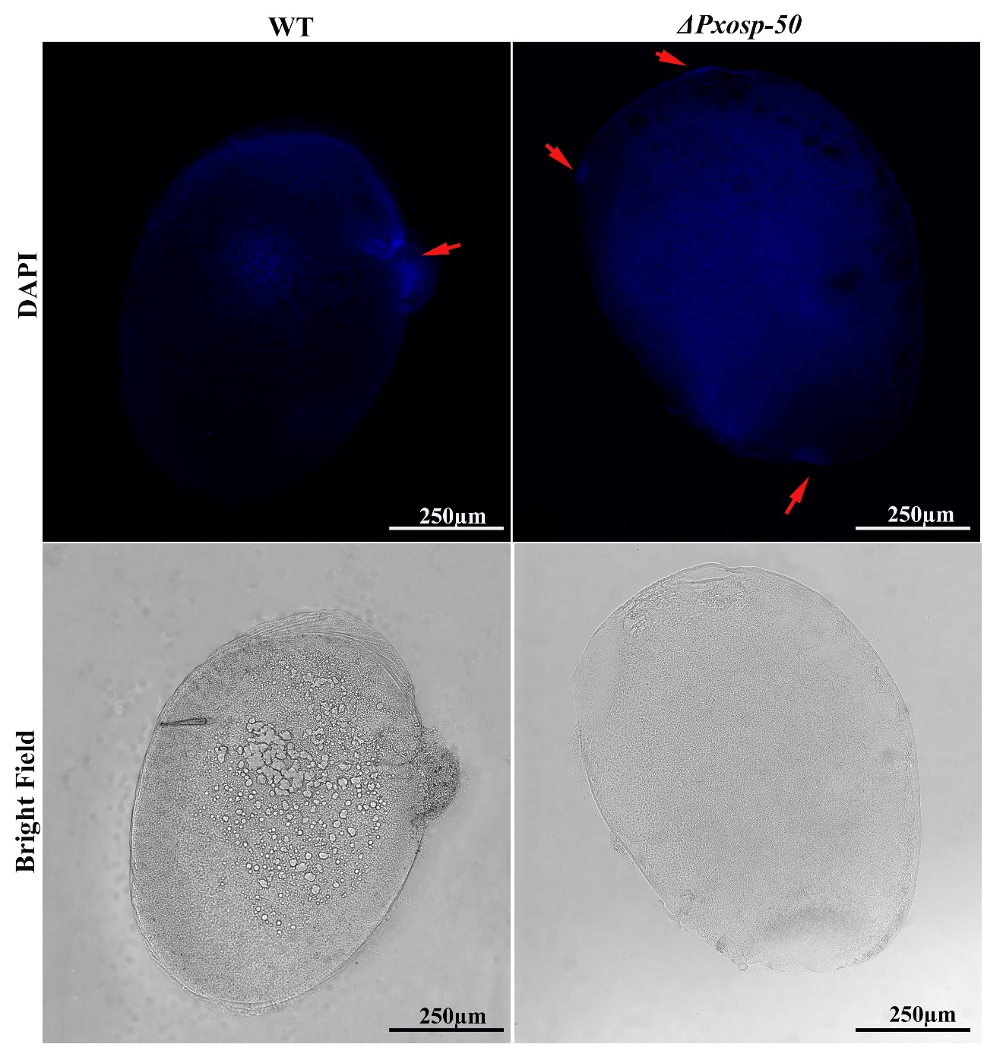
Fig. S9 Nuclear staining of fertilized eggs laid by mutant and WT females. The eggs were treated with nuclear staining DAPI within 15 minutes of oviposition. The red arrows indicate the sperm nuclei.

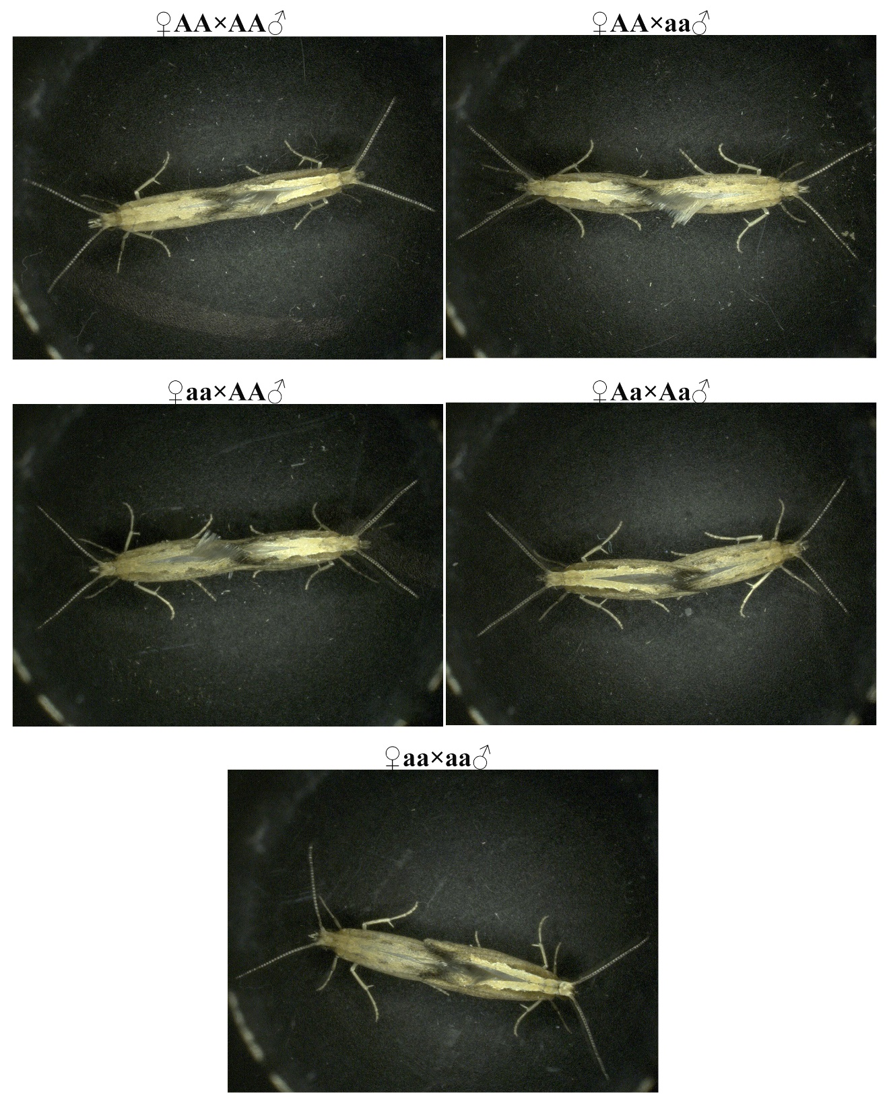
Fig. S10 Mating behaviour of mutant adults with different genotypes compared to WT. The mating of mutants and WT adults were observed using the stereoscope. Pictures were taken using a 1mm scale bar.

