Supplementary Information

Quantitative Analysis of Individual Atoms in the Channels of Beryl
Daniel Knez¹, Christian Gspan², Nikola Šimić², Stefan Mitsche^{1,2}, Harald Fitzek², Karl Gatterer³, Helmar Wiltsche⁴, Gerald Kothleitner^{1,2}, Werner Grogger^{1,2}, Ferdinand Hofer^{1,2}
¹Institute of Electron Microscopy and Nanoanalysis, Graz University of Technology, Steyrergasse 17, 8010 Graz, Austria
²Graz Centre for Electron Microscopy, Steyrergasse 17, 8010 Graz, Austria
³Institute of Physical and Theoretical Chemistry, Graz University of Technology, Stremayrgasse 9, 8010 Graz
⁴Institute of Analytical Chemistry and Food Chemistry, Graz University of Technology, Stremayrgasse 9, 8010 Graz

In this document we present additional information supporting the results presented in the main manuscript addressing following aspects:

- SEM EDX and WDX characterization of the beryl crystal
- Results of the ICP-OES analysis
- Raman microspectrometry results
- Optical absorption spectroscopy in the UV-visible range
- Multislice simulation results demonstrating the influence of channelling effects on the channel intensity

Additional characterization of the Beryl Crystal
The chemical composition of the aquamarine crystal was determined by X-ray spectrometry in a scanning electron microscope (SEM), inductively coupled plasma optical emission spectrometry (ICP-OES), Raman microspectroscopy and optical absorption spectroscopy.

Scanning electron microscopy:
The beryl crystal was cut perpendicular to the c-axis and carefully polished. The elemental composition was analysed in a scanning electron microscope (SEM) equipped with a FEG, an energy dispersive X-ray spectrometer (EDS) and a wavelength dispersive X-ray spectrometer (WDS). The X-ray spectrum shown in Figure S1 was taken from the central region of the beryl crystal and showed the major constituents of Al and Si, with minor concentrations of Fe, Cs. This spectrum corresponds to the region where the TEM sample has been taken. An extremely low K signal was also detected, but it coincides with the sum peaks of the K-lines of Al-Si and Si-Si. Quantitative evaluation yielded the concentrations in Table S1; the low Al concentration of 6.54 at% Al indicates that the aquamarine crystal is an octahedral beryl ¹.
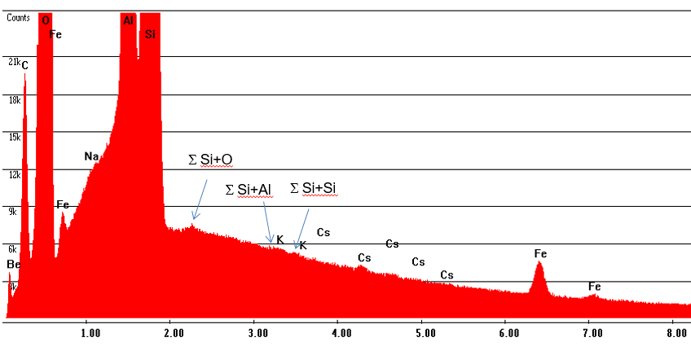

Fig. S1 EDS spectrum of the central region of the crystal, recorded with a SEM at 15 keV acceleration voltage, taken from the central region of the crystal.

Table S1 Elemental composition of the beryl crystal based on EDS spectra in at%, Na is not detectable with EDS; Be has been estimated.

at% | Al | Si | K | Cs | Fe | Be | O
EDS (Fig. S1) | 6.54 | 20.3 | 0.02 | 0.03 | 0.32 | 10.2 | 62.3
Formula | 6.89 | 20.68 |  |  |  | 10.34 | 62.07

The cross-section of the crystal was studied using backscattered electron (BSE) images taken with an angle sensitive detector. The crystal shows a zonal structure perpendicular to the c-axis (Fig. S2). EDS analyses show that the impurity concentration near the edge is much higher than in the central region, where the TEM sample was taken (Fig. S2).
Thus, in the central area 1 we find mainly Cs and Fe in similar concentrations as in the previous spectrum, a very low concentration of Sc but no K (EDS 1). On the other hand, the concentrations of Sc, Cs and Fe increase sharply in the edge area (EDS 2). Sc increases from 0.01 at% to X at%, Cs from 0.2 at% to X at% and Fe from 1.1 at% to X at%. As no Na and K were found in the EDS analyses, the inner and outer areas of the sample were also examined by WDS, which did not find any Na (Fig. S3).
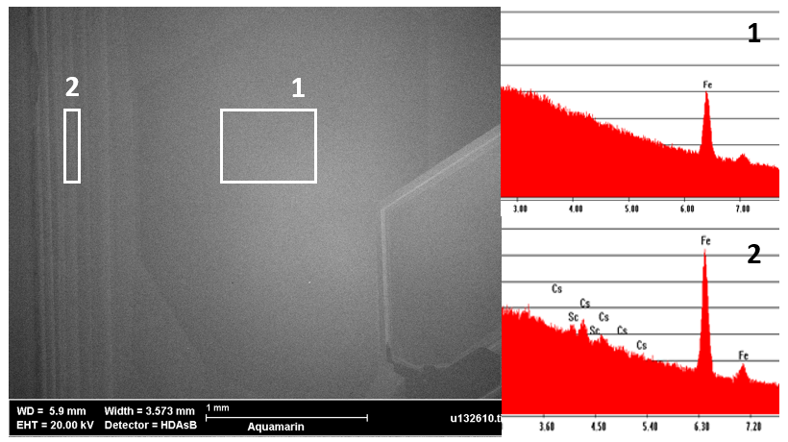
Fig. S2 SEM investigation of the cross-section of the aquamarine crystal, backscattered electron (BSE) image with EDS-spectra from the central region (1) and the edge region (2).

We find that the experimental atomic ratio of Al/Si with 0.322 is considerably lower than the nominal value of 0.333. Assuming that Fe goes to the octahedral site, we can combine the Al and Fe concentrations and obtain Al+Fe/Si = 0.337 which is near the Al/Si ratio for an ideal beryl crystal.

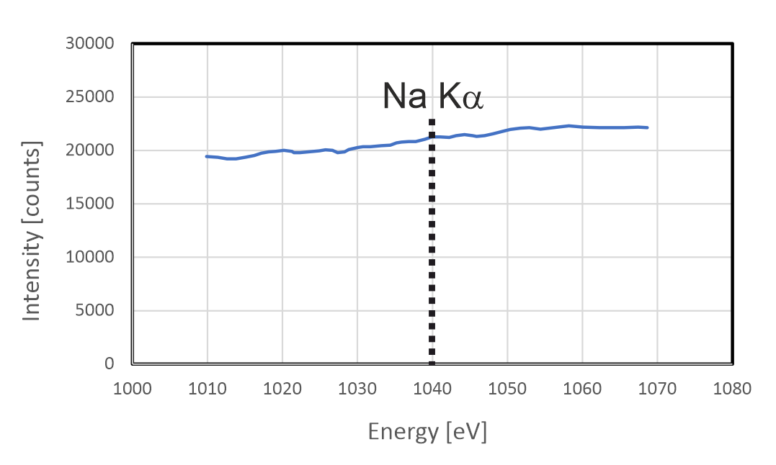
Fig. S3 Wavelength dispersive spectrum recorded in the SEM from the sample region in the centre of the aquamarine crystal; Na is not detectable (energy position of Na Kα highlighted).

The chemical analysis by ICP-OES of a slice of the bulk crystal gives a slightly different result. Table S2 shows a very high concentration of Na, K and Fe, and also Li which cannot be detected by X-ray spectrometry.
The bulk analysis shows that the concentrations of Na, K and Fe are significantly higher than in the EDS measurements in the centre of the crystal. On the one hand this is due to the enrichment of these elements in the peripheral regions of the crystal (Fig. S2) and on the other hand also to the Fe-rich inclusions on the surface of the crystal (see Figure 1 in the main paper). Therefore, the EDS analysis of the central region supplies the correct concentrations for the interpretation of the TEM sample.

Table S2 Elemental concentrations measured with ICP-OES from a slice of the bulk crystal (in at%).

Elemental concentration | Li  670.780 nm | K  766.491 nm | Fe  259.941 nm
at.% | 0.38 | 0.77 | 0.81
Error wt.% | ± 0.004 | ± 0.09 | ± 0.02

In summary, the chemical composition of the TEM sample is consistent with the X-ray spectrum from the center of the cross-section, with K present at 0.02 at% and Cs and Fe present at 0.03 at% and 0.32 at%, respectively. Low concentrations of Fe and alkali, which occur only as trace elements, are in perfect agreement with beryls with type I channel water¹.

Raman microspectrometry
The Raman spectrum of the aquamarine crystal is shown in Figure S3 and the band assignments are given in Table S3 ^{1–4}. In the fingerprint region, only bands assigned to beryl appear. A classification of beryls based on their Raman bands around 3600 cm⁻¹ has been proposed by Łodziński et al. ¹. According to this classification a band at 3606-3609 cm⁻¹ is attributed to I-type water (with the symmetry axis of the molecule perpendicular to the channel axis) and a band at 3597-3594 cm⁻¹ is attributed to II-type water (with the symmetry axis of the molecule parallel to the channel axis). Beryls are classified as alkali-free (<0.08 wt.%) when only the I-type water band appears, alkali-poor (0.08-0.5 wt.%) when the I-type water band is stronger than the II-type water band, and alkali-rich (>0.5 wt.%) when the II-type water band is stronger than the I-type band. The high-resolution spectrum of the region around 3600 cm⁻¹ clearly shows that the aquamarine contains only I-type water and is almost alkali free (in agreement with the EDX measurement). The small shoulder left of the 3608.5 cm¹ peak can be attributed to low amounts of II-type water in the channels¹.

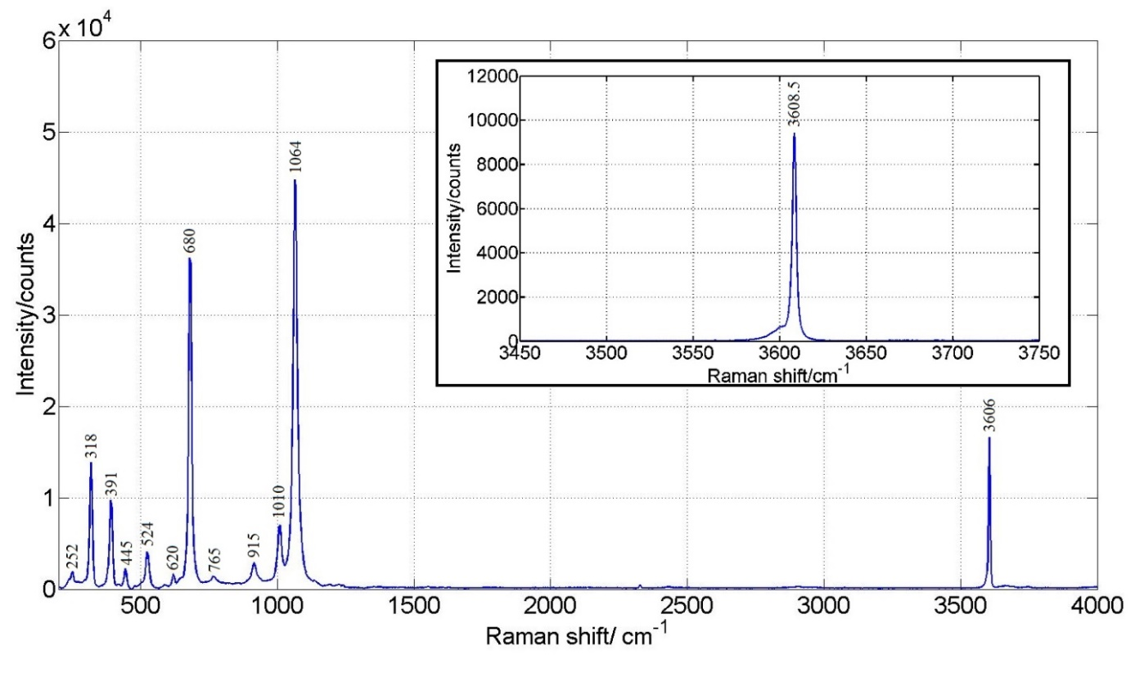
Fig. S4 Raman spectrum of the aquamarine and high-resolution Raman spectrum of the region around 3600 cm⁻¹; the strong band at 3608.5 cm⁻¹ and the absence of a band at 3597-3594 cm⁻¹ indicate an almost alkali-free beryl with I-type water ¹.

Table S3: Assignment of Raman bands

Band position/cm⁻¹ | Band assignment ^{1–4}
252 | E_{1g}
318 | ν_{satellite} ring/E_{2g} + A_{g} overlap
391 | ν_{satellite} ring/A_{g} + E_{2g} overlap
445 | E_{2g} (O-Si-O)
524 | ν(Al-O), sym. Ring def./E_{g1}
620 | A_{g}, characteristic for ring structures
680 | ν(Be-O), sym. Ring def./E_{g1}
765 | ν(Be-O), E_{1g}+E_{2g} overlap
915 | ν(Si-O), E_{2g}+E_{1g}
1010 | ν(Si-O), ring/E_{1g}
1064 | ν(Si-O), ring/A_{g}
3606 (3608.5) | ν₁ H₂O I-type

Optical absorption spectrometry

The pale blue-green beryl has been studied by UV-Vis spectroscopy and shows the absorption features typical of light blue aquamarines ⁵. The spectra were measured both perpendicular and parallel to the c-axis of the crystal.
The peaks at 372 and 427 nm are related to spin-forbidden transitions in Fe³⁺ ions on the octahedral Al³⁺ sites; they do not contribute to the colour due to their rather weak absorption ^{5,6}. The broad absorption band with a maximum at 810 nm is due to Fe²⁺ in a symmetrical environment, probably also on the octahedral sites ^{5,7} .
As expected, the spectrum recorded perpendicular to the c-axis also shows the broad shoulder between 600 and 700 nm, which is associated with intervalence charge transfer transitions (IVCT) between neighbouring Fe²⁺ - Fe³⁺ pairs ^{5,7,8}. In recent work, the IVCT effect is unanimously considered to be the cause of the light blue colour of aquamarine ⁶.

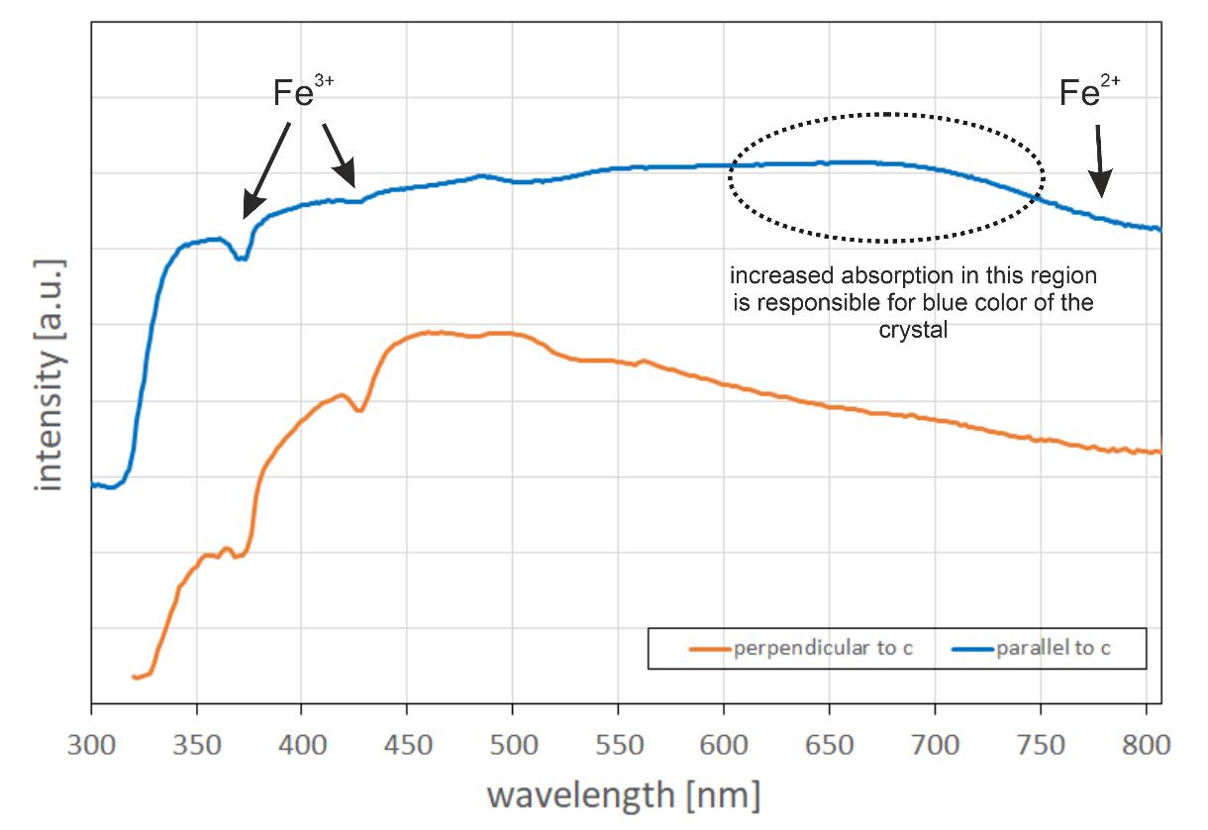

Fig. S5 UV-Vis spectra of the pale blue-green aquamarine crystal recorded perpendicular and parallel to the c-axis revealing the typical absorption features a light blue aquamarine.

Channelling effects in the Beryl channel

Figure S6 shows a plot of the absolute HAADF intensity values as a function of crystal thickness extracted from a series of multislice simulations. Similar to Figure 4 in the main paper, a Cs atom is placed at the top position. The plot shows, that due to channelling effects, the intensity of the empty channel (yellow curve) also increases with crystal thickness and thus contributes additively to the measured intensity in the filled channel sites. The contribution increases significantly above 10-15 nm thickness and must be considered for quantification.

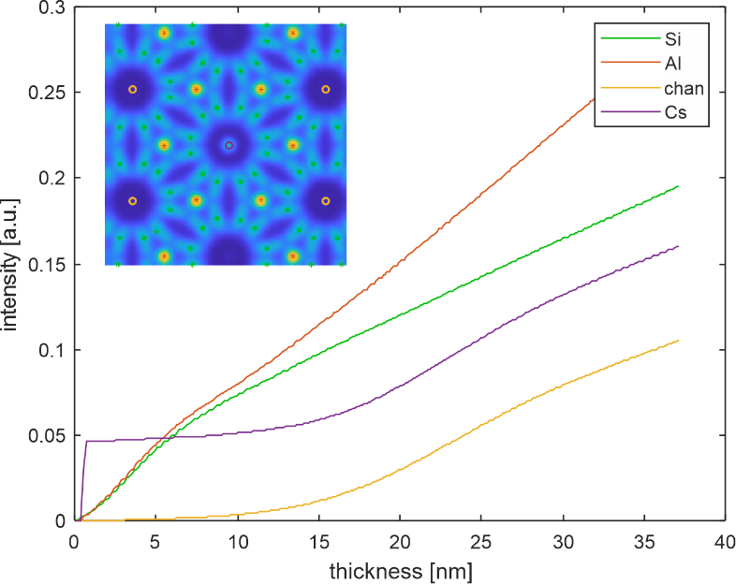
Fig. S6: Absolute HAADF intensity values over crystal thickness as obtained from multislice simulations with 1 Cs in the top position of the center channel. Inset shows a simulated HAADF image with the atomic positions used for intensity integration indicated, with colours corresponding to the graphs.

References
1. Łodziński, M.; Sitarz, M.; Stec, K.; Kozanecki, M.; Fojud, Z.; Jurga, S. Journal of Molecular Structure 2005, 744-747, 1005–1015, DOI:10.1016/j.molstruc.2004.12.042.
2. Adams, D. M.; Gardner, I. R. J. Chem. Soc., Dalton Trans. 1974 (14), 1502, DOI:10.1039/DT9740001502.
3. Kim, C. C.; Bell, M. I.; McKeown, D. A. Physica B: Condensed Matter 1995, 205 (2), 193–208, DOI:10.1016/0921-4526(94)00290-C.
4. Charoy, B.; Donato, P. de; Barres, O.; Pinto-Coelho, C. American Mineralogist 1996, 81 (3-4), 395–403, DOI:10.2138/am-1996-3-414.
5. Andersson, L. O. The Canadian Mineralogist 2019, 57 (4), 551–566, DOI:10.3749/canmin.1900021.
6. Hu, Y.; Lu, R. G&G 2020, 56 (1), 54–65, DOI:10.5741/gems.56.1.54.
7. Spinolo, G.; Fontana, I.; Galli, A. Phys. Status Solidi (b) 2007, 244 (12), 4660–4668, DOI:10.1002/pssb.200743102.
8. Groat, L. A.; Rossman, G. R.; Dyar, M. D.; Turner, D.; Piccoli, P. M.; Schultz, A. J.; Ottolini, L. The Canadian Mineralogist 2010, 48 (3), 597–613, DOI:10.3749/canmin.48.3.597.

