Appendix A – Python Pseudo-Code

Pseudo-Code for Genetic Algorithm Implementation
#Genetic Algorithm
Extract plastic and metal physicochemical properties from Excel
Assign properties to variables.
Create chromosomes containing randomly valued channel parameters (within limits)
Do-while loop with termination criterion (sum of fitness remains relatively constant for 100 consecutive iterations):
Sort chromosomes
Select two chromosomes with a probability proportional to fitness (natural selection)
Perform cross-over (see below)
Calculate fitness (see below) of offspring based on 1-D heat transfer equations (Equation 2.1 & Equation 2.2) for the moulding cycle, with lower cycle times and even mould temperatures across chromosomes resulting in a better fitness function value.
Replace two high fitness old-generation chromosomes with new offspring.
Save channel parameters – mould temperature, coolant temperature, diameter, pitch, base offset, cooling time, and initial melt temperature
#Crossover
Select number of parameters to crossover
Select which parameters to crossover.
Crossover selected parameters of both parents
Ex. X.Diameter = Y.Diameter
For 5% probability for each offspring:
Select the number of parameters to mutate.
Select which parameters to mutate.
Perform mutation (see below) on selected parameters
Return two offspring.
#Mutation
Randomise each parameter value in the list within initial limits
Ex. X.Diameter = random(D_lowerLimit, D_upperLimit)
#Fitness
Start with the initial cool time and mould temperature.
Do until the difference in the calculated mould temperature does not vary:
Calculate the newly derived cooling time from Equation 2.2
Calculate the newly derived mould temperature from Equation 2.1
Save fitness as the sum of the cooling time and variation of mould temperature within all channels.
Save new cooling time and mould temperature.

Pseudo-Code for Control Point Extraction & Position Refinement
#Mould Strip
Import mould’s mesh file supplied by mould tool designer (STL format)
Remove all walls except the one facing the cavity direction.
Save as ‘Stripped Mould File’ (STL format)
#Mould Section
Import Stripped Mould STL file.
Find all normal vectors of section planes at pitch distances.
Find intersection points at all mesh and section plane intersections.
Save all points in sequence obtained for every section in a cavity.
Save normal of section planes.
#Line Refinement
Import sequences of points for all sections
Fix any issues in sequencing of points in order of section.
Delete any points that cause discontinuities in a smooth sectional line.
Join all sections together in one list.
Save joined sectional points coordinate in file.

Pseudo-Code for Heat Extraction
Open Moldex3D Project
Import sectional points coordinate file.
Import final offset points.
Load temperature results from the end of the cooling stage
Query temperature values at each sectional point
Query coolant temperature values at each offset point
Query central temperature at ejector pin locations
Save temperatures obtained at all sectional points.
Save coolant temperatures at offset points.
Save central temperatures at ejector locations.

Pseudo-Code for Offset Variation
#Offset Calculator
Import temperatures obtained at all sectional points.
Import channel parameters.
Find the mean surface temperature at the part surfaces.
Do for all sectional points at the part surface:
Find ∆T from the mean surface temperature.
Perform Golden Search on the 1-D heat transfer equation to find new offset values**
Save all new offset values for every sectional point.
#Golden Search Method
Do for all points in the sectional planes that lie on the part:
Obtain the temperature difference between the temperature at that control point and the mean temperature.
Perform GSSM for offsets between initial offset ± 1 mm:
Change offset value at the golden ratio distance from one limit.
Do until the difference in the calculated mould temperature does not vary:
Calculate the newly derived cooling time.
Calculate the newly derived mould temperature.
The value of the search function is the difference between the original mould temperature and the final derived mould temperature.
Ex. return (T_mold_original – T_mold-deltaT/4)
(The ‘4’ is chosen by trial and error to bring gradual changes to offset values)
Save new offset.

Pseudo-Code for Interference Detection
Import all offset point coordinates.
Import Stripped Mould file (STL format)
Compare each cooling channel* with the others to see if any interference is detected.
If yes:
Find the last nonintersecting point at either end of the channel and join them at the bottom end of the block **
Check if part of a cooling channel interferes with the striped mould
If yes:
Find the last nonintersecting point at either end of the channel and join them at the bottom end of the block **
Save all remaining offset point coordinates.
* Line joining all offset points in the ONE sectional plane
** To avoid interference with part

Appendix B – Material Properties

Tool Steel Properties
Table 9: Tool steel (P20) material characteristics [33]
Property | Value
Metal grade | P20 Tool Steel
Specific heat capacity (C_{p}) | 4620 J/(kg K)
Thermal conductivity | 29 W/(m K)
Young’s modulus | 207 GPa
Poisson’s ratio | 0.3
Coefficient of linear thermal expansion | 1.29e-5 K⁻¹
Density | 7850 kg/m³

Stainless Steel Properties
Table 10: Stainless Steel (SS316L) material characteristics [33]
Property | Value
Metal grade | Stainless Steel 316 L (SS316L)
Specific heat capacity (C_{p}) | 576 J/(kg K)
Thermal conductivity | 16.3 W/(m K)
Young’s modulus | 193 GPa
Poisson ratio | 0.3
Coefficient of linear thermal expansion | 1.59e-5 K⁻¹
Density (20°C, 0 bar gauge) | 8000 kg/m³

Copper-Aluminium Bronze Properties
Table 11: ‘CuAl Bronze’ material data (obtained from Metals for Printing (M4P), Magdeburg, Germany)
Property | Value
Metal grade | Cu9.3Al1.3Fe (weight percentages)
Specific heat capacity (C_{p}) | 420 J/(kg K)
Thermal conductivity | 59 W/(m K)
Young’s modulus | 110 GPa
Poisson ratio | 0.32
Coefficient of linear thermal expansion | 1.62e-5 K⁻¹
Density (20°C, 0 bar gauge) | 7450 kg/m³

Polypropylene Properties
Table 12: Bormed polypropylene (HF840MO) material characteristics [33]
Property | Value
Plastic grade | Bormed HF840MO
Specific heat capacity (C_{p}) | 2400 J/(kg K)
Thermal conductivity | 0.24 W/(m K)
Young’s modulus | 1.25 GPa
Poisson ratio | 0.38
Coefficient of linear thermal expansion | 1.5e-4 K⁻¹
Freezing/glass transition temperature for amorphous polymer | 110°C
Density (20°C, 0 bar gauge) | 904 kg/m³

Appendix C – Supplementary data

Recommended Wall Thickness for a Range of Characterised Plastics
Table 13: Recommended part wall thickness range for injection moulding of some common polymers [34] rounded to 2 decimal points.
Resin name | Recommended wall thickness (mm)
Acrylonitrile butadiene styrene | 1.14 - 3.56
Acetal | 0.76 - 3.05
Acrylic | 0.64 - 3.81
Liquid crystal polymer | 0.76 - 3.05
Long-fibre reinforced plastics | 1.90 - 25.40
Nylon | 0.76 - 2.92
Polycarbonate | 1.02 - 3.18
Polyester | 0.64 - 3.18
Polyethylene | 0.76 -5.08
Polyphenylene sulphide | 0.51 - 4.57
Polypropylene | 0.64 -3.81
Polystyrene | 0.89 - 3.81
Polyurethane | 2.03 - 19.05

Predicted time and warpage values for mould sets in study.
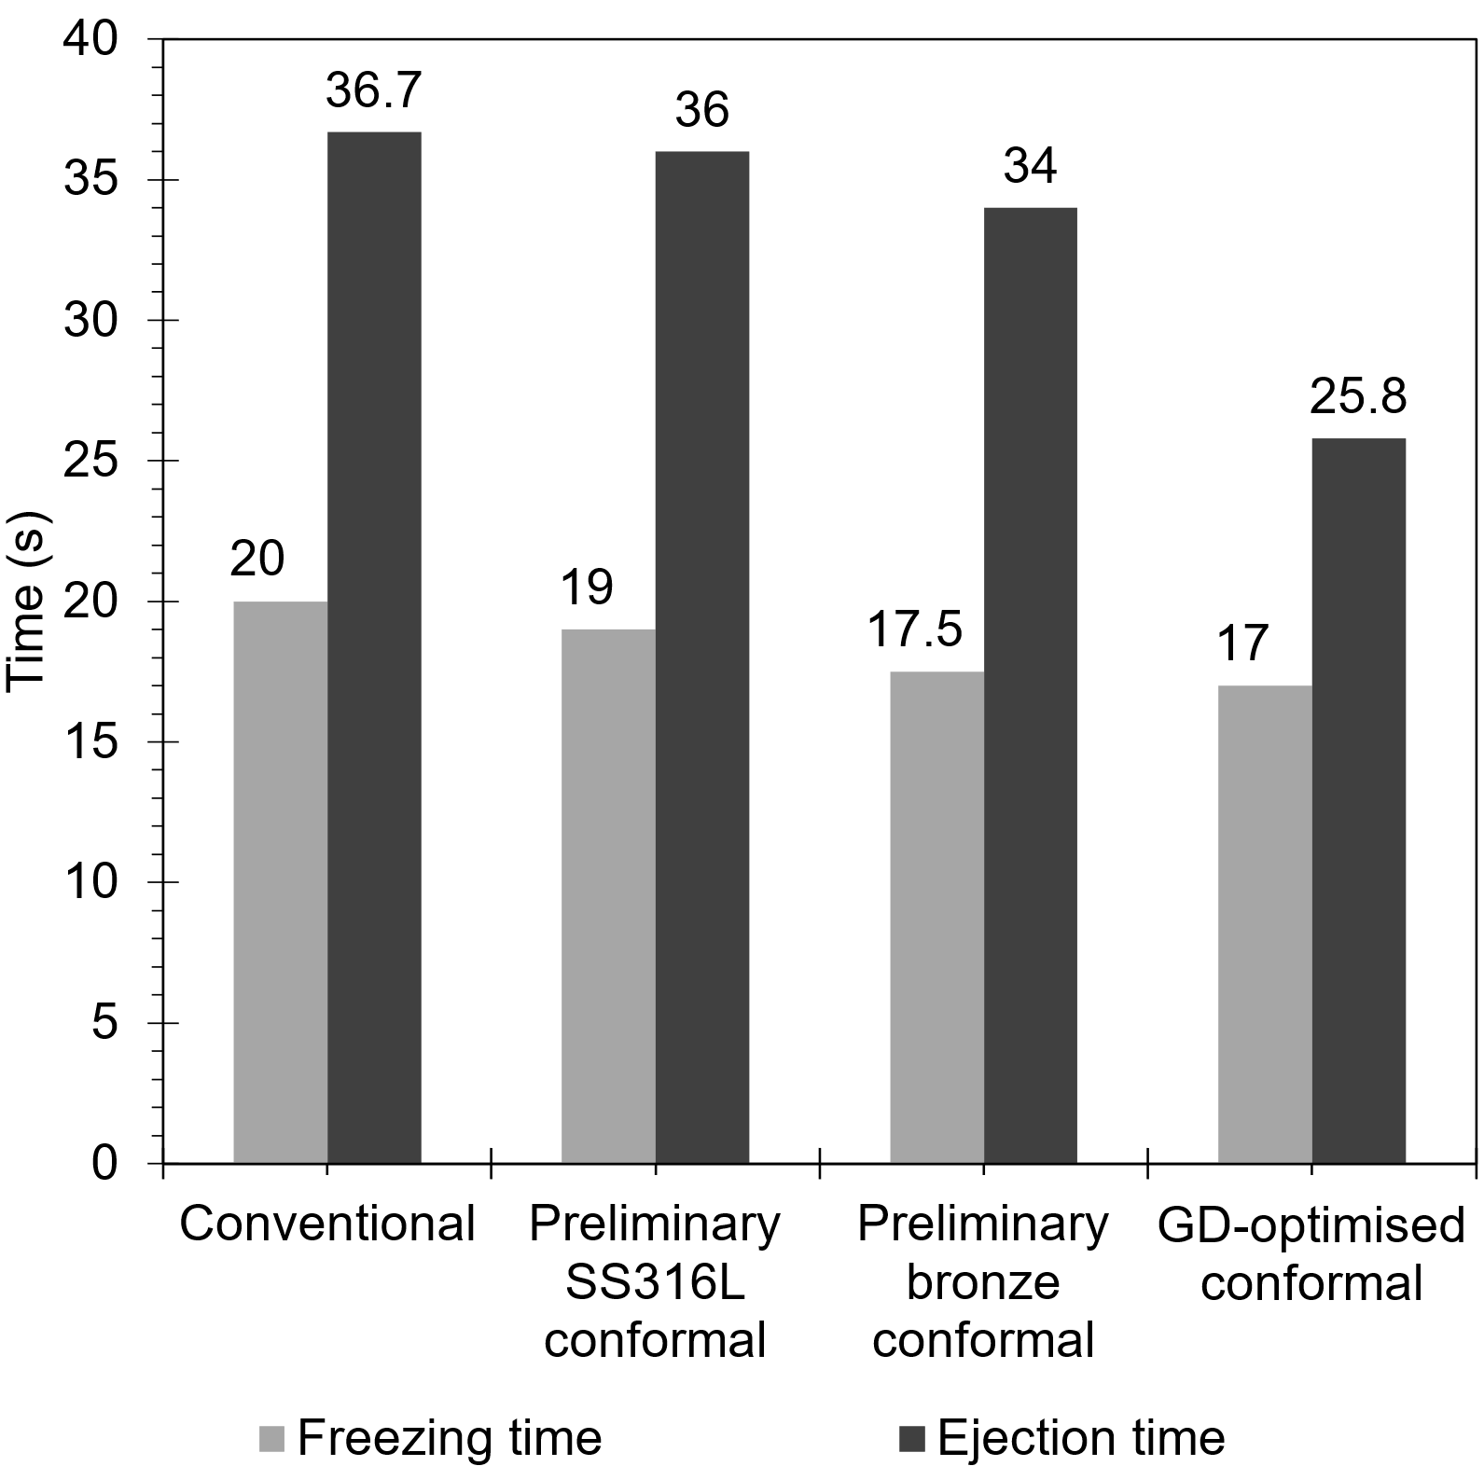
Fig. 16: Predicted freezing times and ejection times (time to reach the moulded polymer’s supplier-defined ejection temperature) for the four mould tool designs studied here.
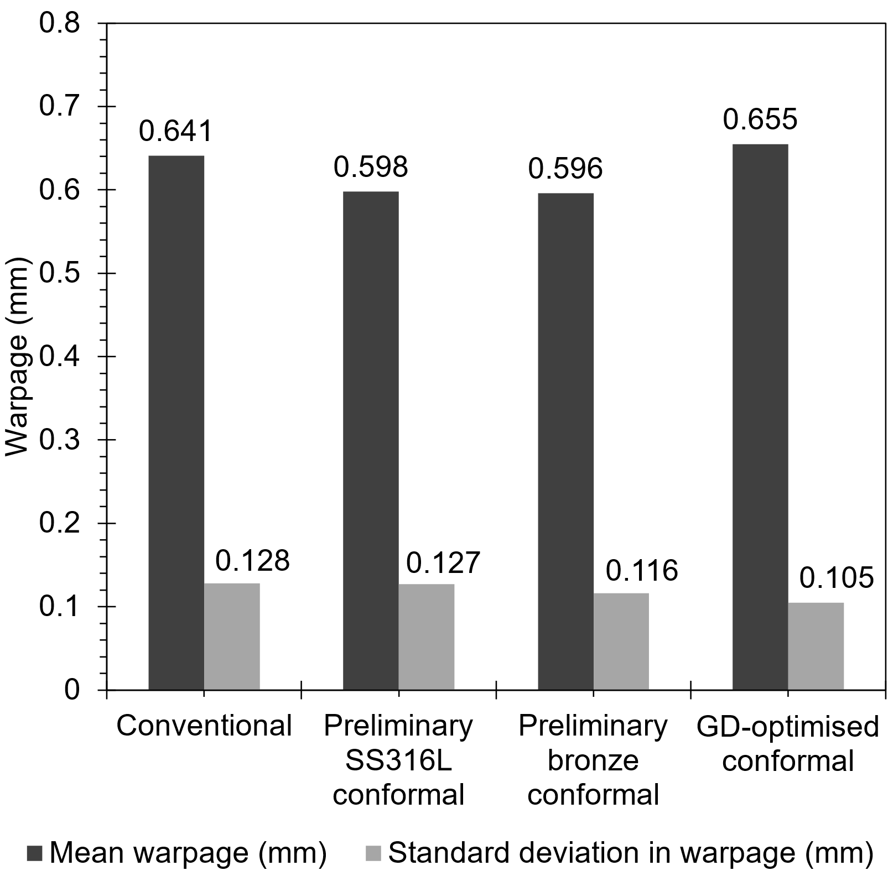
Fig. 17: Predicted average part warpage values and their standard deviation across the part profile for the four mould tool designs studied here.

