Supplemental Materials

Supplemental Figures 1-3
Supplemental Table 1
Supplemental Spread sheet 1
Supplemental Movie 1
Supplemental Data 1
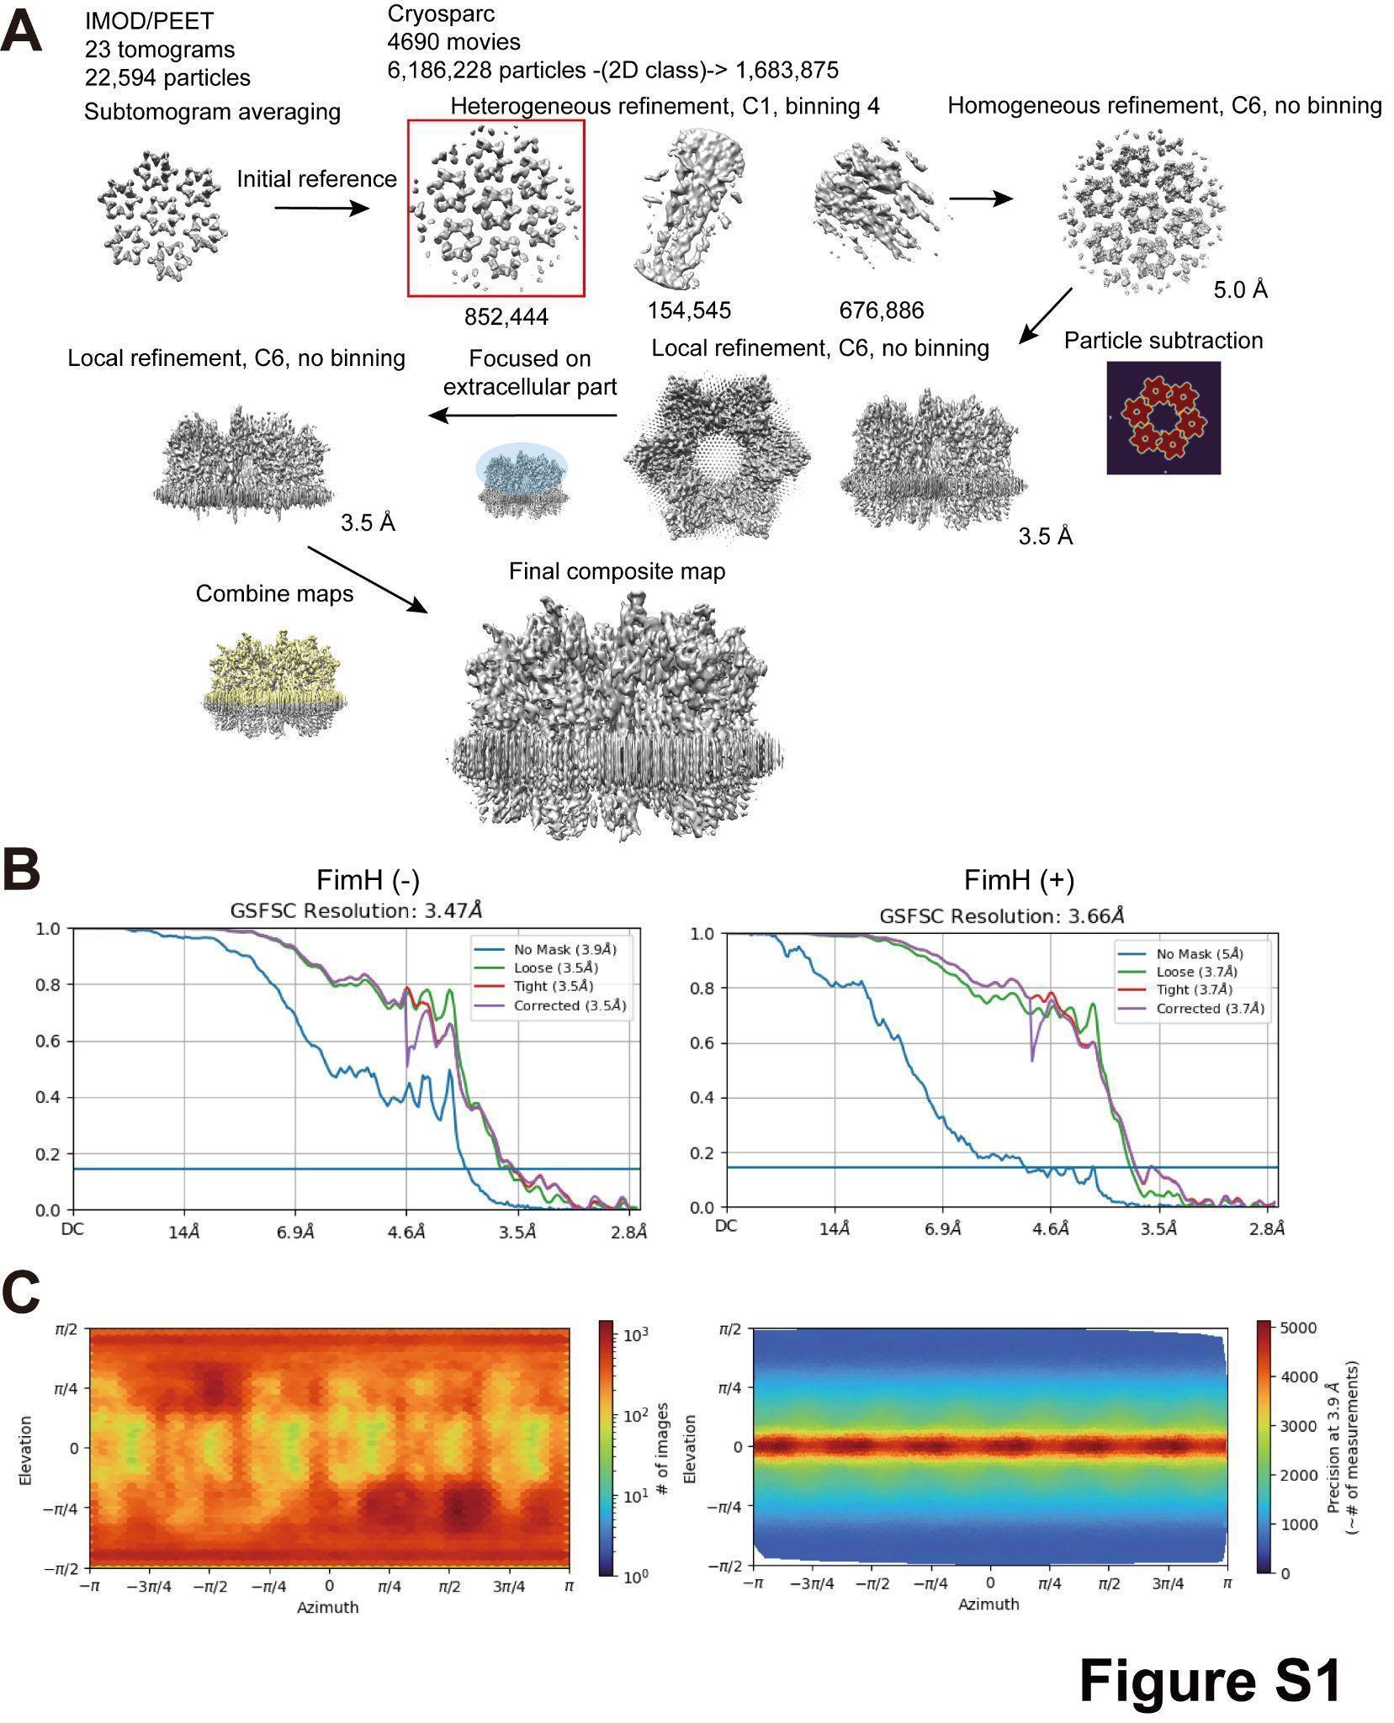
Supplementary Figure 1: Cryo-electron microscopy of the AUM. (A) Summary of the reconstruction procedure. (B) Resolution estimations using Fourier shell correlation. The cut-off value is 0.143. The left and right curves are without and with FimH, respectively. (C) The viewing direction distribution (left) and the posterior precision directional distribution (right). Although the distribution of the views covers nearly entire directions, the precision of the side views deteriorates due to the overlapping molecules.

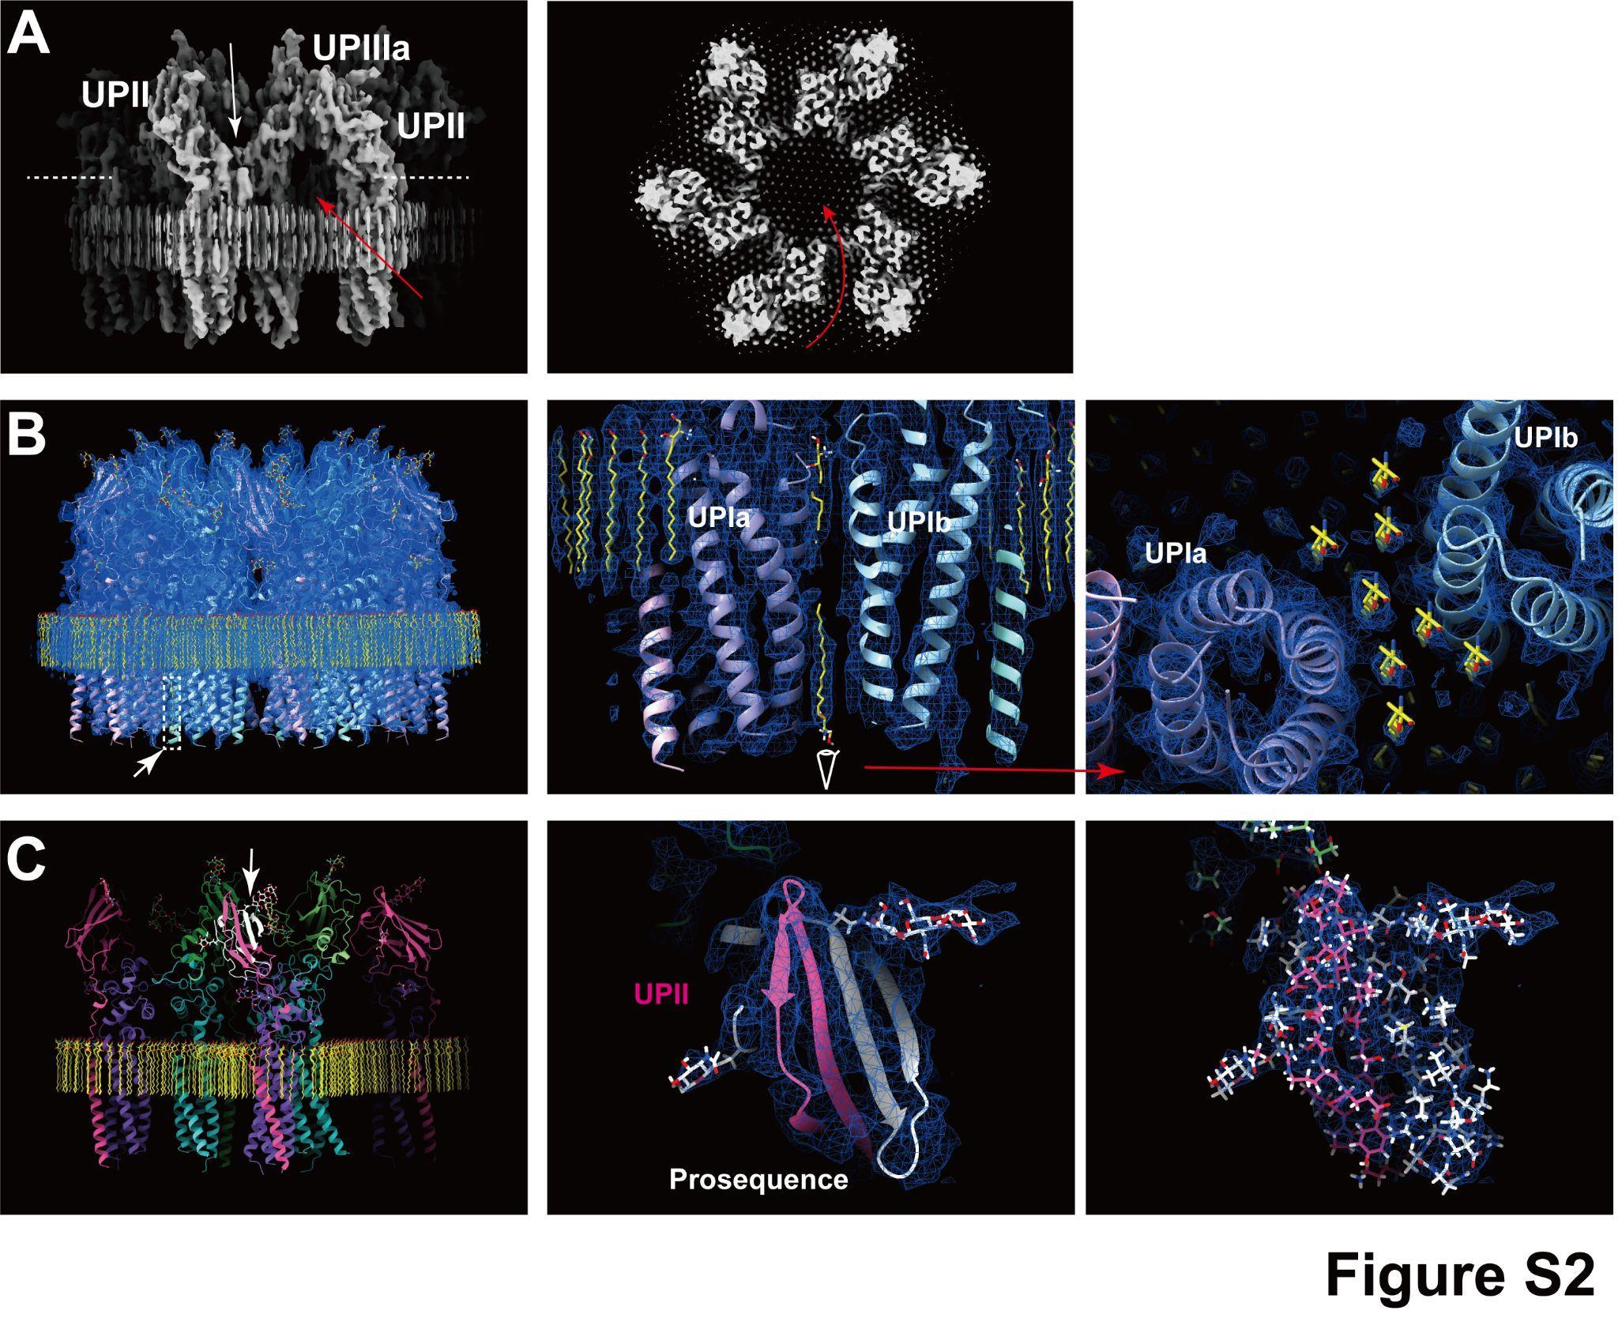
Supplementary Figure 2: Additional structural features. (A) Y-shaped conformation of the uroplakin heterotetramer. The white and red arrows indicate the groove between UPII and UPIIIa, and the channel beneath the II-IIIa arch, respectively. The broken lines indicate the position of the cross-section on the right panal. (B) Weak signals of lipids of the inner leaflet (arrow). The view from the cytoplasmic side (right) shows the hexagonal alignment of the inner lipids (yellow). (C) The prosequence of UPII (arrow, models in white) forms an anti-parallel beta-sheet structure. The electron densities (mesh) validate the assignment of the domain (middle and right).
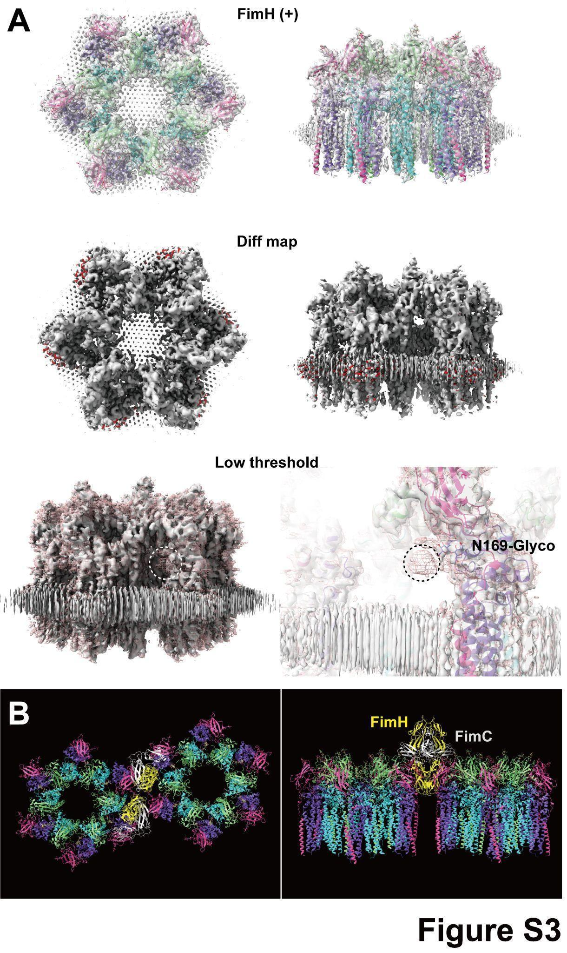
Supplementary Figure 3: FimH-bound uroplakin structure. (A) Uroplakin structure in the presence of FimH-FimC complexes. Model fitting (top) and the difference map (middle) indicate no conformational changes within the uroplakin complex. The difference map shows scattered signals in the lipid regions near the Ia/II heterodimer, suggesting an altered lipid configuration. (B) Model of the uroplakin complex pair with bound FimH-FimC complexes (PDBID: 1QUN). The gap between the two neighboring uroplakin complexes is so narrow that the mannose-binding domain of FimH barely fits.

Supplementary Table 1: Summary of data collection and model validation
Data collection parameters
Magnification | 64,000×
Pixel size (Å) | 1.35
Voltage (keV) | 300
 | Tomography
Defocus range (µm) | 2.5-4.5
Exposure time (sec/tilt) | 0.18
Number of frames per tilt | 10
Angular range (°) | ±60
Increments (°) | 3
Total dose (e⁻/Å²) | 50
Number of tilt series recorded | 95
Number of tilt series processed | 23
Initial number of subtomograms | 83,109
Final number of subtomograms | 22,594
 | SPA
Defocus range (µm) | 1.1-4.5
Exposure time (sec) | 6.7
Number of frames | 50
Total dose (e⁻/Å²) | 50
Tilt angles (°) | 0, 30 , 45, 55
Ratio of tilted images | 1:1:2:2 for 0, 30, 45, 55°
Number of movies recorded | 4,690 (FimH-)/2,733 (FimH+)
Box size (pixels) | 512
Initially picked particles | 12,764,463 (FimH-)/6,619,664 (FimH+)
Final particles | 609,567 (FimH-)/177,303 (FimH+)
Model validation statistics
Initial model used | AlphaFold prediction
Bonds length RSMD (Å) | 0.023
Bonds angles RSMD (°) | 2.466
MolProbability score | 1.74
Clash score | 2.55
Rotamer outliers (%) | 1.49
Ramachandran plot (%) | Favored: 89.25  Allowed: 10.75  Outliers: 0.00
CaBLAM outliers (%) | 4.37
B-factors (min/max/mean) | 59.32/134.09/93.14
Map resolution estimates (Å) | 3.5 (FSC_{half-map}=0.143)  3.6 (FSC_{model}=0.143)

Supplemental spread sheet 1: Numerical data used for generating boxplot in Figure 7.
Supplemental Movie 1: Movie representation of Figure 2A.
Supplemental Data 1: Maps and models used in this manuscript.
8JJ5.pdb: models of the uroplakin heterotetramer.
Associated_lipids.pdb: models of sphingosine associated with the uroplakin complexes.
Other_lipids.mmcif: models of sphingosine surrounding the uroplakin complexes.
EMD-36340.mrc: electron density map of the uroplakin hexameric complex.
EMD-36340-DeepEMhancer_sharpened.mrc: sharpened map using DeepEMhancer tool of CryoSPARC.
36340_8JJ5_ChimeraX_session.csx: session command file for visualization of maps and models using ChimeraX.

