Image
Supplementary figure 1.
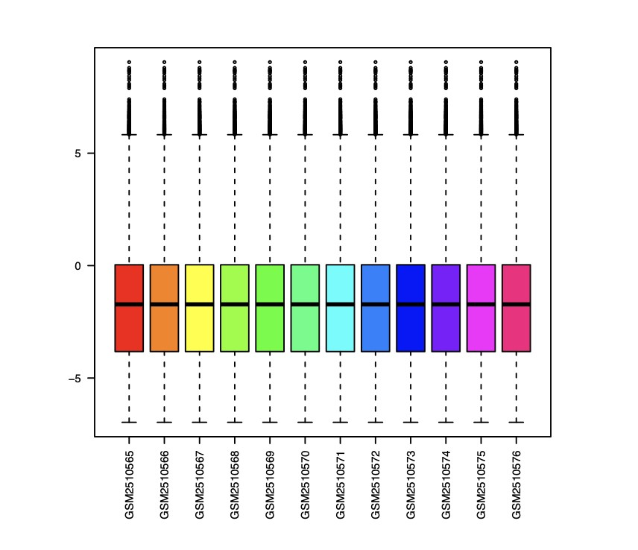
Figure S1. Normalization for GSE95426

