Efficient degradation of sulfamethoxazole by diatomite-supported hydroxyl-modified UIO-66 photocatalyst
Hui-Lai LIU ^{a, b}, Yu ZHANG ^{a, b}, Xin-Xin LV ^{a ,b}, Min-Shu CUI ª, Kang-Ping CUI ª, Zheng-Liang DAI ^{c}， Bei WANG ^{c}, Rohan WEERASOORIYA ^{b, d}, Xing CHEN ^{a, b, d*},
a Key Laboratory of Nanominerals and Pollution Control of Higher Education Institutes, School of Resources and Environmental Engineering, Hefei University of Technology, Hefei 230009, P. R. China
b Key Lab of Aerospace Structural Parts Forming Technology and Equipment of Anhui Province, Institute of Industry and Equipment Technology, Hefei University of Technology, Hefei, 230009, P. R. China
c Anqing Changhong Chemical Co., Ltd., Anqing, 246002, P. R. China
d National Centre for Water Quality Research, National Institute of Fundamental Studies, Hantana, Kandy, Sri Lanka

* Corresponding author:
Xing Chen (xingchen@hfut.edu.cn)

Text S1
Photoelectrochemical measurements
The photocurrent measurements were carried out on a CHI-760E electrochemical workstation (Chenhua Instrument, Shanghai, China) in a conventional three-electrode configuration with the sample modified ATO (20 mm * 50 mm) as the working electrode, Pt as the counter electrode, and Ag/AgCl as the reference electrode. The current measurement i-t curve was performed using an LED lamp (35 W) at 0.4 V bias voltage potential. A 0.5 M Na₂SO₄ aqueous solution was used as the electrolyte.

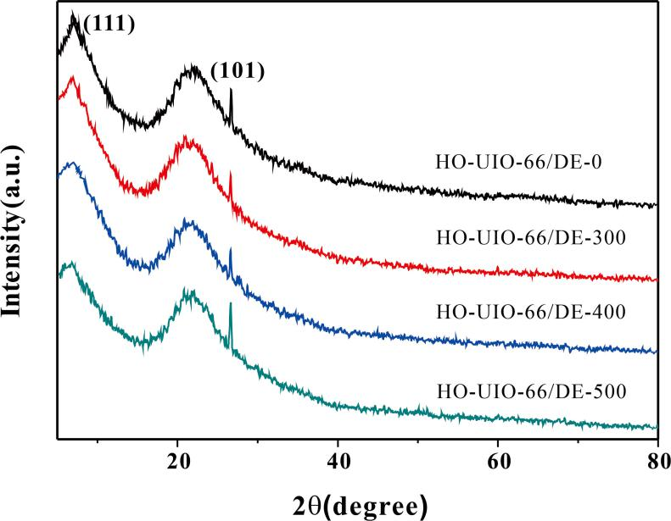
Fig. S1. The XRD patterns of synthesized photocatalysts

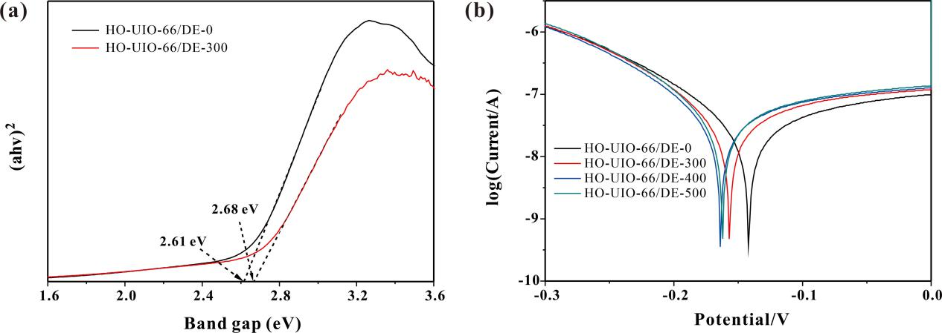
Fig. S2. (a) Kubelka–Munk curves of as-prepared catalysts and (b)Tafel polarization curves

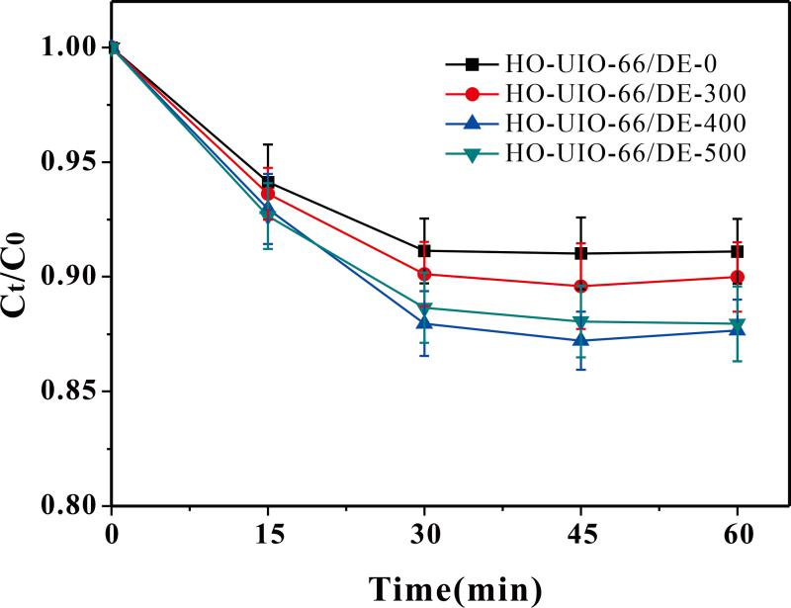

Fig. S3. The effect of different catalysts on SMX adsorption performance. (Reaction conditions: initial SMX, 20.0 mg/L; catalyst, 400 mg/L)

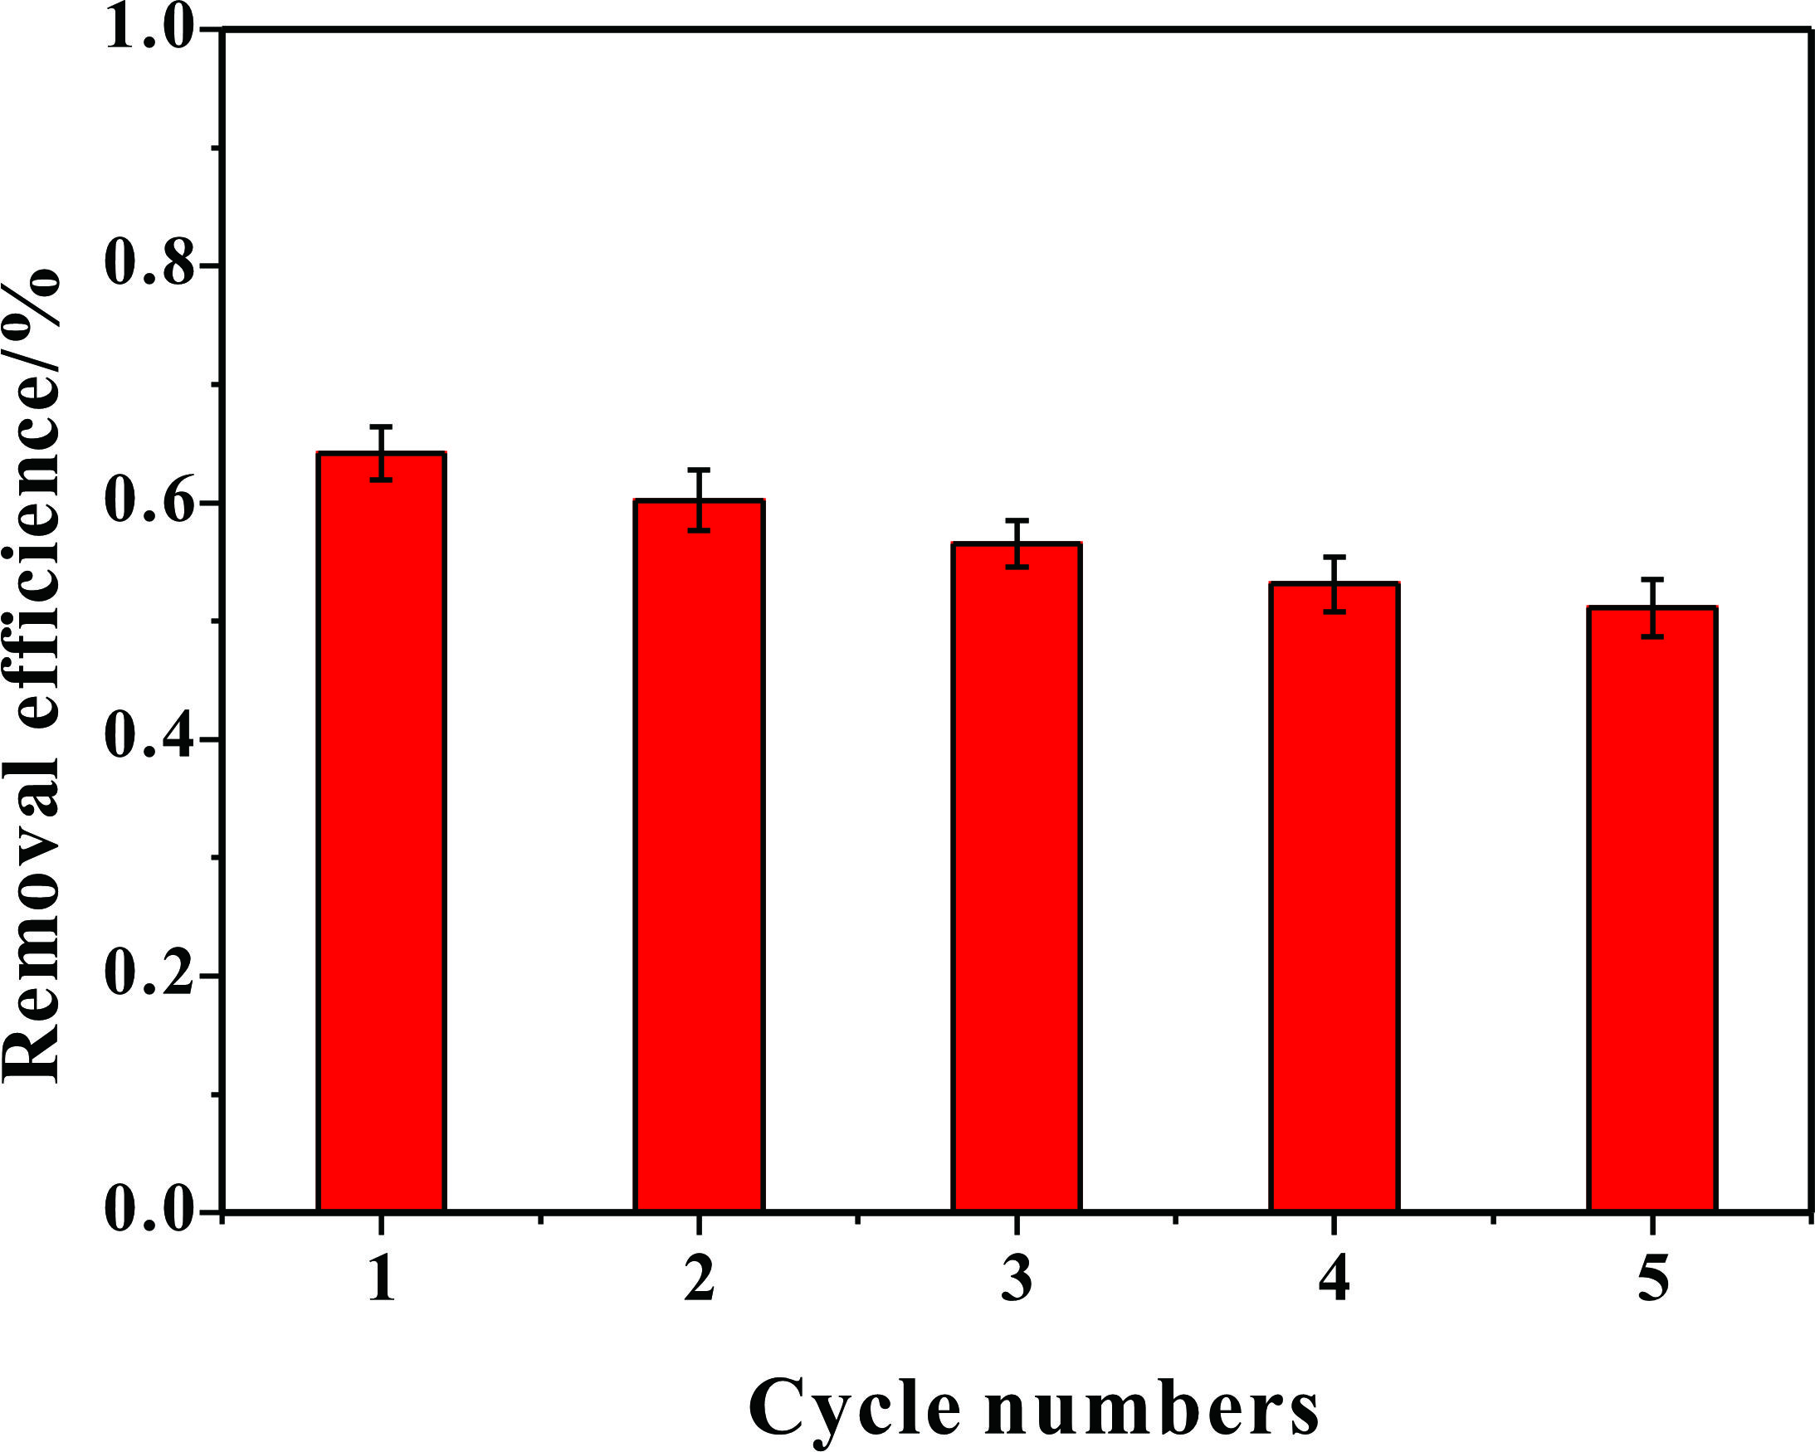
Fig. S4. Removal efficiency of TOC. (Reaction conditions: pH 3.0; initial SMX, 20.0 mg/L; catalyst, 400 mg/L; H₂O₂, 4.0 mM)

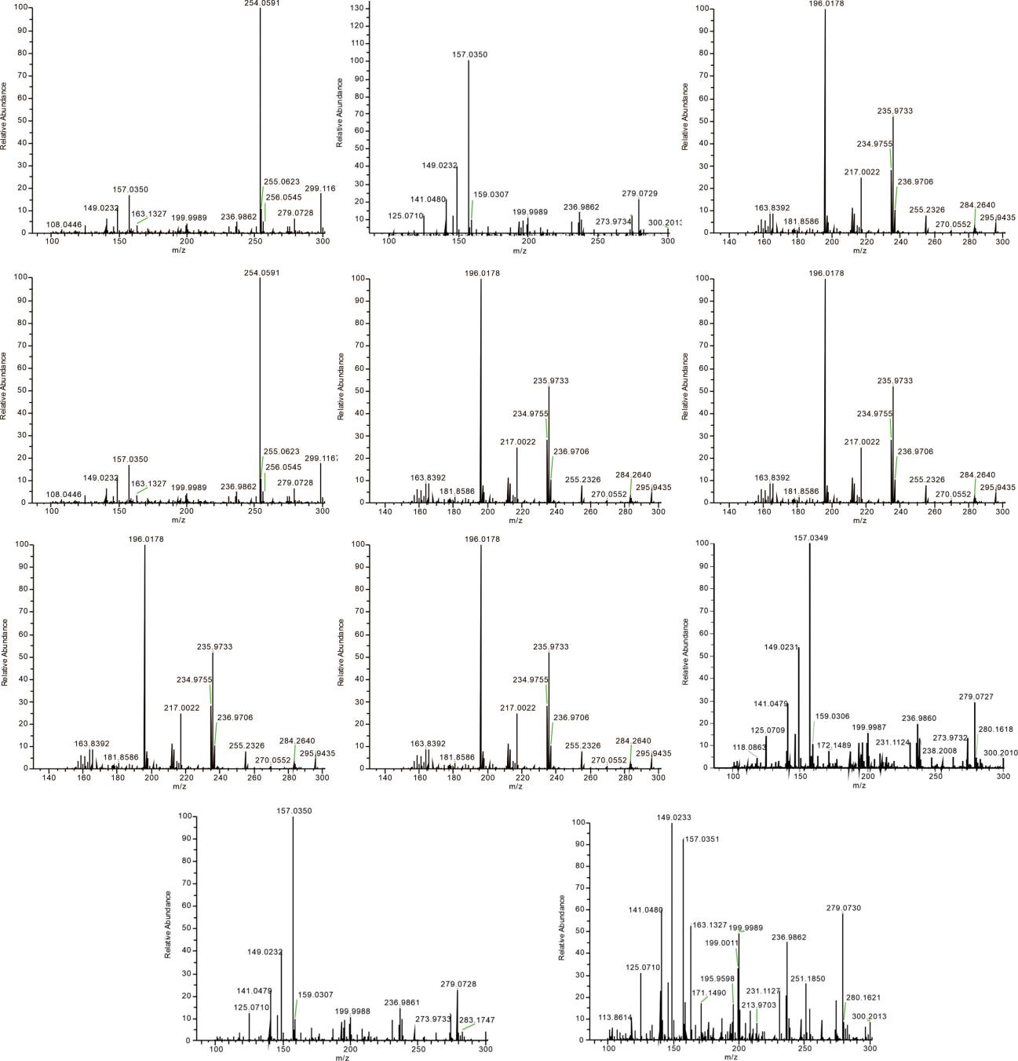
Fig S5. Liquid-mass diagram of SMX and its intermediates in photo-Fenton system

Table S1. The structural information of the possible intermediates products.
Compounds | Formula | m/z | Proposed structure
SMX | C₁₀H₁₁N₃O₃S | 254 | 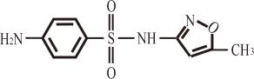
SMX 1 | C₁₀H₁₃N₃O₄S | 272 | 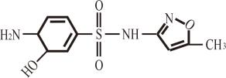
SMX 2 | C₁₀H₁₁N₃O₆S | 299 | 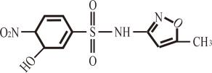
SMX 3 | C₁₀H₉N₃O₅S | 284 | 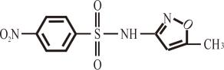
SMX 4 | C₆H₆N₂O₅S | 235 | 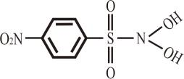
SMX 5 | C₆H₄N₂O₄S | 217 | 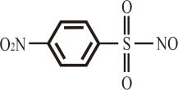
SMX 6 | C₄H₆N₂O₄S | 181 | 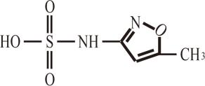
SMX 7 | C₄H₆N₂O₅S | 196 | 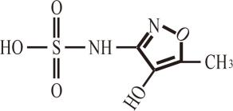
SMX 8 | C₄H₄NO₂ | 113 | 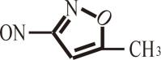
SMX 9 | C₆H₈N₂O₂S | 172 | 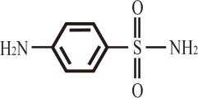
SMX 10 | C₆H₇NO₂S | 156 | 