Appendix 1

Theme | Theme name | Policy name | Representative quotes
Theme 2 - Institutional resource mobilisation
Topic | City | Policy name | Quote or example
Topic 4 | Wollongong City | Climate Change Mitigation Plan 2020 | ‘Leisure Centre Master Plan developed including Stage One Aquatics Design with sustainable building design and performance principles’ (p. 38)
Theme 4 - Adapting to a Changing Climate
Topic | City | Policy name | Quote or example
Topic 2 | Cockburn | Coastal Adaptation Plan | ‘..[R]etreat adaptation planning is cyclical. The flexible adaptation pathway combines decision-making on specific adaptation options (avoid, retreat, accommodate and interim protection) at the time of trigger points with an ongoing strategic planning process that plans for and maintains the same range of adaptation options for future decisions in the longer term. In this way, by choosing to accommodate or protect in the short term, we are not binding future communities to the long-term cost of that decision beyond the design life of the infrastructure or asset’ (p. 3).
Topic 4 | Penrith | Cooling the City Strategy | There is an established and well researched link between urban greening, heat and the liveability of a city. Research found that tree canopy cover in the five priority areas was approximately 10%, while hard surface cover was 32%. This is low compared to an Australianwide analysis of 139 LGs undertaken by the Institute for Sustainable Futures (20:20:20 Vision 2014), where the average tree canopy cover was 39% and average hard surface cover was 8% (p. 15).
Topic 9 | Wellington Shire Council | Building Resilience | Focuses on climate-proofing houses to increase the resilience of Gippsland houses from varying climate risk including bushfires and floods
Topic 13 | Southern Midlands | Climate Change Adaptation Plan 2020 | In relation to changes in flood and bushfires risk from a warming climate, planning scheme overlays should be developed to incorporate scientific data and modelling to appropriately guide development in flood prone areas and in areas with high fire likelihood. (p. 27)
Topic 15 | Noosa | Climate Change Response Plan | ‘Increasing the resilience and adaptive capacity of our communities and the built environment is about designing places, buildings and infrastructure to be more adaptive and sustainable, creating more comfortable and safe homes and workplaces, and reduced emissions and energy costs.’ (p. 39)
Topic 15 | Broome | Coastal Hazard Risk Management and Adaptation Plan | Outlines broad categories of potential adaptation options including avoid new development in areas at risk of coastal hazard, planned retreat allowing existing development until coastal impacts arise and then relocate or remove assets, accommodate but with sufficient adaptation measures such as design and/or management strategies that render the risks from the identified coastal hazards acceptable, and protect requiring coastal protection works where there is a need to preserve the foreshore reserve, public access and public safety, property and infrastructure that is not expendable.
Topic 18 | Mareeba Shire Council | Climate Change Resilience Policy | Managing climate change risk, including council services, infrastructure and operations and supporting the community, are critical responsibilities of local government
Topic 21 | Hawkesbury City Council | Net Zero Emissions and Water Efficiency Strategy | they will ‘ensure that the proposed housing and non-residential sector growth is responsive and adaptive to a changing climate and new developments are delivered with increased drought resistant, lush green areas for an active, healthy and cooler communities’ (p. 4).
Topic 22 | Armidale | A Framework for Climate Action Armidale Regional Council: Climate Emergency Working Group Adaptation | Tree planting and re-vegetation have an important role in absorbing and reducing greenhouse gas emissions as well as adaptation to climate change’ (p. 25). Trees on farms help to modify climate extremes and also provide corridors for wildlife displaced by climate change (p. 25). Increasing insurance costs were also identified as one of the potential catalysts to community action on climate (p. 36).
Topic 24 | Mornington Peninsula Shire | Our Climate Emergency Response from 2020 to 2030 | ‘Prioritise the use of nature-based solutions and infrastructure to adapt to climate change’ (p. 76).
Topic 24 | Ku-ring-gai | Climate Wise Communities Resource Manual | Climate Wise Communities is a ‘Ku-ring-gai Council initiative that is designed to build local resilience and preparedness to extreme weather events such as bushfire, drought, storm and heat stress’ (p. 2). Preparedness is defined as: ‘arrangements to ensure that, should an emergency occur, all those resources and services which are needed to cope with the effects can be efficiently mobilised and deployed. Measures to ensure that, should an emergency occur, communities, resources and services are capable of coping with the effects’. (p. 21)
Topic 28 | Cairns | Cairns Climate Change Strategy 2030 | Aims to ‘build resilience of the food supply system through initiatives to strengthen local food supply chains and improve food security’ (p. 23).
Theme 7 - Coordination, Partnerships and Advocacy for Action
Topic | City | Policy name | Quote or example
Topic 8 | Brimbank | Climate Emergency Plan 2020–2025 | Focuses on building alliances, collaboration with other councils and levels of government. Noted collaborations with other councils and related networks and alliances. These include the Western Greenhouse Alliance and the Climate Emergency Australia Network.
Topic 17 | Bellingen Shire | Community Climate Action Plan – Draft April 2022 | ‘the strong alignment between the proposed projects and current Visions, Strategies or Planning Documents developed either by the Bellingen Shire Council or NSW Government’ (p. 12).
Theme 8 - Equity and Social Justice
Topic | City | Policy name | Quote or example
Topic 9 | Newcastle | Newcastle Climate Action Plan | Seeks to ‘Provide publicly accessible electric vehicle charging infrastructure at key locations throughout the city, powered by onsite renewables where possible’ (p. 19). It also references Sustainable Development Goal 7, the importance of clean and affordable energy. Affordable energy is discussed elsewhere in the policy.
Topic 28 | Gawler | Climate Emergency Plan | ‘Access to clean and affordable technology and solutions that meet community needs without compromising the needs of future generations’ (p.13).

Appendix 2

CED | Number | Council | State/territory | Metro/non-metro
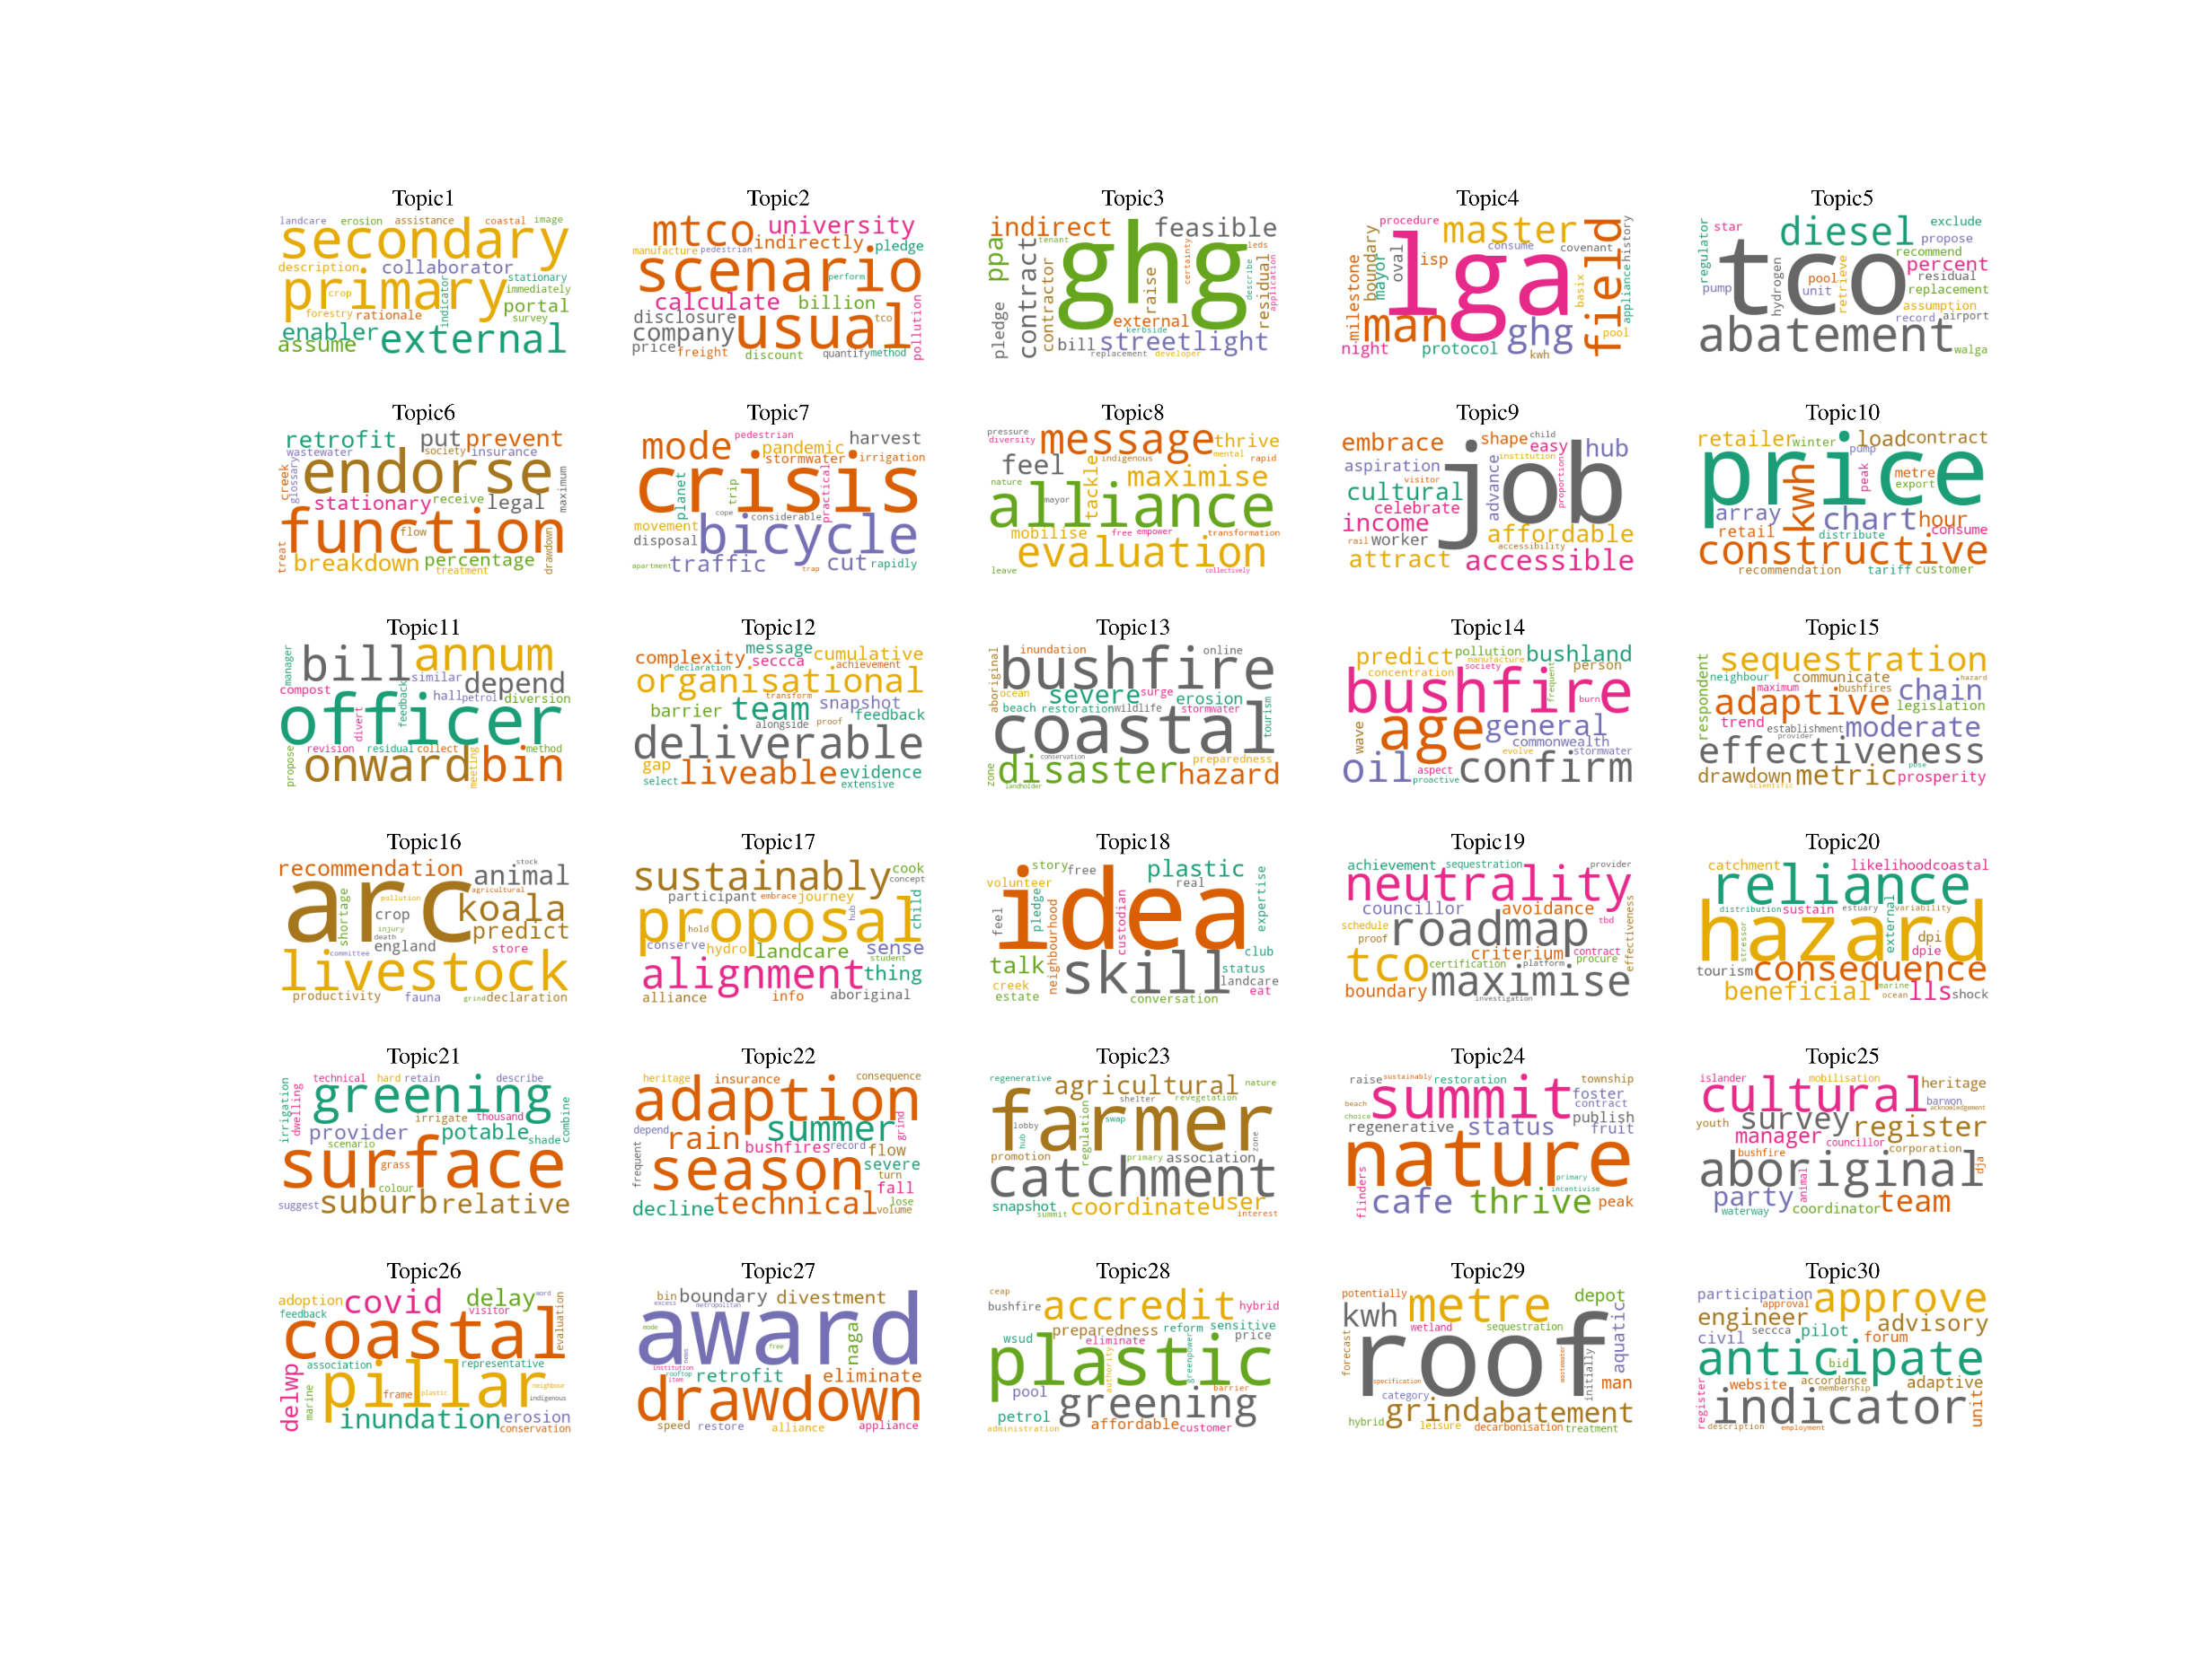Identifying actions’ impact area, external collaborators and enablers | 2 | Bass Coast’s Climate Change Action Plan 2020-2030 | Victoria | Non-metropolitan
 | 2 | Surf Coast Shire’s Community Emissions Profile - Climate Emergency | Victoria | Non-metropolitan
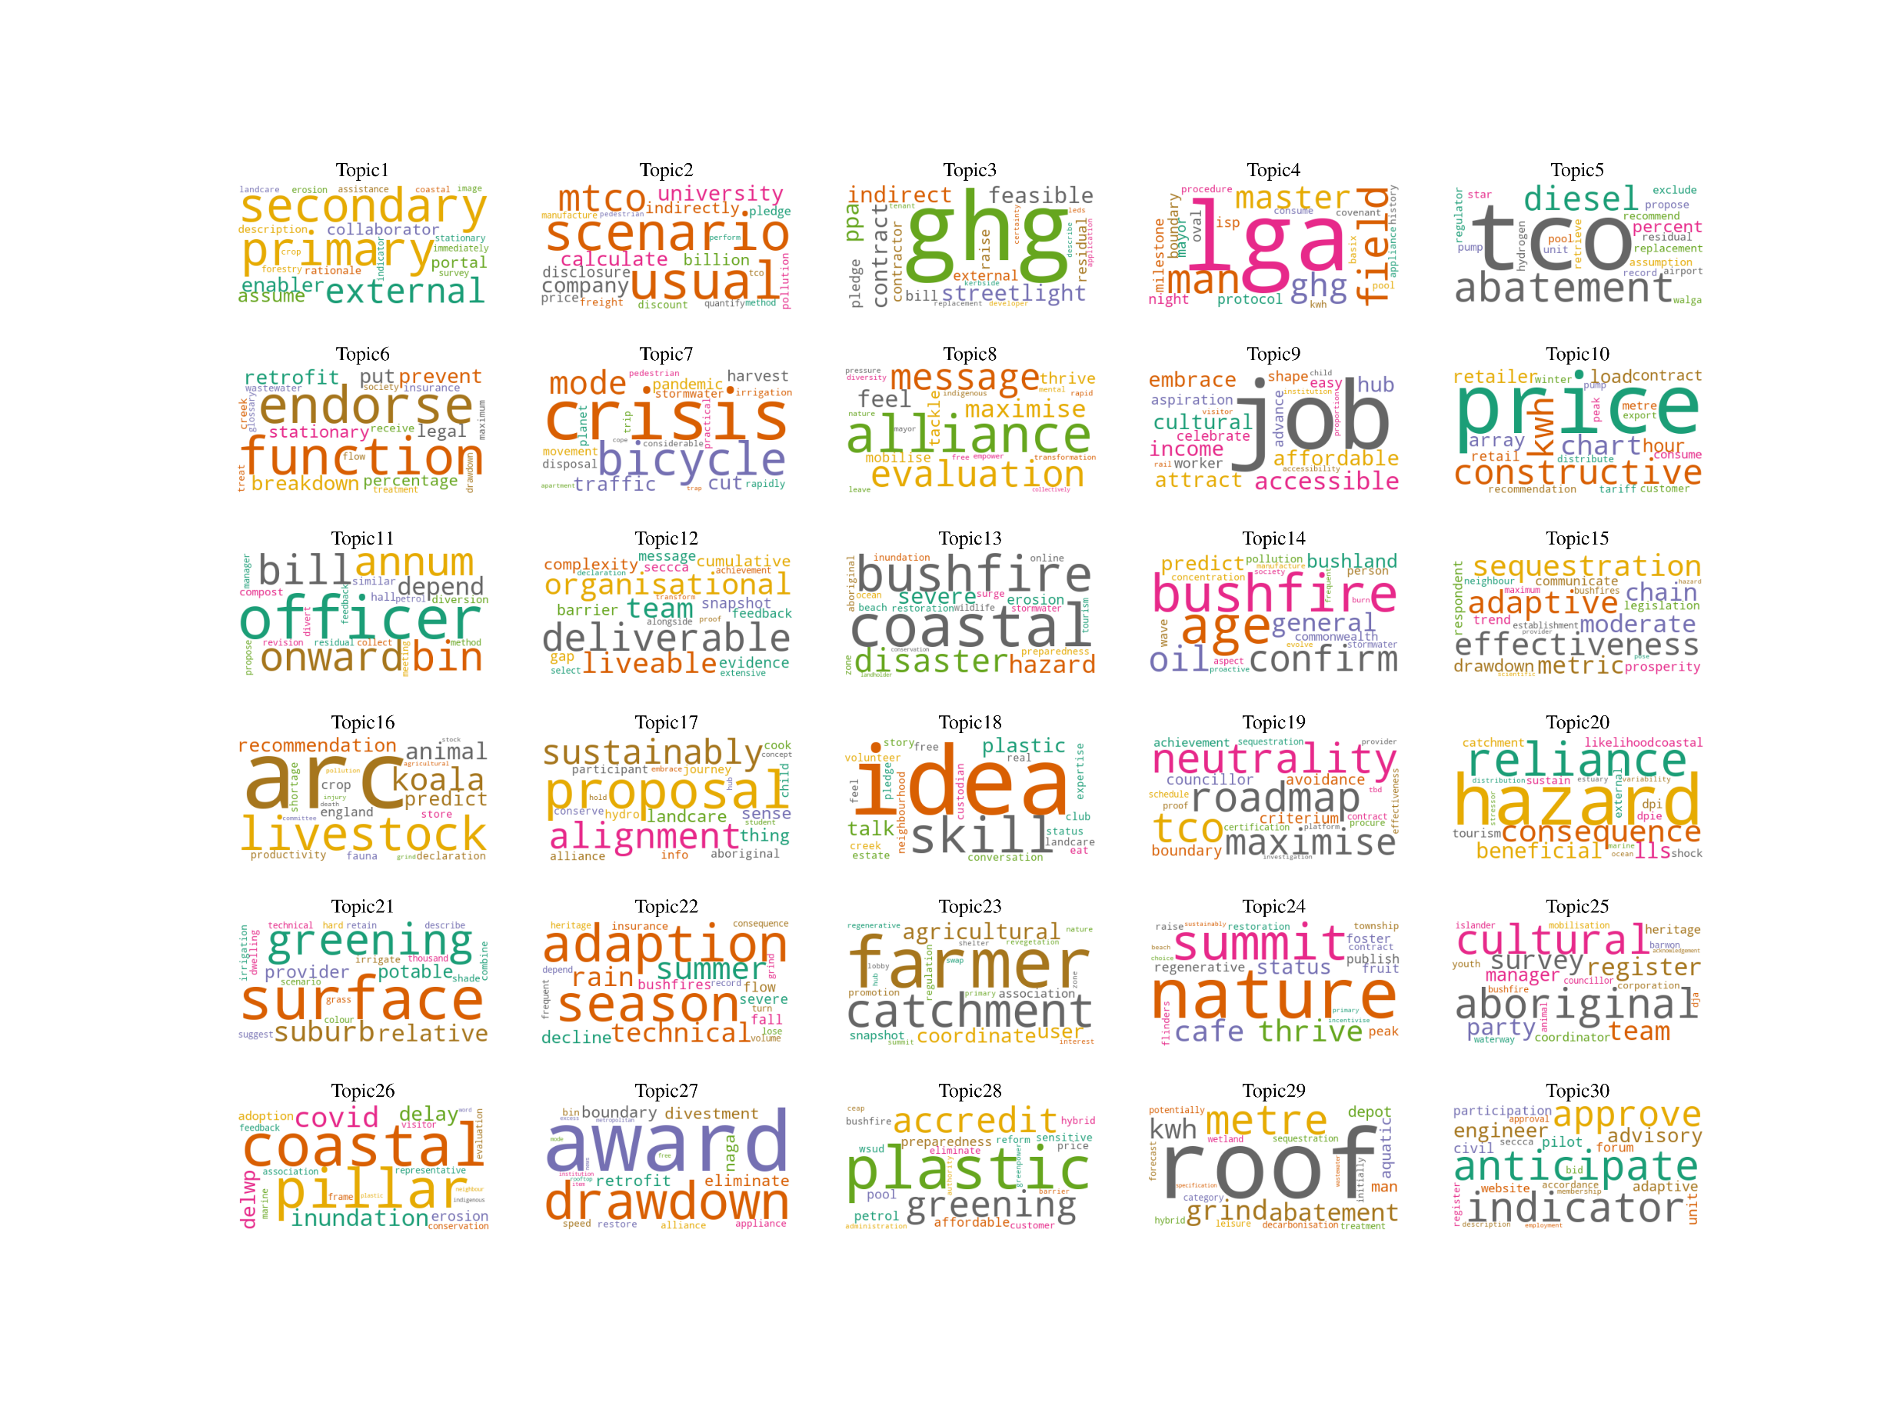Modelling scenarios to calculate and reduce emissions and move away from ‘business as usual’ | 2 | Inner West’s Climate Renewables Strategy | NSW | Metropolitan
 | 2 | City of Melbourne’s Climate Change Mitigation Strategy to 2050 | Victoria | Metropolitan
Reducing greenhouse gas (GHG) emissions, using LED streetlights and working with contractors | 4 | Alpine Shire Council’s Climate Action Position Statement 2021-2024  Alpine Shire Climate Action Plan 2021-2024 | Victoria | Non-metropolitan
 | 4 | Frankston’s Towards Zero Emissions Plan 2019-2023 | Victoria | Metropolitan
 | 4 | Tweed Shire Council’s 2020 – 2021 Interim Climate Change Action Plan | NSW | Non-metropolitan
Local governments’ actions based on master plans for reducing GHG emissions | 4 | City of Canada Bay’s Emissions reduction action plan | NSW | Metropolitan
 | 4 | Kingborough Council’s Climate Change Plan 2019-2024 | Tasmania | Metropolitan
 | 4 | Hunter Hill’s Council Sustainability Action Plan | NSW | Metropolitan
 | 4 | Wollongong City Council’s Climate Change Mitigation Plan | NSW | Non-metropolitan
Abatement of carbon dioxide emissions and the replacement of diesel | 2 | City of Greater Geraldton’s Climate Change Mitigation Plan 2021 | WA | Non-metropolitan
 | 2 | Kiama Municipal Council’s Corporate Emissions Reduction Plan 2021-2031 | NSW | Non-metropolitan
Council functions, endorsement and energy reduction with retrofit | 4 | Maribyrnong’s Climate Emergency Plan 2021-2025  Maribyrnong’s Climate Emergency Strategy 2020-2025 | Victoria | Metropolitan
 | 4 | Mount Barker District Climate Change Action Plan 2019 | SA | Non-metropolitan
 | 4 | Nillumbik’s Climate Action Plan 2022-2032 | Victoria | Metropolitan
Climate crisis, highlighting sustainable mode of transport and learning from the pandemic | 3 | Boroondara’s Climate Action Plan | Victoria | Metropolitan
 | 3 | City of Stonnington’s Towards Zero Carbon 2030: Our Climate Emergency Action Plan 2021-2024 | Victoria | Metropolitan
 | 3 | City of Yarra Climate Emergency Plan 2020-2024 | Victoria | Metropolitan
Building alliances, collaboration with other councils and other levels of government and evaluation of policies | 5 | Brimbank Climate Emergency Plan 2020-2025 | Victoria | Metropolitan
 | 5 | Campbelltown City Council’s Climate Solutions Strategy | NSW | Metropolitan
 | 5 | Glen Eira’s Our Climate Emergency Response Strategy 2021-2025 | Victoria | Metropolitan
 | 5 | City of Greater Dandenong Climate Emergency Strategy 2020-2025 | Victoria | Metropolitan
 | 5 | Greater Geelong’s Climate Change Response Plan 2021-30 | Victoria | Non-metropolitan
New jobs and Sustainable Development Goal of affordable and clean energy | 4 | Georges River 2050 – Leading for Change  Georges River 2050 – Leading for Change (2020 Update) | NSW | Non-metropolitan
 | 4 | Newcastle Climate Action Plan 2021-2025 | NSW | Non-metropolitan
 | 4 | Northern Beaches Climate Change Action Plan | NSW | Metropolitan
Innovation in energy use and delivery to prepare for carbon pricing | 1 | Broken Hill City Council Renewable Energy Action Plan 2020 | NSW | Non-metropolitan
Cost and energy saving (per annum) and responsibilities, and waste management and timeframes | 2 | Bellingen Shire Climate Emergency Program 2020 – 2030 | NSW | Non-metropolitan
 | 2 | Town of Victoria Park’s Climate Emergency Plan 2021 | WA | Metropolitan
Teamwork and organisational support to deliver the action plan | 4 | Bayside Climate Emergency Action Plan 2020 – 2025 | Victoria | Metropolitan
 | 4 | Kingston’s Climate & Ecological Emergency Response Plan 2021 | Victoria | Metropolitan
 | 4 | Town of East Fremantle Climate Emergency Strategy Strategic Objectives | WA | Metropolitan
 | 4 | Yarra Ranges Liveable Climate Plan 2020 – 2030 | Victoria | Metropolitan
Building resilience to disasters such as coastal erosion and bushfire | 3 | Tweed Shire Council Climate Change Management | NSW | Non-metropolitan
 | 3 | Wingecarribee Shire Climate Change Adaptation Plan | NSW | Non-metropolitan
 | 3 | Byron Shire Council Climate Change Adaptation Plan | NSW | Non-metropolitan
Attention to vulnerable aged population and managing bushfires | 4 | Hobsons Bay Response to Climate Change Action Plan | Victoria | Metropolitan
 | 4 | -Mosman Climate Action Plan Mitigation Strategy  -Mosman Climate Action Plan Resilience and Adaptation Strategy | NSW | Metropolitan
 | 4 | Yarra Ranges Adapting to a changing climate and energy future | Victoria | Metropolitan
Effectiveness of actions, carbon sequestration, adaptive actions and sustainable supply chain | 4 | Ballina Shire Council Climate Change Policy | NSW | Non-metropolitan
 | 4 | Darwin 2030 Climate Emergency Strategy | Northern Territory | Metropolitan
 | 4 | City of Launceston Towards Zero Emissions Action Plan 2021-2025 | Tasmania | Metropolitan
 | 4 | Noosa Shire Climate Change Response Plan | Queensland | Non-metropolitan
Reducing emissions from farming and agriculture, protecting endangered animals | 1 | Armidale Regional council A Framework for Climate Action | NSW | Non-metropolitan
Alignment between different groups, proposals and different levels of governance | 1 | Bellingen Shire Community Climate Action Plan 2022 | NSW | Non-metropolitan
Enabling community-led ideas and skills | 1 | Cool Changes Woodend Region Climate Change Action Plan (Macedon Ranges Shire) | Victoria | Non-metropolitan
Roadmap for reducing the emissions to achieve carbon neutrality | 4 | City of Ballarat Carbon Neutrality and 100% Renewables Action Plan 2019–2025 | Victoria | Non-metropolitan
 | 4 | Byron Shire Council Net Zero Emissions Action Plan For Council Operations 2025 | NSW | Non-metropolitan
 | 4 | Mount Alexander Shire Council Roadmap to Carbon Neutrality 2020 – 2025 | Victoria | Non-metropolitan
 | 4 | Indigo Shire Council Climate Emergency Strategic Plan 2020 | Victoria | Non-metropolitan
Preparing for natural hazards and reducing the reliance on external sources of food and energy | 1 | Bega Valley Shire Climate Resilience Strategy | NSW | Non-metropolitan
Urban cooling by greening the urban surfaces | 3 | Kingston Urban Cooling Strategy | Victoria | Metropolitan
 | 3 | Hawkesbury Net Zero Emissions and Water Efficiency Strategy | NSW | Metropolitan
 | 3 | Town of East Fremantle Climate Emergency Strategy  2022-2032 | WA | Metropolitan
Adaptation to the seasonal changes in the climate | 2 | City of Fremantle Climate Change Adaptation Plan | WA | Metropolitan
 | 2 | City of Yarra Climate emergency | Victoria | Metropolitan
Revegetating catchments and supporting farmers for sustainable practices | 3 | Shire of Augusta Margaret River Climate Action Plan Part 1 – Towards Zero Emissions 2020–2030 | WA | Non-metropolitan
 | 3 | City of Ballarat Net Zero Emissions Plan | Victoria | Non-metropolitan
 | 3 | Greater Shepparton Climate Emergency Action Plan | Victoria | Non-metropolitan
Strategies for a thriving nature and its interconnection with humans | 2 | Mornington Peningsula Shire’s Our Climate Emergency Response From 2020 to 2030  Mornington Peningsula Shire’s Our Climate Emergency Response From 2020 to 2030 | Victoria | Non-metropolitan
Drawing on the knowledge of Aboriginal Registered Parties to protect cultural sites from climate change impacts | 2 | Golden Plains Shire Council Climate Emergency Plan 2022-2032 | Victoria | Non-metropolitan
 | 2 | Surf Coast Shire’s Climate Emergency Corporate Response Plan 2021-2031 | Victoria | Non-metropolitan
Coastal hazards and the impact of COVID-19 on the progress of the plans | 4 | Queenscliff Climate Emergency Response Plan 2021-2031 | Victoria | Non-metropolitan
 | 4 | Background document For the Borough of Queenscliff Climate Emergency Response Plan Community Panel workshops | Victoria | Non-metropolitan
 | 4 | Mornington Peningsula Shire’s Climate Emergency Plan Progress Report 2021 | Victoria | Non-metropolitan
 | 4 | Surf Coast Shire’s Climate Emergency Corporate Response Plan 2021-2031 | Victoria | Non-metropolitan
Encourage the public for their sustainability achievements through awards, determination to drawdown carbon dioxide and eliminate emissions by encouraging divestment and retrofitting divestment and retrofitting | 3 | Darebin Climate emergency Plan 2017-2022 | Victoria | Metropolitan
 | 3 | Knox Climate response plan 2021 – 2031 | Victoria | Metropolitan
 | 3 | Nillumbik Climate Change Action Plan 2016-2020 | Victoria | Metropolitan
Eliminating plastic, greening the area, enabling affordable access to accredited renewable energy and preparedness for climate impacts | 2 | City of Mitcham Climate Change Emergency Response | SA | Metropolitan
 | 2 | Gawler Climate Emergency Action Plan 2022-2030 | SA | Non-metropolitan
Generating and saving energy (kWh) from rooftop solar panels and the abatement of emissions | 1 | MidCoast Council Climate Change Strategy: Phase 1 | NSW | Non-metropolitan
Anticipating and approving budgets and resources and finding indicators for assessing the impacts of actions | 1 | City of Greater Dandenong Climate Emergency Strategy 2020 – 2030 Action Plan | Victoria | Metropolitan

Appendix 3

Non-CED | Number | Council | State/territory | Metro/non-metro
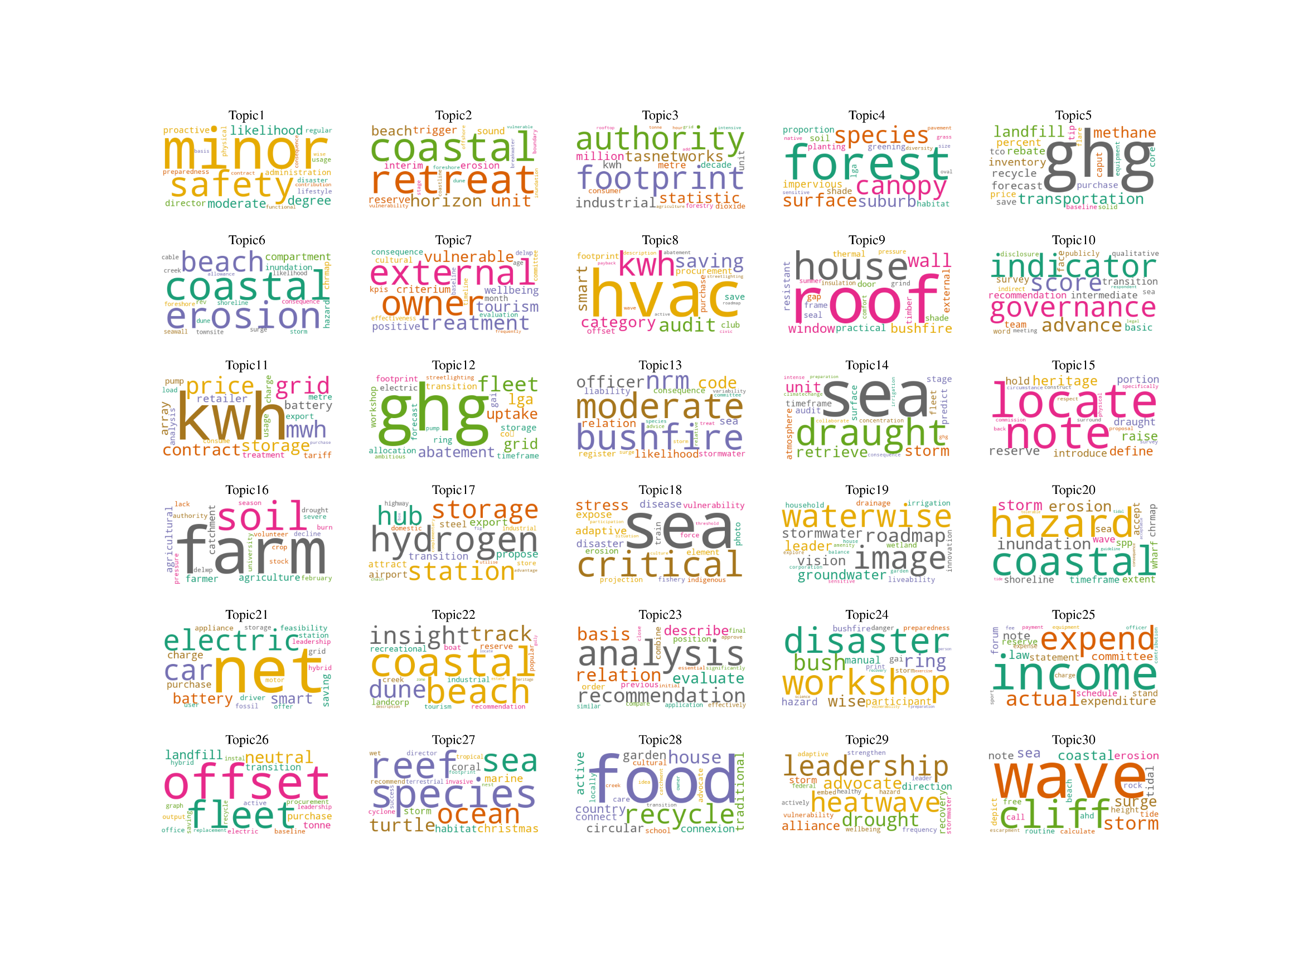Climate risk assessment | 3 | City of Casey Climate Action Plan 2020-2030 | Victoria | Metropolitan
 | 3 | Goulburn Mulwaree Council Climate Change Assessment and Adaptation Planning 2020 | NSW | Non-metropolitan
 | 3 | Wise Hornsby’s Your Vision, Your Future Climate | NSW | Non-metropolitan
Coastal retreat: A framework for long-term adaptation | 1 | City of Cockburn Coastal Adaptation Plan | WA | Metropolitan
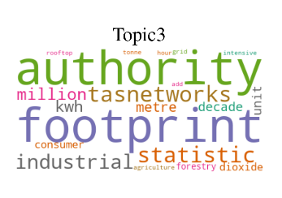Energy use and GHG footprint | 3 | Clarence City Council Community Energy Use and Greenhouse Gas Footprint Summary Report 2019 | Tasmania | Metropolitan
 | 3 | Huon Valley Council Community Energy Use and Greenhouse Gas Footprint Summary Report 2019 | Tasmania | Non-metropolitan
 | 3 | Sorell Council Community Energy Use and Greenhouse Gas Footprint Summary Report 2019 | Tasmania | Non-metropolitan
Maintaining and expanding urban forest, increasing canopy cover and improving native species | 1 | Penrith City Council Cooling the City Strategy 2015 | NSW | Metropolitan
GHG emissions reduction, with a focus on reducing transport and landfill emissions and methane | 3 | City of Armadale Corporate Greenhouse Action Plan 2014/15 to 2019/20 | NSW | Non-metropolitan
 | 3 | Eurobodalla Emissions Reduction Plan 2017-2021 | NSW | Non-metropolitan
 | 3 | Moreton Bay Regional Council Roadmap for A Changing Climate 2013-2016 | Queensland | Non-metropolitan
Managing coastal erosion | 1 | Broome Townsite Coastal Hazard Risk Management and Adaptation Plan 2017 | WA | Non-metropolitan
External partnerships and inclusion of vulnerable people in risk treatment | 2 | Southern Grampians Shire Climate Change Adaptation Plan 2017-2027 | Victoria | Non-metropolitan
 | 2 | Wyndham City Climate Change Adaptation 2016-2020 | Victoria | Metropolitan
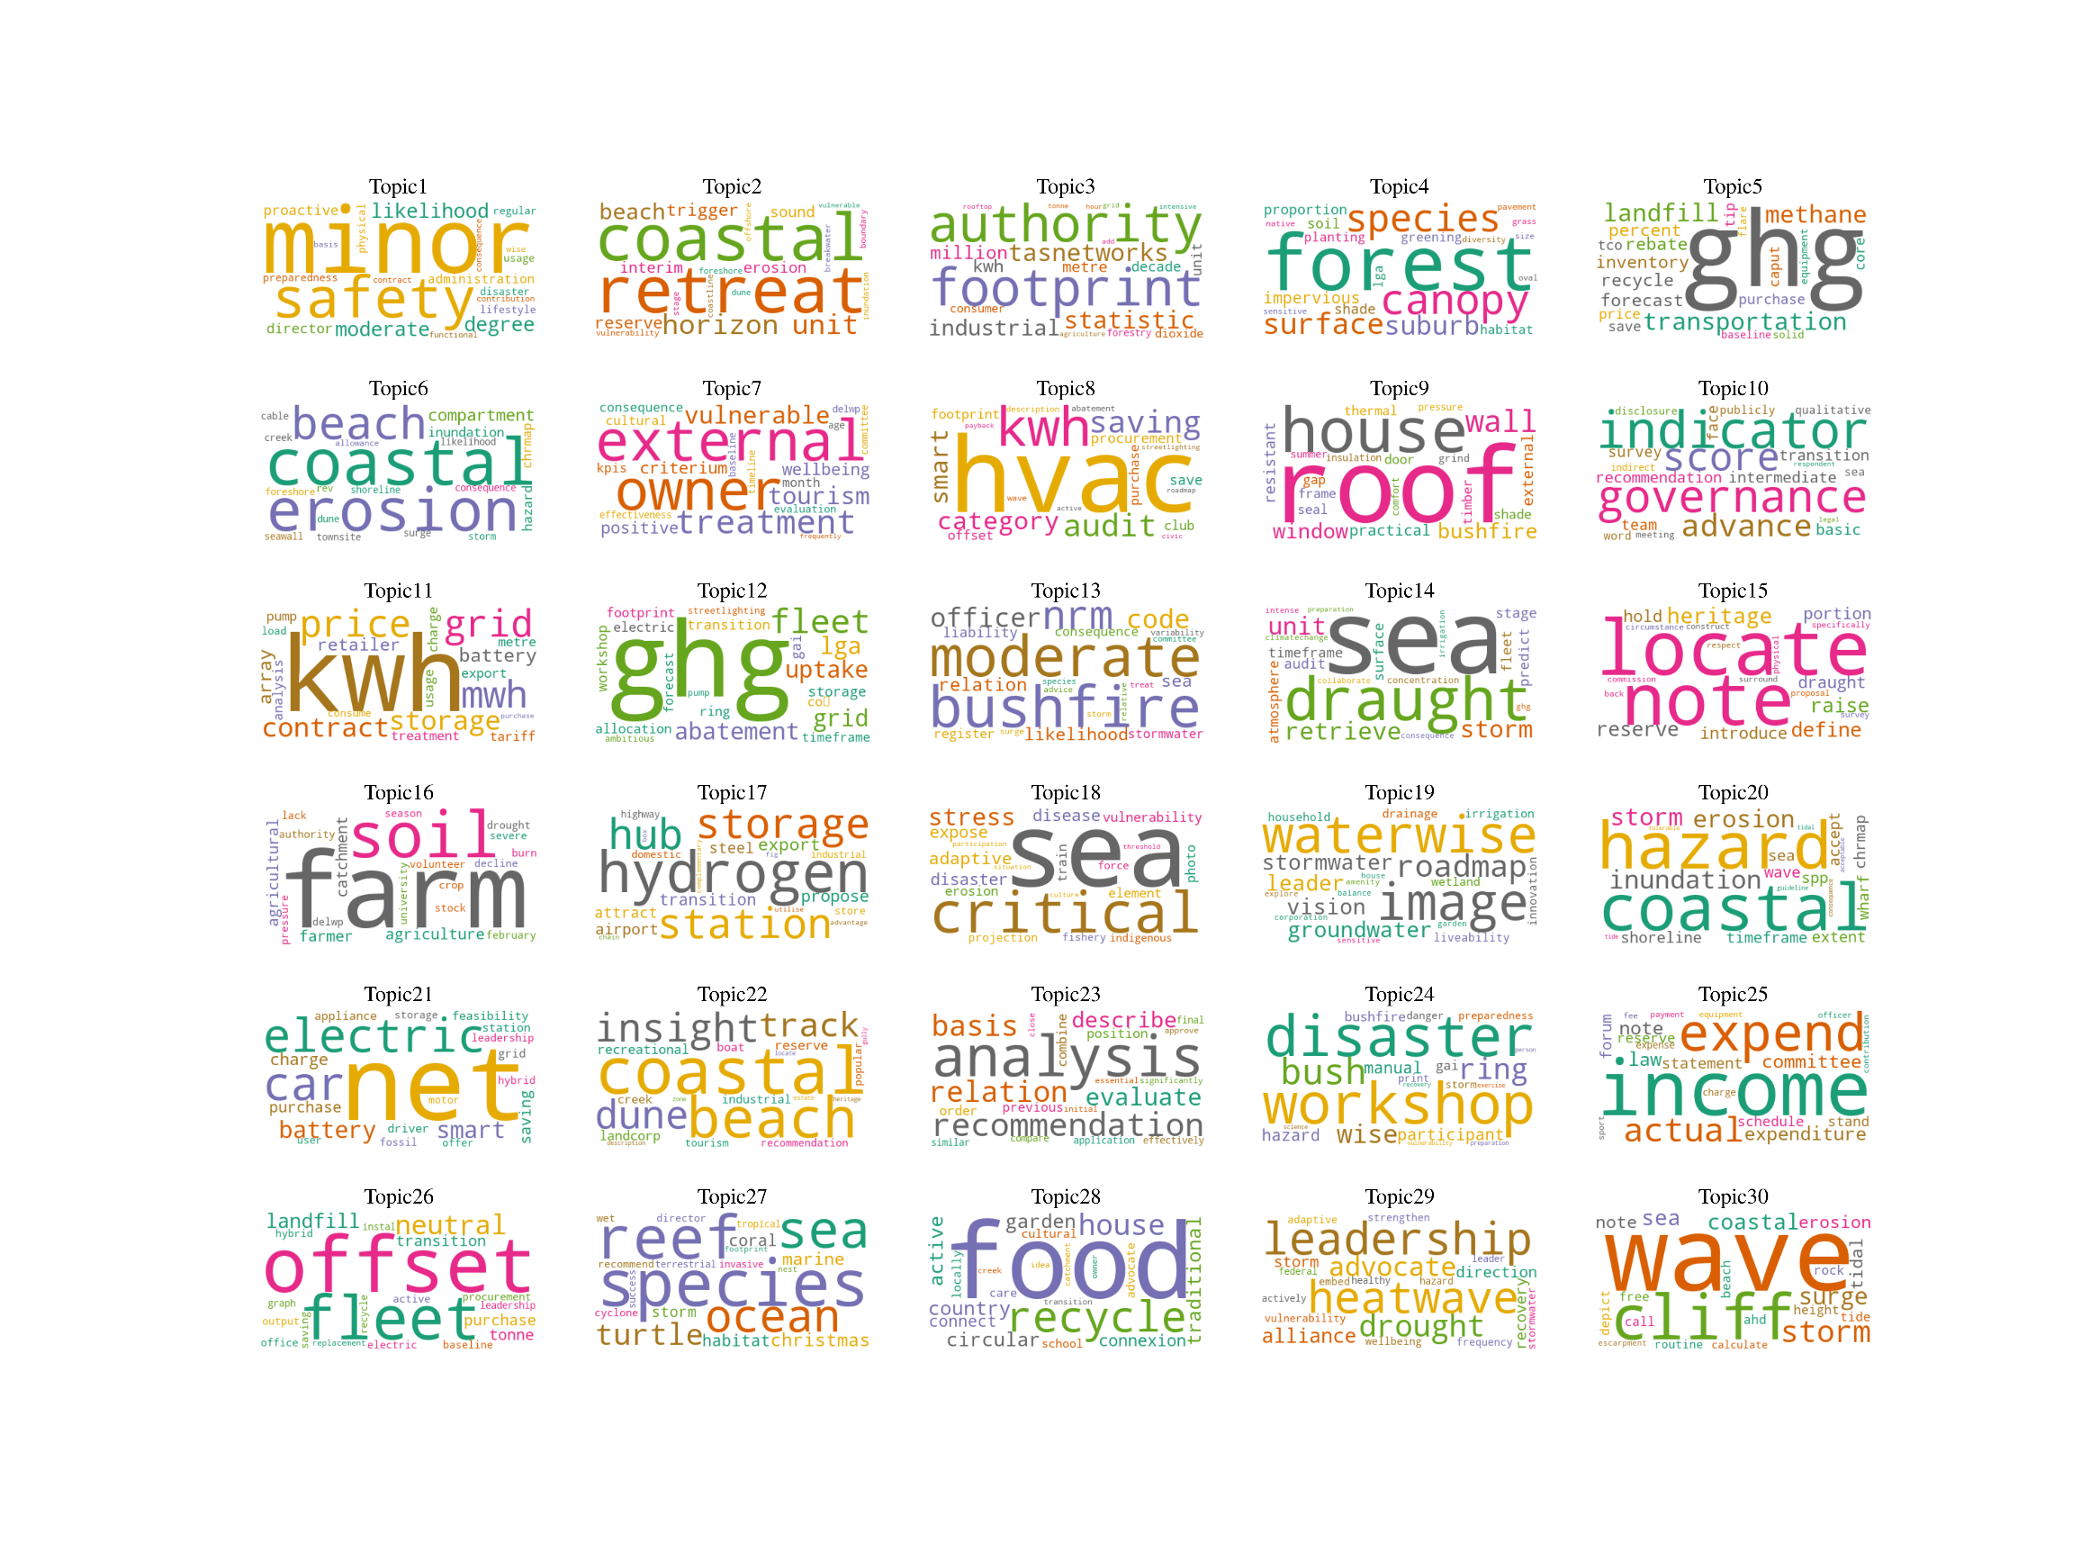Saving energy by using heating, ventilation and air conditioning (HVAC) and smart systems | 1 | City of Bayswater Emission Reduction and Renewable Energy Plan | WA | Metropolitan
Climate-proofing houses | 1 | Wellington Shire Council Building Resilience - A Guide to Consider Climate Change for Gippsland Houses | Victoria | Non-metropolitan
Climate Change Adaptation Governance Assessment | 1 | City of Marion Climate Change Adaptation Governance Assessment Report | SA | Metropolitan
Renewable energy action | 3 | Bathurst Regional Council Climate Change Adaptation Government | NSW | Non-metropolitan
 | 3 | Kyogle Council 100% Renewables, Sustainable Councils and Communities Action Plan 2019 | NSW | Non-metropolitan
 | 3 | Cabonne Shire Council Renewable Energy Action Plan 2019 | NSW | Non-metropolitan
Abatement capacity to reduce emissions—mainly solar uptake and fleet transition | 3 | Queanbeyan – Palerang Regional Council Climate Change Action Plan: Community Plan 2020 to 2030 | NSW | Non-metropolitan
 | 3 | Ku-ring-gai Towards Zero Emissions 2030 Action Plan | NSW | Metropolitan
 | 3 | Queanbeyan-Palerang Regional Council Climate Change Action Plan: Council Operations Plan 2020-2030 | NSW | Non-metropolitan
Bushfire mitigation/scenarios | 3 | Glamorgan Spring Bay Council Corporate Adaptation Plan 2012 | Tasmania | Non-metropolitan
 | 3 | Southern Midlands Council Climate Change Adaptation Plan 2020 | Tasmania | Non-metropolitan
 | 3 | Town of Cottesloe Local Climate Change Adaptation Plan 2011-2016 | WA | Metropolitan
Rising sea levels | 2 | City of Marion Climate Change Policy | SA | Metropolitan
 | 2 | City of Wanneroo Climate Change Adaptation and Mitigation Strategy 2020/21-2025/26 | WA | Metropolitan
Risk management based on the location of assets | 2 | Broome Townsite Coastal Hazard Risk Management and Adaptation Plan | WA | Non-metropolitan
 | 2 | Shire of Chapman Valley Coastal Management Strategy and Action Plan | WA | Non-metropolitan
Storing carbon in the soil | 2 | Midlands Council Climate Change Adaptation in the Midlands Southern | Tasmania | Non-metropolitan
 | 2 | Midlands Council Climate Change Adaptation in the Midlands | Tasmania | Non-metropolitan
Transition to a hydrogen hub, with storage technology and stations | 1 | Karratha Renewable Hydrogen Industry hub | WA | Non-metropolitan
Critical responsibilities to stress—adaptation | 2 | Mareeba Shire Council Climate Change Resilience Policy | Queensland | Non-metropolitan
 | 2 | Torres Strait Regional Adaptation and Resilience Plan 2016-2021 | Queensland | Non-metropolitan
Waterwise city | 1 | City of Cockburn Climate Change Strategy 2020–2030 | WA | Metropolitan
Coastal hazard risk management and adaptation | 1 | Derby Coastal Hazard Risk Management and Adaptation Plan | WA | Non-metropolitan
Achieving net zero via electric cars | 4 | Shire of Chapman Valley Coastal Management Strategy and Action Plan | WA | Non-metropolitan
 | 4 | Dubbo Regional Council Energy Strategy & Implementation Plan2020 –2025 | NSW | Non-metropolitan
 | 4 | Moira Shire Climate Change Adaptation and Mitigation Policy | Victoria | Non-metropolitan
 | 4 | Southern Midlands Council Climate Change Mitigation Energy Efficient Vehicle Choices 2021 | Tasmania | Non-metropolitan
Coastal management | 1 | Shire of Chapman Valley Coastal Management Strategy and Action Plan | WA | Non-metropolitan
Recommendation and evaluate | 2 | Wodonga Council Climate Change Policy | Victoria | Non-metropolitan
 | 2 | Moreton Regional Council Climate Change | Queensland | Non-metropolitan
Disaster resilience | 5 | Ku-ring-gai Council Climate Change Policy Version Number 3 | NSW | Metropolitan
 | 5 | Mackey Regional Council Climate Change Adaptation Policy | Queensland | Non-metropolitan
 | 5 | Ku-ring-gai Council Climate Wise Communities Resource Manual | NSW | Metropolitan
 | 5 | Mackay Regional Council Climate Change Adaptation Policy | Queensland | Non-metropolitan
 | 5 | Southern Midlands Council Bushfire, What Are We In For and How We Can Prepare as Individuals and a Community 2020 | Tasmania | Non-metropolitan
Topic removed
Fleet transition and carbon offset | 4 | Hume City Council Greenhouse Action Plan 2018-2022 Council Operations | Victoria | Metropolitan
 | 4 | Maroondah City Council Carbon Neutral Strategy & Action Plan 2014/15-2020/21 | Victoria | Metropolitan
 | 4 | Moira Council Corporate Emissions Reduction Plan 2018-2021 | Victoria | Non-metropolitan
 | 4 | City of Norwood Payneham & St Peters 2020 –2030 Corporate Emissions Reduction Plan | SA | Metropolitan
Topic removed
Sustainable food production and the circular economy |  | City of Bendigo Climate Change and Environment Strategy | Victoria | Non-metropolitan
 |  | Brighton Council Climate Change and Resilience Strategy | Tasmania | Metropolitan
 |  | Brighton Council Climate Change and Resilience Strategy 2019 | Tasmania | Metropolitan
 |  | Cairns Regional Council Climate Change Strategy 2030 | Queensland | Non-metropolitan
 |  | Brighton Council Climate Change and Resilience Strategy | Tasmania | Metropolitan
 |  | Macedon Ranges Shire Council  Cool Changes: Lancefield and Romsey | Victoria | Non-metropolitan
 |  | City of Greater Bendigo Climate Change and Environment Strategy 2021-2026 | Victoria | Non-metropolitan
Leadership, alliances and advocate on climate action |  | Benalla Rural City Council Climate Change Adaptation Action Plan 2013-2025 | Victoria | Non-metropolitan
 |  | Maroondah City Council Climate Change Risk and Adaptation Strategy 2018/19 - 2021/22 | Victoria | Metropolitan
 |  | City of Whittlesea Climate Ready Climate Change Adaptation Plan | Victoria | Metropolitan
 |  | Wodonga Council Climate Change Adaptation Action Plan (2017-2021) | Victoria | Non-metropolitan
Wave exposure and vulnerability of cliffs |  | City of Marion Coastal Climate Change Adaptation Study | SA | Metropolitan

