Supplementary Material
Table S1
Molecular interactions between atoms within the ligands and targets.
No | Ligands | Interactions | Distance | Category | Type | From | To
1. | Catechuic acid | :O-ALA18 | 4.55 | Hydrophobic bond | Pi-Alkyl | O | ALA18
1. | Catechuic acid | :O-PHE28 | 5.11 | Hydrophobic bond | Pi-Pi T-shaped | O | PHE28
1. | Catechuic acid | :H-TYR32  :H-TYR32 | 2.25  1.69 | Hydrogen bond  Unfavorable bond | Conventional hydrogen bond  Donor-donor clash | H  H | TYR32
1. | Catechuic acid | :O-LYS117  :O-LYS117 | 3.91  4.64 | Hydrophobic bond  Hydrophobic bond | Pi-Alkyl  Alkyl | O  O | LYS117
1. | Catechuic acid | :H-ASP119 | 2.36 | Hydrogen bond | Conventional hydrogen bond | H | ASP119
1. | Catechuic acid | :O-ALA146  :O-ALA146 | 2.52  5.38 | Hydrogen bond  Hydrophobic bond | Conventional hydrogen bond  Pi-Alkyl | O  O | ALA146
1. | Catechuic acid | :O-LYS147  :O-LYS147 | 2.07  5.02 | Hydrogen bond  Hydrophobic bond | Conventional hydrogen bond  Pi-Alkyl | O  O | LYS147
2. | Chlorogenic acid | :O-GLY13 | 2.59 | Hydrogen bond | Conventional hydrogen bond | O | GLY13
2. | Chlorogenic acid | :O-VAL14 | 2.59 | Hydrogen bond | Conventional hydrogen bond | O | VAL 14
2. | Chlorogenic acid | :O-GLY15 | 2.02 | Hydrogen bond | Conventional hydrogen bond | O | GLY15
2. | Chlorogenic acid | :O-LYS16 | 2.23 | Hydrogen bond | Conventional hydrogen bond | O | LYS16
2. | Chlorogenic acid | :H-SER17 | 1.38 | Unfavorable bond | Donor-donor clash | H | SER17
2. | Chlorogenic acid | :O-ALA18 | 5.04 | Hydrophobic bond | Pi-Alkyl | O | ALA18
2. | Chlorogenic acid | :O-PHE28 | 4.94 | Hydrophobic bond | Pi-Pi T-shaped | O | PHE28
2. | Chlorogenic acid | :O-TYR32  :H-TYR32 | 2.12  2.57 | Hydrogen bond  Hydrogen bond | Conventional hydrogen bond  Conventional hydrogen bond | O  H | TYR32
2. | Chlorogenic acid | :H-LYS117  :O-LYS117  :O-LYS117 | 2.69  4.11  2.70 | Unfavorable bond  Hydrophobic bond  Hydrogen bond | Donor-donor clash  Pi-Alkyl  Conventional hydrogen bond | H  O  O | LYS117
2. | Chlorogenic acid | :H-ASP119 | 2.41 | Hydrogen bond | Conventional hydrogen bond | H | ASP119
2. | Chlorogenic acid | :O-ALA146 | 4.55 | Hydrophobic bond | Pi-Alkyl | O | ALA146
2. | Chlorogenic acid | :O-LYS147 | 5.37 | Hydrophobic bond | Pi-Alkyl | O | LYS147
3. | Ellagic acid | :H-TYR64 | 2.37 | Hydrogen bond | Conventional hydrogen bond | H | TYR64
3. | Ellagic acid | :O-ARG68  :O-ARG68  :O-ARG68 | 2.59  2.86  4.66 | Hydrogen bond  Hydrogen bond  Electrostatic bond | Conventional hydrogen bond  Conventional hydrogen bond  Pi-Cation | O  O  O | ARG68
3. | Ellagic acid | :O-MET72  :O-MET72 | 5.65  5.73 | Other bond  Other bond | Pi-Sulfur  Pi-Sulfur | O  O | MET72
3. | Ellagic acid | :O-HIS95 | 1.85 | Hydrogen bond | Conventional hydrogen bond | O | HIS95
3. | Ellagic acid | :O-TYR96 | 4.77 | Hydrophobic bond | Pi-Pi T-shaped | O | TYR96
4. | Pelargonidin | :O-ALA18  :O-ALA18 | 4.30  4.89 | Hydrophobic bond  Hydrophobic bond | Pi-Alkyl  Pi-Alkyl | O  O | ALA18
4. | Pelargonidin | :O-PHE28  :O-PHE28 | 5.02  5.34 | Hydrophobic bond  Hydrophobic bond | Pi-Pi T-shaped  Pi-Pi T-shaped | O  O | PHE28
4. | Pelargonidin | :O-LYS117  :O-LYS117  :O-LYS117  :O-LYS117 | 3.98  5.06  4.02  4.84 | Hydrophobic bond  Hydrophobic bond  Electrostatic bond  Electrostatic bond | Pi-Alkyl  Pi-Alkyl  Pi-Cation  Pi-Cation | O  O  O  O | LYS117
4. | Pelargonidin | :O-SER145 | 2.83 | Hydrogen bond | Conventional hydrogen bond | O | SER145
4. | Pelargonidin | :O-ALA146 | 5.13 | Hydrophobic bond | Pi-Alkyl | O | ALA146
4. | Pelargonidin | :O-LYS147 | 5.15 | Hydrophobic bond | Pi-Alkyl | O | ALA147
5. | Rosmanol | :O-SER17 | 2.38 | Hydrogen bond | Conventional hydrogen bond | O | SER17
5. | Rosmanol | :C-ALA18 | 3.61 | Hydrophobic bond | Alkyl | C | ALA18
5. | Rosmanol | :C-PHE28  :C-PHE28 | 4.95  5.43 | Hydrophobic bond  Hydrophobic bond | Pi-Alkyl  Pi-Alkyl | C  C | PHE28
5. | Rosmanol | :O-GLU31 | 3.50 | Other bond | Carbon bond | O | GLU31
5. | Rosmanol | :O-TYR32 | 2.55 | Hydrogen bond | Conventional hydrogen bond | O | TYR32
5. | Rosmanol | :O-PRO34  :C-PRO34 | 5.18  4.63 | Hydrophobic bond  Hydrophobic bond | Pi-Alkyl  Alkyl | O  C | PRO34
6. | Rosmarinic acid | :H-GLY15 | 1.58 | Unfavorable bond | Donor-donor clash | H | GLY15
6. | Rosmarinic acid | :O-LYS16  :O-LYS16 | 2.57  2.65 | Hydrogen bond  Hydrogen bond | Conventional hydrogen bond  Conventional hydrogen bond | O  O | LYS16
6. | Rosmarinic acid | :O-ALA18 | 5.07 | Hydrophobic bond | Pi-Alkyl | O | ALA18
6. | Rosmarinic acid | :O-PHE28 | 4.91 | Hydrophobic bond | Pi-Pi T-shaped | O | PHE28
6. | Rosmarinic acid | :O-TYR32 | 1.99 | Hydrogen bond | Conventional hydrogen bond | O | TYR32
6. | Rosmarinic acid | :O-LYS117  :O-LYS117 | 3.53  4.13 | Other bond  Hydrophobic bond | Carbon bond  Pi-Alkyl | O  O | LYS117
6. | Rosmarinic acid | :H-ASP119 | 2.62 | Hydrogen bond | Conventional hydrogen bond | H | ASP119
6. | Rosmarinic acid | :O-ALA146 | 4.59 | Hydrophobic bond | Pi-Alkyl | O | ALA146
6. | Rosmarinic acid | :O-LYS147 | 5.33 | Hydrophobic bond | Pi-Alkyl | O | LYS147

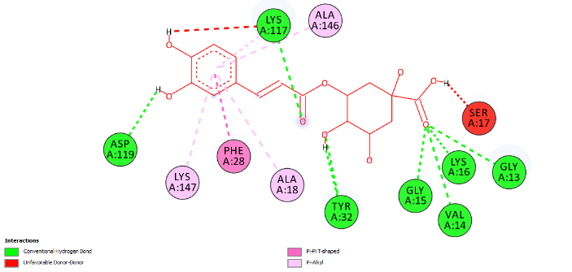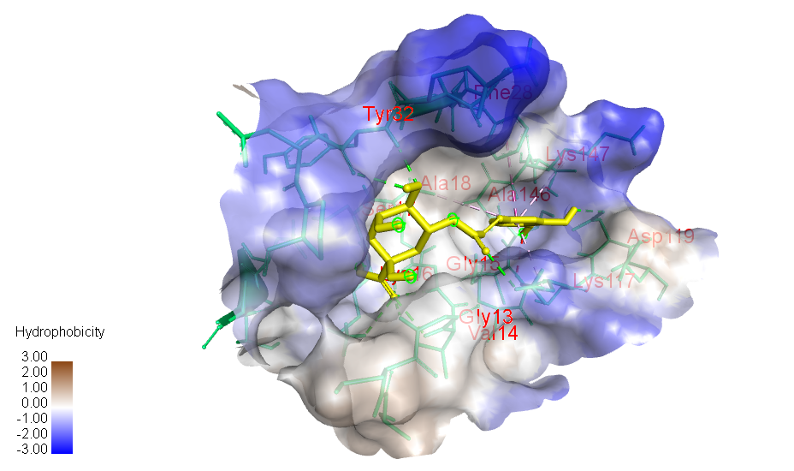
Figure S1. 2D and 3D image of intermolecular interactions between Chlorogenic acid and KRAS G12C residues.

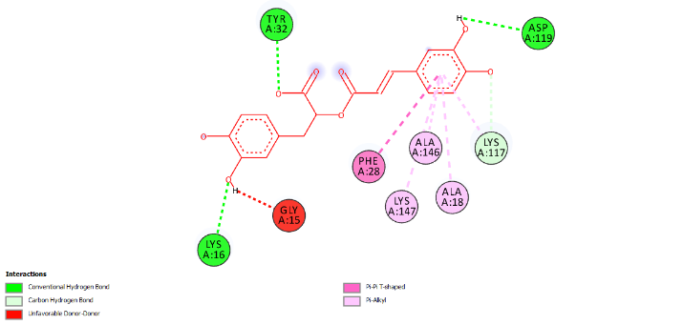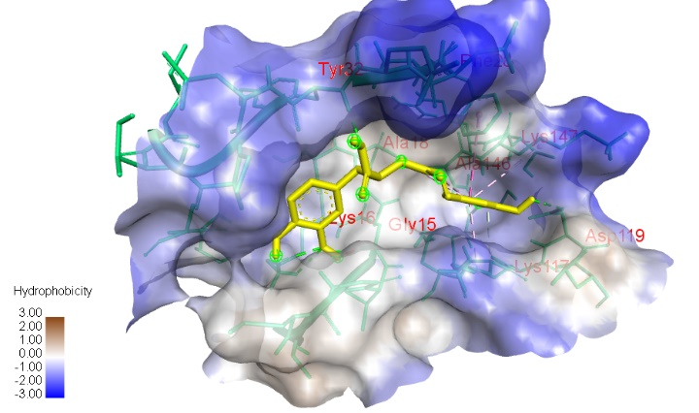
Figure S2. 2D and 3D image of intermolecular interactions between Rosmarinic acid and KRAS G12C residues.
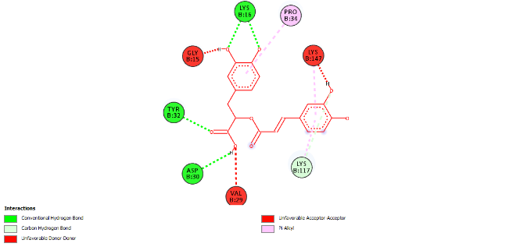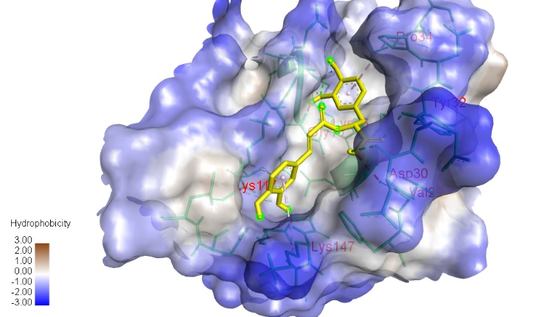
Figure S3. 2D and 3D image of intermolecular interactions between Rosmarinic acid and KRAS G12D residues.

