Supplementary Information
Plasma Catalytic Conversion of Nitrogen and Hydrogen to Ammonia over Silico Alumino Phosphate (SAPO) zeolites
Fnu Gorky,ª Apolo Nambo,^{b} Moises A. Carreon,^{c} and Maria L. Carreon*^{,a}
ª Mechanical Engineering Department, University of Massachusetts Lowell, 1 University Avenue, Lowell, MA, 01854, USA
^{b} Bert Thin Films, LLC, 625 Myrtle St, Louisville, KY, 40298, USA
^{c} Chemical and Biological Engineering Department, Colorado School of Mines, 1613 Illinois Street, Golden, CO 8040, USA

*Corresponding author: maria_carreon@uml.edu
Keywords: Non-Thermal Plasma, Plasma Catalysis, Ammonia Synthesis, SAPO crystals, Ammonia Adsorption.

XRD pattern (for spent catalysts)

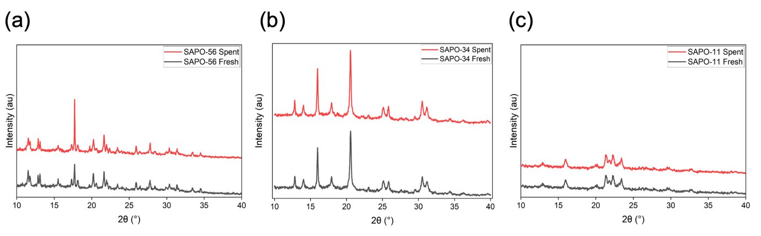

Figure S1. X-ray Diffraction pattern for the fresh and spent catalysts (a) SAPO-56, (b) SAPO-34, (c) SAPO-11.

XRF compositional analysis (for Fresh catalysts)

Table S1. General composition of the SAPOs employed in this study using XRF.
Catalyst |  | Al % | ± | Si % | ± | P % | ± | Si/Al range
SAPO-56 | Fresh | 32.12 | 0.16 | 19.83 | 0.11 | 32.30 | 0.12 | 0.62
SAPO-34 | Fresh | 19.72 | 0.11 | 2.42 | 0.03 | 18.16 | 0.07 | 0.12
SAPO-11 | Fresh | 17.57 | 0.09 | 1.02 | 0.02 | 10.26 | 0.04 | 0.06
Si/Al ratio is Silica/ Alumina ratio.

SEM Images (for Spent catalysts)

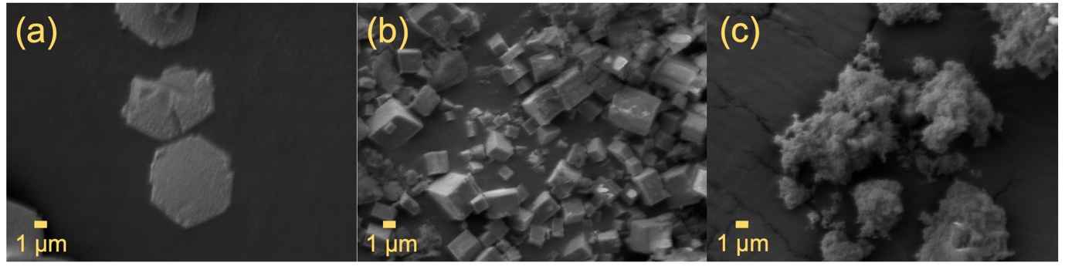

Figure S2. SEM images for the Fresh catalyst employed in this work, (a) SAPO-56, (b) SAPO-34, (c) SAPO-11.

Plasma Catalytic Ammonia Synthesis Rate (all feed ratios)

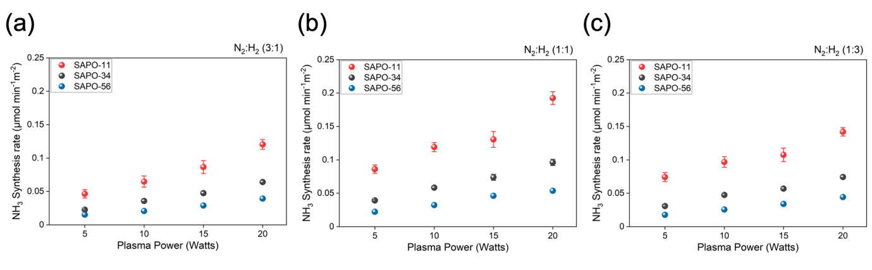
Figure S3. Ammonia synthesis rate performance for the studied SAPO crystals at 3:1, 1:1, 1:3 (N₂:H₂) feed ratio at various plasma powers (W).

OES and Electrical analysis of catalysts employed

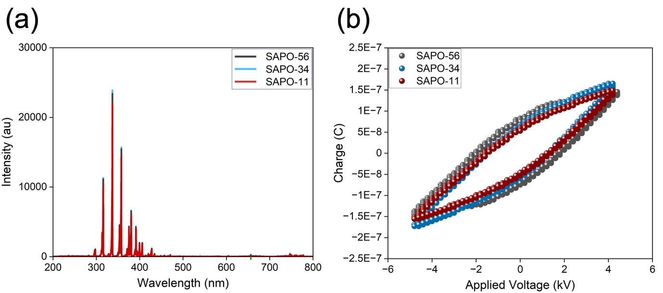

Figure S4. (a) Optical emission spectroscopy analysis for all employed catalysts, (b) electrical characterization (Applied Voltage Vs. Charge) for all employed catalyst.

