S.1 Methods
S.1.2 Closed Canopy Trees
For 16 pairs of sampled trees (one cool, one warm), a closed canopy tree (not gap adjacent) was also sampled, resulting in a total sample size of 90 trees (37 cool edge, 37 warm edge, 16 closed canopy). Closed canopy tree cores were processed, measured, and correlated with climate variables in the same manner as edge trees. Difference in the correlation of closed canopy trees versus edge trees were assessed with an analysis of covariance and Tukey tests.
S.1.1 Drivers of Variation in Tree Response to Climate
To test the relative importance of gap effects on tree response to climate at a watershed scale, we apply multiple linear regression analysis to all sampled trees as individuals (rather than pairs). We focus on r_{WR} to 1 Apr SWE as a response variable because, as an aggregate of earlywood and latewood, it summarizes annual radial growth. In initial analysis, we explore the r_{WR} with individual potential predictor variables (tree DBH, competition, species, northness, elevation, edge position (cool or warm), and near-tree snow depth) and their interactions through linear regression and analyses of covariance (ANCOVA). Additionally, we confirm that relationships between r_{WR} and potential predicter variables are linear, that residual variance is homogenous, and that residuals are normally distributed. Variables were iteratively tested in multiple linear regressions, which were compared using the Akaike Information Criterion (AIC). The final model was selected by having the lowest AIC (minimum difference threshold of 2), and critically assessed for its mechanistic sensibility.
S.2 Results
S.2.1 Distribution of Edge Areas
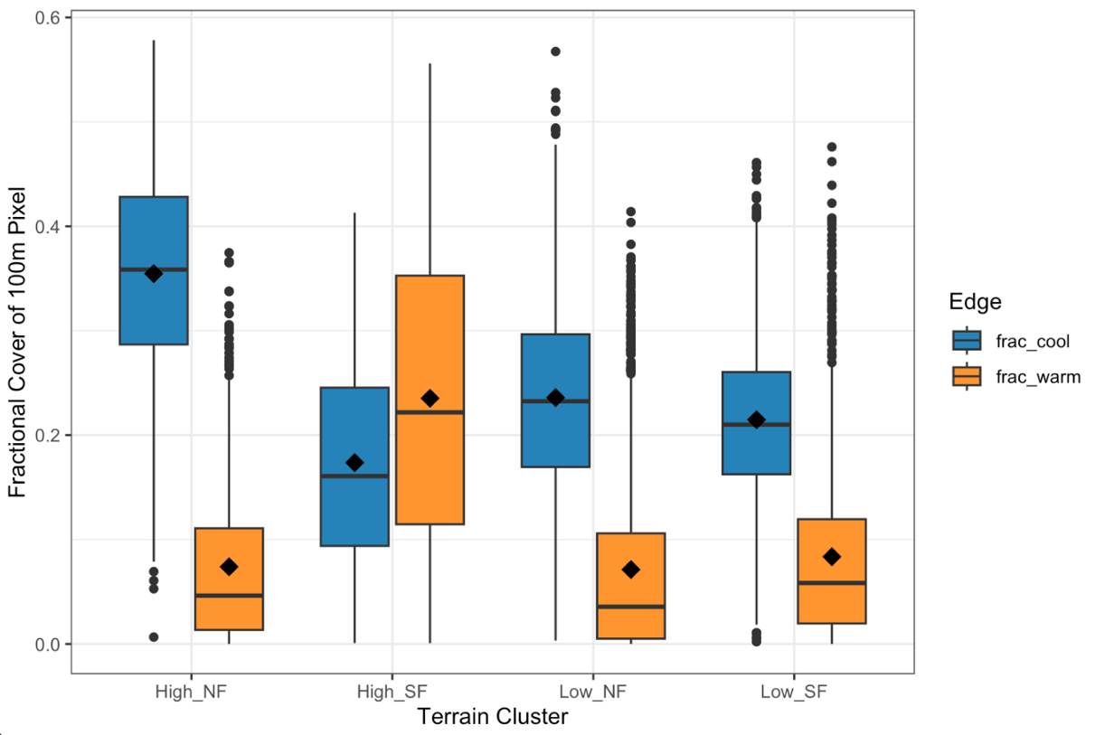
Supp Fig 1 Fractional cover of cool (blue) and warm (orange) edge areas in 100-m grid cells, separated by terrain type. Black diamonds show the mean.
S.2.3 Differences in Response of Paired Edge Trees to Climate
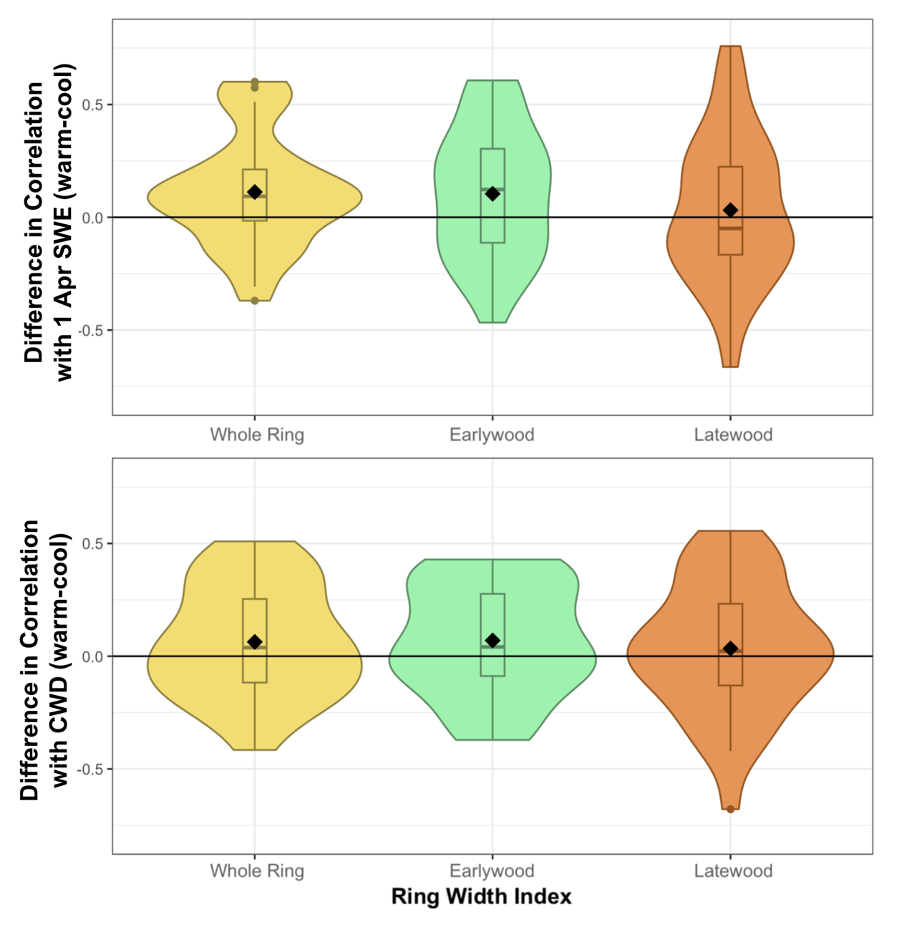
Supp. Fig 2 Violin plots showing the distributions of differences between the correlation coefficients of the warm and cool tree in each sampled tree pair. Correlation coefficients are between ring width indices and climate variables (1 Apr SWE and CWD).
S.2.4 Comparison of Edge and Closed Canopy Trees
For a subset of 16 tree pairs, a matched closed canopy tree was sampled in addition to warm and cool edge trees. For these triplets, correlation of whole ring width index (r_{WR}) to 1 Apr SWE in closed canopy trees was 1.3 times lower than in warm edge trees and 1.8 times higher than in cool edge trees (Supp. Table 1, Supp Fig. 3). Correlation of earlywood width index (r_{EW}) to 1 Apr SWE followed a similar pattern, but no significant differences were detected among correlations of latewood width index (r_{LW}) to 1 Apr SWE (Supp. Table 1). No significant differences were detected in the correlation of ring width indices to CWD for closed canopy versus edge trees.
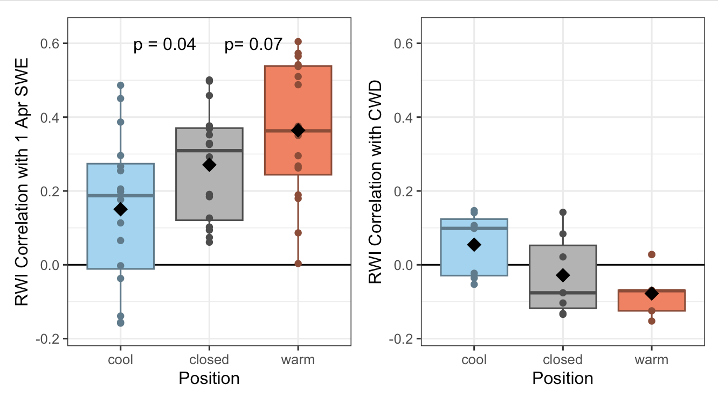
Supp. Fig 3 Boxplots showing tree whole ring width index correlation to 1 Apr SWE and annual CWD for trees in closed canopy, warm edge, and cool edge positions. P values correspond to the difference between close canopy values and edge values. Differences were not significant (p>0.1) for CWD.
Supp. Table 1 Differences in mean correlations to 1 Apr SWE between edge trees and adjacent closed canopy trees.
 | Position | Mean 1 Apr SWE Correlation (R) | Significant Difference (p <0.1) | Significant Difference (p <0.05)
Whole Ring Width Index | Cool | 0.15  0.36  0.27 | c | b
Whole Ring Width Index | Warm | 0.15  0.36  0.27 | a | a
Whole Ring Width Index | Closed Canopy | 0.15  0.36  0.27 | b | a
Earlywood Width Index | Cool | 0.11  0.33  0.24 | c | b
Earlywood Width Index | Warm | 0.11  0.33  0.24 | a | a
Earlywood Width Index | Closed Canopy | 0.11  0.33  0.24 | b | a
Latewood Width Index | Cool | 0.19  0.28  0.23 | a | a
Latewood Width Index | Warm | 0.19  0.28  0.23 | a | a
Latewood Width Index | Closed Canopy | 0.19  0.28  0.23 | a | a

S.2.5 Predictors of Tree Sensitivity
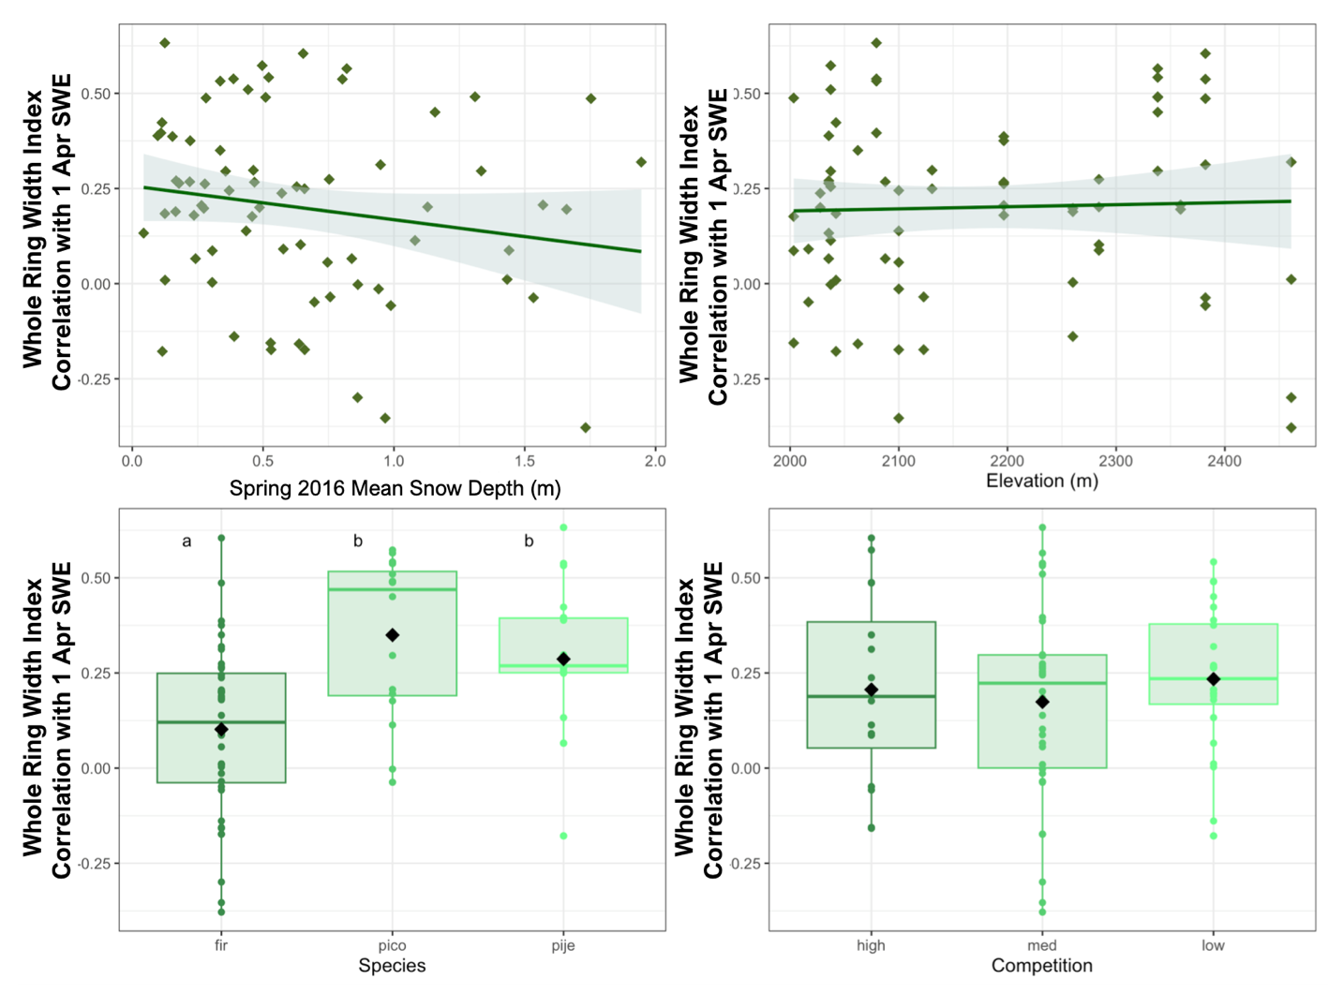
Supp. Fig 5 Variation in r_{WR} to 1 Apr SWE as a function of each sampled tree’s mean adjacent spring snow depth, elevation, species, and competition. Species include white and red fir (pooled), lodgepole pine (pico) and Jeffery pine (pije). Lowercase letter in the species plot indicate significant differences.
Inclusion of spring mean snow depth dramatically improved a multiple linear regression model’s ability to predict r_{WR} to 1 Apr SWE. The best model we tested (AIC = -31.1) included tree species, elevation, and an interaction between snow depth and competition to predict 47% of variance in r_{WR} (p < 0.01, n = 74). The best model that excluded snow depth in favor of gap position (ie, warm or cool edge) was less effective (AIC = -21.7), included tree species, elevation, gap position and an interaction between northness and competition, and explained 42% of variance in r_{WR} to 1 Apr SWE (p < 0.01, n = 74). The best model that excluded snow depth and gap position (ie, warm or cool edge) was far less effective (AIC = -17.1), explained 36% of variance in r_{WR} to 1 Apr SWE (p < 0.01, n = 74), and included tree species, elevation, and an interaction between northness and competition.
Supp. Table 2 Results from the best model tested for predicting RWI sensitivity to 1 Apr SWE among individual trees. SDmean refers to the mean snow depth value over three spring 2016 measurement dates. Species observed were lodgepole pine (pico), Jeffery pine (pije), and white and red firs (categorized together). Effect estimates are based on scaled continuous variables (sensitivity, snow depth mean, and elevation).
 | Estimate of Effect | Standard Error | Statistic | P Value
Intercept | -0.07 | 0.21 | -0.31 | 0.76
Snow Depth mean | -0.28 | 0.29 | -0.97 | 0.34
Competition_low | -0.63 | 0.31 | -2.03 | 0.05
Competition_med | -0.49 | 0.26 | -1.84 | 0.07
Elevation | 0.51 | 0.15 | 3.46 | < 0.01
Species_pico | 1.26 | 0.24 | 5.21 | < 0.01
Species_pije | 0.98 | 0.27 | 3.58 | < 0.01
SDmean:Competition_low | -0.01 | 0.30 | -0.05 | 0.96
SDmean:Competition_med | -0.67 | 0.31 | -2.18 | 0.03

