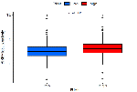
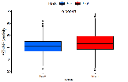
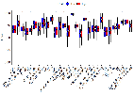
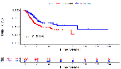
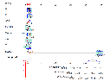
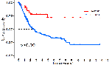
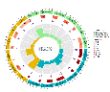
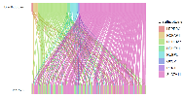
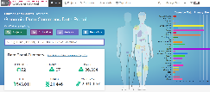
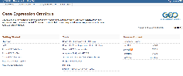
Drug sensitivity analysis

Correlation of risk scores with immunotherapy response

Validation of the risk score model

The nomogram based on risk score in BLCA

Data collection
Correlation of drlncRNAs with TME, GO and KEGG

Genetic expression of drlncRNAs in BLCA

Supplementary Figure S1: The flow chat of the study. drlncRNAs: disulfidptosis-related long noncoding RNAs.

