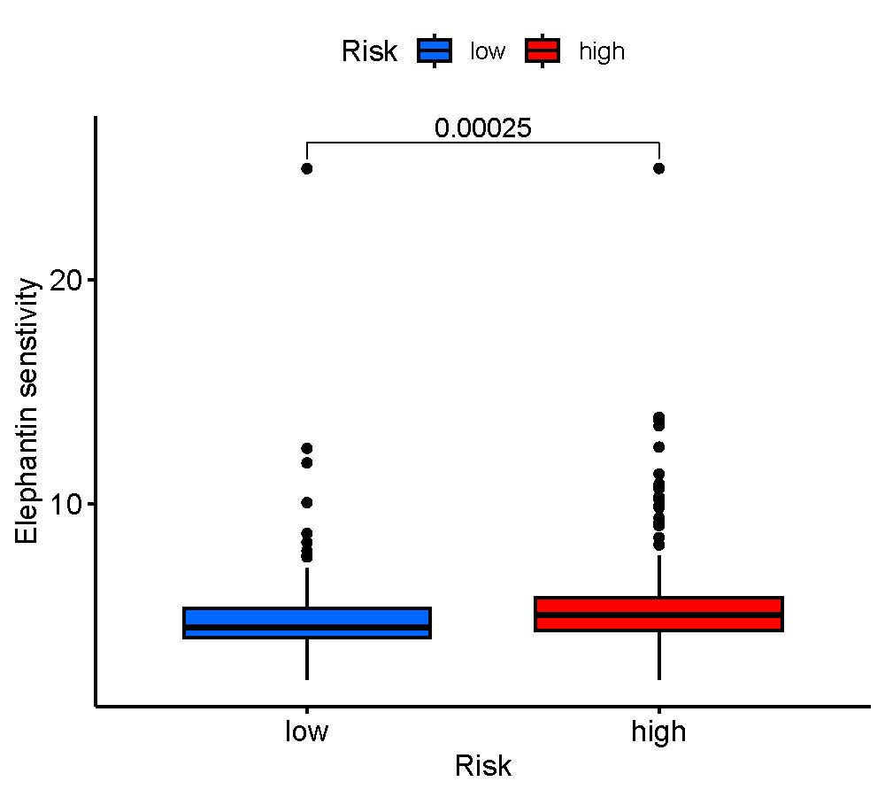
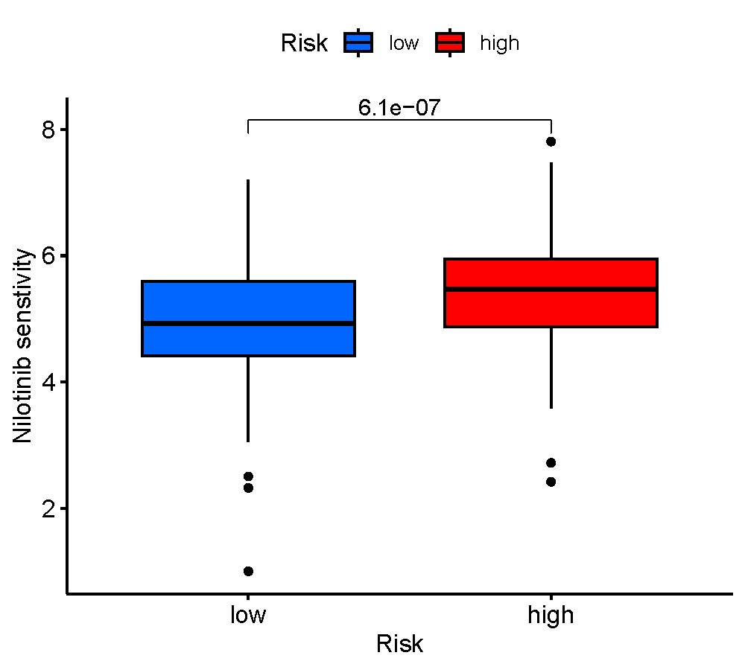
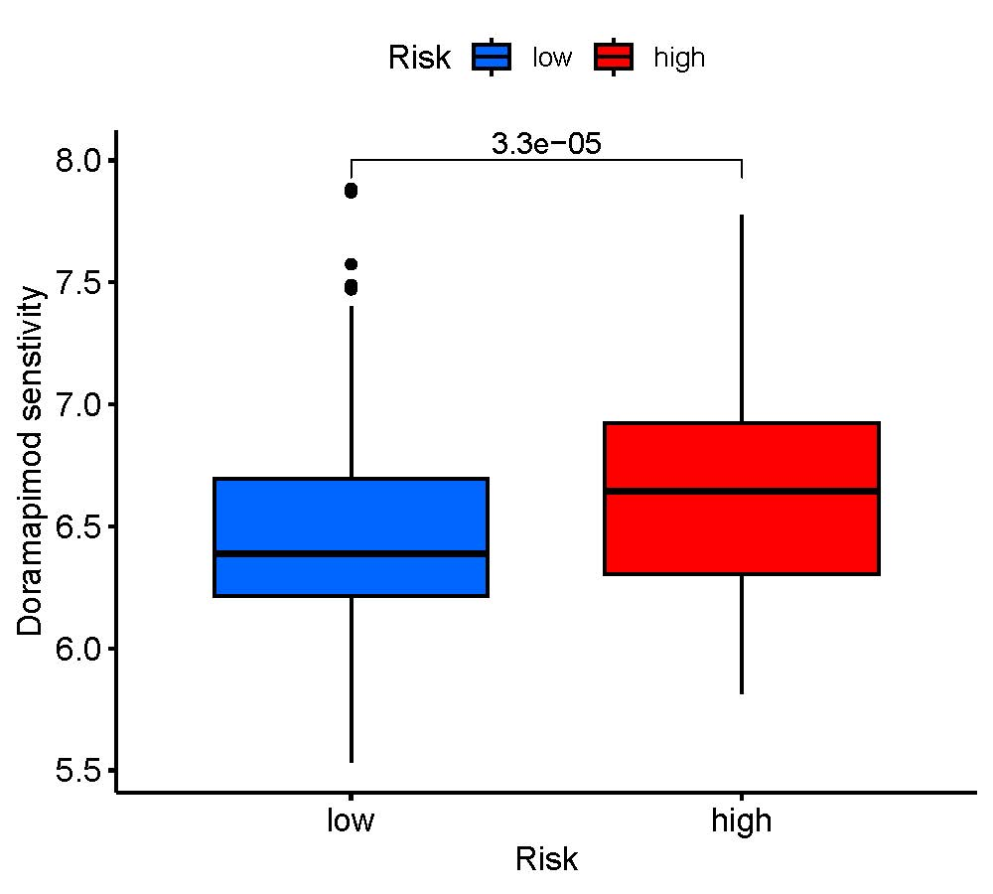
C
B
A

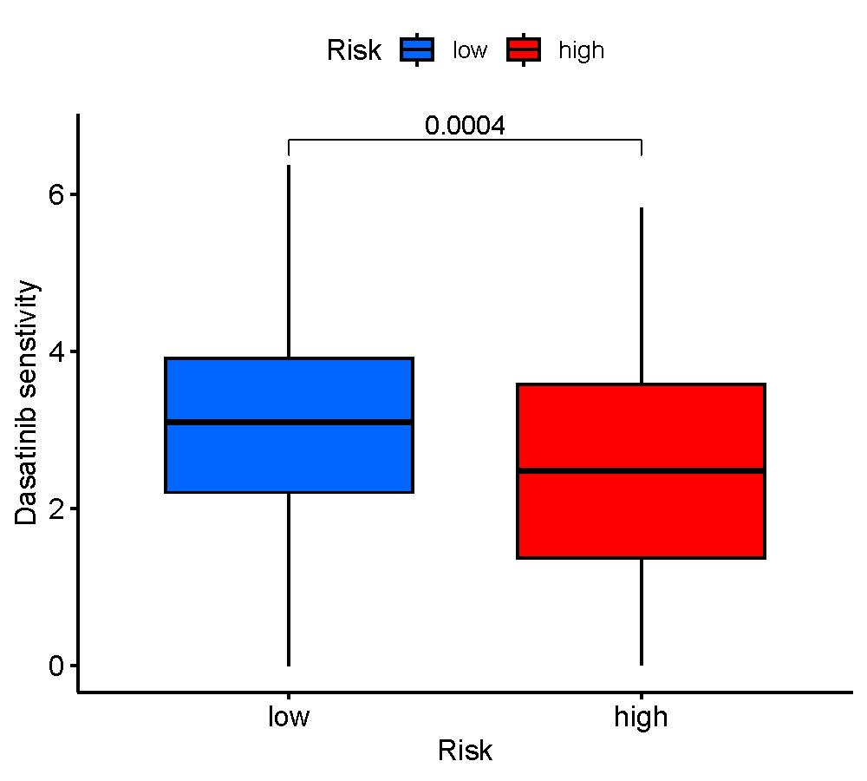
F
E
D
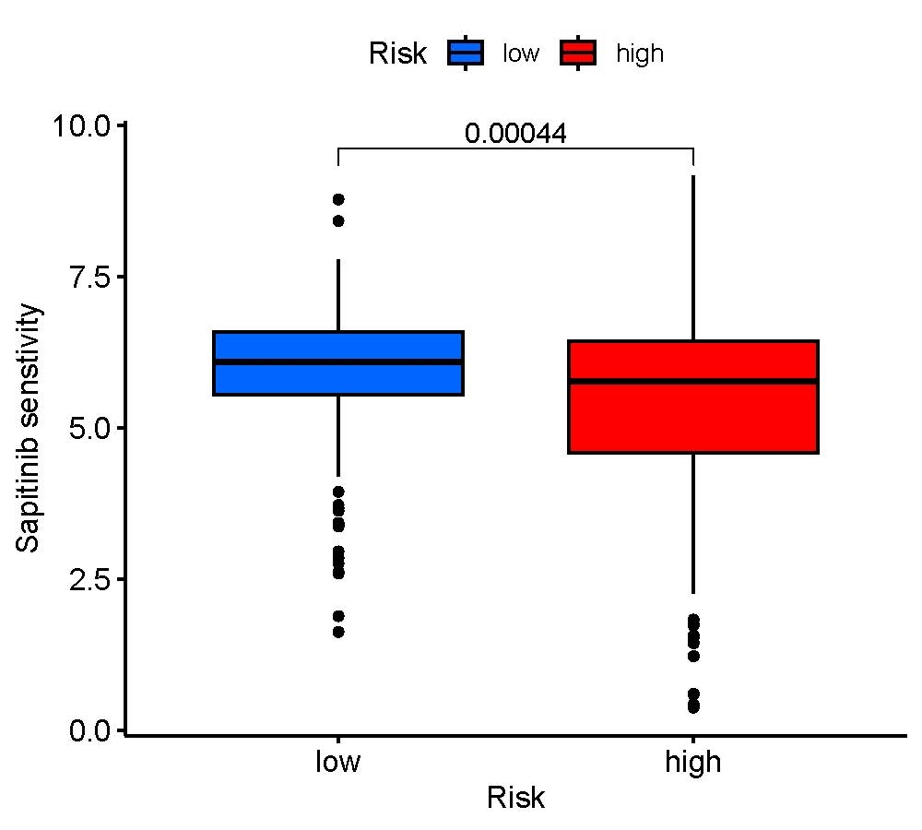
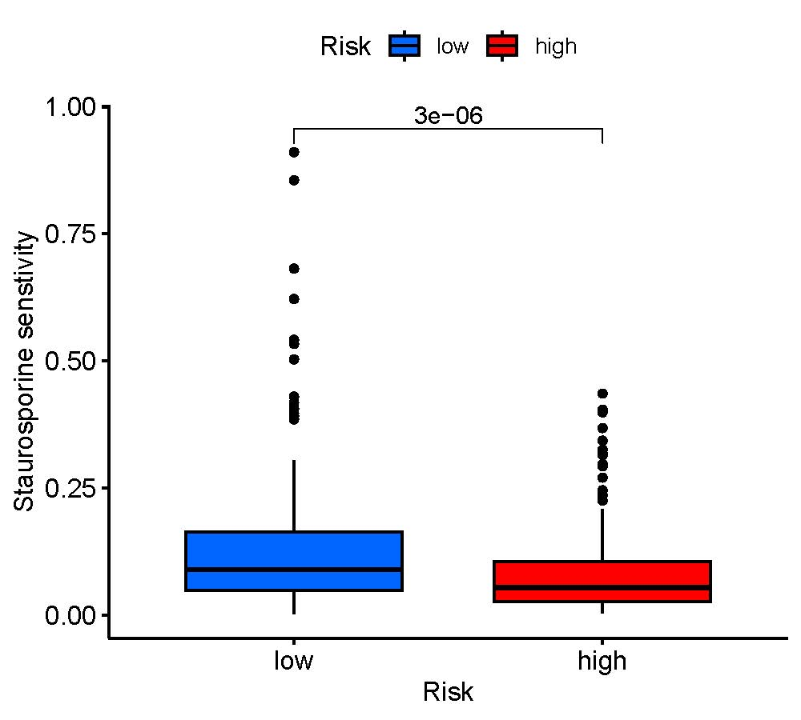

Supplementary Figure S2: Relationships between disulfidptosis-score and medicine sensitivity. Lower IC50 of indicated chemo-therapeutics drugs in low (A-C) and high (D-F) disulfidptosis-score group, respectively. IC50, half-maximal inhibitory concentration prediction.

