Table 2. Fertilizer production ingredients (TVCN 9486:2018)

Orders | Name and Chemical formulas | Components | Common characteristics | Figures
1 | Name:  Ammonium Sulfate.  Chemical formulas:  (NH₄)₂SO₄ | The Ammonium sulfate contains 21% nitrogen which includes ammonium cation, and 24% sulfur as the sulfate anion. | + Classification: Sulfate  + Melting point: 235 °C  + Molecular mass: 132,14 g/mol  + Solubility: water  + Density: 1,77 g/cm³ | 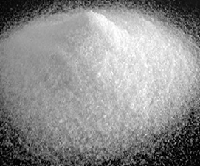
2 | Name:  Photphorit  Chemical formulas:  Ca(H2PO4)2 – Ca3(PO4)2 ;  Mg(PO4)2. | They are calcium phosphate compounds containing Cl–, F, OH– hay CO₃²⁻. | + It is ground from phosphorite ore.  + Golden brown  + Humidity <5%  + D97 sieve size: 80μm | 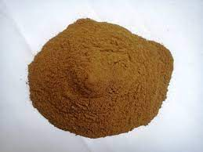
3 | Name:  Kaolin  Chemical formulas:  Al₂O₃.2SiO₂.2H₂O (or Al₄ (OH)8Si₄O₁₀). | The main composition is the mineral kaolinite and some other minerals such as illite, montmorillonite, and quartz. | + Hardness 1 on the Mohs scale.  + Specific gravity is about 2.58-2.60 g/cm³.  + Melting temperature ranges from 1750 - 1787 degrees Celsius. | 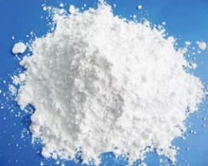
4 | Name:  Kali oxide (or Potash)  Chemical formulas:  K₂O | Potassium oxide contains potassium and oxygen. | + This solid is pale yellow and is the simplest oxide of potassium. Classification: Basic Oxide ; Melting point : 740 °C (1,010 K; 1,360 °F);  + Decomposition: 300 °C  + Density: 2.35 g/cm³  + Molecular Weight: 94.2 g/mol ; Crystal Structure: Cubic Fluorite, cF12. | 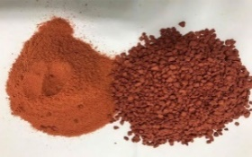
5 | Name:  Talc Shimano  Chemical formulas:  Mg₃Si₄O₁₀(OH)₂ | It contains MgO 30%; SiO2 60% | + White fine powder.  + Fineness: 45 μm (325 mesh).  Whiteness > 83%. | 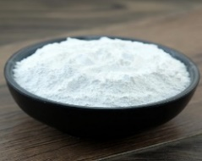
6 | Name:  Peat (or turf) | It contains about 65% organic matter decomposed from dead plants ; and humic acid, fulvic acid, and various mineral elements : C, H, N, O, S.  In addition, it contains other medium - trace substances such as: Fe, Si, Ca, Mg, K, ... | + It has high porosity, loose structure and fiber properties  Peat grade 1: dark black, fineness through 3.5mm sieve and organic content from 30-35%.  + This is the peat with the highest organic content. The average humidity level is 42.1%. | 