Effect of Saline-alkali Stress on Seed Germination of the Halophyte Halostachys caspica
Rui Zhang, Huizhen Zhang, Lai Wang, Youling Zeng*
Supplemental Data
Figure S1
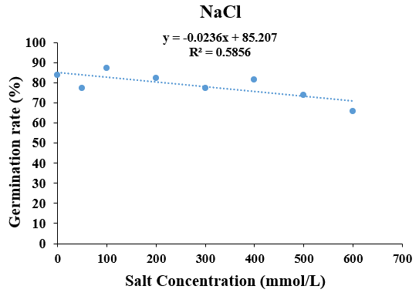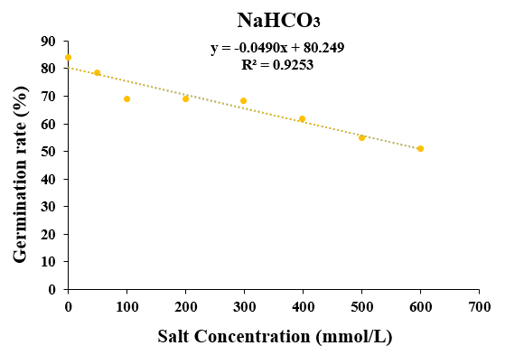
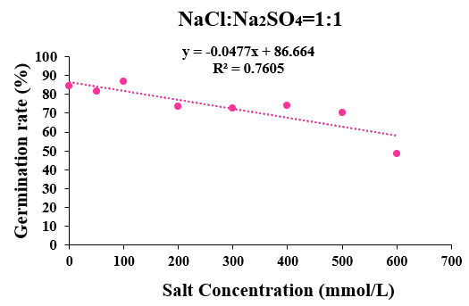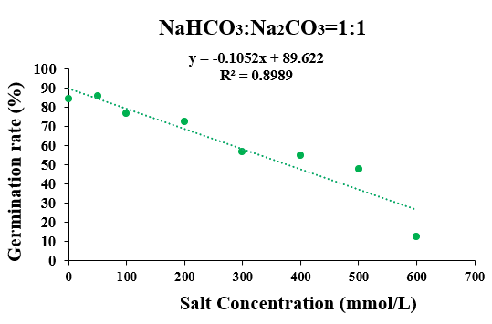
Fig. S1 Linear regression equation under single salt, single alkali, and mixed salt, mixed alkali treatment. (A)NaCl; (B)NaHCO₃; (C) NaCl: NaSO₄=1:1; (D) NaHCO₃: Na₂CO₃=1:1.

Figure S2
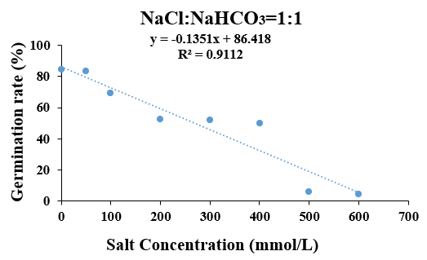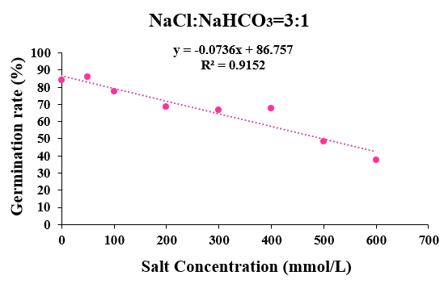
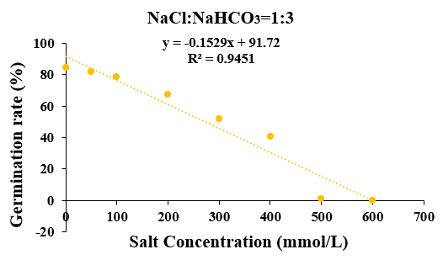
Fig. S2 Linear regression equation under different proportions of mixed salt alkali treatment. (A)NaCl:NaHCO₃=1:1; (B)NaCl:NaHCO₃=3:1; (C)NaCl:NaHCO₃=1:3.

Supplemental Table S1. Effect of different saline-alkali treatments on seed germination of Halostachys caspica
Different Treatment | Salt Concentration  (mmol/L) | Germination Rate（A/C)*100 | Rehydration Germination Rate  [B/(C-A)]*100 | Total  Germination Rate  [(A+B)/C]*100
 | CK | 84.17±1.25a | ---- | 84.17±1.25b
 | 50 | 77.5±0.82b | 33.33±1.69c | 86.66±2.53ab
 | 100 | 87.5±0.82a | 38.33±0.82c | 90.23±1.23a
NaCl | 200 | 82.50±0.82ab | 57.15±0.82b | 84.37±1.25ab
 | 300 | 77.5±0.81bc | 62.96±1.26b | 86.54±2.10ab
 | 400 | 81.67±1.25ab | 66.67±1.25b | 91.16±1.21a
 | 500 | 74.17±0.47c | 74.19±0.47a | 83.01±2.35ab
 | 600 | 65.83±1.70d | 78.05±0.94a | 82.65±1.11ab
 | CK | 84.17±1.25a | ---- | 84.17±1.25a
 | 50 | 78.33±1.54b | 65.38±1.25c | 87.36±2.35a
 | 100 | 70.12±3.51bc | 81.08±3.27a | 85.12±3.23a
NaHCO₃ | 200 | 69.17±1.15bc | 80.2±0.82ab | 83.24±1.21a
 | 300 | 68.33±2.31bc | 78.96±2.16bc | 82.32±2.23ab
 | 400 | 63.33±1.00bc | 81.81±1.63a | 83.56±0.89a
 | 500 | 60.67±1.25bc | 67.25±0.82c | 74.32±1.45c
 | 600 | 50.03±1.50d | 60.53±1.63c | 62.65±1.11d
 | CK | 84.17±1.25a | ---- | 84.17±1.25b
 | 50 | 81.67±2.05ab | 22.36±1.52d | 83.66±2.43b
 | 100 | 86.67±0.47a | 25.11±2.34d | 91.26±0.25a
NaCl:NaSO₄=1:1 | 200 | 73.33±1.32bc | 37.52±1.63c | 80.47±2.25b
 | 300 | 77.5±0.81bc | 72.35±0.35bc | 90.14±1.10ab
 | 400 | 72.50±1.32bc | 78.42±1.25b | 91.21±0.41a
 | 500 | 70.21±1.78bc | 83.28±1.56a | 77.01±3.12c
 | 600 | 48.33±1.24d | 88.05±0.94a | 64.15±1.11d
 | CK | 84.17±1.25a | ---- | 84.17±1.25ab
 | 50 | 85.83±1.25a | 23.53±0.47d | 88.66±2.35a
 | 100 | 76.67±0.94ab | 53.57±0.82c | 82.36±1.14ab
NaHCO₃:Na₂CO₃=1:1 | 200 | 72.50±1.63ab | 60.62±1.25b | 83.66±2.31ab
 | 300 | 56.67±1.70bc | 78.85±1.24a | 64.35±1.48c
 | 400 | 50.33±0.82bc | 72.53±2.74a | 61.56±0.42c
 | 500 | 47.50±0.90bc | 76.12±2.82a | 51.11±0.98d
 | 600 | 12.50±3.98d | 65.53±1.63ab | 40.25±2.51e
Note: The difference in lowercase letters after the same column of data is significant (P<0.05)，and the figures after addition and subtraction are Standard error (σ).

Supplemental Table S2. Effect of different mixed saline-alkali treatments on seed germination of Halostachys caspica
Different  Treatment | Salt Concentration  (mmol/L) | Germination Rate  (A/C)*100 | Rehydration Germination Rate  [B/(C-A)]*100 | Total  Germination Rate  [(A+B)/C]*100
 | CK | 84.17±1.25a | ---- | 84.17±1.25a
 | 50 | 83.83±1.25a | 55.32±0.47bc | 90.00±1.56a
 | 100 | 69.17±1.24b | 48.21±0.82ab | 85.23±2.12ab
NaCl:NaHCO₃=1:1 | 200 | 52.20±1.20bc | 71.67±2.05a | 84.47±0.25ab
 | 300 | 51.67±0.25bc | 75.86±1.25a | 85.96±1.23ab
 | 400 | 50.00±1.20bc | 76.86±2.30a | 85.68±3.21ab
 | 500 | 5.83±2.47d | 76.92±1.63a | 42.53±1.10c
 | 600 | 4.17±2.45d | 78.26±0.86a | 43.96±2.10c
 | CK | 84.17±1.25a | ---- | 84.17±1.25a
 | 50 | 81.67±1.70ab | 22.72±0.47c | 85.00±0.25ab
 | 100 | 78.33±1.87ab | 26.92±1.82c | 85.23±1.52ab
NaCl:NaHCO₃=1:3 | 200 | 67.50±3.56bc | 35.10±1.12bc | 84.47±0.25ab
 | 300 | 67.50±1.25bc | 32.45±2.25bc | 82.98±2.74ab
 | 400 | 40.83±2.05d | 60.00±1.85a | 70.02±1.41c
 | 500 | 0.83±0.47e | 58.92±0.87ab | 55.23±1.48d
 | 600 | 0.00±0.00f | 52.32±1.46ab | 52.50±1.96d
 | CK | 84.17±1.25a | ---- | 84.17±1.25ab
 | 50 | 85.83±1.69a | 23.53±0.47e | 90.00±1.03a
 | 100 | 77.50±0.87b | 33.33±0.82d | 85.12±0.85ab
NaCl:NaHCO₃=3:1 | 200 | 67.50±0.56cd | 50.16±1.26c | 84.47±0.82ab
 | 300 | 66.67±0.94c | 66.66±0.29bc | 82.98±0.74ab
 | 400 | 65.50±2.44cd | 67.66±0.82bc | 70.02±1.41b
 | 500 | 48.33±1.89d | 77.42±1.62a | 55.23±1.48bc
 | 600 | 37.50±0.82de | 69.33±1.70ab | 52.50±1.12bc
Note: The difference in lowercase letters after the same column of data is significant (P<0.05), and the figures after addition and subtraction are Standard error (σ).

Supplemental Table S3. Relative salt damage rate and salt resistance level of Halostachys capsica seeds under different saline-alkali treatments.
Salt type | Salt concentration | Relative salt damage rate | Salt resistance level
 | 50 | 7.88±0.38bc | 1级
 | 100 | -4.17±1.96d | 1级
NaCl | 200 | 1.75±2.03c | 1级
 | 300 | 7.77±1.58bc | 1级
 | 400 | 2.98±0.04c | 1级
 | 500 | 11.72±1.48b | 1级
 | 600 | 21.57±2.34a | 3级
 | 50 | 6.93±0.45d | 1级
 | 100 | 17.78±2.75c | 1级
NaHCO3 | 200 | 17.79±0.69c | 1级
 | 300 | 18.50±2.90c | 1级
 | 400 | 26.69±2.29b | 3级
 | 500 | 34.51±1.98ab | 3级
 | 600 | 39.50±1.49a | 3级
 | 50 | 2.70±2.96c | 1级
 | 100 | -3.06±0.85d | 1级
NaCl:Na₂SO₄=1:1 | 200 | 12.82±1.13b | 1级
 | 300 | 13.80±0.79b | 1级
 | 400 | 11.75±1.29b | 1级
 | 500 | 16.81±0.28b | 1级
 | 600 | 42.42±1.53a | 5级
 | 50 | 2.11±1.25e | 1级
 | 100 | 8.68±2.07d | 1级
NaHCO₃:Na₂CO₃=1:1 | 200 | 13.62±2.52c | 1级
 | 300 | 32.39±2.56bc | 3级
 | 400 | 34.59±0.95bc | 3级
 | 500 | 43.42±1.41b | 5级
 | 600 | 85.19±0.71a | 9级
Note: The difference in lowercase letters after the same column of data is significant (P<0.05), and the figures after addition and subtraction are Standard error (σ).

Supplemental Table S4. Relative salt damage rate and salt resistance level of Halostachys capsica seeds under different saline-alkali treatments.
Salt type | Salt concentration | Relative salt  damage rate | Salt resistance level
 | 50 | 2.79±1.59d | 1级
 | 100 | 17.67±1.41c | 1级
NaCl:NaHCO₃=1:1 | 200 | 37.51±1.27b | 3级
 | 300 | 38.46±1.79b | 3级
 | 400 | 40.45±1.44b | 5级
 | 500 | 93.01±0.56a | 9级
 | 600 | 95.10±0.42a | 9级
 | 50 | 4.79±1.61e | 1级
 | 100 | 6.96±1.22e | 1级
NaCl:NaHCO₃=1:3 | 200 | 19.73±3.51d | 1级
 | 300 | 38.64±0.79c | 3级
 | 400 | 51.63±1.47b | 3级
 | 500 | 99.05±0.45a | 9级
 | 600 | 100±0a | 9级
 | 50 | -0.33±2.97e | 1级
 | 100 | 7.88±0.39d | 1级
NaCl:NaHCO₃=3:1 | 200 | 18.85±1.51c | 1级
 | 300 | 20.58±1.93c | 3级
 | 400 | 19.18±2.45c | 1级
 | 500 | 42.54±1.83b | 5级
 | 600 | 55.36±1.09a | 5级
Note: The difference in lowercase letters after the same column of data is significant (P<0.05), and the figures after addition and subtraction are Standard error (σ).

