Scale CGA-FI
Deficits counted | Points (max denominator 55)
Motivation | Low =1
Self-rated health | Excellent = 0, Good = 0.25, Fair = 0.5, poor/can’t say = 1
Cognition | Dementia = 1,  Mild cognitive Impairments = 0.5,  Delirium = 1  Agitation = 1  Delusions/hallucinations = 1
Mini-mental State Examination | < 19 = 1, ≥ 19 = 0
Emotional state | Anxiety = 1  Recent bereavement = 1  Depression = 1  Fatigue = 1
Sleep | Poor or disrupted = 1  Daytime drowsiness = 1
Speech | Impaired = 1
Hearing | Impaired = 1
Vision (with glasses) | Impaired = 1
Hemiparesis | Weak arm = 1  Weak leg = 1
Grip strength (on non - hemiplegic side) | Weak = 1
Proximal muscle strength (on non - hemiplegic side) | Weak = 1
Weight | Underweight = 1, Obese = 1, slightly overweight = 0
Weight change | Loss = 1, significant gain = 1
Appetite | Poor = 1, fair = 0.5, normal = 0
Continence | Bowels incontinent = 1  Bladder incontinent/catheter = 1
Medical History (scoring 1 point each) | Hypertension  Asthma/Chronic obstructive lung disease  Stroke/Transient ischemic attack  Angina/Myocardial infarction  Heart Failure  Diabetes  Active cancer  Alcohol excess  Pressure sores  Hip fracture  Osteoarthritis/osteoporosis  Parkinson’s disease  1st other medical problem  2nd other medical problem
No. of medications in 24 hours | 0 - 4 = 0, 5 - 9 = 1, 10 - 14 = 2, 15 - 19 = 3, 20 - 24 = 4, > 25 = 5
Transfers | Dependent = 1, Assistance = 0.5
Walking | Dependent = 1, Assistance = 0.5
Movements slow | Yes = 1
Sitting balance | Impaired = 1
Falls in the last 6 months | 3 or more = 1
Feeding | Dependent = 1, Assistance = 0.5
Washing | Dependent = 1, Assistance = 0.5
Dressing | Dependent = 1, Assistance = 0.5
Could manage own medications | Dependent = 1, Assistance = 0.5
Could manage own finances | Dependent = 1, Assistance = 0.5

TableS1: Common Opioid Formulations Equivalent to Opioid Prescription Dose
Opioid Formulation | Conversion Factor
Common oral opioids
Oxycodone | 1.5
Tramadol | 0.25
Parenteral opioids
Dezocine | 1
Meperidine | 0.2
Transdermal opioids
Buprenorphine patch 5μg/hr | 15 for 1 day

TableS2: Demographics and baseline characteristics of patients with and without APSP
Variable | Total | No APSP | APSP | Test value | P value
Variable | (n = 164) | (n = 56) | (n = 108) | Test value | P value
Age (years) | 71.4 ± 4.6 | 72.0 ± 5.2 | 71.1 ± 4.3 | 1.171 | 0.245
Gender |  |  |  | 1.077 | 0.299
Male | 39 (23.8) | 16 (28.6) | 23 (21.3)
Female | 125 (76.2) | 40 (71.4) | 85 (78.7)
BMI |  |  |  | 0.485 | 0.785
≤23.9 | 34 (20.7) | 10 (17.9) | 24 (22.2)
24.0-27.9 | 66 (40.2) | 24 (42.9) | 42 (38.9)
≥ 28.0 | 64 (39.0) | 22 (39.3) | 42 (38.9)
Education level |  |  |  | 1.316 | 0.518
Illiteracy | 49 (29.9) | 15 (26.8) | 34 (31.5)
Primary | 46 (28.0) | 14 (25.0) | 32 (29.6)
Middle or above | 69 (42.1) | 27 (48.2) | 42 (38.9)
ASA class |  |  |  | 0.000 | 1.000
Ⅱ | 12 (7.3) | 4 (7.1) | 8 (7.4)
Ⅲ | 152 (92.7) | 52 (92.9) | 100 (92.6)
Depression | 8 (4.9) | 2 (3.6) | 6 (5.6) | 0.031 | 0.859
Anxiety | 14 (8.5) | 4 (7.1) | 10 (9.3) | 0.027 | 0.869
Hypertension | 98 (59.8) | 33 (58.9) | 65 (60.2) | 0.024 | 0.876
Diabetes | 33 (20.1) | 13 (23.2) | 20 (18.5) | 0.506 | 0.477
ACCI | 3 (2, 4) | 3 (3, 4) | 2 (2, 3.75) | -1.233 | 0.218
PSQI > 5 | 111 (67.7) | 36 (64.3) | 75 (69.4) | 0.449 | 0.503
CRP (mg/L) | 3.0 (2.1, 4.5) | 3.2 (2.2, 5.4) | 3.0 (2.1, 4.0) | -0.236 | 0.814
Alb (g/L) | 39.6 ± 2.6 | 39.3 ± 2.9 | 40.0 ± 2.5 | -1.067 | 0.287
Hb (g/L) | 127.5 ± 13.1 | 126.7 ± 14.4 | 127.9 ± 12.4 | -0.523 | 0.602
Preoperative pain |  |  |  | 11.201 | 0.001*
NRS 0 - 3 | 17 (10.4) | 12 (21.4) | 5 (4.6)
NRS 4 - 10 | 147 (89.6) | 44 (78.6) | 103 (95.4)
Peri-operative parameter
Surgical duration (min) | 115.0 ± 22.8 | 117.0 ± 29.3 | 113.9 ± 18.7 | 0.700 | 0.486
Anesthesia duration (min) | 143.7 ± 24.4 | 145.3 ± 30.5 | 142.8 ± 20.6 | 0.538 | 0.592
Infusion volume (ml) | 1666.8 ± 386.1 | 1613.4 ± 401.4 | 1694.4 ± 376.9 | -1.277 | 0.203
Urine output (ml) | 500 (300, 700) | 450 (200, 700) | 500 (300, 700) | -0.522 | 0.601
Blood loss (ml) | 100 (80, 150) | 100 (53, 150) | 100 (93, 150) | -0.778 | 0.436
Blood transfusion (%) | 3 (1.8) | 3 (5.4) | 0 (0) | 3.288 | 0.070
MME | 0.0 (0.0, 56.3) | 0.0 (0.0, 56.3) | 0.0 (0.0, 56.3) | -0.411 | 0.681
Abbreviations: APSP, acute postsurgical pain; BMI, body mass index; ASA, American Society of Anesthesiologists; ACCI, age-adjusted Charlson Comorbidity Index; PSQI, Pittsburgh Sleep Quality Index; CRP, C-reactive protein; Alb, albumin; Hb, hemoglobin; NRS, Numerical Rating Scale; MME, morphine milligram equivalent

TableS3: Multivariate analysis for factors affecting APSP
Predictive factors | OR | CI | P value
Frailty | 13.232 | 3.731 - 46.929 | < 0.001*
Gender | 1.433 | 0.595 - 3.451 | 0.422
Preoperative pain | 4.015 | 1.206 - 13.363 | 0.023*
Anxiety | 1.001 | 0.217 - 4.621 | 0.999
Depression | 0.636 | 0.086 – 4.699 | 0.657
PSQI | 0.675 | 0.297 - 1.534 | 0.348
Transfusion (YES) | 0.000 | 0.000 | 0.999
MME | 1.004 | 0.992 - 1.017 | 0.504
Abbreviations: PSQI, Pittsburgh Sleep Quality Index; MME, morphine milligram equivalent

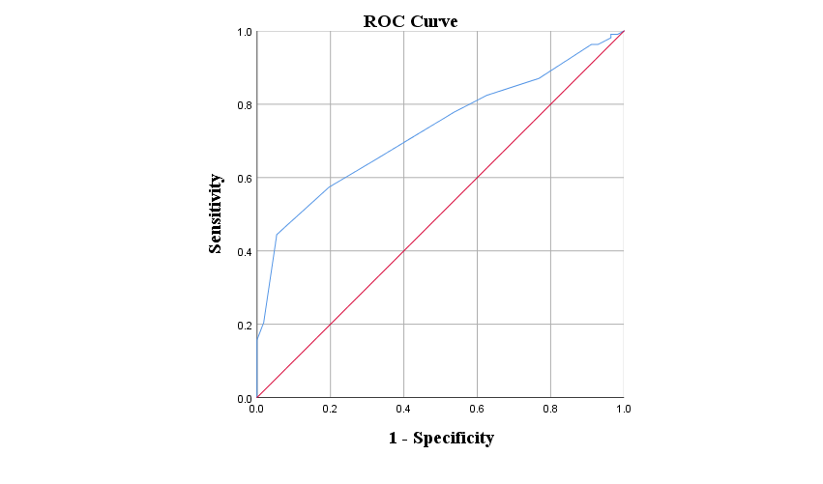
Supplementary Figure S1. The ROC curve for preoperative frailty predicting acute postoperative pain (AUC = 0.728, P < 0.001, 95% CI: 0.652 - 0.804)

