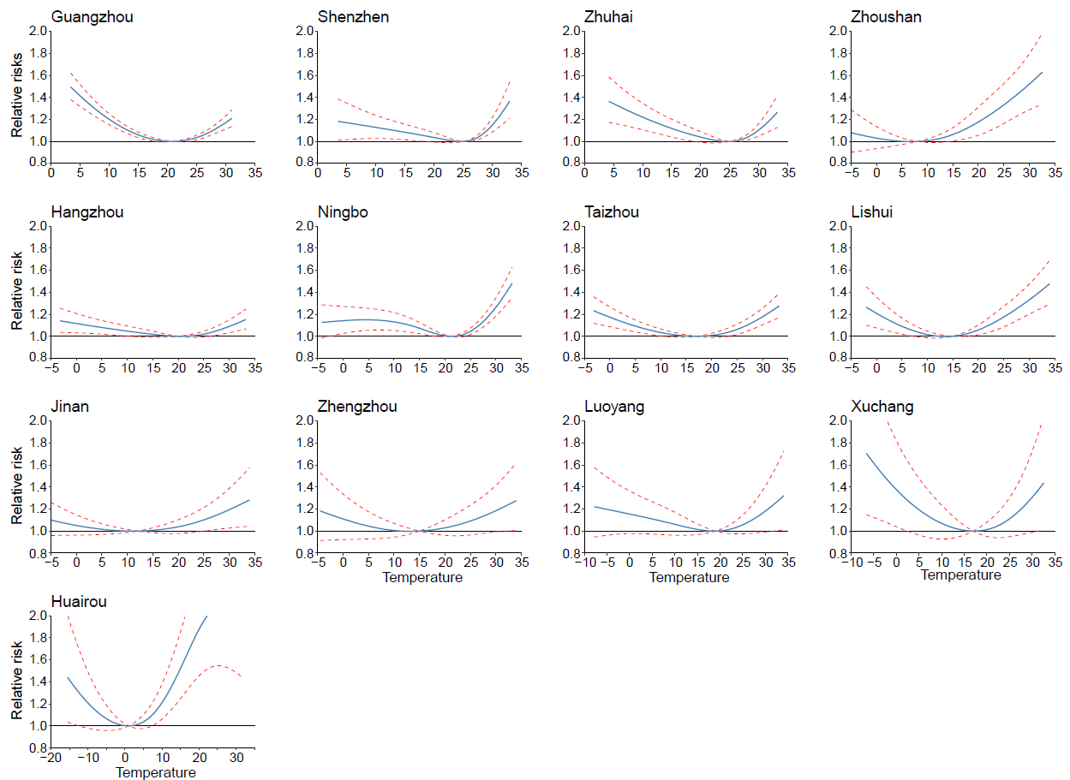
Figure S1. Exposure-response curve of daily mean temperature and ambulance dispatches in 13 cities in China.

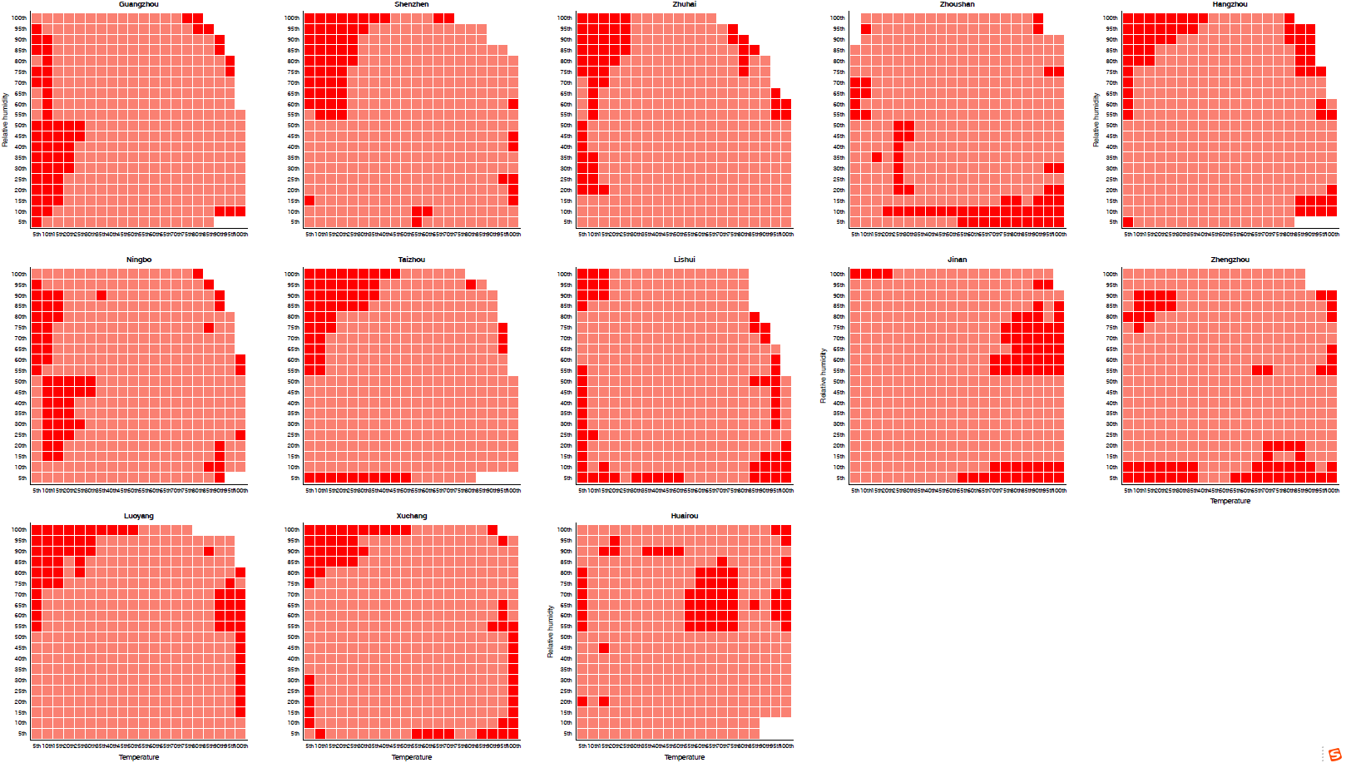
Figure S2. Relative risks during compound temperature-humidity events defined by temperature and humidity combinations in 13 cities in China
Table S1. Summary of daily ambulance dispatches and meteorology condition by city in China, during 2013-2019.
Province | City | Study period | Total ambulance dispatches | Daily mean ambulance dispatches | Daily mean temperature (℃) | Relative humidity (%)
Guangdong | Guangzhou | 2013-2017 | 713,537 | 388 (154, 938) | 23.4 (3.4, 31.1) | 81 (31, 100)
 | Shenzhen | 2015-2016 | 334,495 | 460 (249, 667) | 25.3 (3.5, 33.0) | 69 (22, 97)
 | Zhuhai | 2014-2017 | 125,656 | 84 (43, 162) | 25.0 (4.2, 33.2) | 81 (28, 100)
Zhejiang | Hangzhou | 2014-2018 | 367,903 | 203 (3, 342) | 19.7 (-3.2, 33.3) | 75 (29, 100)
 | Ningbo | 2014-2018 | 99,510 | 53 (16, 117) | 19.2 (-4.2, 33.2) | 77 (32, 100)
 | Taizhou | 2016-2018 | 108,338 | 98 (46, 154) | 20.0 (-3.2, 33.3) | 75 (31, 100)
 | Zhoushan | 2014-2018 | 107,804 | 48 (6, 126) | 18.1 (-5.6, 32.6) | 83 (35, 100)
 | Lishui | 2015-2018 | 32,394 | 22 (8, 41) | 21.0 (-2.0, 34.0) | 75 (33, 97)
Henan | Zhengzhou | 2017-2019 | 269,744 | 273 (0, 493) | 18.8 (-4.5, 34.0) | 59 (15, 100)
 | Luoyang | 2014-2016 | 52,788 | 49 (27, 80) | 16.6 (-7.8, 34.1) | 65 (15, 100)
 | Xuchang | 2017-2019 | 35,964 | 36 (10, 65) | 17.0 (-6.6, 32.6) | 72 (21, 99)
Shandong | Jinan | 2014-2017 | 192,271 | 124 (56, 241) | 17.1 (-12.4, 34.0) | 55 (13, 100)
Beijing | Huairou district | 2016-2018 | 17,377 | 16 (4, 54) | 14.7 (-15.5, 31.6) | 55 (7, 97)

Table S2. Summary of climate models.
Mode/Type | Historical | SSP126 | SSP245 | SSP460 | SSP585 | Resolution(lon*lat) | Period
CanESM5 | √ | √ | √ | √ | √ | 2.813x2.813 | 1979-2100
CMCC-CM2-SR5 | √ | √ | √ | —— | √ | 1.25x0.9375 | 1979-2100
EC | √ | √ | √ | √ | √ | 0.703x0.703 | 1979-2100
FGOALS-g3 | √ | √ | √ | √ | √ | 2x2.25 | 1979-2100
GFDL_CM4 | √ | —— | √ | —— | √ | 1.25x1 | 1979-2100
GFDL_ESM4 | √ | √ | √ | —— | √ | 1.25x1 | 1979-2100
MIROC | √ | √ | √ | √ | √ | 1.406x1.406 | 1979-2100
TaiESM1 | √ | —— | —— | —— | √ | 1.25x0.9375 | 1979-2100
IPSL-CM6A | √ | √ | √ | √ | √ | 2.5x1.259 | 1979-2100
INM-CM4-8 | √ | √ | √ | —— | √ | 2x1.5 | 1979-2100
INM-CM5-0 | √ | √ | √ | —— | √ | 2x1.5 | 1979-2100
ERA5 reanalysis | √ | —— | —— | —— | —— | 0.25X0.25 | 1979-2019

