Rapid determination of warfarin in biological samples: Experimental and theoretical studies of Pt-doped CdTe QDs as fluorescent probes
Meysam Safari, Hosna Ehzari, Mohsen Samimi
Department of Chemical Engineering, Faculty of Engineering, Kermanshah University of Technology, Kermanshah, Iran

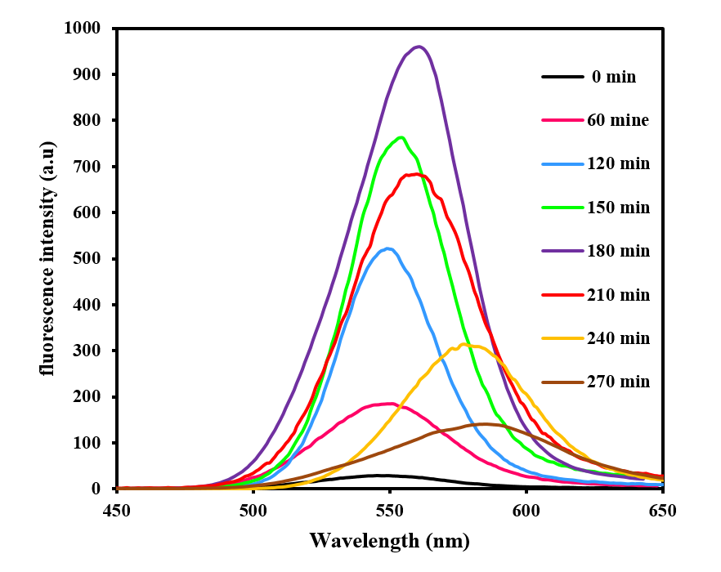

Fig. 1S. Fluorescence spectra of Pt:CdTe QDs (reaction time, 0, 60, 120, 150, 180, 210, 240 and 270 min; λ_{ex} = 330 nm).

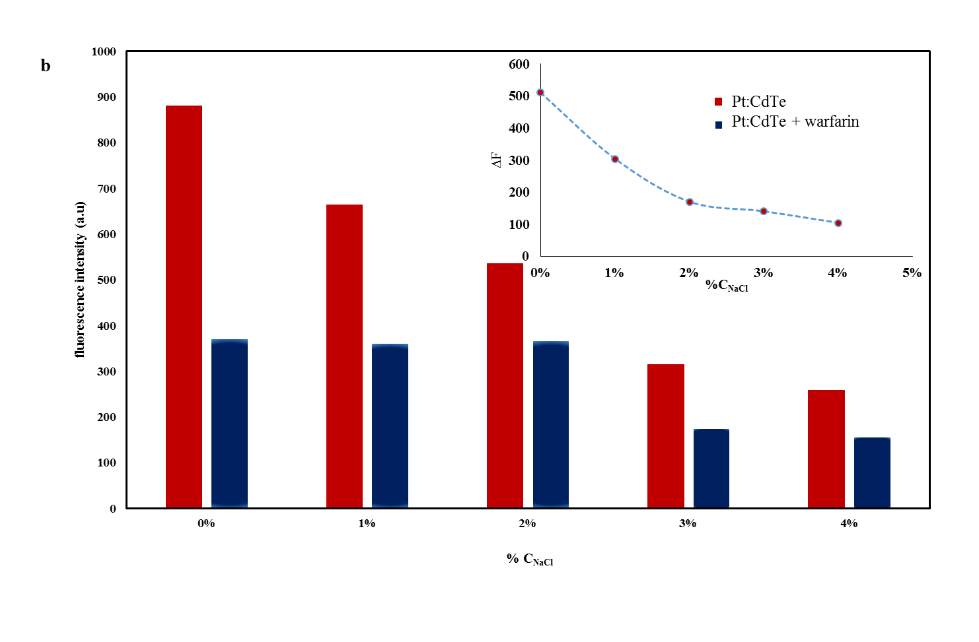

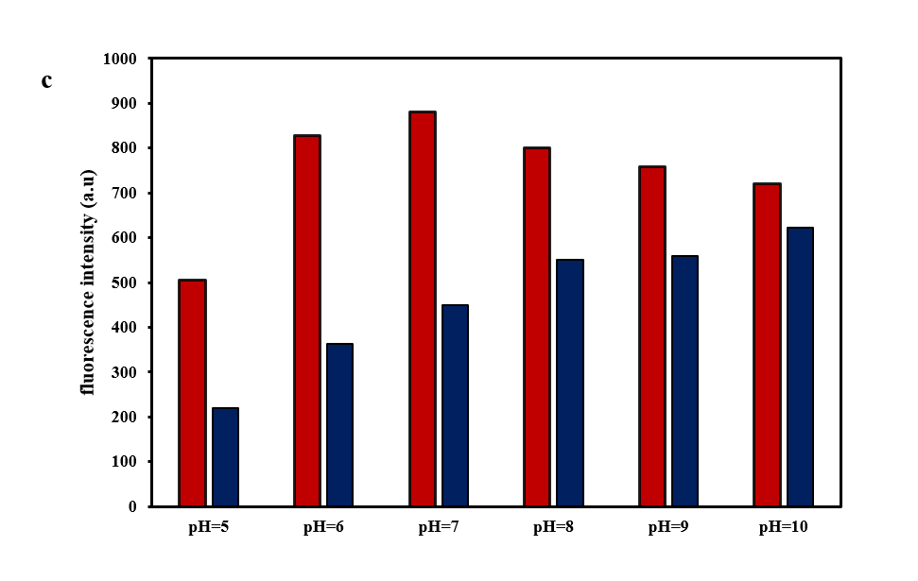
Fig. 2S. a) Effect of reaction time b) influence of ionic strength and c) Effect of pH on the fluorescence intensity of Pt:CdTe QDs after addition of warfarin drug (10 µM), in the mixture of reaction

Fig. 3S. Fluorescence spectra of Pt:CdTe QDs in 1 day and Fluorescence spectra of Pt:CdTe QDs after 3 months.

Email: m.safary85@gmail.com Tel: +98 38 305028; Fax: +98 38305022.

