Theoretical study of the binding mechanism between anticancerous drug mercaptopurine and gold nanoparticles using a cluster model

Duong Thi Huyen,¹ Thanh Q. Bui², Nguyen Thanh Si³, Pham Vu Nhat³*, Phan Tu Quy⁴, Nguyen Thi Ai Nhung²*
¹Department of Chemistry - Biology, Faculty of Basic Science, Tra Vinh University, Tra Vinh, Vietnam
²Department of Chemistry, University of Sciences, Hue University, Hue, Vietnam
³Department of Chemistry, College of Natural Sciences, Can Tho University, Can Tho, Vietnam
⁴Department of Natural Sciences & Technology, Tay Nguyen University, Buon Ma Thuot, Vietnam

*Corresponding authors: - Pham Vu Nhat (Email: nhat@ctu.edu.vn)
- Nguyen Thi Ai Nhung (E-mail: ntanhung@hueuni.edu.vn)

Cartesian coordinates of optimized geometries
Geometries | Cartesian coordinates
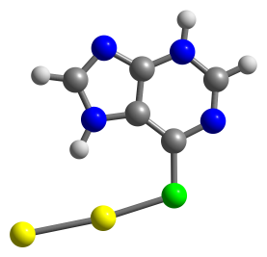  Au₂⋅MP | 16 -1.579184000 -1.994642000 -0.000006000  6 -2.805445000 -0.805940000 -0.000076000  6 -2.647519000 0.605818000 -0.000084000  7 -4.107719000 -1.264371000 -0.000062000  6 -3.754962000 1.467365000 -0.000103000  7 -1.574072000 1.466780000 -0.000048000  6 -5.114517000 -0.435924000 -0.000077000  7 -5.012306000 0.927722000 -0.000102000  7 -3.409430000 2.775801000 -0.000127000  6 -2.072785000 2.730555000 -0.000116000  1 -0.583596000 1.146354000 -0.000005000  1 -6.131747000 -0.832723000 -0.000075000  1 -5.832992000 1.529029000 -0.000117000  1 -1.427263000 3.603517000 -0.000123000  79 0.453146000 -0.874073000 0.000009000  79 2.538482000 0.592495000 0.000061000
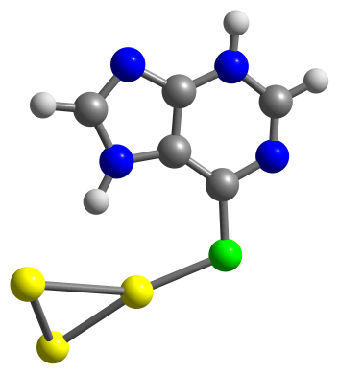  Au₃⋅MP | 16 -2.013918000 -2.042925000 -0.608154000  6 -3.303512000 -1.008549000 -0.165392000  6 -3.252758000 0.358771000 0.211874000  7 -4.556698000 -1.585104000 -0.188381000  6 -4.422312000 1.057550000 0.560080000  7 -2.266438000 1.311162000 0.341234000  6 -5.620546000 -0.905655000 0.136583000  7 -5.623706000 0.404858000 0.524335000  7 -4.193771000 2.349126000 0.886444000  6 -2.869493000 2.461746000 0.736704000  1 -1.250617000 1.181846000 0.137035000  1 -6.596577000 -1.393978000 0.106977000  1 -6.482304000 0.892831000 0.769266000  1 -2.303927000 3.373210000 0.905484000  79 -0.009912000 -0.973347000 -0.245613000  79 1.099171000 1.540273000 -0.447456000  79 2.482286000 -0.573390000 0.541009000
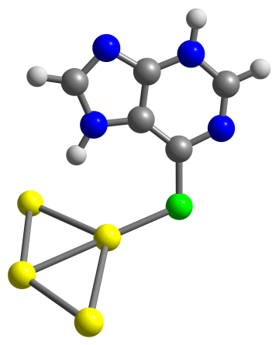  Au₄⋅MP | 16 1.959717000 -1.819072000 -1.317630000  6 3.383240000 -1.385922000 -0.479380000  6 3.586397000 -0.314704000 0.429194000  7 4.477402000 -2.194771000 -0.714026000  6 4.818216000 -0.139462000 1.081876000  7 2.821564000 0.724598000 0.910541000  6 5.609010000 -1.996732000 -0.098755000  7 5.842022000 -1.006933000 0.814909000  7 4.831549000 0.925799000 1.914419000  6 3.599349000 1.426555000 1.774917000  1 1.858648000 0.967513000 0.593080000  1 6.452825000 -2.657674000 -0.306656000  1 6.743700000 -0.897249000 1.273221000  1 3.231244000 2.310194000 2.287424000  79 0.165109000 -0.578308000 -0.555420000  79 0.112998000 2.305850000 -0.447465000  79 -2.192881000 -1.827487000 0.367080000  79 -1.900757000 0.792390000 0.389058000
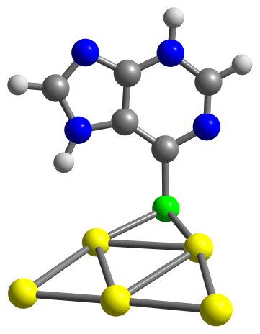  Au₅⋅MP | 16 1.982900000 -0.942544000 -1.504791000  6 3.256123000 -1.354371000 -0.375510000  6 4.014054000 -0.419377000 0.368350000  7 3.539927000 -2.683017000 -0.184907000  6 5.053936000 -0.837089000 1.210077000  7 4.013540000 0.947805000 0.513634000  6 4.505473000 -3.050433000 0.608367000  7 5.319207000 -2.185867000 1.313574000  7 5.665060000 0.189408000 1.843239000  6 5.005530000 1.265989000 1.405389000  1 3.309840000 1.563183000 0.094477000  1 4.715510000 -4.112378000 0.743620000  1 6.055669000 -2.522840000 1.926051000  1 5.210642000 2.287845000 1.705578000  79 -0.108390000 -1.729380000 -0.582714000  79 -2.541333000 -1.939265000 0.489617000  79 0.944609000 1.074028000 -0.756924000  79 -1.593197000 0.511314000 0.370464000  79 -0.648434000 2.973914000 0.174597000
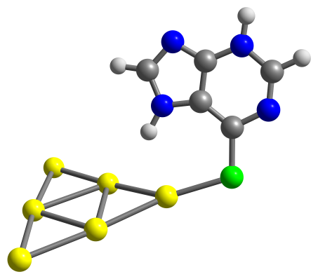  Au₆⋅MP | 16 4.357690000 -1.457617000 -1.157336000  6 5.213428000 -0.573410000 0.028932000  6 4.698013000 0.381373000 0.945007000  7 6.573974000 -0.795047000 0.096360000  6 5.533195000 1.042569000 1.860668000  7 3.455958000 0.911795000 1.211758000  6 7.320601000 -0.165327000 0.960863000  7 6.868932000 0.753581000 1.865860000  7 4.870587000 1.921455000 2.647287000  6 3.609425000 1.811556000 2.218836000  1 2.583488000 0.653939000 0.711975000  1 8.393093000 -0.368141000 0.987816000  1 7.494383000 1.216427000 2.521951000  1 2.770221000 2.373674000 2.617619000  79 2.047304000 -1.027081000 -0.855588000  79 0.232607000 0.972584000 -0.654722000  79 -0.480255000 -1.573888000 -0.120921000  79 -1.510443000 2.954864000 -0.235462000  79 -2.387794000 0.509683000 0.308251000  79 -2.984942000 -2.027012000 0.733674000
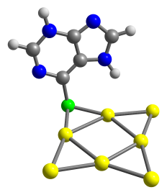  Au₇⋅MP | 16 2.394076000 1.765259000 -1.266383000  6 3.356616000 2.290937000 0.101310000  6 3.990019000 1.443212000 1.039860000  7 3.538365000 3.639147000 0.252656000  6 4.801790000 1.976306000 2.055817000  7 4.040901000 0.087955000 1.270751000  6 4.294632000 4.110327000 1.204913000  7 4.964011000 3.337817000 2.127011000  7 5.327302000 1.029726000 2.863775000  6 4.839698000 -0.109120000 2.361057000  1 3.505048000 -0.612661000 0.738177000  1 4.429405000 5.188457000 1.301437000  1 5.541099000 3.750891000 2.854755000  1 5.038759000 -1.098690000 2.759189000  79 0.107760000 2.085175000 -0.638250000  79 -2.319600000 2.999122000 -0.083284000  79 1.662657000 -0.443136000 -0.834605000  79 -1.883609000 0.383673000 0.168298000  79 1.923651000 -3.069084000 -0.469195000  79 -0.428615000 -1.916971000 0.079088000  79 -2.981360000 -1.942636000 0.846701000
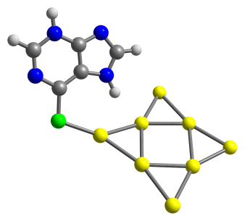  Au₈⋅MP | 16 4.976854000 1.938842000 -0.534854000  6 5.788278000 0.780488000 0.427321000  6 5.255480000 -0.387502000 1.032773000  7 7.136403000 0.998943000 0.622995000  6 6.067977000 -1.253528000 1.785104000  7 4.020398000 -0.993250000 1.083778000  6 7.860082000 0.177058000 1.331216000  7 7.392776000 -0.954562000 1.937507000  7 5.398513000 -2.322036000 2.273741000  6 4.155741000 -2.125998000 1.821699000  1 3.157639000 -0.643974000 0.622722000  1 8.923452000 0.383369000 1.467817000  1 7.999650000 -1.565221000 2.480329000  1 3.315480000 -2.789422000 2.005172000  79 0.064337000 1.891966000 -0.226064000  79 -2.430537000 0.703195000 0.258161000  79 -1.469801000 -1.888038000 -0.029435000  79 0.931527000 -0.616936000 -0.586937000  79 -3.989308000 -1.416940000 0.609545000  79 2.681679000 1.432693000 -0.532337000  79 -2.128613000 3.332861000 0.203318000  79 0.702389000 -3.269852000 -0.681481000
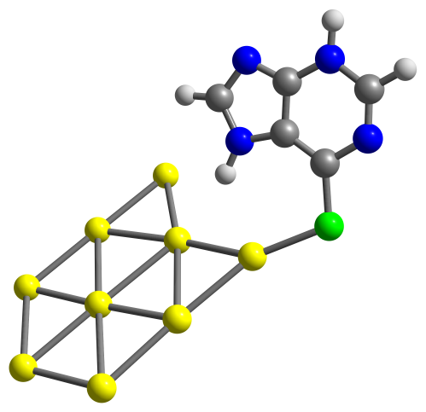  Au₉⋅MP | 16 5.148627000 -2.349580000 -0.593149000  6 6.077675000 -1.307544000 0.397034000  6 5.671554000 -0.105925000 1.031622000  7 7.393330000 -1.675000000 0.583526000  6 6.569504000 0.644347000 1.811353000  7 4.510733000 0.631351000 1.094130000  6 8.199138000 -0.956666000 1.315900000  7 7.853197000 0.198707000 1.956752000  7 6.018285000 1.765791000 2.327487000  6 4.765009000 1.721372000 1.864502000  1 3.617623000 0.398027000 0.622580000  1 9.234031000 -1.279391000 1.444973000  1 8.520354000 0.724300000 2.517800000  1 4.001596000 2.469328000 2.059687000  79 2.909781000 -1.654571000 -0.534097000  79 1.225407000 0.458788000 -0.454313000  79 0.280533000 -2.102059000 -0.247622000  79 -0.770424000 2.457887000 -0.101409000  79 1.783674000 3.067142000 -0.564063000  79 -2.321997000 -2.795768000 0.134456000  79 -1.578954000 -0.157408000 0.019326000  79 -3.363858000 1.866985000 0.320257000  79 -4.187931000 -0.775661000 0.447587000
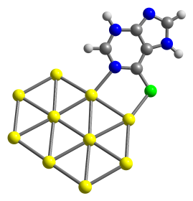  Au₁₀⋅MP | 16 -4.988413000 0.286684000 -0.555100000  6 -4.832235000 -1.314120000 -0.024996000  6 -5.988638000 -2.119274000 0.151675000  7 -3.633054000 -1.961090000 0.267639000  6 -5.942381000 -3.433752000 0.613817000  7 -7.332326000 -1.891623000 -0.037529000  6 -3.616148000 -3.203030000 0.714341000  7 -4.715696000 -3.972179000 0.909929000  7 -7.166412000 -4.006741000 0.714319000  6 -7.988223000 -3.039704000 0.309644000  1 -7.731261000 -1.016396000 -0.367080000  1 -2.642936000 -3.653733000 0.927761000  1 -4.632338000 -4.922334000 1.265511000  1 -9.068765000 -3.129295000 0.254414000  79 -1.485014000 -1.079482000 -0.008537000  79 -2.888844000 1.347101000 -0.251574000  79 -0.171183000 1.396082000 0.020504000  79 1.197807000 -0.937987000 -0.028830000  79 -0.071650000 -3.437126000 -0.201351000  79 -1.511660000 3.704646000 0.047102000  79 2.599100000 1.489755000 0.095624000  79 1.262920000 3.805447000 0.095625000  79 3.931986000 -0.878193000 0.068949000  79 2.630565000 -3.263211000 -0.049745000
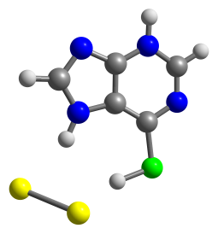  Au₂⋅MPH | 16 1.796753000 -2.067091000 -0.949080000  6 2.926280000 -0.833129000 -0.477155000  6 2.642445000 0.439896000 0.040135000  7 4.230224000 -1.174370000 -0.661000000  6 3.701737000 1.316183000 0.367143000  7 1.515773000 1.165031000 0.351575000  6 5.189553000 -0.330136000 -0.349624000  7 4.980529000 0.905794000 0.165085000  7 3.266293000 2.500788000 0.850412000  6 1.937174000 2.367308000 0.823442000  1 0.529605000 0.868065000 0.245597000  1 6.228899000 -0.617717000 -0.501890000  1 5.766896000 1.516644000 0.391067000  1 1.233803000 3.131106000 1.141285000  1 0.578908000 -1.441717000 -0.497484000  79 -1.103040000 -1.183728000 0.491600000  79 -1.927581000 1.032787000 -0.402479000
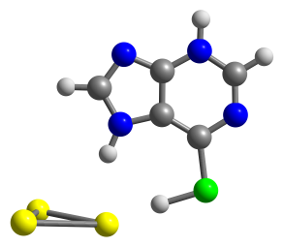  Au₃⋅MPH | 16 3.152881000 -2.197320000 -0.078403000  6 3.991472000 -0.682673000 -0.015773000  6 3.435422000 0.608282000 0.011608000  7 5.351385000 -0.785252000 0.008518000  6 4.275344000 1.741073000 0.066461000  7 2.169629000 1.145629000 -0.001205000  6 6.102505000 0.292869000 0.058359000  7 5.622055000 1.560383000 0.090417000  7 3.582496000 2.902090000 0.087543000  6 2.309921000 2.495639000 0.045151000  1 1.283552000 0.604384000 -0.036916000  1 7.186857000 0.191616000 0.077345000  1 6.256178000 2.359116000 0.131283000  1 1.449717000 3.158285000 0.046591000  1 1.697791000 -1.692722000 -0.075021000  79 -0.089854000 -1.213026000 -0.075886000  79 -1.896630000 0.500062000 -1.256248000  79 -1.888037000 0.333791000 1.317189000
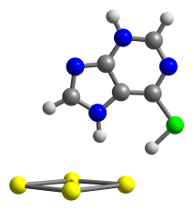  Au₄⋅MPH | 16 4.198863000 -1.425126000 -0.012902000  6 4.416865000 0.297048000 -0.014360000  6 3.417889000 1.281922000 -0.022314000  7 5.715424000 0.705730000 -0.007754000  6 3.771783000 2.648524000 -0.023002000  7 2.044152000 1.302647000 -0.030771000  6 6.009027000 1.988286000 -0.008649000  7 5.088390000 2.983892000 -0.016001000  7 2.693449000 3.464022000 -0.030935000  6 1.666906000 2.607888000 -0.035049000  1 1.414974000 0.481487000 -0.028371000  1 7.052577000 2.300080000 -0.002931000  1 5.377245000 3.963165000 -0.016267000  1 0.618458000 2.893154000 -0.040892000  1 2.746561000 -1.475201000 -0.010174000  79 0.800359000 -1.911051000 0.015415000  79 -0.980034000 -0.282859000 1.321225000  79 -2.717294000 1.298283000 -0.006699000  79 -1.012858000 -0.338508000 -1.310656000
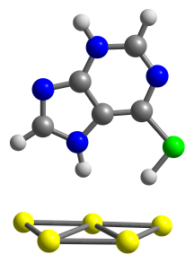  Au₅⋅MPH | 16 2.283192000 -1.207491000 -1.787019000  6 3.778885000 -0.391456000 -1.449492000  6 4.119678000 0.303262000 -0.279675000  7 4.697794000 -0.450711000 -2.450333000  6 5.396058000 0.892976000 -0.157816000  7 3.508303000 0.605059000 0.914567000  6 5.874709000 0.119496000 -2.305629000  7 6.268862000 0.786250000 -1.193190000  7 5.569636000 1.514961000 1.030074000  6 4.402037000 1.320252000 1.648315000  1 2.539062000 0.377244000 1.181969000  1 6.601173000 0.065734000 -3.115458000  1 7.198934000 1.203346000 -1.136576000  1 4.160070000 1.687127000 2.641184000  1 1.639487000 -1.014976000 -0.549975000  79 -1.927477000 2.396600000 -0.738657000  79 -0.060616000 1.547453000 0.988754000  79 0.399030000 -1.109412000 1.228684000  79 -1.127662000 -2.792938000 -0.225547000  79 -1.592264000 -0.214547000 -0.535144000
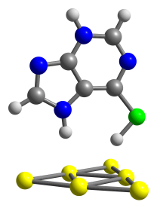  Au₆⋅MPH | 16 4.128878000 -0.000019000 -0.271201000  6 4.032560000 -0.000540000 1.463923000  6 2.876937000 -0.000621000 2.258690000  7 5.240996000 -0.000842000 2.088076000  6 2.993189000 -0.001035000 3.666796000  7 1.518618000 -0.000341000 2.048352000  6 5.310837000 -0.001234000 3.401733000  7 4.232564000 -0.001414000 4.222708000  7 1.792894000 -0.001047000 4.287726000  6 0.926203000 -0.000637000 3.270418000  1 1.024610000 -0.000114000 1.143724000  1 6.285001000 -0.001472000 3.889045000  1 4.348189000 -0.001624000 5.236870000  1 -0.155999000 -0.000532000 3.370564000  1 2.746649000 0.000140000 -0.572209000  79 0.683596000 2.637933000 -1.261703000  79 -1.241118000 1.411911000 0.078409000  79 0.771522000 0.000764000 -1.343776000  79 -3.032862000 -0.001051000 1.414471000  79 0.684601000 -2.636533000 -1.263428000  79 -1.240984000 -1.412343000 0.076962000
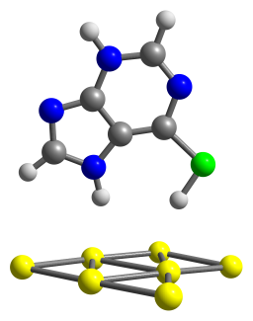  Au₇⋅MPH | 16 1.713875000 3.124776000 0.574626000  6 0.306256000 4.121013000 0.344725000  6 -0.974414000 3.725158000 -0.068202000  7 0.524234000 5.438493000 0.598636000  6 -1.999786000 4.693122000 -0.179184000  7 -1.598964000 2.554311000 -0.432288000  6 -0.452573000 6.310322000 0.476902000  7 -1.715329000 5.990238000 0.104721000  7 -3.176256000 4.162630000 -0.578812000  6 -2.888923000 2.866337000 -0.723181000  1 -1.202160000 1.607251000 -0.512518000  1 -0.264312000 7.362581000 0.685039000  1 -2.437838000 6.708968000 0.036670000  1 -3.591830000 2.099282000 -1.038721000  1 1.150157000 1.879671000 0.373585000  79 -3.410032000 -0.978517000 -0.834117000  79 1.707722000 -0.310896000 -2.097434000  79 3.640603000 -0.251737000 -0.204501000  79 -0.880128000 -0.657661000 -1.618091000  79 -1.597984000 -0.828306000 1.096812000  79 0.179286000 -0.641224000 3.037642000  79 1.078822000 -0.470513000 0.547660000
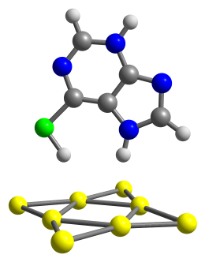  Au₈⋅MPH | 16 -0.624432000 0.109517000 -2.742459000  6 -2.221245000 0.162910000 -3.428663000  6 -3.445223000 0.035524000 -2.755522000  7 -2.240513000 0.351674000 -4.774716000  6 -4.653017000 0.111846000 -3.485484000  7 -3.863247000 -0.160694000 -1.458947000  6 -3.384858000 0.416443000 -5.419530000  7 -4.599122000 0.305567000 -4.828992000  7 -5.744520000 -0.026297000 -2.701167000  6 -5.221428000 -0.189966000 -1.483136000  1 -3.290060000 -0.280164000 -0.605739000  1 -3.387334000 0.568804000 -6.497839000  1 -5.455566000 0.369141000 -5.381167000  1 -5.800806000 -0.335554000 -0.576224000  1 -0.976624000 -0.053542000 -1.425726000  79 1.378636000 1.675584000 0.070192000  79 1.972046000 -1.031901000 -0.226578000  79 -0.565945000 -1.697777000 0.715544000  79 -1.154032000 1.004069000 1.027425000  79 1.168376000 -3.539048000 -0.026251000  79 -0.393154000 3.512447000 0.744140000  79 3.713407000 0.853557000 -0.838724000  79 -2.858731000 -0.884946000 1.751299000
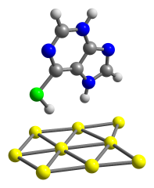  Au₉⋅MPH | 16 1.991368000 -1.209329000 2.892817000  6 0.698383000 -1.848222000 3.863774000  6 -0.602421000 -2.178517000 3.455409000  7 1.033762000 -2.033071000 5.168124000  6 -1.524945000 -2.670643000 4.406644000  7 -1.329372000 -2.154467000 2.286496000  6 0.149228000 -2.498964000 6.022244000  7 -1.124822000 -2.823913000 5.695320000  7 -2.736639000 -2.933435000 3.869876000  6 -2.574928000 -2.608486000 2.584748000  1 -1.022616000 -1.882548000 1.341220000  1 0.430101000 -2.642493000 7.064701000  1 -1.772169000 -3.174586000 6.402513000  1 -3.342644000 -2.685051000 1.819459000  1 1.328080000 -1.111482000 1.694247000  79 2.488900000 2.285936000 0.356551000  79 3.664889000 -0.086433000 -0.459268000  79 -1.976718000 0.437092000 -0.453190000  79 2.059214000 -2.257470000 -1.101906000  79 -0.616838000 -1.933166000 -1.132284000  79 -0.198360000 2.493982000 0.275996000  79 -2.819427000 2.860001000 0.250401000  79 -3.258997000 -1.784578000 -1.181561000  79 0.970564000 0.152847000 -0.424902000
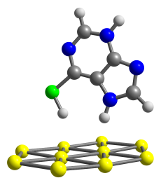  Au₁₀⋅MPH | 16 1.387678000 -0.435542000 3.296482000  6 0.420066000 0.700064000 4.191941000  6 -0.452232000 1.673618000 3.684340000  7 0.553752000 0.592512000 5.539882000  6 -1.165205000 2.505107000 4.578352000  7 -0.871709000 2.100001000 2.445829000  6 -0.124167000 1.385945000 6.340283000  7 -0.983648000 2.342918000 5.914397000  7 -1.969431000 3.384945000 3.941926000  6 -1.761630000 3.105836000 2.652577000  1 -0.590870000 1.757644000 1.517237000  1 -0.008405000 1.289519000 7.418778000  1 -1.484756000 2.929339000 6.583631000  1 -2.242872000 3.610172000 1.818984000  1 1.029053000 -0.069465000 2.022904000  79 -0.090693000 2.181170000 -0.978064000  79 0.149760000 -2.497274000 0.024908000  79 2.853117000 -2.327529000 0.122163000  79 4.107638000 0.081262000 -0.311276000  79 2.613560000 2.336014000 -0.804940000  79 1.406590000 -0.077989000 -0.428995000  79 -1.348873000 -0.230759000 -0.467021000  79 -2.801101000 2.027775000 -0.953844000  79 -2.554973000 -2.622481000 0.061804000  79 -4.050325000 -0.360247000 -0.387323000
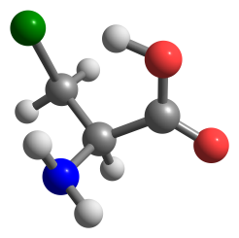  Cys(−H⁺)_1 | 16 -2.013313000 -0.477680000 -0.139367000  1 -0.312572000 -1.259176000 -0.476220000  6 -0.925028000 0.530475000 0.971059000  1 -0.775309000 0.002605000 1.924220000  1 -1.422863000 1.485239000 1.194207000  6 0.445248000 0.857060000 0.360251000  1 1.011566000 1.468274000 1.081093000  7 0.255805000 1.652954000 -0.868383000  1 -0.397949000 1.123428000 -1.459172000  6 1.324944000 -0.378211000 0.094032000  8 0.728793000 -1.443382000 -0.452714000  8 2.534977000 -0.371982000 0.311852000  1 1.138350000 1.718795000 -1.380725000
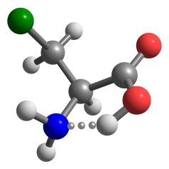  Cys(−H⁺)_2 | 16 -6.907006000 -1.745705000 0.563137000  6 -7.754730000 -1.084551000 -0.940283000  1 -8.712413000 -1.617100000 -1.005263000  1 -7.166550000 -1.321583000 -1.834373000  6 -8.046663000 0.420307000 -0.894723000  1 -8.552498000 0.681482000 -1.839560000  7 -6.885418000 1.309957000 -0.735952000  1 -6.556430000 1.667229000 -1.631890000  1 -7.822133000 2.091873000 0.454728000  6 -9.064254000 0.766871000 0.215272000  8 -10.093787000 0.144856000 0.421695000  8 -8.712238000 1.859373000 0.904930000  1 -6.105129000 0.804734000 -0.292402000
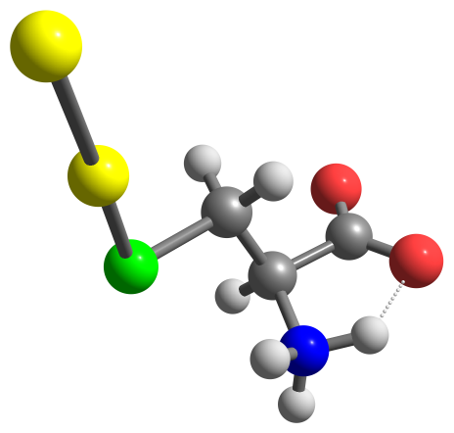  Au₂.Cys(-H⁺) | 16 1.774187000 -1.410665000 -0.212657000  6 2.909166000 0.000065000 -0.612628000  1 2.499303000 0.923573000 -0.183728000  1 2.993399000 0.132877000 -1.696539000  6 4.309030000 -0.257720000 -0.053975000  1 4.785145000 -1.106106000 -0.557731000  7 4.216374000 -0.542343000 1.416402000  1 4.865590000 -1.270903000 1.724420000  1 4.531961000 0.398339000 1.808155000  6 5.185071000 1.038037000 -0.173898000  8 5.582610000 1.342781000 -1.316385000  8 5.352791000 1.649380000 0.931109000  1 3.250185000 -0.830925000 1.659894000  79 -0.345066000 -0.488160000 -0.086272000  79 -2.727466000 0.481838000 0.071822000
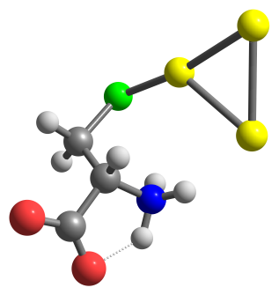  Au₃.Cys(-H⁺) | 16 2.040175000 -2.207877000 -0.808705000  6 3.359330000 -1.385599000 0.196265000  1 4.298245000 -1.594483000 -0.339200000  1 3.429425000 -1.845087000 1.187812000  6 3.177996000 0.117321000 0.390672000  1 2.335435000 0.297699000 1.071812000  7 2.877019000 0.818825000 -0.899701000  1 1.965975000 1.321331000 -0.857769000  1 3.712378000 1.478177000 -0.962521000  6 4.471924000 0.800171000 0.954364000  8 4.871592000 0.402765000 2.068726000  8 4.973358000 1.688898000 0.191660000  1 2.813504000 0.148390000 -1.679975000  79 -0.497926000 1.601013000 -0.329132000  79 -2.319671000 -0.278792000 0.476623000  79 0.081495000 -1.121417000 -0.229945000
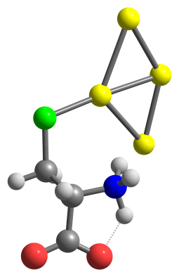  Au₄.Cys(-H⁺) | 16 1.671999000 2.540002000 0.696888000  6 3.326720000 1.720639000 0.703031000  1 3.285202000 0.812022000 1.318761000  1 4.017449000 2.422618000 1.187612000  6 3.910773000 1.412270000 -0.670109000  1 3.933463000 2.323585000 -1.279685000  7 3.134637000 0.362605000 -1.413909000  1 2.787233000 0.681563000 -2.321463000  1 3.915969000 -0.369161000 -1.531890000  6 5.369396000 0.831638000 -0.560247000  8 6.222835000 1.555652000 -0.010727000  8 5.504840000 -0.336754000 -1.054598000  1 2.325119000 -0.015965000 -0.875544000  79 -2.649849000 1.204648000 -0.210556000  79 0.141550000 0.857651000 0.287534000  79 0.993123000 -1.932741000 0.274093000  79 -1.502820000 -1.174766000 -0.174667000
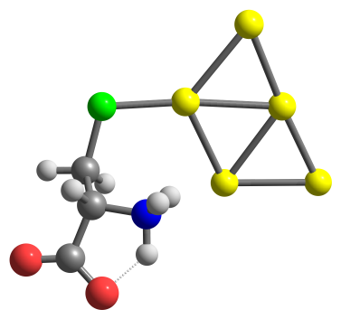  Au₅.Cys(-H⁺) | 16 -3.062860000 1.982538000 -0.677213000  6 -4.156580000 0.497791000 -0.626740000  1 -3.712071000 -0.306962000 -1.228883000  1 -5.099148000 0.794401000 -1.104512000  6 -4.511460000 -0.010620000 0.763622000  1 -4.904763000 0.811508000 1.374070000  7 -3.339593000 -0.613846000 1.483553000  1 -3.096386000 -0.129944000 2.351143000  1 -3.749587000 -1.591456000 1.675285000  6 -5.585956000 -1.160655000 0.712088000  8 -6.670587000 -0.893229000 0.158592000  8 -5.209769000 -2.250530000 1.258139000  1 -2.479575000 -0.673490000 0.892814000  79 1.410953000 2.708824000 0.245763000  79 -0.884234000 1.250597000 -0.286957000  79 -0.569616000 -1.526416000 -0.467506000  79 1.937524000 -2.508514000 0.103387000  79 1.598933000 0.111752000 0.152945000
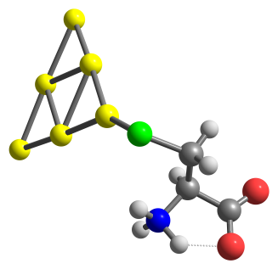  Au₆.Cys(-H⁺) | 16 4.495227000 0.921597000 1.426109000  6 5.447064000 1.000522000 -0.153818000  1 6.500341000 1.117751000 0.142950000  1 5.161302000 1.882261000 -0.736445000  6 5.289556000 -0.232650000 -1.047381000  1 4.292779000 -0.247374000 -1.501401000  7 5.480253000 -1.480222000 -0.238428000  1 4.819942000 -2.221169000 -0.488023000  1 6.463368000 -1.754802000 -0.551595000  6 6.416092000 -0.265720000 -2.135937000  8 6.327827000 0.567571000 -3.060603000  8 7.322456000 -1.134691000 -1.916216000  1 5.373564000 -1.269129000 0.771047000  79 2.270749000 0.536529000 0.802215000  79 0.254773000 -1.200535000 0.347821000  79 -0.178213000 1.476727000 0.176530000  79 -1.822739000 -2.863261000 -0.086759000  79 -2.663680000 2.331715000 -0.428724000  79 -2.354754000 -0.285826000 -0.291436000
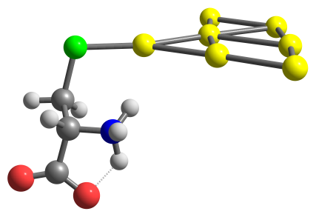  Au₇.Cys(-H⁺) | 16 -4.367583000 1.699243000 1.367348000  6 -5.296031000 1.718096000 -0.229028000  1 -4.670529000 2.166130000 -1.012416000  1 -6.167688000 2.367647000 -0.083709000  6 -5.826299000 0.359958000 -0.684036000  1 -6.490895000 -0.065495000 0.075713000  7 -4.715889000 -0.608590000 -0.965626000  1 -4.905811000 -1.544575000 -0.598027000  1 -4.768005000 -0.627292000 -2.037186000  6 -6.584921000 0.511543000 -2.054598000  8 -7.661757000 1.139290000 -2.032029000  8 -5.976901000 -0.014848000 -3.043339000  1 -3.797189000 -0.295939000 -0.582780000  79 0.459587000 -3.715106000 0.027580000  79 3.041262000 0.875306000 -0.471705000  79 1.763330000 3.244207000 -0.111823000  79 1.907572000 -1.496437000 -0.265932000  79 -0.832498000 -1.388881000 0.412786000  79 -2.265917000 0.853075000 0.828018000  79 0.344960000 1.001743000 0.182712000
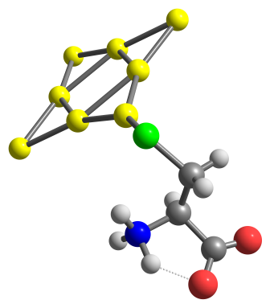  Au₈.Cys(-H⁺) | 16 5.251231000 0.538286000 1.333822000  6 6.098428000 0.895212000 -0.265420000  1 7.167573000 0.979784000 -0.017582000  1 5.770906000 1.856573000 -0.673970000  6 5.894331000 -0.171676000 -1.342412000  1 4.862105000 -0.147279000 -1.708795000  7 6.186962000 -1.531694000 -0.782307000  1 5.523808000 -2.244002000 -1.098650000  1 7.143244000 -1.709160000 -1.226545000  6 6.922978000 0.026414000 -2.507900000  8 6.741346000 1.007689000 -3.256730000  8 7.859994000 -0.838037000 -2.522713000  1 6.172960000 -1.506127000 0.252650000  79 0.850843000 -1.243515000 0.344865000  79 0.620813000 1.447827000 0.306987000  79 -2.115426000 1.274058000 -0.181660000  79 -1.887262000 -1.490470000 -0.123220000  79 -0.897646000 3.619936000 -0.007985000  79 -0.339147000 -3.624859000 0.138244000  79 2.995746000 0.303486000 0.791881000  79 -4.218733000 -0.298834000 -0.515469000
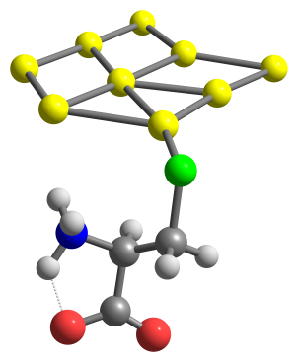  Au₉.Cys(-H⁺) | 16 -4.643702000 2.114200000 -0.982906000  6 -5.395089000 2.220584000 0.701119000  1 -6.475056000 2.360866000 0.541702000  1 -5.019047000 3.105933000 1.225246000  6 -5.138669000 1.014851000 1.590270000  1 -4.060928000 0.930557000 1.788764000  7 -5.577335000 -0.277044000 0.965829000  1 -4.780853000 -0.879325000 0.683757000  1 -6.156137000 -0.673881000 1.780281000  6 -5.895515000 1.082622000 2.966331000  8 -5.740849000 2.118824000 3.642106000  8 -6.576729000 0.038906000 3.235002000  1 -6.156565000 -0.129187000 0.131574000  79 -0.535059000 -3.264540000 -0.102907000  79 -2.791160000 -1.700025000 -0.608919000  79 2.276807000 0.730695000 0.120734000  79 -2.526596000 1.187515000 -0.647650000  79 -0.015404000 2.165633000 -0.309091000  79 1.814277000 -2.068319000 0.202968000  79 4.232411000 -1.006594000 0.558578000  79 2.296444000 3.444520000 -0.018291000  79 -0.408612000 -0.498671000 -0.255534000
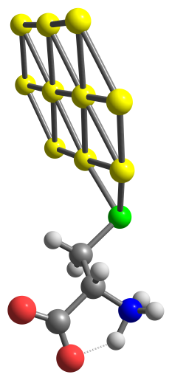  Au₁₀.Cys(-H⁺) | 16 -3.071418000 2.639478000 -0.825754000  6 -3.624928000 3.399312000 0.771035000  1 -3.294431000 4.448038000 0.749812000  1 -3.137137000 2.900672000 1.613269000  6 -5.126673000 3.302455000 0.972980000  1 -5.437524000 2.250405000 0.981007000  7 -5.904622000 4.027903000 -0.090069000  1 -6.609349000 3.442525000 -0.545300000  1 -6.375466000 4.769064000 0.562297000  6 -5.568875000 3.995629000 2.317987000  8 -5.101594000 3.535886000 3.374483000  8 -6.370560000 4.974209000 2.142041000  1 -5.315895000 4.447175000 -0.817561000  79 1.561337000 -2.320509000 0.277854000  79 -0.797733000 1.837807000 -0.435373000  79 -3.294492000 0.254320000 -0.528007000  79 -3.068335000 -2.392687000 -0.228413000  79 -0.667636000 -3.839070000 0.249691000  79 -0.797288000 -0.985572000 -0.128625000  79 1.504959000 0.459834000 -0.043009000  79 3.878140000 -0.896665000 0.345546000  79 1.580526000 3.211339000 -0.312298000  79 3.877039000 1.823734000 0.078518000

