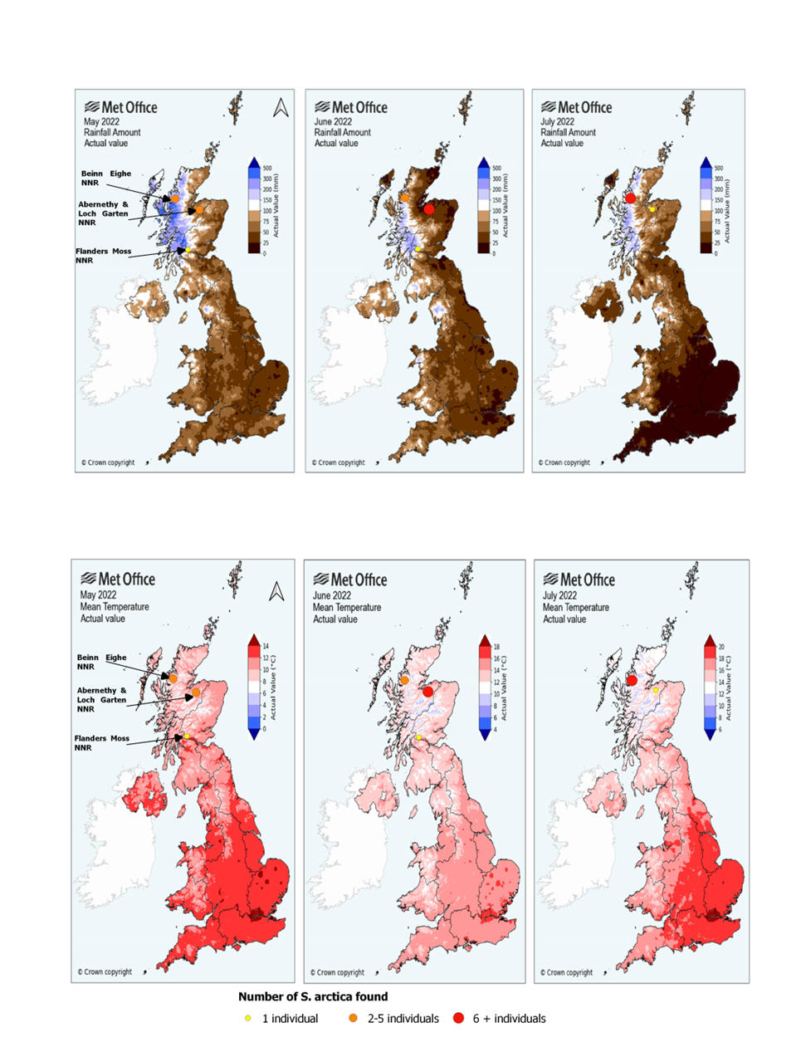
Appendix A
Fig.7 Maps A, B and C show the spatial variation of larvae of S. arctica in the 3 survey locations relative to the mean precipitations (mm) across in the UK. Maps D, E and F show the spatial variation of larvae of S. arctica in the 3 survey locations relative to the mean temperatures (C) across the UK. Base maps generated by MetOffice (2022); Crown copyrights, 2022 ©.
A
B
C
D
E
F

Appendix B
Table 4 Table showing the numbers of S. arctica found in the vicinity of different woodland types, compared to the numbers of L. quadrimaculata and A. juncea. Numbers are inclusive of larvae and exuviae found in individual bog pools.
 | Coniferous woodlands | Broadleaf woodlands | Mixed woodlands
S. arctica | 20 | 1 | 2
L. Quadrimaculata | 62 | 49 | 39
A. Juncea | 49 | 34 | 15

