Electronic Supplementary Material

Revealing enhanced X-Ray radiation shielding of 2D layered materials and their laminar heterostructures
Le Yu,ª Md J. Nine,ª Tran T. Tung,ª Ana C. Pereira,^{a,b} Kamrul Hassan,ª Diana Tran,ª Alexandre Santos,^{c,d} and Dusan Losic ^{a*}

ª School of Chemical Engineering and Advanced Materials, The University of Adelaide, Adelaide, SA 5005, Australia address, Department, ^{b}University, City and Postcode, Countryb² School of Applied Sciences, University of Campinas (UNICAMP), Limeira, 13484-350, Brazil Department, University, City and Postcode, Country
^{c} School of Physical Sciences, University of Adelaide, Adelaide, South Australia 5005, Australia.
^{d} Australian Bragg Centre for Proton Therapy and Research, Adelaide, South Australia 5000, Australia

Figures and Tables

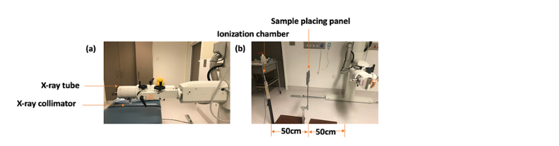
Figures and Tables

Figure S1. Phot of (a) X-ray unit, and (b) experimental set-up of X-ray transmission.

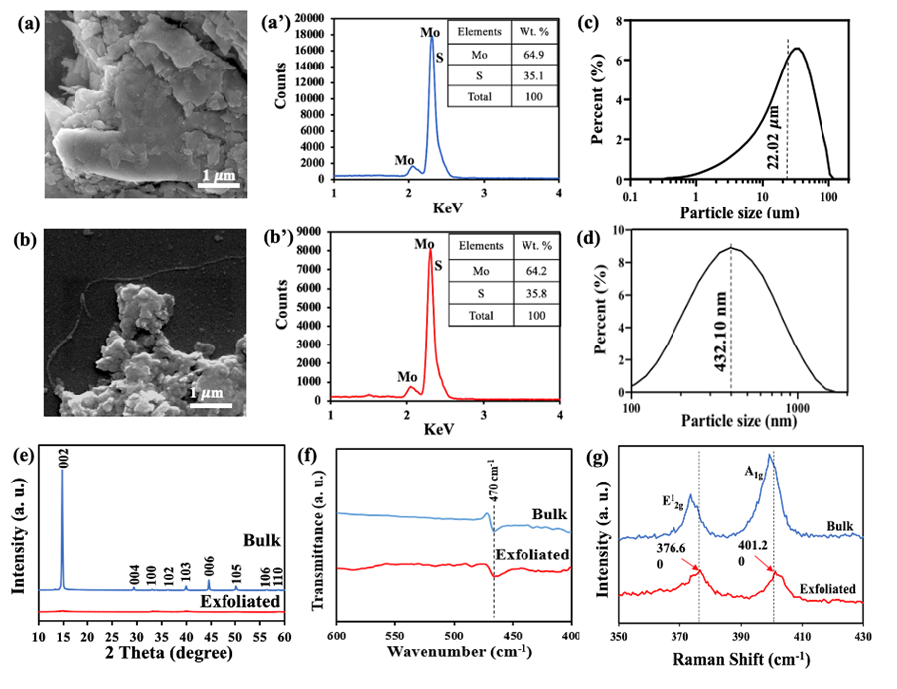

Figure S2. (a, b) SEM images (scale bar = 1 μm), (a’, b’) EDX spectrum, (c, d) particle size distribution (PSD), (e) XRD patterns, (f) FTIR analysis and (g) Raman analysis of bulk and exfoliated MoS2, respectively.

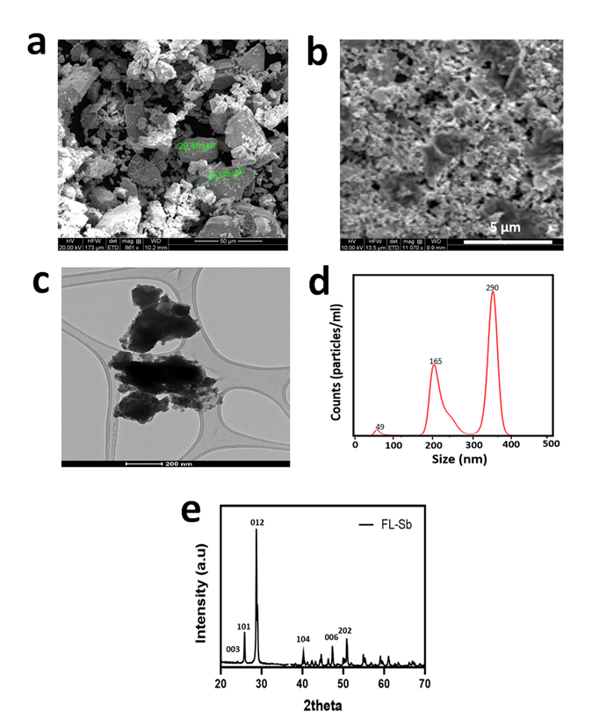

Figure S3. Structural and chemical properties of bulk Sb and exfoliated 2D FL-Sb material. a) SEM micrograph of bulk Sb particles b) SEM micrograph of exfoliated 2D FL-Sb sheets c) high-resolution TEM image of FL-Sb, d) FL-Sb particle size distribution and e) XRD graphs of FL-Sb

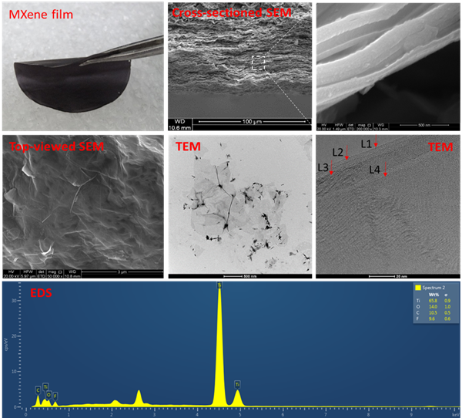

Figure S4. First line from left to right: the freestanding MXene film, cross-sectional SEM image and zoom-in image of the layers. Second line from left to right: Top-view of MXene sheets, TEM image and four-layer of MXene. Third line is the EDS analysis of MXene sheet.

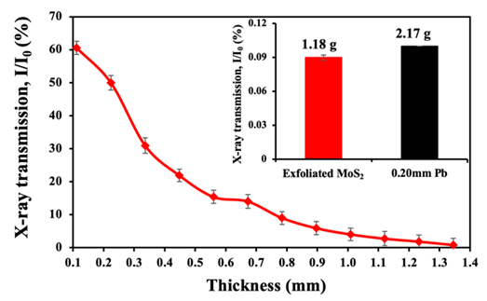

Figure S5. The thickens dependence of X-ray transmission of the layered film composed of exfoliated 2D MoS2 sheets at 30 kVp compared with 0.20 mm Pb sheet (inset)

Table S1. Comparative X-ray transmission value of the layered 2D materials films antimony (Sb), MXene and molybdenum disulfide (MoS2) compared to their matching bulk materials at 30 kVp. Testing done in triplicate.

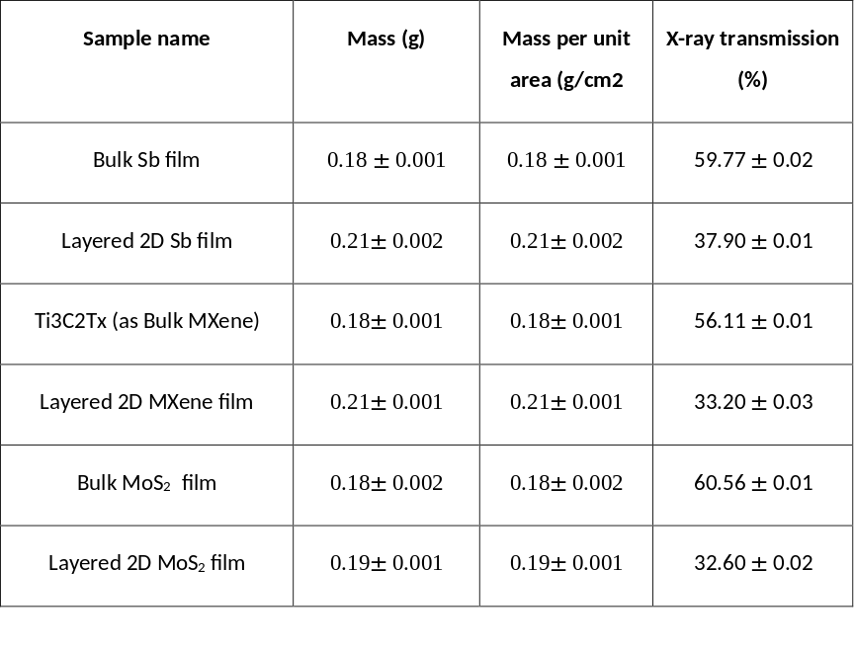

Table S2. X-ray transmission value of the layered 2D materials at 30 kVp. Testing done in triplicate
