Supplementary Tables and figures

Supplementary Table1. Search strategy

Search strategy for Embase：
#1 | ‘ Hypertension’ /exp
#2 | ‘Blood Pressure, High’ :ab,ti OR ‘Blood Pressures, High’ :ab,ti OR ‘High Blood Pressure’ :ab,ti OR ‘High Blood Pressures’ :ab,ti OR ‘elevated blood pressure’ :ab,ti
#3 | ‘Prehypertension’ /exp
#4 | ‘Prehypertension’ :ab,ti
#5 | ‘Mindfulness’ /exp
#6 | mindfulness-based intervention* :ab,ti OR mindfulness-based stress reduction :ab,ti OR MBSR :ab,ti OR mindfulness-based cognitive therapy :ab,ti OR MBCT :ab,ti
#7 | ‘randomized controlled trial’ :it OR randomi?ed :ab,ti OR RCT :ab,ti  ‘controlled clinical trial’ :ab,ti OR ‘random allocation’ :ab,ti OR randomly :ab,ti
#8 | #1 OR #2 OR #3 OR #4
#9 | #5 OR #6
#10 | #7 AND #8 AND #9

Search strategy for Web of Science:
#1 | ((((((((TS= (hypertension)) OR TS= (Blood Pressure, High)) OR TS= (Blood Pressures, High)) OR TS= (High Blood Pressure)) OR TS= (High Blood Pressures)) OR TS= (elevated blood pressure)) OR TS= (Prehypertension)) OR TS= (Pre-Hypertension)) OR TS= (Pre Hypertension)
#2 | (((((TS= (Mindfulness)) OR TS= (mindfulness-based intervention*)) OR TS= (mindfulness-based stress reduction)) OR TS= (MBSR)) OR TS= (mindfulness-based cognitive therapy)) OR TS= (MBCT)
#3 | (((((TS= (Randomized controlled trial)) OR TS= (randomi?ed)) OR TS=(RCT)) OR TS= (controlled clinical trial)) OR TS= (random allocation)) OR TS= (randomly)
#4 | #1 OR #2 OR #3

Search strategy for Pubmed：
#1 | Hypertension [MeSH]
#2 | (Blood Pressure, High [Title/Abstract] OR Blood Pressures, High [Title/Abstract] OR High Blood Pressure [Title/Abstract] OR High Blood Pressures [Title/Abstract] OR elevated blood pressure [Title/Abstract])
#3 | Prehypertension [MeSH]
#4 | (Pre-Hypertension [Title/Abstract] OR Pre Hypertension [Title/Abstract])
#5 | #1 OR #2 OR #3 OR #4
#6 | Mindfulness [MeSH]
#7 | (mindfulness-based intervention* [Title/Abstract] OR mindfulness-based stress reduction [Title/Abstract] OR MBSR [Title/Abstract] OR mindfulness-based cognitive therapy [Title/Abstract] OR MBCT [Title/Abstract])
#8 | #6 OR #7
#9 | Randomized controlled trial [Publication Type] OR randomized [Title/Abstract] OR RCT [Title/Abstract] OR controlled clinical trial [Title/Abstract] OR random allocation [Title/Abstract] OR randomly [Title/Abstract]
#10 | #5 AND #8 AND #9

Search strategy for Cochrane:
#1 | MeSH descriptor: [Hypertension] explode all trees
#2 | (Blood Pressure, High) :ti ,ab,kw OR (Blood Pressures, High) :ti ,ab,kw OR (High Blood Pressure) :ti ,ab,kw OR (High Blood Pressures) :ti ,ab,kw OR (elevated blood pressure) :ti ,ab,kw
#3 | MeSH descriptor: [Prehypertension] explode all trees
#4 | MeSH descriptor: [Mindfulness] explode all trees
#5 | (mindfulness-based intervention*):ti ,ab,kw OR (mindfulness-based stress reduction):ti ,ab,kw OR (MBSR):ti ,ab,kw OR (mindfulness-based cognitive therapy):ti ,ab,kw OR (MBCT):ti ,ab,kw
#6 | (randomized controlled trial):ti ,ab,kw OR (randomi?ed):ti ,ab,kw OR (RCT):ti ,ab,kw (controlled clinical trial):ti ,ab,kw OR (random allocation):ti ,ab,kw
#7 | (randomly):ti ,ab,kw
#8 | #1 OR #2 OR #3
#9 | #4 OR #5
#10 | #6 OR #7
#11 | #8 AND #9 AND #10

Search strategy for CINAHL：
S1 | MH Hypertension OR Blood Pressure, High OR Blood Pressures, High OR MH High Blood Pressure OR High Blood Pressures OR elevated blood pressure
S2 | MH Prehypertension MH Pre-Hypertension OR Pre Hypertension
S3 | MH Mindfulness MH mindfulness-based intervention* OR MH mindfulness-based stress reduction OR MH MBSR OR MH mindfulness-based cognitive therapy OR MH MBCT
S4 | PT Randomized controlled trial OR randomized OR RCT OR MH controlled clinical trial OR random allocation OR randomly
S5 | S1 OR S2
S6 | S3 OR S4 OR S5

Search strategy for Ovid Emcare：
S1 | (Hypertension OR Blood Pressure, High OR Blood Pressures, High OR High Blood Pressure OR High Blood Pressures OR elevated blood pressure).mp.[mp=title, abstract, heading word, drug trade name, original title, device manufacturer, device trade name, keyword heading word]
S2 | (Prehypertension OR Pre-Hypertension OR Pre Hypertension).mp.[mp=title, abstract, heading word, drug trade name, original title, device manufacturer, device trade name, keyword heading word]
S3 | (Mindfulness OR mindfulness-based intervention* OR mindfulness-based stress reduction OR MBSR OR mindfulness-based cognitive therapy OR MBCT).mp.[mp=title, abstract, heading word, drug trade name, original title, device manufacturer, device trade name, keyword heading word]
S4 | (Randomized controlled trial OR randomi?ed OR RCT OR controlled clinical trial OR random allocation OR randomly).mp.[mp=title, abstract, heading word, drug trade name, original title, device manufacturer, device trade name, keyword heading word]
S5 | S1 OR S2
S6 | S3 AND S4 AND S5

Search strategy for PsycINFO：
#1 | MA Hypertension OR AB Blood Pressure, High OR AB Blood Pressures, High OR AB High Blood Pressure OR AB High Blood Pressures OR AB elevated blood pressure
#2 | MA Prehypertension OR AB Pre-Hypertension OR AB Pre Hypertension
#3 | MA Mindfulness OR AB mindfulness-based intervention* OR AB mindfulness-based stress reduction OR AB MBSR OR AB mindfulness-based cognitive therapy OR AB MBCT
#4 | PT Randomized controlled trial OR AB randomi?ed OR AB RCT OR AB controlled clinical trial OR AB random allocation OR AB randomly
#5 | #1 OR #2
#6 | #3 AND #4 AND #5

For the China National Knowledge Infrastructure (CNKI), Wanfang databases, and VIP China Science, the following search strategy was used:
AB=高血压 AND AB=正念 OR 正念干预 OR 正念减压 OR 正念认知 OR MBSR OR MBCT AND AB=随机对照 OR随机 OR RCT

Supplementary Table 2. Basic characteristics of included studies.
First Author,  year | Study  design | Country | Participants |  |  |  |  | Interve-ntion | Comp-arator | BP Assessment |  |  | Anxiety,  Depression,  Stress  Outcomes | Main Findings
First Author,  year | Study  design | Country | Study population | Total  (IG:  CG) | Female  （%） | Mean age  (SD) | Anti-  Hypertensive medication  (%) | Interve-ntion | Comp-arator | Time  Points | Outcome | Devices | Anxiety,  Depression,  Stress  Outcomes | Main Findings
Palta,  2012 | RCT | USA | Hypertension | 20  (12:8) | 95 | IG: 72.3  (4.4)  CG: 73.7  (5.8) | 90 | MBSR | AC:  social support group | Baseline,  Postinter-vention | Clinic SBP  and DBP | Electronic blood pressure machine | Not reported | SBP:  IG exhibited 21.92mmHg lower than CG (p=0.020) DBP:  IG exhibited 16.70mmHg lower than CG (p=0.003)
Blom,  2013 | RCT | Canada | Prehypertensi-on or grade 1 hypertension | 101  (50:  51) | Total:62  IG: 64  CG: 63 | IG: 57  (12)  WL: 55  (11) | Unmedicated | MBSR | WL | Baseline,  Week 12,  Week 24 | 24h  ambulatory BP | Automated office BP measureme-nt device | not reported | SBP:  IG -0.4 ± 6.7 mmHg  (P > 0.05)  DBP:  IG 0.04 ± 4.9 mmHg  (P > 0.05)
Hughes,  2013 | RCT | USA | Prehypertensi-on | 56  (28:  28) | Total:57  IG:61  CG:54 | 50.3 (6.5) | Unmedicated | MBSR | AC:  progressive muscle relaxation (PMR) training | Preinter-vention,  Postinter-vention | Clinic  SBP/DBP  Ambulatory  SBP and DBP | Automated oscillometric  BP device:  Accutor Plus Oscillometric  BP Monitor | not reported | SBP:  IG - 4.8mm Hg (p = .016) DBP:  IG - 1.9mm Hg (p = .008) MBSR did not result in larger decreases in ambulatory BP than in PMR.
Parswani,  2013 | RCT | India | Hypertension | 30  (15:  15) | all were males | IG: 47.27(12.15)  CG: 50.60(8.21) | 100 | MBSR | TAU | Preinter-vention,  Postinter-vention,  Follow up at 3 months | Clinic SBP  and DBP | Sphygmomanometer | Anxiety and depressive symptoms:  HADS  Perceived stress:  PSS | SBP:  IG 135.67 ± 124.47 mmHg to 124.47 ± 8.97 (P < 0.001)  DBP:  IG 84.16 ± 5.48 mmHg to 81.60 ± 5.19 (P > 0.05)  Anxiety:  IG 7.87 ± 3.31 to 3.27 ± 1.27 (P < 0.001)  Depression:  IG 6.13 ± 2.03 to 3.33 ± 1.59 (P < 0.001)  Perceived stress:  IG 30.13 ± 4.87 to 19.60 ± 3.22 (P < 0.001 )
Nejati,  2015 | RCT | Iran | Hypertension | 30  (15:  15) | Total: 46.67  IG:40  CG:53 | IG: 43.66 (5.14)  CG: 43.13 (5.04) | 100 | MBSR | AC: yoga training | Preinter-vention,  Postinter-vention,  Follow up at 2 months | Clinic SBP  and DBP | Not reported | Not reported | SBP:  IG 154.67 ± 7.54 to 138.11 ± 5.62 (p < 0.001)  DBP:  IG 90.58 ± 5.25 to 86.14 ± 5.65 (p <0.001)
Momeni,  2016 | RCT | Iran | Hypertension | 60  (30:  30) | 42 | Total: 47(7)  IG: 49.16(6.31)  CG:46.16  (6.27) | 100 | MBSR | WL | Preinter-vention,  Postinter-vention | Clinic SBP  and DBP | Desk mercury sphygmomanometer | Perceived Stress:  PSS | SBP  IG 134.16 ±7.99 mmHg to 118.33 ± 7.46 mmHg (P < 0.05)  DBP:  IG 81.66 ± 10.11 mmHg to 80.00 (P=0.61)  PS  IG 30.25 ± 9.59 to 16.74 ±4.76 (P< 0.05)
Kumar,  2017 | RCT | India | Grade 1 hypertension with Type 2 diabetes | 40  (20:  20) | Total：60.5  IG: 60.11  CG: 60 | 35-60  years | Total：68.4  IG: 66.67  CG: 70 | MBSR | WL | Preinter-vention,  Postinter-vention | Clinic SBP  and DBP | Mercury  sphygmomanometer | Not reported | SBP:  IG 144.56 ± 4.105 mmHg to 143.22 ± 3.828 mmHg (P = 0.006)  DBP:  IG 94.33 ± 3.447 mmHg to 93.67 ± 3.834 mmHg (P=0.187)
Márquez, 2018 | RCT | Spain | Prehypertension or grade 1 hypertension | 42  (24:  18) | 57.14 | 56.5  (7.77) | 65 | MBCT | AC:  Health education | Preinter-vention,  week 4,  Posinter-  Vention,  Follow-up at week 20 | ClinicSBP and DBP  ABPM | OMRON M6 | Anxiety and depression: DASS-21  Perceived Stress:  PSS-10 | Clinic SBP:  IG 130.54 ± 2.42 mmHg VS CG 133.21 ± 2.64 mmHg (P = 0.02)  Clinic DBP:  IG 84.25 ± 1.88 mmHg VS 87.11 ± 2.08 mmHg (P=0.89)
Liu,  2019 | RCT | China | Hypertension | 110  (57:  53) | Total: 43.6  IG: 43.9  CG：43.4 | IG: 56.19 (7.78)  CG: 55.89 (7.77) | 100 | MBSR | TAU | Baseline,  Postinter-vention | Clinic SBP  and DBP | Sphygmomanometer | not reported | SBP:  IG 158.59 ±13.03 mmHg to 120.52 ± 14.89 mmHg (P < 0.01)  DBP:  IG 105.35 ± 9.62 mmHg to 80.77 ± 8.15 mmHg (P < 0.01)
An,  2021 | RCT | USA | Prehypertension or hypertension | 37  (20:  17) | Total:75  IG:70  CG:81 | IG: 58  (12.6)  CG: 64  (9.0) | >60 | MAP | AC:  Health Promo-tion Program | Baseline,  week 6,  Follow-up at week12 | Clinic SBP  and DBP | BP monitor (Omron 3 series) | Not reported | SBP:  IG 138 ±15 mmHg to 119 ± 6 mmHg (P = 0.005) DBP:  IG 89 ±11 mmHg to 77 ± 7 mmHg (P = .003)
Yang,  2021 | RCT | China | Hypertension | 113  (57:  56) | Total: 49.56  IG: 50.88  CG: 48.21 | IG: 64.73 (2.03)  CG: 64.56 (2.18) | 100 | MBSR | TAU | Preinter-vention,  Postinter-vention | Clinic SBP  and DBP | Not reported | Anxiety:  SAS  Depression: SDS | SBP:  IG 161.48 ± 16.34 mmHg to 128.32 ± 12.06 mmHg (P<0.05)  DBP:  IG 102.17 ± 10.06 mmHg to 85.42 ± 8.13 mmHg (P<0.05)  Anxiety:  IG 60.11 ± 5.70 to 44.70 ± 4.31 (P<0.05)  Depression:  IG 57.88 ± 5.53 to 42.06 ± 4.15 (P<0.05)
Babak，2022 | RCT | Iran | Hypertension | 80  (40:  40) | 100 | IG:  48.67  (1.42)  CG:  49.32  (2.31) | Not reported the proportion | MBSR | TAU | Preinter-vention,  Week 13 | Clinic SBP  and DBP | Not reported | Anxiety:  SAS  Depression: DASS-21 | SBP:  IG -9.11 ± 0.85mmHg (P<0.001)  DBP:  IG -7.22 ± 0.67mmHg (P<0.001)  Anxiety:  IG -3.85 ± 0.15 (P<0.05)  Stress:  IG -4.76 ± 2.25 (P<0.05)  Depression:  IG -4.62 ± 2.11 (P<0.001)

IG: intervention group；CG：control group；AC: active control；WL: wait list；TAU: treatment as usual；NS: non-significant；ABPM：ambulatory blood pressure monitoring；HADS: Hospital Anxiety and Depression Scale；PSS: Perceived Stress Scale；DASS-21：Depression, Anxiety and Stress Scales；SAS: Self-Rating Anxiety Scale；SDS：Self-rating depression scale

Supplementary Table 3. Characteristics of interventions of included studies.
Study | Type of MBIs | Performer | Curriculum design
Study | Type of MBIs | Performer | Duration  of MBIs | Class length  (hour) | Home  Practice  (min) | Details of MBIs
Palta,  2012 | MBSR | interventionist trained in MBSR; through the Center for Mindfulness at the University of Massachusetts. | 8 | 1.5 | Yes, but the time was not reported. | Introducing mindfulness,  cultivating a non-judgmental attitude,  building self-awareness,  developing patience,  mindful communication, coping with change and maintaining realistic expectations
Blom,  2013 | MBSR | 2 trained therapists | 8 | 2.5 | 45 | Formal meditation, informal mindfulness  practice, psycho-education activities, and self-monitoring/  reflection exercises.
Hughes,  2013 | MBSR | MBSR therapist | 8 | 2.5 | Yes, but the time was not reported. | Body scan exercise, sitting meditation, and yoga exercises.
Parswani,  2013 | MBSR | NA | 8 | 1-1.5h | 30 | Body scan, sitting meditation, mindful  walking, mindful eating, 3-min breathing space, mastery and pleasure activities and cognitive restructuring.
Nejati,  2015 | MBSR | NA | 8 | NA | NA | Sitting meditation, 3-min breathing exercise, conscious yoga, mindfulness of sounds and thoughts, etc.
Momeni,  2016 | MBSR | 1 licensed psychologist who was experienced in doing meditation exercises | 8 | 2.5 | 15-45 | Mindful body scan, sitting meditation, walking meditation, and yoga.
Kumar,  2017 | MBSR | NA | 8 | NA | NA | Mindfulness breathing,  body scan, sounds and thoughts.
Márquez, 2018 | MBCT | 1 psychiatrist trained in MBCT | 8 | 2 | 45 | Body scanning, routine activity, breathing, conscious yoga and sounds and thoughts
Liu,  2019 | MBSR | NA | 8 | NA | NA | Mindful awareness, body scan, sitting meditation, 3-min breathing exercise, mindfulness of sounds and thoughts, unpleasant and pleasant experience etc.
An,  2021 | MAP | MARC-certified instructors | 6 | 2 | NA | Introduction to mindfulness, listening, embodiment, and obstacles, difficult emotions/positive emotions, thoughtful and mindful interactions.
Yang,  2021 | MBSR | Nurses | 8 | 0.75 | NA | Introduction to mindfulness, sitting meditation, breathing exercise and body scan.
Babak,  2022 | MBSR | 1 psychologist skilled in MBSR | 8 | 2 | 45 | Body scan exercises, sitting meditation, and  yoga.

MBSR: mindfulness-based stress reduction; MBCT: mindfulness-based cognitive therapy; MAP: mindfulness awareness practice; MARC: Mindful (also known as mindfulness) Awareness Research Center; NA: not available.

Supplementary Figure A-1: subgroup analysis of MBIs on SBP – by sample size.

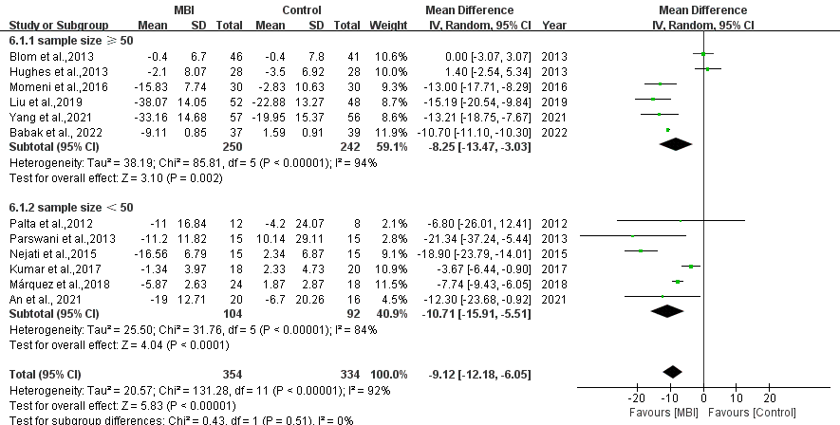

Supplementary Figure A-2: subgroup analysis of mean difference of SBP – by control group.

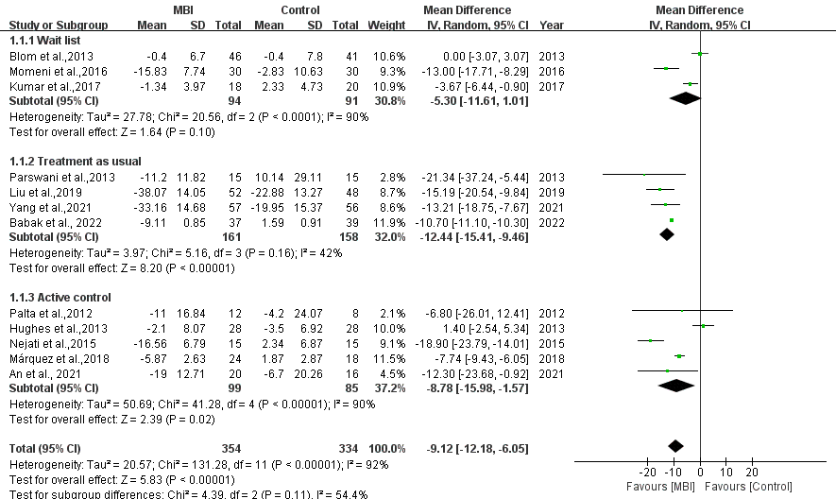

Supplementary Figure A-3: subgroup analysis of mean difference of SBP – by baseline SBP.

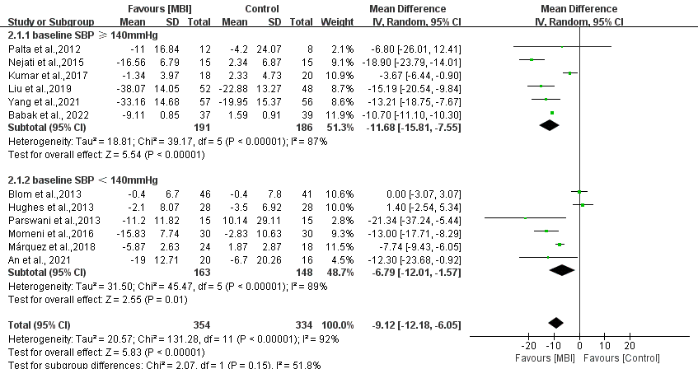

Supplementary Figure A-4: subgroup analysis of mean difference of SBP – by female proportion.

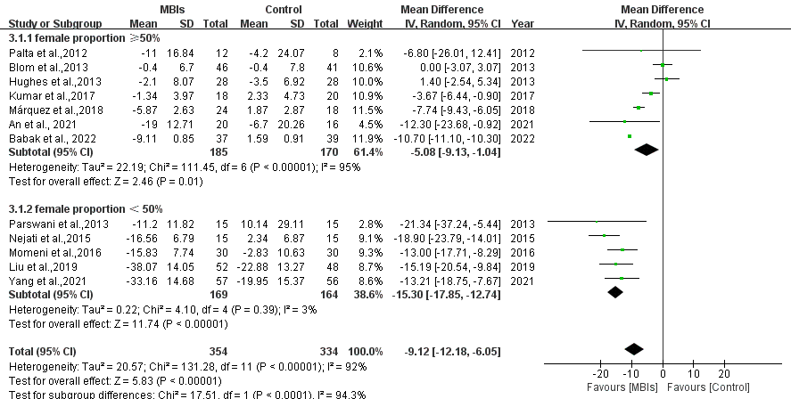

Supplementary Figure A-5: subgroup analysis of mean difference of SBP – by use of antihypertensive drugs.

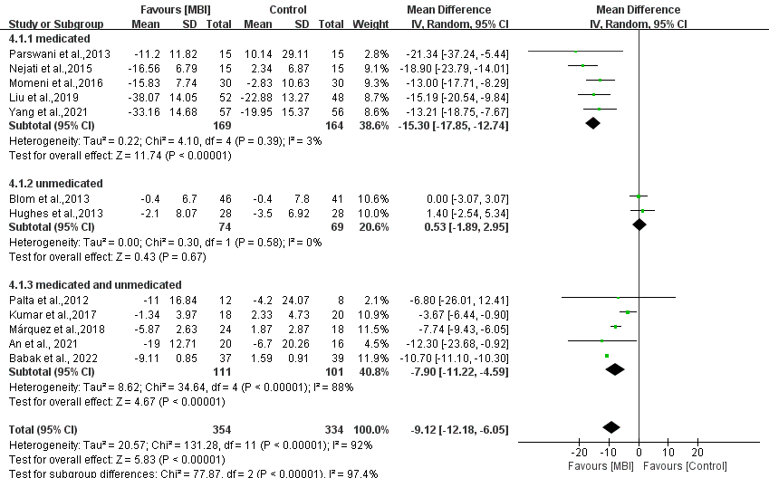

Supplementary Figure A-6: subgroup analysis of mean difference of SBP – by the type of MBIs.

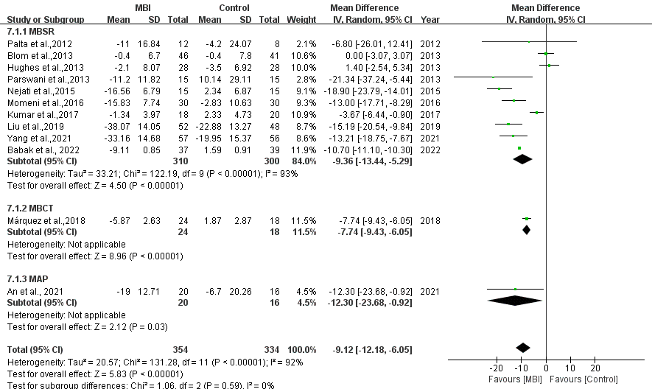

Supplementary Figure A-7: subgroup analysis of mean difference of SBP – by the source of population.

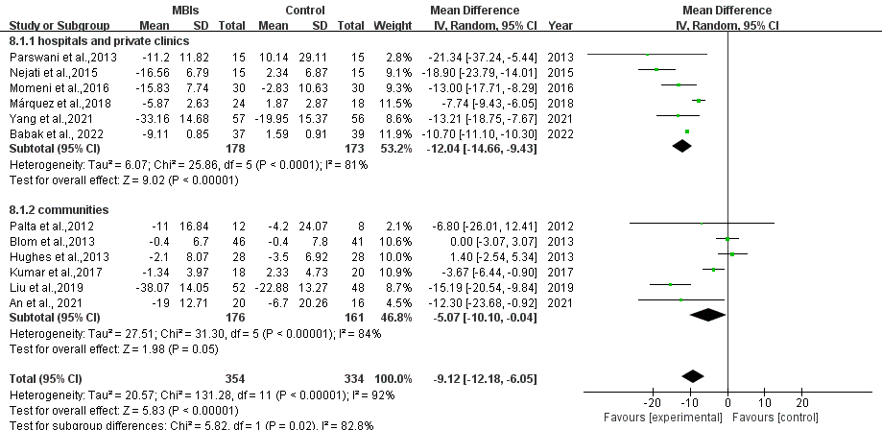

Supplementary Figure B-1: subgroup analysis of MBIs on DBP – by sample size.

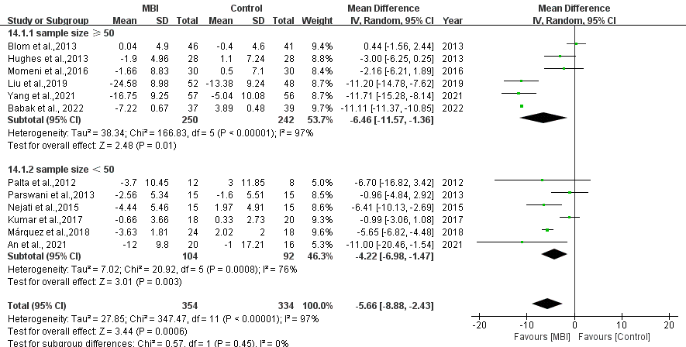

Supplementary Figure B-2: subgroup analysis of mean difference of DBP – by control group.

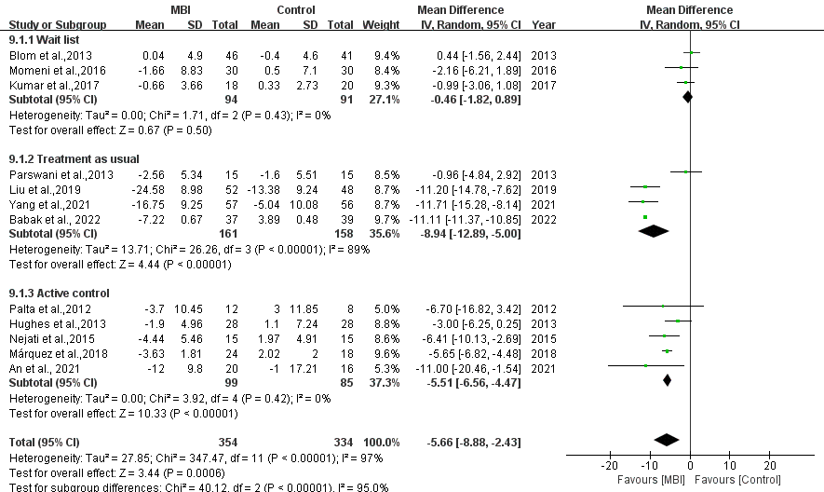

Supplementary Figure B-3: subgroup analysis of mean difference of DBP – by baseline DBP.

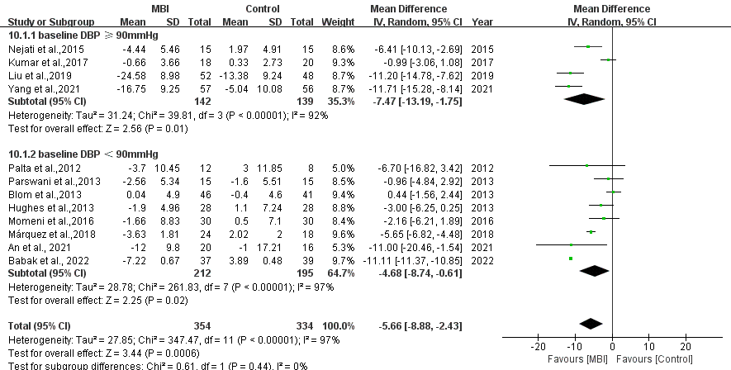

Supplementary Figure B-4: subgroup analysis of mean difference of DBP – by female proportion.

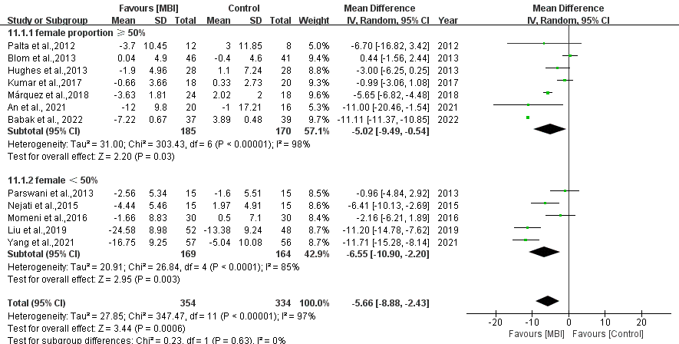

Supplementary Figure B-5: subgroup analysis of mean difference of DBP – by use of antihypertensive drugs.

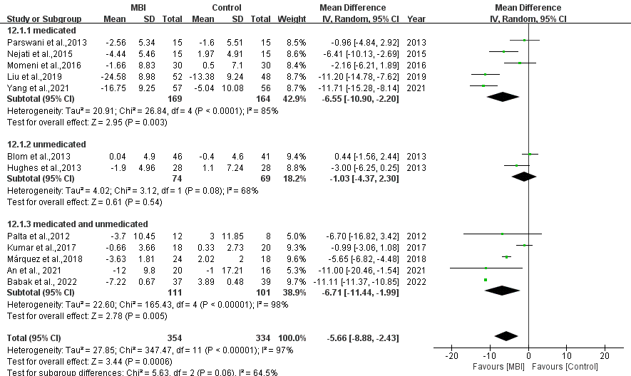

Supplementary Figure B-6: subgroup analysis of mean difference of DBP – by the type of MBIs.

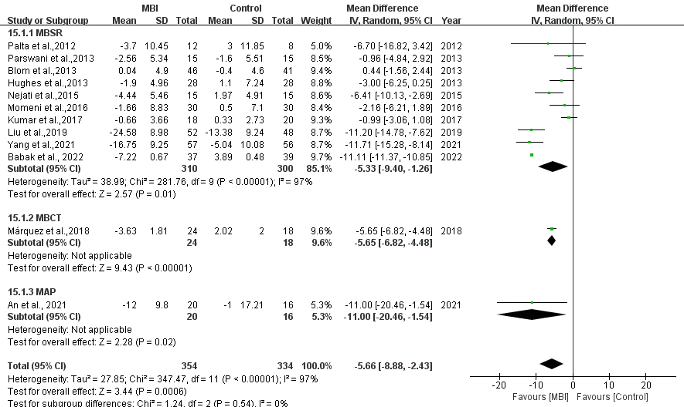

Supplementary Figure B-7: subgroup analysis of mean difference of DBP – by the source of population.

