Supplementary Materials
Interaction with Endogenous Microorganisms, Comamonas testosteroni Enhanced the Degradation of Polycyclic Aromatic Hydrocarbon in Soil
Xueting Sun, Xin Li, Yue Cui, Ziwei Jiang, Qiao Wang, Qian Lu*, Jizhe Cui*

College of Life Sciences and Technology, Harbin Normal University, Harbin 150025, China

* Corresponding author Address: College of Life Sciences and Technology, Harbin Normal University, Harbin 150025, China.

E-mail address: cuijz@hrbnu.edu.cn

Supporting Information Includes:
- 1 table
- 2 figures

Table S1 Primers used for the qPCR of 16SrRNA, 3α-HSD/CR, NahAc.
Gene | Primer
16S rRNA | F: 5′-GATTAGATACCCTGGTAG-3′  R: 5′-CTTGTGCGGGCCCCCGTCAATTC-3′
3α-HSD/CR | F:5′-CAGGCGATTGCCGATGTA-3  R:5′-TTGACCGAAACCACATTG-3′
NahAc | F:5′-AAATGCCTGGGCTTGAAA-3′  R:5′-AGTGCTTGAAGATGGGTT-3′

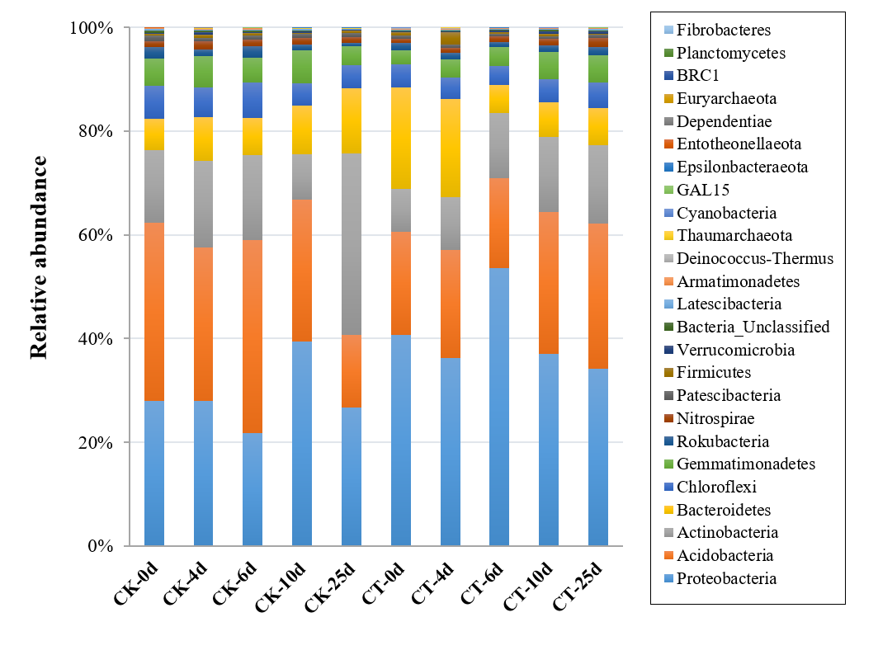
Fig.S1. Relative abundance of bacteria phylums during incubation experiment.
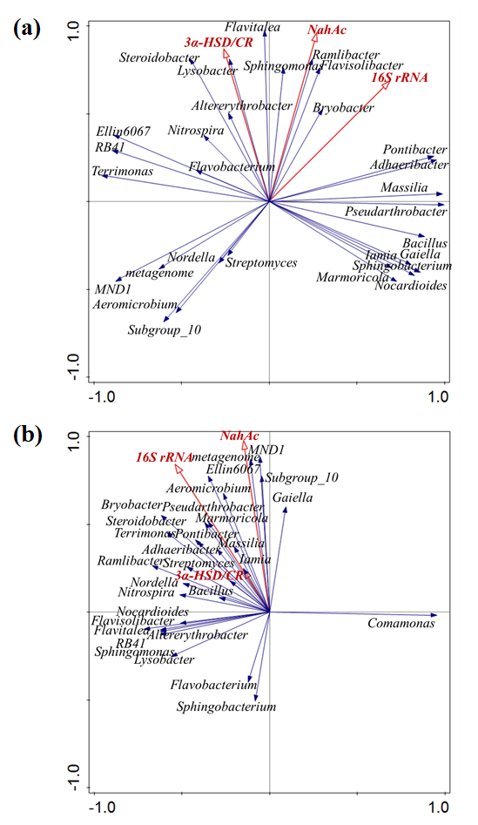
Fig.S2. Redundancy analyses of the correlation between bacteria genera and functional genes in CK (a) and CT (b).

