Supplementary information

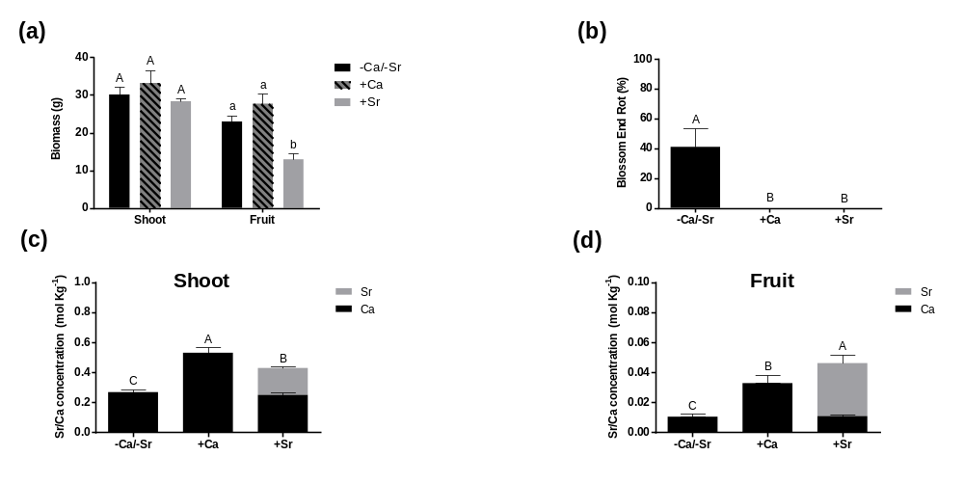
Fig. S1 Additional long-term experiment, Exp.1 Biomass – DW (a), Blossom end rot (BER) (b) and the concentration of Ca²⁺ and Sr²⁺ in the shoot (c) and fruit (d) of the tomato plants after 40 days of exposure to 1 mM CaCl₂ (+Ca), 1 mM SrCl₂ (+Sr) and to the treatment that did not contain any of them (-Ca/-Sr). Vertical bars indicate means ±SE, n=5 for all treatments. On all panels, means indicated with the different letters are significantly different according to Tukey’s HSD-test (p≤0.05). Additionally, on the panels (c) and (d), in the group +Sr, Ca²⁺ and Sr²⁺ concentrations have been added together and compared with two other groups
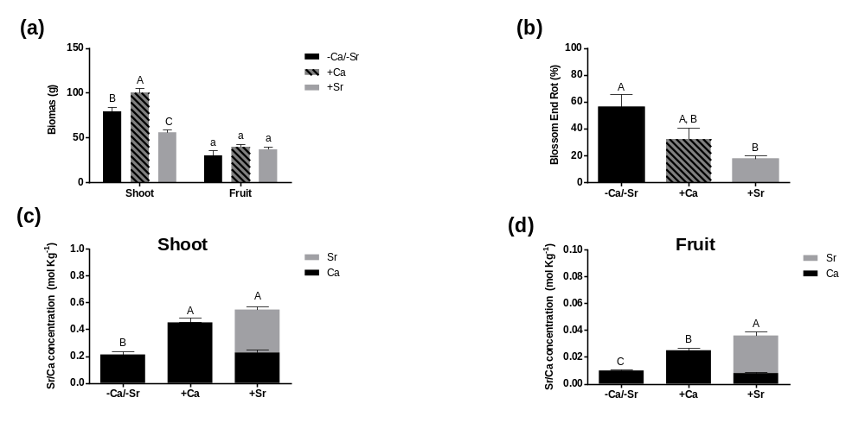
Fig. S2 Additional long-term experiment, Exp. 2 Biomass – DW (a), Blossom end rot (BER) (b) and the concentration of Ca²⁺ and Sr²⁺ in the shoot (c) and fruit (d) of the tomato plants after 26 days of exposure to 2 mM CaCl₂ (+Ca), 2 mM SrCl₂ (+Sr) and to the treatment that did not contain any of them (-Ca/-Sr). Vertical bars indicate means ±SE, n=5 for all treatments. On all panels, means indicated with the different letters are significantly different according to Tukey’s HSD-test (p≤0.05). Additionally, on the panels (c) and (d), in the group +Sr, Ca²⁺ and Sr²⁺ concentrations have been added together and compared with two other groups

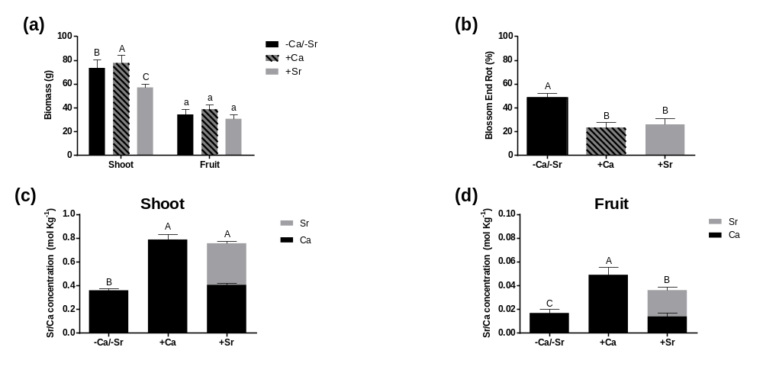
Fig. S3 Additional long-term experiment, Exp. 3 Biomass – DW (a), Blossom end rot (BER) (b) and the concentration of Ca²⁺ and Sr²⁺ in the shoot (c) and fruit (d) of the tomato plants after 29 days of exposure to 4 mM CaCl₂ (+Ca), 4 mM SrCl₂ (+Sr) and to the treatment that did not contain any of them (-Ca/Sr). Vertical bars indicate means ±SE, n=5 for all treatments. On all panels, means indicated with the different letters are significantly different according to Tukey’s HSD-test (p≤0.05). Additionally, on the panels (c) and (d), in the group +Sr, Ca²⁺ and Sr²⁺ concentrations have been added together and compared with two other groups

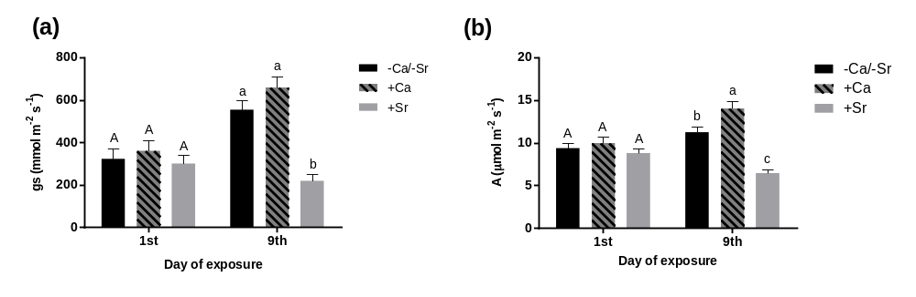
Fig. S4 Stomatal conductance and photosynthesis measurement, one and nine days after “+Ca”, “+Sr” and -Ca/-Sr treatment, Exp. 3 Stomatal conductance (gs) (a) and net photosynthesis (A) (b) on the first and the ninth day after the beginning of the treatment with 4 mM CaCl₂ (+Ca) or 4mM SrCl₂ (+Sr) or the treatment that did not contain any of them (-Ca/-Sr) during June-September 2018 (Exp. 3). Vertical bars indicate means ±SE, n=5 for all treatments. The means indicated with the different letters are significantly different (p≤0.05) according to Tukey’s HSD-test

