Table-2. List of compounds identified using HPTLC and GCMS/MS.
Compound Name | Compound Structure | Molecular weight (g/mol) | Molecular formula | Occurrence | Uses
3-carene | 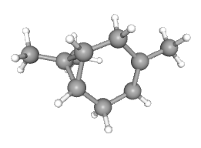 | 136.23 | C₁₀H ₁₆ | N.nepetella  X.aromatica  M.spicata  F.suspensa  B.carterii, etc. | Inflammation, Bone disorder, antihistamine, antimicrobial  (Jeong et al., 2007; Shu et al., 2019)
Alpha-pinene | 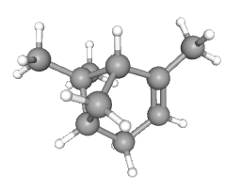 | 136.23 | C₁₀H ₁₆ | X.aromatica  T.mortanum  L.strichnifolia  J.nigra  C.monieri, etc. | Fungicidal agent, flavors, fragrances, antiviral, antimicrobial, anticancer (Salehi et al., 2019)
Alpha-thujene | 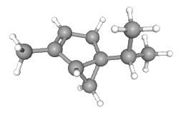 | 136.23 | C₁₀H ₁₆ | S.tormnetosa  J.taiwaniana  F.schiandrae  T.leptophylla, O.syriacum, etc. | Antihelmenthic, antimicrobial, Flavoring agent (Shaikh et al., 2023)
D-Limonene | 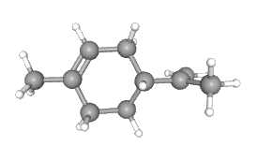 | 136.23 | C₁₀H ₁₆ | L.strichnifolia, C.amada  V.rotundifolia  R.lancifolia  S.extensa, etc. | GERD, anticancer,  Cholesterolemia,  Heartburn (Sun, 2007)
Sylvestrene | 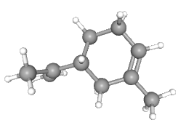 | 136.23 | C₁₀H ₁₆ | P.sylvestris, M.sinaica  S.aurea  T.vulgaris  D.littoralis, etc. | Antioxidant (Kazemi & Rostami, 2015)
Hexanedioc acid, bis (2-ethylhexyl)ester | 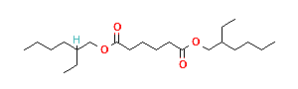 | 370.6 | C₂₂H ₄₂ O₄ | P.ginseng | No activity reported
Isopulegol | 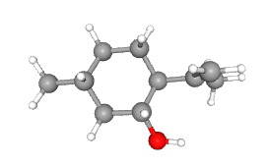 | 154.25 | C₁₀H₁₈O | T.cyprium  V.heynei  P.elatus  A.pustulosa  V.karroo, etc. | Flavoring agent, anesthetic  (Torok, 2021)
2,5-cyclohexadiene-1,4-diol | 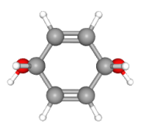 | 112.13 | C₆H₈O₂ | E.gracilis  A.cerana | No activity reported
1,2- cyclohexanedione | 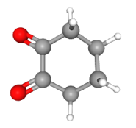 | 112.13 | C₆H₈O₂ | N.tabacum | No activity reported
4-methyl cyclohexanone | 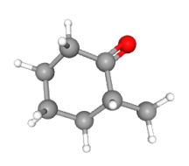 | 112.17 | C₇H₁₂O | - | intermediate for glimepiride, flavoring agent (Shomu)
2-methyl  cyclohexanone | 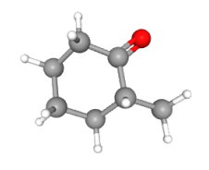 | 112.17 | C₇H₁₂O | S.lycopersicum | No activity reported
Cycloheptanone | 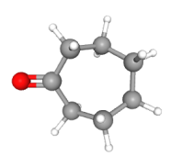 | 112.17 | C₇H₁₂O | G.hirsutum | No activity reported
2-methyl-n-(2-methylbutylidene)-1-butanamine | 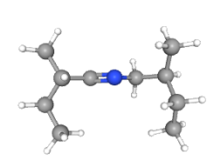 | 155.28 | C₁₀H₂₁N | - | Antimicrobial (Al-Rubaye et al., 2017)
Quercetin | 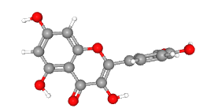 | 5280343 | C₁₅H₁₀O₇ | L.ucranicus  V.mocanera  M.alba  C.asiatica  W.mollis, etc. | Cardiovascular diseases, rheumatic disease, cancer, hypercholesterolemia (NCBI)
Kaempferol | 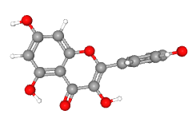 | 5280863 | C₁₅H₁₀O₆ | L.ucranicus  V.mocanera  M.tomentosa  H.tubifera  J.nigra, etc. | Antioxidant, antibacterial, geroprotector (NCBI)

