Supporting Information
Validation of phytochemicals from Houttuynia cordata for their effect on dipeptidyl peptidase IV and sodium/glucosecotransporter 2: an in silico study
Careen Liza Pakyntein¹ǂ, Daiahun Thabah¹ǂ, Donkupar Syiem*, Anita Kumari Rai²
ǂAuthors contributed equally
Affiliation
^{*,1,3} Natural Products, Diabetes and Anti-inflammatory Lab, Department of Biochemistry, School of Life Sciences, North-Eastern Hill University, Shillong-793022, Meghalaya, India

Correspondence:
Prof. Donkupar Syiem*
Department of Biochemistry
NEHU, Shillong-793022
Email id: dsyiem@yahoo.com

Fig.1S:Mass Spectrum of aqueous extract of H.cordata
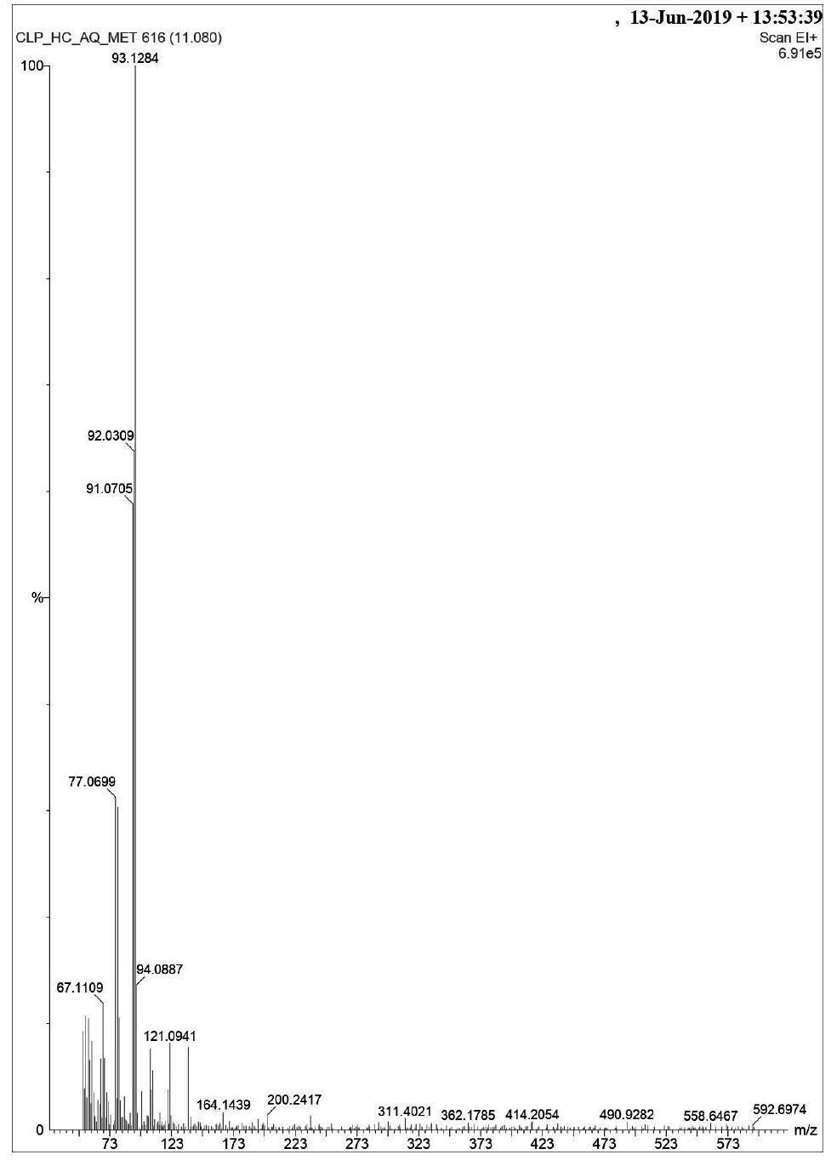
(a)

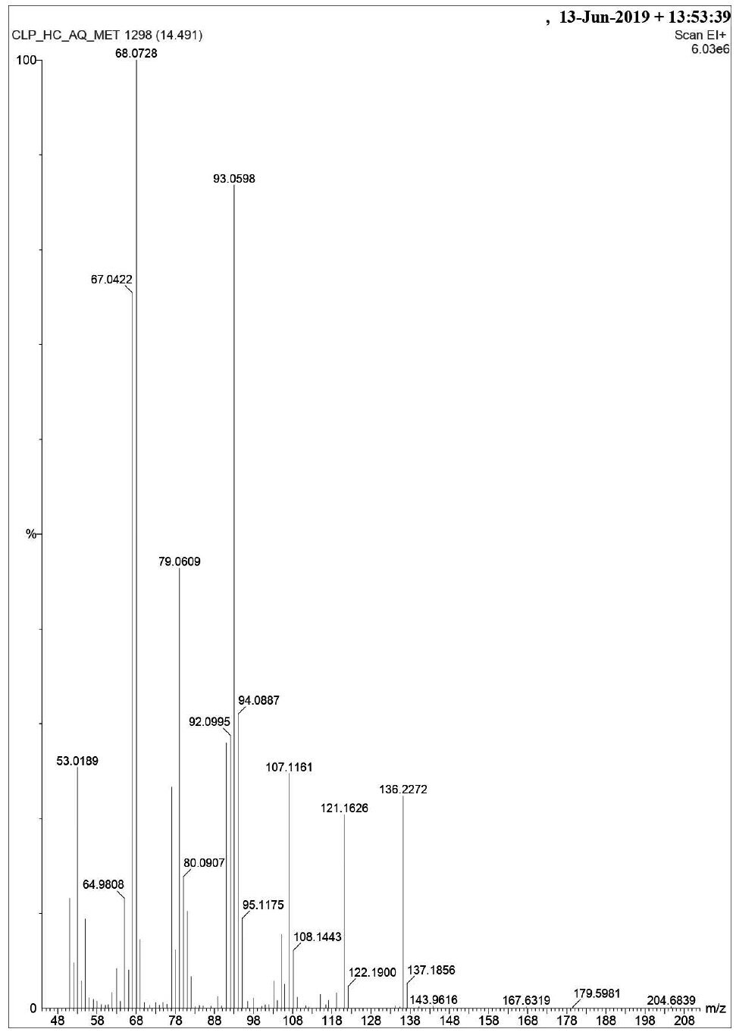
(b)
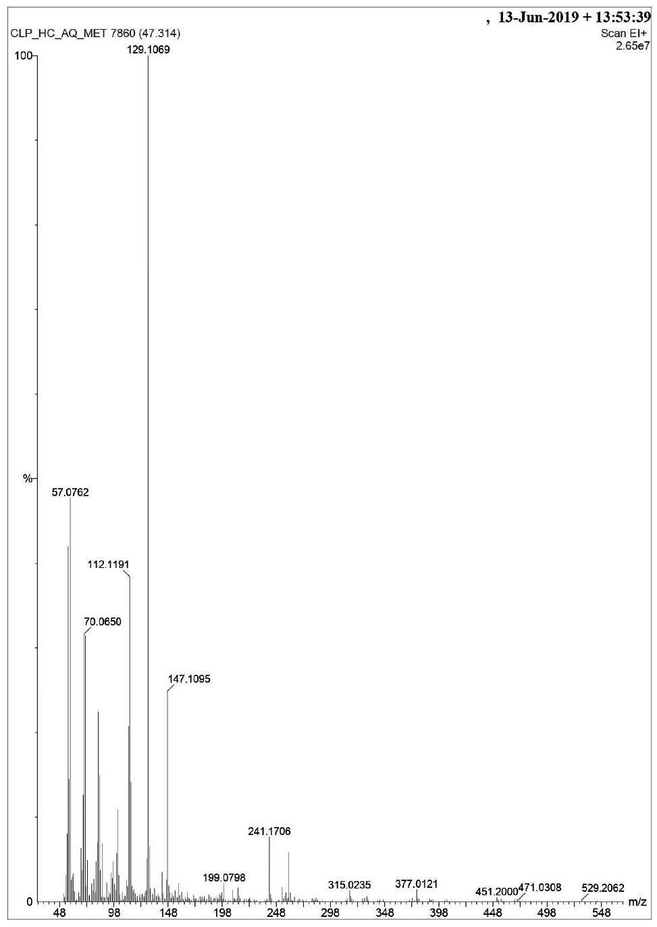
(c)

