Table-5: Pharmacokinetic properties of vildagliptin and dapagliflozin.
Properties | Vildagliptin | Dapagliflozin
3D-Structure | 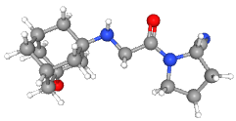 | 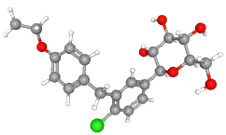
WLogP | 0.79 | 1.52
XLogP3 | 0.88 | 2.35
TPSA | 76.36 | 99.38
ESOL LogS | -2.01 | -3.78
ESOL Class | S | S
Ali LogS | -2.07 | -4.08
Ali Class | S | MS
Silicos-IT LogSw | -2.28 | -4.46
Silicos-IT Class | S | MS
Bioavailability Score | 0.55 | 0.55
GI absorption | High | High
Blood Brain Barrier | No | No
# Lipinski’s violation | 0 | 0
Mutagenicity | None | None
Tumorigenicity | None | None
Reproductive Effectiveness | None | None
Irritant | None | None
Toxicity | Non-Toxic | Non-Toxic
MW, the number of rotatable bonds, the percentage of aromatic heavy atoms, and Daylight's CLOGP are the five molecular characteristics that the ESOL model shows as having a linear connection with log S. The Ali model connects log S, log Po/w, and TPSA. SILICOS-IT is a hybrid technique that uses 27 pieces and 7 topological descriptors. The Bioavailability Score is a rule-based, semi-quantitative score that considers total charge, TPSA, and Lipinski filter violations.

