Table-4a: List of compounds reported from H.cordata.
Compound | Compound Structure | Molecular weight  (g/mol) | Molecular formula
Rutin | 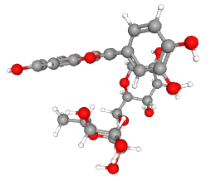 | 610.5 | C₁₅H₁₀O₅
Apigenin | 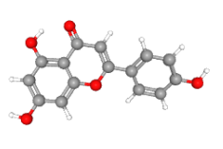 | 270.24 | C₁₅H₁₀O₅
Afzelin | 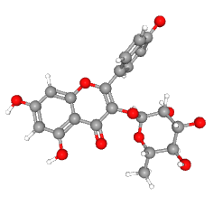 | 432.4 | C₂₁H₂₀O₁₀
Chlorogenic acid | 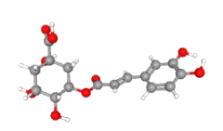 | 354.31 | C₁₆H₁₈O₉
Hyperin | 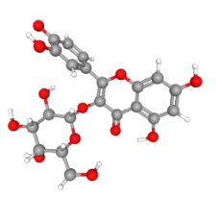 | 464.4 | C₂₁H₂₀O₁₂
Protocatechuic acid | 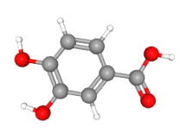 | 154.12 | C₇H₆O₄
Phloridzin | 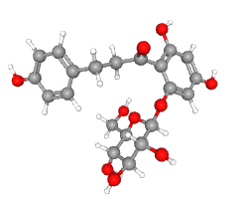 | 436.4 | C₂₁H₂₄O₁₀
Quinic acid | 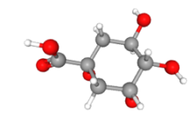 | 192.17 | C₇H₁₂O₆
Quercitrin | 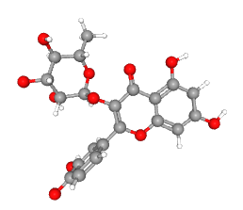 | 448.4 | C₂₁H₂₀O₁₁
Caffeic acid | 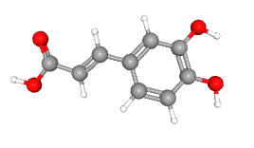 | 180.16 | C₉H₈O₄
Avicularin | 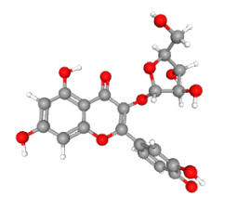 | 434.3 | C₂₀H₁₈O₁₁
Vanillic acid | 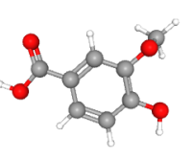 | 168.15 | C₈H₈O₄
Isorhamnetin | 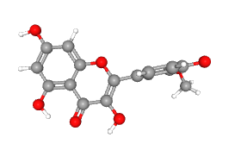 | 316.26 | C₁₆H₁₂O₇
Chlorogenic acid methyl ester | 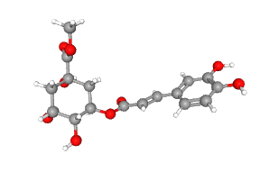 | 368.3 | C₁₇H₂₀O₉
Cryptochlorogenic acid | 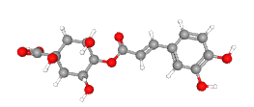 | 354.31 | C₁₆H₁₈O₉
Methyl-cis-ferulate | 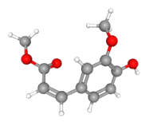 | 208.21 | C₁₁H₁₂O₄
Isoquercitrin | 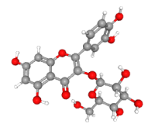 | 464.4 | C₁₂H₂₀O₁₂
Neochlorogenic acid | 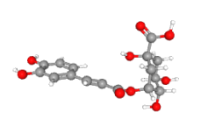 | 354.31 | C₁₆H₁₈O₉
Procyanidin B | 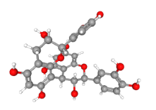 | 578.5 | C₃₀H₂₆O₁₂
Vanillin | 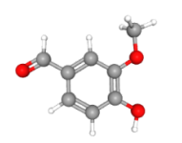 | 152.15 | C₈H₈O₃
Catechin | 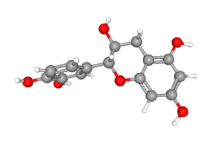 | 290.27 | C₁₅H₁₄O₆

