In vitro and in vivo assessment of the safety and applications of potential probiotics isolated from Egyptian fermented food products
Fatma I. Abdel Tawab^{4†}, Menna H. Abd El kadr^{3†}, Amany M. Sultan², Ehdaa O. Hamed², Ayatollah S. El-Zayat¹, Marwa N. Ahmed^{1*}

- Department of Microbiology, Faculty of Agriculture, Cairo University, Giza, Egypt.
- Department of Biochemistry, Toxicology Unit, Animal Health Research Institute, Agricultural Research Center, Giza Egypt.
- Microbiology Lab, Research Park, Faculty of Agriculture, Cairo University, Giza, Egypt.
- Oil Crops Biotechnology Lab, Agricultural Genetic Engineering Institute, Agricultural Research Center, Giza Egypt.

Running title: Fermented food products as a potential source of probiotics
†These authors contributed equally to this work and share first authorship.
*Corresponding author:
Marwa N. Ahmed, PhD
Lecturer
Department of Microbiology
Faculty of Agriculture
Cairo University
El-Gamaa Street
12613
Giza, Egypt
marwa.nabil@agr.cu.edu.eg
https://orcid.org/0009-0009-3685-6859
Table S1 List of the selected eight LAB isolates and the fermented food sources for each isolate
Isolates | Fermented food source
IS02 | Soybean
IS03 | Soybean
IS04 | Soybean
IS05 | Plant-based luncheon meat
IS06 | Soy sausage
IS07 | Pickles
IS10 | Soy sausage
IS18 | Pickles

 | Optical density (OD 600)
Isolates | 0h | 6h
IS02 | 0.25 ± 0.01 | 0.06 ± 0.00
IS03 | 0.11 ± 0.03 | 0.33 ± 0.02
IS04 | 0.60 ± 0.02 | 0.80 ± 0.04
IS05 | 0.10 ± 0.03 | 0.23 ± 0.03
IS06 | 0.05 ± 0.02 | 0.29 ± 0.03**
IS07 | 0.03 ± 0.01 | 0.15 ± 0.00**
IS10 | 0.11 ± 0.01 | 0.03 ± 0.02
IS18 | 0.30 ± 0.05 | 0.40 ± 0.01
Table S2 Tolerance of the selected LAB isolates to 8% NaCl

Data are represented in means of three replicates ± standard error. **P < 0.01

PATHOGEN  ISOLATE | Listeria  monocytogenes | Escherichia coli O157: H7 | Bacillus cereus | Methicillin-resistant  Staphylococcus aureus | Salmonella  Typhimurium | Pseudomonas  aeruginosa | Staphylococcus aureus
IS03 | 18 ± 0.13 | 15 ± 0.63 | 19 ± 0.57 | 20 ± 0.05 | 20 ± 0.43 | 25 ± 0.23 | 17 ± 0.36
IS05 | 25 ± 0.03 | 19 ± 0.20 | 20 ± 0.31 | 18 ± 0.19 | 8 ± 0.21 | 9 ± 0.03 | 15 ± 0.04
IS06 | 19 ± 0.32 | 18 ±0.00 | 19 ± 0.12 | 18 ± 0.08 | 10 ± 0.00 | 9 ± 0.00 | 13 ± 0.18
IS07 | 29 ± 0.46 | 18 ± 0.27 | 15 ± 0.28 | 20 ± 0.17 | 11 ± 0.09 | 8 ± 0.00 | 20 ± 0.20
Table S3 Distribution of the Inhibition zone diameters (mm) of LAB isolates against indicator pathogenic bacteria
Values are means of three replicates ± standard error of the mean

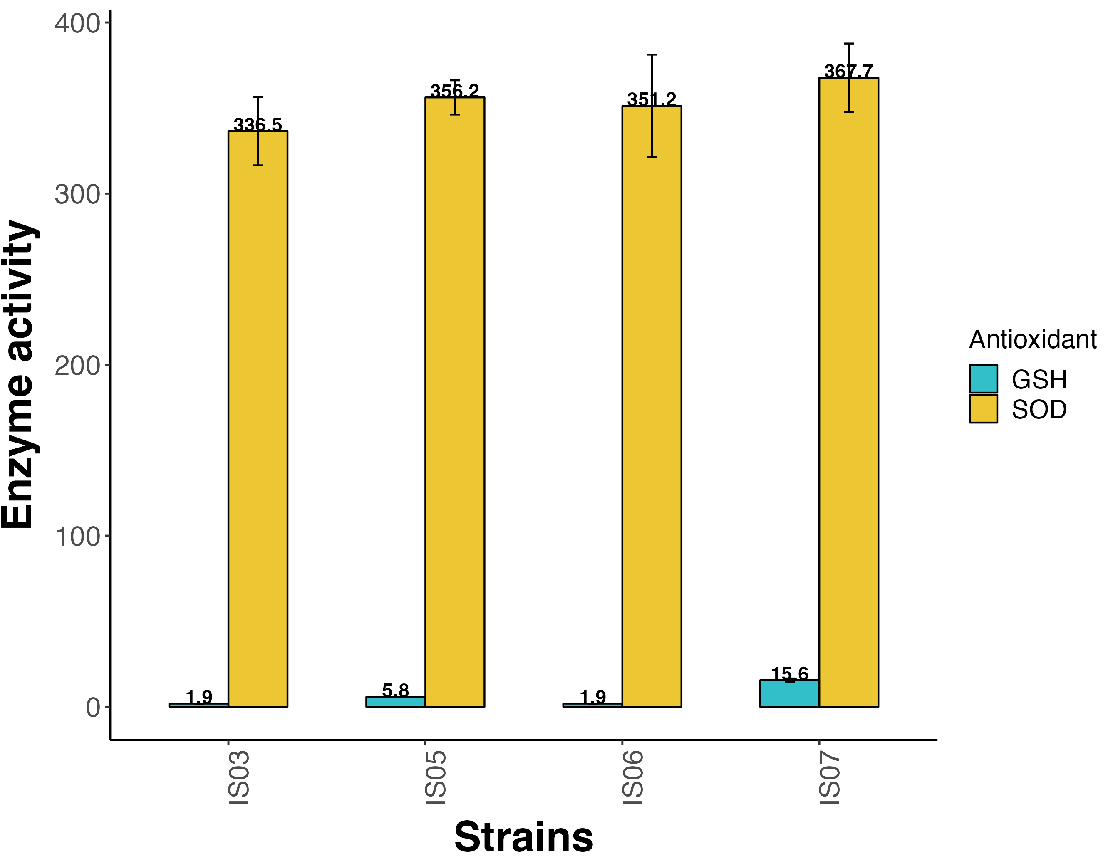

Ffig. S1 Antioxidant levels in the cellular extract of LAB strains. Data are represented in means of three replicate values ± standard error of the mean

