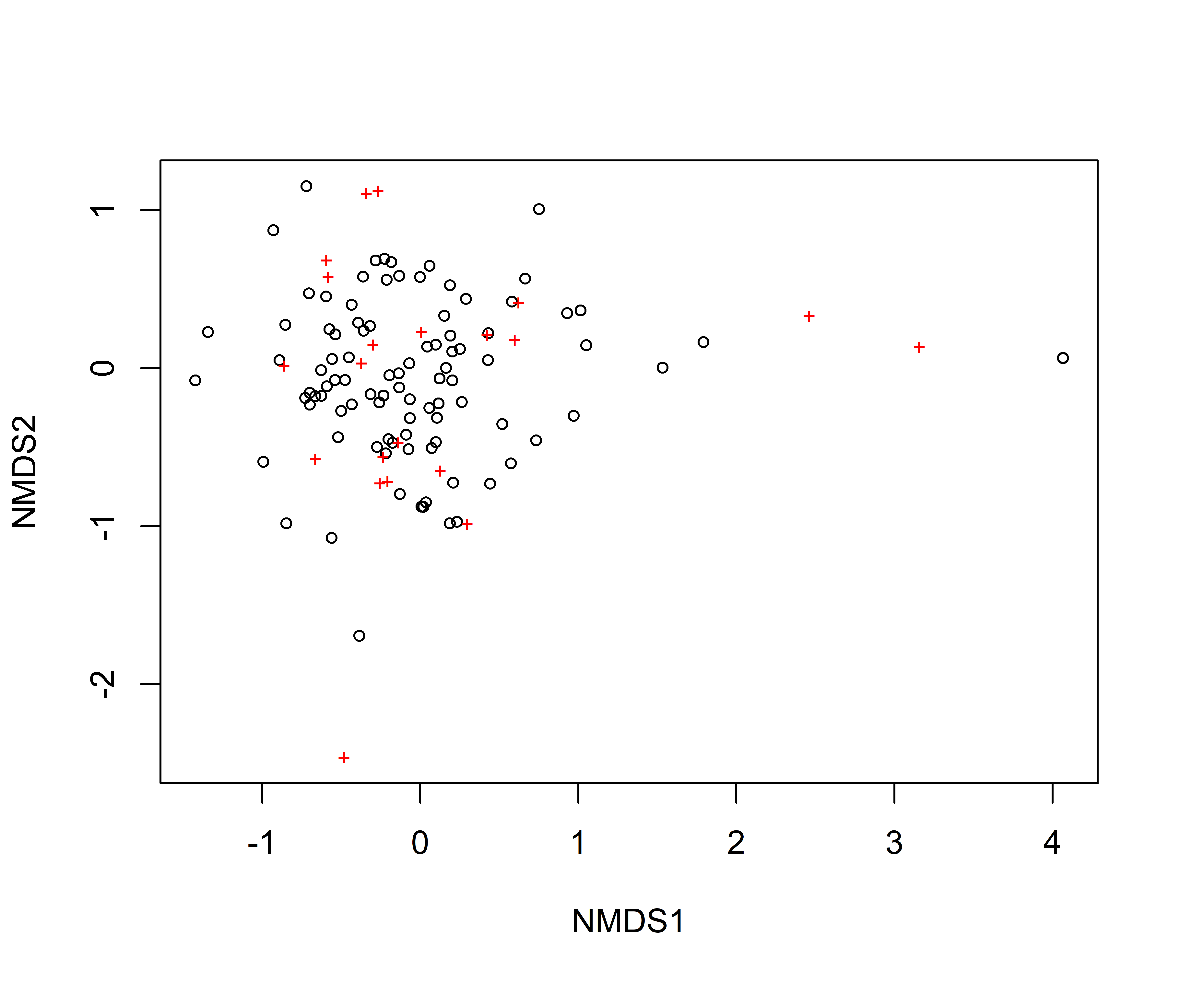
Figure S1. Non-metric multidimensional scaling (NMDS) analysis showing fruit-feeding butterfly community diversity in Lafia urban gradient, North-Central, Nigeria.
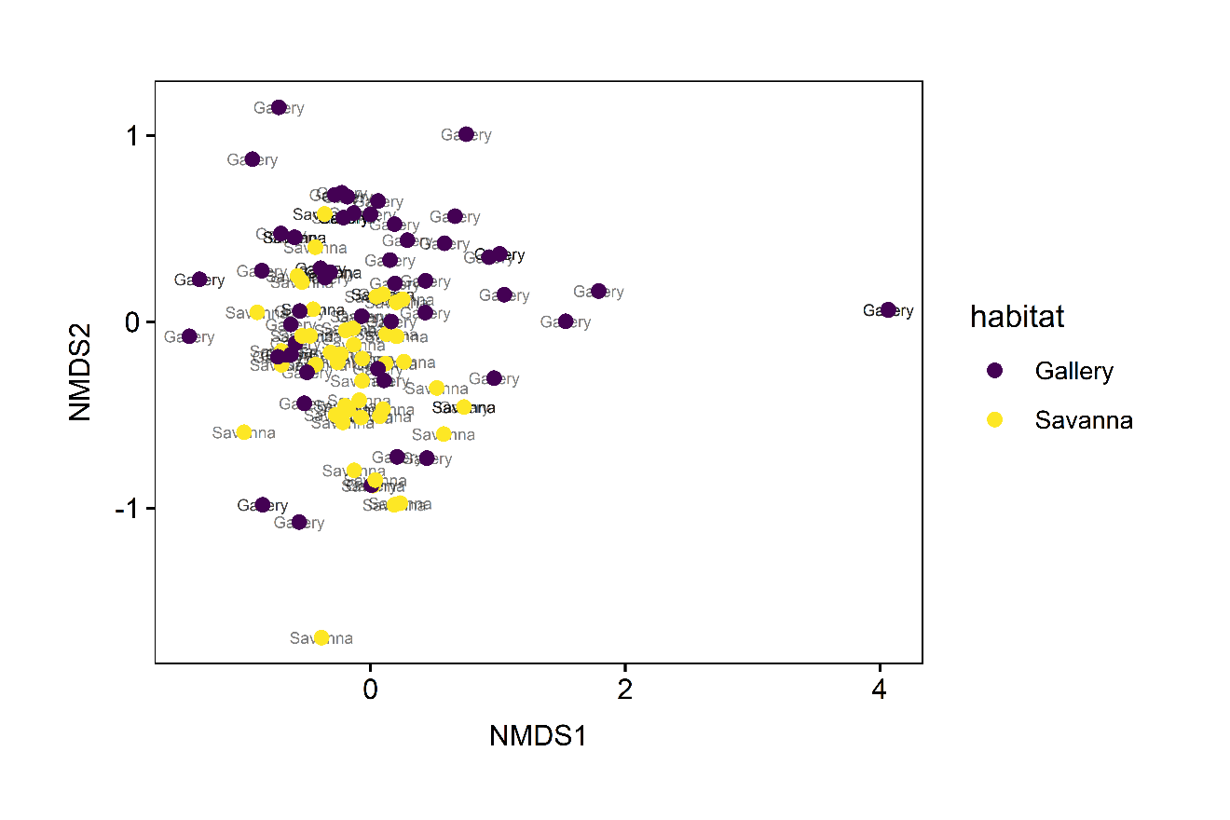
Figure S2. Non-metric multidimensional scaling (NMDS) analysis on the dispersion of the community similarity structure across habitats in a tropical urban landscape in Lafia using 510 fruit-feeding butterflies’ data from 36 collection spots across two urban habitats (savannah woodland vs gallery forest). Coloured points represent butterflies collected across six weeks.

Table 1: Checklist of butterfly species recorded by habitat type
Species | Gallery forest | Savanna woodland
Subfam. Biblidinae (2)
Byblia anvatara crameri |  | ✓
Sevenia occidentalium occidentalium | ✓
Charaxinae (10)
Charaxes achaemenes monticola | ✓ | ✓
Charaxes ameliae ameliae | ✓
Charaxes boueti boueti | ✓ | ✓
Charaxes brutus brutus | ✓ | ✓
Charaxes candiope | ✓
Charaxes castor castor | ✓
Charaxes epijasius | ✓ | ✓
Charaxes tiridates tiridates | ✓
Charaxes varanes vologeses | ✓ | ✓
Charaxes viola viola | ✓ | ✓
Limenitidinae (2)
Hamanumida Daedalus | ✓ | ✓
Neptis serena serena | ✓
Nymphalinae (5)
Junonia chorimene |  | ✓
Junonia oenone oenone |  | ✓
Junonia orithya madagascariensis | ✓ | ✓
Junonia sophia Sophia | ✓ | ✓
Precis antilope |  | ✓
Satyrinae (1)
Bicyclus vulgaris | ✓

