Supplementary Information for
Depopulation and Infrastructure in U.S. Cities: Looking Toward 2100

Details on Data sources

1.1 Data for current population trend
To identify the current population trend, we used population data from 2010 to 2020 (available at the time of the analysis) from the American Community Survey (ACS). We used ACS 5-year estimates since data for areas with a population of less than 20,000 are only available in 5-yr estimates [1]. The spatial unit for this analysis are “Places,” defined by the U.S. census bureau [2] as: “Places are “organic”— they expand (or contract) over time as population and commercial activity increases (or decreases)” [2]. Places include towns, cities, villages, and boroughs. Places are agglomerations of humans inside counties. We chose places as the unit of analysis because it is more representative of human settlement area at a granular scale and socio-demographic variables such as income, age distribution, vehicle ownership, commute time are available at place level in the census. Since the term “place” is generic in the common language, we used the term “city” to refer to places in this article.
A Mann Kendall trend test (MK test) was performed to find the population trend from the time series data. The MK test is one of many statistically robust methods that are available to identify whether time series data have a monotonic increasing (or decreasing) trend or not. Since this test is nonparametric, no assumption about the data distribution is required. A minimum number of three data points are necessary to detect the trend using this method. While the test captures the trend of data, it does not capture the extent of change in the trend. For example, capturing sudden excessive loss or gain in population requires different measures than monitoring loss or gain over time. For this, the mean value of annual percent change in population and the total percent change from consecutive value of the year 2010 and 2020 were used to label the cities based on both the trend and the extent of population loss. The cut off values for labeling is presented in Table SI 1.

Table SI 1 Labeling the cities based on mean and total population change along with their trend
Total population change from 2010-2020 | Trend from MK test | Mean population change rate from 2010-2020
Total population change from 2010-2020 | Trend from MK test | x <= -0.25 | - 0.25 < x <= -0.05 | - 0.05 < x <= -0.025 | -0.025 < x <= 0 | 0 < x <= 0.025 | 0.025 < x <= 0.05 | 0.05 < x <= 0.25 | x > 0.25
x <= -0.5 | Decreasing | 10 | 636 | 84 | 33 | 10 | 13 | 34 | 13
 | Increasing | 0 | 0 | 1 | 0 | 1 | 0 | 0 | 0
 | No trend | 1 | 151 | 84 | 56 | 50 | 38 | 96 | 51
- 0.5 < x <= -0.1 | Decreasing | 0 | 139 | 1160 | 1573 | 79 | 15 | 23 | 9
 | Increasing | 0 | 3 | 3 | 6 | 1 | 1 | 0 | 0
 | No trend | 1 | 19 | 473 | 2226 | 388 | 109 | 148 | 25
- 0.1 < x <= 0 | Decreasing | 0 | 0 | 0 | 1951 | 87 | 9 | 5 | 3
 | Increasing | 0 | 0 | 2 | 15 | 14 | 3 | 2 | 1
 | No trend | 0 | 1 | 1 | 2105 | 1180 | 84 | 79 | 12
0 < x <= 0.1 | Decreasing | 0 | 0 | 0 | 0 | 32 | 0 | 2 | 0
 | Increasing | 0 | 0 | 0 | 0 | 2331 | 8 | 5 | 0
 | No trend | 0 | 0 | 0 | 0 | 3016 | 151 | 67 | 10
0.1 < x <= 0.5 | Decreasing | 0 | 0 | 0 | 0 | 5 | 2 | 9 | 0
 | Increasing | 0 | 0 | 0 | 0 | 2278 | 1501 | 116 | 6
 | No trend | 0 | 0 | 0 | 0 | 1352 | 1486 | 554 | 32
x > 0.5 | Decreasing | 0 | 0 | 0 | 0 | 0 | 0 | 0 | 1
 | Increasing | 0 | 0 | 0 | 0 | 0 | 199 | 1455 | 205
 | No trend | 0 | 0 | 0 | 0 | 0 | 19 | 883 | 203

where,
Severely depopulating |  |  | Slowly increasing |  |  | Fluctuating
Moderately depopulating |  |  | Moderately increasing
Slowly depopulating |  |  | Highly increasing

Table SI 2 shows the number of cities with different trends before and after labeling them considering their extent of population loss.
Table SI 2 No of cities labeled based on mean and total population change
Trend from MK test trend before labeling | # cities | Trend labeled | # cities | Total | Total cities
Decreasing  No trend  Increasing | 5937  15160  8157 | Severely depopulating | 968 | 11838 | 29254
Decreasing  No trend  Increasing | 5937  15160  8157 | Moderately depopulating | 1853 | 11838 | 29254
Decreasing  No trend  Increasing | 5937  15160  8157 | Slowly depopulating | 9017 | 11838 | 29254
Decreasing  No trend  Increasing | 5937  15160  8157 | Fluctuating | 1479 | 1479 | 29254
Decreasing  No trend  Increasing | 5937  15160  8157 | Slowly increasing | 5628 | 15928 | 29254
Decreasing  No trend  Increasing | 5937  15160  8157 | Moderately increasing | 7298 | 15928 | 29254
Decreasing  No trend  Increasing | 5937  15160  8157 | Highly increasing | 3002 | 15928 | 29254
Decreasing  No trend  Increasing | 5937  15160  8157 | Not enough data | 9 | 9

1.2 Data preparation for future population trend
Hauer [3] projected population (mentioned as Hauer’s data) up to 2100 for five Shared Socio-economic pathways (SSPs) for the 50 U.S. states and the District of Columbia from historical population data from 1990-2015. In contrast Gao [4] provided 1-km grid cell level population projection from 2010 to 2100 for the world (mentioned as NCAR data), downscaling the population projection from [5] that is consistent with the five SSPs. These SSP scenarios were developed considering different human development strategies to adapt and mitigate the impacts of climate change [6]. A detailed description of the five scenarios with their storylines can be found in [7]. Since they were created, these five SSPs have been used by researchers to project future trends of land use, growth, and GHG emissions [7]–[9]. To find the city level population from these projected data, Hauer’s data was distributed from county level to city level based on population weights from the 2020 census population as explained in the methodology section of the main article. On the other hand, an area weighted aggregation was performed for NCAR data to convert 1-km grid level population to city level population.
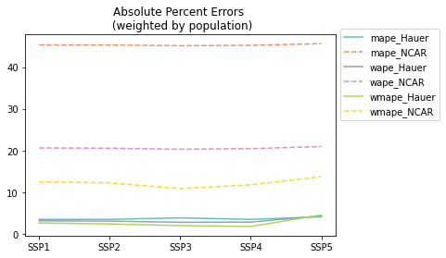
Fig. SI 1 Percent error in actual and projected population from data for 2020
To find future population trends in cities, we investigated the accuracy of both datasets to predict the 2020 city level population. Fig. SI 1 shows the mean absolute percent error (MAPE), weighted absolute percent error (WAPE), and weighted mean absolute percent error (WMAPE) calculated for all five SSPs for the two datasets. The weighted errors were calculated using population weights. The figure shows that for all scenarios, Hauer’s projection is more aligned with the population for the year 2020, and SSP 4 has the lowest error. For NCAR data, the lowest WMAPE can be found for SSP 3. Fig. SI 2 shows that while Hauer’s projection closely follows the census data, the values from NCAR data shows fluctuations with mostly under projection for cities with a population of 20~200 thousands.
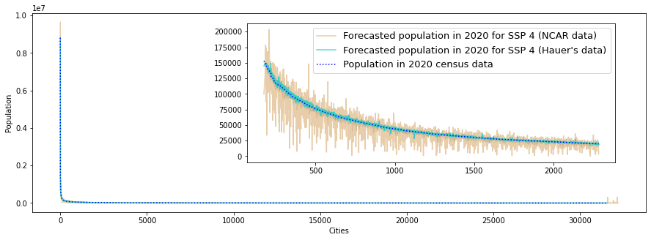
Fig. SI 2 Population in the cities in 2020 as per census data and from projected population
Although Hauer’s projection performs well in terms of error, there are cases where both datasets under project and over project population for cities in 2020 as shown in Fig. SI 2. Forecasting based on these values will cause error in identifying the population trend of such cities. Therefore, we used a weighted dataset combining both projections based on their error contribution in forecasting 2020 population to leverage from both the datasets.

1.3 Scenario selection
Among the five SSP scenarios, we analyzed three scenarios in this article:
- SSP 1: Taking the Green Road (Low Challenges),
- SSP 2: Middle of the Road (Intermediate Challenges), and
- SSP 4: A Road Divided (Adaptation challenges dominate).
SSP 2 refers to middle of the path scenario following the historical experience while SPP 1 and SSP 4 refer to the two extremes of adaptation to socio-economic challenges [9]. We excluded SSP 3 from consideration since it shows a drastic drop in population which with the current trend seems unrealistic as presented in Fig. SI 3, which displays the total population for cities up to 2100 projected by both datasets along with the total population from ACS 5-year estimates from 2010-2020. SPP 5 is excluded since it is also unrealistic as it assumes important fossil fuel-based investments and developments.
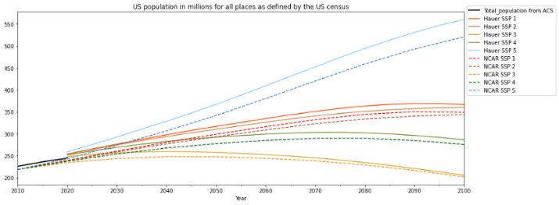
Fig. SI 3 Total population for both datasets for all scenarios

1.3 Future population trends
Table SI 3 shows the number of cities with their future population trends. SSP 4 predicts the highest number of cities with a decreasing trend while SSP 1 predicts the lowest number of cities with a decreasing trend. However, irrespective of scenario, we can see that around 50% of the cities will have a decreasing population trend by 2100.
Table SI 3 Population trend from 2020 to 2100 population projection
Expected trend | SSP 1 | SSP 2 | SSP 4
Decreasing | 14799 | 15732 | 20356
Increasing | 12901 | 12634 | 5724
No trend | 3868 | 3202 | 5488

A comparison of current population trend and future population trend is presented in Table SI 4. The values are presented as percent of total cities in each current population label. From the we can see that there are cities that are currently going through a decreasing trend can go back to an increasing trend and vice versa. A large share of moderately and highly increasing cities is likely to depopulated over time for each of the three scenarios. Hence, city planners and authorities should be cautious about planning any scheme considering the current population trend.
Table SI 4 Current trend vs. future trend
Current trend | Future trend | % cities in SSP 1 | % cities in SSP 2 | % cities in SSP 4
Severely depopulating | Decreasing | 60.3 | 61.7 | 76.6
Severely depopulating | Increasing | 27.1 | 26.5 | 11.5
Severely depopulating | No trend | 12.6 | 11.7 | 11.8
Moderately depopulating | Decreasing | 64.7 | 66.9 | 79.6
Moderately depopulating | Increasing | 24.5 | 24.1 | 10.6
Moderately depopulating | No trend | 10.7 | 9.0 | 9.7
Slowly depopulating | Decreasing | 57.4 | 60.8 | 76.5
Slowly depopulating | Increasing | 29.2 | 28.5 | 9.7
Slowly depopulating | No trend | 13.4 | 10.7 | 13.8
Fluctuating | Decreasing | 56.9 | 60.0 | 73.6
Fluctuating | Increasing | 30.2 | 29.8 | 11.9
Fluctuating | No trend | 12.9 | 10.3 | 14.4
Slowly increasing | Decreasing | 32.6 | 35.5 | 51.9
Slowly increasing | Increasing | 54.5 | 53.3 | 20.8
Slowly increasing | No trend | 12.9 | 11.3 | 27.3
Moderately increasing | Decreasing | 37.2 | 40.0 | 52.9
Moderately increasing | Increasing | 51.9 | 51.0 | 29.1
Moderately increasing | No trend | 10.9 | 9.0 | 18.0
Highly increasing | Decreasing | 43.4 | 46.9 | 61.3
Highly increasing | Increasing | 43.9 | 43.2 | 23.6
Highly increasing | No trend | 12.7 | 9.9 | 15.1

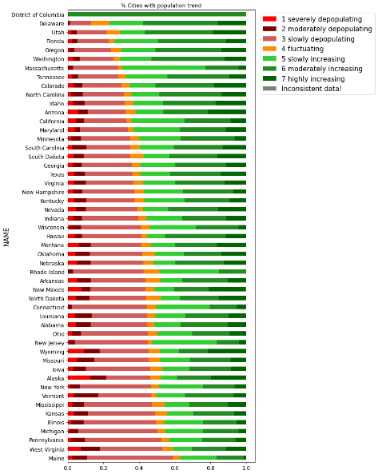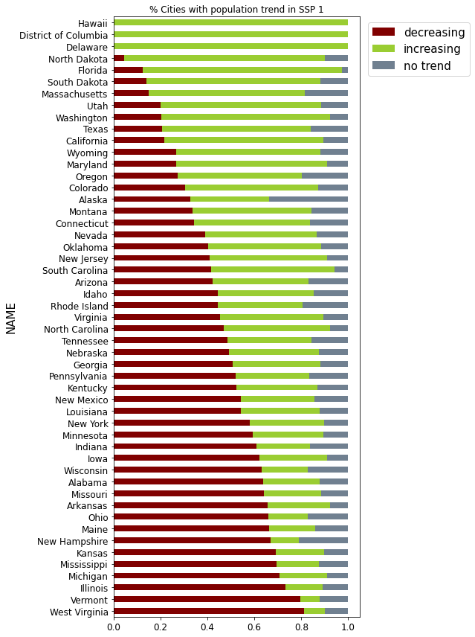
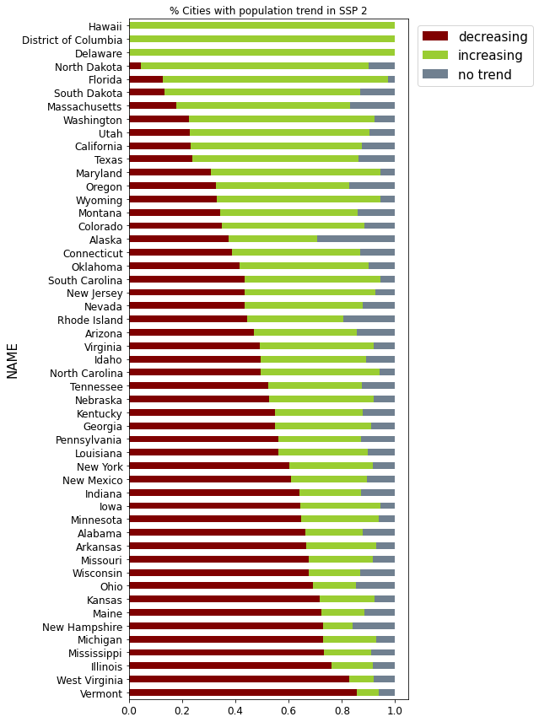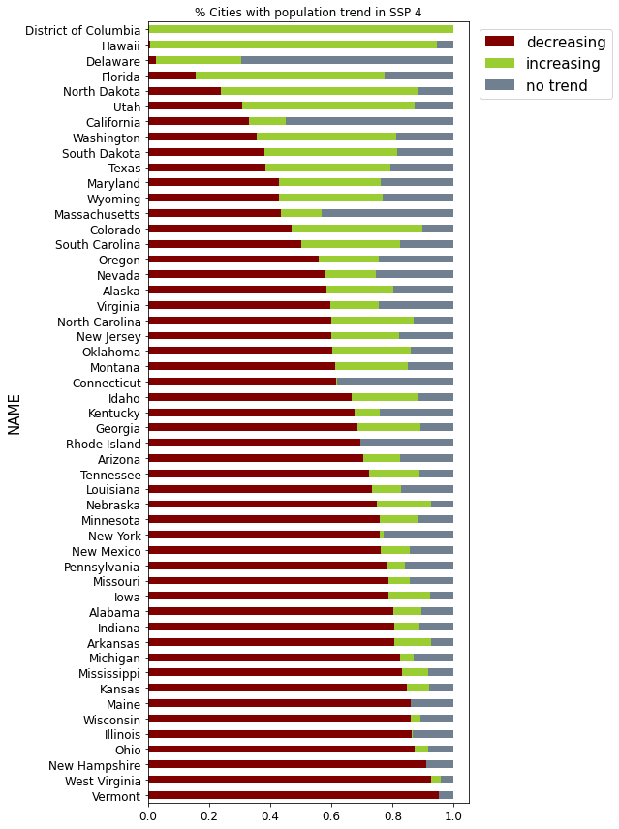
Fig. SI 4 Percent cities with different labels for all the states in the U.S. from ACS 5yr estimates 2010-2020 (top left), future trend from projection population 2020-2100 for SSP 1 (top right), SSP 2 (bottom left), and SSP 4 (bottom right). The figure shows that currently all states have cities that are depopulating to some extent except the District of Columbia. This trend will continue for cities as we can see from all three scenarios. Vermont and West Virginia will face the worst challenges since more than 80% of cities are likely to lose population.

2. Characteristics of depopulating cities

2.1 Classification based on Degree of urbanization
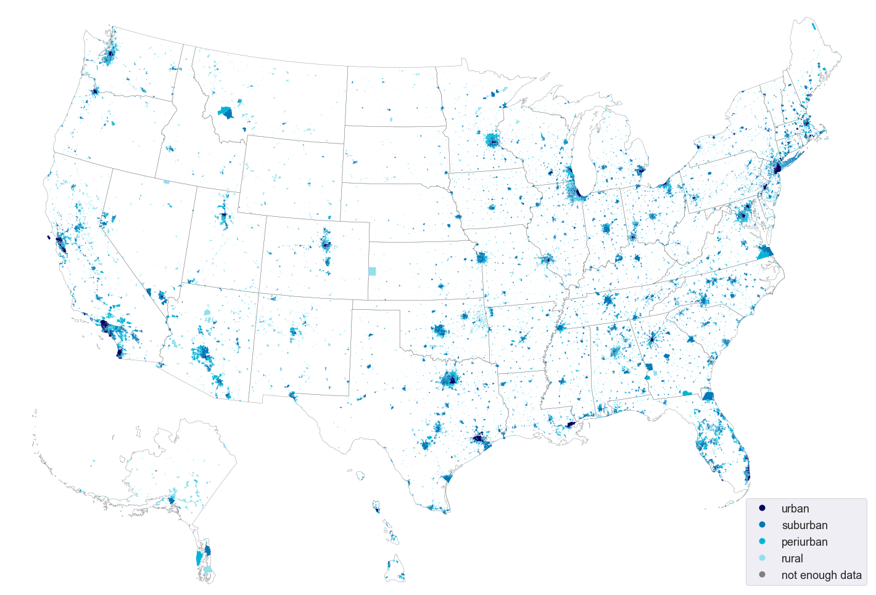
Fig. SI 5 Cities classified based on degree of urbanization in the U.S.

2.2 Variation based on degree of urbanization (urban – suburban – periurban – rural)

Fig. SI 6 (a) shows that, similar to SSP 2, for scenario SSP 1, for all regions, urban cities are likely to increase although 21% of the urban cities in Midwest are likely to lose population. In the West and South, a significant share of suburban and periurban cities are likely to increase. While for scenario SSP 4, as presented in Fig. SI 6(b), for all regions, the number of cities with declining population trend are likely to increase. We see that, in the South, the number of increasing urban cities is larger than the number of declining urban cities. The share of suburban and periurban cities with an increasing population trend are likely to be low.

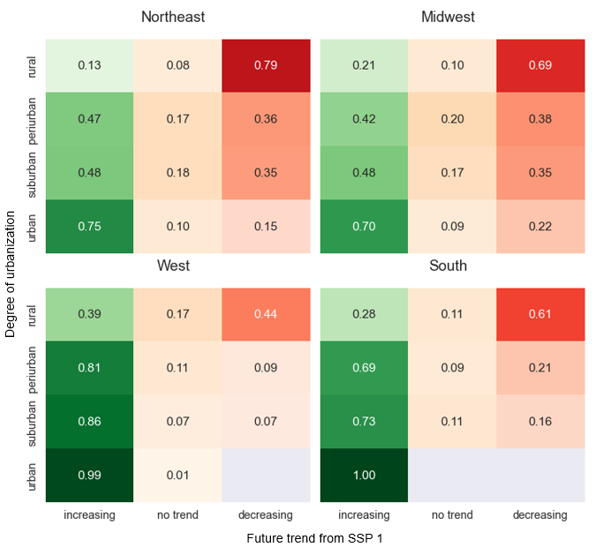
(a)
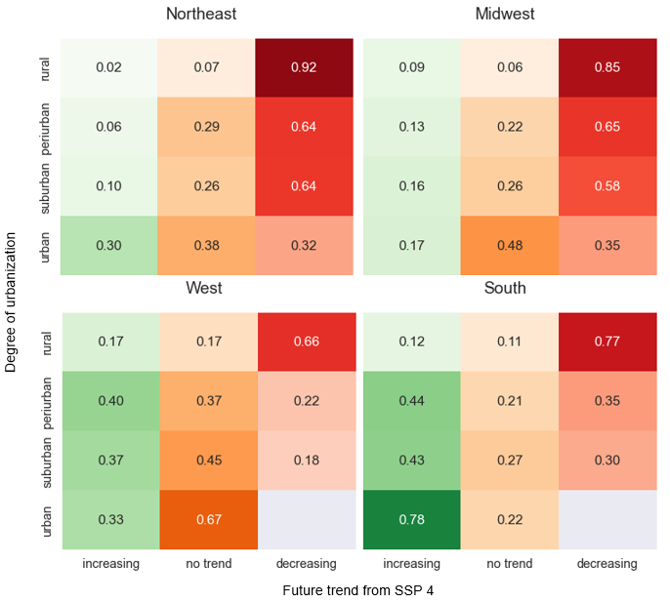
(b)
Fig. SI 6 Percent cities for different regions with future population trend in (a) SSP 1 and (b) SSP 4

2.3. Population trends and median income

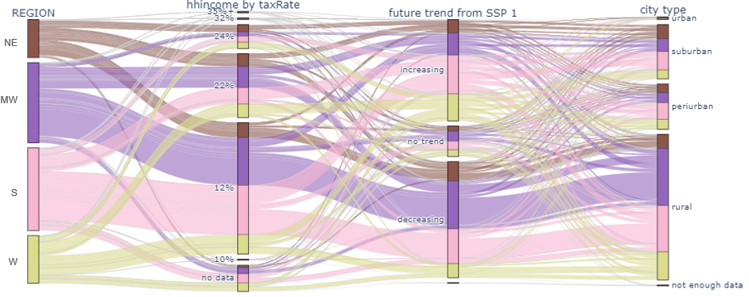
(a)
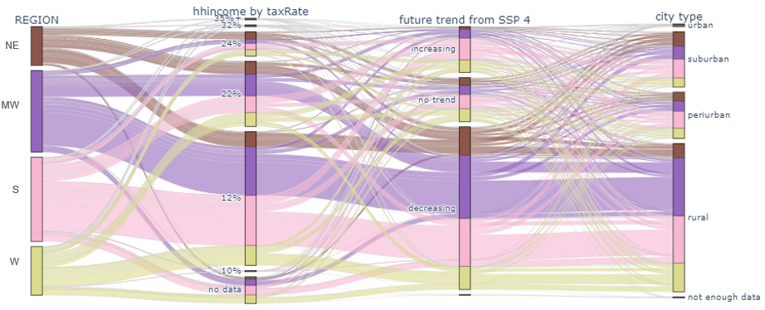
(b)
Fig. SI 7 Median income in 2020 classified by tax rate with future population trends for scenario (a) SSP 1 and (b) SSP 4. Here, NE = Northeast, MW = Midwest, S = South, W = West. From Fig. SI 7(a) we find that at SSP 1, similar to SSP 2, high income suburban, periurban and rural cities are likely to gain population in all four regions. Urban cities will flourish except for some low-income urban cities in Northeast and Midwest. On the contrary, at SSP 4, most of the cities in Northeast and Midwest will likely go through a declining trend which includes high income cities irrespective of their degree of urbanization. Most urban cities that are likely to flourish are located in the West region and their income level ranges from low to high, while in the South, even low-income urban cities are likely to gain population as illustrated in Fig. SI 7(b).

2.4. Population trends and vehicle ownership

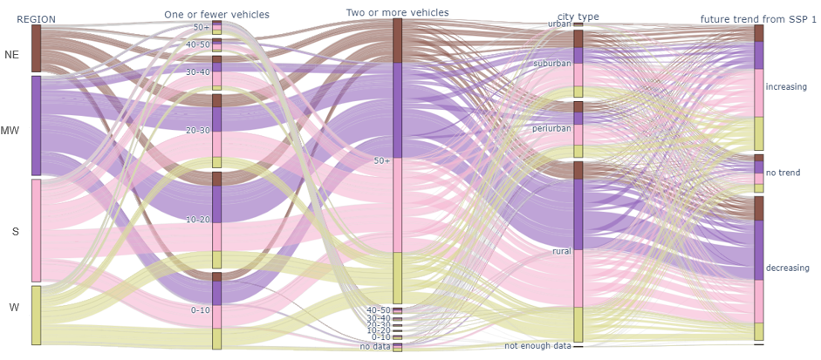
(a)
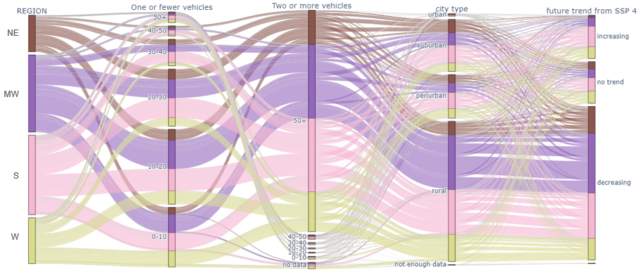
(b)
Fig. SI 8 Current vehicle ownership with future population trend for scenario (a) SSP 1 and (b) SSP 4 Here, NE = Northeast, MW = Midwest, S = South, W = West. From Fig. SI 8(a) we find that at SSP 1, a large number of suburban, periurban and rural cities, with high vehicle ownership, are likely to go through an increasing trend. This may lead to accessibility challenges for residents with low vehicle ownership in those cities which can further drive them out of those cities. Urban cities with both low and high vehicle ownership are likely to gain population. Fig. SI 8(b) presents the results for SSP 4. The results show that for South and West regions, a larger number of suburban and periurban cities with higher vehicle ownership are likely to lose population compared to those of gaining population. Most urban cities with low vehicle ownership will go through neither an increasing nor a decreasing trend in the Northeast and Midwest while the South and West regions will be gaining population. In contrast, urban cities with higher vehicle ownership are likely to show no trend in the South and West. Overall, at SSP 4 a higher number of suburban, periurban, and rural cities are likely to go through declining trend in population for all four regions while urban cities in South and West will continue to gain population.

3. Adding international immigration
Migration plays a substantial role in determining population growth in the US. Migration data is usually available at larger geographic scale. To find a city level impact of migration from metropolitan level international immigration data, we explored cities that are more prone to immigration and therefore less likely to endure the impacts of depopulation. To distribute the metropolitan statistical area (MSA) immigration data, we leverage immigrant settlement pattern from existing literature as explained in the methodology in the main article.
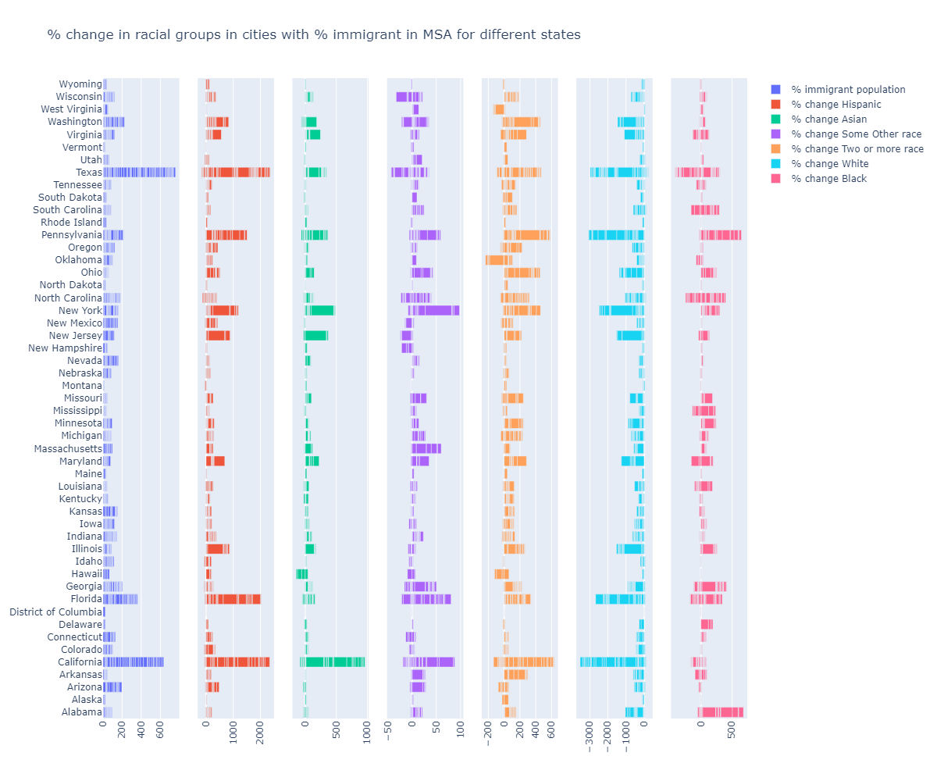
Fig. SI 9 Percent immigrant population with change in racial share from 2010 to 2020. The figure shows that there exists a positive correlation between the percent immigrant population in MSAs and the percent change in Hispanic and Asian populations in cities. Based on this correlation, we identified cities that are more likely to gain population from international immigration, and as a result, they are likely to be less vulnerable to depopulation.

4. References
[1] U. C. Bureau, “Understanding and Using American Community Survey Data: What All Data Users Need to Know,” Census.gov, Sep. 2020. https://www.census.gov/programs-surveys/acs/library/handbooks/general.html (accessed Mar. 20, 2023).
[2] M. Ratcliffe, “Understanding ‘Place’ in Census Bureau Data Products.” U.S. Census Bureau, 2012.
[3] M. E. Hauer, “Population projections for U.S. counties by age, sex, and race controlled to shared socioeconomic pathway,” Sci. Data, vol. 6, no. 1, Art. no. 1, Feb. 2019, doi: 10.1038/sdata.2019.5.
[4] J. Gao, “Downscaling Global Spatial Population Projections from 1/8-degree to 1-km Grid Cells,” 2017, doi: 10.5065/D60Z721H.
[5] B. Jones and B. C. O’Neill, “Spatially explicit global population scenarios consistent with the Shared Socioeconomic Pathways,” Environ. Res. Lett., vol. 11, no. 8, p. 084003, Jul. 2016, doi: 10.1088/1748-9326/11/8/084003.
[6] K. Riahi et al., “The Shared Socioeconomic Pathways and their energy, land use, and greenhouse gas emissions implications: An overview,” Glob. Environ. Change, vol. 42, pp. 153–168, Jan. 2017, doi: 10.1016/j.gloenvcha.2016.05.009.
[7] R. C. Estoque, M. Ooba, T. Togawa, and Y. Hijioka, “Projected land-use changes in the Shared Socioeconomic Pathways: Insights and implications,” Ambio, vol. 49, no. 12, pp. 1972–1981, Dec. 2020, doi: 10.1007/s13280-020-01338-4.
[8] H. Buhaug and J. Vestby, “On Growth Projections in the Shared Socioeconomic Pathways,” Glob. Environ. Polit., vol. 19, no. 4, pp. 118–132, Nov. 2019, doi: 10.1162/glep_a_00525.
[9] D. P. van Vuuren et al., “The Shared Socio-economic Pathways: Trajectories for human development and global environmental change,” Glob. Environ. Change, pp. 148–152, 2017, doi: 10.1016/j.gloenvcha.2016.10.009.

