Effect of fines percentage in Cellulose Nanofibrils on Ultrasonic dewatering
Udita Ringania¹, Robert J. Moon² and M. Saad Bhamla¹*

1 Chemical and Biomolecular Engineering, Georgia Tech, Atlanta, GA 30332
2 The Forest Products Laboratory, U.S.D.A. Forest Service, Madison, WI 53726

Robert J. Moon ORCID iD: 0000-0001-9526-0953
*Corresponding author: saadb@chbe.gatech.edu

Online Resource 1

Analysis of changing area of samples during drying

Timelapse images of both the samples collected at 2 fps are analyzed to extract the change in area of CNF as the drying process progressed using FIJI. The image is first cropped to an ROI (region of interest) defined by the circular center of the transducer where the CNF samples are placed. The image is then threshold so that CNF pixels get highlights and can be differentiate from the background. Area of the highlighted pixels are then calculated across the entire timelapse sequence and plotted against time to see the change of area as drying progressed for both the fines percentage. Detailed steps are presented below:
- Image sequence of the timelapse is first opened in FIJI in an 8-bit format (file >import>image sequence>select ‘convert to 8 bit’). Images are selected at intervals of 5 which translates to an image at every 2.5 sec timestamp.
- The scale (distance/pixel) is set based on the known diameter of the transducer metal center (1.6 cm) (Analyze>Set Scale)
- ROI around the transducer center is selected using the oval brush selection followed by cropping of images to this ROI (image<crop)
- We then threshold the image sequence to highlight the CNF pixels within a range (image > Adjust > Threshold>select stack histogram... We adjust the sliders so that pixels representing CNF turns white while the transducer area turns black.
- To measure the area of the CNF sample in the image sequence we first set the preferences ( Analyze > Set Measurements... and click the Area and Limit to Threshold checkboxes. This will set a preference to measure only the highlighted pixels within our ROI)
- We then measure the area of the highlighted pixels in the ROI (Analyze>analyze particles>select summaries and show results) The total area in the summary window is the area of the total area of the highlighted pixels in the image sequence presented for each image. This is the approximate area of the CNF samples used for further studies in this work.
SI-Movie 3 and SI-Movie 4 show the thresholded videos for 60 and 90% fines respectively.

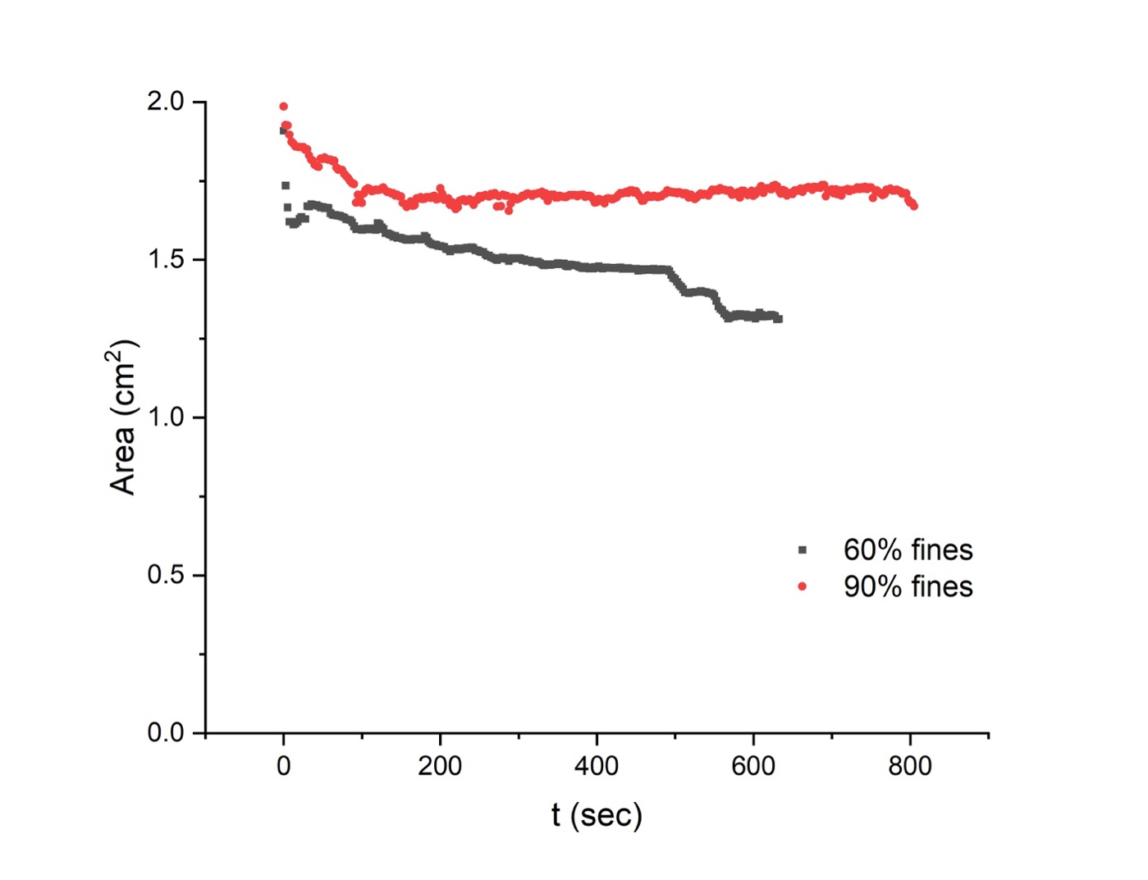
SI-Fig 1: CNF area on the transducer as dewatering progressed for 60% fines and 90% fines. The area is calculated through the analysis of the timelapse images using ImageJ software. Ultrasound is applied at every 30 sec intervals for both cases.
SI-Fig 1 presents the area reduction of the CNF sample during the drying process for both 60% fines and 90% fines. It's important to note that these timelapse images were captured in a cycle mimicking the actual experiment: ultrasound was applied for 30 seconds, then turned off for a 30-second period during which the weight of the CNF was measured. This cycle was repeated until complete water removal was achieved (refer to SI-Movie 1 and SI-Movie 2). Therefore, the timeline in the graph includes both 'on' and 'off' periods, making it longer than the actual drying time.
The observed area reduction pattern for the two types of fines differs. For 60% fines, a dramatic area reduction occurs immediately after the first application of ultrasound, followed by a gradual, slower area change. Finally, another drastic area reduction occurs during the last phase of the drying process. Conversely, for 90% fines, the area reduction occurs mostly within the initial 100 seconds, after which the area largely remains constant. Consequently, the total area reductions for 90% fines and 60% fines are 13% and 31.5%, respectively.
Analysis of Gravitational settling data (and curve fitting)
Timelapse images for the suspensions settling under gravity (recorded at 0.2 fps) were analyzed using FIJI in a similar way as the changing area during drying was calculated. As each image sequences consists of various samples, an ROI around the suspension of each sample is selected and duplicated to perform the area analysis (SI-Fig 2 demonstrates this process with a sample image). The area measured for each sample (using the steps below) are then divided by the width of the bounding ROI. This gives us the changing height of the particles in the suspension (note the area that gets recorded is of the particle suspension not the open area occupied by the clear water.). We next subtract the ROI height from the particle suspension height calculated in the previous step to get the height of the clear water from top. This gives us the change in height of the suspension (h). We next divide this height with the original measured height (H) of the suspension from the center of the lower meniscus to the bottom of the vial. This gives us the fractional change of height (h/H).
Steps for measuring area
- Image sequence of the timelapse is first opened in FIJI in an 8-bit format(file >import>image sequence>select ‘convert to 8 bit’). Images are selected at intervals of 5 which translates to an image at every 25 sec time-stamp.
- The scale (distance/pixel) is set based on the known diameter of the glass vial (2.7cm) (Analyze>Set Scale)
- ROI around the suspension for each sample is selected using the rectangle brush selection and duplicated (image<duplicate<select all stack)
- We then threshold the image sequence to highlight the CNF pixels within a range (image > Adjust > Threshold>select stack histogram... We adjust the sliders so that pixels representing CNF turns white while the clear water area turns black.
- To measure the area of the CNF sample in the image sequence we first set the preferences ( Analyze > Set Measurements... and click the Area and Limit to Threshold checkboxes. This will set a preference to measure only the highlighted pixels within our ROI)
- We then measure the area of the highlighted pixels in the ROI (Analyze>analyze particles>select summaries and show results) The total area in the summary window is the area of the highlighted pixels in the image sequence presented for each image. Row by row. This is the approximate area of the CNF suspension used for further analysis in this work
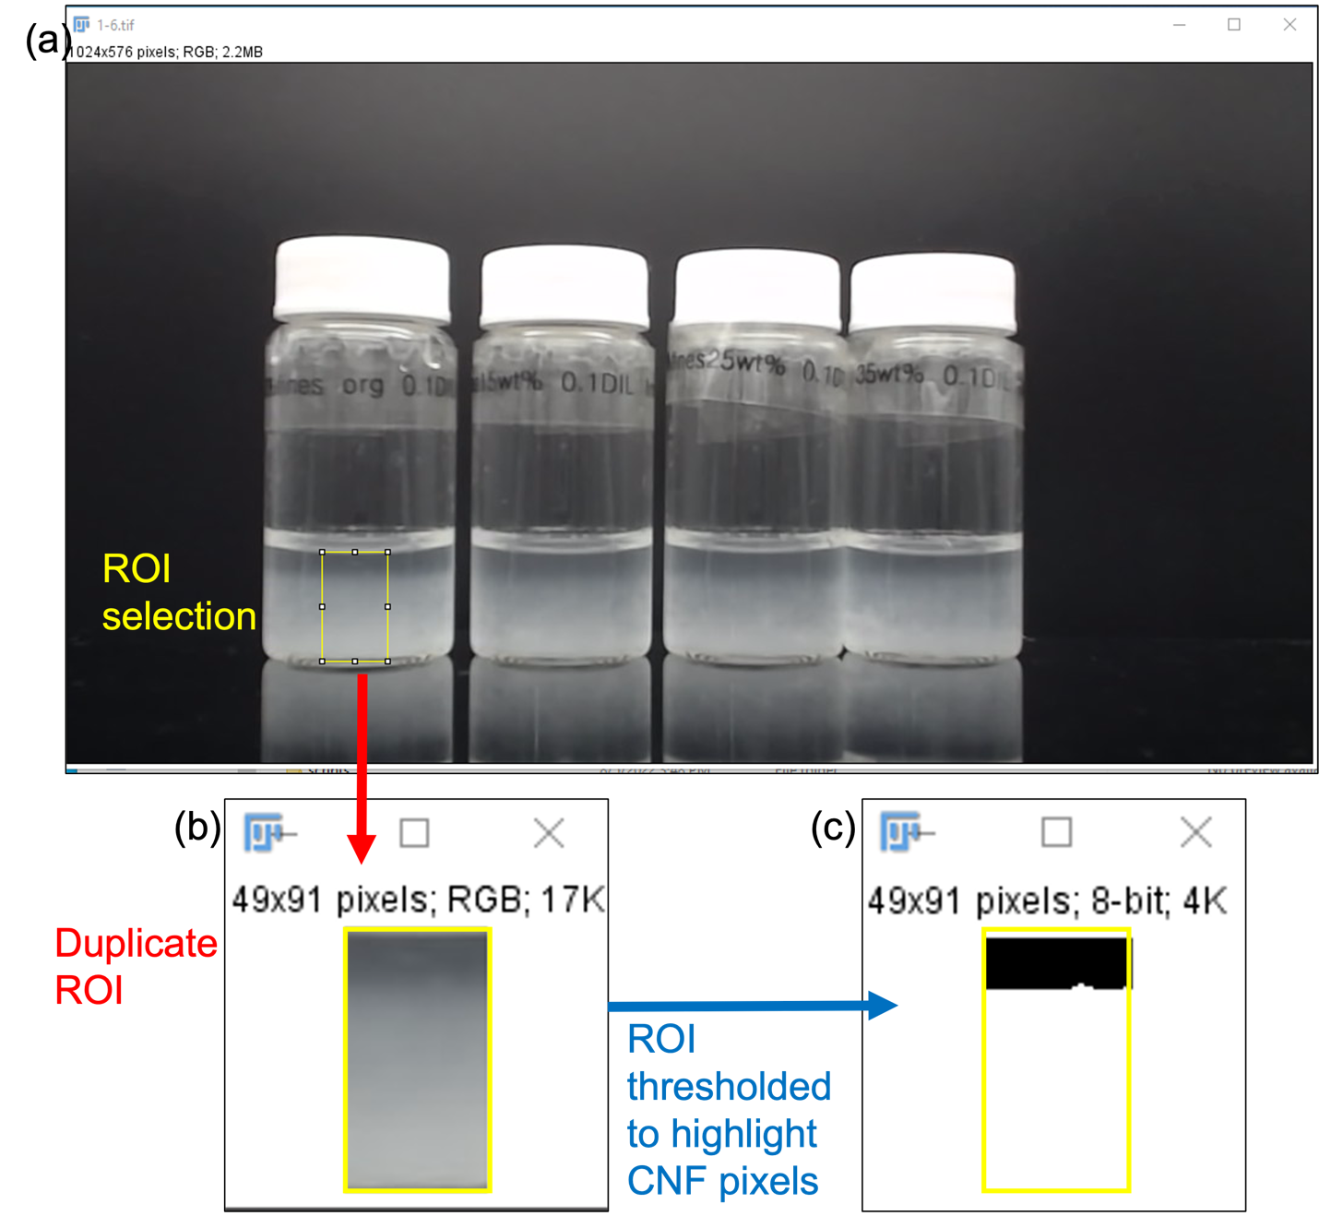
SI-Fig 2: (a) A representative timelapse image of the gravitational showing the ROI selected for further analysis. (b) a duplicate of the ROI is created which is then used for calculation of the area occupied by CNF particles. (c) The duplicate ROI is thresholded to highlight the CNF pixels. The area of the highlighted pixels is calculated using ImageJ build in functions. This is repeated for every image sequence of every samples.
The graphs obtained by plotting the fractional change in height with time looked like a growing exponential curve reaching an asymptote. Using Origin plots, we found out that exponential fit (equation below) gives the best fit.
$$y=y_{0}+Aexp (R_{0}*x)$$
Here $y_{0}$ gives us the final fraction change in height of the settlement, and $R_{0}$reflects the rate and x is time. Using this fit, y₀ for each sample was calculated. The graphs for fractional change in height and their respective exponential fit for all samples are presented in SI-Fig 3, 4 and 5.
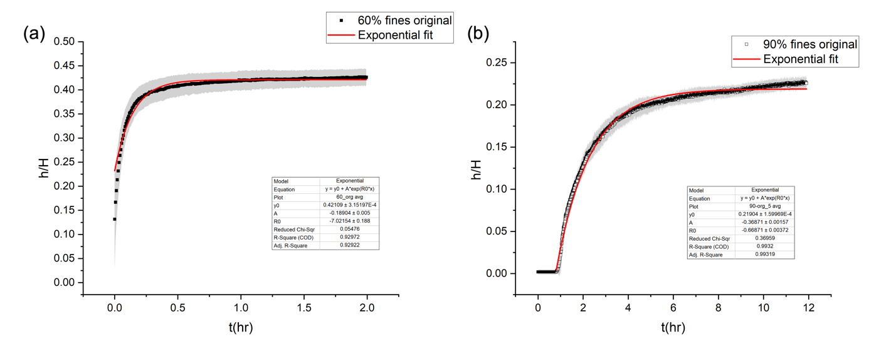
SI-Fig 3: Normalized change in height for gravitational settling experiments along with the exponential fit for original(a) 60 % fines and (b) 90% fines. The insets provide the parameter values for the fits. The grey area around the curves represents the standard deviation error.
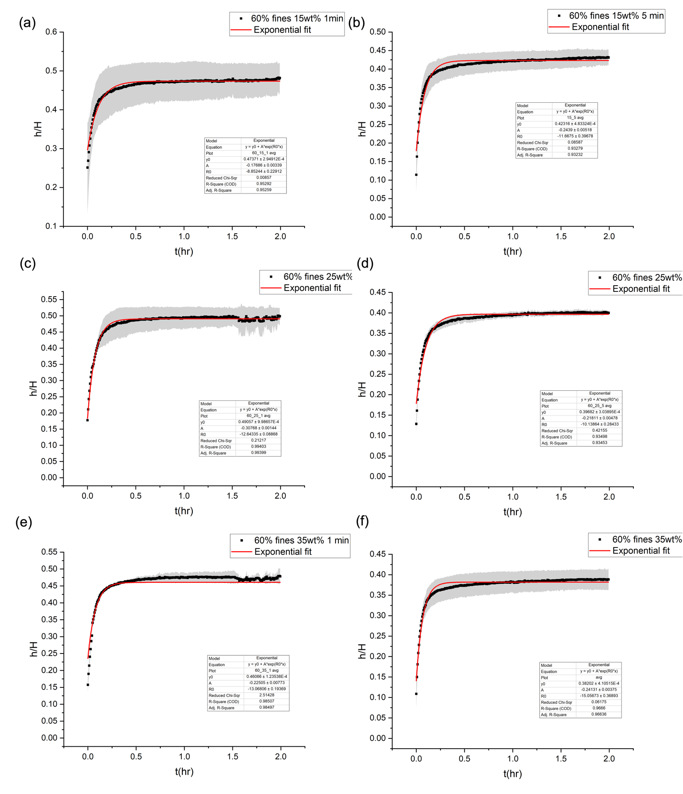
SI-Fig 4: Normalized change in height for gravitational settling experiments for 60% fines dewatered and redispersed to (a) 15 wt.%, 1 min (b) 15 wt.%, 5 min (c) 25 wt.%, 1 min (d) 25 wt.%, 5 min (e) 35 wt.%, 1min (f) 35wt.%, 5 min. Insets provide parameter values for the fit. The grey area around the curves represents the standard deviation error.
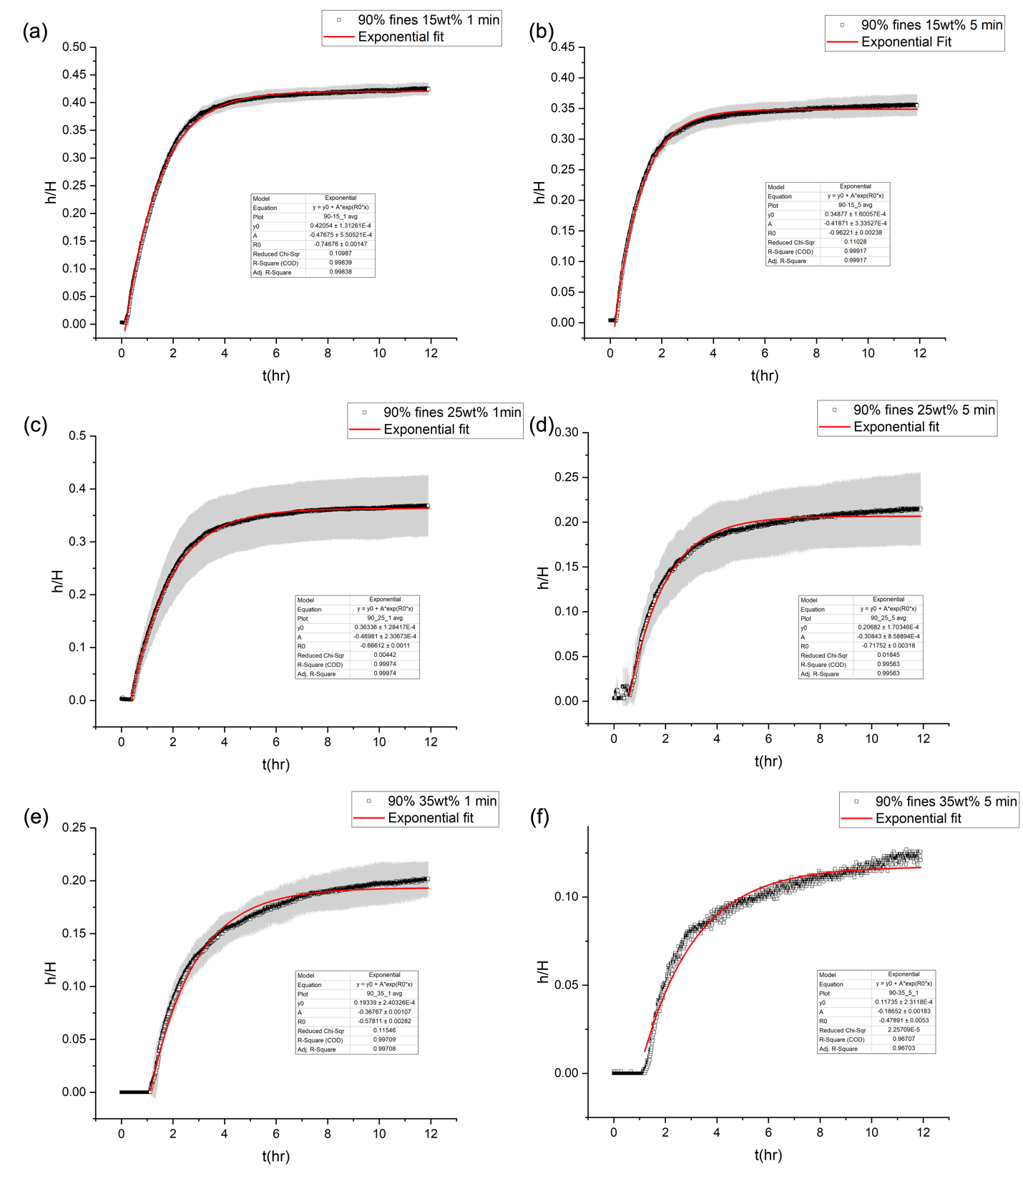
SI-Fig 5: Normalized change in height for gravitational settling experiments for 90% fines dewatered and redispersed to (a) 15 wt.%, 1 min (b) 15 wt.%, 5 min (c) 25 wt.%, 1 min (d) 25 wt.%, 5 min (e) 35 wt.%, 1min (f) 35wt.%, 5 min. Insets provide parameter values for the fit. The grey area around the curves represents the standard deviation error.
UV-visible transmission spectroscopy for CNFs with various fines %
We received samples with various fines percentages from UMaine, detailed in SI-Table 1. UV-vis transmission spectroscopy was conducted on all samples to assess the relationship between fines percentage and transmittance. SI-Fig 6 and SI-Fig 7 display the transmittance data for all fines percentages during wavelength sweeps from 350nm to 800nm and at 550nm, respectively.

SI-Fig 8 and SI-Fig 9 depict the UV-vis transmittance for a wavelength sweep from 350 to 800 nm for all 60 percent fines and 90 percent fines samples, respectively.

SI-Table 1: Specifications of CNF fines obtained from University of Maine
% fines | Lot #
60% fines | U136-K
70% fines | U136-G
80% fines | U135
90% fines | U140
96.3% fines | U138-S3-F
100% fines | U125

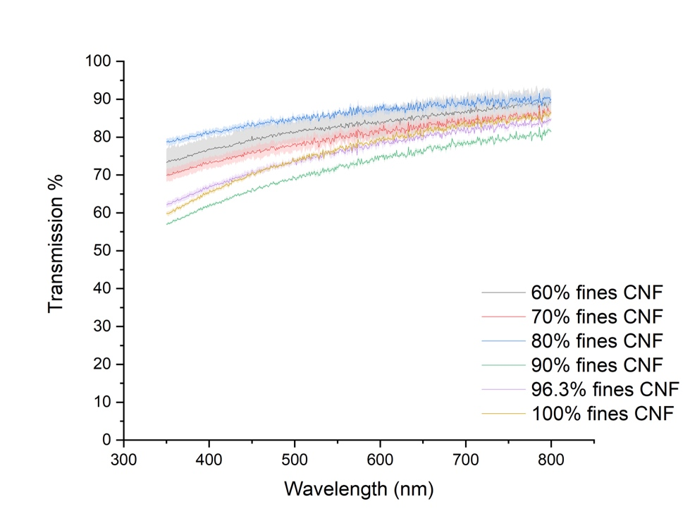
SI-Fig 6: UV-Vis transmission sweep data between 350-800 nm for CNF samples with various fines % received from University of Maine and diluted to 0.01 wt.%.
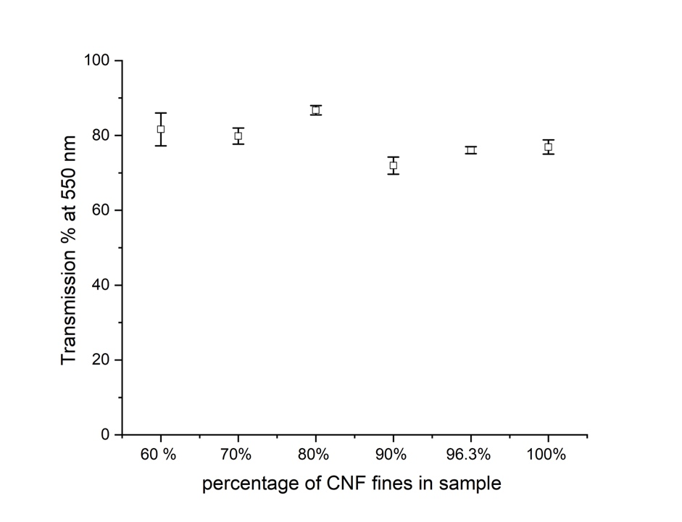
SI-Fig 7: UV-Vis transmission data at 550 nm for CNF samples with various fines % received from University of Maine and diluted to 0.01 wt.%.
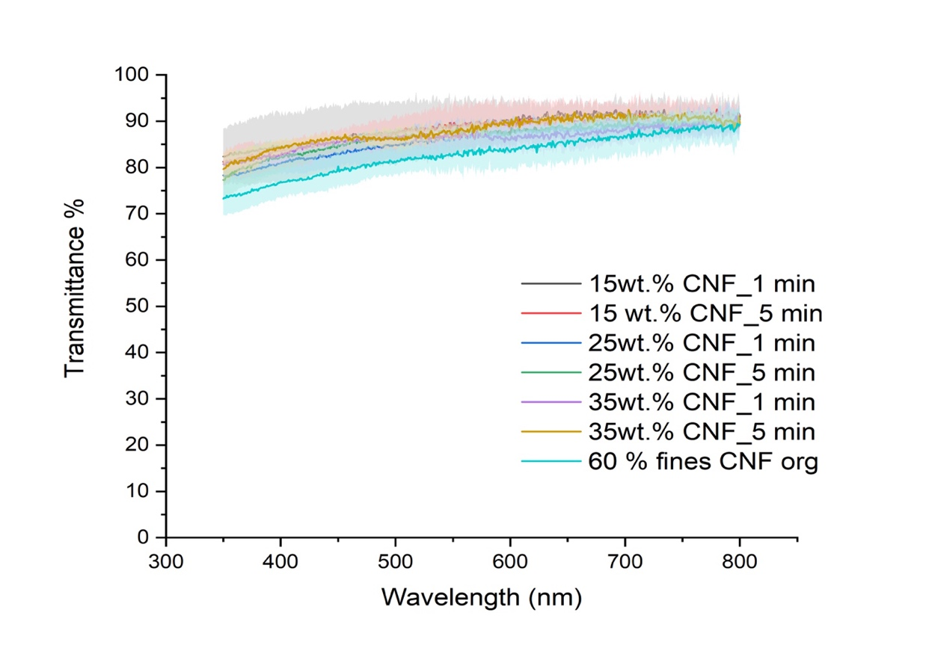
SI-Fig 8: UV-Vis transmission sweep data between 350-800 nm for 60% fines samples dewatered using ultrasound to various wt.% and redispersed for 1 min and 5 min.
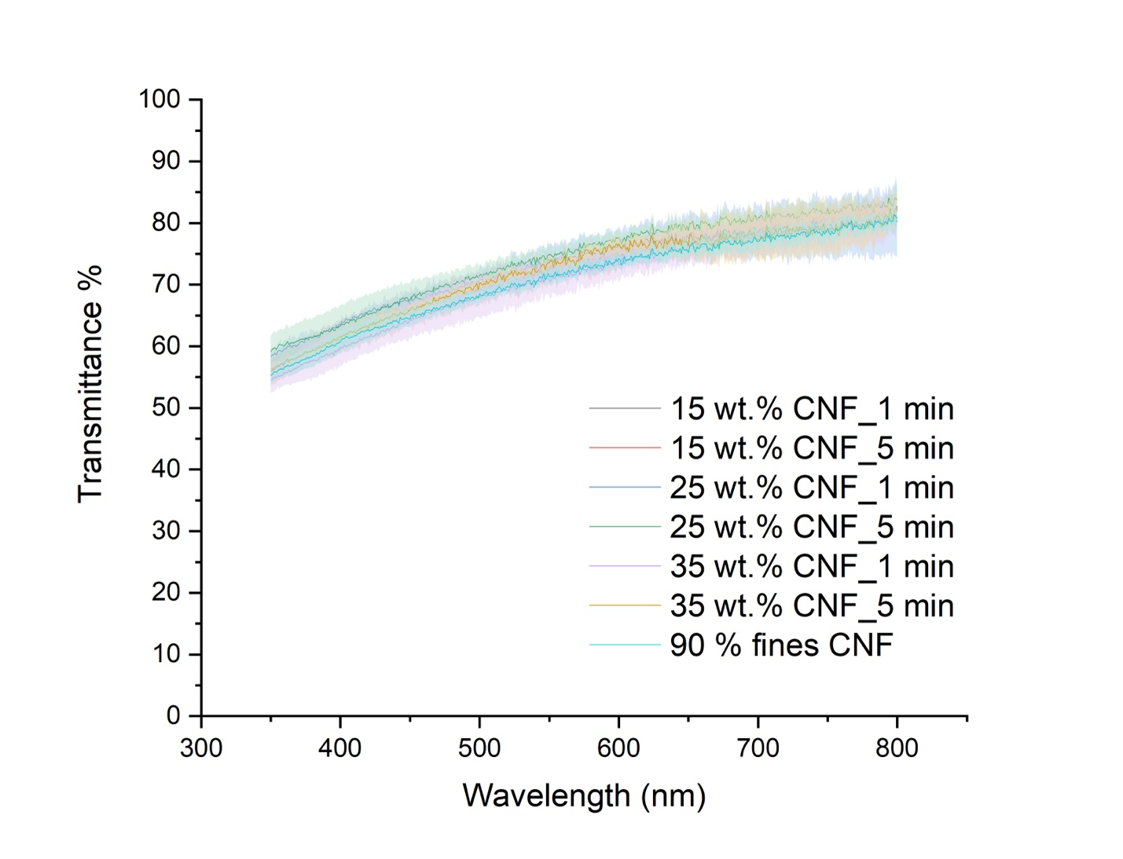
SI-Fig 9: UV-Vis transmission sweep data between 350-800 nm for 90% fines samples dewatered using ultrasound to various wt.% and redispersed for 1 min and 5 min.

Normalized wt. vs time data for samples dewatered to various wt.%
SI-Fig 10 shows the dewatering curves for the 60% fines samples for dewatering performed for various wt. %. SI-Fig 11 shows the dewatering curves for the 90% fines samples. Both the samples were dewatered to 15, 25, 35 and 100 wt.% CNF. The curve profiles are similar with a reasonable level of overlap, but perfect overlap is not achieved, which we believe a result of some variability in this testing method. As the ultrasound is applied at an interval of 30 secs in our work, controlling the wt.% precisely at each interval is difficult as it directly depends on the amount of water removed from the system. Hence, for any given wt.%, we observe a range of time within which it is achieved. This can potentially be overcome if we reduce the ultrasound application interval or if we can measure the wt.% of the CNF continuously during the process. 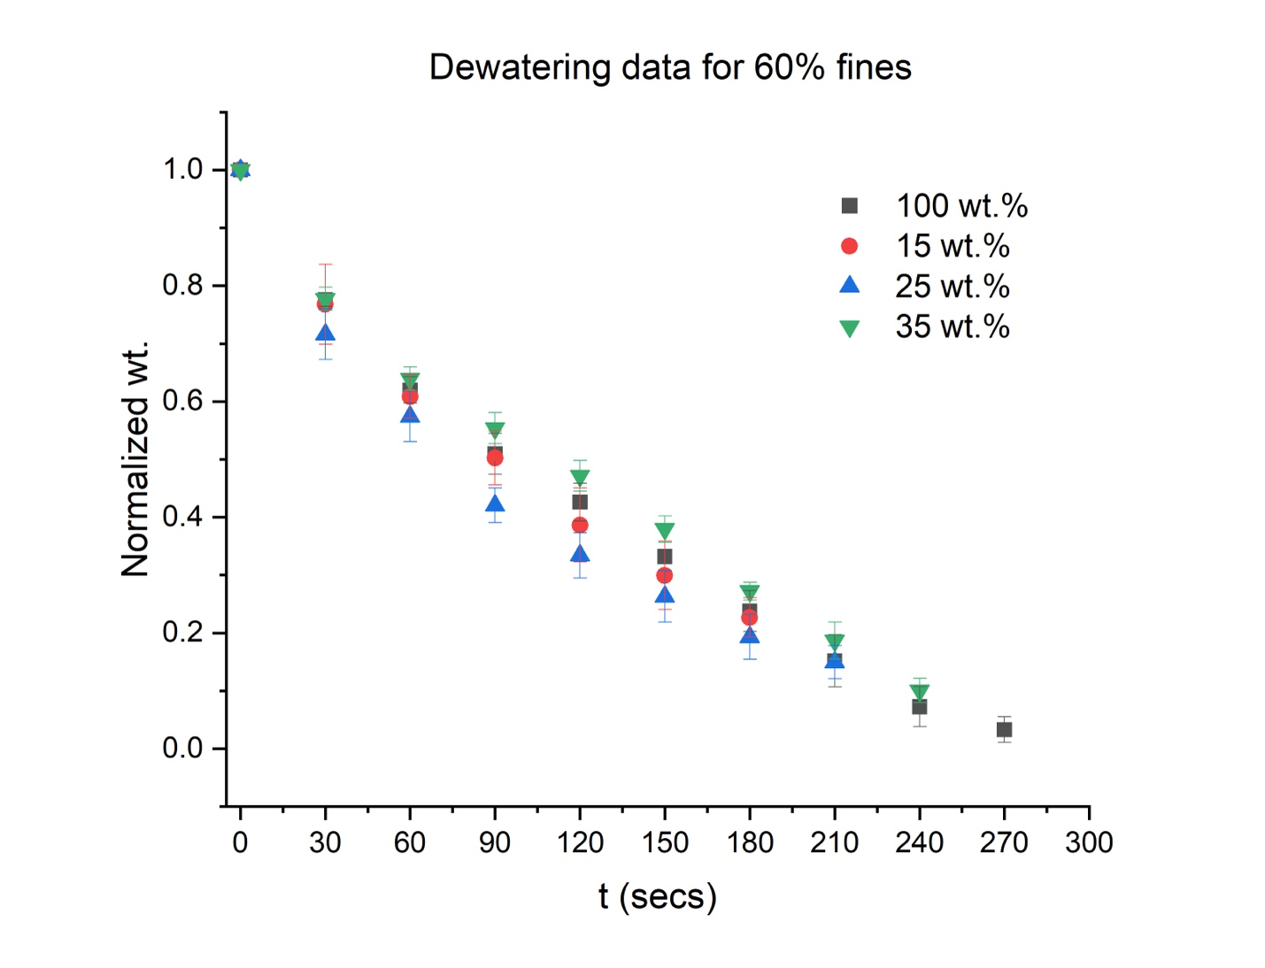
SI-Fig 10: Normalized wt. of CNF as dewatering progressed for 60% fines samples dewatered to various final solid wt.%. The trend for dewatering is similar for all samples with higher dewatering time required to achieve higher final solid wt.%.
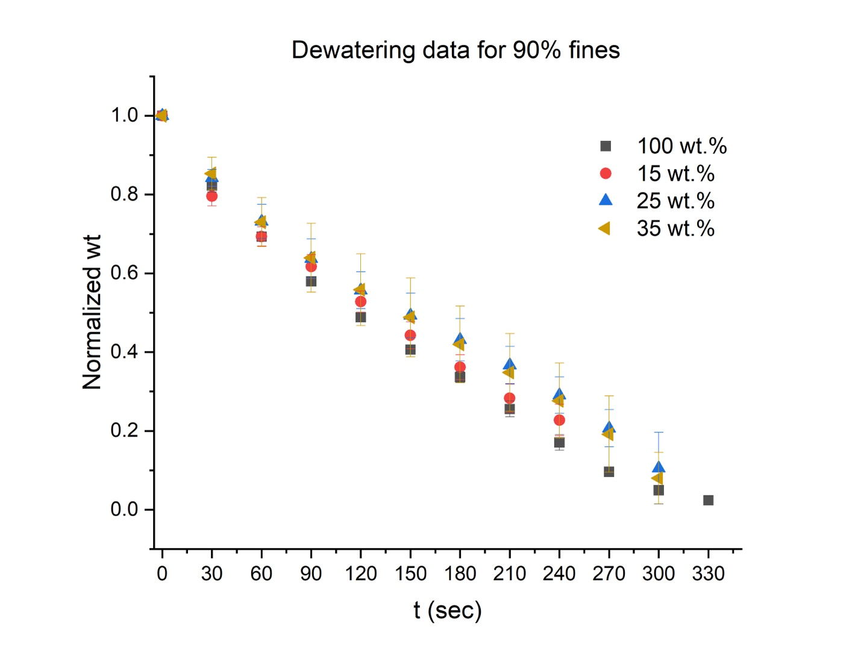
SI-Fig 11: Normalized wt. of CNF as dewatering progressed for 90% fines samples dewatered to various final solid wt.%. The trend for dewatering is similar for all samples with higher dewatering time required to achieve higher final solid wt.%.

Non-linear graph for water removed vs CNF wt.%
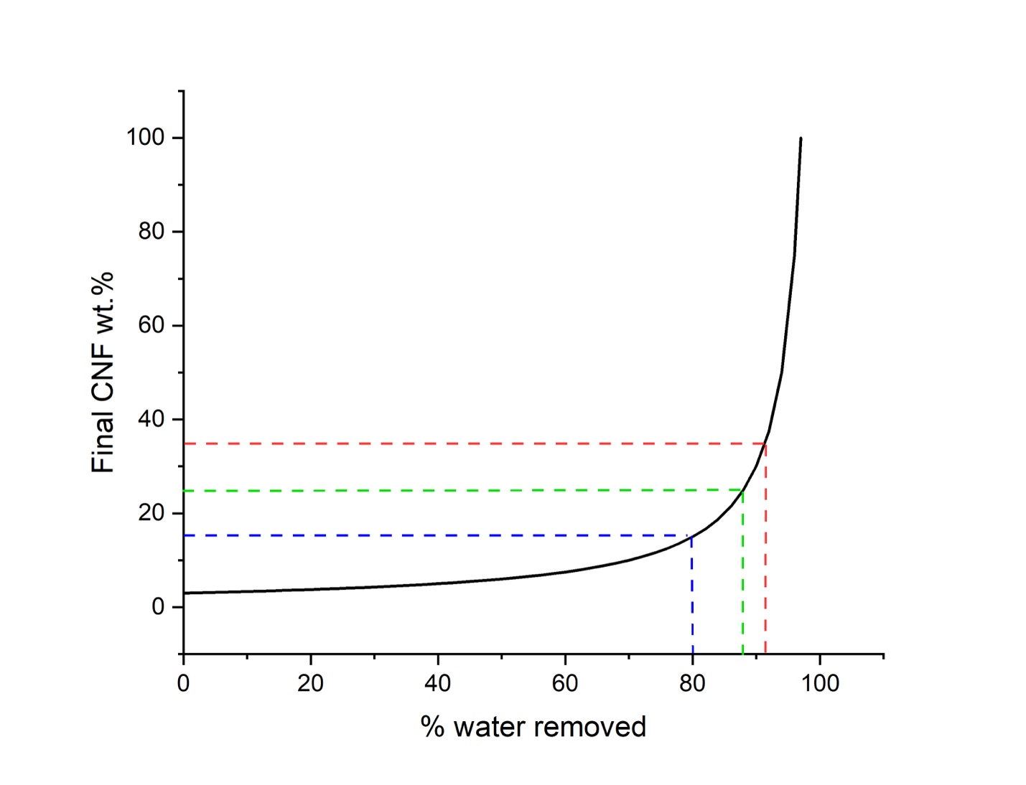
SI-Fig 12: The graph represents the final CNF wt.% as a function of the percentage of water removed from the system, displaying an exponential rise. This non-linear relationship suggests that substantial water removal in the initial phase only results in a marginal increase in the CNF wt.%. However, in the latter stages of the graph, beyond the 90% water removal mark, even a minor increase in the percentage of water removed corresponds to an exponential increase in CNF wt.%.

Statistic tests for our data:

To assess the similarities or differences in the data for settling height, t₉₀, and UV vis transmission for dewatered samples compared to the original sample, we conducted Welch's t-tests. This test evaluates whether two sample populations have identical means. Its null hypothesis postulates that the means of the two-sample populations are similar. Since this test does not assume equal variance among the two samples, it suits our data.
We used the built-in function t.test() in R Studio to conduct these tests for all the samples in our study. The test outputs a p-value and a 95% confidence interval. A small p-value (typically ≤0.05) suggests that we can reject the null hypothesis, indicating a statistically significant difference in the means of the two sample populations. The 95% confidence interval provides an estimate of the range within which the difference in the means of the two populations likely falls. If this range includes zero, we cannot reject the null hypothesis, indicating that the means of the two populations are statistically similar.
We used these two parameters to evaluate the similarity of our dewatered samples' data with the original sample. If the p-value <0.05 and the 95% confidence interval includes zero, we consider the dewatered sample's data similar to the original sample. The table below presents the p-values and 95% confidence intervals for various pairs and their respective deductions. Online Resource 2 contains the R file results.
SI-Table 2
 | Sample pairs with original | p-value | 95% confidence interval | Deductions in terms of original sample
Gravitational settling for 60% fines | 15 wt.% 1 min | 0.459 | [-0.146,0.084] | Similar
Gravitational settling for 60% fines | 25 wt.% 1 min | 0.267 | [-0.111,0.036] | Similar
Gravitational settling for 60% fines | 35 wt.% 1 min | 0.400 | [-0.104,0.049] | Similar
Gravitational settling for 60% fines | 15 wt.% 5 min | 0.514 | [-0.051,0.090] | Similar
Gravitational settling for 60% fines | 25 wt.% 5 min | 0.399 | [-0.044,0.097] | Similar
Gravitational settling for 60% fines | 35 wt.% 5 min | 0.077 | [-0.009,0.134] | Similar
Gravitational settling for 90% fines | 15 wt.% 1 min | 0.017 | [-0.136, -0.023] | Dissimilar
Gravitational settling for 90% fines | 25 wt.% 1 min | 0.052 | [-0.253,0.003] | Dissimilar
Gravitational settling for 90% fines | 35 wt.% 1 min | 0.054 | [-0.227,0.004] | Dissimilar
Gravitational settling for 90% fines | 15 wt.% 5 min | 0.545 | [-0.092,0.059] | Similar
Gravitational settling for 90% fines | 25 wt.% 5 min | 0.343 | [-0.054,0.112] | Similar
Gravitational settling for 90% fines | 35 wt.% 5 min | 0.523 | [-0.033,0.057] | Similar
t₉₀ for 60% fines | 15 wt.% 1 min | 0.866 | [-0.944,0.984] | Similar
t₉₀ for 60% fines | 25 wt.% 1 min | 0.733 | [-0.090,0.120] | Similar
t₉₀ for 60% fines | 35 wt.% 1 min | 0.516 | [-0.378,0.480] | Similar
t₉₀ for 60% fines | 15 wt.% 5 min | 0.689 | [-0.134,0.177] | Similar
t₉₀ for 60% fines | 25 wt.% 5 min | 0.655 | [-0.067,0.100] | Similar
t₉₀ for 60% fines | 35 wt.% 5 min | 0.142 | [-0.025,0.132] | Similar
t₉₀ for 90% fines | 15 wt.% 1 min | 0.0005 | [0.618,1.138] | Dissimilar
t₉₀ for 90% fines | 25 wt.% 1 min | 0.011 | [0.463,1.607] | Dissimilar
t₉₀ for 90% fines | 35 wt.% 1 min | 0.011 | [0.371,1.352] | Dissimilar
t₉₀ for 90% fines | 15 wt.% 5 min | 0.140 | [-0.096,0.473] | Similar
t₉₀ for 90% fines | 25 wt.% 5 min | 0.736 | [-0.930,1.131] | Similar
t₉₀ for 90% fines | 35 wt.% 5 min | 0.193 | [-0.210,0.675] | Similar
UV vis Transmission at 550nm for 60% fines | 15 wt.% 1 min | 0.271 | [16.424,6.884] | Similar
UV vis Transmission at 550nm for 60% fines | 25 wt.% 1 min | 0.082 | [-8.497,0.687] | Similar
UV vis Transmission at 550nm for 60% fines | 35 wt.% 1 min | 0.077 | [-8.716,0.636] | Similar
UV vis Transmission at 550nm for 60% fines | 15 wt.% 5 min | 0.128 | [-15.778,3.272] | Similar
UV vis Transmission at 550nm for 60% fines | 25 wt.% 5 min | 0.0692 | [-7.905,0.480] | Similar
UV vis Transmission at 550nm for 60% fines | 35 wt.% 5 min | 0.0573 | [-8.876,0.196] | Similar
UV vis Transmission at 550nm for 90% fines | 15 wt.% 1 min | 0.487 | [-3.661,2.085] | Similar
UV vis Transmission at 550nm for 90% fines | 25 wt.% 1 min | 0.227 | [-7.217,2.641] | Similar
UV vis Transmission at 550nm for 90% fines | 35 wt.% 1 min | 0.858 | [-3.280,3.779] | Similar
UV vis Transmission at 550nm for 90% fines | 15 wt.% 5 min | 0.585 | [-4.722,3.179] | Similar
UV vis Transmission at 550nm for 90% fines | 25 wt.% 5 min | 0.145 | [-4.954,0.973] | Similar
UV vis Transmission at 550nm for 90% fines | 35 wt.% 5 min | 0.411 | [-4.139,1.939] | Similar

