Appendix A
The model
- The bank's profit function
Let $C\left(X\right)$ be the transaction costs of the bank, where $C\left(X\right)$ is assumed to be convex. Therefore, the bank's profit function can be written as:
$π=\left(1+r\right)θX-C\left(X\right)-X$, which implies that $π=\left(\left(1+r\right)θ-1\right)X-C\left(X\right)$ with $X≥0$ and $C\left(X\right)≥0$.
- Showing that $∂E(π)/∂X=0$is equivalent to solving the equation $C^{'}\left(X\right)=\left(\left(1+r\right)θ-1\right)$
$∂E(π)/∂X=0$ ⇒$\int_{-∞}^{+∞}{\frac{∂h\left(X,z\right)}{∂X}}dz=0$, where $h\left(X,z\right)=\left[\left(\left(1+r\right)θ-1\right)X-C\left(X\right)+z\right]{ g}_{Z}\left(z\right)$.
Since $X$ and $Z$ are independent variables, it follows that: $\frac{∂h\left(X,z\right)}{∂X}=$ $\left[\left(\left(1+r\right)θ-1\right)-C^{'}\left(X\right)\right]{ g}_{Z}\left(z\right)$ Therefore : $\int_{-∞}^{+∞}{\frac{∂h\left(X,z\right)}{∂X}}dz=0$ ⇒$\int_{-∞}^{+∞}{\left[\left(\left(1+r\right)θ-1\right)-C^{'}\left(X\right)\right]{ g}_{Z}\left(z\right)dz=0}$
Thus $\left[\left(\left(1+r\right)θ-1\right)-C^{'}\left(X\right)\right]\int_{-∞}^{+∞}{{ g}_{Z}\left(z\right)dz=0}$.
Which implies that: $\left[\left(\left(1+r\right)θ-1\right)-C^{'}\left(X\right)\right]=0$ since $\int_{-∞}^{+∞}{{ g}_{Z}\left(z\right)dz=1}$.
$∂E(π)/∂X=0$ is thus equivalent to solving the equation $C^{'}\left(X\right)=\left(\left(1+r\right)θ-1\right)$. This equation has a unique solution because if $C$ is convex, then $C^{'}$ is invertible. Denoting by $C^{'-1}$ and $X^{*}$ the inverse of $C^{'}$ and the solution of this equation respectively, we have: $X^{*}=C^{'-1}\left[\left(\left(1+r\right)θ-1\right)\right].$
- Let's show that $E\left(π^{*}\right)<-K_{P}$ implies $z<{-K}_{P}-\left(\left(1+r\right)θ-1\right)X^{*}+C\left(X^{*}\right)$.
By replacing $X^{*}$ in the expression of $E\left(π\right)$, we obtain the expression of the bank optimal expected profit:
$$E\left(π^{*}\right)=\int_{-∞}^{+∞}{\left[\left(\left(1+r\right)θ-1\right)X^{*}-C\left(X^{*}\right)+z\right]}g_{Z}\left(z\right)dz$$
$E\left(π^{*}\right)<-K_{P}$ ⇒$\int_{-∞}^{+∞}{\left[\left(\left(1+r\right)θ-1\right)X^{*}-C\left(X^{*}\right)+z\right]}g_{Z}\left(z\right)dz <-K_{P}$
Therefore, $\int_{-∞}^{+∞}{\left[\left(\left(1+r\right)θ-1\right)X^{*}-C\left(X^{*}\right)+z\right]}g_{Z}\left(z\right)dz <\int_{-∞}^{+∞}{-K_{P}g_{Z}\left(z\right)dz}$ as $\int_{-∞}^{+∞}{g_{Z}\left(z\right)dz=1}$.
This implies that $\int_{-∞}^{+∞}{\left[\left(\left(1+r\right)θ-1\right)X^{*}-C\left(X^{*}\right)+z+K_{P}\right]}g_{Z}\left(z\right)dz<0$.
Since $g_{Z}\left(z\right)>0$, we can conclude that $\left[\left(\left(1+r\right)θ-1\right)X^{*}-C\left(X^{*}\right)+z+K_{P}\right]<0$, which in turn implies that $z<{-K}_{P}-\left(\left(1+r\right)θ-1\right)X^{*}+C\left(X^{*}\right).$
Therefore, $E\left(π^{*}\right)<-K_{P}$ ⇒ $z<{-K}_{P}-\left(\left(1+r\right)θ-1\right)X^{*}+C\left(X^{*}\right)$.
- Let's show that $P=G_{Z}\left[{-K}_{P}-\left(\left(1+r\right)θ-1\right)X^{*}+C\left(X^{*}\right) \right]$
$P=Prob \left(E\left(π^{*}\right)<-K_{P} \right)$ ⇒ $P=Prob \left(z<{-K}_{P}-\left(\left(1+r\right)θ-1\right)X^{*}+C\left(X^{*}\right) \right)$
Therefore, $P=G_{Z}\left[{-K}_{P}-\left(\left(1+r\right)θ-1\right)X^{*}+C\left(X^{*}\right) \right]$
- Let's show that $∂P/∂K_{P}<0$.
We know that : $∂P/∂K_{P}=-g_{Z}\left[{-K}_{P}-\left(\left(1+r\right)θ-1\right)X^{*}+C\left(X^{*}\right)\right]$, but $g_{Z}\left[{-K}_{P}-\left(\left(1+r\right)θ-1\right)X^{*}+C\left(X^{*}\right)\right]>0$; hence $∂P/∂K_{P}<0.$

Appendix B
Figure 2: The functions $f_{1}\left(gov\right)$ and $f_{2}\left(gov\right)$
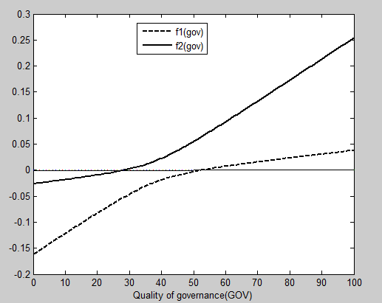

Source: The author's estimates

