Extended Data Fig. 1 Band inversion in mechanical spring models depicted through polyyne and oligoynes.
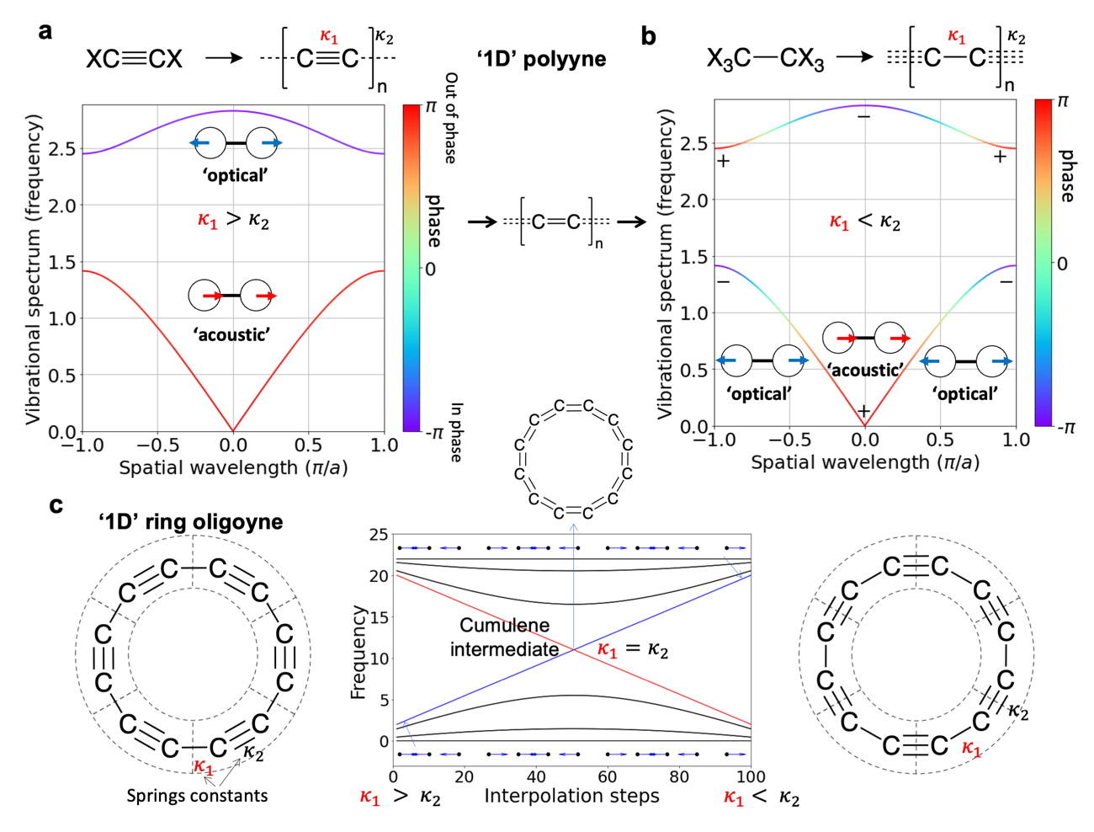
a Trivial case of the SSH model (trivial polymer) consists of monomers of two triple bonded carbon atoms that are single bonded to their neighbours. In the trivial band structure, bands can be classified as optical and acoustic in terms of the inner product between vibrational displacement in one unit-cell. When the inner product is positive, the atoms move in-phase while otherwise they move out-of-phase. For the trivial polymer, the lower energy vibrations move in-phase (acoustic branch), while the higher energy vibrations move out-of-phase (optical branch). b The topological case of the SSH model (topological polymer) occurs by exchanging the strong and weak springs, which produces an inversion in the phase of the branches along the unit cell wavevector, without affecting the vibrational spectrum. The outer-most in-phase vibration is shifted to a higher energy and, at the same time the outer-most out-of-phase vibration is shifted to lower energies. The net effect is that the phase of both branches is inverted when spanning the symmetrical wavelength interval $\left[-\frac{π}{a} , \frac{π}{a}\right]$ or first Brillouin zone, with associated winding number (Supplementary Figure 1). c. Band inversion explained without band theory: The spectrum of finite spring chains which can be understood as a mechanical oligoyne is obtained upon switching values of $κ_{1}$ and $κ_{2}$ from 10 to 1 in a periodic system of 12 masses results in the inversion of one eigenmode. The inset images show the (real space) displacement vectors for the eigenmode transported from low to high frequency (blue line).

