SUPPLEMENTARY INFORMATION
Deciphering the Ages of Saline Water in the Baltic Sea by Anthropogenic Radiotracers

This 9-page Supporting Information file includes supplementary text for 2 figures, 3 tables, and SI references.

Supplementary Figures and Tables
Figure S1. Mixing diagrams of ¹²⁹I concentration (A) vs salinity and NR-derived ²³⁶U concentration vs salinity (B) in the Baltic Sea. The functions for mixing lines are as below:
(A) Surface samples (2015)
Saline waters: C_{I-129} = -51.8 × sal. + 1872 (10⁹ at/kg) R²=0.641
Brackish waters: C_{I-129} = 4.43 × sal. - 29.6 (10⁹ at/kg) R²=0.972
(A) Profile samples (2018-2019)
Saline waters: C_{I-129} = -31.5 × sal. + 1111 (10⁹ at/kg) R²=0.963
Brackish waters: C_{I-129} = 0.922 × sal. + 2.01 (10⁹ at/kg) R²=0.845
(B) Surface samples (2015)
Saline waters: C_{U-236} = -13.0 × sal. + 501 (10⁶ at/kg) R²=0.585
Brackish waters (upper limit): C_{U-236} = 11.5 × sal. - 50.6 (10⁶ at/kg) R²=0.999
Brackish waters (lower limit): C_{U-236} = 1.47 × sal. + 5.87 (10⁶ at/kg) R²=0.997
(B) Profile samples (2018-2019)
Saline waters: C_{U-236} = -16.8 × sal. + 602 (10⁶ at/kg) R²=0.856
Brackish waters (upper limit): C_{U-236} = 2.57 × sal. + 6.13 (10⁶ at/kg) R²=0.980
Brackish waters (lower limit): C_{U-236} = 1.70 × sal. + 5.81 (10⁶ at/kg) R²=0.984

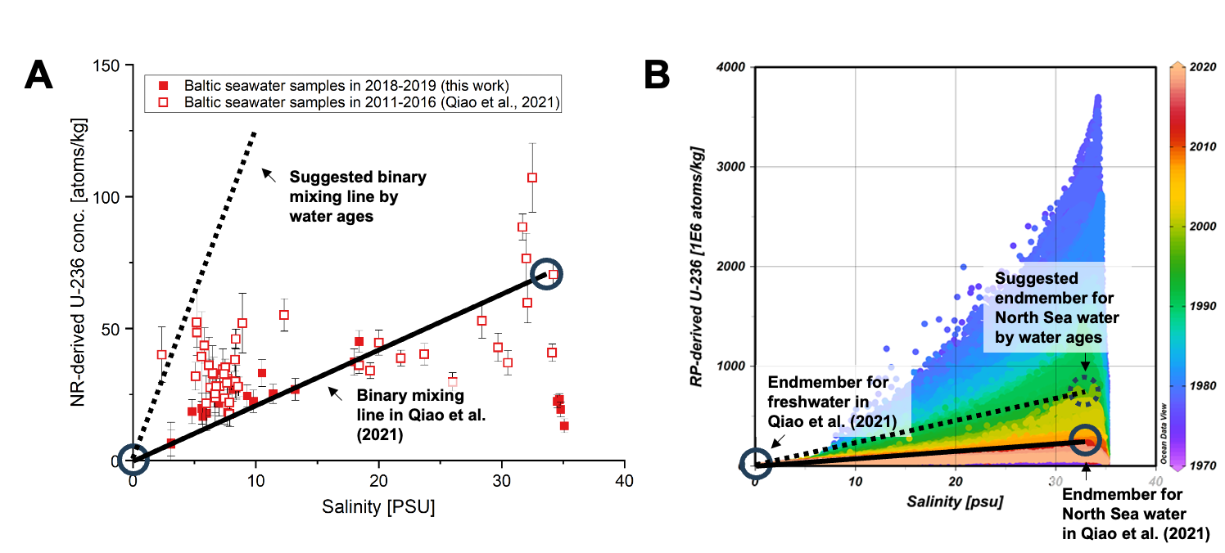
Figure S2. (A) Observed mixing diagram for NR-derived ²³⁶U concentration vs salinity for Baltic seawater samples reported in Qiao et al. (2021) and this work; (B) Simulated mixing diagram of RP-derived ²³⁶U vs salinity for 74 stations in the Baltic Sea during the past five decades. The solid circles represent the endmembers of the freshwater and North Sea water adopted in Qiao et al. (2021), and the solid line is the corresponding binary mixing line. The dashed circle represents the suggested “aged” endmember of the North Sea water according to the age of the surface water in the central Baltic Sea, and the dashed line is the corresponding binary mixing line.

Table S1. Major sources of ¹²⁹I, ²³⁶U, and ²³³U in the environment. Discharge data of Sellafield and La Hague refer to the releases before 2017. Other nuclear reprocessing plants releasing ¹²⁹I include Hanford (USA), Savannah River (USA), Mayak (USSR), Seversk (USSR), and Zhelesnogorsk (USSR).

Sources | ¹²⁹I [kg] | Ref. | ²³⁶U [kg] | Ref. | ²³³U [kg] | Ref.
Natural production | 263 | 1,2 | 35 | 3
Nuclear weapons testing | 90 | 4 | 900 - 2100 | 5–8 | 9 - 15 | 9
Nuclear reprocessing plants
Sellafield (UK) | 1880 (liquid)  159 (gaseous) | 10–12 | >237 | 13
La Hague (France) | 5703 (liquid)  75 (gaseous) | 10–12 | 25 | 13 | 7.5 x 10⁻⁶ | 14
Marcoule (France) | 45 (liquid)  145 (gaseous) | 15 | 10 - 20 | 16
Others | 669 (gaseous) | 12
Nuclear accidents
Chernobyl accident | 1.3 - 6 | 17,18 | 60 - 80 | 19,20
Fukushima accident | 1.2 | 21 | 3 x 10⁻⁴ | 22
Total | 9033 |  | 1882 |  | 12

Table S2: The overall measurement results for ¹²⁹I, ²³⁶U, and ²³³U during 2015-2019 and the estimated ages of saline water in the Baltic Sea (see the supplemented spreadsheet).
Table S3. Comparison between the simulation-based results from Meier (2007) and the observation-based estimations in this work for the ages of surface water in the Baltic Sea. The typical uncertainty of the estimated age of surface water is 20% in this work.
Sub-basins | Estimated ages for saline water [yr.]
Sub-basins | Meier (2007) | This work
Arkona and Bornholm Basins | 24-30 | 18-23 (n=7)
East Gotland Basin | 28-30 | 20-22 (n=5)
West Gotland Basin | 30-32 | 17-23 (n=4)
Gulf of Finland | 30-34 | 22 (n=1)
Bothnian Sea | 34-38 | 23 (n=1)
Bothnian Bay | 40-42 | 24 (n=1)

References
1. Fabryka-Martin, J., Bentley, H., Elmore, D. & Airey, P. Natural iodine-129 as an environmental tracer. Geochimica et Cosmochimica Acta 49, 337–347 (1985).
2. Muller, R. A., Alvarez, L. W., Holley, W. R. & Stephenson, E. J. Quarks with unit charge: a search for anomalous hydrogen. Science 196, 521–523 (1977).
3. Steier, P. et al. Natural and anthropogenic 236U in environmental samples. Nuclear Instruments and Methods in Physics Research Section B: Beam Interactions with Materials and Atoms 266, 2246–2250 (2008).
4. Snyder, G., Aldahan, A. & Possnert, G. Global distribution and long-term fate of anthropogenic 129I in marine and surface water reservoirs. Geochemistry, Geophysics, Geosystems 11, (2010).
5. Sakaguchi, A. et al. First results on 236U levels in global fallout. Science of The Total Environment 407, 4238–4242 (2009).
6. Casacuberta, N. et al. A first transect of 236U in the North Atlantic Ocean. Geochimica et Cosmochimica Acta 133, 34–46 (2014).
7. Christl, M. et al. A depth profile of uranium-236 in the Atlantic Ocean. Geochimica et Cosmochimica Acta 77, 98–107 (2012).
8. Winkler, S. R., Steier, P. & Carilli, J. Bomb fall-out 236U as a global oceanic tracer using an annually resolved coral core. Earth and Planetary Science Letters 359–360, 124–130 (2012).
9. Lin, M. et al. 70-Year Anthropogenic Uranium Imprints of Nuclear Activities in Baltic Sea Sediments. Environ. Sci. Technol. 55, 8918–8927 (2021).
10. HELCOM. HELCOM MORS Discharge database. https://helcom.fi/%20baltic-sea-trends/data-maps/databases/ (2020).
11. OSPAR. OSPAR Liquid Discharges from Nuclear Installations. https://odims.ospar.org/en/search/?dataset=discharges_nuclear (2021).
12. Hou, X. et al. A review on speciation of iodine-129 in the environmental and biological samples. Analytica Chimica Acta 632, 181–196 (2009).
13. Castrillejo, M. et al. Unravelling 5 decades of anthropogenic 236U discharge from nuclear reprocessing plants. Science of The Total Environment 717, 137094 (2020).
14. HELCOM. HELCOM MORS Discharge database. https://helcom.fi/%20baltic-sea-trends/data-maps/databases/ (2020).
15. Raisbeck, G. M. & Yiou, F. 129I in the oceans: origins and applications. Science of The Total Environment 237–238, 31–41 (1999).
16. Castrillejo, M. et al. Anthropogenic 236U and 129I in the Mediterranean Sea: First comprehensive distribution and constrain of their sources. Science of The Total Environment 593–594, 745–759 (2017).
17. Aldahan, A., Alfimov, V. & Possnert, G. 129I anthropogenic budget: Major sources and sinks. Applied Geochemistry 22, 606–618 (2007).
18. Paul, M. et al. Measurement of 129I concentrations in the environment after the Chernobyl reactor accident. Nuclear Instruments and Methods in Physics Research Section B: Beam Interactions with Materials and Atoms 29, 341–345 (1987).
19. Sources and effects of ionizing radiation: United Nations Scientific Committee on the Effects of Atomic Radiation: UNSCEAR 2000 report to the General Assembly, with scientific annexes. (United Nations, 2000).
20. Salbu, B. et al. Challenges associated with the behaviour of radioactive particles in the environment. Journal of Environmental Radioactivity 186, 101–115 (2018).
21. Hou, X. et al. Iodine-129 in Seawater Offshore Fukushima: Distribution, Inorganic Speciation, Sources, and Budget. Environ. Sci. Technol. 47, 3091–3098 (2013).
22. Sakaguchi, A., Steier, P., Takahashi, Y. & Yamamoto, M. Isotopic Compositions of 236U and Pu Isotopes in “Black Substances” Collected from Roadsides in Fukushima Prefecture: Fallout from the Fukushima Dai-ichi Nuclear Power Plant Accident. Environ. Sci. Technol. 48, 3691–3697 (2014).
23. Meier, H. E. M. Modeling the pathways and ages of inflowing salt- and freshwater in the Baltic Sea. Estuarine, Coastal and Shelf Science 74, 610–627 (2007).

