Supplementary Information 1 – Device Fabrication
The pumpless culture platform consisted of a 96-well plate based microfluidic device and a 2D rocker (BenchRocker). Briefly, the device was assembled using a bottomless 96-well plate (Grenier bio one), a polydimethylsiloxane (PDMS, Sylgard 184, Dow Corning) layer, pressure-sensitive adhesive (PSA, Arcare 90106, Adhesive Research) layers, a transparent polyester (PETE) membrane layer used for controlling the flow rate of medium (Sterlitech 1300028, 3 μm pores, and 12 μm thickness), a transparent polyester (PETE) membrane layer used to separate the EPC and ENC chambers (Sterlitech 1300017, 0.4 μm pores, and 12 μm thickness, and a rigid glass coverslip (72192-75, Electron Microscopy Sciences). According to the supplier’s specifications, the flow rate-controlling membrane contained the surface density of 6x10⁵ pores cm⁻² and the overall open surface area of 4.2%. The chambers-separating membrane contained 2x10⁵ pores cm⁻² and 0.3% open surface area. The PSA and PDMS layers were cut and patterned using a digital craft cutter (Silhouette CAMEO) with a spatial resolution of 500 µm.
As shown in Figure. S1, the following procedures were used to fabricate the device: (1) the first PSA layer was directly adhered to the coverslip and used to create the ENC chamber; (2) the transparent polyester membranes (0.4 μm pores for chamber separation and 3 μm pores for flow control) were digitally cut and placed between the first and second PSA layers; (3) the second PSA layer was used to secure the membranes, control the shape and dimensions of the EPC chamber, and pattern and produce the culture medium reservoirs and the ENC seeding port; (4) the PDMS layer was used to build the thickness of the cell seeding port to 0.4 mm (Figures. S1A and S1C); and (5) the third PSA layer was used to increase the surface tension of the cell seeding port and therefore prevent medium leaking through the open port and adhere the microfluidic device to the bottomless well plate. The holes in the PDMS layer were patterned using biopsy punchers (Miltex) of 1.5 mm, 3 mm, and 6 mm in diameter. The PDMS layer was plasma-treated prior to bonding to the adjacent PSA layers.
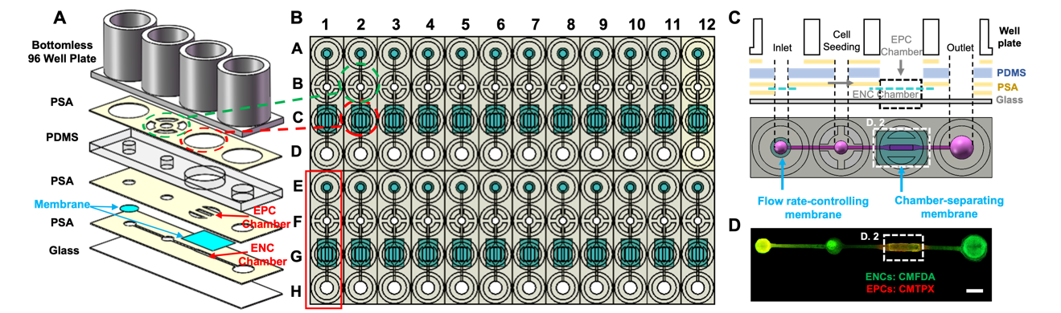
Figure S1. Microfluidic device fabrication. (A) Schematic illustration of the layer-by-layer assembly used to produce the device. (B) Schematic illustration of the top view of the 96-well plate configuration. (C) Schematic illustration of cross-sectional view and top views of: (1) the inlet port and membrane used to control the flow rate of culture medium through the ENC chamber, (2) the cell seeding port used to seed ENCs in the ENC culture chamber, (3) the membrane used to separate the ENC and EPC culture chambers, and (4) the outlet port used to generate gravity-driven flow in conjunction with the inlet port. (D) Top view of the actual device with ENCs and EPCs cultured in the ENC and EPC chambers, respectively, and labeled with CMFDA (green) and CMTPX (red), Scale bar: 2 mm.

Supplementary Information 2 – Permeability Measurements
As illustrated in Figure. S2B, P_{D} of 70 kDa FITC-dextran (ThermoFisher Scientific) through the ENC and EPC layers was measured. Specifically, after washing the ENC and EPC chambers three times with PBS, dextran (2 mg mL⁻¹) was added to the ENC chamber in the 37 ⁰C incubator while 200 μL of the common culture medium was added to the EPC chamber. The medium was collected from the EPC chamber at time points of 0, 10, 20, 30, 40, 50, and 60 min. Three tissue samples were used for each time point. The relative increase in the fluorescence intensity in the medium was plotted as a function of time in Figures. S2E and S2G.
As described in our previous study,(Sui et al. 2022) , P_{D} through the tissue samples was estimated from the data in Figures. S2E and S2G using the following equation:(Sui et al. 2022; Deosarkar et al. 2015; Kreft et al. 2015)
$${ P}_{D}=\left(\frac{h}{I_{ENC}}\right)\left(\frac{dI_{EPC}}{dt}\right)$$ | (1)
where I_{ENC} is the original intensity of dextran in the ENC chamber, dI_{EPC}/dt is the intensity change of dextran with respect to time (the slope of the curves shown in Figures. S2E and S2G), and h is the height of the ENC chamber (0.14 mm). Actual P_{D} through the tissue samples was obtained using the following equation:(Kreft et al. 2015)
$$\frac{1}{P_{D}}=\frac{1}{P_{D, Total}}-\frac{1}{P_{D, Without cells}}$$ | (2)

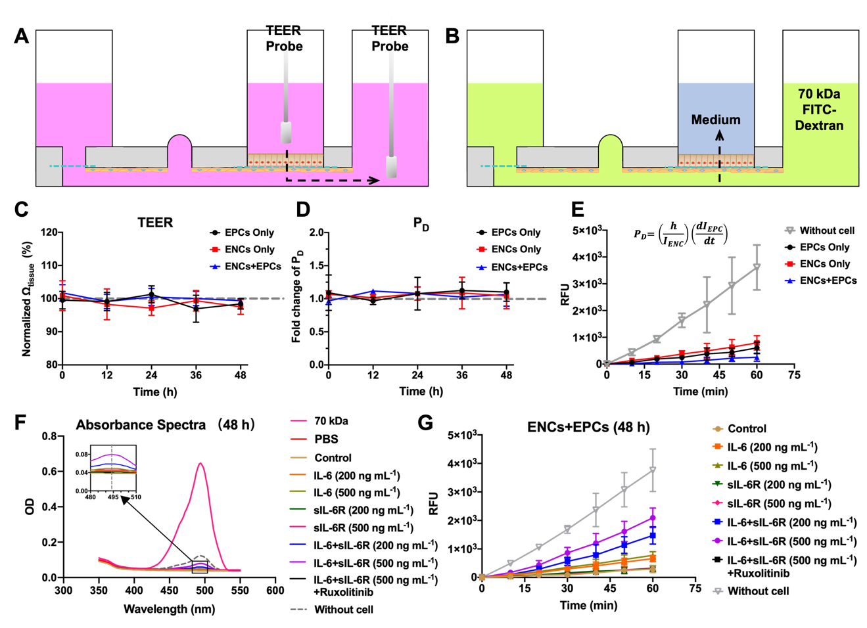
Figure S2. Methods for assessing barrier properties by TEER and P_{D} measurements. (A) Schematic illustration of electrical probes placement for TEER measurements. (B) Schematic illustration of P_{D} measurements in which 70 kDa FITC-dextran was added to the ENC chamber while both the ENC and EPC chambers were filled with the common culture medium. Subsequently, the medium from the EPC chamber was sampled and measured for fluorescence intensity in a plate reader at 10-min intervals for 60 min. (C) Normalized Ω_{tissue} measured from ENCs only, EPCs only, and ENCs+EPCs during 48-h culture. (D) Changes in P_{D} measured through ENCs only, EPCs only, and ENCs+EPCs during 48-h culture. (E) Changes in fluorescence intensity in the collected medium as a function of time for without cell, ENCs only, EPCs only, and ENCs+EPCs and used to determine P_{D} prior to various treatment conditions. (F) Fluorescence absorbance spectra in the medium after 48-h treatments with various combinations of cytokines and drugs. (G) Fluorescence intensity change in the medium plotted as a function of time and used to determine P_{D} after various treatment conditions.

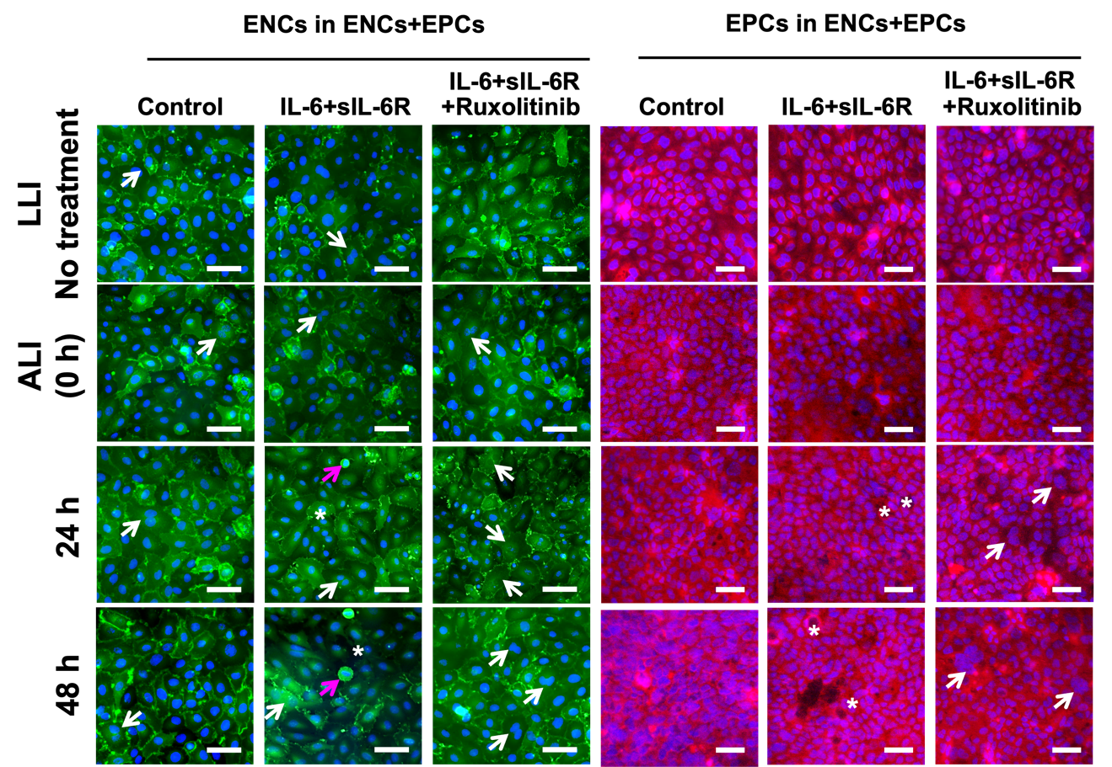
Figure S3. Effects of IL-6, sIL-6R and/or ruxolitinib treatments on the morphology of ENCs and EPCs cocultured in the device. ENCs labeled with VE-Cad (green), EPCs labeled with ZO-1 (red), and nuclei labeled with DAPI (blue). ALI culture was established right before the 48 h treatments began (i.e., 0 h). Prior to ALI culture, ENCs and EPCs were cocultured with the EPC chamber filled with liquid medium (i.e., LLI). The white arrows point to proliferating cells. The pink arrows point to dead cells. The white stars point to pores. Scale bars = 50 μm.

Supplementary References
C. Sui, J. Zilberberg, and W. Lee, Sci Rep. 12, 1439 (2022). https://doi.org/10.1038/s41598-022-05520-4
S. P. Deosarkar, B. Prabhakarpandian, B. Wang, J. B. Sheffield, B. Krynska, and M. F. Kiani, PLoS One. 10, e0142725 (2015). https://doi.org/10.1371/journal.pone.0142725
M. E. Kreft, U. D. Jerman, E. Lasic, N. Hevir-Kene, T. L. Rizner, L. Peternel, and K. Kristan, Eur J Pharm Sci. 69, 1 (2015). https://doi.org/10.1016/j.ejps.2014.12.017

