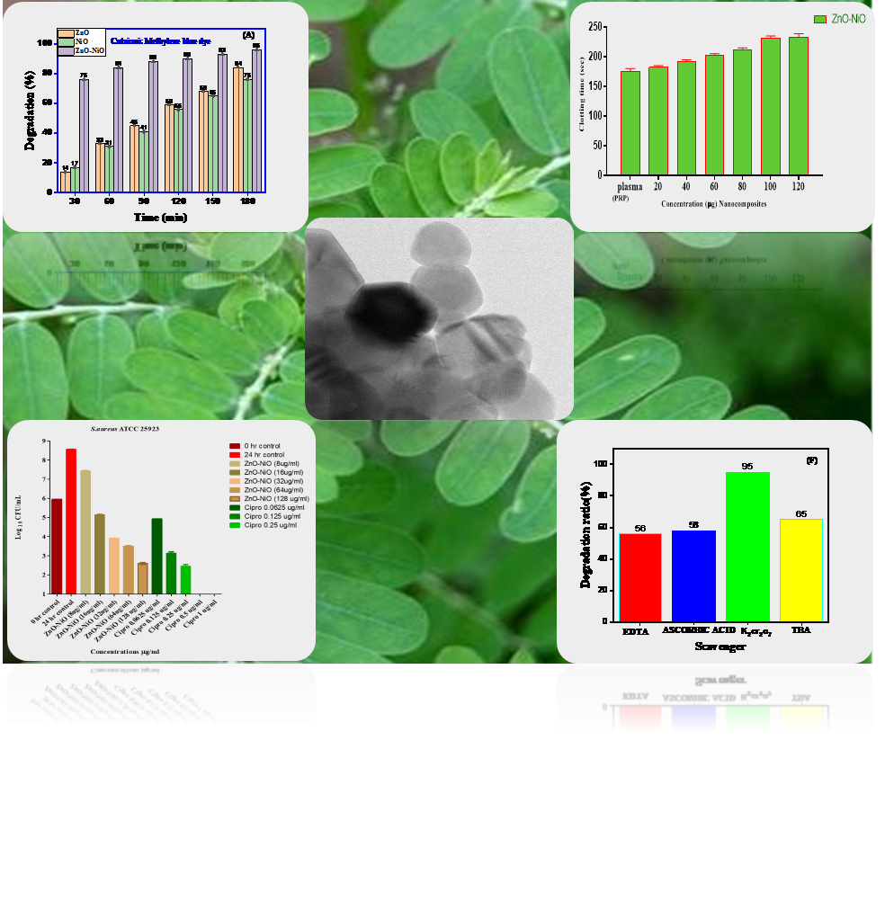
GRAPHICAL ABSTRACT

