Supplementary information
Fig. S1: Relative abundance by cave and season of 12 bat species most found in 15 caves sampled in dry and wet seasons in Costa Rica. Blank spaces are from bat species that only occurred in those sites and are excluded from the plot. Cave abbreviations can be found in Table S1.
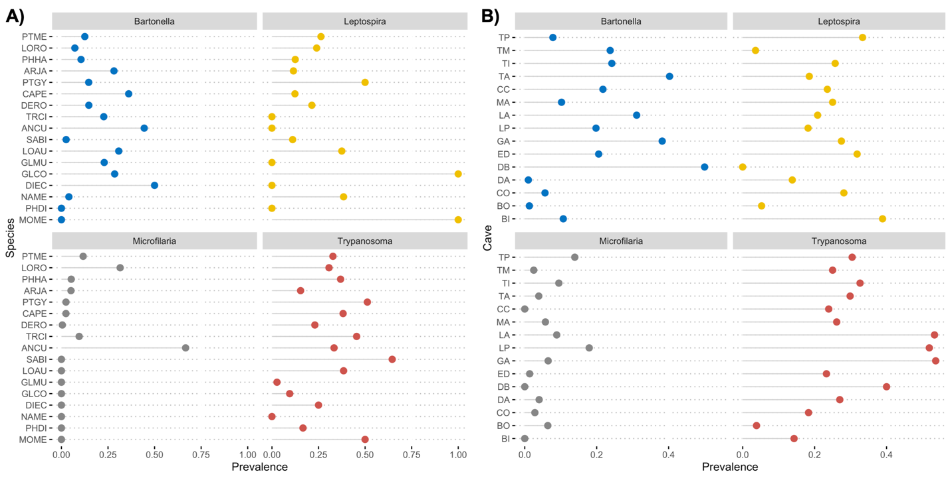
Fig. S2. Pathogen prevalence. Pathogen prevalence across A) caves and B) bat species for 15 cave-dwelling bat assemblages in Costa Rica. Caves and species abbreviations can be found in Table S1.

Fig. S3: Principal component analysis. Loadings of environmental and disturbance data (red) taken from 15 caves sampled in Costa Rica on the first two principal components. Caves abbreviations can be found in Table S1.

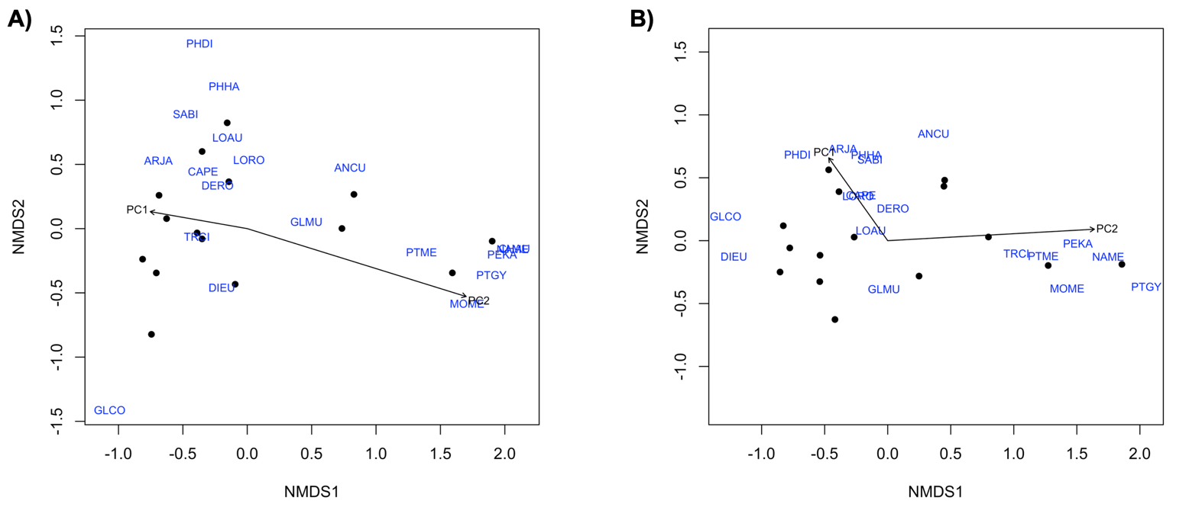
Fig. S4: Cave complexity affects bat community composition. Non-metric multidimensional scaling (NMDS) showing bat assemblages in the A) dry and B) wet seasons for 15 caves sampled in Costa Rica, using Bray-Curtis similarity (dry stress = 0.08, wet stress = 0.09). Black dots represent the caves, and bat species are in blue. The vectors indicate the effect of habitat quality (PC1) and cave complexity (PC2) on bat community assemblage. Species abbreviations can be found in Table S1.

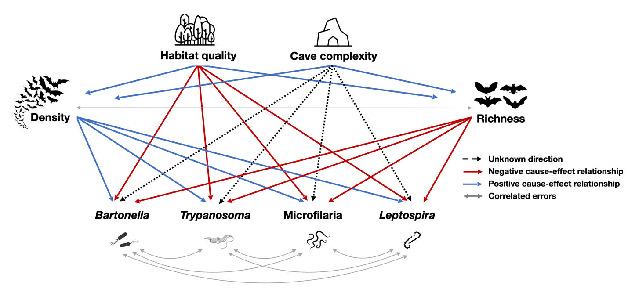
Fig. S5: Hypothesized structural equation model. A priori hypothesized model based on previous research. Habitat quality (PC1) and cave complexity (PC2) are expected to increase both bat density and richness, as has been shown in our analysis and previous work ⁴³. Moreover, bat density is expected to increase pathogen prevalence, while richness is expected to decrease prevalence, if the negative association of biodiversity and disease (i.e., dilution effect ⁶¹) is as common as it has been reported ³. Greater habitat quality is expected to decrease pathogen prevalence, while the association of cave complexity to pathogen prevalence is unknown.

Table S1. Codes of caves and bat species studied in Costa Rica.
Cave | code | Species | code
Bijagual | BI | Anoura cultrata | ANCU
Bombaza | BO | Artibeus jamaicensis | ARJA
Corredores | CO | Carollia perspicillata | CAPE
Damas | DA | Chrotopterus auritus | CHAU
Dos Brazos | DB | Desmodus rotundus | DERO
El Duende | ED | Diphylla ecaudata | DIEC
Gabinarraca | GA | Glossophaga commissarisi | GLCO
Laguna Perdida | LP | G. mutica | GLMU
Los Araya | LA | Lonchophylla robusta | LORO
Mina Aguacate | MA | Lonchorhina aurita | LOAU
Mina Ciudad Colón | CC | Mormoops megalophylla | MOME
Túnel Arenal | TA | Natalus mexicanus | NAME
Túnel ICE 2 | TI | Peropteryx kappleri | PEKA
Túnel Miraflores | TM | Phyllostomus discolor | PHDI
Túnel Peralta | TP | Phyllostomus hastatus | PHHA
 |  | Pteronotus gymnonotus | PTGY
 |  | P. mesoamericanus | PTME
 |  | Saccopteryx bilineata | SABI
 |  | Trachops cirrhosus | TRCI

Table S2. Results of PERMANOVA comparing the effects of habitat quality (PC1) and cave complexity (PC2) on bat community composition in the dry and wet season in Costa Rica. Significant results are in bold.
 | Sum of sqs | R² | F | p-value
Dry
PC1 | 0.201 | 0.060 | 1.075 | 0.337
PC2 | 0.879 | 0.264 | 4.693 | 0.012
Residual | 2.247 | 0.675
Wet
PC1 | 0.179 | 0.057 | 1.029 | 0.365
PC2 | 0.880 | 0.279 | 5.047 | 0.001
Residual | 2.091 | 0.664

Table S3. The full path model statistics including unstandardized and standardized estimated pathway coefficients and corresponding p-values for the dry and the wet season. R² is shown for each response variable. The last seven rows are correlated errors. Significant pathway p-values are bolded. The c denotes that the path is constrained among seasons. Path model is visualized in Fig. 3.
Response | Predictor | Dry |  |  |  | Wet |  |  |  | R²
Response | Predictor | Estimate | Sdt. Error | Standardized Estimate | p-value | Estimate | Sdt. Error | Standardized Estimate | p-value | R²
Richness | PC1 | -0.044 | 0.030 | - | 0.139 | c | c | - | c | 0.39
Richness | PC2 | 0.095 | 0.027 | - | 0.000 | c | c | - | c
Log.density | PC1 | 0.285 | 0.067 | 0.608 | 0.000 | c | c | 0.599 | c | 0.46
 | PC2 | 0.163 | 0.075 | 0.312 | 0.038 | c | c | 0.307 | c
Bartonella | PC1 | -0.292 | 0.061 | -0.409 | 0.000 | 0.238 | 0.070 | 0.327 | 0.001 | 0.52
 | PC2 | 0.167 | 0.040 | 0.216 | 0.000 | c | c | 0.216 | c
 | Richness | -0.098 | 0.042 | -0.150 | 0.019 | c | c | -0.140 | c
 | Log.density | 0.296 | 0.129 | 0.194 | 0.022 | -0.589 | 0.138 | -0.385 | 0
Trypanosoma | PC1 | -0.004 | 0.052 | -0.006 | 0.937 | 0.191 | 0.070 | 0.261 | 0.006 | 0.91
 | PC2 | 0.011 | 0.035 | 0.013 | 0.760 | c | c | 0.013 | c
 | Richness | 0.220 | 0.038 | 0.328 | 0.000 | c | c | 0.306 | c
 | Log.density | -0.104 | 0.081 | -0.068 | 0.204 | c | c | -0.069 | c
Microfilaria | PC1 | 0.185 | 0.087 | 0.254 | 0.033 | c | c | 0.254 | c | 0.62
 | PC2 | -0.202 | 0.068 | -0.248 | 0.003 | c | c | -0.248 | c
 | Richness | 0.366 | 0.079 | 0.533 | 0.000 | c | c | 0.497 | c
 | Log.density | -0.133 | 0.168 | -0.086 | 0.427 | c | c | -0.087 | c
Leptospira | PC1 | -0.061 | 0.073 | -0.089 | 0.399 | c |  | -0.089 | c | 0.13
 | PC2 | 0.063 | 0.066 | 0.082 | 0.344 | c |  | 0.082 | c
 | Richness | -0.024 | 0.071 | -0.037 | 0.737 | c |  | -0.035 | c
 | Log.density | -0.106 | 0.143 | -0.072 | 0.460 | c |  | -0.073 | c
Bartonella | Trypanosoma | 0.740 | - | 0.740 | 0.001 | 0.628 | - | 0.628 | 0.008
Bartonella | Leptospira | 0.168 | - | 0.168 | 0.283 | -0.741 | - | -0.741 | 0.001
Bartonella | Microfilaria | -0.287 | - | -0.287 | 0.160 | 0.122 | - | 0.122 | 0.339
Trypanosoma | Leptospira | 0.231 | - | 0.231 | 0.214 | -0.233 | - | -0.233 | 0.212
Trypanosoma | Microfilaria | 0.009 | - | 0.009 | 0.487 | -0.135 | - | -0.135 | 0.322
Microfilaria | Leptospira | 0.409 | - | 0.409 | 0.073 | -0.217 | - | -0.217 | 0.228
Richness | Log.density | 0.318 | - | 0.318 | 0.134 | 0.292 | - | 0.292 | 0.155

