Supplementary Table S1. Patients information
Characteristic |  | All | TrainingSet(n=248) | ValidationSet(n=249) | p value
Age(years) | ≤60 | 112 | 49 | 63 | 0.17
Age(years) | >60 | 385 | 199 | 186 | 0.17
progression-free survival | Living | 447 | 224 | 223 | 0.893
progression-free survival | Dead | 50 | 24 | 26 | 0.893
Gender | female | 362 | 180 | 182 | 0.978
Gender | male | 135 | 68 | 67 | 0.978
pathologic_T | T 1 | 142 | 72 | 70 | 0.225
pathologic_T | T 2 | 162 | 85 | 77 | 0.225
pathologic_T | T 3 | 170 | 83 | 87 | 0.225
pathologic_T | T 4 | 21 | 6 | 15 | 0.225
pathologic_N | N 0 | 228 | 118 | 110 | 0.502
pathologic_N | N 1/N X | 269 | 130 | 139 | 0.502
pathologic_M | M 0 | 281 | 133 | 148 | 0.449
pathologic_M | M 1/ M X | 215 | 115 | 100 | 0.449
Tumor Stage | Stage Ⅰ | 279 | 140 | 139 | 0.875
Tumor Stage | Stage Ⅱ | 52 | 27 | 25 | 0.875
Tumor Stage | Stage Ⅲ | 111 | 52 | 59 | 0.875
Tumor Stage | Stage Ⅳ | 53 | 28 | 25 | 0.875

Supplementary Table S2. 4-mRNA signature information
Symbol | coef | HR | Z-score | P value | Low 95%CI | High 95%CI
PDZK1IP1 | 0.06992 | 1.0724 | 0.673 | 0.501 | 0.875 | 1.314
LRP2 | -0.12947 | 0.8786 | -0.799 | 0.424 | 0.6395 | 1.207
KCNJ13 | -0.46758 | 0.6265 | -1.346 | 0.178 | 0.3171 | 1.238
TMC3 | -0.59456 | 0.5518 | -1.107 | 0.268 | 0.1925 | 1.582

Supplementary Table S3. Clinicopathological correlations of the gene signature in the TCGA cohort
Variables | N | Gene signature |  | p value
Variables | N | Low-risk score | High-risk score | p value
Age (years) |  |  |  | 0.379
< 55 | 332 | 170 (51.2%) | 162 (48.8%)
≥ 55 | 165 | 78 (47.3%) | 87 (52.7%)
Gender |  |  |  | 0.379
Male | 135 | 63 (46.7%) | 72 (53.3%)
Female | 362 | 185 (51.1%) | 177 (48.9%)
ETE |  |  |  | ＜0.001
Yes | 152 | 46 (30.3%) | 106 (69.7%)
No | 328 | 192 (58.5%) | 136 (41.5%)
T Stage |  |  |  | ＜0.001
T1-T2 | 304 | 179 (58.9%) | 125 (41.1%)
T3-T4 | 191 | 69 (36.1%) | 122 (63.9%)
LNM |  |  |  | ＜0.001
N0 | 228 | 138 (60.5%) | 90 (39.5%)
N1 | 219 | 79 (36.1%) | 140 (63.9%)
DM |  |  |  | 0.727
M0 | 281 | 133 (47.3%) | 148 (52.7%)
M1 | 8 | 3 (37.5%) | 5 (62.5%)
Notes: Italic and bold type indicates statistical significance
Abbreviations: TCGA, The Cancer Genomics Atlas; ETE, extrathyroidal extension; LNM, lymph node metastasis; DM, distant metastas

Supplementary Table S4. Clinicopathological association of the 4 genes in the TCGA cohort
Variables | PDZK1IP1 |  | p value | LRP2 |  | p value | KCNJ13 |  | p value | TMC3 |  | p value
Variables | High-risk score | Low-risk score | p value | High-risk score | Low-risk score | p value | High-risk score | Low-risk score | p value | High-risk score | Low-risk score | p value
Median Age (years) | 47.55 | 47.08 | 0.748 | 45.97 | 48.63 | 0.073 | 46.51 | 48.13 | 0.274 | 47.34 | 49.27 | 0.08
Gender |  |  | 0.401 |  |  | 0.632 |  |  | 0.513 |  |  | 0.642
Female | 174（54.0%） | 148（46.0%） |  | 160(49.7%) | 162(50.3%) |  | 163(50.6%) | 159(49.4%) |  | 157(48.8%) | 165(51.2%)
Male | 61(49.6%) | 62(50.4%) |  | 58(47.2%) | 65(52.8%) |  | 58(47.2%) | 65(52.8%) |  | 63(51.2%) | 60(48.8%)
T Stage |  |  | 0.029 |  |  | ＜0.001 |  |  | ＜0.001 |  |  | ＜0.001
T1 | 64(49.2%) | 66(50.8%) |  | 75(57.7%) | 55(42.3%) |  | 81(62.3%) | 49(37.7%) |  | 72(55.4%) | 58(44.6%)
T2 | 64(46.4%) | 74(53.6%) |  | 74(53.6%) | 63(46.4%) |  | 78(56.5) | 60(43.5%) |  | 81(58.7%) | 57(41.3%)
T3 | 92(58.6%) | 65(41.4%) |  | 66(42.0%) | 91(58.0%) |  | 60(38.2%) | 97(61.8) |  | 63(40.1%) | 94(59.9%)
T4 | 15(75%) | 5(25%) |  | 3(15.0%) | 17(85.0%) |  | 2(10.0%) | 18(90.0%) |  | 4(20.0%) | 16(80.0%)
LNM |  |  | ＜0.001 |  |  | ＜0.001 |  |  | ＜0.001 |  |  | 0.026
Negative | 90(39.6%) | 137(60.4%) |  | 138(60.8%) | 89(39.2%) |  | 131(57.7%) | 96(42.3%) |  | 124(54.6%) | 103(45.4%)
Positive | 145(66.5%) | 73(33.5%) |  | 80(36.7%) | 138(63.3%) |  | 90(41.3%) | 128(58.7%) |  | 96(44.0) | 122(56.0)
DM |  |  | 0.751 |  |  | 0.703 |  |  | 0.19 |  |  | 0.627
M0 | 147(54.2) | 124(45.8%) |  | 135(49.8%) | 136(50.2%) |  | 140(51.7%) | 131(48.3%) |  | 131(48.3%) | 140(51.7%)
M1 | 3(50%) | 3(50%) |  | 2(33.3%) | 4(66.7%) |  | 1(16.7%) | 5(83.3%) |  | 4(66.7%) | 2(33.3%)
Mx | 85(50.6%) | 83(49.4%) |  | 81(48.2%) | 87(51.8%) |  | 80(47.6%) | 88(52.4%) |  | 85(50.6%) | 83(49.4%)
Stage |  |  | 0.002 |  |  | 0.001 |  |  | ＜0.001 |  |  | 0.001
I | 125(50.6%) | 122(49.4%) |  | 133(53.8%) | 114(46.2%) |  | 138(55.9%) | 109(44.1%) |  | 137(55.5%) | 110(44.5%)
II | 13(30.2%) | 30(69.8%) |  | 27(62.8%) | 16(37.2%) |  | 26(60.5%) | 17(39.5%) |  | 25(58.1%) | 18(41.9%)
III | 64(61.5%) | 40(38.5%) |  | 43(41.3%) | 61(58.7%) |  | 47(45.2%) | 57(54.8%) |  | 43(41.3%) | 61(58.7%)
IV | 33(64.7%) | 18(35.3%) |  | 15(29.4%) | 36(70.6%) |  | 10(19.6%) | 41(80.4%) |  | 15(29.4%) | 36(70.6%)
ETE |  |  | ＜0.001 |  |  | ＜0.001 |  |  | ＜0.001 |  |  | ＜0.001
No | 129(45.3) | 156（54.7%） |  | 155(54.4%) | 130(45.6%) |  | 165(57.9%) | 120(42.1%) |  | 160(56.1%) | 125(43.9%)
Yes | 101（70.1%） | 43（29.9%） |  | 54(37.5%) | 90(62.5%) |  | 47(32.6%) | 97(67.4%) |  | 53(36.8%) | 91(63.2%)
Notes: Italic and bold type indicates statistical significance
Abbreviations: TCGA, The Cancer Genomics Atlas; ETE, extrathyroidal extension; LNM, lymph node metastasis; DM, distant metastasis

Supplementary Table S5. MOD of 4 genes in recurrent and non-recurrent patients
 | T1/T2 PTC |  |  | LA-PTC
 | Currence | No currence | p value | Currence | No currence | p value
PDZK1IP1 | 0.261(0.071-0.277) | 0.233(0.207-0.245) | 0.006 | 0.253(0.171-0.277) | 0.236(0.102-0.250) | 0.001
LRP2 | 0.172(0.153-0.175) | 0.186(0.180-0.198) | 0.007 | 0.173(0.163-0.183) | 0.174(0.166-0.185) | 0.039
KCNJ13 | 0.137(0.125-0.140) | 0.141(0.140-0.145) | 0.028 | 0.133(0.125-0.145) | 0.139(0.130-0.144) | 0.005
TMC3 | 0.131(0.122-0.134) | 0.130(0.126-0.140) | 0.496 | 0.124(0.117-0.139) | 0.127(0.115-0.142) | 0.491
Notes: Italic and bold type indicates statistical significance
Supplementary Figure 1
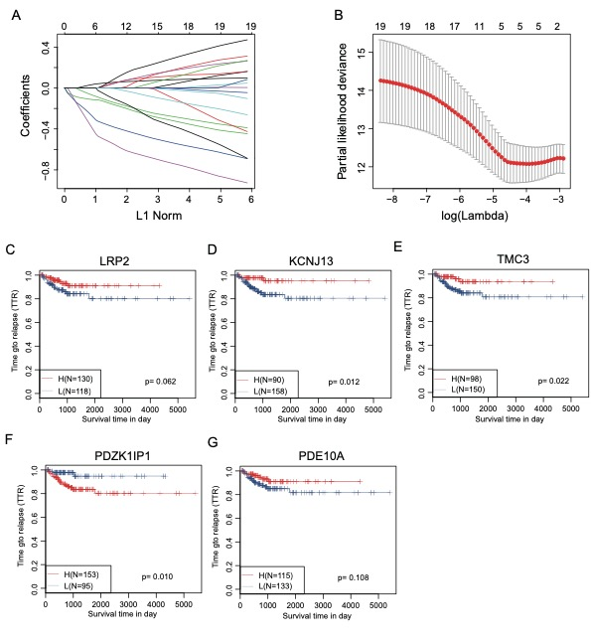
Supplementary Figure 2
