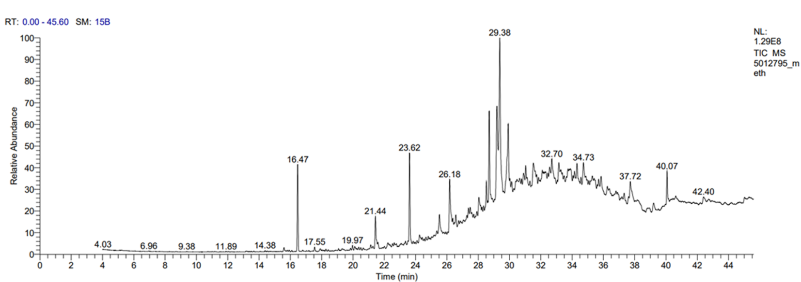
a
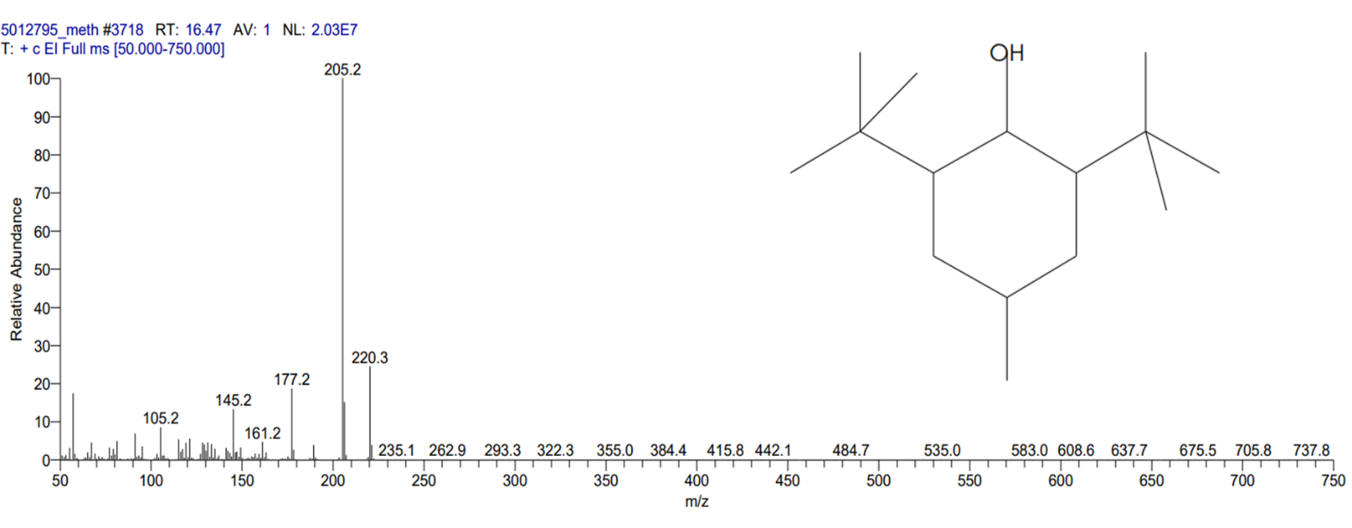
b
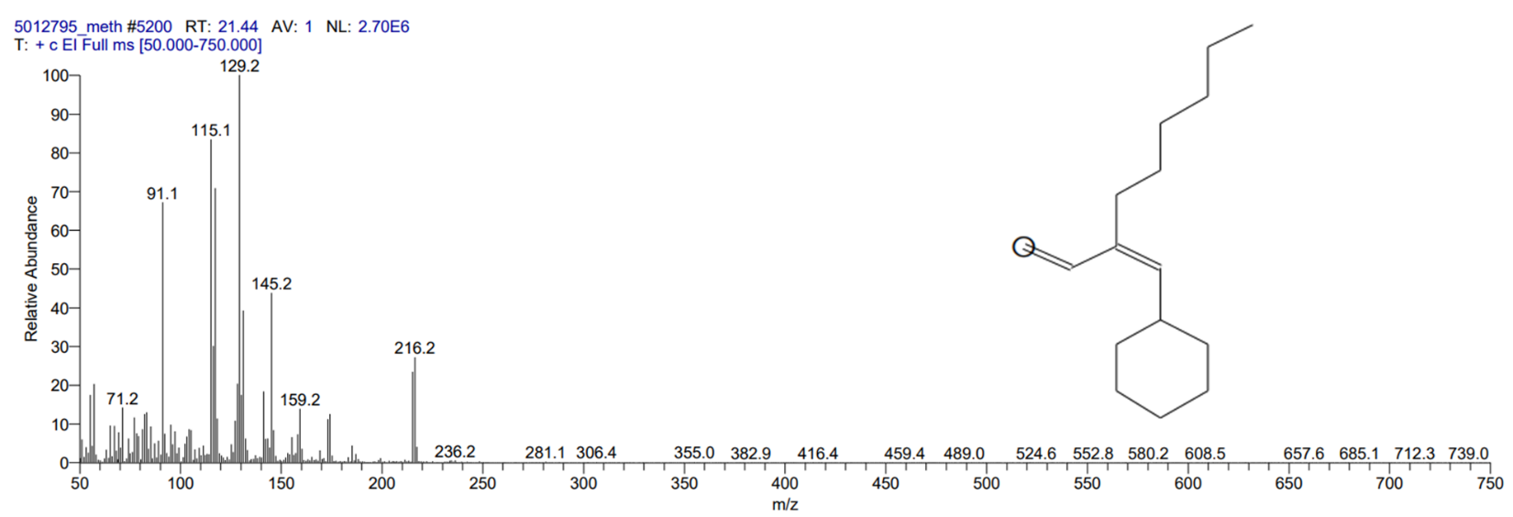
c
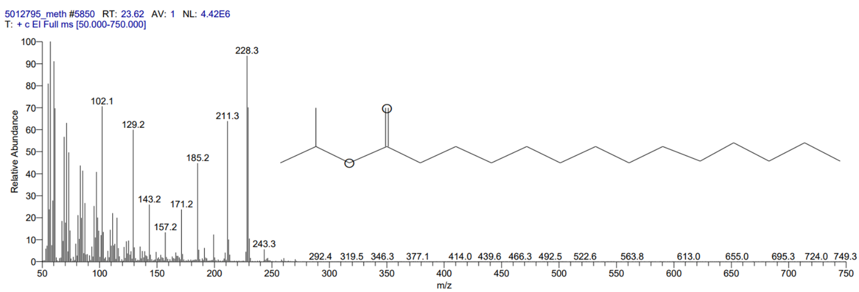
d
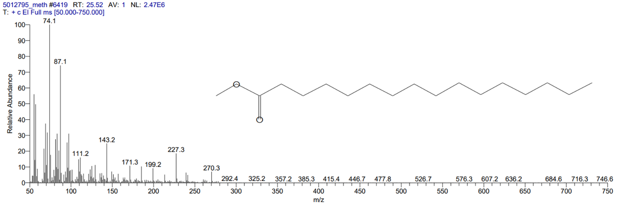
e
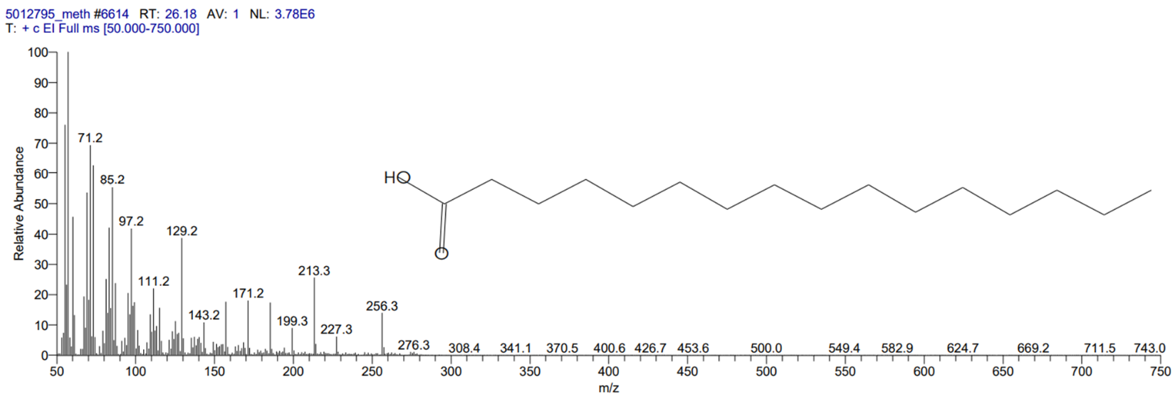
f
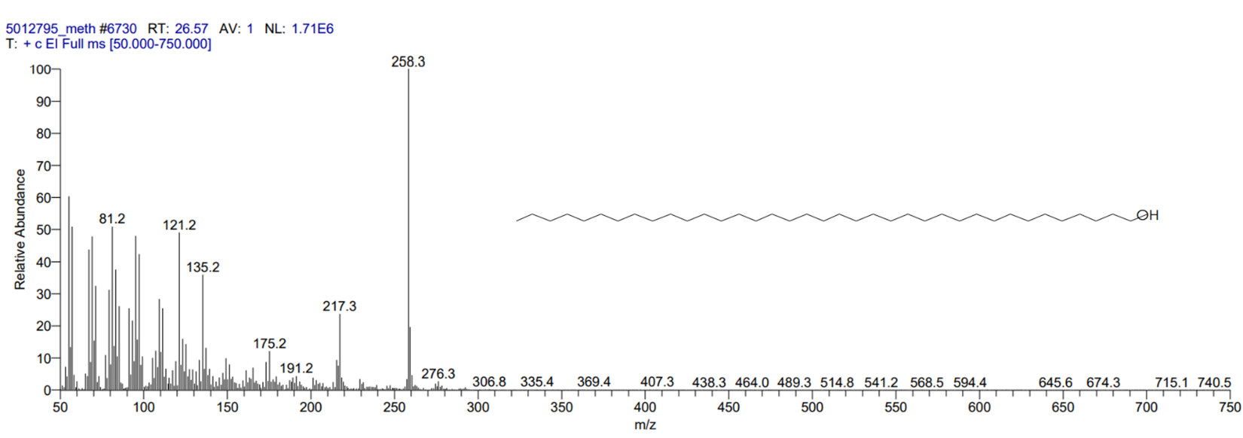
g
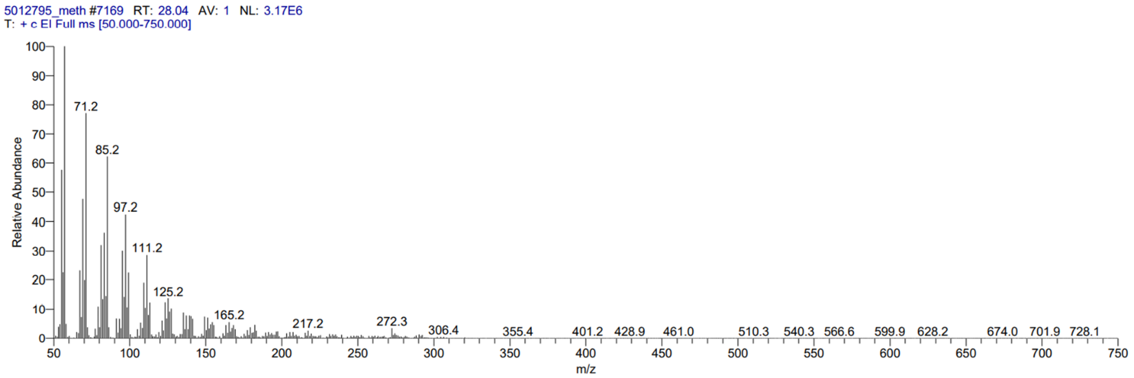
h
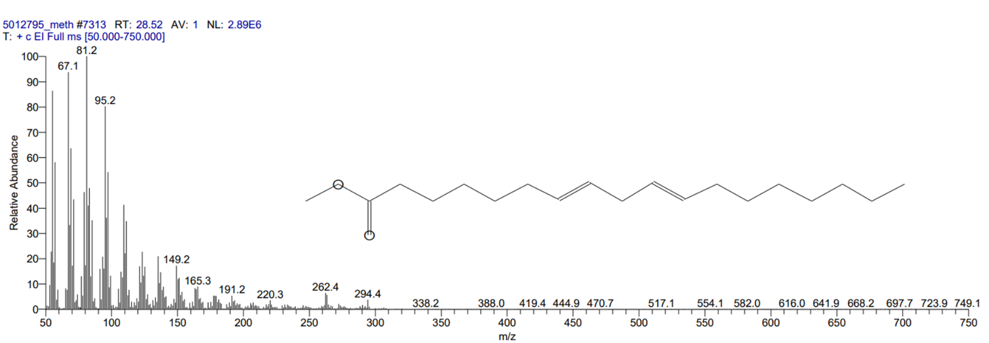
i
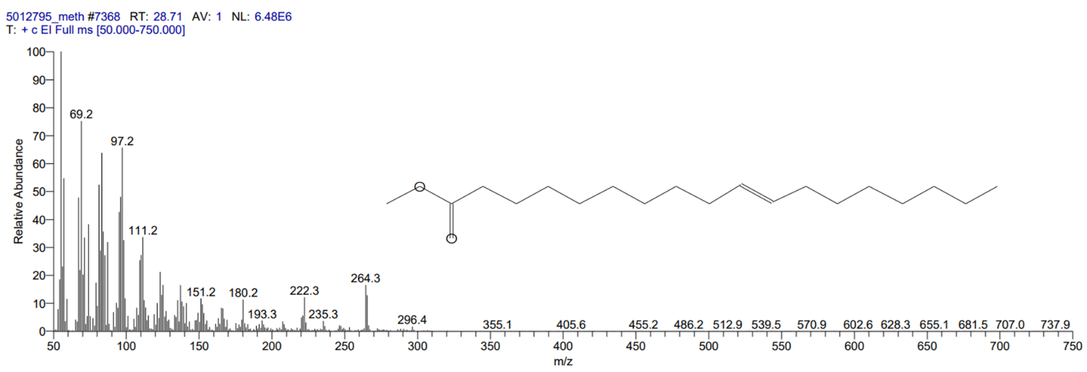
j
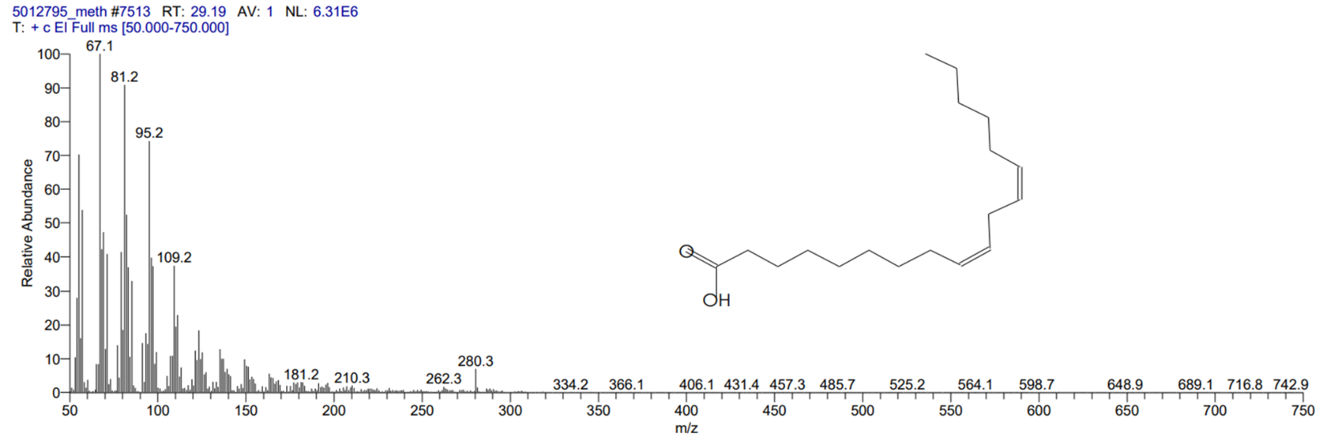
K
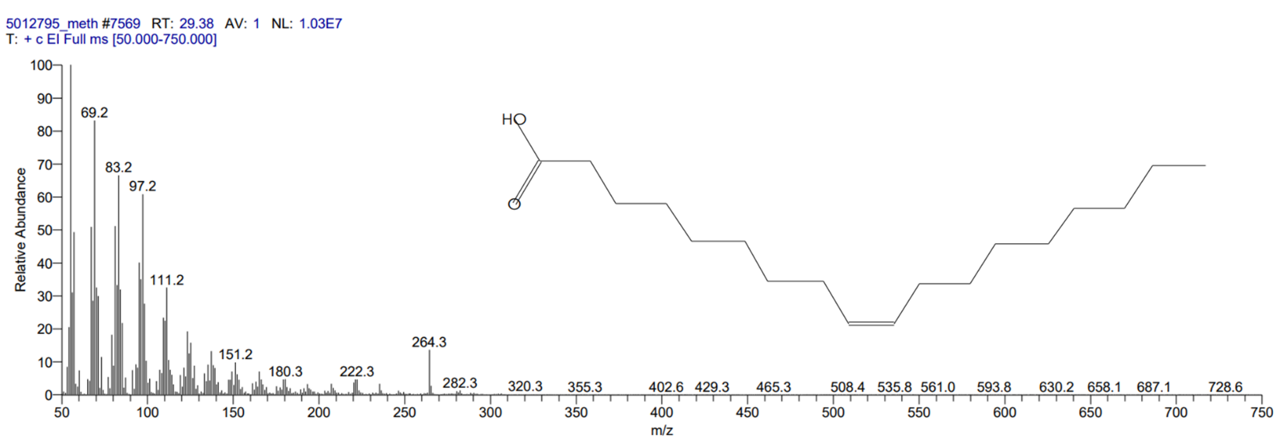
l
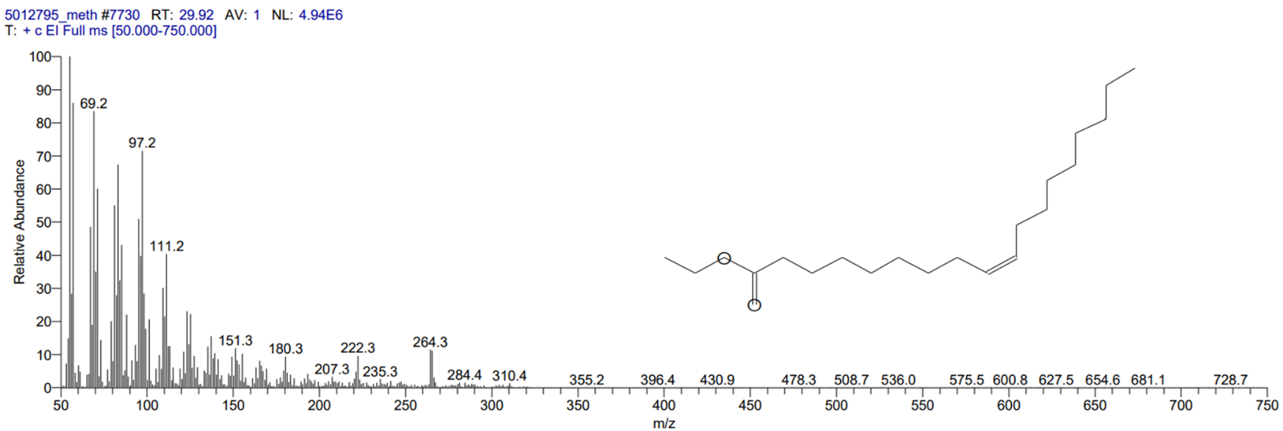
m
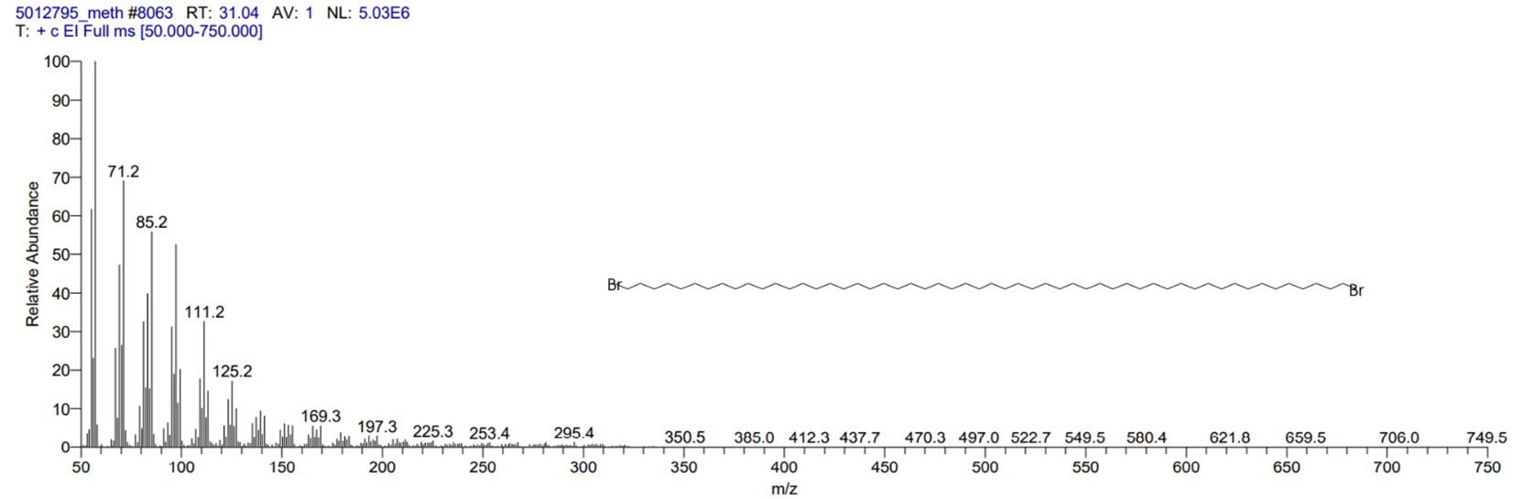
n
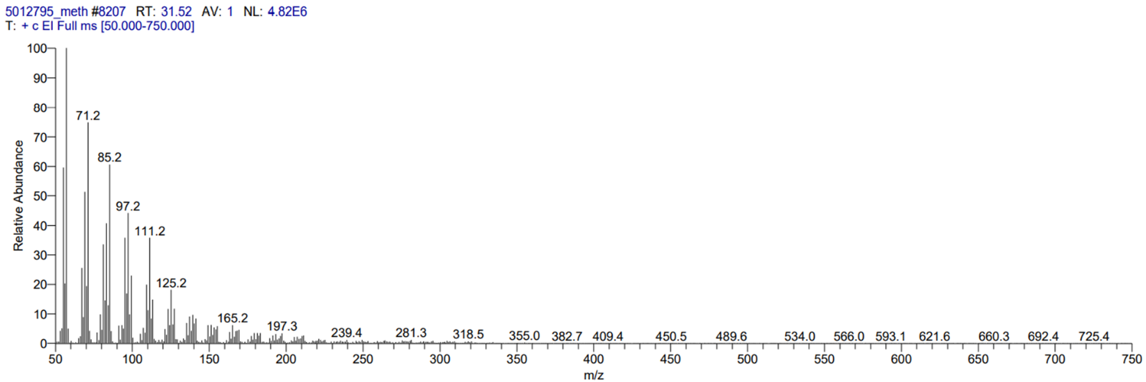
o
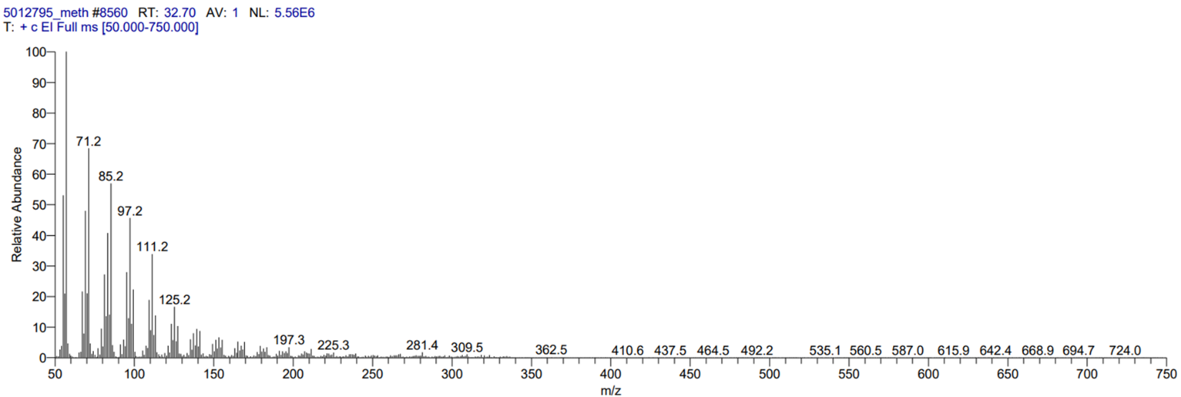
p
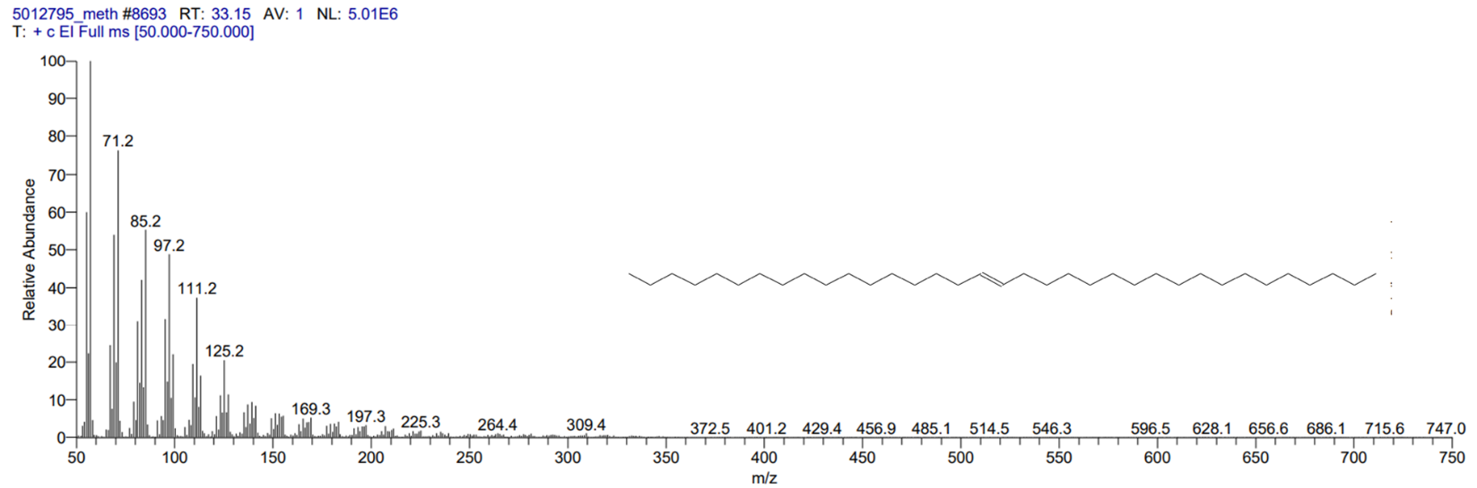
q
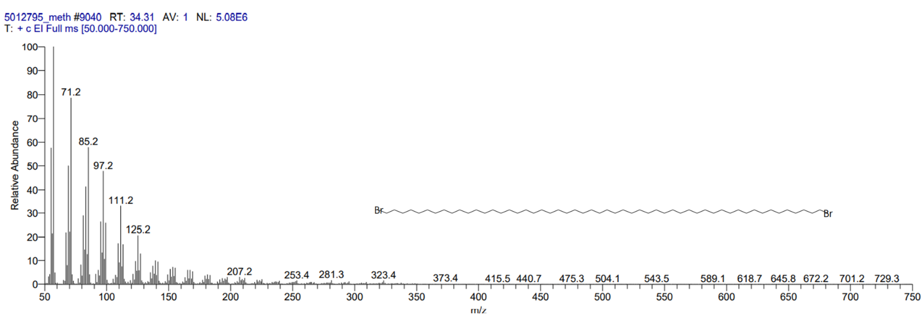
r
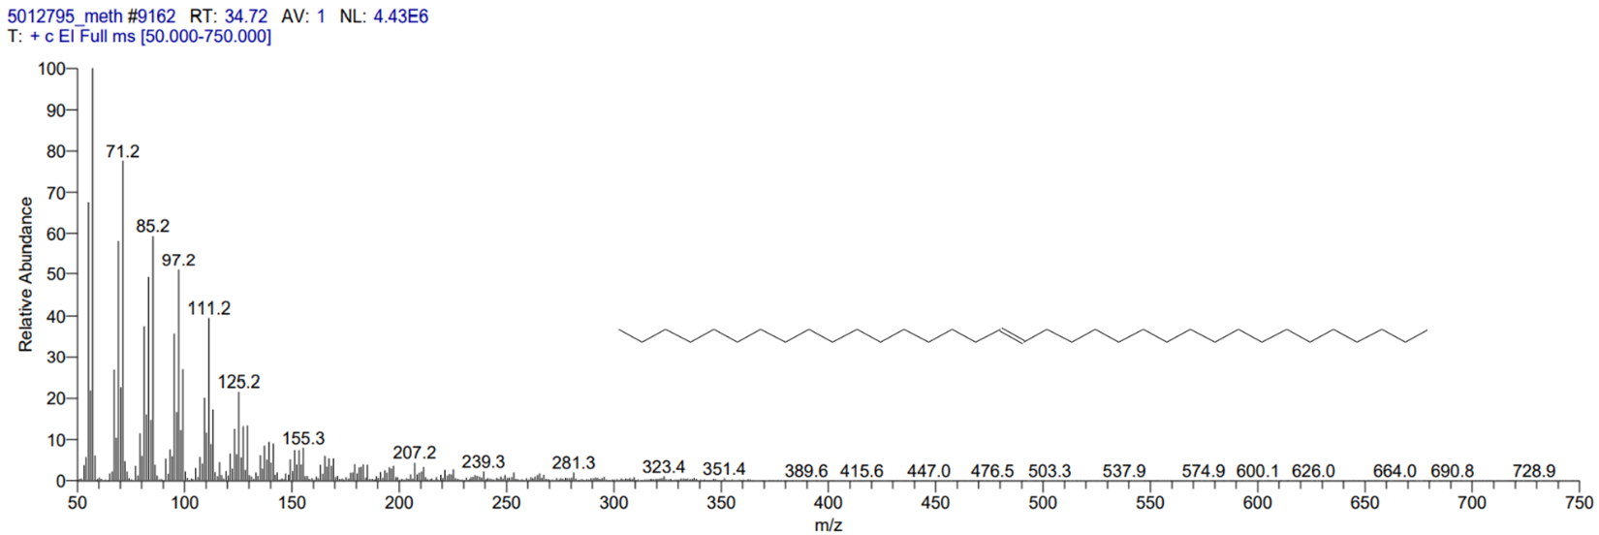
s
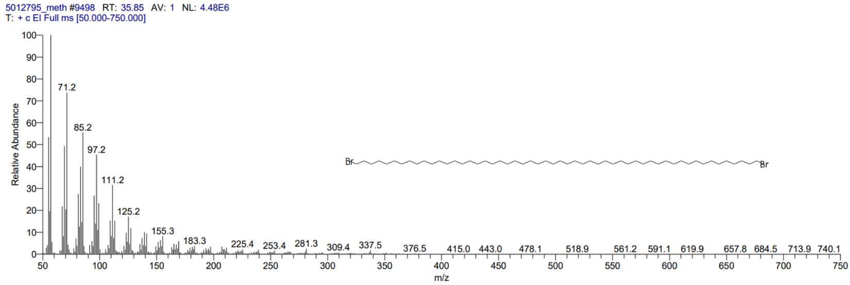
t
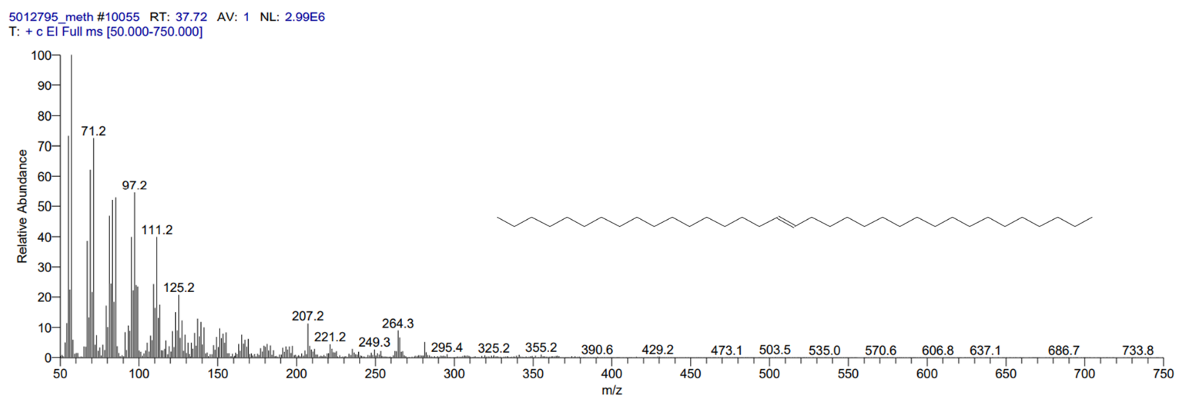
u
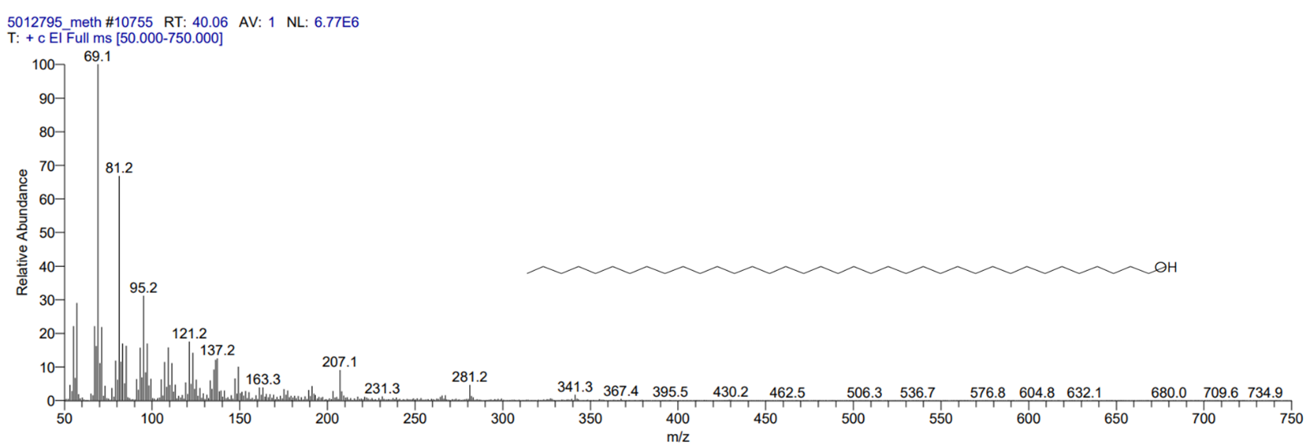
v

Figure S1. The total ion chromatogram of (a) the Argan oil and the mass spectrum of (b) Butylated Hydroxytoluene, (c) Octanal, 2-(phenylmethylene)-, (d) Isopropyl myristate, (e) Palmitic Acid methyl ester, (f) Hexadecanoic acid, (g) 1-Heptatriacotanol, (h) 14-á-H-Pregna, (i) 7,10- Hexadecanoic acid, methyl ester, (j) 10-Octadecenoic acid, methyl ester, (k) 9,12-Octadecadienoic acid (Z,Z)-, (l) Oleic Acid, (m) Ethyl Oleate, (n) Tetrapentacontane, 1,54-dibromo-, (o) 14-á-H-Pregna, (p) 14-á-H-Pregna, (q) 17-Pentatriacontene, (r) Tetrapentacontane, 1,54-dibromo-, (s) 17-Pentatriacontene, (t) Tetrapentacontane, 1,54-dibromo-, (u) 17-Pentatriacontene, and (v) 1-Heptatriacotano.

