Perceived health inequalities: Are the UK and US public aware of occupation-related health inequality, and do they wish to see it reduced?

Supplemental Materials
Supplemental Methods
Socio-demographic Measures
Both samples included data on gender (female, male), age, household income and education. Respondent age was categorised into three comparably-sized groups of under 40s, 40-59 year-olds and over 60s. UK annual household income was provided in £5,000 increments, however, US household income indicated only whether income was <$40,000, $40,000 to $80,000 or >$80,000. Harmonisation was achieved by calculating sterling equivalent categories for the three US levels based on exchange rate in February 2021 (<£30,000; £30,000-£60,000; >£60,000) and re-coding UK data accordingly. UK data on highest level of education comprised 18 different options which were recoded to four levels: no formal qualifications (no formal qualifications), level 2-3 or equivalent (youth training certificate, trade apprenticeship, clerical and commercial, City & Guilds, City & Guilds advanced, ONC, CSE grade 1, CSE grades 2-5, Scottish Ordinary, A level/Higher, Scottish Higher), University degree or equivalent (Nursing qualification, Teaching qualification, University diploma, University degree) or post-graduate/higher (University higher degree, other technical, professional or higher qualification). The six levels provided for US education were recoded into four comparative levels of education: no high school, high school graduate, college level (some college, 2-year college, 4-years college) and post-graduate.
UK respondent data also included a self-report measure of political attention (“How much attention do you generally pay to politics?“ on a scale from 0-10), which for descriptive analyses was recoded to high (7-10), medium (5-6) and low (0-4). Respondents had indicated whether they voted Remain, Leave, Did not vote or Can’t remember in the EU 2016 Referendum. Participants who said they could not remember were removed from analyses. Respondents indicated whether they voted Conservative, Labour or Other (Liberal Democrat, Scottish National Party, Plaid Cymru, Brexit Party, Green, other, Don’t Know) or did not vote in the General Election in December 2019. Finally, data on participants’ household social grade (based mainly but not only on occupation and employment status of Chief Income Earner) was categorised into high (A: higher managerial, administrative and professional, B: Intermediate managerial, administrative and professional), medium (C1: Supervisory, clerical and junior managerial, administrative and professional, C2: skilled manual workers) and low social grade (D: semi-skilled and unskilled manual workers, E: state pensioners, casual and lowest grade workers, unemployed with state benefits).
US panel data was separated according to how respondents voted in the 2020 Presidential election, either for Joe Biden, Donald Trump, Other candidates (Jo Jorgensen, Howie Hawkins or Other) or Did not vote for President. US respondents also indicated which racial or ethnic group best describes them: White, Black, Hispanic or other persons of colour (Asian, Native American, Two or more races, Other, or Middle Eastern).

Supplemental Tables
Supplemental Table S1. Sociodemographic characteristics and median estimated and ideal life expectancy ratios of professional to routine workers
 | United Kingdom (N = 1,599) |  |  | United States (N = 1,039)
 |  | Median Ratio Prof/Routine |  |  | Median Ratio Prof/Routine
 | N | Estimated | Ideal | N | Estimated | Ideal
Total Sample (weighted) | 1,599 | 1.0588 | 1.0000 | 1039 | 1.0291 | 1.0000
Age
18-39 | 522 | 1.0533 | 1.0000 | 397 | 1.0635 | 1.0000
40-59 | 553 | 1.0625 | 1.0000 | 317 | 1.0134 | 1.0000
60+ | 524 | 1.0533 | 1.0000 | 325 | 1.0000 | 1.0000
Gender
Female | 820 | 1.0533 | 1.0000 | 533 | 1.0256 | 1.0000
Male | 779 | 1.0605 | 1.0000 | 506 | 1.0400 | 1.0000
Income
<$40,000/£30,000 | 553 | 1.0625 | 1.0000 | 356 | 1.0259 | 1.0000
$40,000-$80,000/£30,000 - £60,000 | 397 | 1.0532 | 1.0000 | 294 | 1.0258 | 1.0000
>$80,000/>£60,000 | 188 | 1.0625 | 1.0000 | 234 | 1.0455 | 1.0000
Education
No High school/No formal qualifications | 92 | 1.0000 | 1.0000 | 54 | 1.0496 | 1.0000
High school graduate/Level 2-3 or equivalent | 736 | 1.0526 | 1.0000 | 365 | 1.0000 | 1.0000
College / University | 423 | 1.0592 | 1.0000 | 511 | 1.0400 | 1.0000
Post-grad | 284 | 1.0625 | 1.0000 | 109 | 1.0488 | 1.0000
Social Grade
High | 336 | 1.0625 | 1.0000 | N/A | N/A | N/A
Medium | 614 | 1.0534 | 1.0000 | N/A | N/A | N/A
Low | 649 | 1.0493 | 1.0000 | N/A | N/A | N/A
Political Attention
High | 448 | 1.0626 | 1.0000 | N/A | N/A | N/A
Medium | 800 | 1.0625 | 1.0000 | N/A | N/A | N/A
Low | 352 | 1.0411 | 1.0000 | N/A | N/A | N/A
General Election 2019 Vote
Conservative | 524 | 1.0506 | 1.0000 | N/A | N/A | N/A
Labour | 387 | 1.0647 | 1.0000 | N/A | N/A | N/A
Otherª | 319 | 1.0629 | 1.0000 | N/A | N/A | N/A
Didn't Vote | 367 | 1.0286 | 1.0000 | N/A | N/A | N/A
Race
White | N/A | N/A | N/A | 664 | 1.0375 | 1.0000
Black | N/A | N/A | N/A | 125 | 1.0000 | 1.0000
Hispanic | N/A | N/A | N/A | 162 | 1.0351 | 1.0000
Other persons of color^{b} | N/A | N/A | N/A | 88 | 1.038 | 1.0000
Presidential Election 2020 Vote
Joe Biden | N/A | N/A | N/A | 485 | 1.0625 | 1.0000
Donald Trump | N/A | N/A | N/A | 330 | 1.0000 | 1.0000
Other^{c} | N/A | N/A | N/A | 38 | 1.0523 | 1.0000
Didn't Vote | N/A | N/A | N/A | 186 | 1.0401 | 1.0000
ªLiberal Democrat, SNP, Plaid Cymru, Brexit Party, Green, Other, Don’t Know
^{b}Asian, Native American, Two or more races, Other, Middle Eastern
^{c}Jo Jorgensen, Howie Hawkins, Other

Figure S1. Forest plot showing odds ratios (and 95% confidence intervals) of perceiving higher life expectancy for professional than routine workers for the two samples, including household income (upper panel: UK = 1,137; lower panel: US = 886).
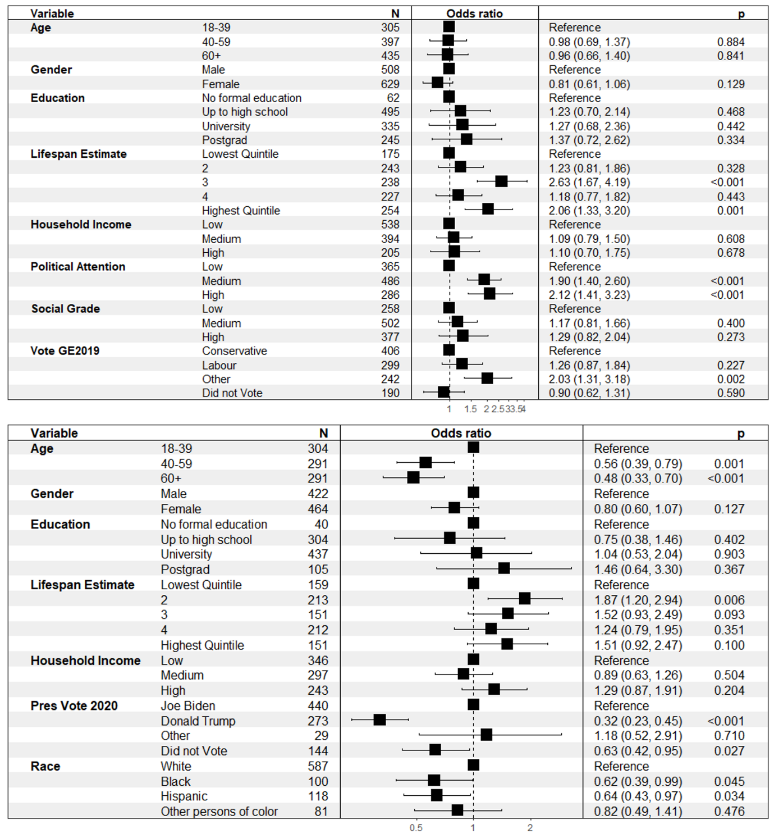

Figure S2. Forest plot showing odds ratios (and 95% confidence intervals) of desiring equal life expectancy for professional than routine workers for the two samples, including household income (upper panel: UK = 1,137; lower panel: US = 886).
