SUPPLEMENTARY MATERIAL
Figures overview:
Figure 1*, 3*: Chao alpha diversity boxplots showing the difference in alpha diversity between 2 groups.
Figure2*. Jaccard Principal Coordinate Analysis (PCoA) showing the difference in beta diversity between 2 groups.
Figure 4*-6* Linear Discriminant Analysis Effect Size (Lefse) in some specific group combinations, representing the bacteria significantly enriched for each cohort, separated in green and red colour, depending on if they are enriched or reduced compared to the other.
Figure 7*. Heatmap representing the abundance of species. Different colors show differences for lower-abundant organisms.

Table 1*. Overview of all p values for microbial diversity
Comparison | Alpha diversity |  |  | Beta diversity
Comparison | Chao, p | Shannon, p | Simpson, p | Bray-Curtis, p | Jaccard, p
G5 vs G1G3 (S1) | 0.14 | 0.81 | 0.62 | 0.12 | 0.09
G1 vs G3 (S1) | 0.01 | 0.63 | 0.86 | 0.46 | 0.54
G1A vs G3A (S1) | 0.00097* | 0.6 | 1 | 0.26 | 0.27
G1B vs G3B (S1) | 0.91 | 0.97 | 0.97 | 0.9 | 0.86
G5 vs G1G3 (S2) | 0.67 | 0.71 | 0.81 | 0.23 | 0.25
G1 vs G3 (S2) | 0.18 | 0.53 | 0.75 | 0.39 | 0.4
G1A vs G3A (S2) | 0.01* | 0.6 | 0.66 | 0.22 | 0.2
G1B vs G3B (S2) | 0.55 | 0.17 | 0.44 | 0.51 | 0.6
S1 vs S2 (G1G3) | 0.55 | 0.46 | 0.77 | 0.12 | 0.09
S1 vs S2 (G5) | 0.83 | 0.64 | 0.62 | 0.99 | 0.99
S1 vs S2 (G1) | 0.81 | 0.66 | 0.84 | 0.98 | 0.99
S1 vs S2 (G1A) | 0.85 | 0.91 | 0.85 | 0.98 | 0.99
S1 vs S2 (G1B) | 0.73 | 0.63 | 0.91 | 0.91 | 0.96
S1 vs S2 (G3) | 0.34 | 0.73 | 0.84 | 0.99 | 0.99
S1 vs S2 (G3A) | 0.63 | 0.3 | 0.16 | 0.96 | 0.98
S1 vs S2 (G3B) | 0.45 | 0.63 | 0.44 | 0.98 | 0.99
*Values in bold are statistically significant. This table presents specific comparisons between our cohorts and diversity indexes applied, along with the p value of each test. Abbreviations: S1=sample 1; S2=sample 2.

Fig.1*. Chao alpha diversity boxplots (species level), G1A vs G3A, sample 1
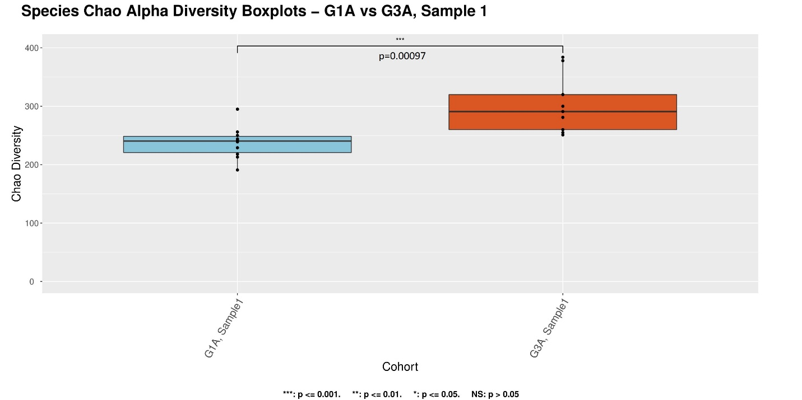

Fig.2*. Jaccard Principal Coordinate Analysis (PCoA)-G5 vs G1G3, sample 1 (species level)
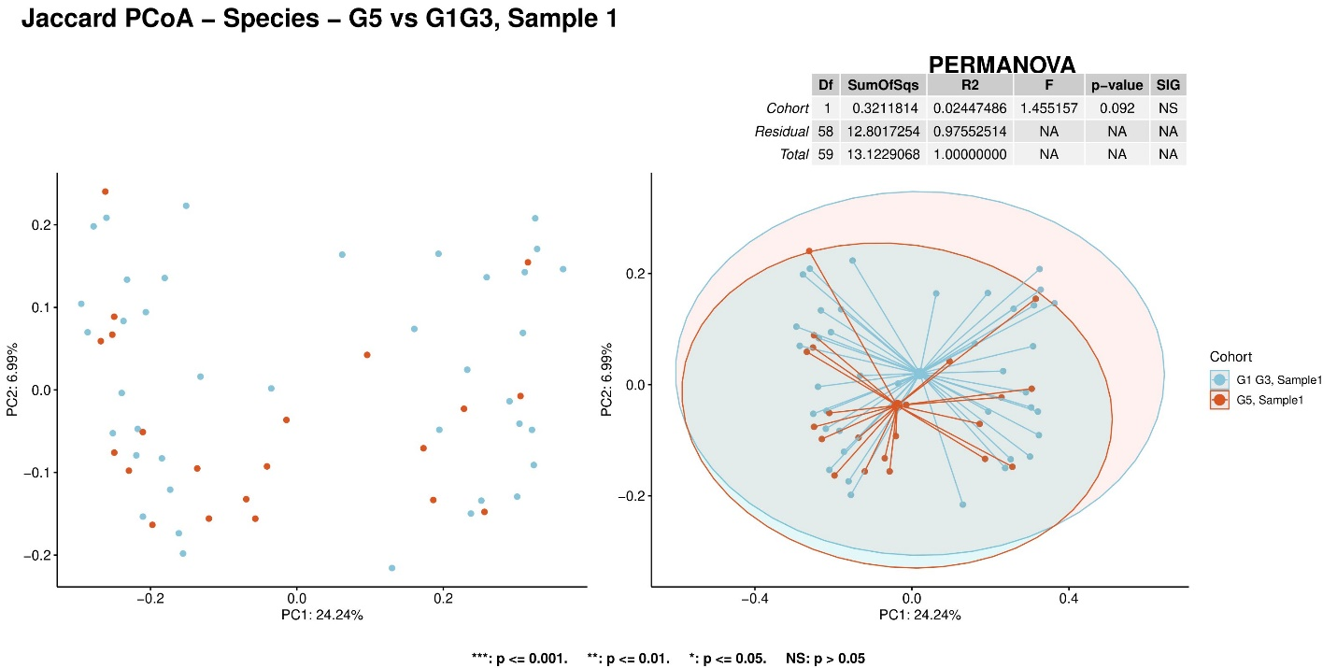

Fig.3*. Chao alpha diversity boxplots (species level)-G1A vs G3A, sample 2

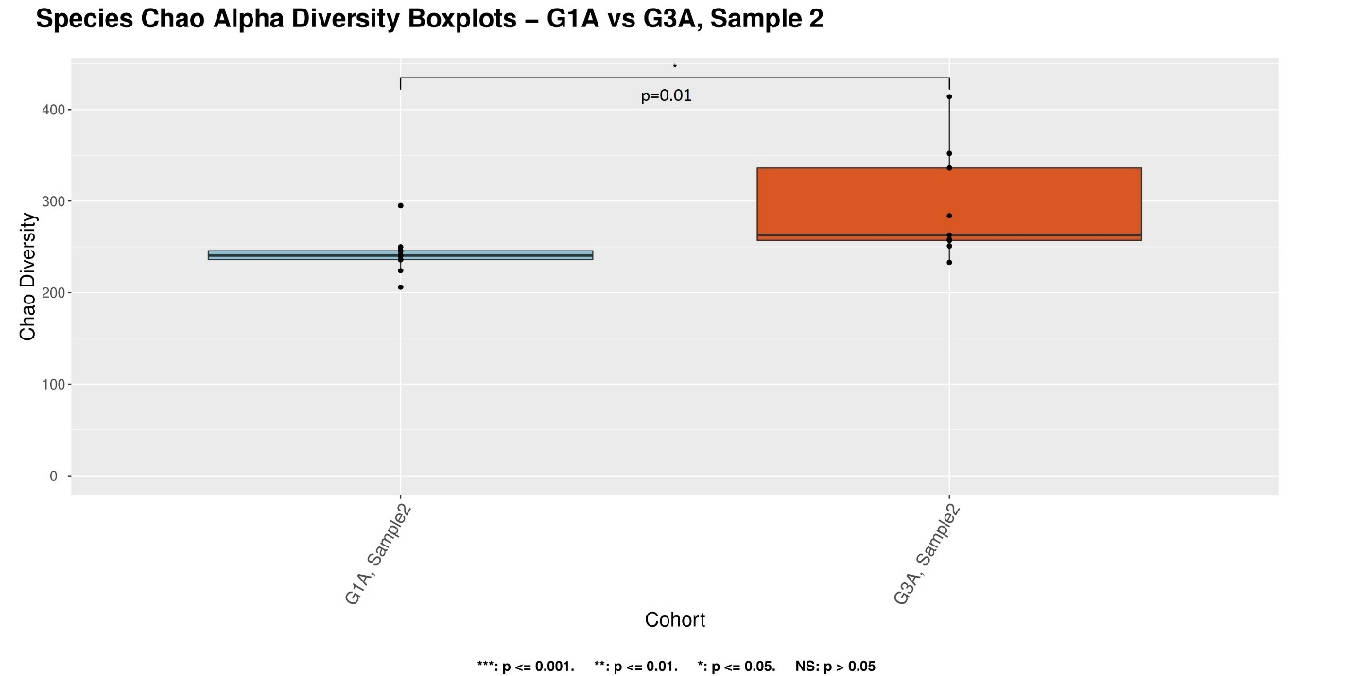

Fig.4*. Linear Discriminant Analysis Effect Size (Lefse) at genus level between G1A and G3A (sample 2).
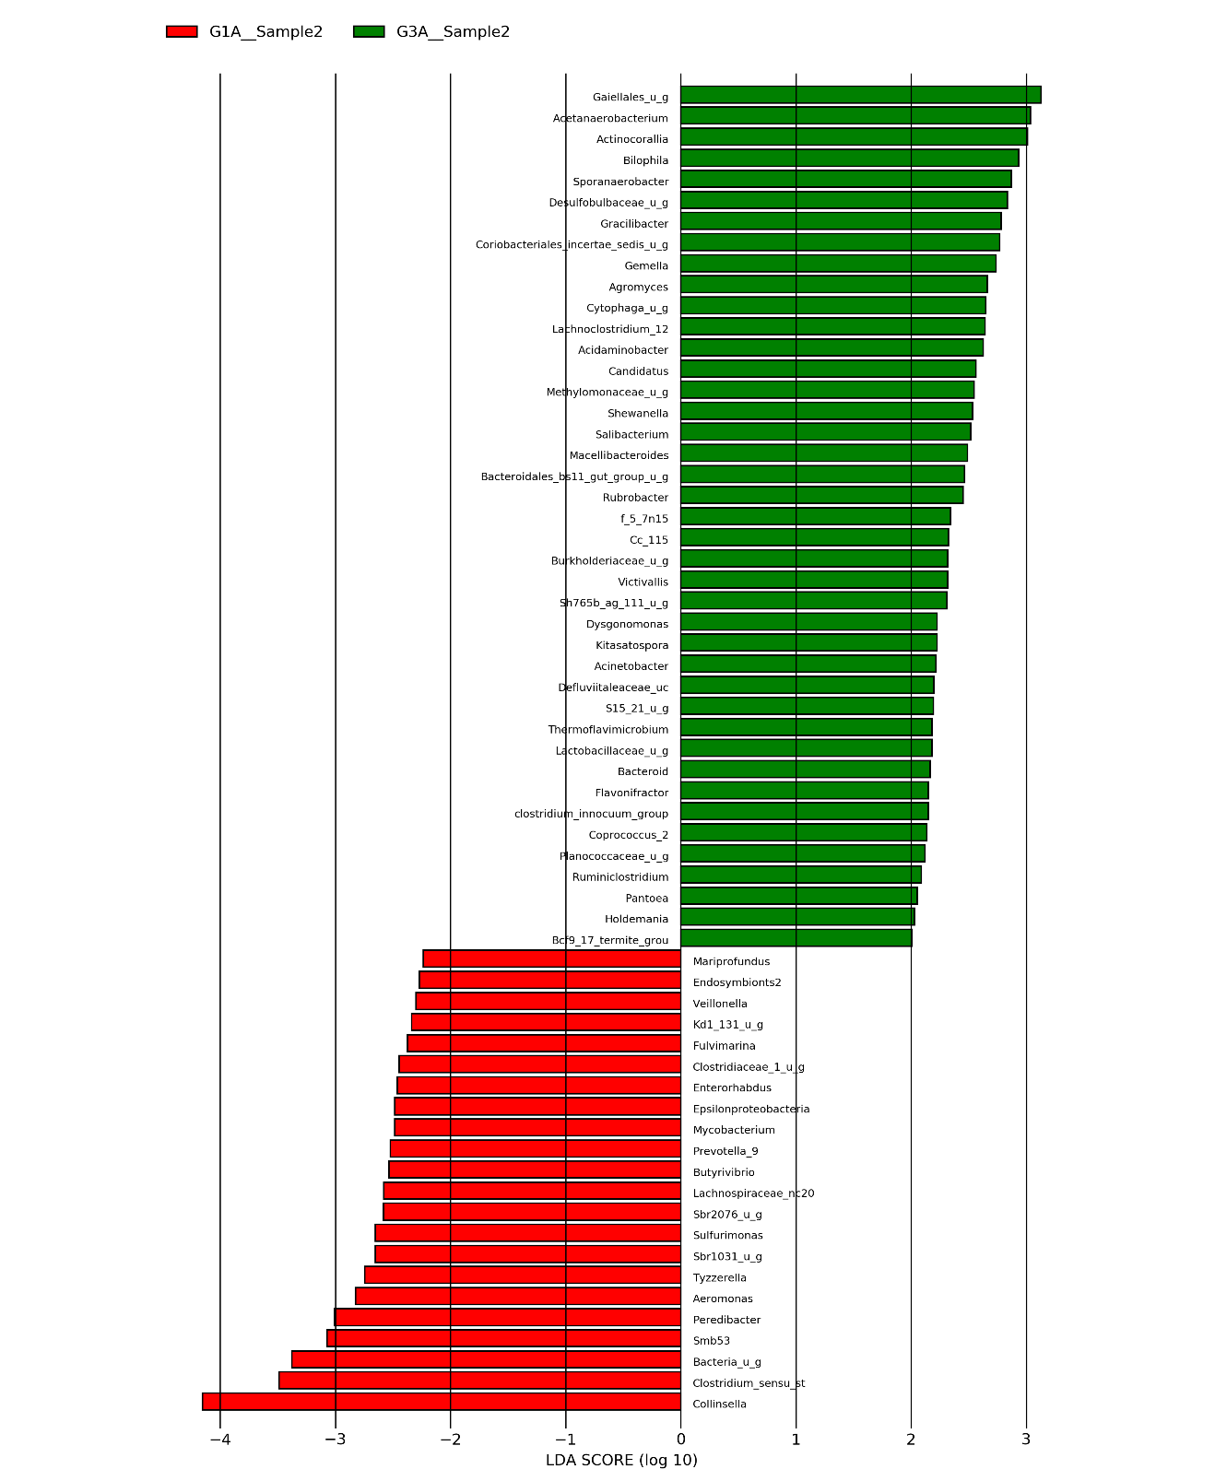

Fig.5*. Lefse analysis at species level between G1A and G3A (sample 2).

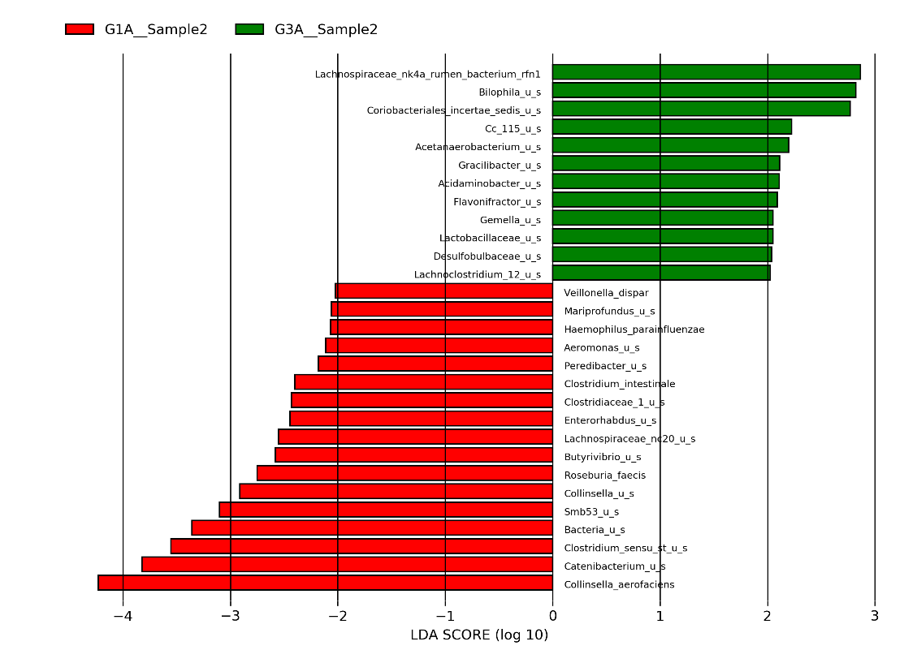
Fig.6*. Lefse analysis at species level between sample 1 and sample 2 for G1 group
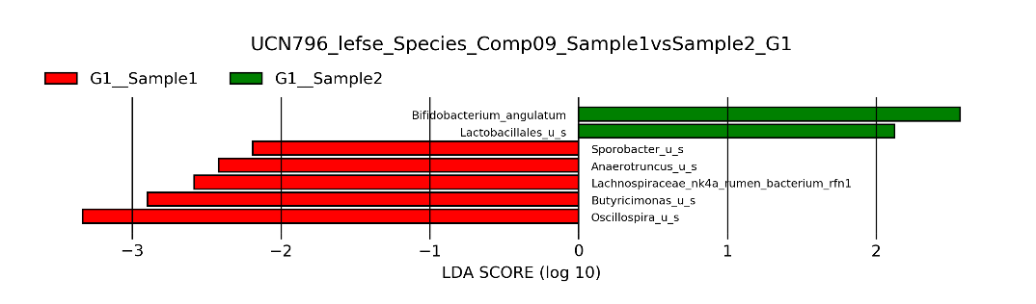

Fig.7*. Relative abundance heatmap (species level)- sample 1 vs sample 2 (G1G3), unclustered
