Electronic Supplementary Material

Fibroblast Activation Protein identifies progressive bladder cancer and allows peritoneal metastasis detection by ⁶⁸Ga-FAPI PET/CT imaging – a brief manuscript

Journal: Molecular Imaging and Biology

Bastiaan J. Viergever^{1,2,a} & Esther Strating^{1,a}, Marnix Lam³, Onno Kranenburg^{1,4} and Richard P. Meijer^{1,2,*}
Affiliation:1.Laboratory Translational Oncology, University Medical Center Utrecht, 3584CX Utrecht, The Netherlands. 2.Department of Oncological Urology, University Medical Center Utrecht, 3584CX Utrecht, The Netherlands. 3. Department of Radiology, University Medical Center Utrecht, Utrecht University, Utrecht, The Netherlands. 4.Utrecht Platform for Organoid Technology, Utrecht University, 3584 CX Utrecht, The Netherlands; a: Authors BV and ES contributed equally to this work. *Corresponding author; Dr. Richard P. Meijer, Department of Oncological Urology, University Medical Center Utrecht, Heidelberglaan 100, 3584 CX, Utrecht, The Netherlands. Tel. No.:+31-887558079. Email: rmeijer6@umcutrecht.nl; ORCID-ID: 0000-0003-2510-7982.

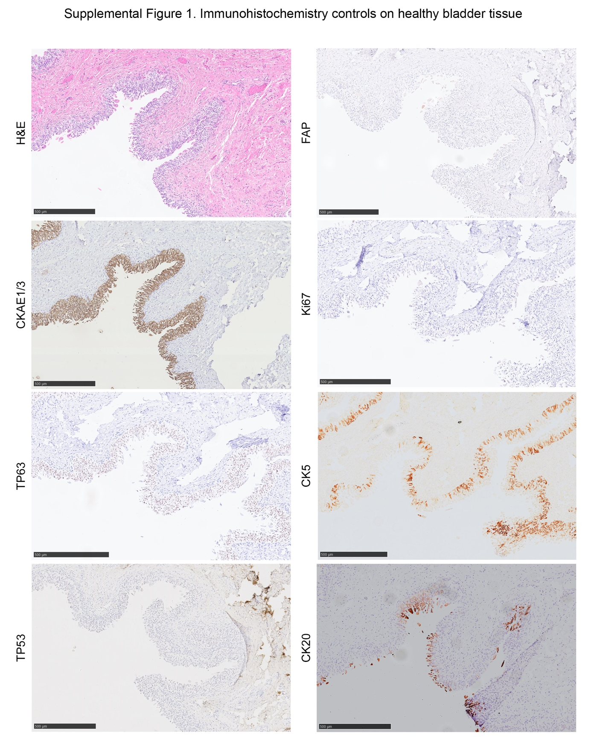
Supplemental Figure 1. Immunohistochemistry controls on healthy bladder tissue. Immunohistochemical analysis of patient 1 displayed with hematoxylin and eosin (H&E) and their expression of Ki67, tumor protein (TP) 53, TP63, cytokeratin (CK) 5 and CK20. Scale bars with are 500 µm.
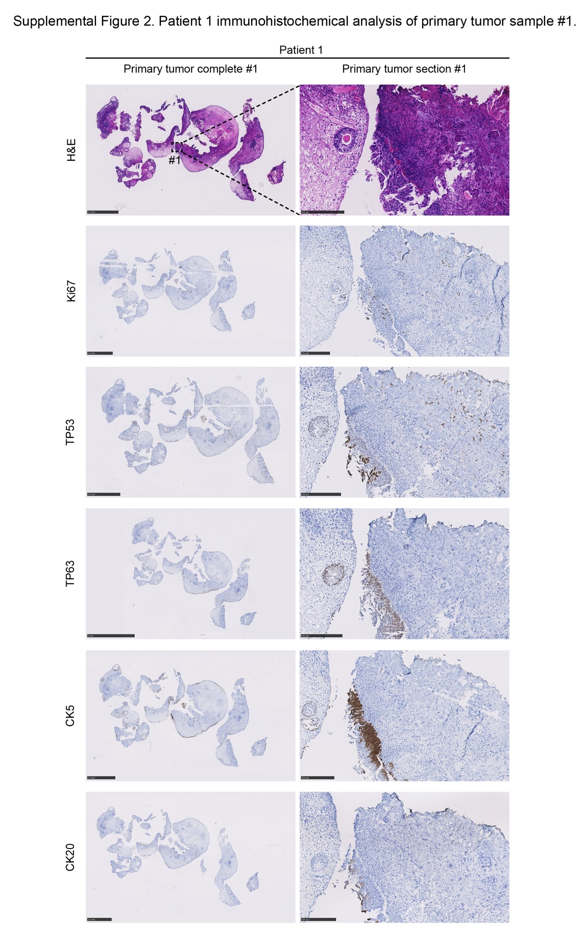
Supplemental Figure 2. Patient 1 immunohistochemical analysis of primary tumor sample 1. Immunohistochemical analysis of patient 1 displayed with hematoxylin and eosin (H&E) and their expression of Ki67, tumor protein (TP) 53, TP63, cytokeratin (CK) 5 and CK20. Scale bars of complete scans are 5mm. Tumor section zooms are indicated in the respective complete H&E slide with #1, with tumor section scale bars of 500 µm.

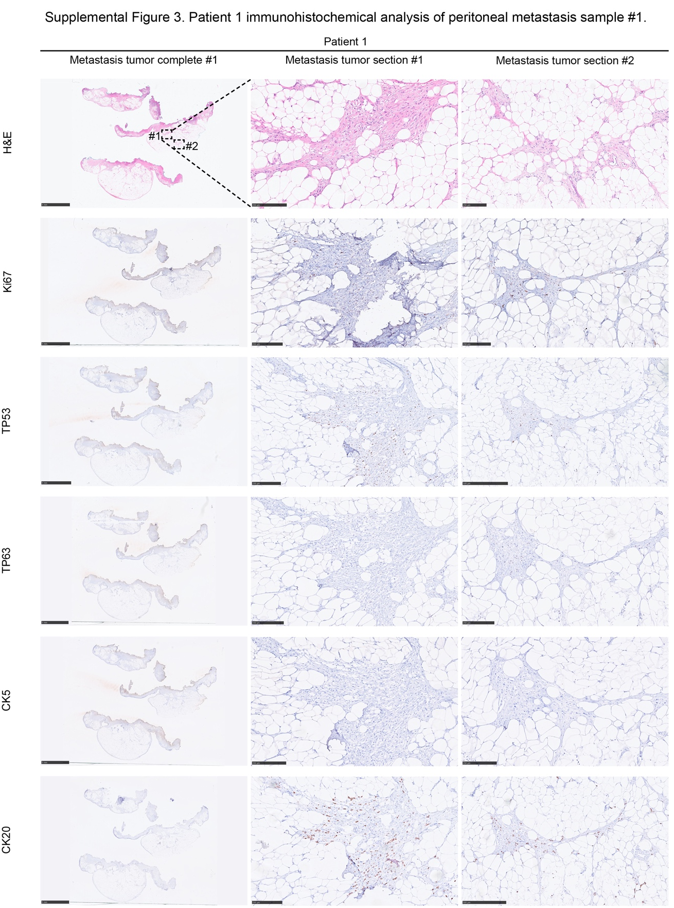
Supplemental figure 3. Patient 1 immunohistochemical analysis of peritoneal metastasis sample #1. Immunohistochemical analysis of patient 1 displayed with hematoxylin and eosin (H&E) and their expression of Ki67, tumor protein (TP) 53, TP63, cytokeratin (CK) 5 and CK20. Scale bars of complete scans are 5mm. Tumor section zooms are indicated in the complete H&E slide with #1 and #2 respectively, with tumor section scale bars of 500 µm.

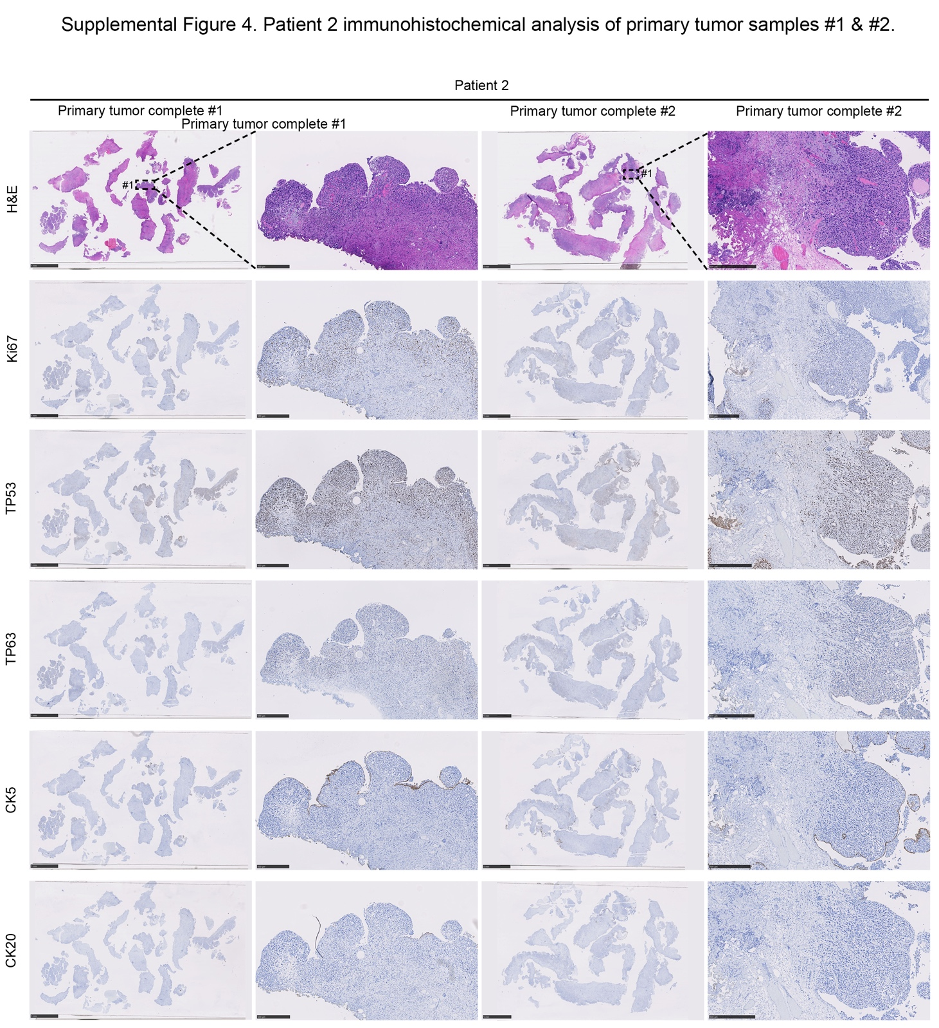
Supplemental figure 4. Patient 2 immunohistochemical analysis of primary tumor samples #1 and #2. Immunohistochemical analysis of patient 2 displayed with hematoxylin and eosin (H&E) and their expression of Ki67, tumor protein (TP) 53, TP63, cytokeratin (CK) 5 and CK20. Scale bars of complete scans are 5mm. Tumor section zooms are indicated in the respective complete H&E slide with #1, with tumor section scale bars of 500 µm.

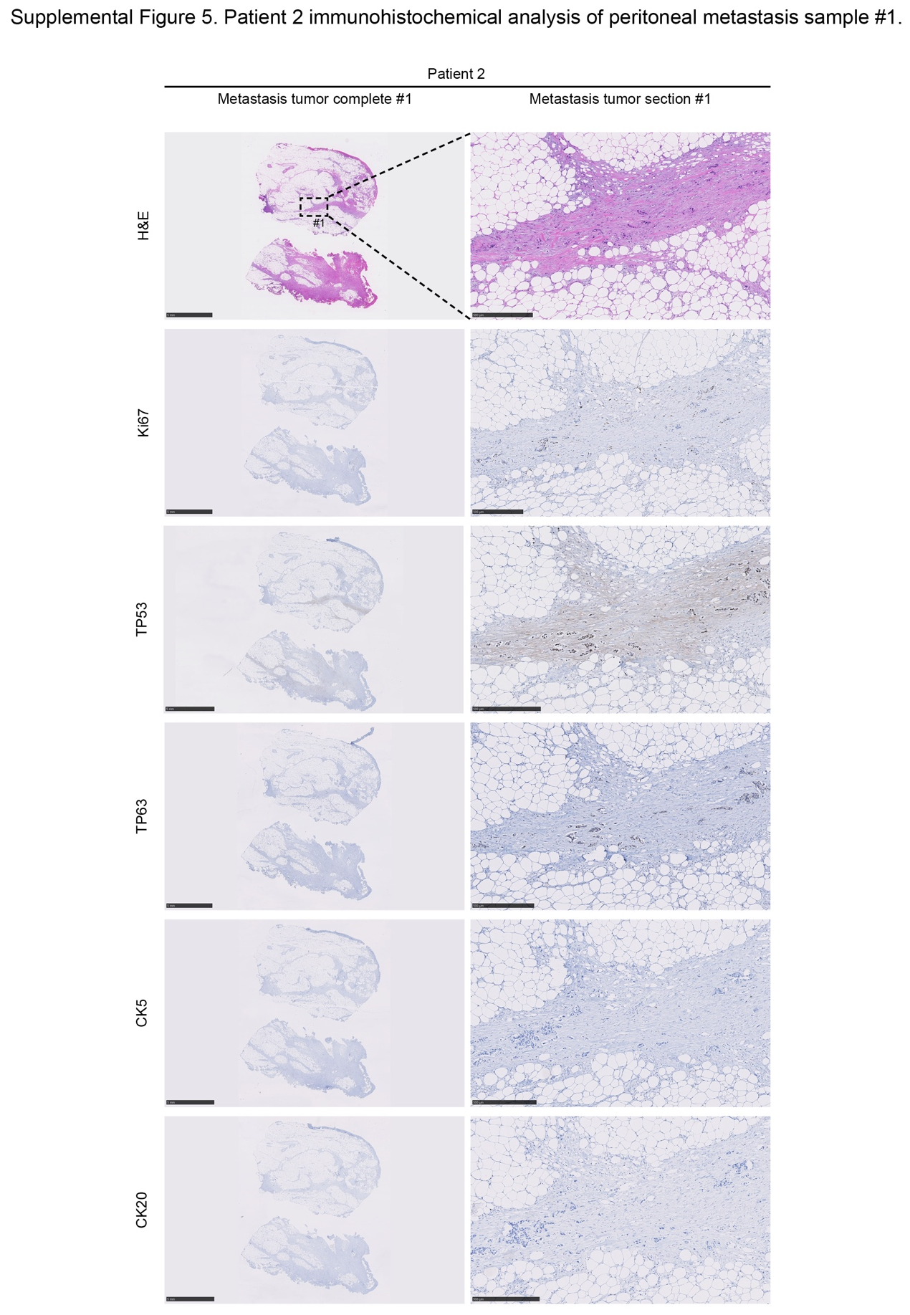
Supplemental figure 5. Patient 2 immunohistochemical analysis of peritoneal metastasis sample #1. Immunohistochemical analysis of patient 1 displayed with hematoxylin and eosin (H&E) and their expression of Ki67, tumor protein (TP) 53, TP63, cytokeratin (CK) 5 and CK20. Scale bars of complete scans are 5mm. Tumor section zooms are indicated in the complete H&E slide with #1 respectively, with tumor section scale bars of 500 µm.

