ONLINE RESOURCE

Identification of a predictive multiplex biomarker of delayed cerebral ischemia and early metabolic deregulation after aneurysmal subarachnoid haemorrhage based on metabolomics and lipidomics
Translational Stroke Research
Manuscript ID #

Karim Chikh^{1,2}, David Tonon^{3,4}, Thibaut Triglia^{3,4}, David Lagier^{3,4}, Anouk Buisson¹, Marie-Christine Alessi³, Catherine Defoort³, Sherazade Benatia³, Lionel J Velly⁵, Nicolas Bruder⁴, Jean-Charles Martin³

Corresponding author:
Jean-Charles Martin, Aix-Marseille Université, Faculté de Médecine, 27 bd Jean Moulin, 13005 Marseille, France. E mail: jean-charles.martin@univ-amu.fr
Supplemental methods
Study populations
Method for the metabolomics analysis
Methods for lipidomics analysis
Total fatty acid quantification
Statistical analyses
Supplemental tables
Table 1. Control patients used to test our predictive DCI score
Table 2. Patient-sample characteristics
Table 3. Biological function associated with metabolites in CSF
Table 4. Biological function associated with metabolites in plasma
Table 5. Composition of lipid blocks in CSF
Table 6. Composition of lipid blocks in plasma
Table 7. Links between gut bacteria and metabolites according to published data

Supplemental figures
Figure 1. Graphical summary of the clinical data before and after the normalisation procedure
Figure 2. Predicted power according to sample size in each group using the 20 selected variables discriminating DCI+ and DCI- patients
Figure 3. Clustering of the CSF and plasma lipidomes of the study population for hierarchical PLS analysis
Figure 4. Model performance in unblocked (left panel) and blocked (right panel) PLS-DA models
Figure 5. Venn plot showing the most common biological functions and lipid clusters that were shown to be significant using either the univariate t-test (with FDR-adjusted p-value at 0.05), the machine-learning random forest variable importance values and PLS-DA VIP values
Figure 6. Mass spectrometry detector response values for plasma cotinine and plasma lactate in DCI+ and DCI- patients
Figure 7. Lipid composition of plasma lipid cluster 11 with top discriminating lipid species (random forest variable importance index, as mean decrease accuracy)
Figure 8. Lipid composition of plasma lipid cluster 10 and 12 with top discriminating lipid species (random forest variable importance index, as mean decrease accuracy)

Supplemental methods
Study populations
The study was designed and conducted following the Strengthening the Reporting of Observational Studies in Epidemiology guidelines [1]. Ethical approval for this study (N8 2013-1316) was provided by the institutional review board of the Assistance Public–Hôpitaux de Marseille, France (Chairperson: Professor Y. Jammes) on 16 May 2013. To be eligible for inclusion, patients had to be over 18 years old and admitted to the NCCU of La Timone university hospital (Marseille) within 24h post-bleeding, and their conditions had to require clinically indicated external ventricular drainage. Patients were excluded if pregnant, if they had vasospasm on the first diagnostic angiogram or if their condition was so severe that they were unlikely to survive more than 48 h. Patient details were collected, including age, gender, and individual scores on the Simplified Acute Physiology Score II disease severity classification system, the World Federation of Neurological Surgeons (WFNS) grading system, and Hunt and Hess score, as described in Triglia et al [2]. Radiographic characteristics of the initial haemorrhage were identified, including localisation of the aneurysm, modified Fisher grade and volume of the intraventricular haemorrhage (IVH) evaluated using the IVH score as explained in Triglia [2]. Radiographic grading-scale scores were determined by two authors (L.V. and D.L.) who were blinded to the clinical outcome of patients studied. In addition, we collected data on duration of mechanical ventilation and external ventricular drainage placement, length of stay in the NCCU, modified Rankin Scale score, and Glasgow Outcome Scale extended at 1 month [2]. All patients were followed with transcranial Doppler sonography (TCD; Philips CX50 with a S3–1 transducer, Philips Healthcare, Suresnes, France) and received continuous intravenous nimodipine. Acceleration of TCD mean blood flow velocity above 120 cm s⁻¹ in the middle or anterior cerebral artery or daily change in mean TCD velocities greater than 50 cm s⁻¹ were suggestive of cerebral vasospasm. DCI was defined, based on the latest recommendations [3], as follows: a development of focal neurological signs; a drop of at least 2 points on the Glasgow Coma Scale that lasts for at least 1 h and is associated with angiographic cerebral vasospasm, detected either with computed tomography (CT) angiography or digital subtraction angiography; or a new cerebral infarction detected by CT, either within 6 weeks after aSAH or before discharge, after first ruling out a procedure-related infarction. Patients without aSAH admitted to the NCCU for other neurological disorders (see supplemental Table 1) were included as control patients (n=9). Blood and CSF were sampled in the first 24 h post-aSAH. CSF samples were collected from the external ventricular drain into anticoagulant-free sterile tubes. Blood samples were collected in sterile vacutainer citrate tubes. Samples were centrifuged, and immediately transferred to cryotubes and stored at -80°C until analysis.
Method for the metabolomics analysis
Preparation of dried extracts and LC-MS/MS method
All the dried polar extracts of both CSF and plasma were first reconstituted with 125 μL acetonitrile/water (90:10; v:v). The samples were separated using an Ultimate 3000 ultra-performance liquid chromatography (UPLC) (Thermo Scientific) coupled to a Q-Exactive Plus quadrupole-orbitrap hybrid high-resolution mass spectrometer (HRMS) equipped with a heated-electrospray ionisation source (H-ESI II). Chromatographic separation was performed on a binary solvent system using a reverse-phase C18 column (Hypersil Gold, Thermo Scientific, 100mm × 2.1mm, 1.9µm) at 40°C at a flow rate of 0.4 mL min-1 and a HILIC column (Merk, SeQuant® ZIC®-HILIC, 150 mm × 2.1 mm, 5µm, 200 A) at 25°C at a flow rate of 0.25 mL min-1. Injection volume for both columns was 5μL. The mobile phase consisted of a combination of solvent A (0.1% formic acid in water, v/v) and solvent B (0.1% formic acid in acetonitrile, v/v). The following gradient conditions were used: 0 to 1 minute, isocratic 100% A; 1 to 11 minutes, linear from 0 to 100% B; 11 minutes to 13 minutes, isocratic 100% B; 13 minutes to 14 minutes, linear from 100% to 0% B; 14 to 16 minutes, isocratic 100% A. The separated molecules were analyzed in both positive and negative ionisation modes in the same run. The mass spectra were collected using 35,000 full-width at half-maximum (FWHM) resolving power for the theoretical mass-to-charge ratio (m/z) 200. Full scan mass spectra were acquired in the 80−1000 m/z range. The ionisation source parameters for positive and negative ion mode were as follows: capillary temperature 320°C, spray voltage 3.5 kV, sheath gas 30 (arbitrary units), auxiliary gas 8 (arbitrary units), probe heater temperature 310°C, S-lens RF level set at 55 v. MS/MS experiments were performed using higher-energy collision-induced dissociation (HCD), and the normalised collision energy (NCE) applied was ramped from 10% to 40%. To ensure good repeatability of the analysis, a quality control sample (QC) was formed by pooling a small aliquot of each biological sample. The QC sample was analyzed intermittently (1 out of every 4 samples) for the duration of the analytical study to assess the variance observed in the data throughout the sample preparation, data acquisition and data pre-processing steps.
The mobile phase for HILIC column separation consisted of a combination of solvent A (100% water, 16 mM Ammonium formate) and solvent B (100% Acetonitrile 0.1% formic acid). The following gradient conditions were used: 0 to 2 minutes, isocratic 97% B; 2 to 10 minutes, linear from 97 to 70% B; 10 to 15 minutes, linear from 70 to 10% B; 15 to 17 minutes, isocratic 10% B; 17 to 18 minutes, linear from 10 to 97% B; 18 to 22 minutes, isocratic 97% B. The separated molecules were analyzed in both positive and negative ionisation modes in the same run. The mass acquisition parameters were the same used for the C18 column. The repeatability of the analysis was checked by analyzing the replicates of the QC sample.
Data processing and molecule identification:
After LC/MS acquisition, raw data files of the full scan – MS1 in both positive and negative modes – were converted into mzXML files. The data was processed using the R package XCMS (https://bioconductor.org/packages/release/bioc/html/xcms.html) as described in a previous paper [4], to generate a data matrix of deconvoluted ions with m/z, retention time and intensity. For metabolomics analysis, the XCMS matrix was annotated using an internal database of more than 1300 reference compounds (based on exact mass and retention time and MS/MS spectra when detected) [4]. For lipidomics analysis, the XCMS matrix was annotated using MS/MS data imported into LipidSearch 4.1 software (Thermo Fisher Scientific, San Jose, CA) and XCMS, as described in [5]. The annotated metabolomics and lipidomics datasets were further processed by probabilistic quotient normalisation to prevent sample-to-sample variation in the MS intensity response. All datasets were then combined with total fatty acid content in both plasma and CSF to obtain a single data matrix that served for further statistical analysis.

Methods for lipidomics analysis
Sample extractions, LC-MS/MS method and data processing
Plasma and CSF samples were extracted as described previously [4] (apolar extract). The dried extracts were then taken up in 120 μL of acetonitrile/water solution (1: 1), and vortexed and centrifuged at 11000 g for 10 minutes at 4 ° C. The samples were separated using an Ultimate 3000 ultra-performance liquid chromatography (UPLC) (Thermo Scientific) coupled to a Q-Exactive Plus quadrupole-orbitrap hybrid high-resolution mass spectrometer (HRMS) equipped with a heated-electrospray ionisation source (H-ESI II). Chromatographic separation was performed at a flow rate of 0.4 mL min⁻¹ using an Accucore™ C18 column (Thermo Scientific, 150 × 2.1 mm, 2.6 μm) at 45°C. The mobile phase consisted of a combination of solvent A (water/acetonitrile; 60:40 (v:v); 10 mM ammonium formate) and solvent B (isopropanol/acetonitrile 90:10 (v:v); 10 mM ammonium formate). The injection volume was 5μL. The following gradient conditions were used: 0 to 4 minutes, linear from 35 to 60% B; 4 to 12 minutes, linear from 60 to 85% B; 12 to 21 minutes, linear from 85 to 100% B; 21 to 24 minutes, isocratic 100% B; at 24 minutes, dropped to 35% B; from 24 to 28 minutes, isocratic 35% B. The separated molecules were analyzed in both positive and negative ionisation modes in the same run. The mass spectra were collected using 35,000 full-width at half-maximum (FWHM) resolving power for the theoretical mass-to-charge ratio (m/z) 200. Full scan mass spectra were acquired in the 250−1200 m/z range. The ionisation source parameters for positive and negative ion modes were as follows: capillary temperature 285 °C, spray voltage 3.5 kV, sheath gas 60 (arbitrary units), auxiliary gas 20 (arbitrary units), probe heater temperature 370°C, and S-lens RF level set at 45 v. except MS/MS experiments were performed using higher-energy collision-induced dissociation (HCD), and the normalized collision energy (NCE) applied was ramped from 10% to 40%. MS/MS acquisitions were performed intermittently throughout the analysis sequence with at intervals of 10 samples. The purpose of MS/MS fragmentation is to generate fragments for each metabolite that can serve to determine in silico the structure of the lipid molecule and to determine its identity using LipidSearch 4.1 software (Thermo Fisher Scientific, San Jose, CA). Data was processed using XCMS and LipidSearch as described in [5].

Total fatty acid quantification
Total plasma and CSF fatty acid composition was measured using gas chromatography with a flame ionisation detection system [5]. 250 µL of plasma and 1.9 mL of a stock methylation solution (1.8 mL methanol and 100 μL of freshly-prepared acetyl chloride) were combined in screw-capped glass tubes. The tubes were then capped and heated at 100°C for 60 min, and left to cool to room temperature. Hexane (1 mL) was then added, and the tubes were vortexed for 30s. The upper organic phase was collected with a Pasteur pipette. This extraction procedure was repeated as above in order to optimize the extraction of fatty acid methyl esters. The combined hexane solutions were then evaporated under nitrogen to dryness, and the dry residue was dissolved in 100 µL of hexane, transferred to GC vials, and capped under nitrogen. Fast GC analyses were performed with a Perkin-Elmer Clarus 680 system on 0.5 μL of sample injected in split mode by hydrogen flow at 10 mL/min. The column used was a BP×70 capillary column of 10m × 0.1mm ID × 0.2µm film thickness (SGE International Pty. Ltd., Australia). The temperature programme was as follows: initial, 60°C with a 0.5 min hold; ramp: 20°C/min to 200°C, 7°C/min to 225°C with a 1 min hold, and then 160°C/min to 250°C with a 1 min hold. Instrumental conditions were as follows: carrier gas was H2 at a flow rate of 61.4 cm/s and a constant head pressure of 206.8 kPa; FID set at 280°C; air and nitrogen make-up gas flow rates of 450 mL/min and 45 mL/min, respectively; split ratio of 200:1; sampling frequency of 50 Hz; 0.5 µl autosampler injection volume. Run- time for a single sample was 13.23 min, and sample turnaround time was 16 min.
Statistical analyses
Continuous variables were reported as mean plus standard derivation. For univariate statistics, data was transformed by Pareto scaling to obtain a Gaussian distribution across patients. Intergroup comparisons of means were performed using a t-test with adjustments for false discovery rate.
For metabolomics data, features from both ionisation modes for HILIC and RP data were combined into a single dataset, while both ionisation modes were combined for the lipid data. All data were mean-centred and divided by the standard deviation of each variable (autoscaling mode). Univariate statistical analysis, simple PLS-DA, random forest, hierarchical clustering, heatmapping, power calculation, ROC analysis, and correlation plotting were all performed using the online tool MetaboAnalyst 5.0. Partial correlations were calculated with the R package GeneNet, and network visualisation was performed using Cytoscape. Hierarchical PLS-DA and multiplex biomarker score calculations were performed with SIMCA 12 (Umetrics, Umea, Sweden). Models were validated by cross-validation analysis of variance (CV-ANOVA) (significance threshold ≤ 0.05) and by permutation tests (200 permutations).
Discriminant metabolites in the PLS-DA analysis were determined from their variable importance in projection (VIP) values determined by the NIPALS algorithm. The significant threshold of VIP was calculated using a normal probability plot indicating which VIP values of the corresponding metabolites deviated the most from normal distribution due to treatment. A similar method was employed to select the PLS-DA VIP cut-off threshold for significant lipid species. H-PLS-DA modeling was performed based on the contribution of separate orthogonal PLS-DAs calculated from all functional sets of metabolites, enabling us to generate a composite score value for each functional set. Multiblock PLS or hierarchical PLS enables aggregation of the data into biological function blocks to ease data interpretation and biological understanding of the implications of DCI on the system. The functional metabolic blocks were ‘weighted’ to take into account the number of metabolites per block [6]. For lipid blocking, lipid species were grouped according to clusters calculated by hierarchical clustering analysis (Ward method). Lipid block score values were generated by H-PLS-DA as above. Scores from the H-PLS-DA multiblock analysis were analysed to determine the most significant biological functions related to clinical outcome, using a t-test after adjustment for FDR (Padj ≤ 0.05), random forest and PLS-DA analyses. The blocks selected by at least two statistical methods were retained (supplemental Figure 5) and were also graphed in a partial correlation network to assess the importance of each block (function) in the integrated system, as determined by the betweenness centrality topology coefficient of the network (calculated using the Cytoscape tool ‘NetworkAnalyser’).
Pathway enrichment was performed using the enrichment tool bundled with MetaboAnalyst ((http://www.metaboanalyst.ca) for polar and semi-polar metabolites, and LION for lipids (http://www.lipidontology.com).

Supplemental Tables
Table 1. Control patients used to test our predictive DCI score
Control | Gender | Age | Neurological disorders
P10 | M | 69 | Ischaemic stroke
P17 | M | 55 | Arteriovenous malformation
P26 | F | 79 | Cerebral tumours
P39 | M | 44 | Intra-ventricular haemorrhage
P42 | M | 18 | Arteriovenous malformation
P52 | F | 17 | Arteriovenous malformation
P56 | F | 29 | Arteriovenous malformation
C | H | 54 | Ischaemic stroke
P | F | 75 | Ischaemic stroke

Table 2. Patient-sample characteristics
 | All patients (n=61 patients) | DCI- (n=39 patients) | DCI+ (n=22 patients) | Unadjusted p value | Adjusted P value (FDR)
Demographic variables, risk factors and comorbidities
Men | 28 (45.9%) | 17 (43.6%) | 11 (50%) | 0.64 | 0.83
Age, years | 55.6 ± 12.4 | 58.2 ± 11.8 | 51.0 ± 12.4 | 0.03* | 0.23
Diabetes mellitus | 6 (9.8%) | 5 (12.8%) | 1 (4.5%) | 0.31 | 0.65
Dyslipidaemia | 6 (9.8%) | 4 (10.3%) | 2 (9.1%) | 0.89 | 0.89
Smoking | 22 (36.1%) | 11 (28.2%) | 11 (50%) | 0.09 | 0.39
Alcohol | 12 (19.7%) | 7 (17.9%) | 5 (22.7%) | 0.66 | 0.83
BMI | 25.5 ± 5.3 | 26.3 ± 5.9 | 24.2 ± 4.0 | 0.79 | 0.85
Hypertension | 21 (34.4%) | 15 (38.5%) | 6 (27.3%) | 0.39 | 0.65
Dysthyroidism | 7 (11.5%) | 5 (12.8%) | 2 (9.1%) | 0.67 | 0.83
Depression | 9 (14.8%) | 6 (15.4%) | 3 (13.6%) | 0.86 | 0.89
Migraine | 6 (9.8%) | 2 (5.1%) | 4 (18.2%) | 0.10 | 0.39
Clinical presentation, complications and outcomes
WNFS scale | 3.7 ± 1.3 | 3.5 ± 1.4 | 3.9 ± 1.2 | 0.25 | 0.65
Fischer grade | 3.8 ± 0.5 | 3.7 ± 0.6 | 3.9 ± 0.4 | 0.39 | 0.65
Vasospasm | 20 (32.8%) | 0 (0%) | 20 (90.1%) | 2.6*10⁻²⁷ | 3.9*10⁻²⁶
Favourable GOSE | 39 (63.9%) | 27 (69.2%) | 12 (54.5%) | 0.29 | 0.65

Results are expressed as number (%) or as mean ± SD. DCI, delayed cerebral infarction; BMI, body mass index; WNFS, World Federation of Neurological Surgeons grading system scale; GOSE, Glasgow Outcome Scale–Extended.* Student t-test p-values for patients with DCI (DCI+) vs. without DCI (DCI-) were considered significant at < 0.05. Values were transformed by Pareto scaling to obtain a Gaussian distribution across patients (see supplemental fig. 3).

Table 3. Biological functions associated with metabolites in CSF
CSF
Metabolites | Biological function
Pro-Leu | amino acid metabolism
2-Oxoadipate | amino acid metabolism
4-Acetamidobutanoate | amino acid metabolism
Alanine | amino acid metabolism
Arginine | amino acid metabolism
Asparagine | amino acid metabolism
Citrulline | amino acid metabolism
Glutamine | amino acid metabolism
Glutarate | amino acid metabolism
Glycine | amino acid metabolism
Hippurate | amino acid metabolism
Histidine | amino acid metabolism
L-Threo-3-phenylserine | amino acid metabolism
N-Acetylasparagine | amino acid metabolism
N-Acetylaspartate | amino acid metabolism
N-Acetylputrescine | amino acid metabolism
N-Methylaspartate | amino acid metabolism
Norleucine | amino acid metabolism
Ornithine | amino acid metabolism
Phenylalanine | amino acid metabolism
Pipecolate | amino acid metabolism
Serine | amino acid metabolism
Threonine | amino acid metabolism
Azelate | anti-inflammatory
Caffeine | anti-inflammatory
N-Acetyltryptophan | anti-inflammatory
3-Hydroxyphenylacetate | antioxidant
Ascorbate | antioxidant
Biliverdin | antioxidant
Dehydroascorbate | antioxidant
Hydroxyphenyllactate | antioxidant
Inosine | antioxidant
N-Acetylmethionine | antioxidant
N-Acetyltryptophan | antioxidant
Urate | antioxidant
4-Guanidinobutanoate | arginine metabolism
N-Acetylputrescine | arginine metabolism
Ornithine | arginine metabolism
Deoxycholate | bile acid metabolism
3-Methylcrotonyl-L-carnitine | Branched-chain amino acid metabolism
Isovaleryl-L-carnitine | branched chain amino acid metabolism
N-acetyl-DL-valine | branched-chain amino acid metabolism
3-Methylglutaconic acid | branched-chain amino acid metabolism
2-Hydroxy 3-methylbutyric acid | branched-chain amino acid metabolism
2-Hydroxyisocaproic acid | branched-chain amino acid metabolism
2-Isopropylmalic acid | branched-chain amino acid metabolism
3-isopropylmalic acid | branched-chain amino acid metabolism
3-Methylglutaconic acid | branched-chain amino acid metabolism
3-Methylglutaric acid | branched-chain amino acid metabolism
Ketoleucine | branched-chain amino acid metabolism
Methyl-succinic acid | branched-chain amino acid metabolism
N-Acetylleucine | branched-chain amino acid metabolism
Valine | branched-chain amino acid metabolism
Mandelate | catecholamine metabolism
Ascorbate | catecholamine metabolism
Noradrenaline | catecholamine metabolism
Phenylalanine | catecholamine metabolism
2-Deoxy-D-glucose | cell growth and proliferation
2-Hydroxybutyrate | cell growth and proliferation
LysoPA(16:0) | cell growth and proliferation
LysoPA(18:1) | cell growth and proliferation
Methylthioadenosine | cell growth and proliferation
N-Acetylputrescine | cell growth and proliferation
Phosphorylcholine | cell growth and proliferation
Serine | cell growth and proliferation
LysoPA(16:0) | cell signalling
LysoPA(18:1) | cell signalling
Myoinositol | cell signalling
N-Acetylglucosamine | cell signalling
2-Deoxy-D-glucose | CHO metabolism
2-Hydroxybutyrate | CHO metabolism
2-Phosphoglycerate | CHO metabolism
Alanine | CHO metabolism
Fucose | CHO metabolism
Galactitol_mannitol_sorbitol | CHO metabolism
Galactose | CHO metabolism
Glycerol 3-phosphate | CHO metabolism
Hexose_1 | CHO metabolism
Hexose_2 | CHO metabolism
Hexose_3 | CHO metabolism
Hexose_4 | CHO metabolism
Iso-melibiose | CHO metabolism
Mannitol | CHO metabolism
N-acetyl-DL-valine | CHO metabolism
Pentose | CHO metabolism
Phosphoenolpyruvate | CHO metabolism
Ribitol | CHO metabolism
Saccharate | CHO metabolism
Betaine | cysteine and homocysteine metabolism
Cystathionine | cysteine and homocysteine metabolism
Cystine | cysteine and homocysteine metabolism
Folate | cysteine and homocysteine metabolism
Homocysteine | cysteine and homocysteine metabolism
Methionine | cysteine and homocysteine metabolism
N-Acetylmethionine | cysteine and homocysteine metabolism
O-Succinyl-homoserine | cysteine and homocysteine metabolism
S-Adenosylmethionine | cysteine and homocysteine metabolism
Glucuronate | detoxication
Iso-glucuronate | detoxication
Saccharate | detoxication
Carnitine | energy metabolism
Creatine | energy metabolism
Creatinine | energy metabolism
Galactose | energy metabolism
Glycine | energy metabolism
Lauroylcarnitine | energy metabolism
N,N,N-trimethyllysine | energy metabolism
O-Acetyl-L-carnitine | energy metabolism
Phosphocreatine | energy metabolism
Pyruvic acid | energy metabolism
Betaine | epigenetic modification
Folate | epigenetic modification
Methionine | epigenetic modification
N-Acetylhexosamine | epigenetic modification
Caffeine | exogenous compound
Carnitine | fatty acid beta-oxidation
Lauroylcarnitine | fatty acid beta-oxidation
Palmitoyl-L-carnitine | fatty acid beta-oxidation
10-Hydroxydecanoate | fatty acid metabolism
2,2-Dimethylsuccinic acid | fatty acid metabolism
Azelate | fatty acid metabolism
Petroselinate | fatty acid metabolism
Suberate | fatty acid metabolism
Glycine | folate metabolism
1-Methyladenosine | gene expression
Methionine | gene expression
Methylthioadenosine | gene expression
N,N,N-Trimethyllysine | gene expression
Cytosine | general metabolism
Nicotinamide | general metabolism
Pantothenate | general metabolism
2-Deoxy-D-glucose | glycolysis
2-Hydroxybutyrate | glycolysis
2-Phosphoglycerate | glycolysis
Glycerol 3-phosphate | glycolysis
Bilirubin | heme metabolism
Biliverdin | heme metabolism
1-Methylnicotinamide | inflammation
2,2-Dimethylsuccinic acid | inflammation
2,6-Dihydroxybenzoic acid | inflammation
Histidine | inflammation
LysoPC(14:0) | inflammation
LysoPC(16:0) | inflammation
LysoPE(16:0) | inflammation
LysoPE(18:0) | inflammation
LysoPI(16:0) | inflammation
LysoPS(18:1) | inflammation
3-Methylglutaconic acid | metabolic disorder
1-methylnicotinamide | metabolic disorder
2-Hydroxy 3-methylbutyric acid | metabolic disorder
2-Hydroxyisocaproic acid | metabolic disorder
3-hydroxymethylglutarate | metabolic disorder
3-Methylcrotonyl-L-carnitine | metabolic disorder
3-Methylglutaconic acid | metabolic disorder
3-Methylglutaric acid | metabolic disorder
4-Guanidinobutanoate | metabolic disorder
Butyrylcarnitine | metabolic disorder
Creatine | metabolic disorder
Creatinine | metabolic disorder
Fucose | metabolic disorder
Galactitol_mannitol_sorbitol | metabolic disorder
Glutarate | metabolic disorder
Hippurate | metabolic disorder
Isovaleryl-L-carnitine | metabolic disorder
Ketoleucine | metabolic disorder
LysoPC(14:0) | metabolic disorder
LysoPC(16:0) | metabolic disorder
LysoPI(16:0) | metabolic disorder
LysoPS(18:1) | metabolic disorder
Mannitol | metabolic disorder
Mevalonolactone | metabolic disorder
N-acetylalanine | metabolic disorder
Norleucine | metabolic disorder
Palmitoyl-L-carnitine | metabolic disorder
Phosphoric acid | metabolic disorder
Phosphorylcholine | metabolic disorder
Saccharate | metabolic disorder
Sebacic acid | metabolic disorder
Trans-aconitate | metabolic disorder
Trigonelline | metabolic disorder
Urate | metabolic disorder
Valine | metabolic disorder
1,3-Acetonedicarboxylic acid | microbiota metabolism
2,6-Dihydroxybenzoic acid | microbiota metabolism
2-Hydroxycaproic acid | microbiota metabolism
Hippurate | microbiota metabolism
Hydroxyphenyllactate | microbiota metabolism
Indoxyl sulfate | microbiota metabolism
Iso-MELIBIOSE | microbiota metabolism
N-formyl-l-methionine | microbiota metabolism
O-Hydroxyhippuric acid | microbiota metabolism
Pipecolate | microbiota metabolism
Ribitol | microbiota metabolism
Salicylate | microbiota metabolism
Shikimate | microbiota metabolism
Xanthosine | microbiota metabolism
Mevalonolactone | miscellaneous
Anserine | miscellaneous
Cotinine | miscellaneous
N-methyl-2-pyridone-5-carboxamide | miscellaneous
Cortisol | miscellaneous
Pregnenolone sulphate | miscellaneous
3-Methylglutaconic acid | mitochondrial function
2-Oxoadipate | mitochondrial function
3-Hydroxymethylglutarate | mitochondrial function
3-Methylcrotonyl-L-carnitine | mitochondrial function
3-Methylglutaconic acid | mitochondrial function
3-Methylglutaric acid | mitochondrial function
Aspartate | mitochondrial function
Butyrylcarnitine | mitochondrial function
Glutarate | mitochondrial function
Isovaleryl-L-carnitine | mitochondrial function
N-Formyl-L-methionine | mitochondrial function
O-Acetyl-L-carnitine | mitochondrial function
Palmitoyl-L-carnitine | mitochondrial function
Ureidopropionate | mitochondrial function
4-Acetamidobutanoate | neurone metabolism and neurotransmitters
4-Imidazoleacetate | neurone metabolism and neurotransmitters
5-Hydroxytryptophan | neurone metabolism and neurotransmitters
Anthranilate | neurone metabolism and neurotransmitters
Asparagine | neurone metabolism and neurotransmitters
Betaine | neurone metabolism and neurotransmitters
Cytidine | neurone metabolism and neurotransmitters
Inosine | neurone metabolism and neurotransmitters
N-Acetylaspartate | neurone metabolism and neurotransmitters
N-Acetylglutamate | neurone metabolism and neurotransmitters
Threonine | neurone metabolism and neurotransmitters
4-Guanidinobutanoate | neurone metabolism and neurotransmitters
Cytidine 2',3'-cyclic phosphate | neuroprotection
Ethanolaminephosphate | neuroprotection
Guanosine | neuroprotection
Nicotinamide | neuroprotection
Phosphocreatine | neuroprotection
Xanthine | neuroprotection
6-Hydroxydopamine | neurotoxicity
Homocysteine | neurotoxicity
Ketoleucine | neurotoxicity
Succinate semialdehyde | neurotoxicity
5-Hydroxyindole-3-acetic-acid | neurotransmitter
6-hydroxydopamine | neurotransmitter
Aspartate | neurotransmitter
Glutamine | neurotransmitter
N-Methylaspartate | neurotransmitter
Noradrenaline | neurotransmitter
Tyrosine | neurotransmitter
5'-Deoxyadenosine | oxidative stress
Allantoin | oxidative stress
Cystine | oxidative stress
Gulonolactone | oxidative stress
LysoPE(16:0) | oxidative stress
LysoPE(18:0) | oxidative stress
Succinate semialdehyde | oxidative stress
2-Hydroxyphenylacetic acid | phenylalanine metabolism
L-Threo-3-phenylserine | phenylalanine metabolism
Phenylalanine | phenylalanine metabolism
Salicylate | phenylalanine metabolism
Choline | phospholipid metabolism
Cytidine | phospholipid metabolism
Ethanolaminephosphate | phospholipid metabolism
LysoPA(16:0) | phospholipid metabolism
LysoPA(18:1) | phospholipid metabolism
LysoPC(14:0) | phospholipid metabolism
LysoPC(16:0) | phospholipid metabolism
LysoPE(16:0) | phospholipid metabolism
LysoPE(18:0) | phospholipid metabolism
LysoPI(16:0) | phospholipid metabolism
LysoPS(18:1) | phospholipid metabolism
N-Acetylneuraminate | phospholipid metabolism
Phosphorylcholine | phospholipid metabolism
Sphingomyelin | phospholipid metabolism
Uridine | phospholipid metabolism
Alanine | protein metabolism
Asparagine | protein metabolism
Aspartate | protein metabolism
Glucosamine | protein metabolism
Glutamine | protein metabolism
Serine | protein metabolism
N,N,N-trimethyllysine | protein metabolism
1-Methyladenosine | purine metabolism
4-Imidazoleacetate | purine metabolism
Guanosine | purine metabolism
Hypoxanthine | purine metabolism
Inosine | purine metabolism
Urate | purine metabolism
Xanthine | purine metabolism
Xanthosine | purine metabolism
Cytidine | pyrimidine metabolism
Cytidine 2',3'-cyclic phosphate | pyrimidine metabolism
Cytosine | pyrimidine metabolism
Ureidopropionate | pyrimidine metabolism
1-Methyl-l-histidine | redox status
Cystine | redox status
Histidine | redox status
Oxoproline | redox status
Ureidopropionate | redox status
1-Methyl-l-histidine | stress response
Biliverdin | stress response
Hypoxanthine | stress response
Lysine | stress response
Cis-aconitate | TCA
Citrate | TCA
Malate | TCA
Maleate | TCA
Oxoglutarate | TCA
Pyruvic acid | TCA
Succinic acid | TCA
5-Hydroxyindole-3-acetic-acid | tryptophan metabolism
5-Hydroxytryptophan | tryptophan metabolism
Anthranilate | tryptophan metabolism
N-Acetyltryptophan | tryptophan metabolism
Tryptophan | tryptophan metabolism
Indoxyl sulfate | tryptophane metabolism
3-Hydroxyphenylacetate | tyrosine metabolism
Hydroxyphenyllactate | tyrosine metabolism
Tyrosine | tyrosine metabolism
Arginine | urea cycle
Citrulline | urea cycle
N-Acetylglutamate | urea cycle
Ornithine | urea cycle
1-Methylnicotinamide | vascular health
Caffeine | vascular health
Folate | vascular health
Homocysteine | vascular health
Lysine | vascular health
N-Acetylmethionine | vascular health
Norleucine | vascular health
Theophylline | vascular health
4-Pyridoxate | vitamin metabolism
Ascorbate | vitamin metabolism
Choline | vitamin metabolism
Gulonolactone | vitamin metabolism
Pantothenate | vitamin metabolism
10-Hydroxydecanoate | omega-oxidation
Omega-hydroxydodecanoate | omega-oxidation
Sebacic acid | omega-oxidation
Suberate | omega-oxidation
Petroselinate | omega-oxidation
2,6-Dihydroxybenzoic acid | xenobiotic
2-Hydroxyphenylacetic acid | xenobiotic
3-(2-Hydroxyphenyl)propanoate | xenobiotic
PEG200_1 | xenobiotic
PEG200_4 | xenobiotic
PEG200_5 | xenobiotic
PEG200_6 | xenobiotic
PEG200_7 | xenobiotic
PEG200_8 | xenobiotic
PEG200_9 | xenobiotic
Raffinose | xenobiotic
Salicylate | xenobiotic
Shikimate | xenobiotic
Theophylline | xenobiotic

Table 4. Biological functions associated with metabolites in plasma
PLASMA
Metabolites | Biological function
Cys-Gly | active dipeptide
2-Aminoisobutyrate | amino acid metabolism
2-Isopropylmalic acid | amino acid metabolism
4-Acetamidobutanoate | amino acid metabolism
Alanine | amino acid metabolism
Arginine | amino acid metabolism
Asparagine | amino acid metabolism
Citrulline | amino acid metabolism
Glycine | amino acid metabolism
Hippurate | amino acid metabolism
Histidine | amino acid metabolism
Leucine | amino acid metabolism
N-Acetylasparagine | amino acid metabolism
N-Acetylphenylalanine | amino acid metabolism
N-Acetylputrescine | amino acid metabolism
Ornithine | amino acid metabolism
Phenylalanine | amino acid metabolism
Pipecolate | amino acid metabolism
Proline | amino acid metabolism
Putrescine | amino acid metabolism
Pyroglutamate | amino acid metabolism
Serine | amino acid metabolism
Threonine | amino acid metabolism
Caffeine | anti-inflammatory
Resveratrol | anti-inflammatory
1.7-Dimethyluric acid | antioxidant
1-Methylxanthine | antioxidant
3-Hydroxypicolinamide | antioxidant
Biliverdin | antioxidant
Dehydroascorbate | antioxidant
Hydroxyphenyllactate | antioxidant
Inosine | antioxidant
Leucine | antioxidant
Resveratrol | antioxidant
Urate | antioxidant
4-Guanidinobutanoate | arginine metabolism
N-Acetylputrescine | arginine metabolism
Ornithine | arginine metabolism
12-Ketolithocholic acid | bile acid metabolism
7.12-Diketolithocholic acid | bile acid metabolism
Deoxycholate | bile acid metabolism
Taurocholic acid | bile acid metabolism
Spermine | biogenic amine
3-Hydroxybutyric acid | beta-oxidation
2-Hydroxyisocaproic acid | branched-chain amino acid metabolism
2-Isopropylmalic acid | branched-chain amino acid metabolism
4-Methyl-2-oxovaleric acid | branched-chain amino acid metabolism
Isoleucine | branched-chain amino acid metabolism
Ketoleucine | branched-chain amino acid metabolism
N-Acetylleucine | branched-chain amino acid metabolism
1.7-Dimethyluric acid | caffeine metabolism
1-Methylxanthine | caffeine metabolism
Homovanillate | catecholamine metabolism
2-Hydroxyphenylacetate | catecholamine metabolism
Dopamine | catecholamine metabolism
Phenylalanine | catecholamine metabolism
Methylthioadenosine | cell growth and proliferation
N-Acetylputrescine | cell growth and proliferation
Putrescine | cell growth and proliferation
Serine | cell growth and proliferation
Spermine | cell growth and proliferation
Adenosine | cell transduction and communication
N-Acetylglucosamine | cell transduction and communication
Sphingomyelin | cell transduction and communication
Alanine | CHO metabolism
Hexose | CHO metabolism
Lactose | CHO metabolism
Mannitol | CHO metabolism
Ribose | CHO metabolism
Saccharate | CHO metabolism
Proline | collagen metabolism
Trans-4-hydroxy-L-proline | collagen metabolism
2-hydroxybutyrate | cysteine and homocysteine metabolism
Betaine | cysteine and homocysteine metabolism
Cystine | cysteine and homocysteine metabolism
Homocysteine | cysteine and homocysteine metabolism
Methionine | cysteine and homocysteine metabolism
Glucuronate | detoxication
Saccharate | detoxication
2-Hydroxy-4-(methylthio)butanoate | drug
N-Formylglycine | endocannabinoid metabolism
Lactate | energy expenditure
3-Hydroxyisovaleric acid | energy metabolism
Adenosine | energy metabolism
Creatine | energy metabolism
Glutamine | energy metabolism
Glycine | energy metabolism
Isoleucine | energy metabolism
N,N,N-trimethyllysine | energy metabolism
O-acetyl-l-carnitine | energy metabolism
Betaine | epigenetic modification
Methionine | epigenetic modification
N-Acetylglucosamine | epigenetic modification
Succinic acid | epigenetic modification
Uracil 5-carboxylate | epigenetic modification
2.6-Dihydroxybenzoic acid | exogenous compound
3-(2-hydroxyphenyl)propanoate | exogenous compound
4-Hydroxybenzoate | exogenous compound
Caffeine | exogenous compound
O-Acetylserine | exogenous compound
PEG200_5 | exogenous compound
PEG200_6 | exogenous compound
PEG200_7 | exogenous compound
PEG200_8 | exogenous compound
PEG200_9 | exogenous compound
Resveratrol | exogenous compound
Salicylate | exogenous compound
Theophylline | exogenous compound
Vanillic Acid | exogenous compound
10-Hydroxydecanoate | fatty acid metabolism
2.2-Dimethylsuccinic acid | fatty acid metabolism
Petroselinate | fatty acid metabolism
Omega-Hydroxydodecanoate | fatty acid w-oxidation
Petroselinate | fatty acid w-oxidation
Glycine | folate metabolism
N-Acetylneuraminate | ganglioside metabolism
1-Methyladenosine | gene expression
Methionine | gene expression
Methylthioadenosine | gene expression
N,N,N-Trimethyllysine | gene expression
Adenine | general metabolism
Glutamate | general metabolism
Glutamine | general metabolism
Pantothenate | general metabolism
Purine | general metabolism
Riboflavin | general metabolism
1.5-Anhydro-D-Sorbitol | glycaemic control
2-Hydroxyisocaproic acid | gut function
Sphingosine 1-Phosphate | gut function
Bilirubin | heme metabolism
Biliverdin | heme metabolism
1-Methyladenosine | immune function
2.4-Dihydroxypteridine | immune function
Sphingosine 1-Phosphate | immune function
LysoPC 16:0 | inflammation
LysoPC 18:0 | inflammation
1-Methylnicotinamide | inflammation
2.2-Dimethylsuccinic acid | inflammation
2.6-Dihydroxybenzoic acid | inflammation
5-Aminopentanoate | inflammation
Deoxycholate | inflammation
Histidine | inflammation
LysoPE 16:0 | inflammation
LysoPE 18:0 | inflammation
LysoPS 18:1 | inflammation
Sphingosine 1-phosphate | inflammation
3-Hydroxybutyric acid | ketogenesis
Creatinine | kidney function
N-Acetylalanine | kidney function
Phosphoric acid | kidney function
3-Hydroxybutyric acid | lipid metabolism
Cortisol | metabolic control
1.5-Anhydro-D-sorbitol | metabolic disorder
LysoPC 16:0 | metabolic disorder
LysoPC 18:0 | metabolic disorder
1-Methylnicotinamide | metabolic disorder
2-Aminoisobutyrate | metabolic disorder
2-Hydroxyisocaproic acid | metabolic disorder
4-Guanidinobutanoate | metabolic disorder
4-Methyl-2-oxovaleric acid | metabolic disorder
Butyryl carnitine | metabolic disorder
Creatine | metabolic disorder
Creatinine | metabolic disorder
Hippurate | metabolic disorder
Homogentisic acid | metabolic disorder
Isoleucine | metabolic disorder
Ketoleucine | metabolic disorder
LysoPC 16:0 | metabolic disorder
LysoPS 18:1 | metabolic disorder
MANNITOL | metabolic disorder
N-Acetylalanine | metabolic disorder
N-Acetylphenylalanine | metabolic disorder
N-Formylglycine | metabolic disorder
Ornithine | metabolic disorder
Phosphoric acid | metabolic disorder
Saccharate | metabolic disorder
Sebacic acid | metabolic disorder
Sorbitol | metabolic disorder
Urate | metabolic disorder
Succinic Acid | metabolic hub
Tryptophan | metabolic hub
Tyrosine | metabolic hub
Uracil | metabolic hub
2-Hydroxy-4-(Methylthio)Butanoate | methionine metabolism
Methylthioadenosine | methionine metabolism
12-Ketolithocholic acid | microbiota metabolism
2.4-Dihydroxypteridine | microbiota metabolism
2.6-Dihydroxybenzoic acid | microbiota metabolism
2-Hydroxycaproic acid | microbiota metabolism
2-Phenylglycine | microbiota metabolism
4-Hydroxybenzaldehyde | microbiota metabolism
4-Hydroxybenzoate | microbiota metabolism
5-Hydroxyindole-3-Acetic Acid | microbiota metabolism
Dehydroacetic acid | microbiota metabolism
Deoxycholate | microbiota metabolism
Hippurate | microbiota metabolism
Hydroxyphenyllactate | microbiota metabolism
Indoxyl Sulfate | microbiota metabolism
N-Methylglutamate | microbiota metabolism
O-Acetylserine | microbiota metabolism
O-Hydroxyhippuric acid | microbiota metabolism
Pipecolate | microbiota metabolism
Salicylate | microbiota metabolism
2-Aminoisobutyrate | mitochondrial function
Aspartate | mitochondrial function
Beta-Alanine | mitochondrial function
Butyryl Carnitine | mitochondrial function
O-Acetyl-L-Carnitine | mitochondrial function
Tryptophan | multiple disorders
3-Hydroxyisovaleric acid | muscle metabolism
Anserine | muscle metabolism
Beta-Alanine | muscle metabolism
Butyryl carnitine | muscle metabolism
Creatine | muscle metabolism
Creatinine | muscle metabolism
Lactate | muscle metabolism
Lysine | muscle metabolism
Threonine | neurone metabolism and neurotransmitters
2-Aminopyridine-3-Carboxylic acid | neurone metabolism and neurotransmitters
4-Acetamidobutanoate | neurone metabolism and neurotransmitters
4-Guanidinobutanoate | neurone metabolism and neurotransmitters
4-Guanidinobutanoate | neurone metabolism and neurotransmitters
5-Hydroxytryptophan | neurone metabolism and neurotransmitters
Asparagine | neurone metabolism and neurotransmitters
Betaine | neurone metabolism and neurotransmitters
Inosine | neurone metabolism and neurotransmitters
Cytidine 2',3'-Cyclic Phosphate | neuroprotection
Ethanolamine Phosphate | neuroprotection
4-Methyl-2-Oxovaleric Acid | neurotoxicity
Beta-Alanine | neurotoxicity
Homocysteine | neurotoxicity
Ketoleucine | neurotoxicity
2-Phenylglycine | neurotransmitter
Aspartate | neurotransmitter
Dopamine | neurotransmitter
Glutamate | neurotransmitter
Homovanillate | neurotransmitter
Pyroglutamate | neurotransmitter
Tyrosine | neurotransmitter
3-Hydroxypicolinamide | niacin metabolism
Cotinine | nicotine metabolism
Arginine | NO metabolism
Citrulline | NO metabolism
Ribose | nucleic acid metabolism
Spermine | nucleic acid metabolism
Uracil | nucleic acid metabolism
Uracil 5-Carboxylate | nucleic acid metabolism
Uridine | nucleic acid metabolism
Deoxyuridine | nucleotide metabolism
Ribose | nucleotide metabolism
Omega-Hydroxydodecanoate | oxidation
2-Hydroxybutyrate | oxidative stress
Cys-Gly | oxidative stress
Cystine | oxidative stress
LysoPE 16:0 | oxidative stress
LysoPE 18:0 | oxidative stress
2-Hydroxyphenylacetate | phenylalanine metabolism
Phenylalanine | phenylalanine metabolism
Salicylate | phenylalanine metabolism
LysoPC 16:0 | phospholipid metabolism
LysoPC 18:0 | phospholipid metabolism
PC (16:0, 16:0) | phospholipid metabolism
Choline | phospholipid metabolism
Ethanolamine Phosphate | phospholipid metabolism
LPC 16:0 | phospholipid metabolism
LysoPE 16:0 | phospholipid metabolism
LysoPE 18:0 | phospholipid metabolism
LysoPS 18:1 | phospholipid metabolism
N-Acetylneuraminate | phospholipid metabolism
Sphingomyelin | phospholipid metabolism
Uridine | phospholipid metabolism
Sorbitol | polyol metabolism
5-Aminopentanoate | porphyrin metabolism
N-Acetylalanine | post-translational regulation
Raffinose | prebiotic
3-Hydroxyisovaleric acid | protein metabolism
Alanine | protein metabolism
Asparagine | protein metabolism
Aspartate | protein metabolism
Glutamate | protein metabolism
Leucine | protein metabolism
Oxoglutarate | protein metabolism
Proline | protein metabolism
Serine | protein metabolism
N,N,N-Trimethyllysine | protein metabolism (breakdown)
Hexosamine | protein metabolism (glycoproteins)
1-Methyladenosine | purine metabolism
1-Methylxanthine | purine metabolism
2.4-Dihydroxypteridine | purine metabolism
Adenine | purine metabolism
Adenosine | purine metabolism
Hypoxanthine | purine metabolism
Inosine | purine metabolism
Purine | purine metabolism
Urate | purine metabolism
2-Aminopyridine-3-Carboxylic acid | pyridine metabolism
Cytidine 2',3'-Cyclic Phosphate | pyrimidine metabolism
Deoxyuridine | pyrimidine metabolism
Uracil | pyrimidine metabolism
Uracil 5-Carboxylate | pyrimidine metabolism
1.7-Dimethyluric acid | redox status
1-Methyl-L-Histidine | redox status
4-Hydroxybenzaldehyde | redox status
Cys-Gly | redox status
Cystine | redox status
Histidine | redox status
4-Pyridoxate | riboflavin metabolism
3-Alpha,11-Beta,17-Alpha,21-Tetrahydroxy- 5-Alpha-Pregnan-20-One 3,21-Diacetate | steroid metabolism
Cortisol | steroid metabolism
1-Methyl-L-Histidine | stress response
Biliverdin | stress response
Glutamine | stress response
Hypoxanthine | stress response
Lysine | stress response
Pyroglutamate | stress response
Trans-4-Hydroxy-L-Proline | stress response
N-Formylglycine | sulphur metabolism
Cis-Aconitate | TCA
Citrate | TCA
Malate | TCA
Malonate | TCA
Oxoglutarate | TCA
Succinic Acid | TCA
2-Hydroxybutyrate | threonine metabolism
1-Methylnicotinamide | thrombotic process
2-Aminophenol | tryptophan metabolism
5-Hydroxyindole-3-Acetic acid | tryptophan metabolism
5-Hydroxytryptophan | tryptophan metabolism
Tryptophan | tryptophan metabolism
Indoxyl Sulfate | tryptophan metabolism
Dopamine | tyrosine metabolism
Homovanillate | tyrosine metabolism
Hydroxyphenyllactate | tyrosine metabolism
Tyrosine | tyrosine metabolism
Citrulline | urea cycle
Indoxyl Sulfate | uremic toxins
5-Hydroxyindole-3-Acetic Acid | uremic toxins
Homocysteine | vascular health
Lysine | vascular health
Caffeine | vascular health
Theophylline | vascular health
3-Hydroxypicolinamide | vitamin metabolism
4-Pyridoxate | vitamin metabolism
Choline | vitamin metabolism
Pantothenate | vitamin metabolism
Riboflavin | vitamin metabolism
Phosphoric acid | vitamin metabolism
10-Hydroxydecanoate | omega-oxidation
Sebacic acid | omega-oxidation

Table 5. Composition of lipid blocks in CSF
CSF
Lipids | clusters
DG(36:3p) | 1
TG(16:0/18:1/21:0) | 1
TG(16:0/18:1/23:1) | 1
TG(18:0/18:1/20:3) | 1
TG(18:0/18:1/22:5) | 1
TG(18:1/18:2/22:6) | 1
TG(18:2/18:2/22:6) | 1
TG(18:3+OO/14:0/15:0) | 1
TG(20:1/18:1/18:1) | 1
TG(57:6+OO) | 1
DG(18:1/18:2) | 2
DG(18:1/20:4) | 2
DG(34:1p) | 2
PC(39:2p) | 2
TG(16:0/18:1/22:1) | 2
TG(16:0/18:1/24:0) | 2
TG(16:0/18:2/20:4) | 2
TG(16:0e/16:0/18:1) | 2
TG(16:2/18:2/18:3) | 2
TG(18:0/18:0/18:1) | 2
TG(18:0/18:1/18:1) | 2
TG(18:0e/16:0/18:1) | 2
TG(18:1/18:1/24:0) | 2
TG(18:1/18:2/20:4) | 2
TG(18:1p/16:0/18:1) | 2
TG(20:1p/16:0/16:0) | 2
TG(22:0/18:2/18:2) | 2
TG(24:4/16:0/18:1) | 2
Cer(d17:1/24:0) | 3
Cer(d18:1/24:0) | 3
DG(53:2) | 3
DG(55:4) | 3
LPE(16:0) | 3
LPE(20:4) | 3
LPE(22:6) | 3
PC(16:0p/16:0) | 3
PC(18:1/18:1) | 3
PE(20:0p/18:2) | 3
SM(d20:0/18:2) | 3
SM(d20:1/20:0) | 3
SM(d42:1) | 3
DG(16:0/18:1) | 4
DG(18:1/18:1) | 4
DG(32:0p) | 4
TG(16:0/14:0/18:1) | 4
TG(16:0/16:0/18:1) | 4
TG(16:0/17:0/18:1) | 4
TG(16:0/17:1/18:1) | 4
TG(16:0/18:1/22:0) | 4
TG(16:1/17:1/18:1) | 4
TG(17:0/18:1/18:1) | 4
TG(18:3+OO/15:1/18:3) | 4
PC(16:0/18:2) | 5
TG(15:0/18:2/18:2) | 5
TG(16:0/18:1/22:4) | 5
TG(18:0/16:0/18:1) | 5
TG(18:0/18:1/20:4) | 5
TG(18:1/17:1/18:1) | 5
TG(18:1/17:1/18:2) | 5
TG(18:1/18:1/20:4) | 5
TG(18:3/17:1/18:2) | 5
TG(18:3+O/18:1/18:2) | 5
TG(19:0/18:1/18:1) | 5
TG(19:1/18:1/18:1) | 5
TG(53:6+4O) | 5
ChE(18:1) | 6
PC(18:0/22:6) | 6
PI(18:0/22:5)_2 | 6
SM(d20:0/18:1) | 6
SM(d22:0/20:3) | 6
SM(d34:0) | 6
ChE(20:2) | 7
ChE(20:3) | 7
ChE(20:4) | 7
ChE(22:6) | 7
SM(d36:0) | 7
ZyE(18:1) | 7
Co(Q10) | 8
LPC(18:2) | 8
PC(18:0/20:3) | 8
PC(33:2) | 8
PI(18:0/20:4) | 8
SM(d20:0/20:3) | 8
SM(d30:1) | 8
SM(d32:2) | 8
SM(d35:2) | 8
SM(d39:1) | 8
SM(d41:1) | 8
TG(18:3+O/16:0/18:1) | 8
TG(18:3+O/18:1/18:1) | 8
ChE(16:1) | 9
ChE(17:1) | 9
ChE(18:3) | 9
PC(16:0/20:4) | 9
PC(16:0p/22:6) | 9
PC(18:0/20:4) | 9
PC(18:1/20:4) | 9
PC(34:2) | 9
PC(36:24O) | 9
LPC(18:0) | 10
LPC(20:4)_1 | 10
LPC(22:6) | 10
PC(16:0e/18:2) | 10
PC(16:0p/18:2) | 10
PC(18:0e/18:1) | 10
PC(18:0e/22:6) | 10
PC(34:2+O) | 10
PI(18:0/18:1) | 10
PI(18:0/22:5)_1 | 10
SM(d40:0) | 10
TG(20:5/18:2/20:4) | 10
LPC(18:1) | 11
LPC(20:4)_2 | 11
PC(16:0e/16:0) | 11
PC(16:0e/20:3) | 11
PC(16:0p/20:3) | 11
PC(16:0p/20:4) | 11
PC(18:0/20:2) | 11
PC(18:0/22:4) | 11
PC(18:0p/20:4) | 11
PC(18:0p/22:6) | 11
SM(d37:1) | 11
LPC(37:4) | 12
PC(16:0/14:0) | 12
PC(16:0/16:0) | 12
PC(16:0/16:1) | 12
PC(16:0/18:1) | 12
PC(16:0p/18:1) | 12
PC(17:0/18:1) | 12
PC(18:0/16:0) | 12
PC(18:0/18:1) | 12
PC(18:0p/16:0) | 12
PC(38:2) | 12
PE(18:0p/22:6) | 12
SM(d18:0/18:1) | 12
SM(d39:2) | 12
Cer(d18:2/24:1) | 13
dMePE(22:63O/20:4) | 13
dMePE(22:64O/20:4) | 13
LPE(18:0) | 13
PE(18:0/20:3) | 13
PE(18:0/22:5) | 13
PE(18:0e/20:4) | 13
PE(18:1/18:1) | 13
PE(18:1/18:2) | 13
PE(20:0p/22:6) | 13
PE(22:63O/20:4) | 13
PI(16:0/20:4) | 13
PI(18:1/20:4) | 13
PS(38:4) | 13
Cer(d18:1/18:0) | 14
CerG1(d18:1/24:1) | 14
PC(35:1) | 14
PC(42:4p) | 14
PE(16:0/18:1) | 14
PE(16:0p/18:1) | 14
PE(18:0/18:1) | 14
PE(18:0/20:4) | 14
PE(18:0/22:4) | 14
PE(18:0e/22:4) | 14
PE(18:0e/22:6) | 14
PE(18:0p/18:1) | 14
PE(18:0p/22:4) | 14
PE(18:1p/18:1) | 14
PE(18:1p/20:4) | 14
PE(18:1p/22:6) | 14

Table 6. Composition of lipid blocks in plasma
PLASMA
Lipids | Clusters#
DG(16:0/16:0) | 1
DG(16:0/16:1) | 1
DG(16:0/18:1) | 1
DG(16:0/18:2) | 1
DG(16:1/18:2) | 1
DG(18:0/16:0) | 1
DG(18:0/18:1) | 1
DG(18:1/18:1) | 1
DG(18:1/18:2) | 1
DG(18:1/20:4) | 1
DG(18:1/22:6) | 1
DG(18:3/18:2) | 1
DG(32:0p) | 1
PEt(15:0/18:1) | 1
Cer(d18:1/20:0) | 2
Cer(d18:1/24:1) | 2
PC(15:0/22:6)_2 | 2
PC(17:4/18:0) | 2
PE(16:0/18:1) | 2
PE(16:0/18:2) | 2
PE(16:0/20:4) | 2
PE(16:0/20:5) | 2
PE(16:0/22:6) | 2
PE(18:0/18:1) | 2
PE(18:0/18:2) | 2
PE(18:0/20:3) | 2
PE(18:0/20:4) | 2
PE(18:0/22:5) | 2
PE(18:0/22:6) | 2
PE(18:1/20:4) | 2
Cer(d20:2/18:0+O) | 3
LPC(14:0) | 3
LPC(15:0) | 3
LPC(16:1)_1 | 3
LPC(16:1)_2 | 3
LPC(18:3) | 3
LPE(18:1)_1 | 3
LPE(18:1)_2 | 3
LPE(18:2)_1 | 3
LPE(18:2)_2 | 3
LPE(20:4)_1 | 3
LPE(20:4)_2 | 3
LPE(22:6) | 3
TG(10:0/10:0/18:2) | 3
LdMePE(16:0)_1 | 4
LdMePE(16:0)_2 | 4
LdMePE(18:0) | 4
LdMePE(18:1) | 4
LdMePE(18:2) | 4
LPC(16:0) | 4
LPC(16:0e) | 4
LPC(16:0p) | 4
LPC(17:1) | 4
LPC(18:0) | 4
LPC(18:0e) | 4
LPC(18:1) | 4
LPC(18:1p) | 4
LPC(18:2) | 4
LPC(20:1) | 4
LPC(20:2) | 4
LPC(20:3) | 4
LPC(20:4)_1 | 4
LPC(20:4)_2 | 4
LPC(20:5)_1 | 4
LPC(20:5)_2 | 4
LPC(22:4) | 4
LPC(22:5) | 4
LPC(22:6)_1 | 4
LPC(22:6)_2 | 4
LPE(16:0)_1 | 4
LPE(16:0)_2 | 4
LPE(18:0) | 4
LPI(18:0)_1 | 4
LPI(18:0)_2 | 4
LPI(20:4) | 4
PC(16:0/16:0) | 5
PC(16:0/18:2) | 5
PC(16:0/20:3) | 5
PC(16:0/22:6) | 5
PC(18:0/18:2) | 5
PC(18:0/20:4) | 5
PC(18:0/22:5) | 5
PC(21:0CHO) | 5
PC(23:0CHO) | 5
PC(24:0CHO) | 5
PC(25:0CHO) | 5
PC(27:0CHO) | 5
PC(34:1) | 5
PC(34:2) | 5
PC(35:3)_2 | 5
PC(36:4+3O) | 5
PC(38:6) | 5
PI(41:7 | 5
SM(d34:1) | 5
TG(15:0/18:1/20:4) | 5
TG(18:1/18:1/22:6) | 5
TG(49:3+4O) | 5
TG(53:6+OO) | 5
TG(9:0CHO/16:0/18:1) | 5
TG(15:0/16:0/18:2) | 6
TG(15:0/18:1/18:2) | 6
TG(16:0/10:0/18:1) | 6
TG(16:0/12:0/14:0) | 6
TG(16:0/12:0/18:1) | 6
TG(16:0/14:0/16:0) | 6
TG(16:0/14:0/18:1) | 6
TG(16:0/16:0/18:1) | 6
TG(16:0/17:0/18:1) | 6
TG(16:0/17:1/18:1) | 6
TG(16:0/18:1/21:5) | 6
TG(16:0/18:2/20:5) | 6
TG(16:1/14:0/18:2) | 6
TG(16:1/18:1/18:2) | 6
TG(17:0/18:1/18:1) | 6
TG(18:0/18:1/20:4) | 6
TG(18:0/18:2/20:4) | 6
TG(18:1/18:1/20:2) | 6
TG(18:1/18:1/22:3) | 6
TG(18:2/17:1/18:2) | 6
TG(20:0/18:1/18:1) | 6
TG(47:3+4O) | 6
TG(51:2+4O) | 6
TG(58:3) | 6
PC(14:0/18:2) | 7
PC(16:0e/18:2) | 7
PC(32:2) | 7
PC(34:2e)_2 | 7
PC(34:4) | 7
PC(40:8) | 7
PC(42:10) | 7
PE(16:0p/18:2) | 7
PE(16:0p/20:4) | 7
PE(18:0p/18:2) | 7
PE(18:0p/20:3) | 7
PE(18:0p/20:4)_2 | 7
PE(18:1p/18:2) | 7
PE(18:1p/20:4) | 7
PE(36:1p) | 7
PE(38:6e) | 7
LPC(34:3) | 8
PC(16:0e/20:3) | 8
PC(16:0p/18:1) | 8
PC(16:0p/18:2) | 8
PC(18:0p/22:5) | 8
PC(18:1/18:1) | 8
PC(19:0/18:2) | 8
PC(34:2e)_1 | 8
PC(34:2p) | 8
PC(36:2e) | 8
PC(37:7p) | 8
PE(16:0p/18:1) | 8
PE(16:0p/22:6)_2 | 8
PE(18:0e/22:6) | 8
PE(18:0p/22:6) | 8
PE(18:1p/22:6) | 8
PEt(44:6) | 8
Cer(d18:0/22:0) | 9
Cer(d18:1/22:0) | 9
PC(16:0/18:1) | 9
PC(16:0/20:4) | 9
PC(18:0/20:5) | 9
PC(18:1/18:2) | 9
PC(36:3) | 9
TG(18:3O/18:1/18:1) | 9
CerG1(d18:1/24:0) | 10
PC(15:0/18:1) | 10
PC(16:0/16:1) | 10
PC(18:0/18:1) | 10
PC(18:0/20:3) | 10
PC(18:0/22:4) | 10
PC(18:0p/18:2) | 10
PC(33:0) | 10
PC(33:1) | 10
PC(34:0CHO) | 10
PC(34:2+O) | 10
PC(36:2p) | 10
PC(37:2) | 10
PC(37:3) | 10
PC(38:2) | 10
PC(38:3e) | 10
PC(38:4) | 10
PE(18:0p/20:4)_1 | 10
PI(14:0/20:2) | 10
PI(16:0/16:1) | 10
PI(16:0/18:1)_1 | 10
PI(16:0/18:1)_2 | 10
PI(16:0/18:2) | 10
PI(16:0/20:3) | 10
PI(16:0/20:4) | 10
PI(18:0/18:1) | 10
PI(18:0/18:2) | 10
TG(16:0/8:0/18:1) | 10
PC(15:0/18:2) | 11
PC(17:0/20:4) | 11
PC(35:3)_1 | 11
PC(35:4) | 11
PC(37:6) | 11
PC(39:5) | 11
PC(39:6) | 11
PI(18:0/20:3)_1 | 11
PI(18:0/20:3)_2 | 11
PI(18:0/20:4) | 11
SM(d30:1) | 11
SM(d31:1) | 11
SM(d32:1) | 11
SM(d32:2) | 11
SM(d33:1) | 11
SM(d33:2) | 11
SM(d35:1) | 11
SM(d35:2) | 11
SM(d35:4) | 11
SM(d36:2) | 11
SM(d38:1) | 11
SM(d38:2) | 11
SM(d39:1) | 11
SM(d40:1) | 11
SM(d40:2) | 11
SM(d40:4) | 11
SM(d41:1) | 11
SM(d41:4) | 11
SM(d42:1) | 11
SM(d42:5) | 11
SM(d43:4) | 11
SM(d44:4) | 11
Cer(d18:1/16:0) | 12
CerG1(d18:1/16:0) | 12
CerG2(d18:1/16:0) | 12
PC(32:0) | 12
SM(d18:1/24:1) | 12
SM(d20:0/16:0) | 12
SM(d34:0) | 12
SM(d34:2) | 12
SM(d36:0) | 12
SM(d36:1) | 12
SM(d38:4) | 12
SM(d42:3) | 12
SM(d44:2) | 12
SM(d44:5) | 12
CerG2(d18:1/24:1) | 13
PC(16:0e/22:4) | 13
PC(16:0e/22:5) | 13
PC(16:0p/20:3) | 13
PC(16:1p/20:2) | 13
PC(18:2p/19:2) | 13
PC(32:0e) | 13
PC(32:1e) | 13
PC(34:1e) | 13
PC(36:4p) | 13
PC(38:4e) | 13
PC(40:5e) | 13
PC(40:6e)_2 | 13
PC(42:3p) | 13
PC(42:4p) | 13
PC(42:6e) | 13
PC(15:0/20:4) | 14
PC(15:0/22:6)_1 | 14
PC(16:0p/20:4) | 14
PC(17:0/18:1) | 14
PC(17:0/22:6) | 14
PI(16:0/22:6) | 14
SM(d18:1/16:0) | 14
SM(d20:0/20:3) | 14
SM(d22:0/18:1) | 14
SM(d22:0/20:3) | 14
SM(d22:1/16:0) | 14
SM(d32:0) | 14
SM(d37:1) | 14
SM(d39:2) | 14
SM(d42:2) | 14
SM(d43:2) | 14
SM(d43:3) | 14
PC(14:0e/22:6) | 15
PC(16:0/20:5) | 15
PC(16:0e/16:0) | 15
PC(16:0p/22:6) | 15
PC(18:0/22:6) | 15
PC(18:0e/22:6) | 15
PC(18:0p/22:6) | 15
PC(18:1/22:6) | 15
PC(18:2/18:2) | 15
PC(20:0p/20:4) | 15
PC(38:6e) | 15
PC(40:6e)_1 | 15
PC(40:6p) | 15
PC(40:7) | 15
PC(44:7e) | 15
PE(16:0p/20:5) | 15
PE(16:0p/22:6)_1 | 15
PI(18:0/22:5) | 15
PI(18:0/22:6) | 15

Table 7. Links between gut bacteria and metabolites according to published data
Plasma | microorganism | references | CSF | microorganism | references
12-Ketolithocholic Acid | Escherichia coli (strain K12, MG1655) | https://ecmdb.ca/compounds/M2MDB006161 | 1,3-Acetonedicarboxylic acid | various bacteria | patent/US20140273110A1/en
2,4-Dihydroxypteridine | Alcaligenes metalcaligenes | doi:10.1136/bmj.1.5074.803  J Biol Chem. 1959 Apr;234(4):955-61 | 1,3-Acetonedicarboxylic acid | various bacteria | Doi 10.1128/jb.41.5.675-684.1941
2,6-Dihydroxybenzoic acid | uncharacterized bacteria | doi:10.1038/s41598-020-80093-8 doi:10.3390/nu11112725 | 2,6-Dihydroxybenzoic acid | uncharacterized bacteria | Doi: 10.1038/s41598-020-80093-8 doi:10.3390/nu11112725
2-Hydroxycaproic acid | Peptostreptococcus anaerobius | Doi 10.1016/j.chom.2017.06.007 | 2-Hydroxycaproic acid | Peptostreptococcus anaerobius | Doi 10.1016/j.chom.2017.06.007
2-Phenylglycine | Streptomyces pristinaespiralis doi.org/10.1016/j.jbiotec.2010.12.001 |  | Hippurate | Lactobacillus plantarum 299v | Doi 10.1016/j.jff.2013.08.006
4-Hydroxybenzaldehyde | unknown bacteria | doi:10.1016/j.abb.2018.03.016 | Hippurate | Bacillus subtilis | Doi 10.1016/j.jff.2013.08.006
4-Hydroxybenzoate | Bacteroidetes fragilis Ruminoccocus gnavus  Escherichia coli | Doi 10.1007/BF02913067 doi 10.1161/CIRCULATIONAHA.107.730515 https://ecmdb.ca/compounds/M2MDB000143 | Hydroxyphenyllactate | Bifidobacterium bifidum | Doi 10.1111/j.1469-0691.2012.03863.x
5-Hydroxyindole-3-acetic acid | Ruminococcus spp |  | Hydroxyphenyllactate | Klebsiella spp | Doi 10.1038/s41598-018-35171-3
Deoxycholate | Bacteroides thetaiotaomicron Escherichia coli | Doi 10.1371/journal.pbio.1001221 https://ecmdb.ca/compounds/M2MDB001782 | Hydroxyphenyllactate | Pseudomonas spp
Hippurate | Lactobacillus plantarum 299v | Doi 10.1016/j.jff.2013.08.006 | Indoxyl Sulfate | Eubacterium spp | Doi 10.3389/fimmu.2016.00290
Hippurate | Bacillus subtilis | Doi 10.1016/j.jff.2013.08.006 | Indoxyl Sulfate | Clostridium spp
Hydroxyphenyllactate | Bifidobacterium bifidum | Doi 10.1111/j.1469-0691.2012.03863.x | Indoxyl Sulfate | Eubacterium rectale
Hydroxyphenyllactate | Klebsiella spp | Doi 10.1038/s41598-018-35171-3 | Indoxyl Sulfate | Roseburia spp
Hydroxyphenyllactate | Pseudomonas spp |  | Iso-MELIBIOSE | various bacteria | https://ecmdb.ca/compounds/M2MDB000015
Indoxyl Sulfate | Eubacterium spp | Doi 10.3389/fimmu.2016.00290 | N-Formyl-L-Methionine | various bacteria | https://pubchem.ncbi.nlm.nih.gov/compound/N-Formylmethionine
Indoxyl Sulfate | Clostridium spp |  | O-Hydroxyhippuric Acid | various gut bacteria | Doi 10.1038/ijo.2010.44
Indoxyl Sulfate | Eubacterium rectale |  | O-Hydroxyhippuric Acid |  | Doi 10.1016/j.tim.2011.05.006
Indoxyl Sulfate | Roseburia spp |  | Ribitol | gram negative bacteria cell wall | https://ecmdb.ca/compounds/M2MDB001816
N-Methylglutamate | Methylbacterium extorquens? | doi.org/10.1128/AEM.04160-13 | Salicylate | Faecalibacterium prausnitzii | Doi 10.1128/mBio.00300-15
 |  | doi: 10.1128/JCM.03561-13 | Shikimate | various bacteria | https://ecmdb.ca/compounds/M2MDB000477
O-Acetylserine | https://ecmdb.ca/compounds/M2MDB000473 |  | Xanthosine | Ruminoccocus torques | Doi 10.3390/ijms23010483
 | https://pubchem.ncbi.nlm.nih.gov/compound/O-acetyl-L-serine |  | Xanthosine | Faecalibacterium prausnitzii
O-Hydroxyhippuric acid | various gut bacteria | Doi 10.1038/ijo.2010.44 | Xanthosine | Eubacterium rectale
 |  | Doi 10.1016/j.tim.2011.05.006 | Xanthosine | Bacteroidetes uniformis
Salicylate | Faecalibacterium prausnitzii | Doi 10.1128/mBio.00300-15 | Xanthosine | Bacteroidetes ovatus
 |  |  | Xanthosine | Bacteroidetes vulgatus
 |  |  | Xanthosine | uminoccocus obeum
 |  |  | Xanthosine | Lachnospiraceae bacterium
 |  |  | Xanthosine | Roseburia inulinivorans
 |  |  | Xanthosine | Bacteroides thetaiotaomicron
 |  |  | Xanthosine | Clostridium bolteae
 |  |  | Xanthosine | Bacteroides caccae
 |  |  | Xanthosine | Bacteroides xylanisolvens
 |  |  | Xanthosine | Dorea longicatena
 |  |  | Xanthosine | Roseburia hominis
 |  |  | Xanthosine | Roseburia intestinalis
 |  |  | Xanthosine | Parabacteroides merdae
 |  |  | Xanthosine | Bifidobacterium longum
 |  |  | Xanthosine | Flavonifractor plautii
 |  |  | Xanthosine | Alistipes putredinis

Supplemental figures

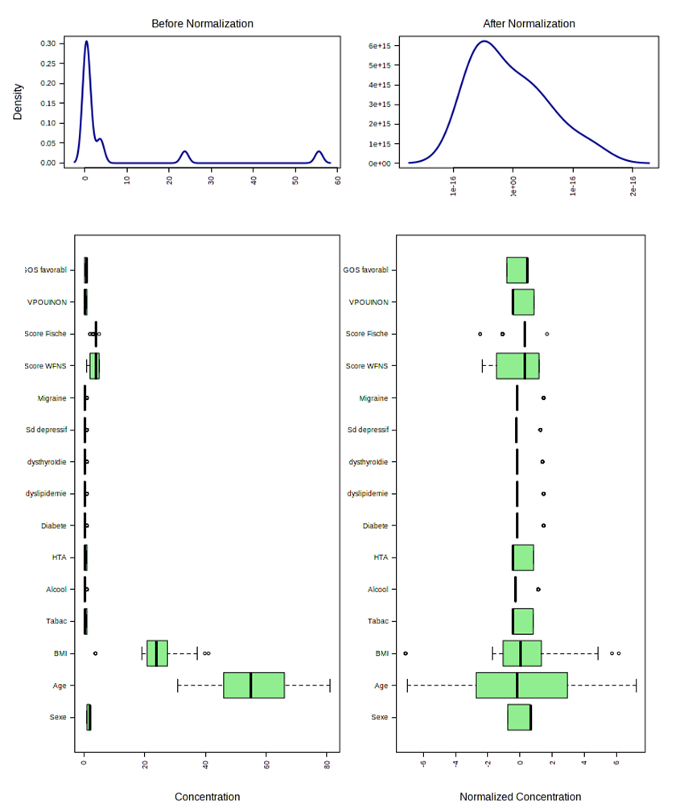
Figure 1. Graphical summary of the clinical data before and after the normalisation procedure
Clinical data were transformed by Pareto scaling (mean-centred and divided by the square-root of the standard deviation) to obtain a Gaussian distribution of the clinical variables. Left panel: before transformation; right panel: after transformation; upper views: data distribution displayed as kernel density estimation plots; lower views: data distribution displayed as boxplots.

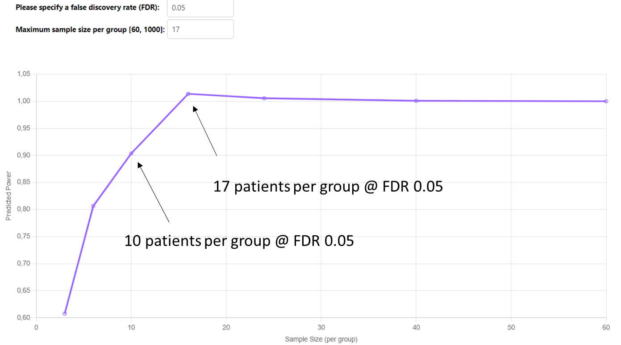
Figure 2. Predicted power according to sample size in each group using the 20 selected variables discriminating DCI+ and DCI- patients

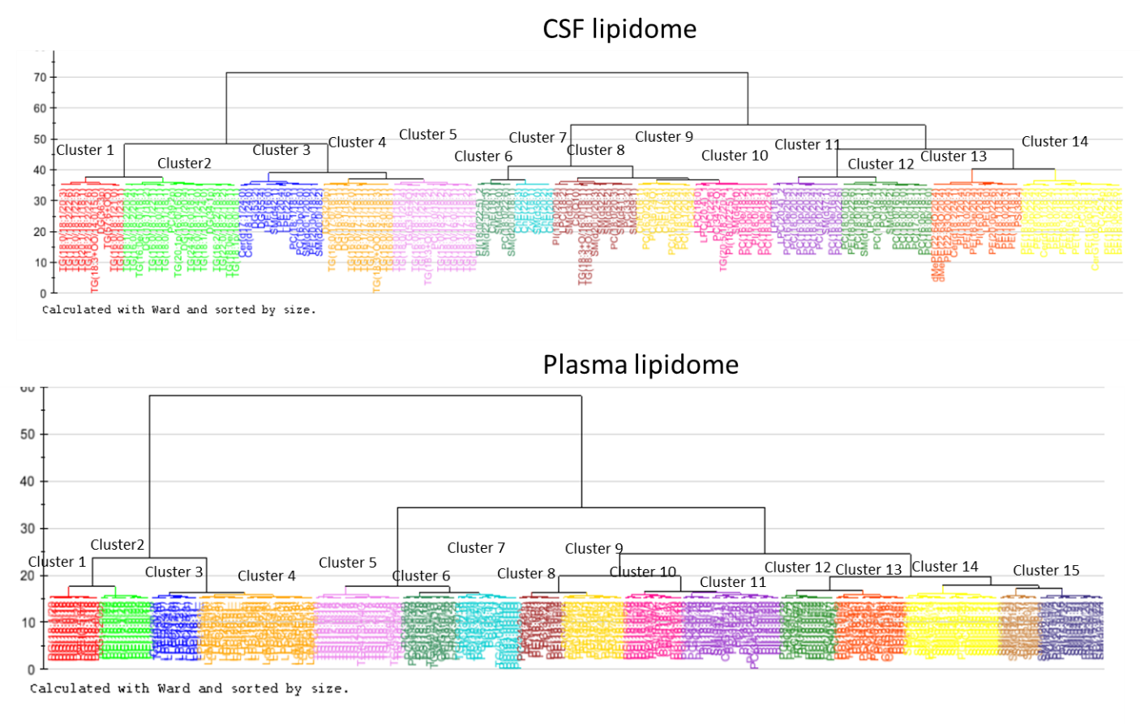
Figure 3. Clustering of the CSF and plasma lipidomes of the study population for hierarchical PLS analysis

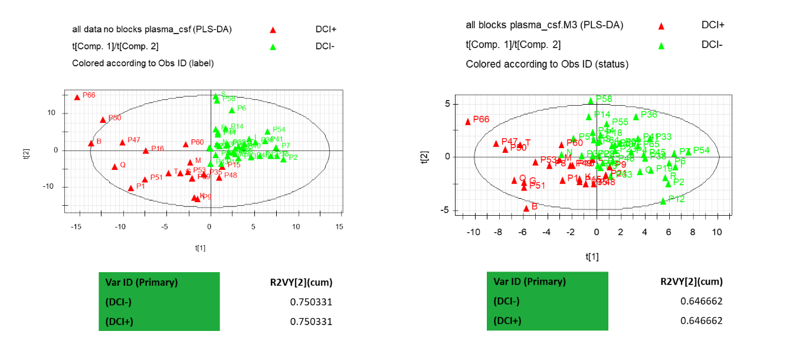
Figure 4. Model performance in unblocked (left panel) and blocked (right panel) PLS-DA models
Observations displayed in a PLS-DA score plot. R2VY stands for the proportion of the Y variable explained by the models (DCI status).

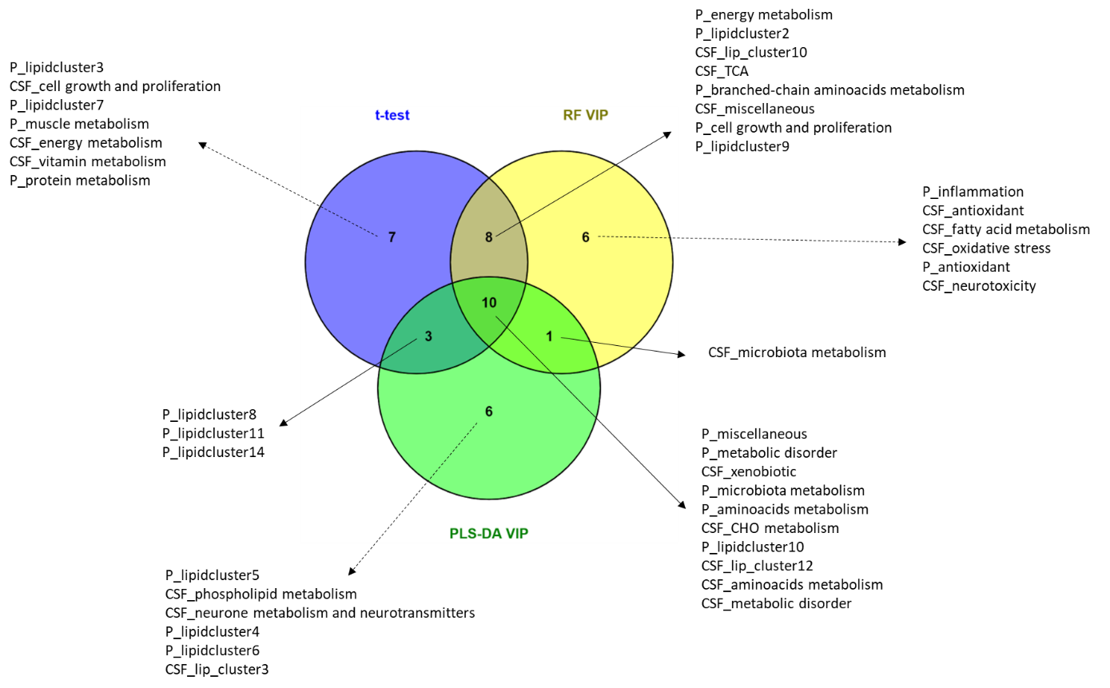
Figure 5. Venn plot showing the most common biological functions and lipid clusters that were shown to be significant using either the univariate t-test (with FDR-adjusted p-value at 0.05), the machine-learning random forest variable importance values and PLS-DA VIP values
Only composite variables found in at least two tests were kept as robustly significant to discriminate DCI+ vs DCI- patients (shown in bold). See Supplemental Tables 2-5 for details on biological function and lipid cluster composition.

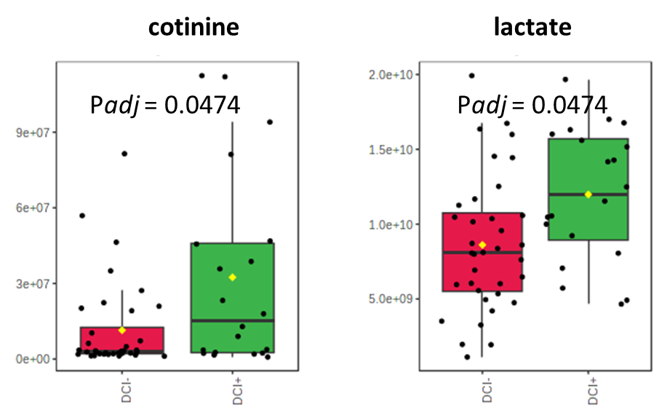
Figure 6. Mass spectrometry detector response values for plasma cotinine and plasma lactate in DCI+ and DCI- patients.

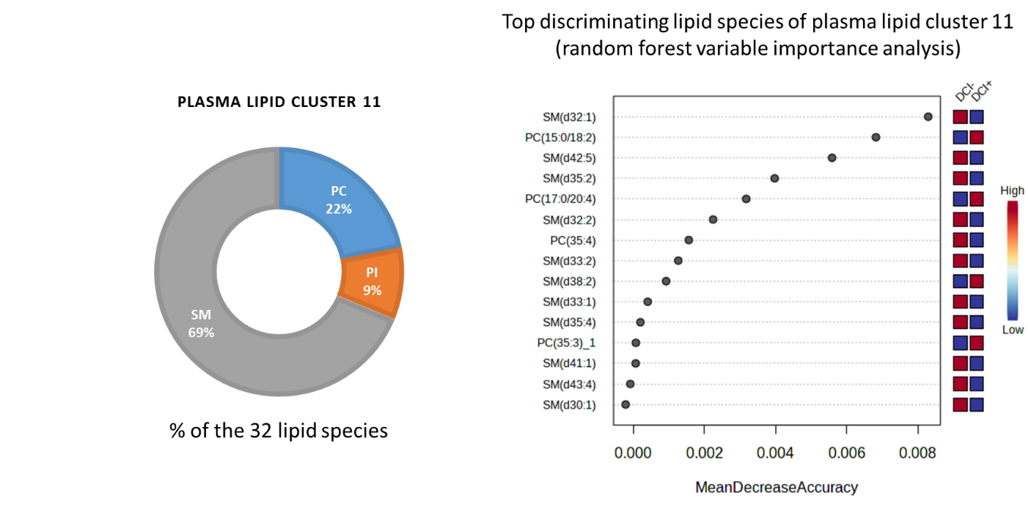
Figure 7. Lipid composition of plasma lipid cluster 11 with top discriminating lipid species (random forest variable importance index, as mean decrease accuracy)

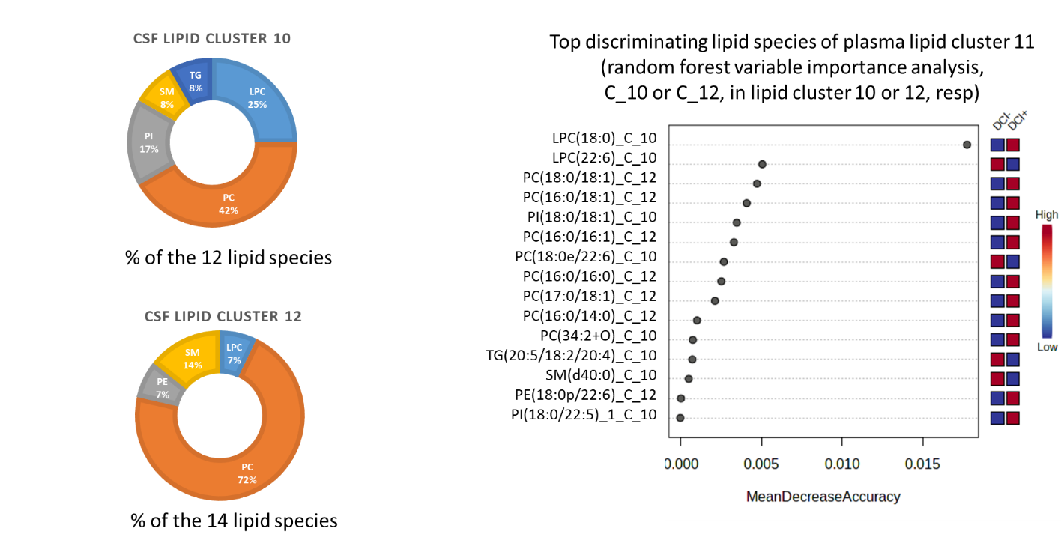
Figure 8. Lipid composition of plasma lipid cluster 10 and 12 with top discriminating lipid species (random forest variable importance index, as mean decrease accuracy)

Supplemental references
- von Elm E, Altman DG, Egger M, Pocock SJ, Gøtzsche PC, Vandenbroucke JP, et al. The Strengthening the Reporting of Observational Studies in Epidemiology (STROBE) statement: guidelines for reporting observational studies. PLoS Med. 2007;4(10):e296.
- Triglia T, Mezzapesa A, Martin JC, Verdier M, Lagier D, Dufour H, et al. Early matrix metalloproteinase-9 concentration in the first 48 h after aneurysmal subarachnoid haemorrhage predicts delayed cerebral ischaemia: An observational study. Eur J Anaesthesiol. 2016;33(9):662‑9.

- Vergouwen MDI, Vermeulen M, van Gijn J, Rinkel GJE, Wijdicks EF, Muizelaar JP, et al. Definition of delayed cerebral ischemia after aneurysmal subarachnoid hemorrhage as an outcome event in clinical trials and observational studies: proposal of a multidisciplinary research group. Stroke. 2010;41(10):2391‑5.
- Martin JC, Bal-dit-Sollier C, Bard JM, Lairon D, Bonneau M, Kang C, et al. Deep phenotyping and biomarkers of various dairy fat intakes in an 8-week randomized clinical trial and 2-year swine study. J Nutr Biochem. 2022;113:109239.
- Aidoud N, Delplanque B, Baudry C, Garcia C, Moyon A, Balasse L, et al. A combination of lipidomics, MS imaging, and PET scan imaging reveals differences in cerebral activity in rat pups according to the lipid quality of infant formulas. FASEB J. 2018;32(9):4776‑90.
- Wold S, Kettaneh N, Tjessem K. Hierarchical multiblock PLS and PC models for easier model interpretation and as an alternative to variable selection. J Chemom. 1996;10(5‑6):463‑82.

