Supplementary Information
Methodological challenges
For the first time, planar optodes were combined with root exudation and a treatment of partial soil sterilization in a gypsum soil to visualize root activity of in this particular alkaline soil. As addressed in the Discussion, the high soil humidity requirements of the pH sensor restricted our observations of root activity to well-watered conditions. This situation in gypsum ecosystems will not always represent the natural conditions, but it would take place in the most favourable moment of the year, when gypsum plants tend to grow and maximize their demand for N and P (Cera et al., 2021b). Unfortunately, this technique cannot be used to monitor plant-soil interactions under drought.
The physical properties of gypsum soil and its high solubility in water led to soil movements in the rhizobox visible surface, including the area in contact with the sensor foil, sometimes creating air bubbles or intrusions of soil particles that altered the signal of the sensor. In addition to the changing conditions of the soil, the rapid and variable speed of root growth in the different individuals limited the number of pictures that could be evaluated for each replicate. After measuring fourteen consecutive days five replicates of both treatments (i.e. theoretically 5 x 14 = 70 pictures per treatment), only 29 and 44 pictures (from natural and fungi-sterile treatments, respectively) showing clear root activity could be included in the analyses.
On the other hand, the sterilization treatment and posterior bacteria inoculation changed the microbial communities in the soil and, as shown in Figure 2, the relative abundance of Fungi was reduced but did not completely disappear. It has been reported that fungi are more sensitive to gamma-irradiation than bacteria, and typically a gamma-irradiation of 10 kGy will eliminate fungi and Actinobacteria, while the majority of soil bacteria are eliminated by 20 kGy (McNamara et al., 2003). In our case, the presence of fungi might be due to an insufficient dose of irradiation or, alternatively, to the non-sterile conditions in which the experiment was conducted and the fact that the rhizoboxes containing gamma-irradiated soil were placed next to those containing natural soil. Hence, fungal spores or propagules might had reached the rhizoboxes containing gamma-irradiated soil and thrived there until the end of the experiment. Despite these complications, we could compare root behaviour in natural gypsum soil and in gypsum soil with an altered microbial life and decreased fungal presence, observing similar trends in all treatment replicates.

Table S1. Mean and SD values observed for mean, maximum and minimum pH observed in the different replicates during the experiment measures. Treatment differences for pHmean, pH min and pH max are included in Figure 3. Acidification was also significantly different among treatments (Kruskal- Wallis, p-val=<0.001)
 | pHmean |  | pHmin |  | pHmax |  | acidification |  | N
 | mean | SD | mean | SD | mean | SD | mean | SD | N
Natural | 7.98 | 0.28 | 6.98 | 0.08 | 9.37 | 0.19 | 2.39 | 0.26 | 29
Fungi sterile | 7.72 | 0.28 | 7.05 | 0.17 | 9.15 | 0.49 | 2.09 | 0.48 | 44

Table S2. Measured values for each replicate x day combination for mean pH, maximum pH and minimum pH observed with the optodes for the filtered pictures with a clear appreciation of the root passing through the sensor.
Treatment | rep | day | pHmean | pHmax | pHmin | Acidification
NAT | 1 | 1 | 7.6 | 8.4 | 7.1 | 1.3
NAT | 1 | 2 | 7.7 | 9.4 | 6.9 | 2.5
NAT | 1 | 3 | 7.7 | 9.4 | 6.8 | 2.6
NAT | 1 | 4 | 7.7 | 9.4 | 6.9 | 2.5
NAT | 1 | 5 | 7.8 | 9.4 | 6.9 | 2.5
NAT | 1 | 6 | 7.7 | 9.4 | 6.9 | 2.5
NAT | 1 | 7 | 7.8 | 9.4 | 7.1 | 2.3
NAT | 1 | 8 | 7.8 | 9.4 | 7 | 2.4
NAT | 1 | 9 | 7.8 | 9.4 | 7 | 2.4
NAT | 1 | 10 | 7.8 | 9.4 | 6.9 | 2.5
NAT | 1 | 11 | 7.8 | 9.4 | 7 | 2.4
NAT | 1 | 12 | 7.8 | 9.4 | 7 | 2.4
NAT | 1 | 13 | 7.8 | 9.4 | 7 | 2.4
NAT | 1 | 14 | 7.8 | 9.4 | 6.9 | 2.5
NAT | 3 | 1 | 8.9 | 9.5 | 6.9 | 2.6
NAT | 5 | 1 | 7.9 | 9.4 | 7.1 | 2.3
NAT | 5 | 2 | 7.9 | 9.4 | 6.9 | 2.5
NAT | 5 | 3 | 7.9 | 9.4 | 6.9 | 2.5
NAT | 5 | 4 | 8.1 | 9.4 | 7 | 2.4
NAT | 5 | 5 | 8.1 | 9.4 | 7 | 2.4
NAT | 5 | 6 | 8.2 | 9.4 | 6.9 | 2.5
NAT | 5 | 7 | 8.2 | 9.4 | 7 | 2.4
NAT | 5 | 8 | 8.3 | 9.4 | 7.1 | 2.3
NAT | 5 | 9 | 8.2 | 9.4 | 7.1 | 2.3
NAT | 5 | 10 | 8.2 | 9.4 | 7 | 2.4
NAT | 5 | 11 | 8.2 | 9.4 | 7 | 2.4
NAT | 5 | 12 | 8.2 | 9.4 | 7 | 2.4
NAT | 5 | 13 | 8.2 | 9.4 | 7 | 2.4
NAT | 5 | 14 | 8.2 | 9.4 | 7 | 2.4
FUNGI ST | 1 | 1 | 7.9 | 9.4 | 7.1 | 2.3
FUNGI ST  FUNGI ST  FUNGI ST  FUNGI ST  FUNGI ST  FUNGI ST  FUNGI ST  FUNGI ST  FUNGI ST  FUNGI ST  FUNGI ST  FUNGI ST  FUNGI ST  FUNGI ST  FUNGI ST  FUNGI ST  FUNGI ST  FUNGI ST  FUNGI ST  FUNGI ST  FUNGI ST  FUNGI ST  FUNGI ST  FUNGI ST  FUNGI ST  FUNGI ST  FUNGI ST  FUNGI ST  FUNGI ST  FUNGI ST  FUNGI ST  FUNGI ST  FUNGI ST  FUNGI ST  FUNGI ST  FUNGI ST  FUNGI ST  FUNGI ST  FUNGI ST  FUNGI ST  FUNGI ST  FUNGI ST  FUNGI ST FUNGI ST  FUNGI ST  FUNGI ST  FUNGI ST  FUNGI ST  FUNGI ST  FUNGI ST  FUNGI ST | 2 | 1 | 8 | 9.4 | 7.1 | 2.3
 | 2 | 2 | 7.9 | 9.4 | 7.2 | 2.2
 | 2 | 3 | 7.8 | 9.4 | 7.2 | 2.2
 | 2 | 4 | 7.9 | 9.4 | 7.3 | 2.1
 | 2 | 5 | 7.9 | 9.4 | 7.3 | 2.1
 | 2 | 6 | 7.9 | 9.4 | 7.3 | 2.1
 | 2 | 7 | 7.9 | 9.4 | 7.3 | 2.1
 | 2 | 8 | 7.9 | 9.4 | 7.2 | 2.2
 | 2 | 9 | 7.9 | 9.4 | 7.3 | 2.1
 | 2 | 10 | 7.9 | 9.4 | 7.3 | 2.1
 | 2 | 11 | 7.9 | 9.4 | 7.3 | 2.1
 | 2 | 12 | 7.9 | 9.4 | 7.1 | 2.3
 | 2 | 13 | 7.9 | 9.4 | 7.2 | 2.2
 | 2 | 14 | 7.9 | 9.4 | 7.1 | 2.3
 | 3 | 1 | 7.6 | 9.4 | 7 | 2.4
 | 3 | 2 | 7.6 | 9.4 | 6.7 | 2.7
 | 3 | 3 | 7.5 | 9.4 | 6.8 | 2.6
 | 3 | 4 | 7.5 | 9.4 | 6.9 | 2.5
 | 3 | 5 | 7.6 | 8.5 | 7 | 1.5
 | 3 | 6 | 7.6 | 9.4 | 7.1 | 2.3
 | 3 | 7 | 7.6 | 9.4 | 6.9 | 2.5
 | 3 | 8 | 7.6 | 8.9 | 6.9 | 2
 | 3 | 9 | 7.6 | 9.4 | 6.9 | 2.5
 | 3 | 10 | 7.6 | 9.4 | 7 | 2.4
 | 3 | 11 | 7.5 | 8.9 | 6.8 | 2.1
 | 3 | 12 | 7.5 | 8.9 | 7 | 1.9
 | 3 | 13 | 7.5 | 9.4 | 7 | 2.4
 | 3 | 14 | 7.5 | 9.4 | 6.9 | 2.5
 | 4 | 1 | 8.8 | 7.4 | 7.3 | 0.1
 | 5 | 1 | 8.3 | 9.4 | 7.1 | 2.3
 | 5 | 2 | 7.5 | 8 | 6.6 | 1.4
 | 5 | 3 | 8 | 9.4 | 7.1 | 2.3
 | 5 | 4 | 7.9 | 9.4 | 7.3 | 2.1
 | 5 | 5 | 7.6 | 9.4 | 7 | 2.4
 | 5 | 6 | 7.6 | 9.4 | 7 | 2.4
 | 5 | 7 | 7.5 | 9.4 | 7 | 2.4
 | 5 | 8 | 7.5 | 9.4 | 7.1 | 2.3
 | 5 | 9 | 7.4 | 8.2 | 7.1 | 1.1
 | 5 | 10 | 7.5 | 8.9 | 7 | 1.9
 | 5 | 11 | 7.4 | 8.2 | 7 | 1.2
 | 5 | 12 | 7.4 | 8.2 | 6.9 | 1.3
 | 5 | 13 | 7.4 | 9.4 | 7 | 2.4
 | 5 | 14 | 7.4 | 8.4 | 6.9 | 1.5

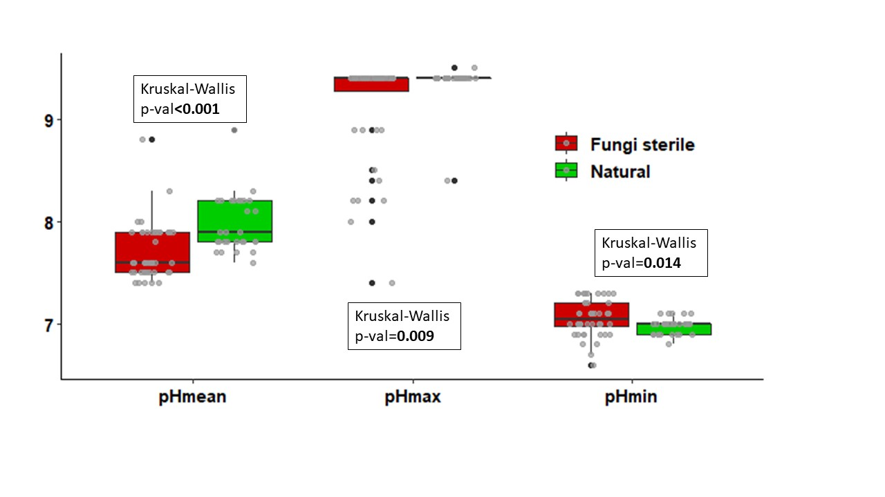
Figure Supplementary 1. Maximum, minimum and mean pH observed in the sensor foils placed in the roots of the growing seedlings of Ononis tridentata, compared per soil treatment: green boxes for the natural treatment, red boxed for the fungi-sterile treatment. P-values of Kruskal Wallis tests show the significance of the differences between treatments. The variability of the maximum pH could be due to the calcium carbonate with variable presence in each iece of soil observed.

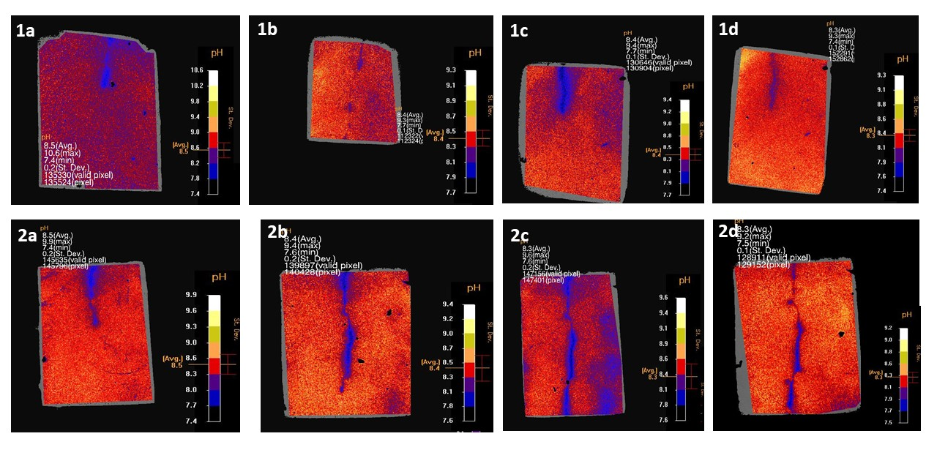
Figure Supplementary 2. IDL evaluation images of a preliminary experiment done with the methodology described but with other species living on gypsum. 1) Helianthemum squamatum: fungi-sterile treatment first day for 1a and ninth day for 1b, 1c and 1d represent H. squamatum natural treatment first day and fourth day, respectively. 2 a, b, c, d) Helianthemum syriacum fungi-sterile treatment days 1st, 4th, 6th and 11th respectively.

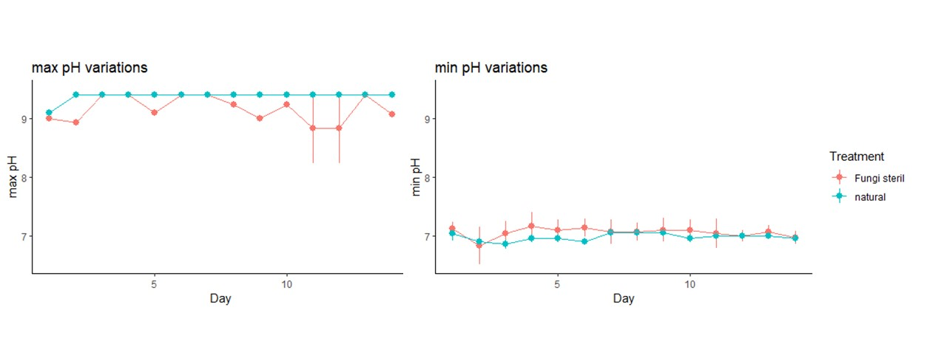
Figure Supplementary 3. pH min and pH max variations by experimental days. These data were not treated in the main analysis due to the different developmental status of each individual, which made these data not comparable.

